Good Shepherd Lutheran Church
Second Sunday of Easter
April 11, 2021

Pre-Service Music & Welcome
Divine Service Setting One – Lutheran Service Book (LSB) 151

+CONFESSION AND ABSOLUTION+

Opening Hymn “Awake, My Heart, with Gladness” LSB 467
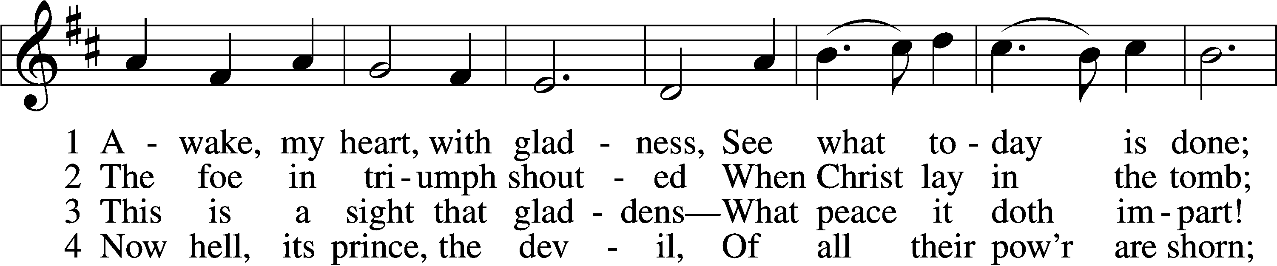
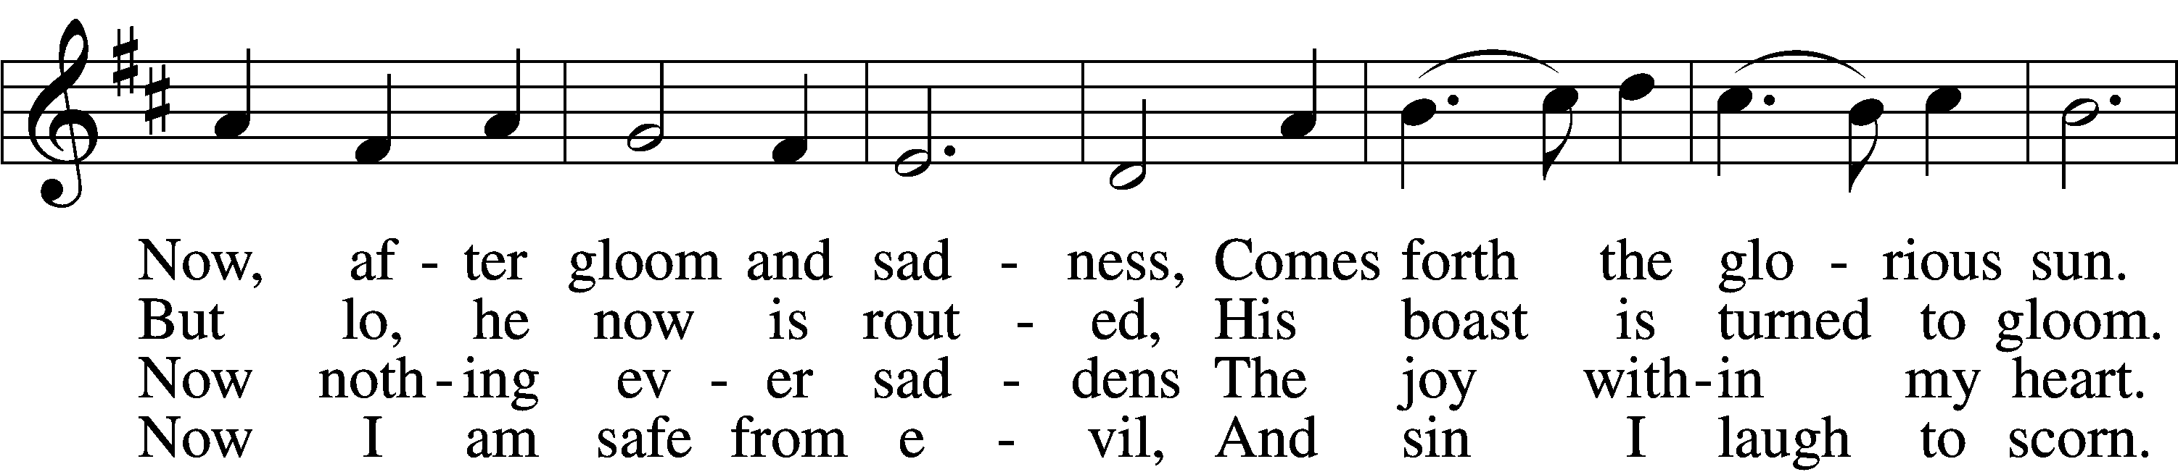
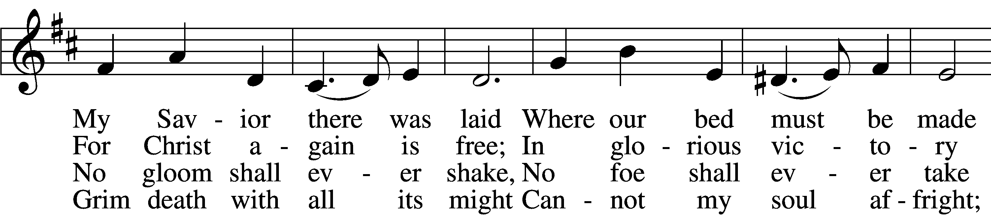
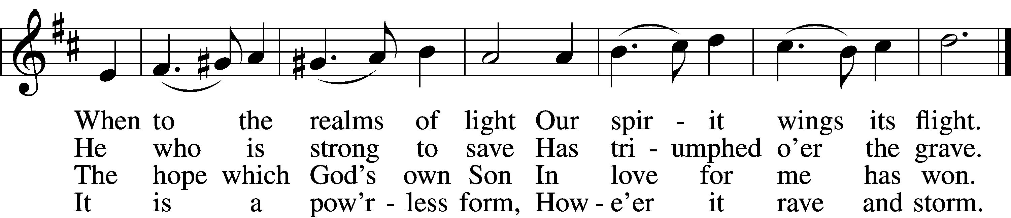

5 The world against me rages,
Its fury I disdain;
Though bitter war it wages,
Its work is all in vain.
My heart from care is free,
No trouble troubles me.
Misfortune now is play,
And night is bright as day.

6 Now I will cling forever
To Christ, my Savior true;
My Lord will leave me never,
Whate’er He passes through.
He rends death’s iron chain;
He breaks through sin and pain;
He shatters hell’s grim thrall;
I follow Him through all.

7 He brings me to the portal
That leads to bliss untold,
Whereon this rhyme immortal
Is found in script of gold:
“Who there My cross has shared
Finds here a crown prepared;
Who there with Me has died
Shall here be glorified.”
Text and tune: Public domain

Stand

The sign of the cross T may be made by all in remembrance of their Baptism.

Invocation
P In the name of the Father and of the T Son and of the Holy Spirit.
C Amen.

Exhortation LSB 151
P If we say we have no sin, we deceive ourselves, and the truth is not in us.
C But if we confess our sins, God, who is faithful and just, will forgive our sins and cleanse us from all unrighteousness.

Silence for reflection on God’s Word and for self-examination.

Confession of Sins LSB 151
P Let us then confess our sins to God our Father.
C Most merciful God, we confess that we are by nature sinful and unclean. We have sinned against You in thought, word, and deed, by what we have done and by what we have left undone. We have not loved You with our whole heart; we have not loved our neighbors as ourselves. We justly deserve Your present and eternal punishment. For the sake of Your Son, Jesus Christ, have mercy on us. Forgive us, renew us, and lead us, so that we may delight in Your will and walk in Your ways to the glory of Your holy name. Amen.

Absolution LSB 151
P Almighty God in His mercy has given His Son to die for you and for His sake forgives you all your sins. As a called and ordained servant of Christ, and by His authority, I therefore forgive you all your sins in the name of the Father and of the T Son and of the Holy Spirit.
C Amen.

+SERVICE OF THE WORD+

Introit Psalm 81:1, 7a, 10, 16b; antiphon: 1 Peter 2:2a
Like newborn infants, Alleluia,*
long for the pure spiritual milk [of the Word.] Alleluia.
Sing aloud to God our strength;*
shout for joy to the God of Jacob!
In distress you called, and I delivered you;*
I answered you in the secret place of thunder.
I am the Lord your God,*
who brought you up out of the land of Egypt.
Open your mouth wide, and I will fill it;*
and with honey from the rock I would satisfy you.
Glory be to the Father and to the Son*
and to the Holy Spirit;
as it was in the beginning,*
is now, and will be forever. Amen.
Like newborn infants, Alleluia,*
long for the pure spiritual milk [of the Word.] Alleluia.

Kyrie LSB 152
A In peace let us pray to the Lord.
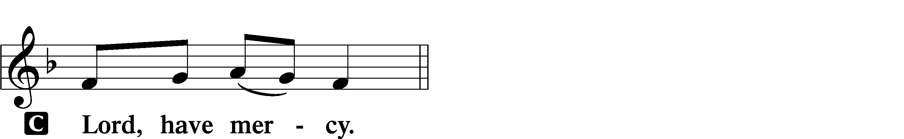

A For the peace from above and for our salvation let us pray to the Lord.
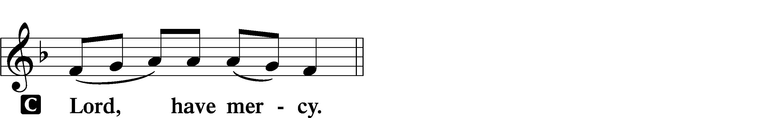

A For the peace of the whole world, for the well-being of the Church of God, and for the unity of all let us pray to the Lord.
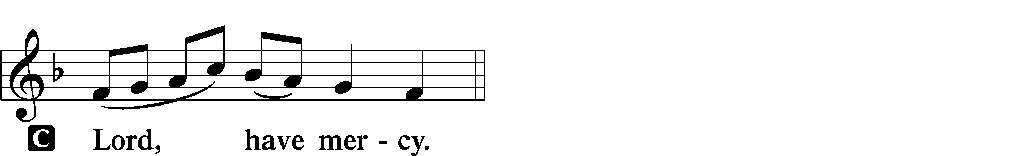

A For this holy house and for all who offer here their worship and praise let us pray to the Lord.
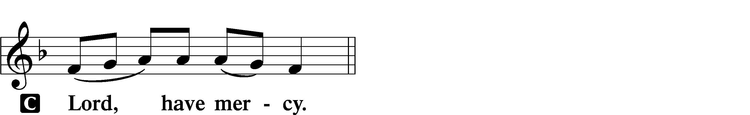

A Help, save, comfort, and defend us, gracious Lord.
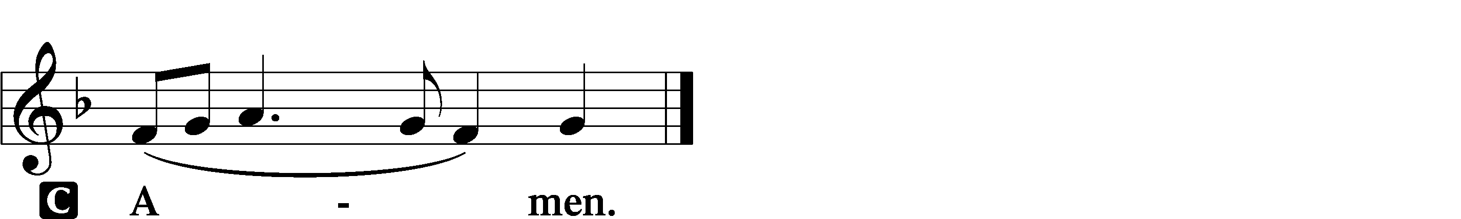

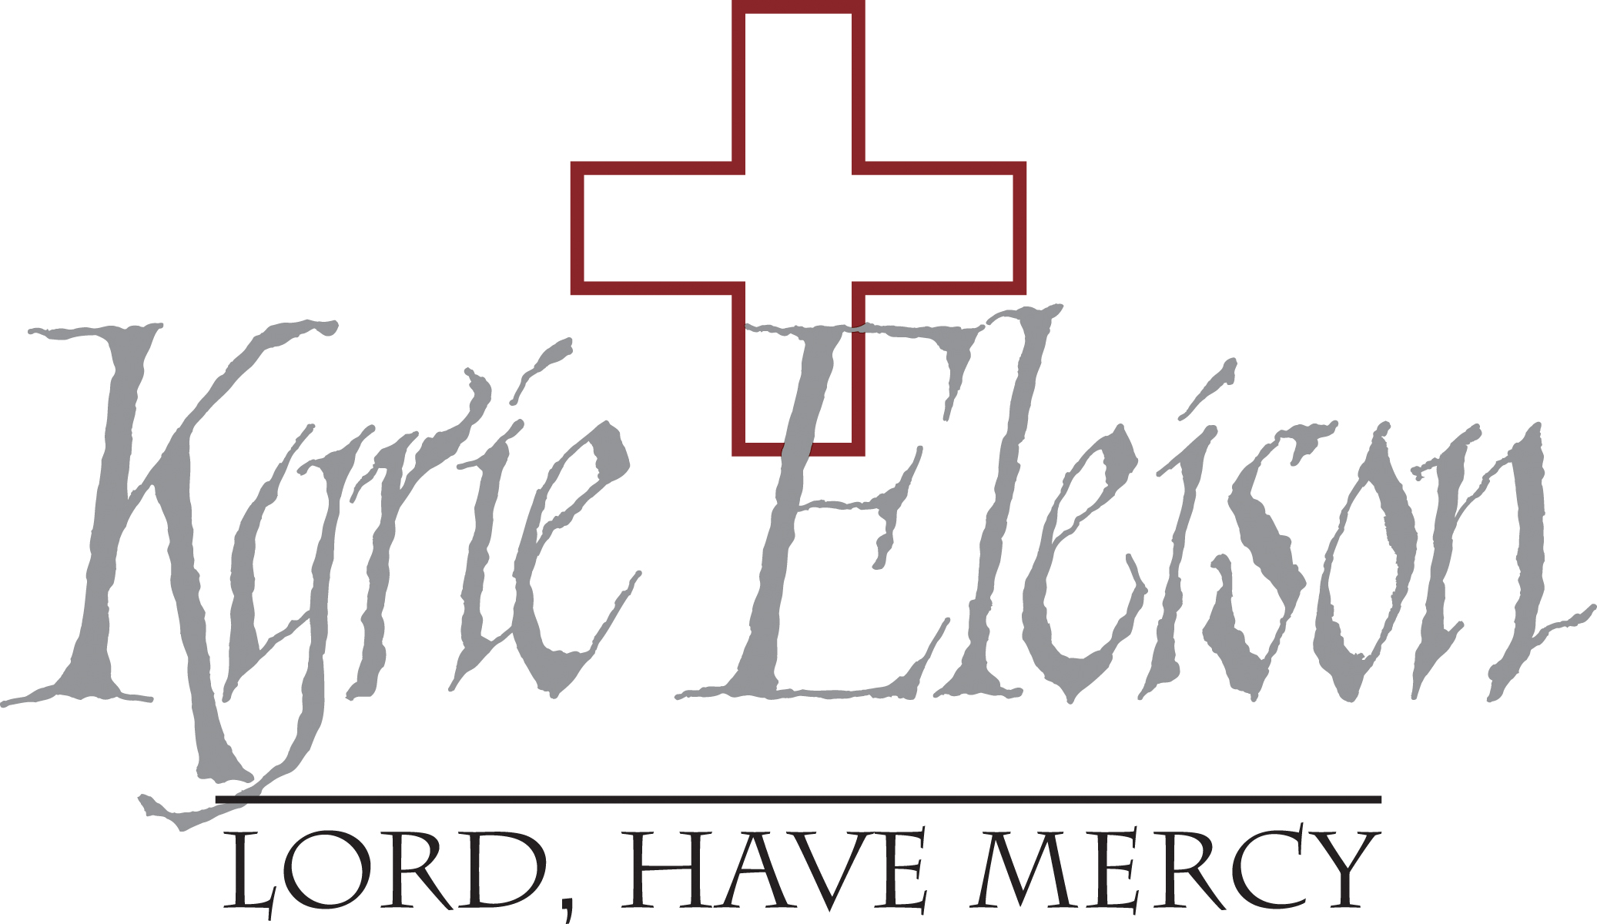

This Is the Feast LSB 155
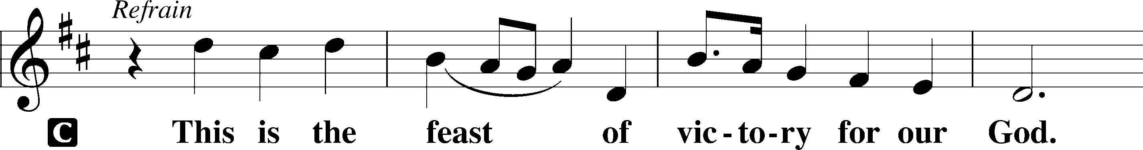
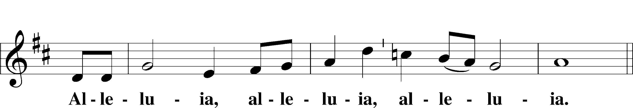
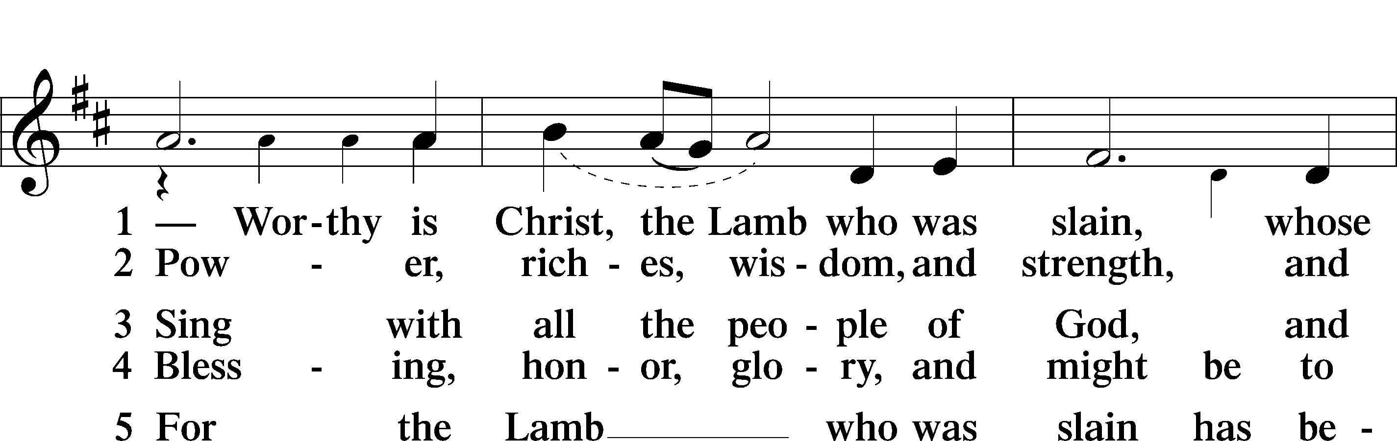
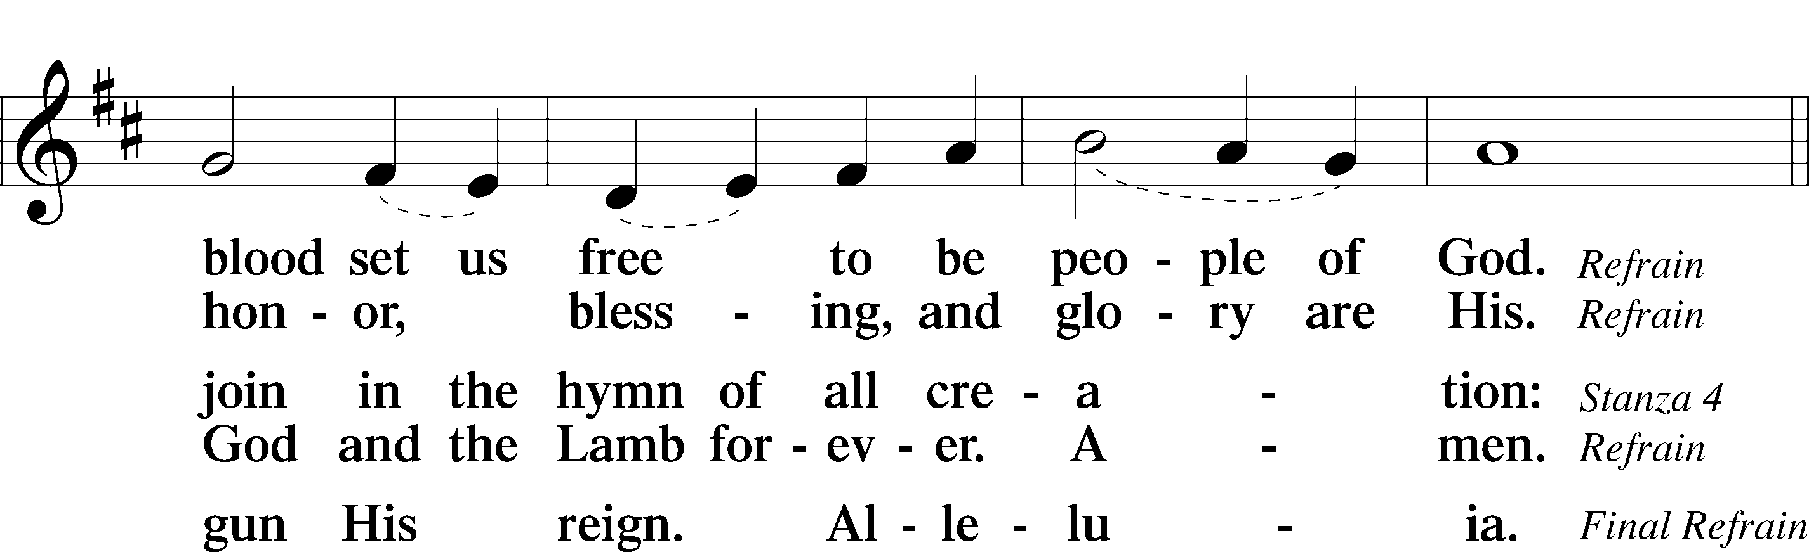
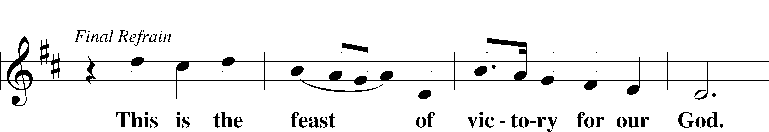
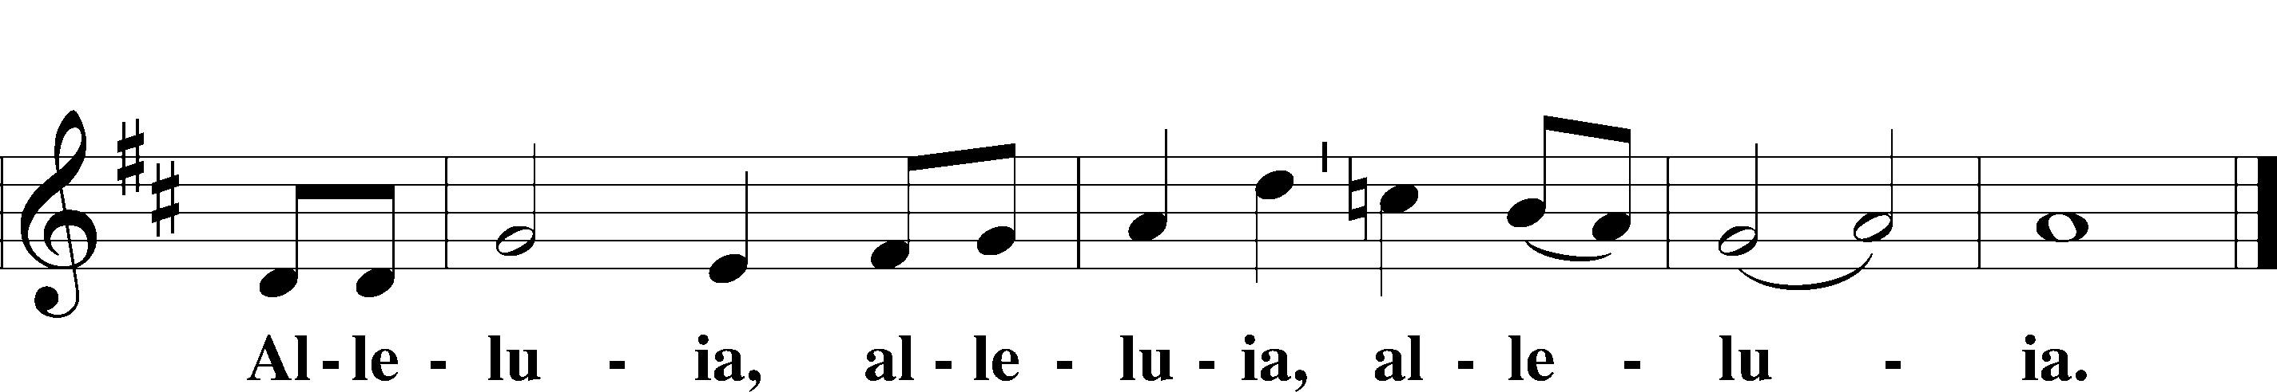

Salutation and Collect of the Day
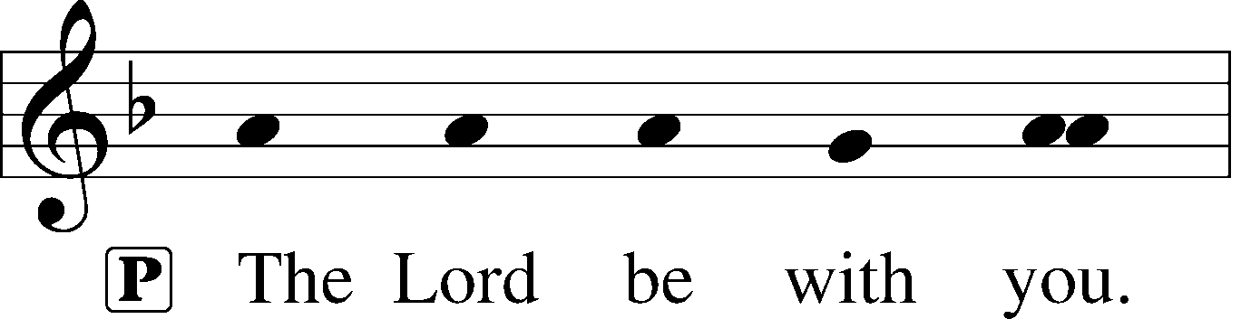
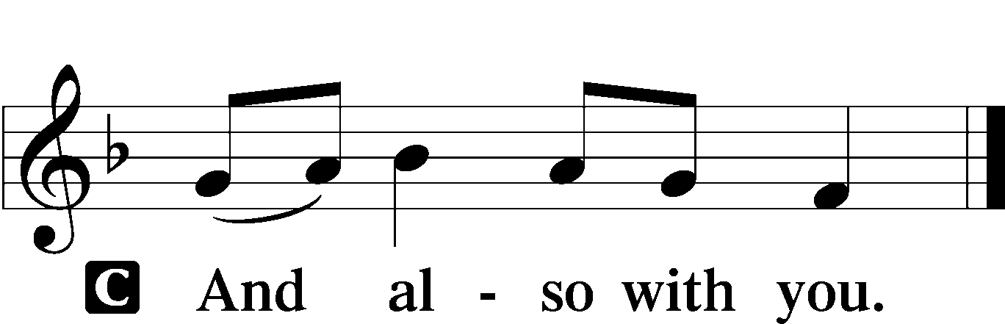

P Let us pray.
C Almighty God, grant that we who have celebrated the Lord’s resurrection may by Your grace confess in our life and conversation that Jesus is Lord and God; through the same Jesus Christ, Your Son, who lives and reigns with You and the Holy Spirit, one God, now and forever. Amen.

Sit

Old Testament Reading Ezekiel 37:1–14
1The hand of the Lord was upon me, and he brought me out in the Spirit of the Lord and set me down in the middle of the valley; it was full of bones. 2And he led me around among them, and behold, there were very many on the surface of the valley, and behold, they were very dry. 3And he said to me, “Son of man, can these bones live?” And I answered, “O Lord God, you know.” 4Then he said to me, “Prophesy over these bones, and say to them, O dry bones, hear the word of the Lord. 5Thus says the Lord God to these bones: Behold, I will cause breath to enter you, and you shall live. 6And I will lay sinews upon you, and will cause flesh to come upon you, and cover you with skin, and put breath in you, and you shall live, and you shall know that I am the Lord.”
7So I prophesied as I was commanded. And as I prophesied, there was a sound, and behold, a rattling, and the bones came together, bone to its bone. 8And I looked, and behold, there were sinews on them, and flesh had come upon them, and skin had covered them. But there was no breath in them. 9Then he said to me, “Prophesy to the breath; prophesy, son of man, and say to the breath, Thus says the Lord God: Come from the four winds, O breath, and breathe on these slain, that they may live.” 10So I prophesied as he commanded me, and the breath came into them, and they lived and stood on their feet, an exceedingly great army.
11Then he said to me, “Son of man, these bones are the whole house of Israel. Behold, they say, ‘Our bones are dried up, and our hope is lost; we are clean cut off.’ 12Therefore prophesy, and say to them, Thus says the Lord God: Behold, I will open your graves and raise you from your graves, O my people. And I will bring you into the land of Israel. 13And you shall know that I am the Lord, when I open your graves, and raise you from your graves, O my people. 14And I will put my Spirit within you, and you shall live, and I will place you in your own land. Then you shall know that I am the Lord; I have spoken, and I will do it, declares the Lord.”

A This is the Word of the Lord.
C Thanks be to God.

Psalm Psalm 33
¹Shout for joy in the Lord, O you righteous!*
Praise befits the upright.
²Give thanks to the Lord with the lyre;*
make melody to him with the harp of ten strings!
³Sing to him a new song;*
play skillfully on the strings, with loud shouts.
⁴For the word of the Lord is upright,*
and all his work is done in faithfulness.
⁵He loves righteousness and justice;*
the earth is full of the steadfast love of the Lord.
⁶By the word of the Lord the heavens were made,*
and by the breath of his mouth all their host.
⁷He gathers the waters of the sea as a heap;*
he puts the deeps in storehouses.
⁸Let all the earth fear the Lord;*
let all the inhabitants of the world stand in awe of him!
⁹For he spoke, and it came to be;*
he commanded, and it stood firm.
¹⁰The Lord brings the counsel of the nations to nothing;*
he frustrates the plans of the peoples.
¹¹The counsel of the Lord stands forever,*
the plans of his heart to all generations.
¹²Blessèd is the nation whose God is the Lord,*
the people whom he has chosen as his heritage!
¹³The Lord looks down from heaven;*
he sees all the children of man;
¹⁴from where he sits enthroned he looks out*
on all the inhabitants of the earth,
¹⁵he who fashions the hearts of them all*
and observes all their deeds.
¹⁶The king is not saved by his great army;*
a warrior is not delivered by his great strength.
¹⁷The war horse is a false hope for salvation,*
and by its great might it cannot rescue.
¹⁸Behold, the eye of the Lord is on those who fear him,*
on those who hope in his steadfast love,
¹⁹that he may deliver their soul from death*
and keep them alive in famine.
²⁰Our soul waits for the Lord;*
he is our help and our shield.
²¹For our heart is glad in him,*
because we trust in his holy name.
²²Let your steadfast love, O Lord, be upon us,*
even as we hope in you.
Glory be to the Father and to the Son*
and to the Holy Spirit;
as it was in the beginning,*
is now, and will be forever. Amen.

Epistle 1 John 5:4–10
4For everyone who has been born of God overcomes the world. And this is the victory that has overcome the world—our faith. 5Who is it that overcomes the world except the one who believes that Jesus is the Son of God?
6This is he who came by water and blood—Jesus Christ; not by the water only but by the water and the blood. And the Spirit is the one who testifies, because the Spirit is the truth. 7For there are three that testify: 8the Spirit and the water and the blood; and these three agree. 9If we receive the testimony of men, the testimony of God is greater, for this is the testimony of God that he has borne concerning his Son. 10Whoever believes in the Son of God has the testimony in himself. Whoever does not believe God has made him a liar, because he has not believed in the testimony that God has borne concerning his Son.

A This is the Word of the Lord.
C Thanks be to God.

Gospel Procession
Please stand. During the Easter Season, we will hear the Holy Gospel proclaimed from the midst of the congregation, remembering that our crucified and risen Lord Jesus Christ is here in our very mist right now! (Matthew 18:20). Please turn to face the processional cross as Pastor moves toward the center of the sanctuary with the Gospel. As we prepare to hear God’s Word, the choir will sing a festive musical setting of the Alleluia, then the congregation will speak together the Easter verse below, then we will all sing the festive setting of the Alleluia together. At last, we’ll hear the eternal Gospel of Jesus Christ proclaimed!

952 Alleluia (Choir)
V Alleluia, alleluia! Alleluia, alleluia!
Verse (Spoken by congregation) LSB 156
C Alleluia. He has risen from the dead, and behold, he is going before you to Galilee. Alleluia. Eight days later Jesus came and stood among them and said, “Peace be with you.” Alleluia.

952 Alleluia (Congregation)
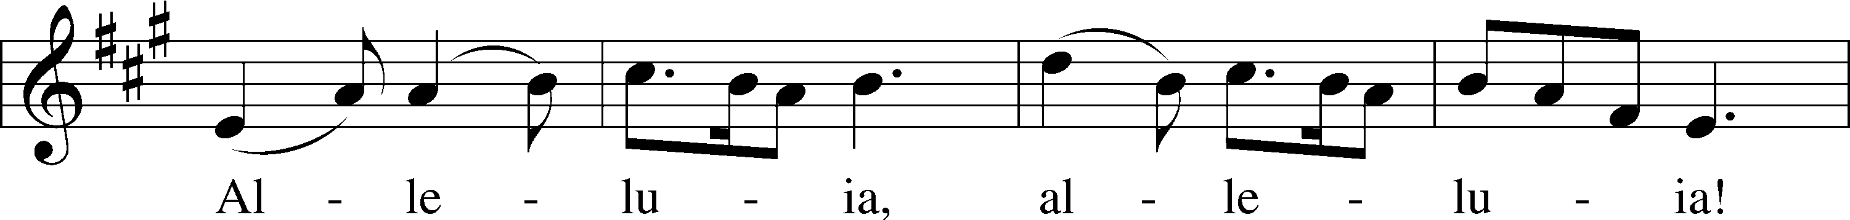
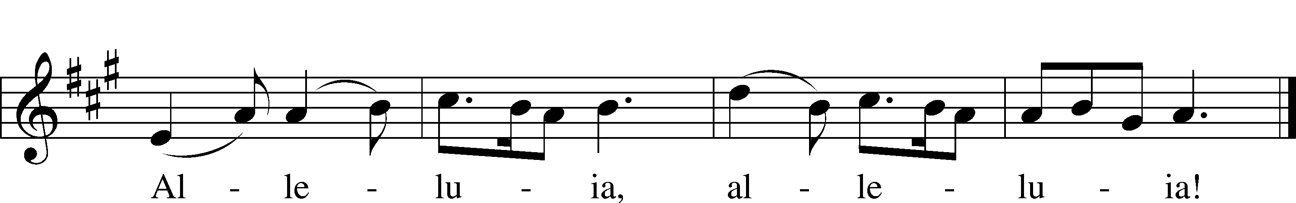
Text: Public domain
Tune: © 1985 Fintan O’Carroll and Christopher Walker, admin. OCP Publications. Used by permission: LSB Hymn License no. 110016438

Holy Gospel John 20:19–31
P The Holy Gospel according to St. John, the twentieth chapter.

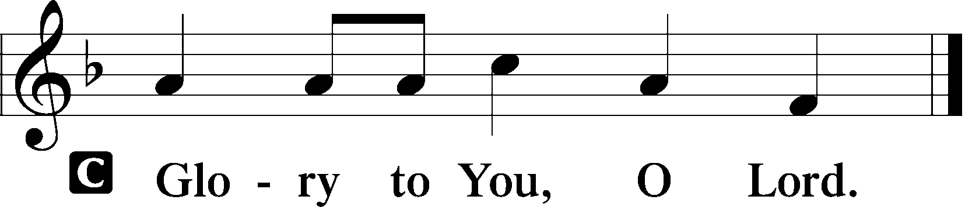

19On the evening of that day, the first day of the week, the doors being locked where the disciples were for fear of the Jews, Jesus came and stood among them and said to them, “Peace be with you.” 20When he had said this, he showed them his hands and his side. Then the disciples were glad when they saw the Lord. 21Jesus said to them again, “Peace be with you. As the Father has sent me, even so I am sending you.” 22And when he had said this, he breathed on them and said to them, “Receive the Holy Spirit. 23If you forgive the sins of anyone, they are forgiven; if you withhold forgiveness from anyone, it is withheld.”
24Now Thomas, one of the Twelve, called the Twin, was not with them when Jesus came. 25So the other disciples told him, “We have seen the Lord.” But he said to them, “Unless I see in his hands the mark of the nails, and place my finger into the mark of the nails, and place my hand into his side, I will never believe.”
26Eight days later, his disciples were inside again, and Thomas was with them. Although the doors were locked, Jesus came and stood among them and said, “Peace be with you.” 27Then he said to Thomas, “Put your finger here, and see my hands; and put out your hand, and place it in my side. Do not disbelieve, but believe.” 28Thomas answered him, “My Lord and my God!” 29Jesus said to him, “Have you believed because you have seen me? Blessed are those who have not seen and yet have believed.”
30Now Jesus did many other signs in the presence of the disciples, which are not written in this book; 31but these are written so that you may believe that Jesus is the Christ, the Son of God, and that by believing you may have life in his name.

P This is the Gospel of the Lord.

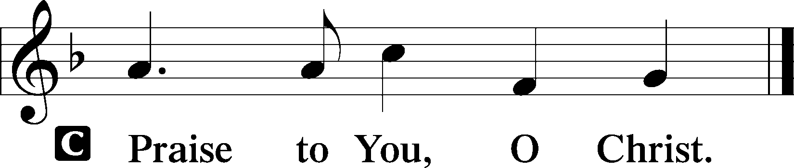

Nicene Creed
C I believe in one God,
the Father Almighty,
maker of heaven and earth
and of all things visible and invisible.

And in one Lord Jesus Christ,
the only-begotten Son of God,
begotten of His Father before all worlds,
God of God, Light of Light,
very God of very God,
begotten, not made,
being of one substance with the Father,
by whom all things were made;
who for us men and for our salvation came down from heaven
and was incarnate by the Holy Spirit of the virgin Mary
and was made man;
and was crucified also for us under Pontius Pilate.
He suffered and was buried.
And the third day He rose again according to the Scriptures
and ascended into heaven
and sits at the right hand of the Father.
And He will come again with glory to judge both the living and the dead,
whose kingdom will have no end.

And I believe in the Holy Spirit,
the Lord and giver of life,
who proceeds from the Father and the Son,
who with the Father and the Son together is worshiped and glorified,
who spoke by the prophets.
And I believe in one holy Christian and apostolic Church,
I acknowledge one Baptism for the remission of sins,
and I look for the resurrection of the dead
and the life T of the world to come. Amen.

Sit

Children’s Message
“Peace be with you.” John 20:26

Hymn of the Day “O Sons and Daughters of the King” LSB 470
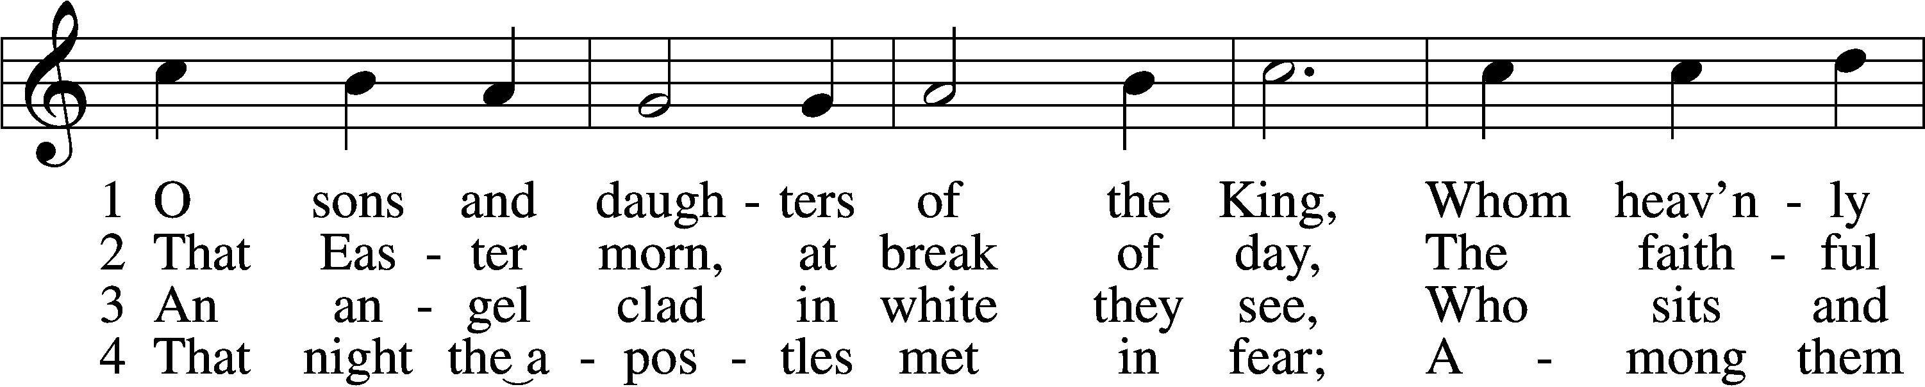
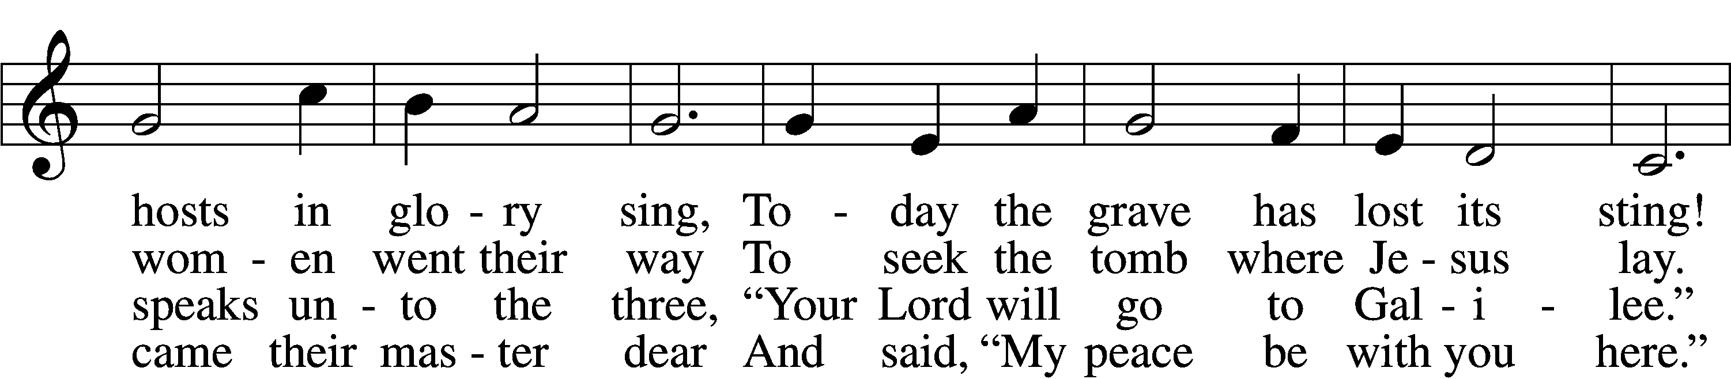
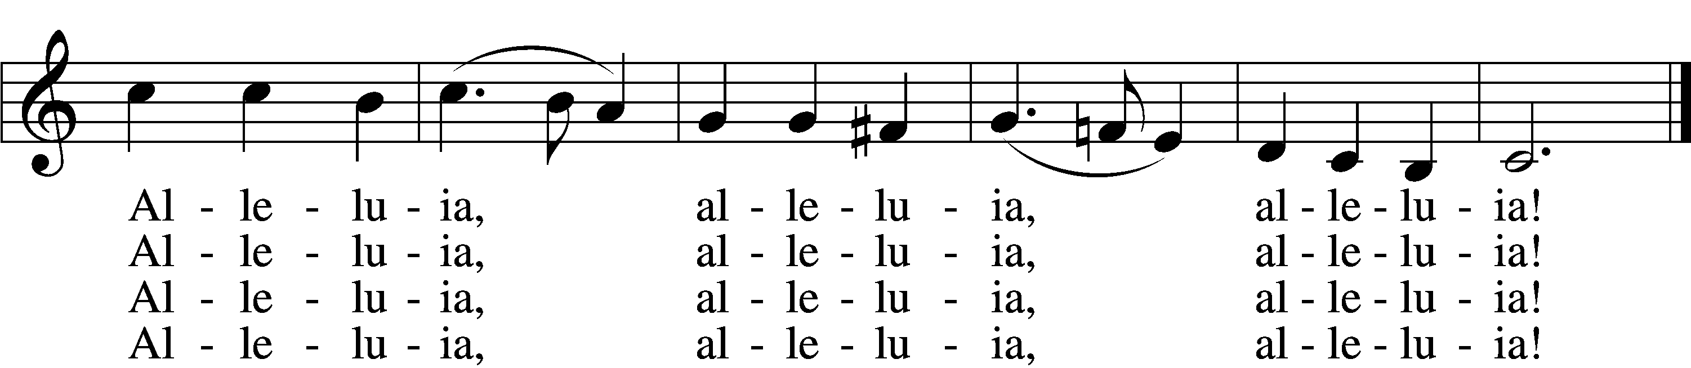

5 When Thomas first the tidings heard
That they had seen the risen Lord,
He doubted the disciples’ word.
Alleluia, alleluia, alleluia!

6 “My piercèd side, O Thomas, see,
And look upon My hands, My feet;
Not faithless but believing be.”
Alleluia, alleluia, alleluia!

7 No longer Thomas then denied;
He saw the feet, the hands, the side;
“You are my Lord and God!” he cried.
Alleluia, alleluia, alleluia!

8 How blest are they who have not seen
And yet whose faith has constant been,
For they eternal life shall win.
Alleluia, alleluia, alleluia!

9 On this most holy day of days
Be laud and jubilee and praise:
To God your hearts and voices raise.
Alleluia, alleluia, alleluia!
Tune and text: Public domain

Sermon

Stand

Offertory LSB 159
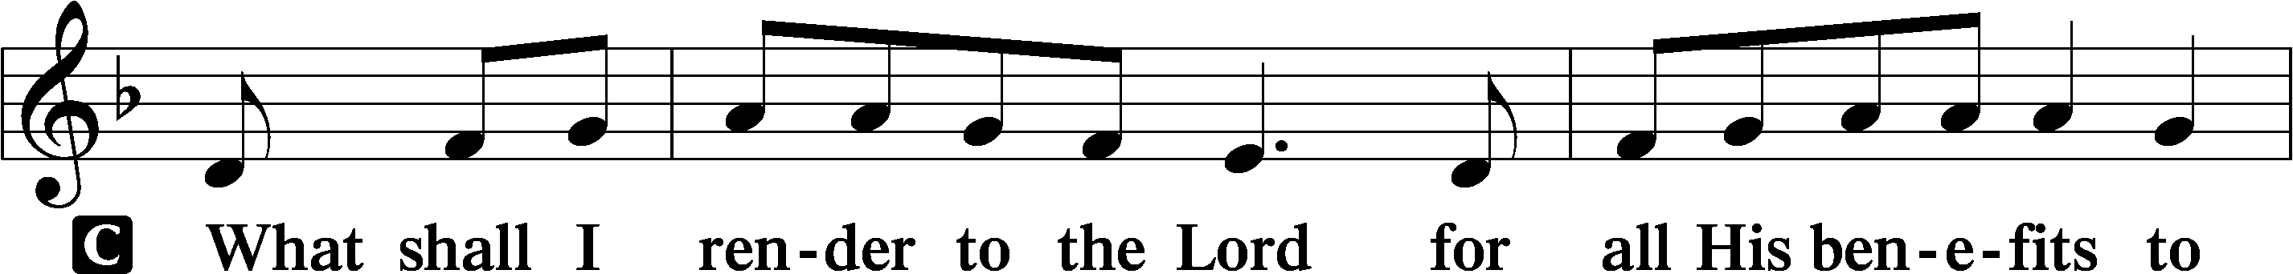
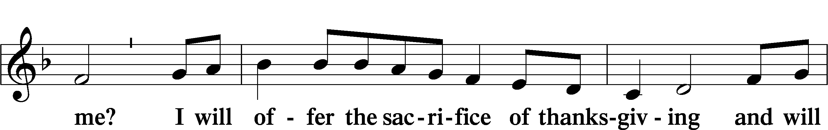
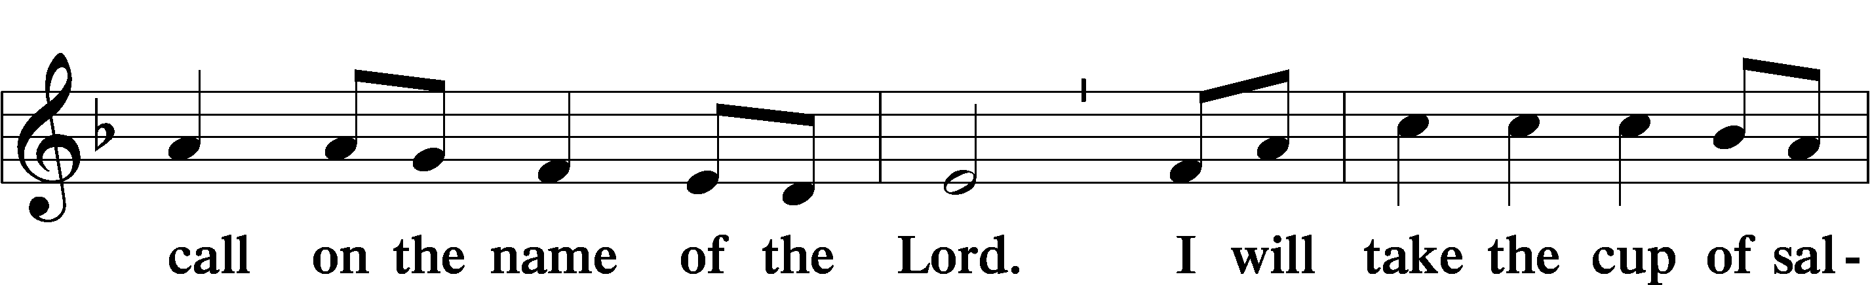
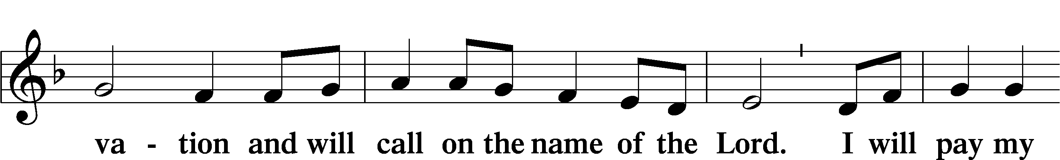
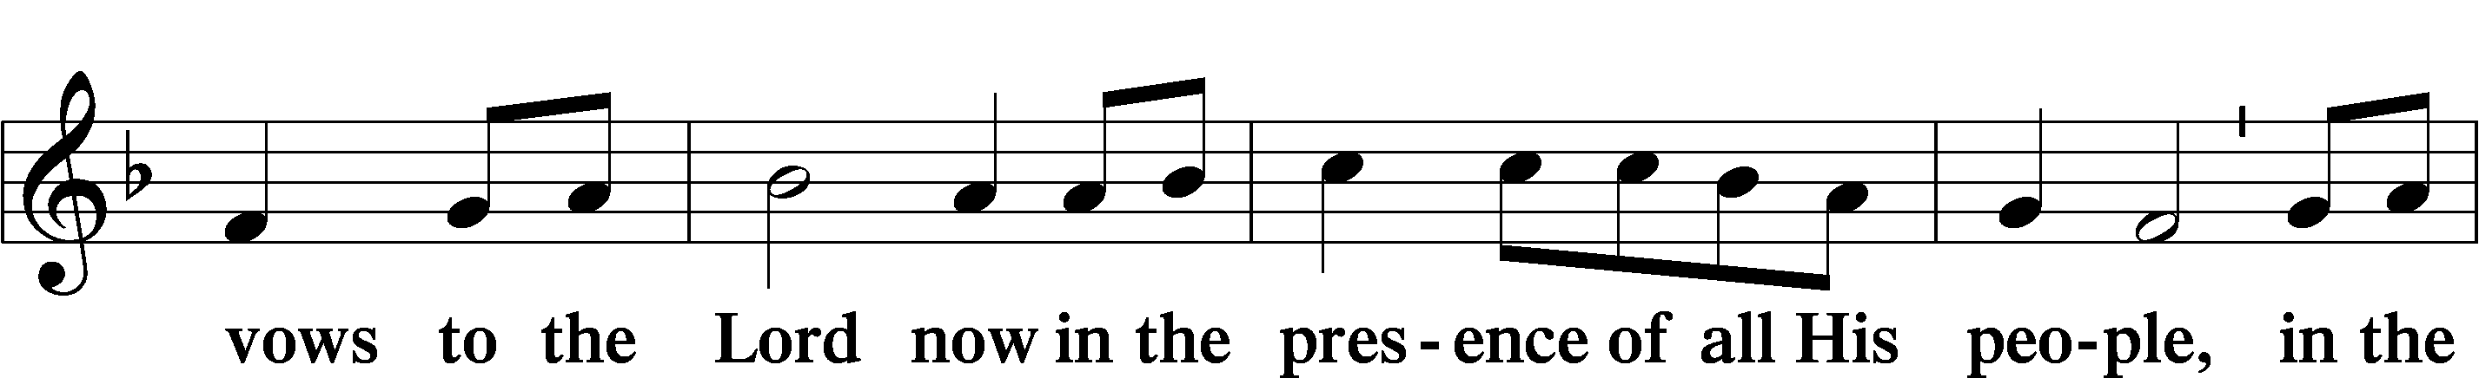
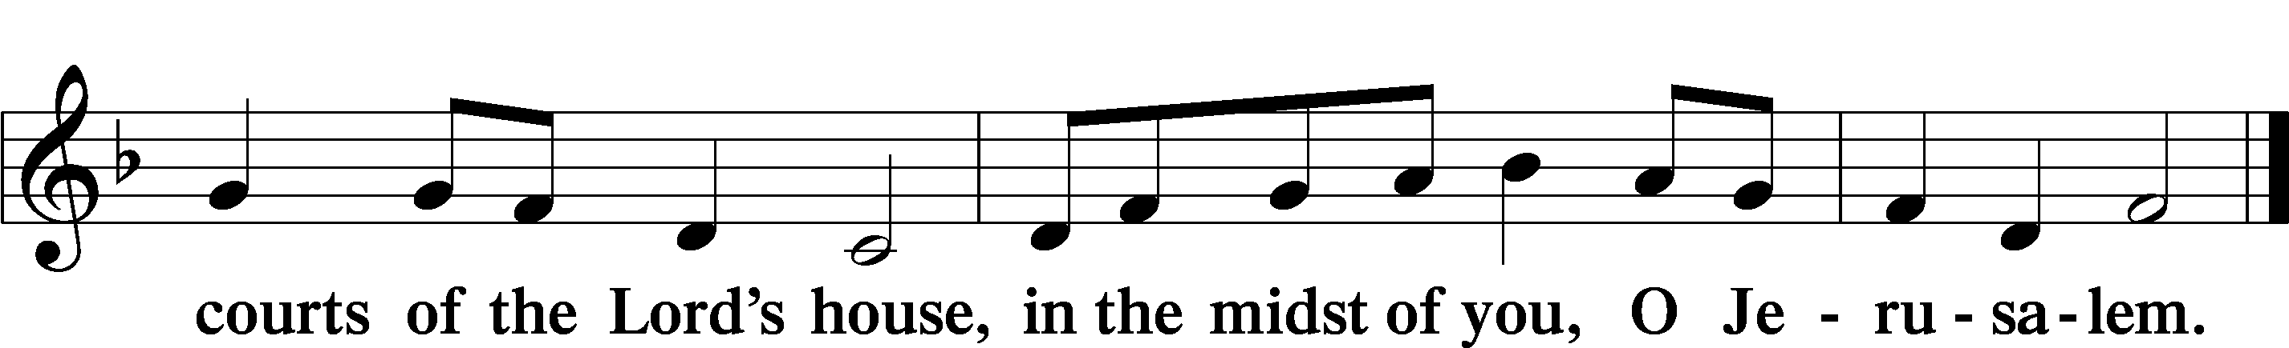

Sit

Announcements

We have returned to passing our offering plates and worship attendance forms! Please take a moment to fill out the attendance form, located at the inside of each row, and pass towards the outside of each row. There is hand sanitizer clipped to the log for your use. If you sanitize please do this after passing the offering plate so that the sanitizer doesn’t tarnish the metal.

Offering

Stand

Prayer of the Church

+SERVICE OF THE SACRAMENT+

Preface LSB 160
P The Lord be with you.
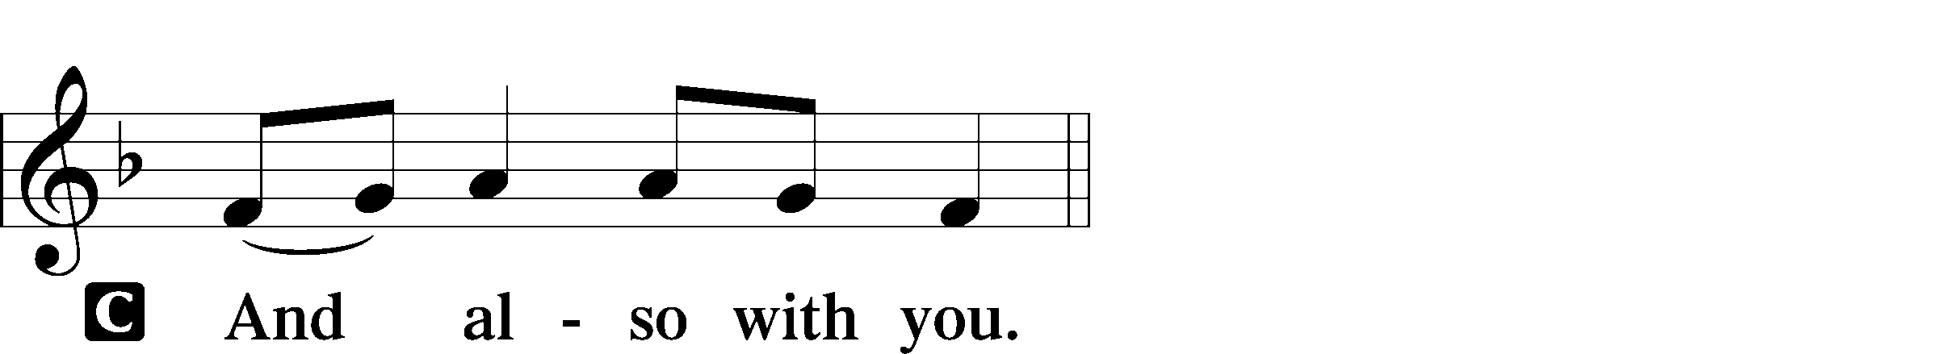

P Lift up your hearts.
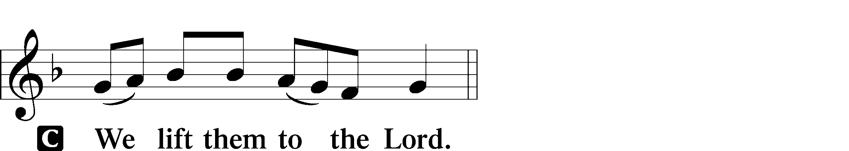

P Let us give thanks to the Lord our God.
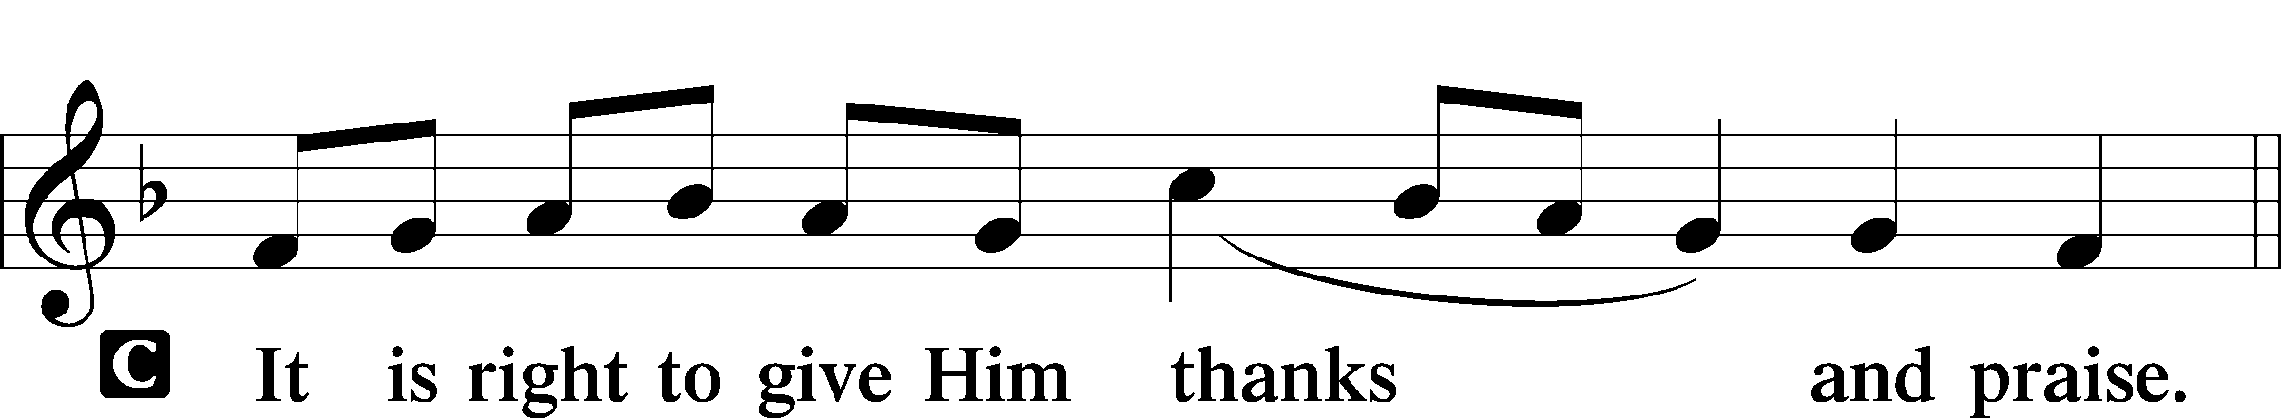

Proper Preface (Full)
P It is truly good, right, and salutary that we should at all times and in all places give thanks to You, holy Lord, almighty Father, everlasting God. And most especially are we bound to praise You on this day for the glorious resurrection of Your Son, Jesus Christ, the very Paschal Lamb, who was sacrificed for us and bore the sins of the world. By His dying He has destroyed death, and by His rising again He has restored to us everlasting life. Therefore with Mary Magdalene, Peter and John, and with all the witnesses of the resurrection, with angels and archangels, and with all the company of heaven we laud and magnify Your glorious name, evermore praising You and saying:

Sanctus LSB 161
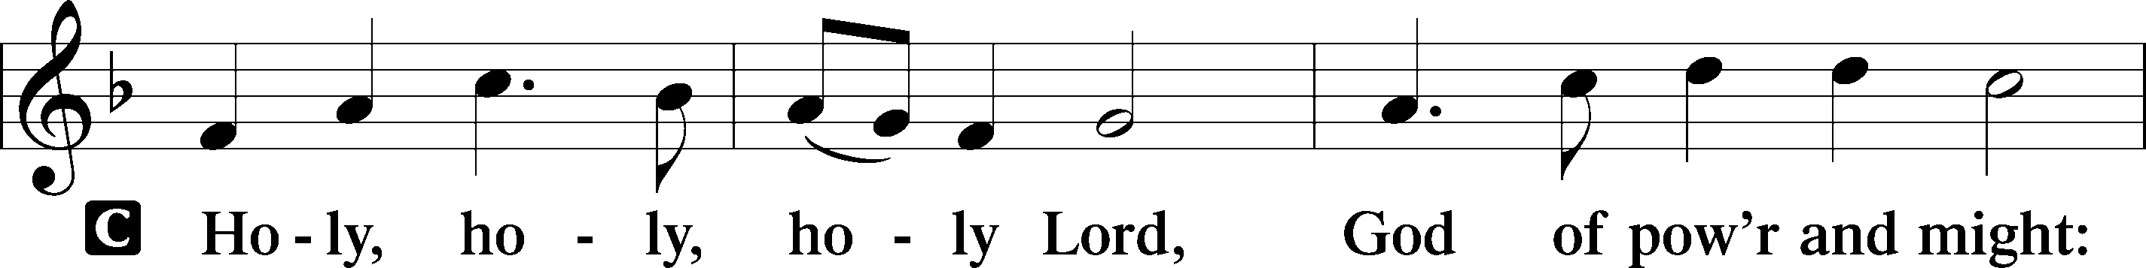
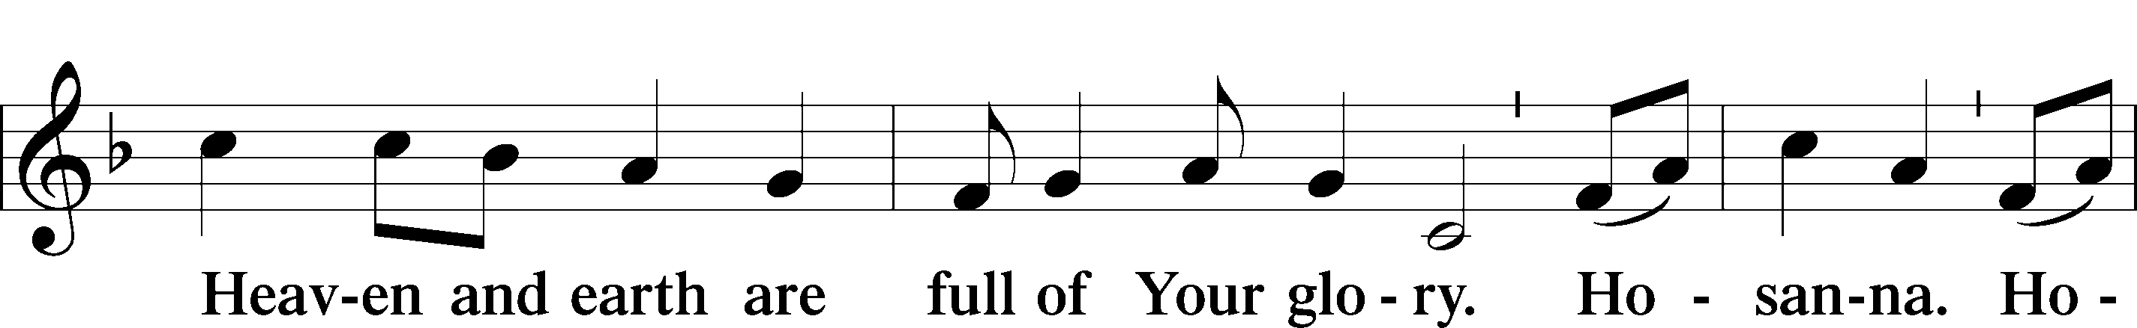
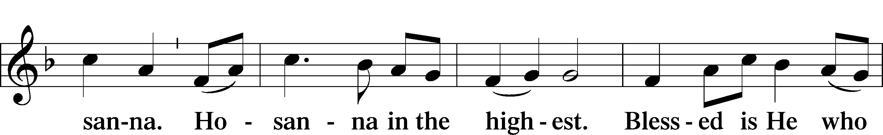
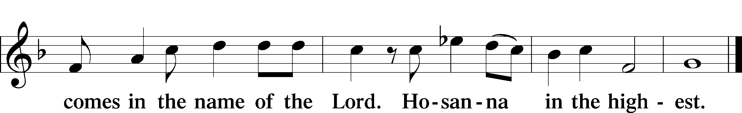

Lord’s Prayer
C Our Father who art in heaven,
hallowed be Thy name,
Thy kingdom come,
Thy will be done on earth
as it is in heaven;
give us this day our daily bread;
and forgive us our trespasses
as we forgive those
who trespass against us;
and lead us not into temptation,
but deliver us from evil.
For Thine is the kingdom
and the power and the glory
forever and ever. Amen.
The Words of Our Lord
P Our Lord Jesus Christ, on the night when He was betrayed, took bread, and when He had given thanks, He broke it and gave it to the disciples and said: “Take, eat; this is My T body, which is given for you. This do in remembrance of Me.”

In the same way also He took the cup after supper, and when He had given thanks, He gave it to them, saying: “Drink of it, all of you; this cup is the new testament in My T blood, which is shed for you for the forgiveness of sins. This do, as often as you drink it, in remembrance of Me.”

Pax Domini LSB 163
P The peace of the Lord be with you always.
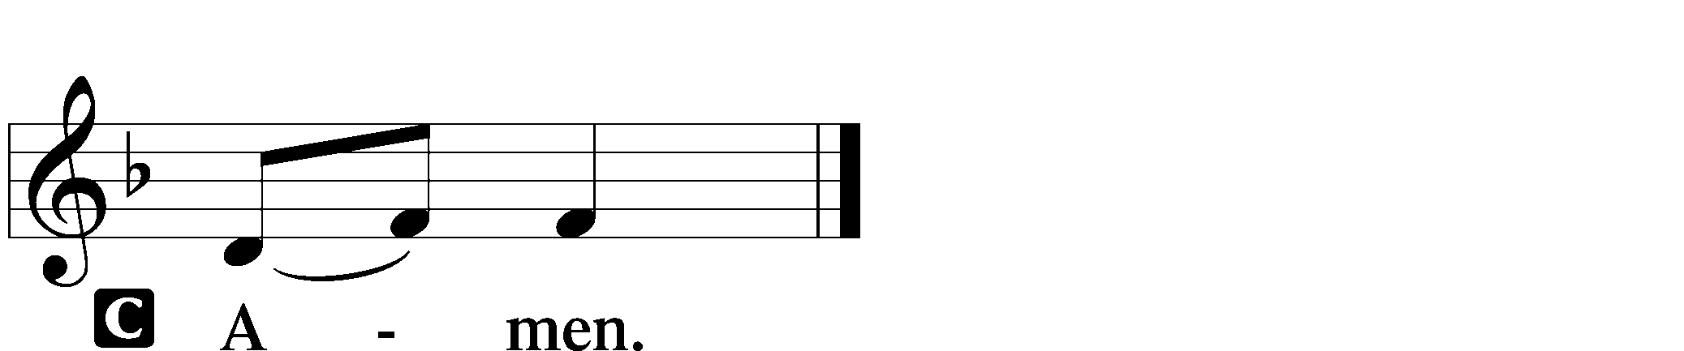

Agnus Dei LSB 163
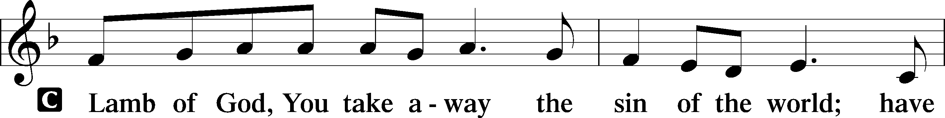
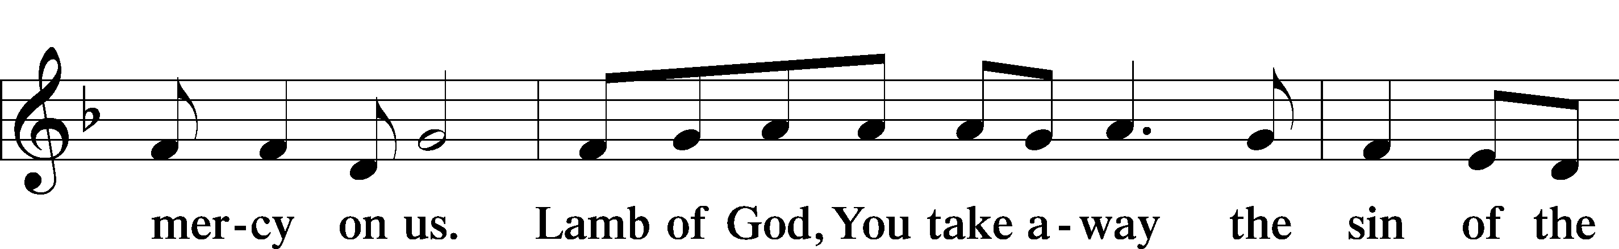
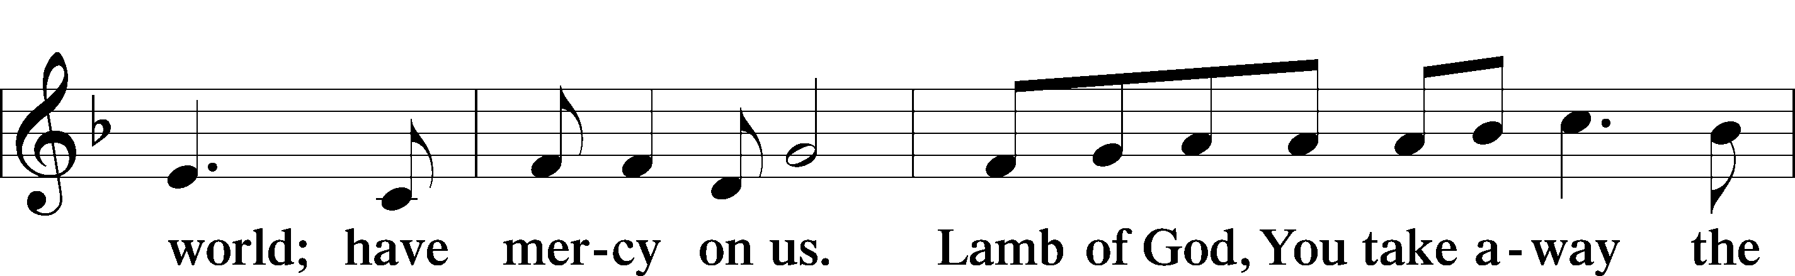
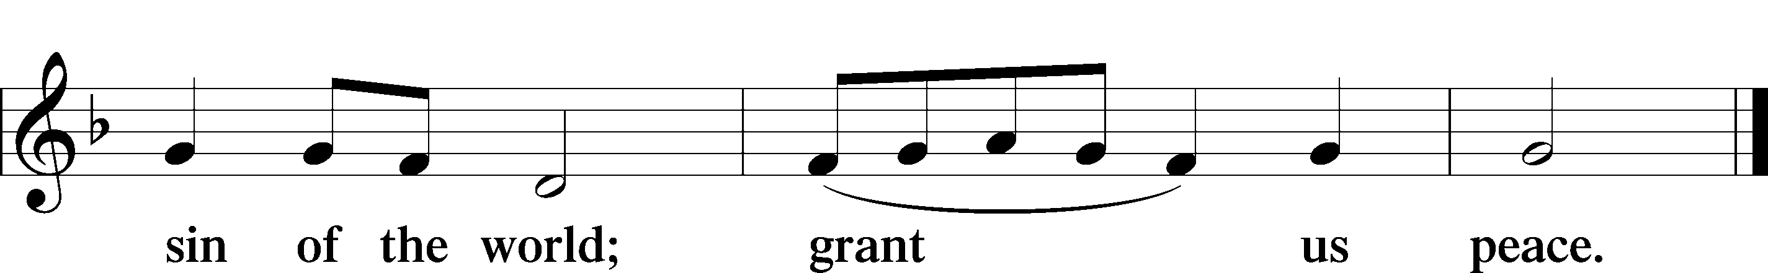

Sit

Distribution

Distribution Hymn “Love Divine, All Loves Excelling” LSB 700
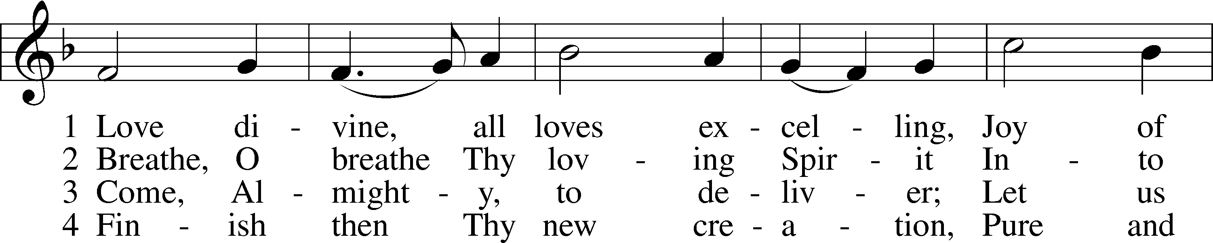
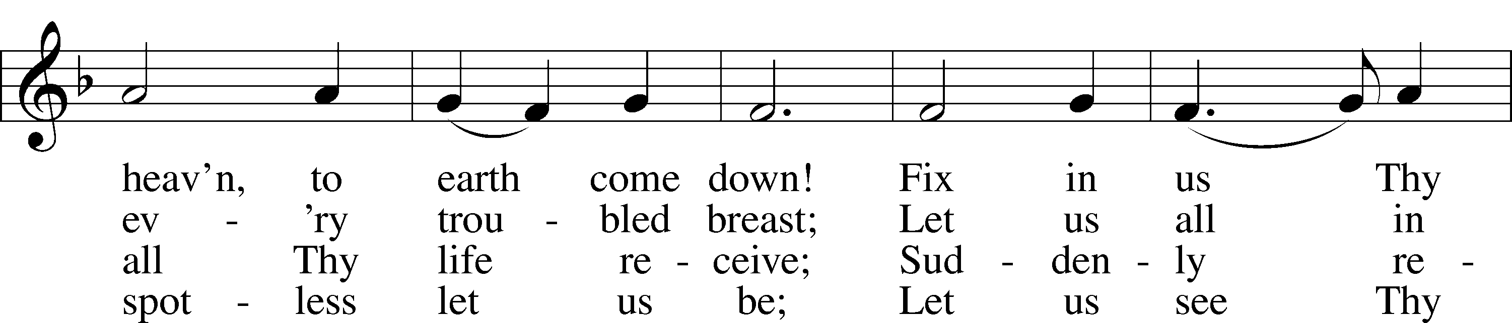
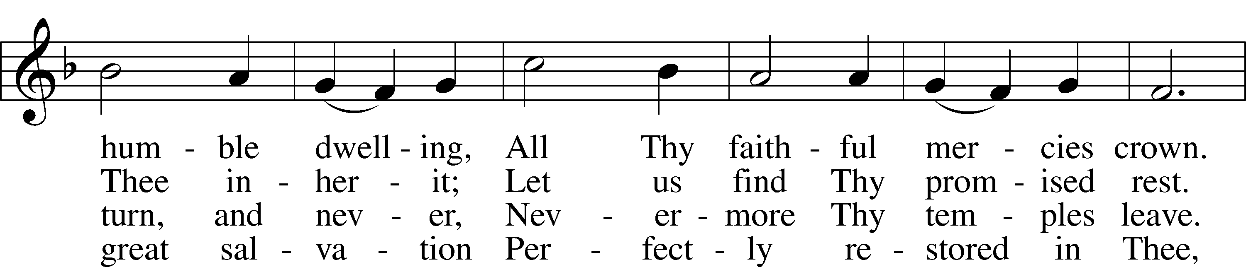
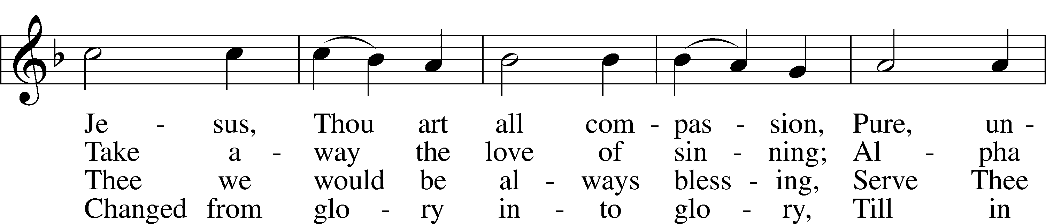
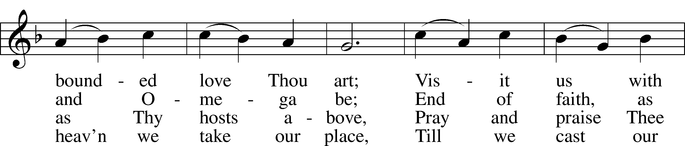
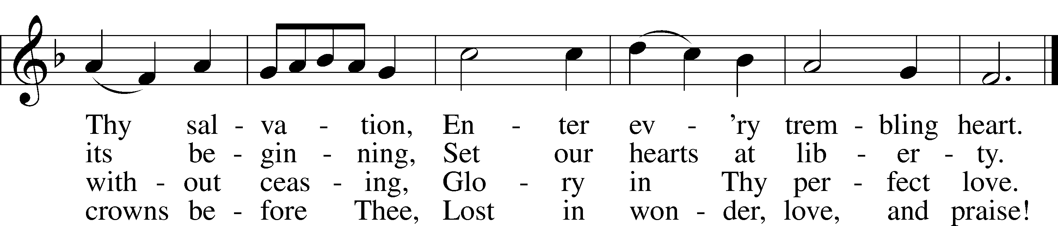
Tune and text: Public domain

Distribution Hymn “Alleluia, Alleluia! Hearts to Heaven” LSB 477
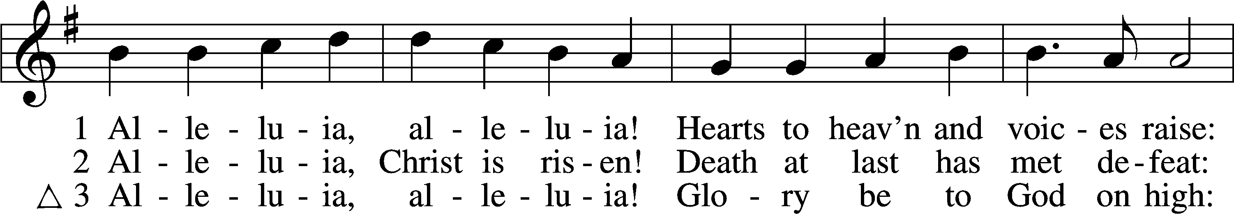
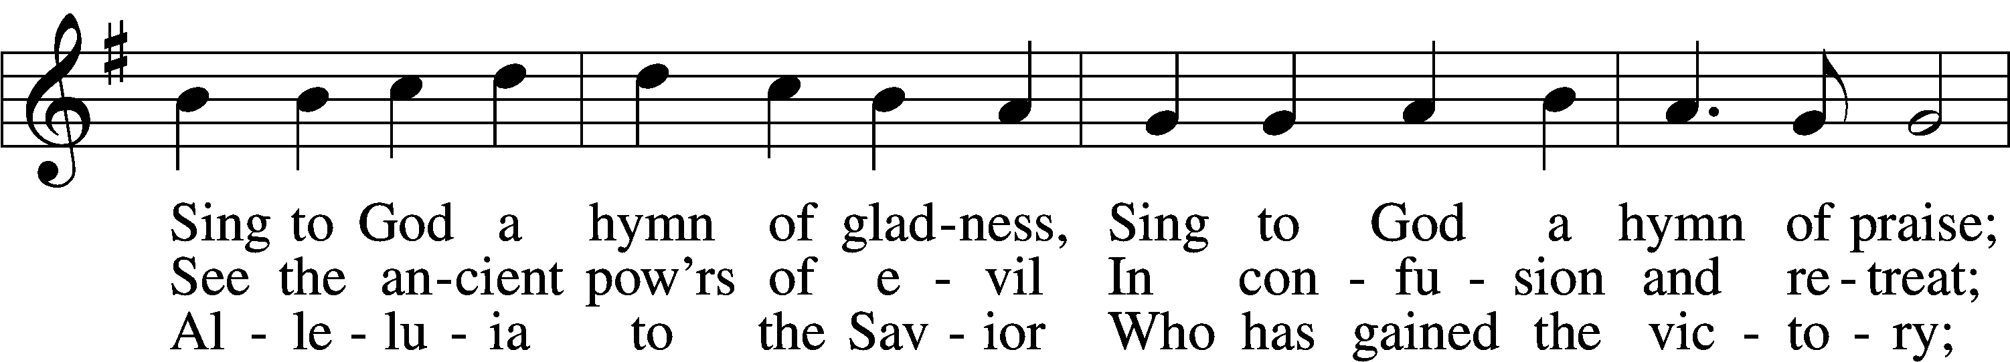
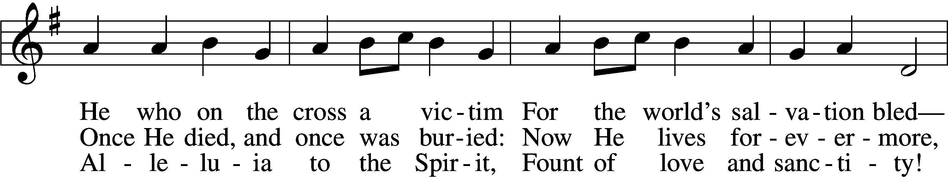
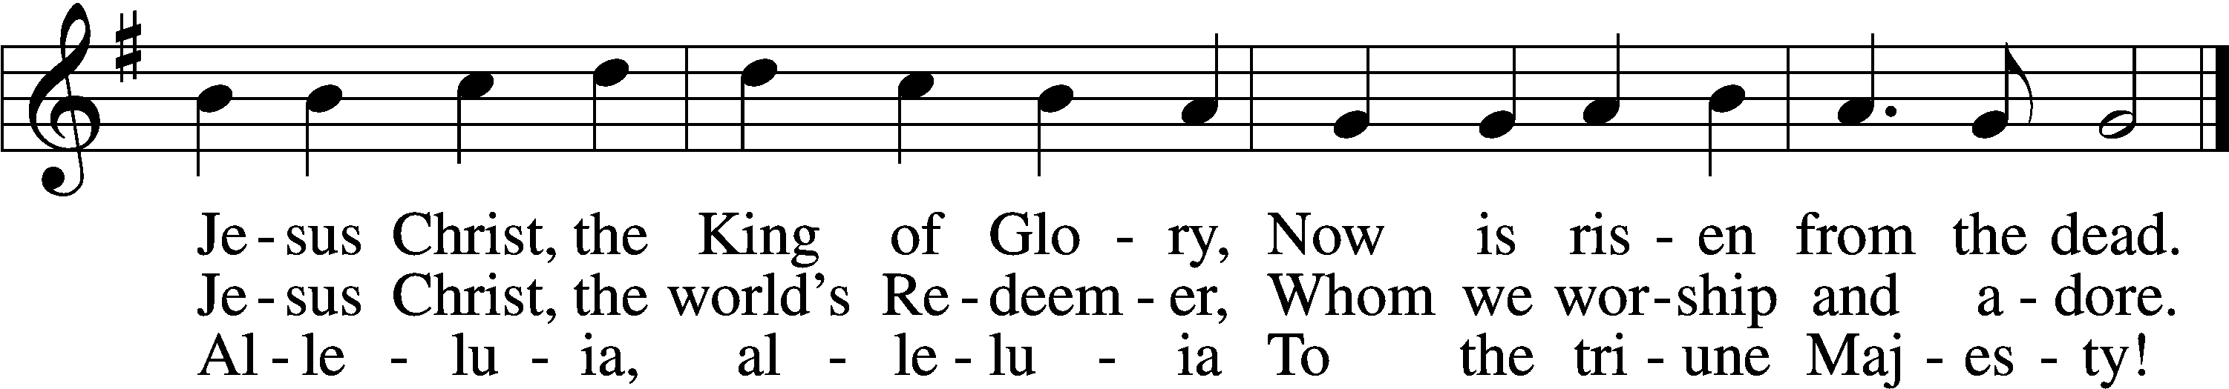
Text (sts. 1, 3) and tune: Public domain
Text (st. 2): © 1982 The Jubilate Group, admin. Hope Publishing Co. Used by permission: LSB Hymn License no. 110016438

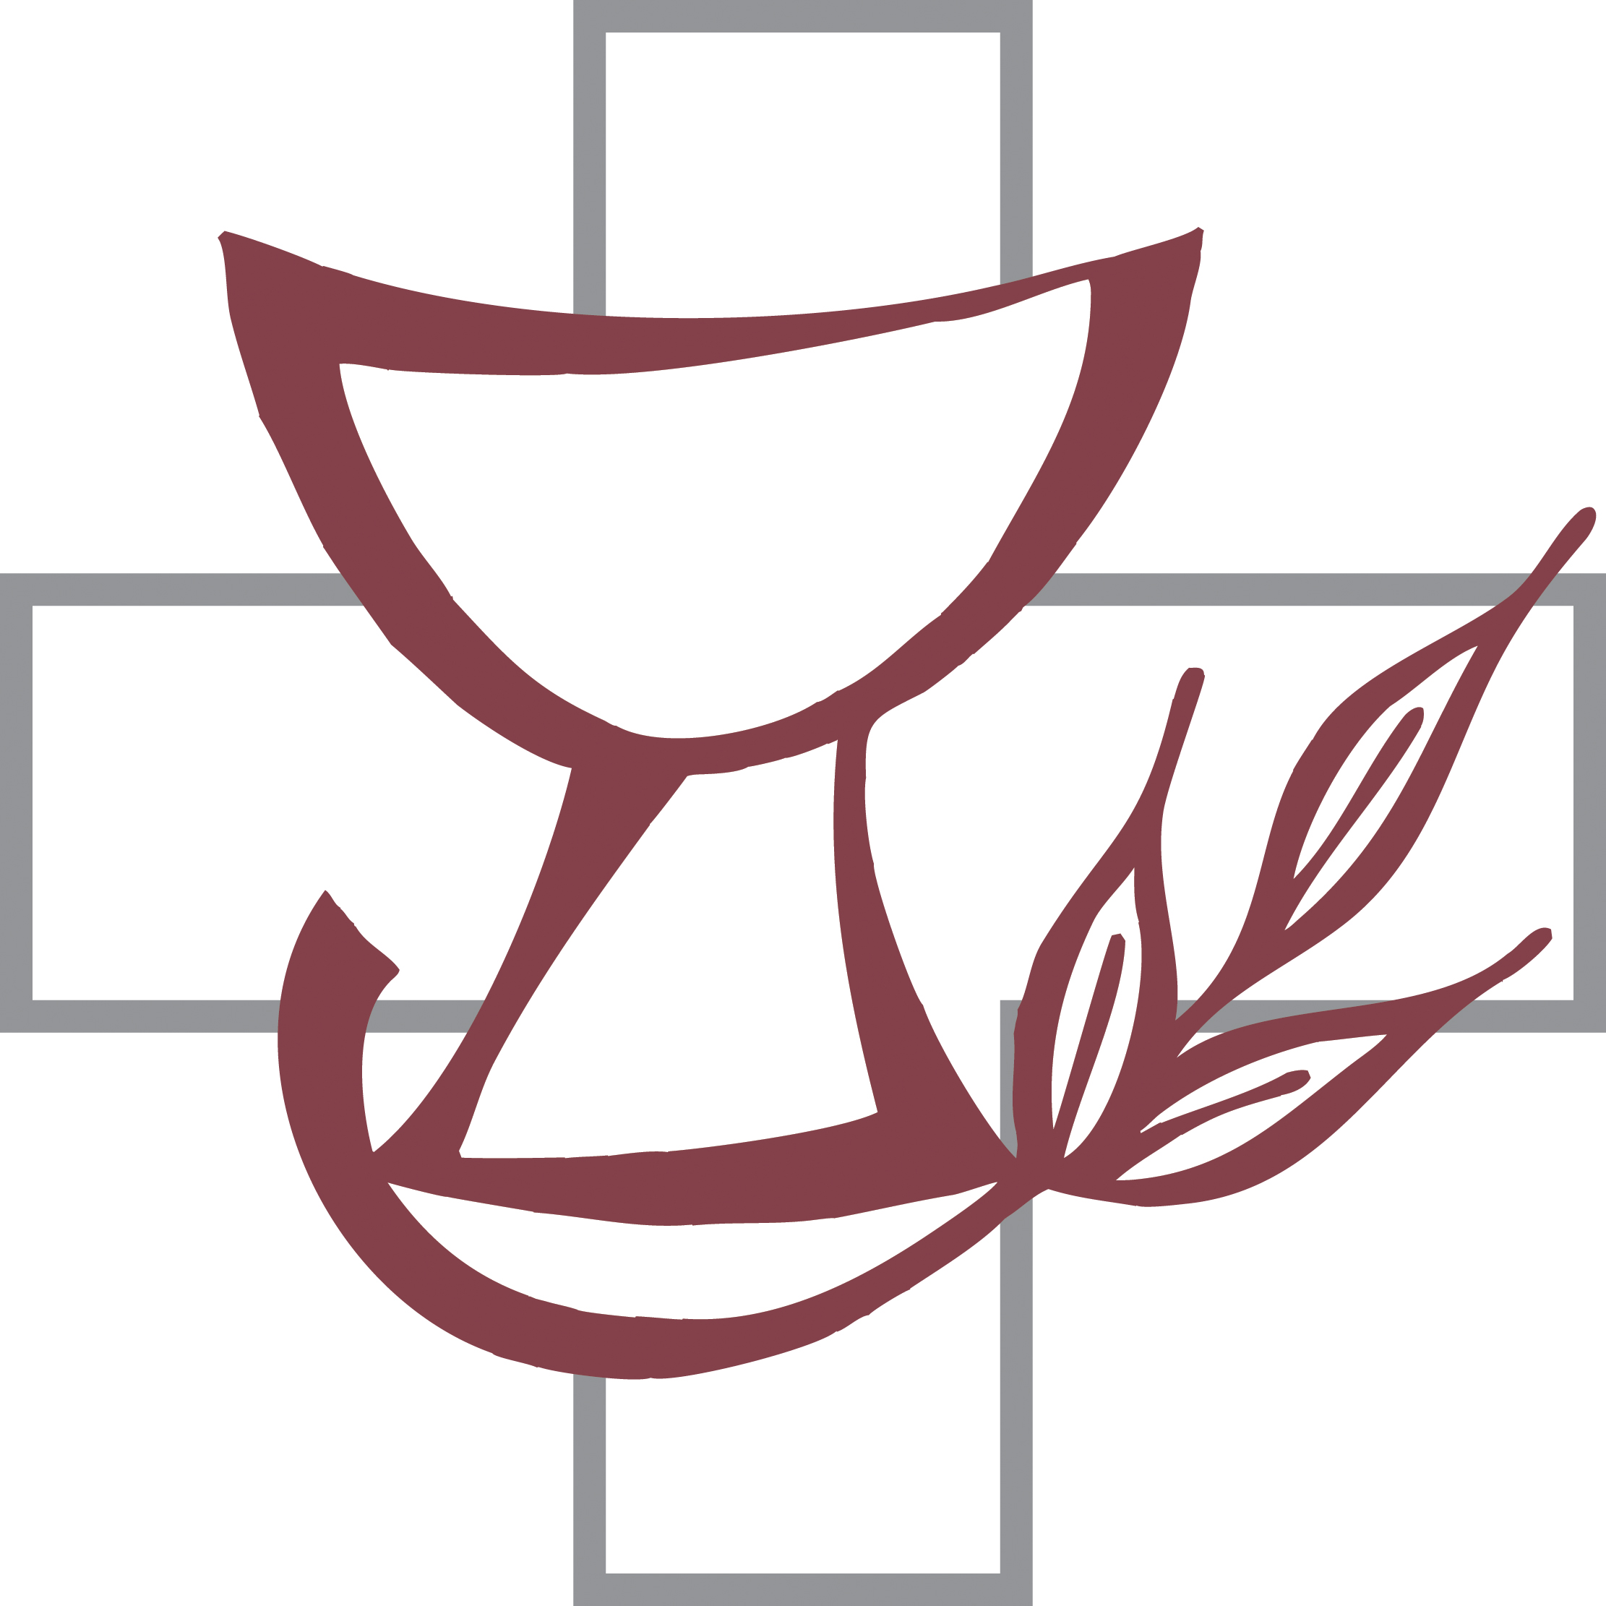

Distribution Hymn “He Is Arisen! Glorious Word” LSB 488
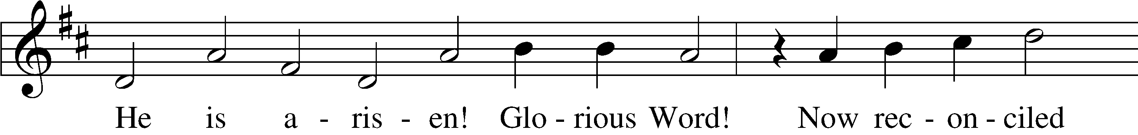
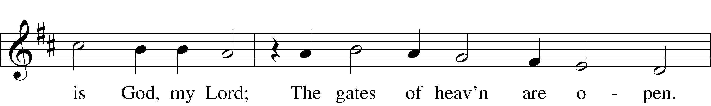
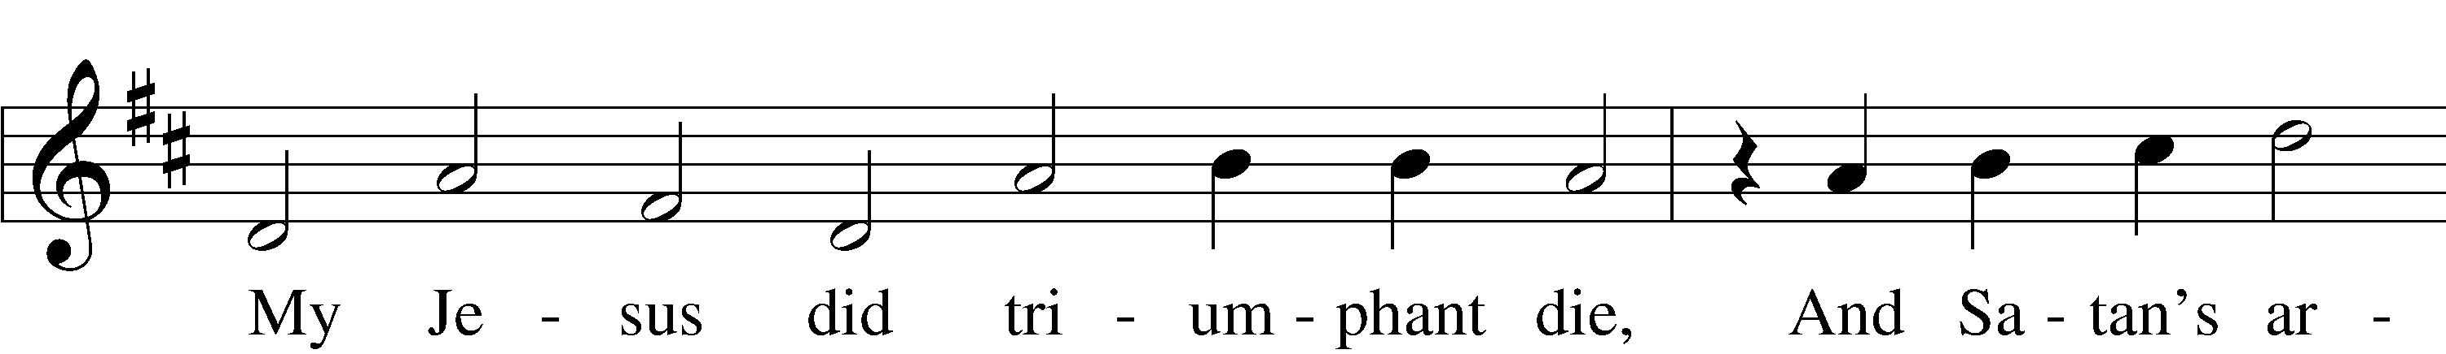
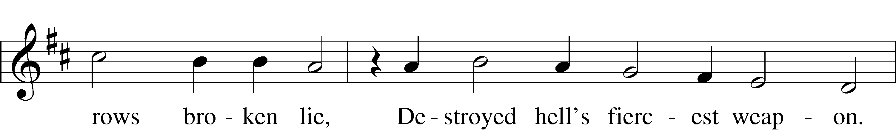
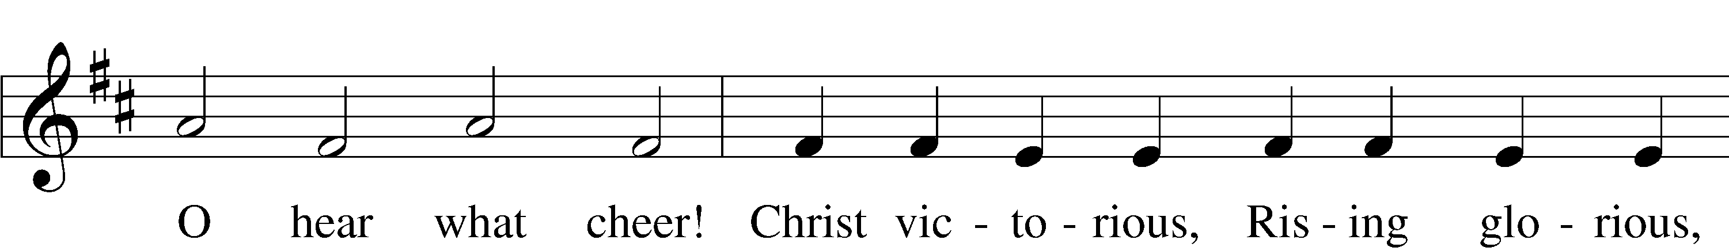
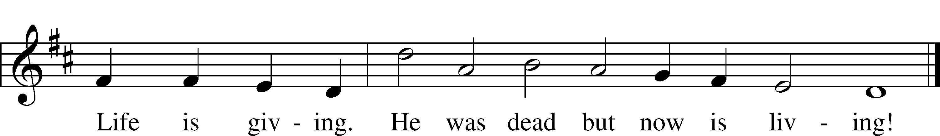
Text and tune: Public domain

Stand

Nunc Dimittis LSB 165
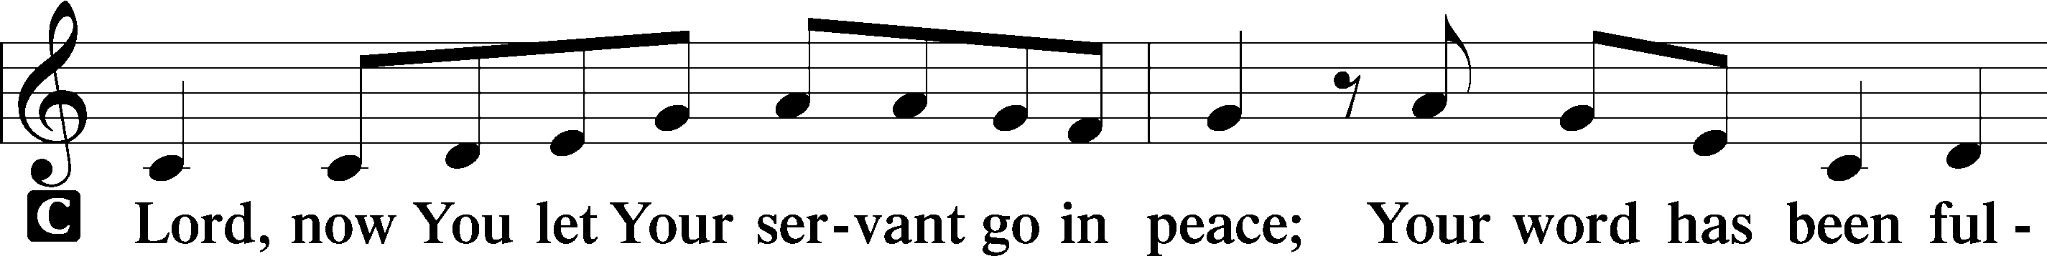
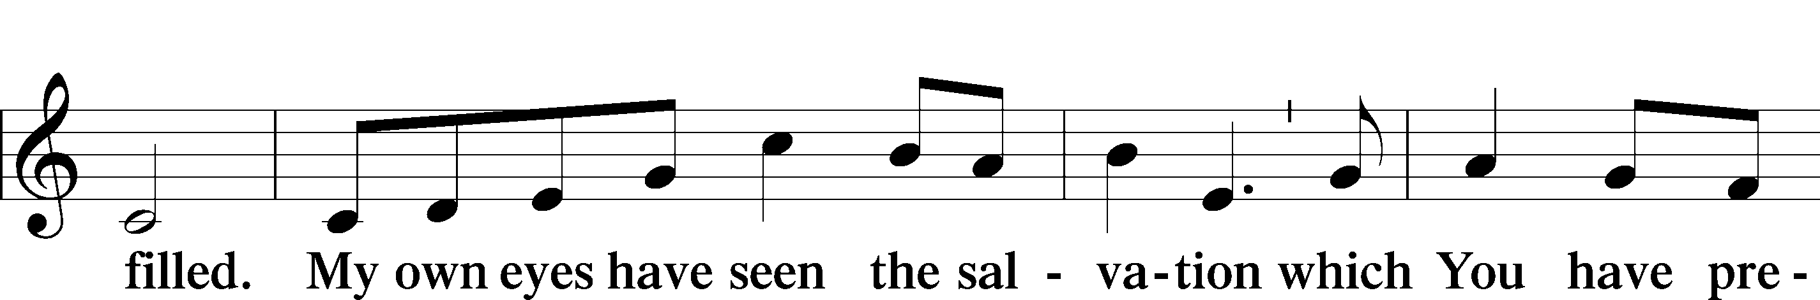
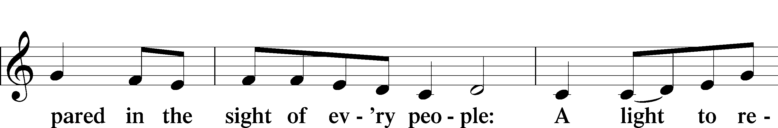
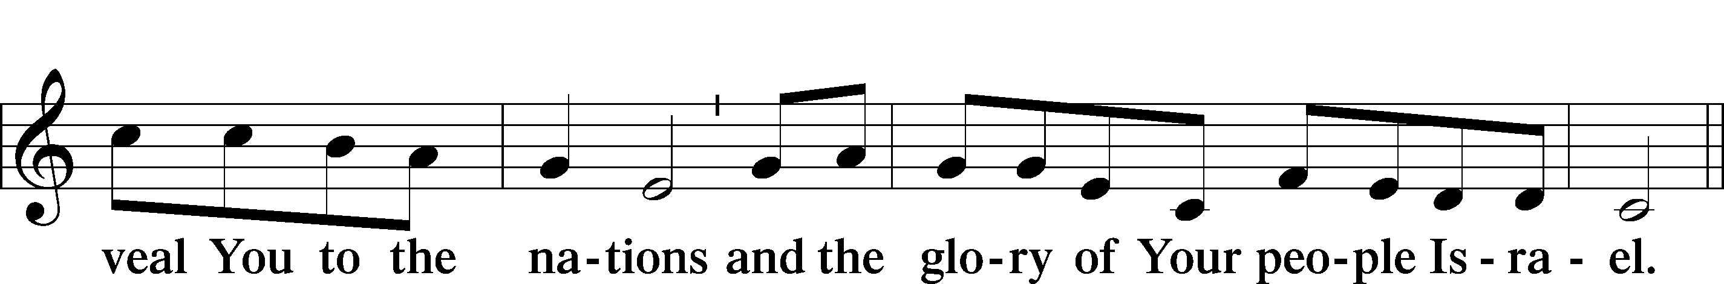
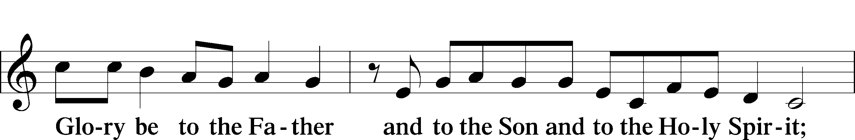
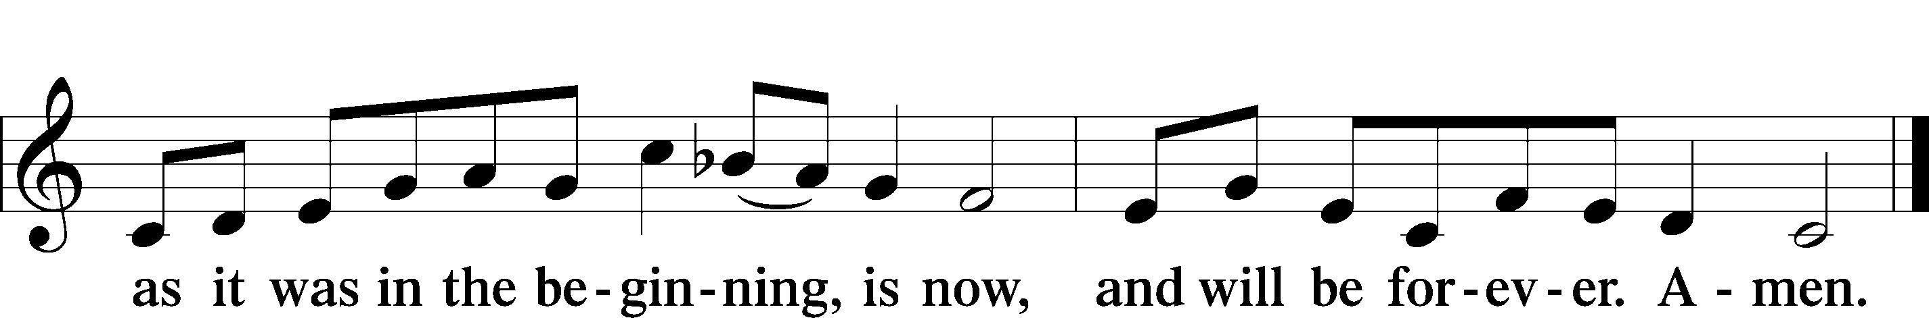

Post-Communion Collect
A Let us pray.
We give thanks to You, almighty God, that You have refreshed us through this salutary gift, and we implore You that of Your mercy You would strengthen us through the same in faith toward You and in fervent love toward one another; through Jesus Christ, Your Son, our Lord, who lives and reigns with You and the Holy Spirit, one God, now and forever.
C Amen.

Benediction LSB 166
P The Lord bless you and keep you.
The Lord make His face shine on you and be gracious to you.
The Lord look upon you with favor and T give you peace.
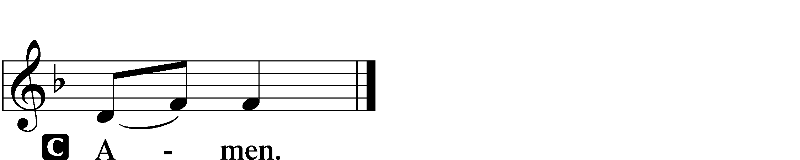

Closing Hymn “Our Paschal Lamb, That Sets Us Free” LSB 473
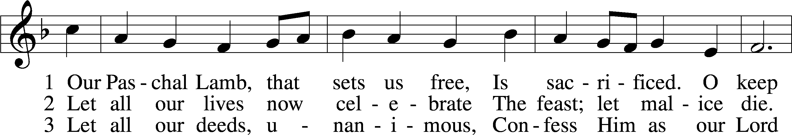
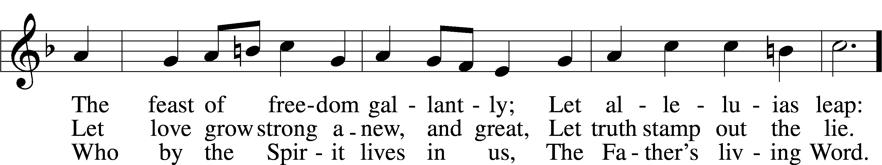
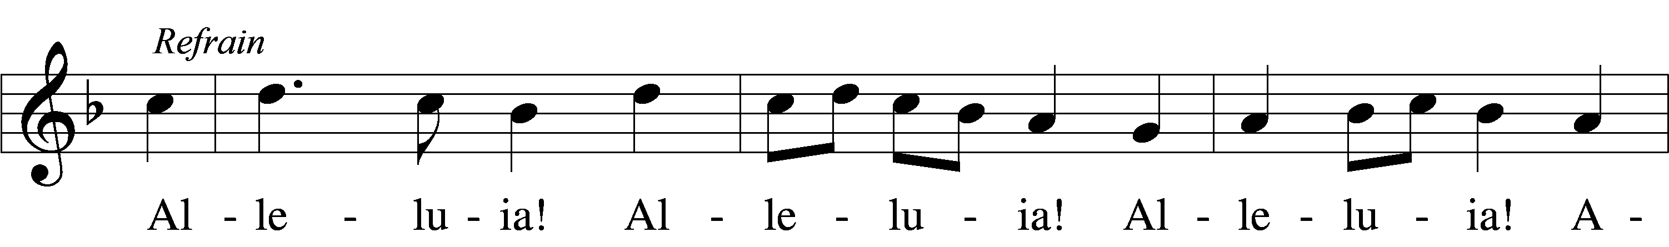
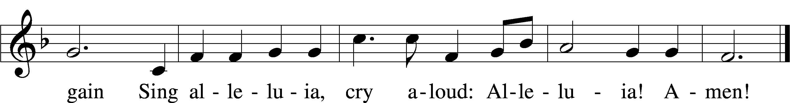
Tune and text: © 1974 Augsburg Publishing House. Used by permission: LSB Hymn License no. 110016438

Acknowledgments
Unless otherwise indicated, Scripture quotations are from the ESV® Bible (The Holy Bible, English Standard Version®), copyright © 2001 by Crossway, a publishing ministry of Good News Publishers. Used by permission. All rights reserved.
Created by Lutheran Service Builder © 2021 Concordia Publishing House.

Serving Our Lord in His House Today:
Pastor: Rev. David Wurdeman
Organist: Linda Ecker
Elders: Joe Engel & Jerry Ecker

Gifts from God: John 20:19 – “Jesus came and stood among them and said to them, ‘Peace be with you.’ ” The peace we have in Jesus is what makes a life of good works possible. Since we know that it is Jesus who saved us – not our works – we are now free to do good works. Good works shouldn’t be done out of
self-interest but for the right reasons – out of thanksgiving toward God and love for our neighbors.

Services: We are back to a single Sunday service! Our regular Sunday schedule is 9:00 a.m. worship and 10:15 a.m. education hour. Wednesday Services will be at 5:00 p.m. with the same content as the previous Sunday. If you are uncomfortable or unable to attend Sunday worship, please reach out to Pastor to coordinate a home visit or to schedule a communion service at church during the week.

Upcoming Sunday Bible Study: We are starting a new Sunday Bible Study called “Lutheranism 101.” It’s based on a new book from Concordia Publishing House. Lutheranism 101 gives you a quick, usable, and comprehensive overview of our faith and practice at Good Shepherd. In a conversational atmosphere, we’ll discuss some common topics of modern Christianity including: our Relationship with God, Lutheran Spirituality, living as Christians in a non-Christian country, and why there so many denominations. Whether you’re a life-long member or a guest, all are welcome. More details to come. -Pastor Wurdeman

Confirmation Student Party: All confirmation students are invited for hot dogs and s’mores (and maybe bagpipes). Sunday, April 25, 2021 at 5:00 p.m.
1709 McClean Ave, Tomah. Please RSVP to Pastor or Shaina Wurdeman.

New Ladies Bible Study: We are starting a Ladies Bible Study “Chosen” by Donna Snow here at Good Shepherd. Chosen is based on the book of Esther and talks about how each of us are chosen for a purpose. The study will cost $14.99, it is an 8-16 week study, (depending on how much we discuss). We are looking at Wednesday night at 7:00pm, but will work with what works best for all that want to attend. If you are interested please contact Joan Anderson at 608-343-8164 and let her know by April 10th so that enough books are ordered. We will plan to begin April 14th at 7:00pm. See you then!

Young At Heart (YAH): YAH group will be meeting Thursday, April 22 at noon here at church for a pot-luck lunch. There will be set up going on for the rummage sale so we will need to meet in the conference room for our lunch.
A little different but it will work out for this one time. After lunch we will need to discuss where we will be going with our group this year, so have some thoughts on what you would like to accomplish and what if any service projects we should undertake. Please consider joining us for fellowship and a good lunch. Questions, see Kathy Berg.

Rummage sale April 23 and 24: Items for the Rummage Sale can be brought to church at anytime now. The church office is open Monday-Friday from 8am to Noon. If you have items that you need to deliver after this time contact Lorna Rosenow or Kathy Berg to make arrangements to deliver. Any large furniture items can be donated Wednesday, April 21 after 6 pm or Thursday 8am-9pm.
Set up for the sale will be held April 19 through the 22, during office hours and in the afternoon/evening hours. Tables will be set up and marked for placement of items. Kathy Berg will be at church during the morning hours and Lorna Rosenow for the late afternoon and evening hours. All interested in helping with set up and to help during the sale are welcome. Help is needed in all areas. Please notify Lorna Rosenow. We are also looking for bakers to donate items for the bake sale. Baked goods can be dropped off Thursday, April 22 8am-8pm. Please contact Lorna Rosenow with any questions: 608-372-6584 or
608-343-5584.

Livestream: Our Sunday Service is livestreamed weekly on our YouTube channel “Good Shepherd Lutheran Church Tomah.”

Hymnals: If you would like to use a Hymnal at home, you can sign one out from church. We also have free devotion pamphlets and Portals of Prayer.

PO Box: For mailed offerings, please use the following:
Good Shepherd Lutheran Church
P.O. Box 551
Tomah, WI. 54660

Our Worship attendance last week: Holy Week:
Maundy Thursday: 43
Good Friday: 44
Easter Vigil (Sat.): 26
Easter Sunday: 103
Wednesday: 7
Total: 223

Scripture Lessons for next week: Ezekiel 34:11-16
1 Peter 2:21-25
John 10:11-16

Secretary Office Hours: Monday-Friday: 8am-12pm

*See Following Page for Weekly Schedule*

Our Week With Our Lord:
Today 9:00am Divine Service w/Holy Communion
(livestreamed via YouTube)
10:15am Adult Bible Study & Sunday School
Mite Box Sunday
SCRIP Orders Due
Monday 10:00am Staff Meeting
4:45pm LWML Meeting
6:15pm Outreach Committee Meeting
Tuesday 6:00pm Board of Education Meeting
Wednesday 5:00pm Divine Service w/Holy Communion 6:15pm Adult Choir
6:30pm Confirmation Class
7:00pm Women’s Bible Study – “Chosen”
Thursday 6:00pm Couples Club
Friday
Saturday
Sunday 9:00am “Here I Stand Sunday”
Divine Service w/Holy Communion
(livestreamed via YouTube)
10:15am Adult Bible Study & Sunday School

*See Following Page for Weekly Prayers*

HIS FLOCK AT PRAYER
Propers for the Second Week of Easter

Psalm for the Week: Psalm 33
Daily Scripture Readings:
Sunday—John 20:19-23 Thursday—John 21:7-14
Monday—John 20:24-31 Friday—John 21:15-19
Tuesday—Colossians 3:1-6 Saturday—John 21:20-23
Wednesday—John 21:1-6

Collect for the Week:
Almighty God, grant that we who have celebrated the Lord’s resurrection may by Your grace confess in our life and conversation that Jesus is Lord and God; through the same Jesus Christ, Your Son, who lives and reigns with You and the Holy Spirit, one God, now and forever.

Hymn of the Week: “O Sons and Daughters of the King” LSB 470

Congregational Petitions for this Week:
+ For those who are ill or recovering, especially: Karen Salzman, Brenda Kolb,
Paula Sopel, Shawn Zabinski, Karen Griggel, Margaret Palmer, Ladene Zabinski,
Carrie Wilbanks, Bob and Linda Goad, Amy Franks, Rose Benning, Dalton &
Carrie Simonson.
+ For those who are mourning the loss of a loved one, especially:
Jerry Rapp, family and friends at the loss of Judy Rapp
Vickie Vaningan, family and friends at the loss of Calvin Koehn,
Vickie’s brother
+ For those who are home-bound, especially: John Fox, Darlene Griffin,
Al Mansfield, Virginia Tillman, Linda Goad, Roemelle McArdle,
Sharon Herried.
+ For those who serve in the military, especially: Isaac Preuss, Tania Adler, and
Joshua Ecker.
+ For expectant mothers and the children in their womb, especially Christin Gole and Bethany Ritchart.
+ For those suffering from the pandemic, especially those in our congregation who have been infected, those who are suffering financially, and those who work in the medical field.

