Good Shepherd Lutheran Church
Ninth Sunday after Trinity
August 1, 2021

Pre-Service Music & Welcome
Divine Service Setting Four – Lutheran Service Book (LSB) 203

+CONFESSION AND ABSOLUTION+

Stand

Opening Hymn “O Word of God Incarnate” LSB 523
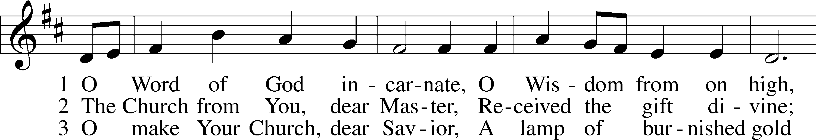
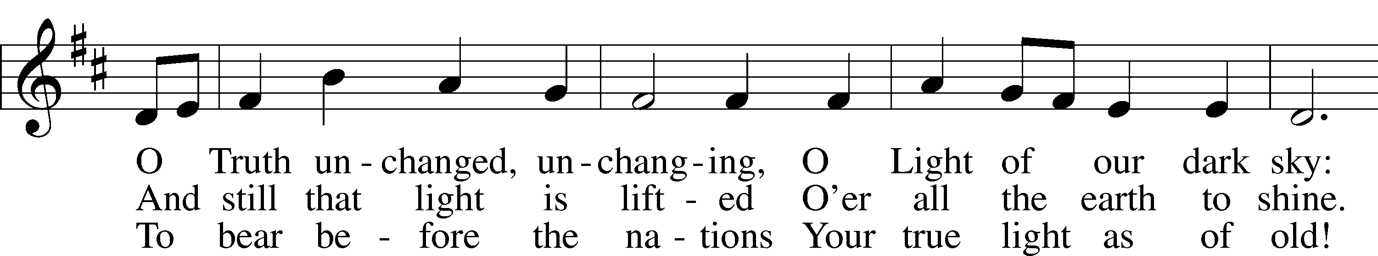
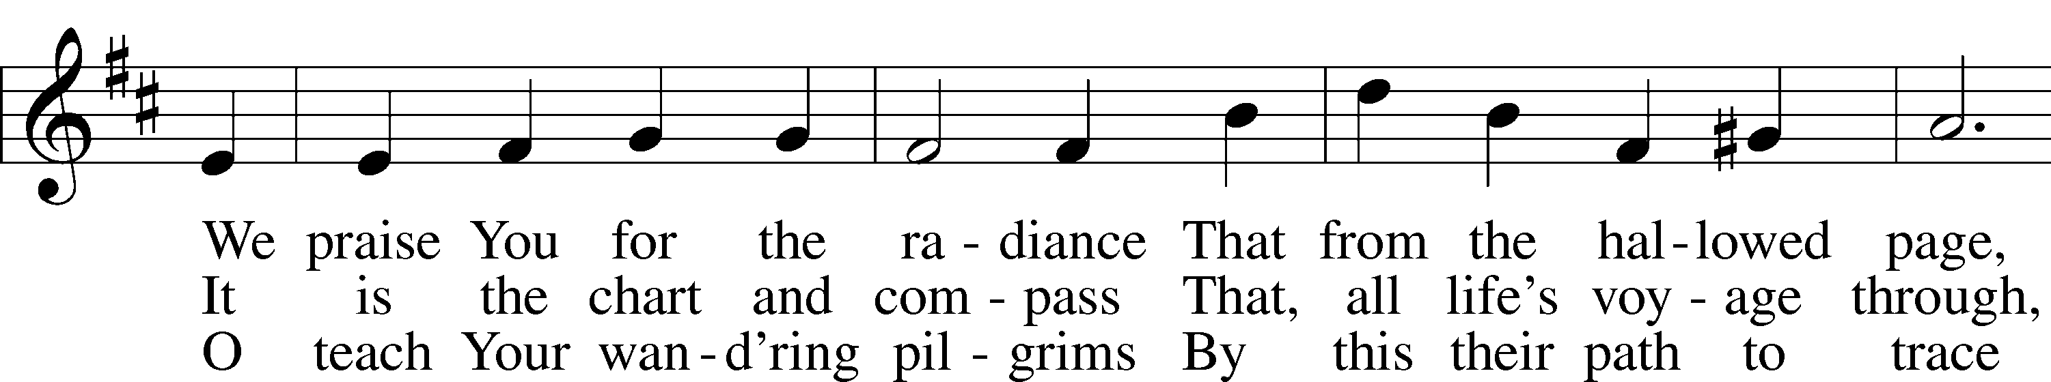
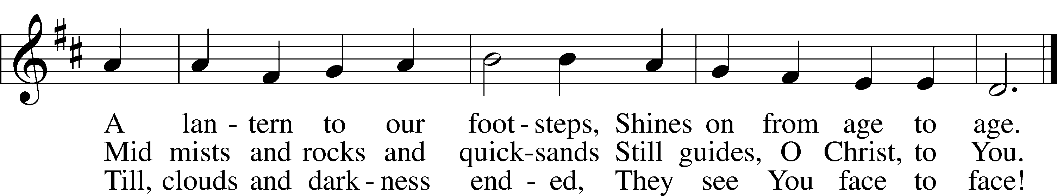
Tune and text: Public domain

The sign of the cross T may be made by all in remembrance of their Baptism.
Invocation
P In the name of the Father and of the T Son and of the Holy Spirit.
C Amen.

Exhortation LSB 203
P Our help is in the name of the Lord,
C who made heaven and earth.

P If You, O Lord, kept a record of sins, O Lord, who could stand?
C But with You there is forgiveness; therefore You are feared.
P Since we are gathered to hear God’s Word, call upon Him in prayer and praise, and receive the body and blood of our Lord Jesus Christ in the fellowship of this altar, let us first consider our unworthiness and confess before God and one another that we have sinned in thought, word, and deed, and that we cannot free ourselves from our sinful condition. Together as His people let us take refuge in the infinite mercy of God, our heavenly Father, seeking His grace for the sake of Christ, and saying: God, be merciful to me, a sinner.

Confession of Sins LSB 203
C Almighty God, have mercy upon us, forgive us our sins, and lead us to everlasting life. Amen.

Prayer for Forgiveness
P Almighty God, merciful Father, in Holy Baptism You declared us to be Your children and gathered us into Your one, holy Church, in which You daily and richly forgive us our sins and grant us new life through Your Spirit. Be in our midst, enliven our faith, and graciously receive our prayer and praise; through Your Son, Jesus Christ, our Lord.
C Amen.
+SERVICE OF THE WORD+

Introit Psalm 54:1–3, 7; antiphon: vv. 4–5
Behold, God is my helper;*
the Lord is the upholder of my life.
He will return the evil to my enemies;*
in your faithfulness put an end to them.
O God, save me, by your name,*
and vindicate me by your might.
O God, hear my prayer;*
give ear to the words of my mouth.
For strangers have risen against me; ruthless men seek my life;*
they do not set God before themselves.
For he has delivered me from every trouble,*
and my eye has looked in triumph on my enemies.
Glory be to the Father and to the Son*
and to the Holy Spirit;
as it was in the beginning,*
is now, and will be forever. Amen.
Behold, God is my helper;*
the Lord is the upholder of my life.
He will return the evil to my enemies;*
in your faithfulness put an end to them.

Kyrie LSB 204
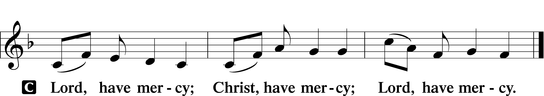

A For the peace from above and for our salvation let us pray to the Lord.

A For the peace of the whole world, for the well-being of the Church of God, and for the unity of all let us pray to the Lord.

A For this holy house and for all who offer here their worship and praise let us pray to the Lord.

A Help, save, comfort and defend us, gracious Lord.

Gloria in Excelsis LSB 204
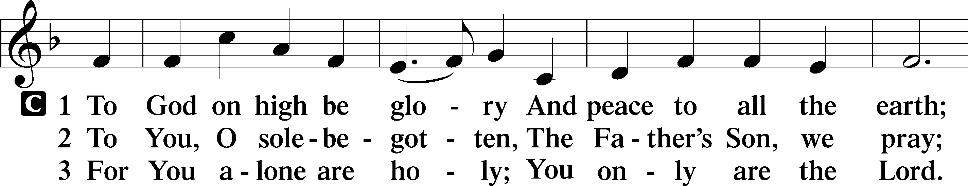
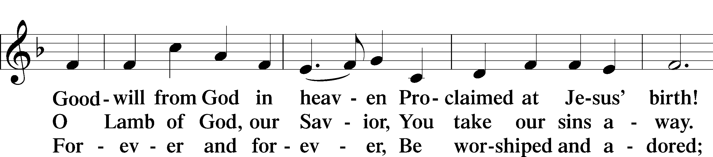
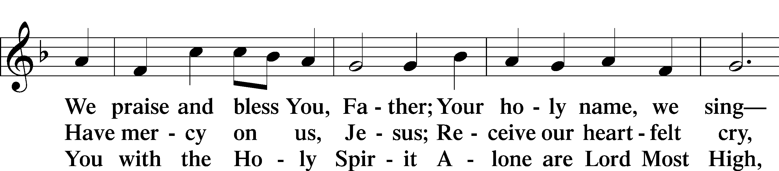
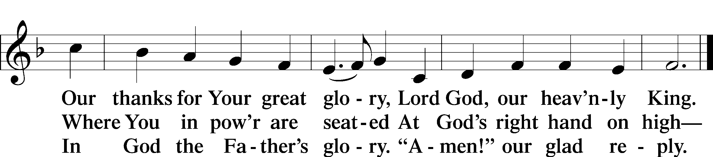

Salutation and Collect of the Day
P The Lord be with you.
C And also with you.

P Let us pray.
C Let Your merciful ears, O Lord, be open to the prayers of Your humble servants; and that they may obtain their petitions, make them to ask such things as shall please You; through Jesus Christ, Your Son, our Lord, who lives and reigns with You and the Holy Spirit, one God, now and forever. Amen.

Sit

Old Testament Reading 2 Samuel 22:26–34
26“With the merciful you show yourself merciful;
with the blameless man you show yourself blameless;
27with the purified you deal purely,
and with the crooked you make yourself seem tortuous.
28You save a humble people,
but your eyes are on the haughty to bring them down.
29For you are my lamp, O Lord,
and my God lightens my darkness.
30For by you I can run against a troop,
and by my God I can leap over a wall.
31This God—his way is perfect;
the word of the Lord proves true;
he is a shield for all those who take refuge in him.
32“For who is God, but the Lord?
And who is a rock, except our God?
33This God is my strong refuge
and has made my way blameless.
34He made my feet like the feet of a deer
and set me secure on the heights.”

A This is the Word of the Lord.
C Thanks be to God.

Gradual Psalm 8:1
O Lord, our Lord,*
how majestic is your name in all the earth!
You have set your glory*
above the heavens.

Epistle 1 Corinthians 10:6–13
6Now these things took place as examples for us, that we might not desire evil as they did. 7Do not be idolaters as some of them were; as it is written, “The people sat down to eat and drink and rose up to play.” 8We must not indulge in sexual immorality as some of them did, and twenty-three thousand fell in a single day. 9We must not put Christ to the test, as some of them did and were destroyed by serpents, 10nor grumble, as some of them did and were destroyed by the Destroyer. 11Now these things happened to them as an example, but they were written down for our instruction, on whom the end of the ages has come. 12Therefore let anyone who thinks that he stands take heed lest he fall. 13No temptation has overtaken you that is not common to man. God is faithful, and he will not let you be tempted beyond your ability, but with the temptation he will also provide the way of escape, that you may be able to endure it.

A This is the Word of the Lord.
C Thanks be to God.

Stand

Alleluia and Verse
Alleluia LSB 205
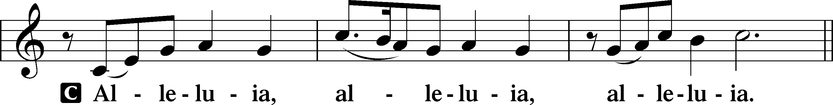

Verse LSB 205
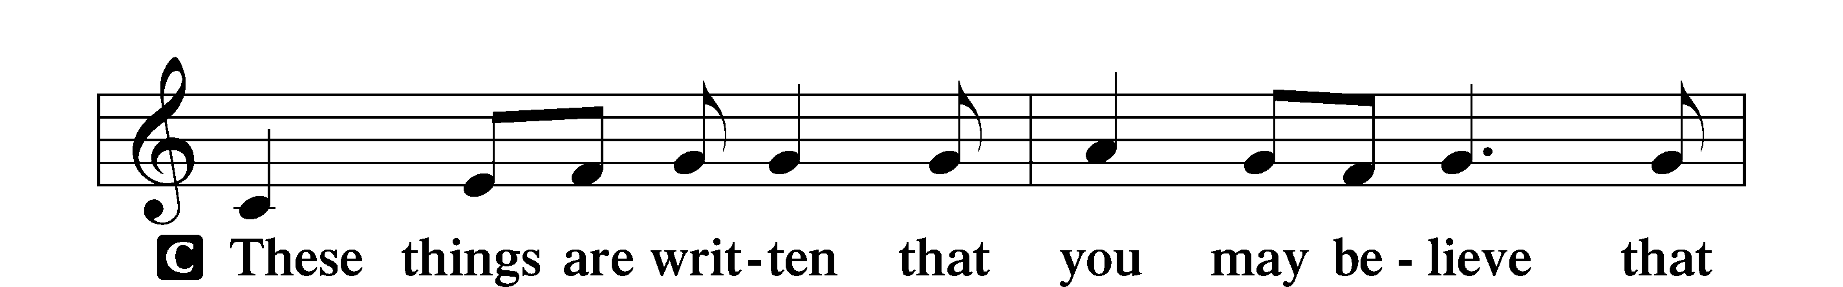
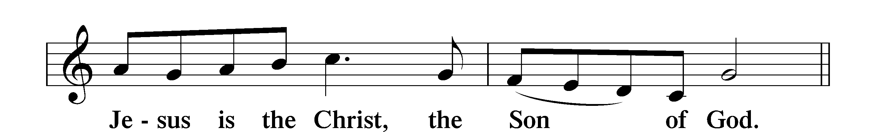

Alleluia LSB 205
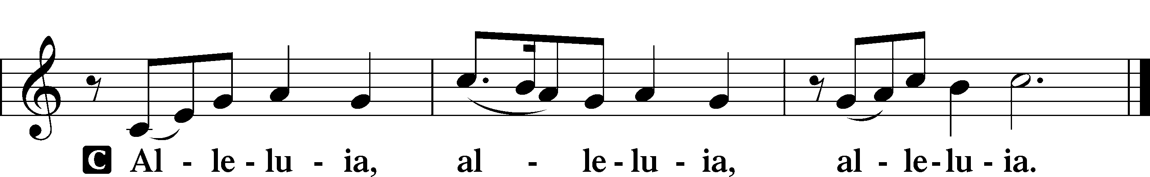

Holy Gospel Luke 16:1–9
P The Holy Gospel according to St. Luke, the sixteenth chapter.
C Glory to You, O Lord.

1[Jesus] also said to the disciples, “There was a rich man who had a manager, and charges were brought to him that this man was wasting his possessions. 2And he called him and said to him, ‘What is this that I hear about you? Turn in the account of your management, for you can no longer be manager.’ 3And the manager said to himself, ‘What shall I do, since my master is taking the management away from me? I am not strong enough to dig, and I am ashamed to beg. 4I have decided what to do, so that when I am removed from management, people may receive me into their houses.’ 5So, summoning his master’s debtors one by one, he said to the first, ‘How much do you owe my master?’ 6He said, ‘A hundred measures of oil.’ He said to him, ‘Take your bill, and sit down quickly and write fifty.’ 7Then he said to another, ‘And how much do you owe?’ He said, ‘A hundred measures of wheat.’ He said to him, ‘Take your bill, and write eighty.’ 8The master commended the dishonest manager for his shrewdness. For the sons of this world are more shrewd in dealing with their own generation than the sons of light. 9And I tell you, make friends for yourselves by means of unrighteous wealth, so that when it fails they may receive you into the eternal dwellings.”

P This is the Gospel of the Lord.
C Praise to You, O Christ.

Nicene Creed
C I believe in one God,
the Father Almighty,
maker of heaven and earth
and of all things visible and invisible.

And in one Lord Jesus Christ,
the only-begotten Son of God,
begotten of His Father before all worlds,
God of God, Light of Light,
very God of very God,
begotten, not made,
being of one substance with the Father,
by whom all things were made;
who for us men and for our salvation came down from heaven
and was incarnate by the Holy Spirit of the virgin Mary
and was made man;
and was crucified also for us under Pontius Pilate.
He suffered and was buried.
And the third day He rose again according to the Scriptures
and ascended into heaven
and sits at the right hand of the Father.
And He will come again with glory to judge both the living and the dead,
whose kingdom will have no end.

And I believe in the Holy Spirit,
the Lord and giver of life,
who proceeds from the Father and the Son,
who with the Father and the Son together is worshiped and glorified,
who spoke by the prophets.
And I believe in one holy Christian and apostolic Church,
I acknowledge one Baptism for the remission of sins,
and I look for the resurrection of the dead
and the life T of the world to come. Amen.

Sit
Children’s Message

Hymn of the Day “What Is the World to Me” LSB 730
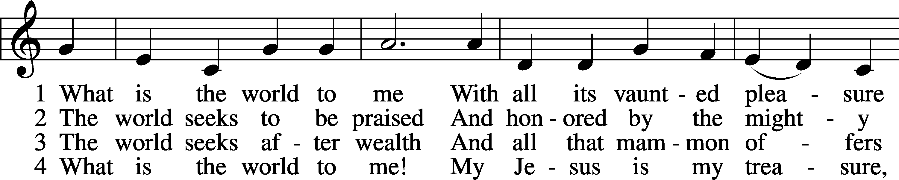
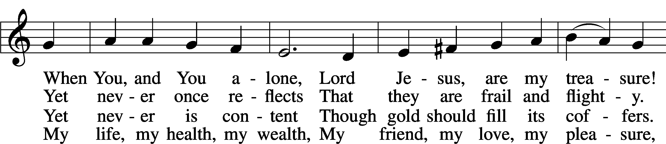
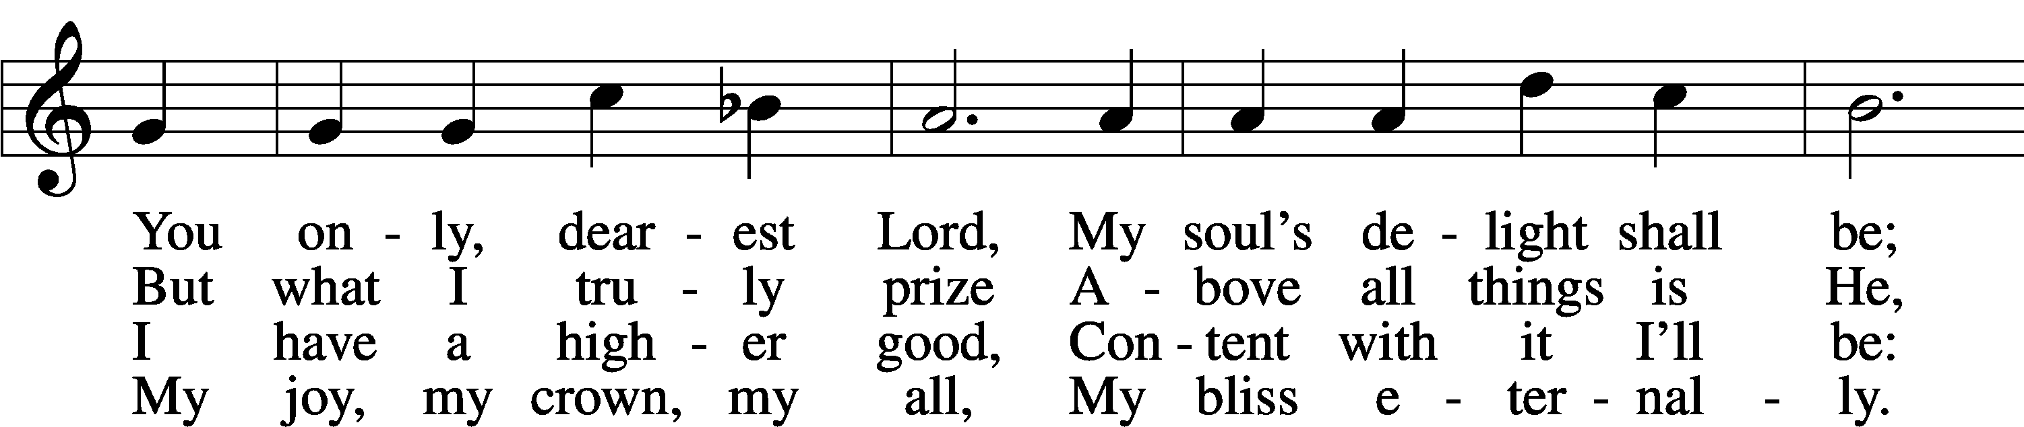
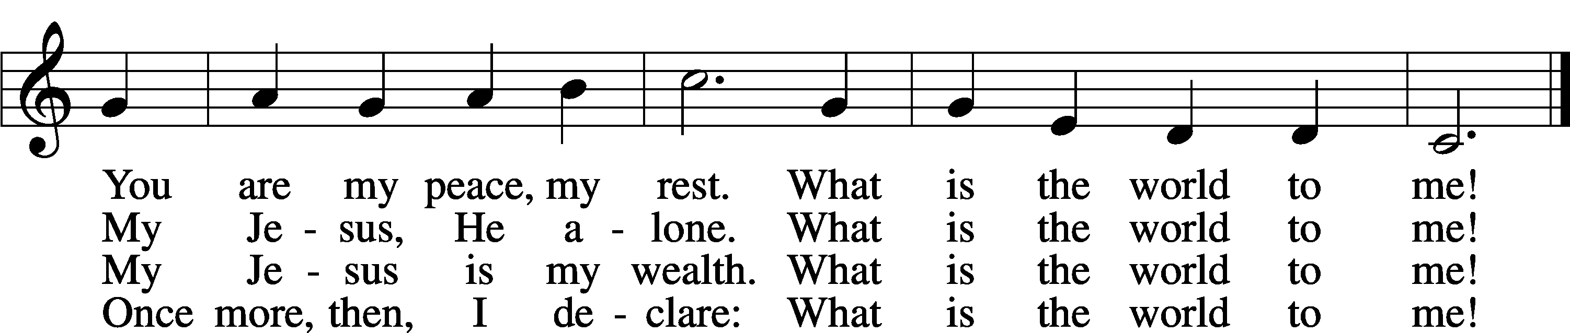
Tune and text: Public domain

Sermon

Offering

Stand
Prayer of the Church

+SERVICE OF THE SACRAMENT+

Preface LSB 208

P The Lord be with you.
C And also with you.

P Lift up your hearts.
C We lift them to the Lord.

P Let us give thanks to the Lord our God.
C It is right to give Him thanks and praise.

P It is truly good, right, and salutary that we should at all times and in all places give thanks to You, O Lord, holy Father, almighty and everlasting God, for the countless blessings You so freely bestow on us and all creation. Above all, we give thanks for Your boundless love shown to us when You sent Your only-begotten Son, Jesus Christ, into our flesh and laid on Him our sin, giving Him into death that we might not die eternally. Because He is now risen from the dead and lives and reigns to all eternity, all who believe in Him will overcome sin and death and will rise again to new life. Therefore with angels and archangels and with all the company of heaven we laud and magnify Your glorious name, evermore praising You and saying:

Sanctus LSB 208
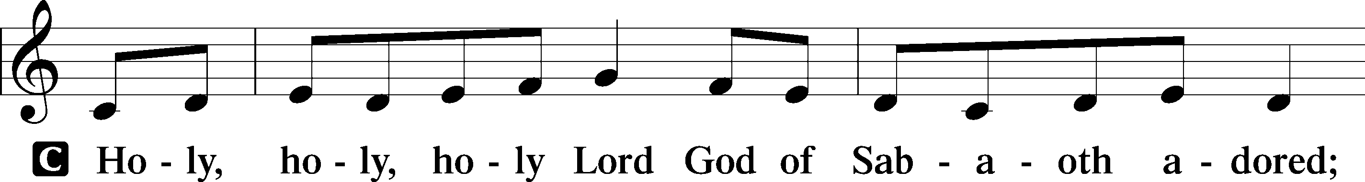
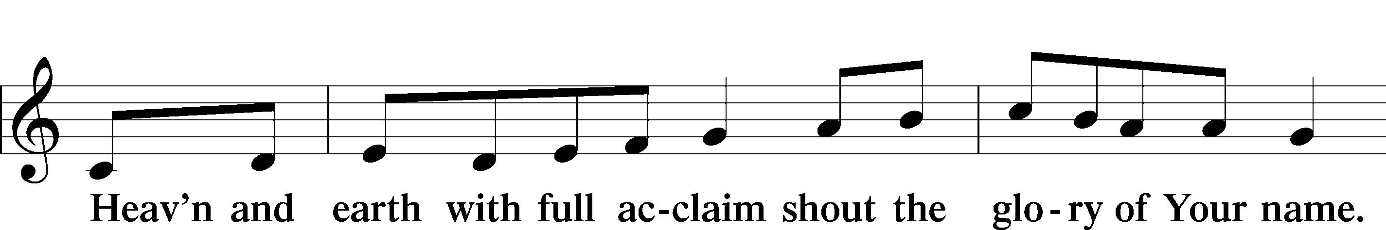
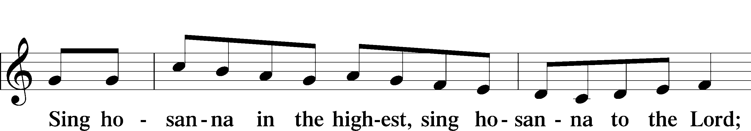
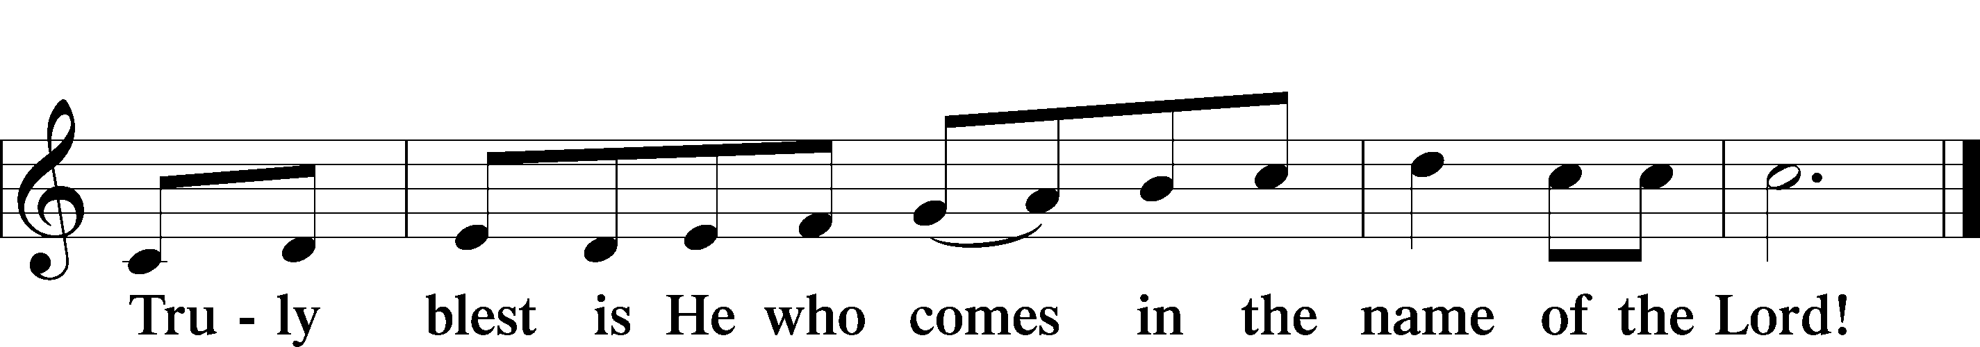

Lord’s Prayer
C Our Father who art in heaven,
hallowed be Thy name,
Thy kingdom come,
Thy will be done on earth
as it is in heaven;
give us this day our daily bread;
and forgive us our trespasses
as we forgive those
who trespass against us;
and lead us not into temptation,
but deliver us from evil.
For Thine is the kingdom
and the power and the glory
forever and ever. Amen.
The Words of Our Lord
P Our Lord Jesus Christ, on the night when He was betrayed, took bread, and when He had given thanks, He broke it and gave it to the disciples and said: “Take, eat; this is My T body, which is given for you. This do in remembrance of Me.”

In the same way also He took the cup after supper, and when He had given thanks, He gave it to them, saying: “Drink of it, all of you; this cup is the new testament in My T blood, which is shed for you for the forgiveness of sins. This do, as often as you drink it, in remembrance of Me.”

Pax Domini
P The peace of the Lord be with you always.
C Amen.

Agnus Dei LSB 210
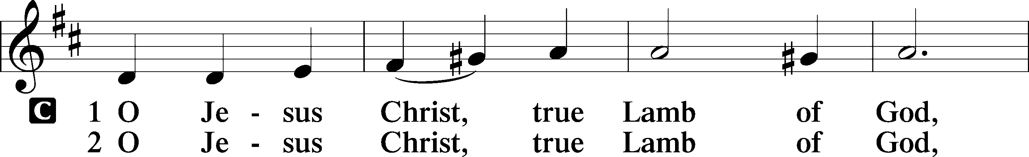
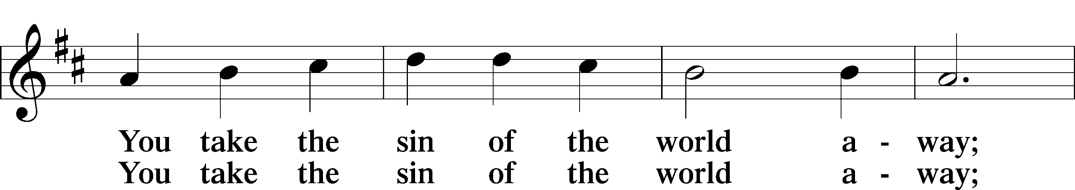
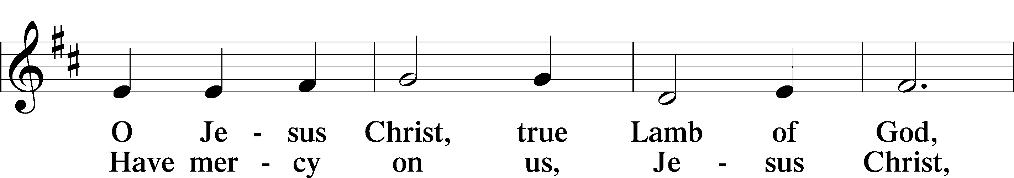
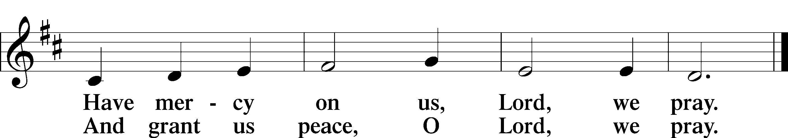

Sit
Distribution
Distribution Hymn “Rock of Ages, Cleft for Me” LSB 761
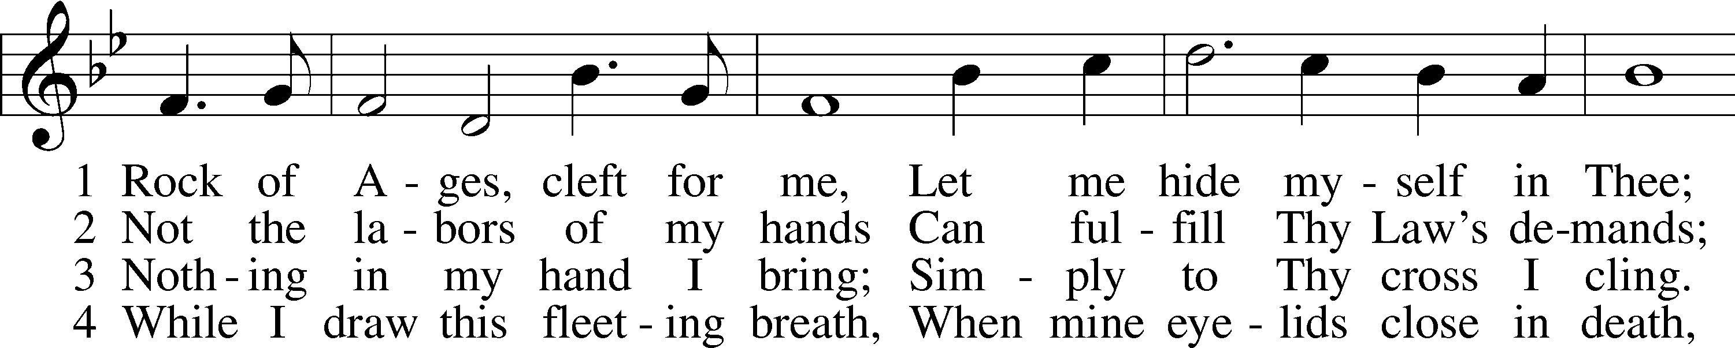
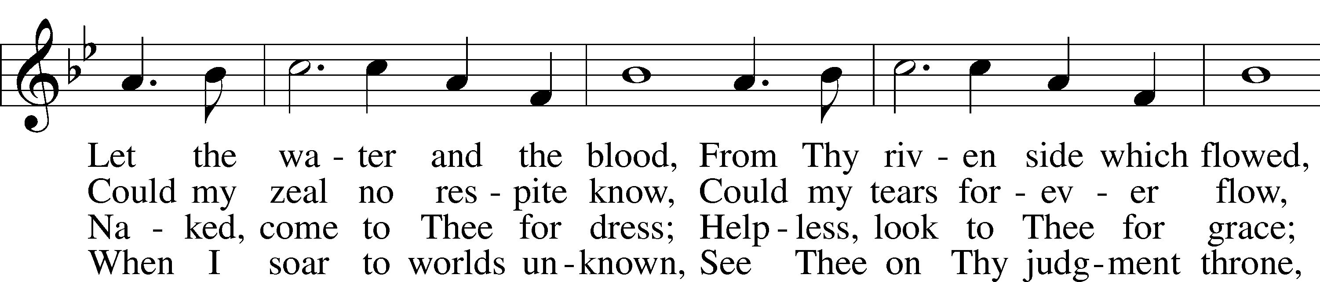
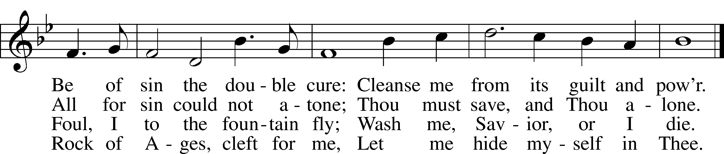
Tune and text: Public domain

Distribution Hymn “Seek Ye First” LSB 712
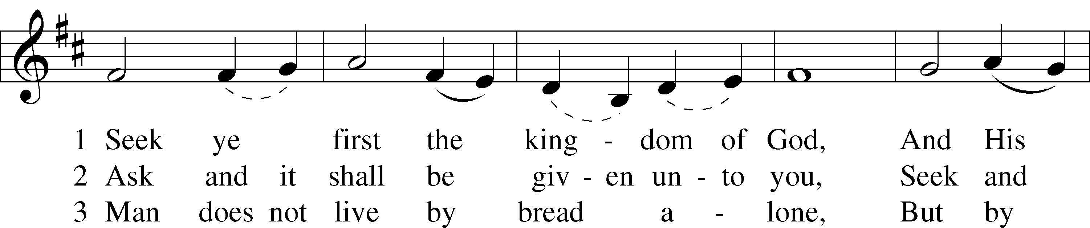
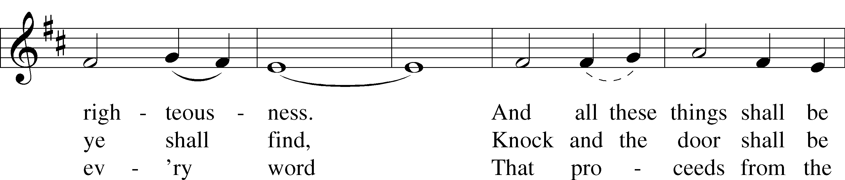
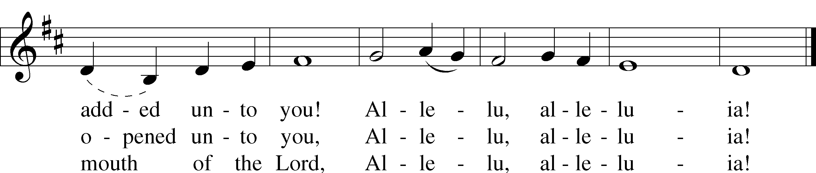
Text and tune: © 1972 Maranatha! Music, admin. EMI. Used by permission: CCLI no. 586279

Distribution Hymn “My Soul Rejoices” LSB 933
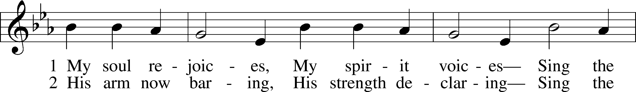
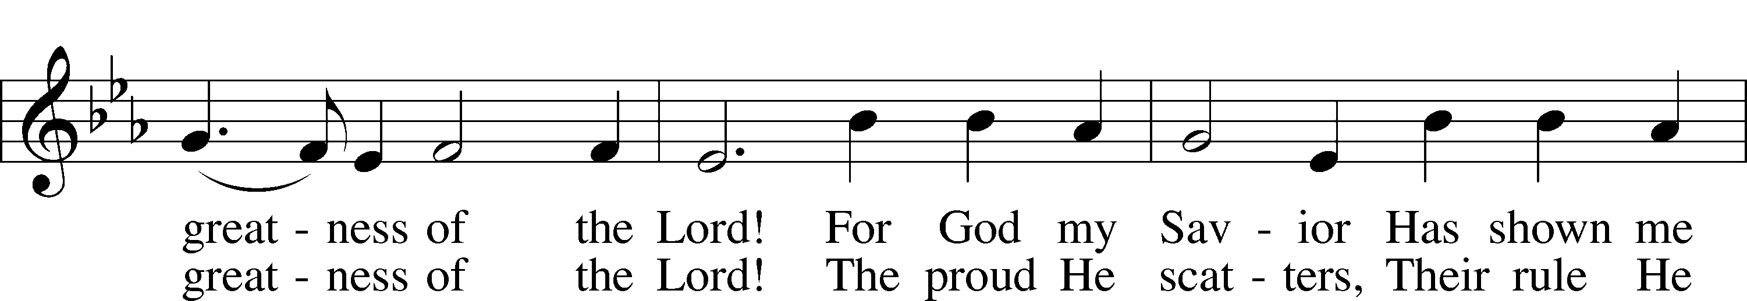
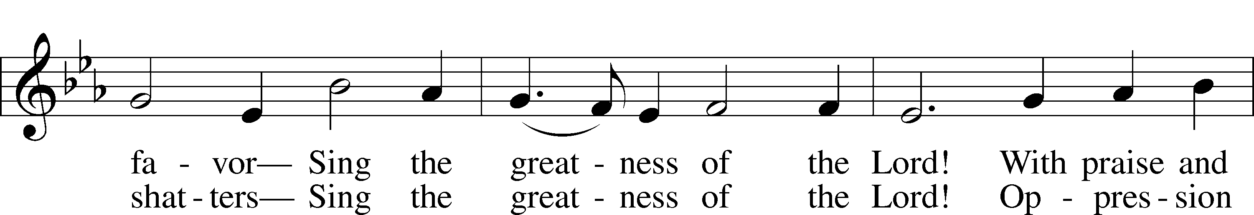
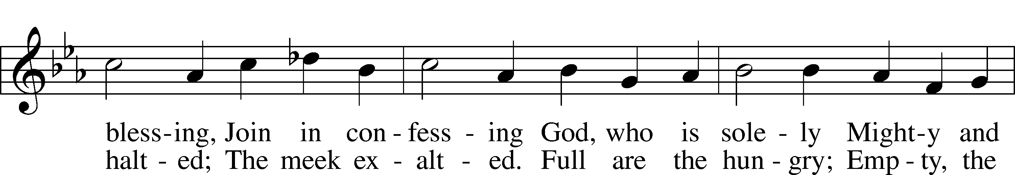
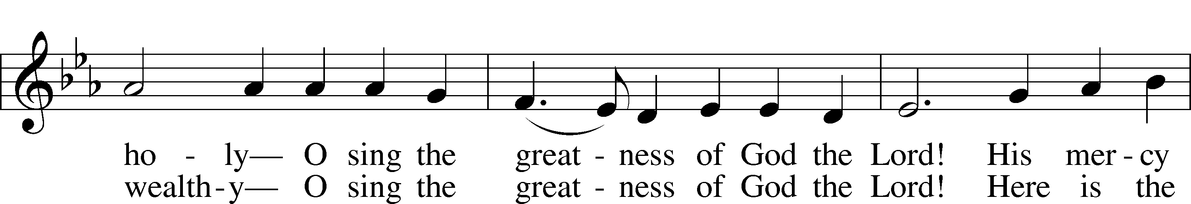
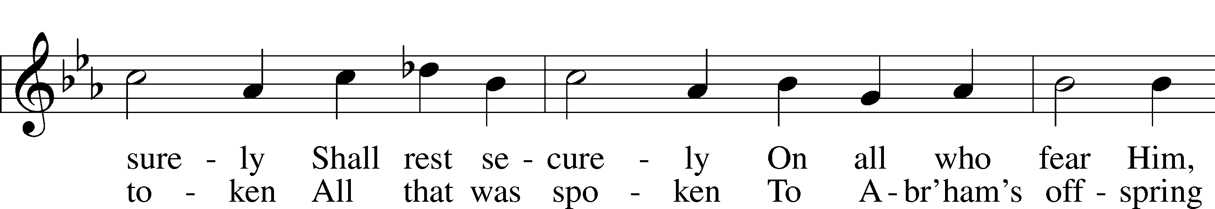
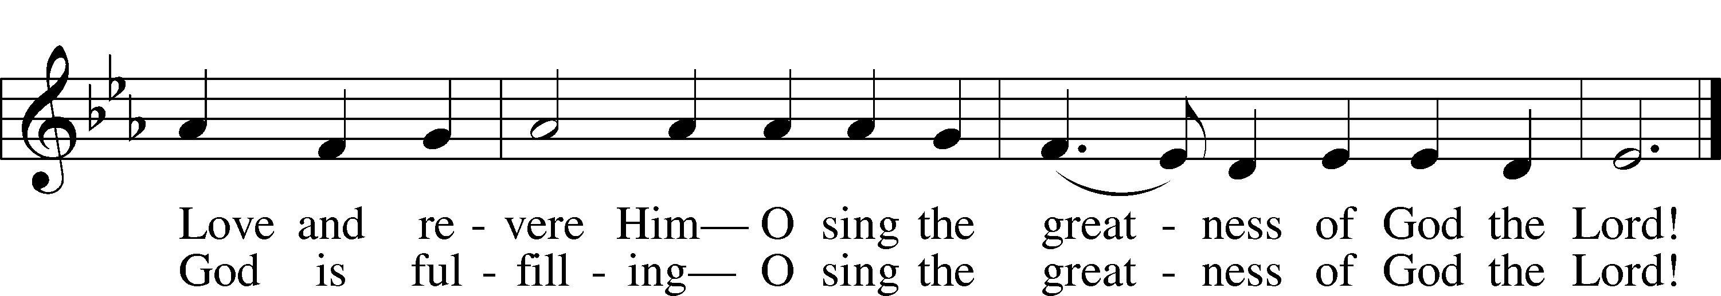
Tune: Public domain
Text: © 1991 Stephen P. Starke, admin. Concordia Publishing House. Used by permission: LSB Hymn License no. 110016438

Stand

Nunc Dimittis LSB 211
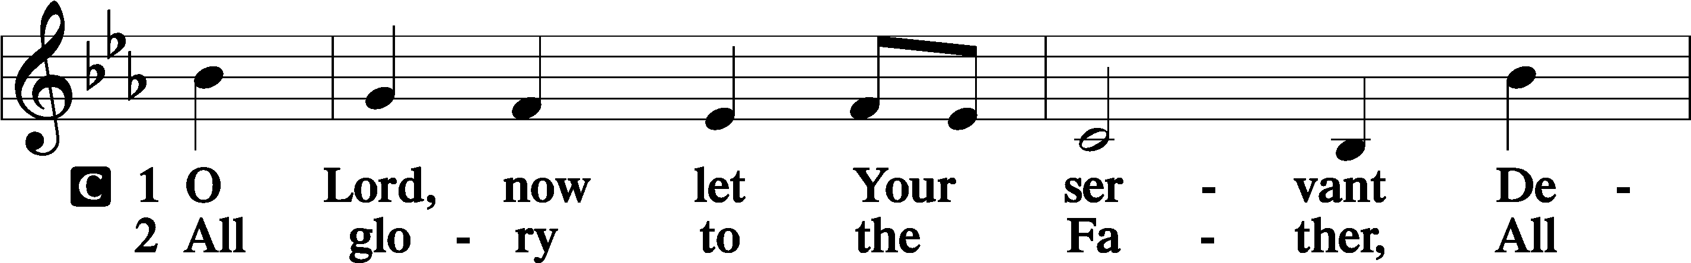
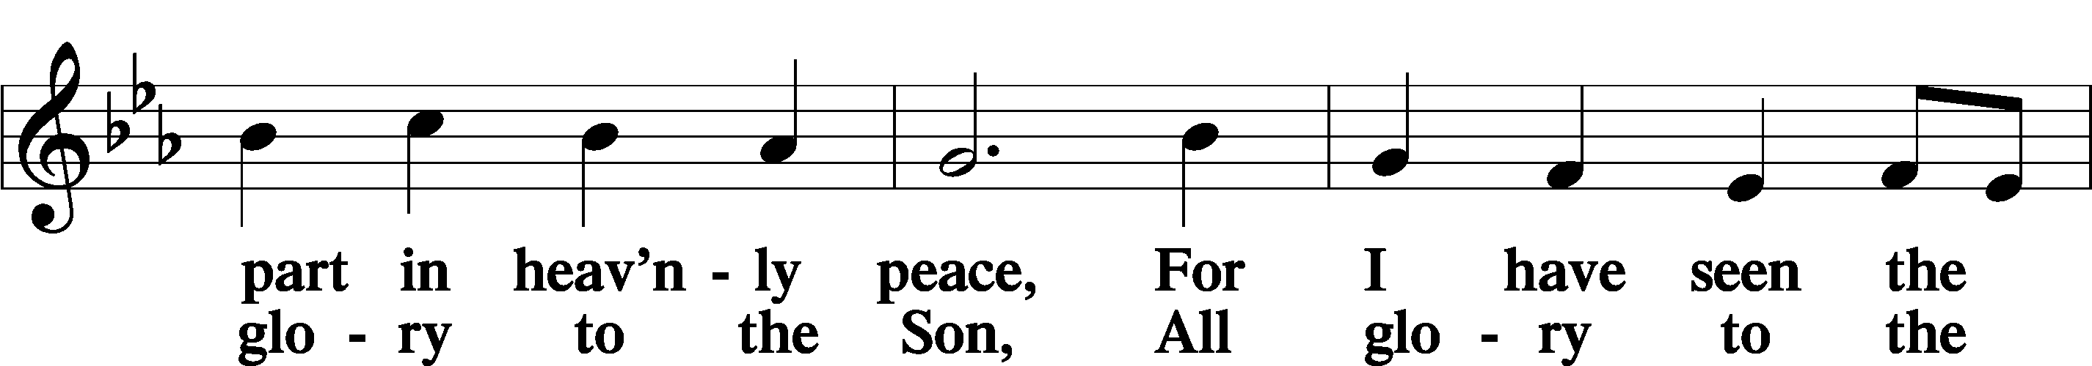
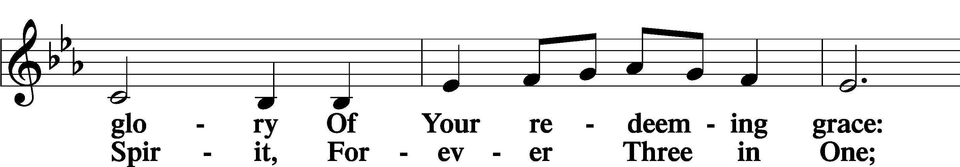
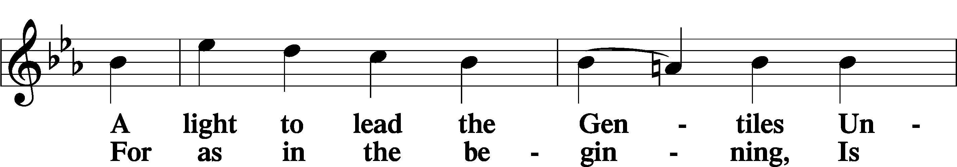
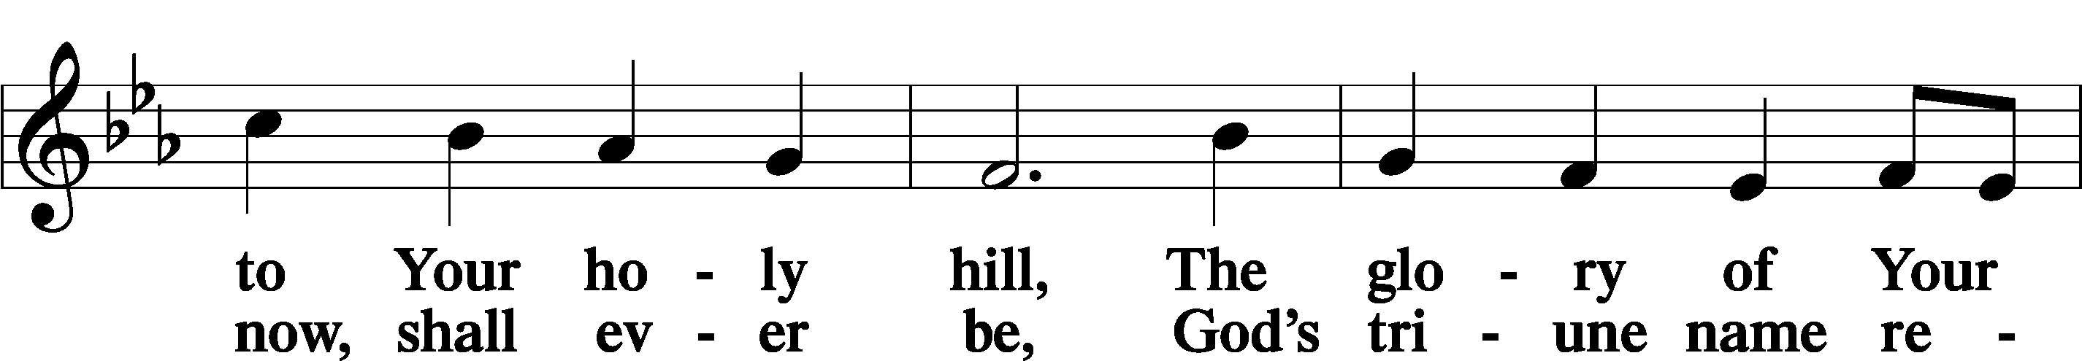
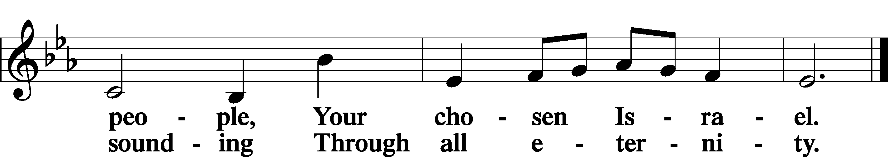

Post-Communion Collect
A Let us pray.
We give thanks to You, almighty God, that You have refreshed us through this salutary gift, and we implore You that of Your mercy You would strengthen us through the same in faith toward You and in fervent love toward one another; through Jesus Christ, Your Son, our Lord, who lives and reigns with You and the Holy Spirit, one God, now and forever.
C Amen.
Benedicamus LSB 212
A Let us bless the Lord.
C Thanks be to God.

Benediction
P The Lord bless you and keep you.
The Lord make His face shine on you and be gracious to you.
The Lord look upon you with favor and T give you peace.
C Amen.

Closing Hymn “How Firm a Foundation” LSB 728
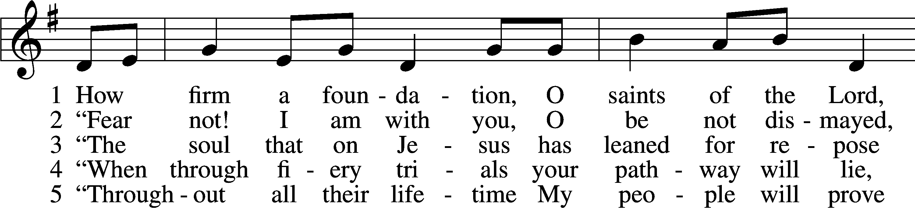
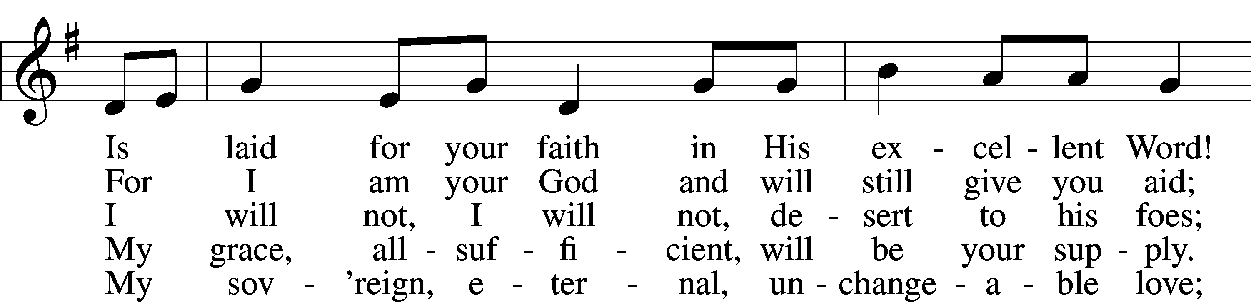
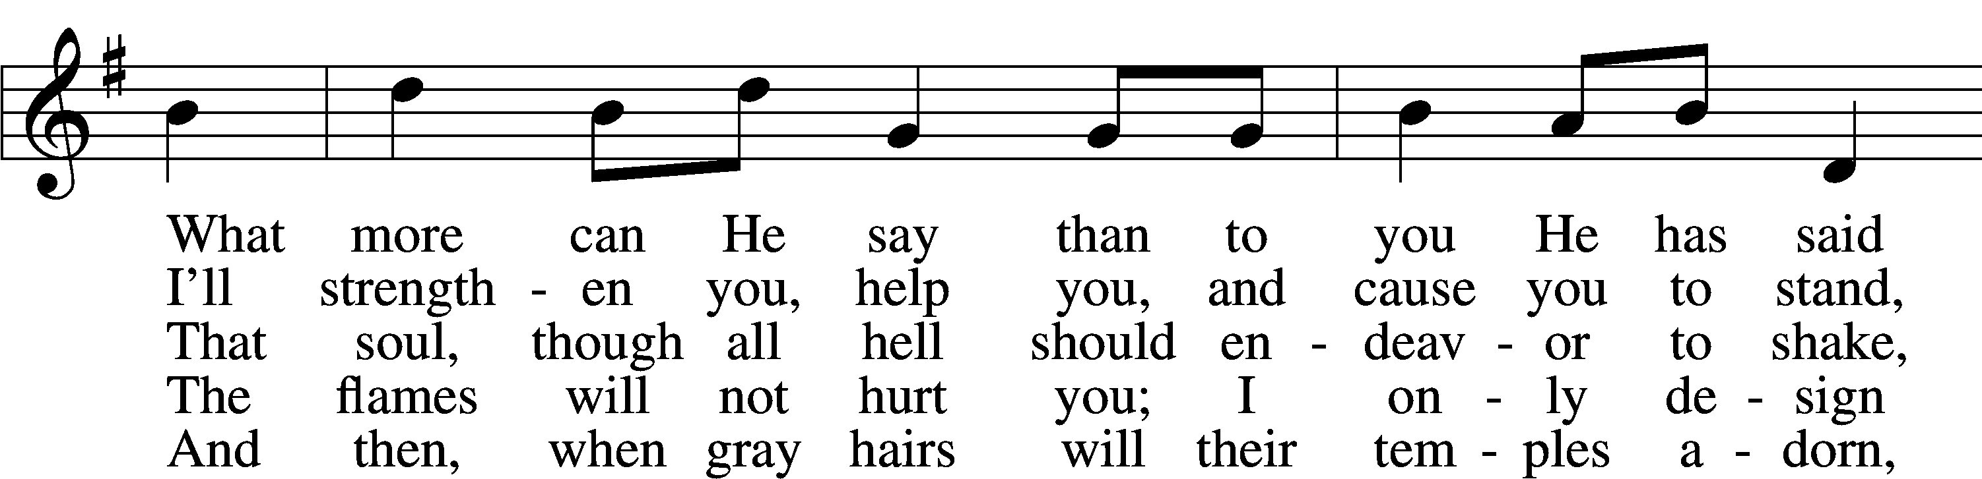
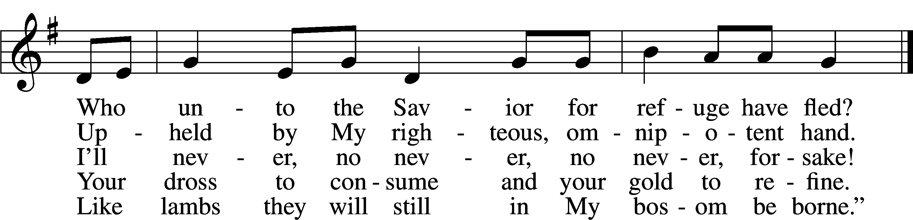
Text and tune: Public domain

Acknowledgments
Unless otherwise indicated, Scripture quotations are from the ESV® Bible (The Holy Bible, English Standard Version®), copyright © 2001 by Crossway, a publishing ministry of Good News Publishers. Used by permission. All rights reserved.
Created by Lutheran Service Builder © 2021 Concordia Publishing House.

Serving Our Lord in His House Today:
Pastor: Rev. David Wurdeman
Organist: Linda Ecker
Elders: Jerry Ecker & Josh Church

Gifts from God: Luke 16:8-9 – “… For the sons of this world are more shrewd in dealing with their own generation than the sons of light. And I tell you, make friends for yourselves by means of unrighteous wealth, so that when it fails they may receive you into the eternal dwellings.” The things of this world, including wealth, are merely tools. They can be used for good or ill. They can be squandered or used efficiently. How we use them will be determined by what is most important to us. What is most important to you in your life? Does the way you use the things of this world reflect that?

VBS-The Lord’s Army: VBS starts tonight! It will run for 5 fun evenings: Sunday, August 1-Thursday, August 5. Registration opens at 5:30 pm, VBS takes place from 6:00 pm- 8:00 pm. No supper beforehand this year.

Church Office Closed: Please be advised the church office will be closed on Friday, August 6th and Monday, August 9th as the secretary will be on vacation.
If you need immediate assistance during this time, please contact the Congregation President, Salz Salzman at 608-387-2636 or Head Elder, Bob Pulley at
608-372-7649.

Usher Volunteers: A calling to the men of our congregation! The Elders are looking for volunteers who are willing to be an usher during our worship services. Being an usher is a great way to be involved with our worship services and is a great service to our Lord. The goal at this time is to recruit enough men to setup usher teams that will be assigned to specific weekends on the church calendar. Please sign-up on the easel board in the narthex or let an elder know that you are interested!
Sunday morning Greeters: We are looking for members to serve the church on Sunday morning by being a Greeter. It is a BLESSING to meet all those worshipping, guests and members alike! Call Sylvia Engel at 608-343-9645 if you would be interested in participating in this Hospitality Ministry or have any questions.

Volunteers Needed: Good Shepherd is participating in the Downtown Thursday Nights from July 1-August 12. Toro has paid the fees for the booth, but we need volunteers to help run the booth. What a wonderful opportunity to get our church’s name out in the community! The booth is located in the kid’s area, near the bounce house. We are selling kid friendly treats. There is a sign-up roster on the easel in the Narthex. Please contact Lorna Rosenow with any questions at 608-372-6584.

Livestream: Our Sunday Service is livestreamed weekly on our YouTube channel “Good Shepherd Lutheran Church Tomah.”

Hymnals: If you would like to use a Hymnal at home, you can sign one out from church. We also have free devotion pamphlets and Portals of Prayer.

PO Box: For mailed offerings, please use the following:
Good Shepherd Lutheran Church
P.O. Box 551
Tomah, WI 54660

Our Worship attendance last week: Sunday: 57
Wednesday: 6
Total: 63

Scripture Lessons for next week: Jeremiah 8:4-12
1 Corinthians 12:1-11
Luke 19:41-48

Secretary Office Hours: Monday, August 2-Thursday, August 5: 8am-12pm
Friday, August 6 and Monday, August 9: Office Closed
Tuesday, August 10-Friday, August 13: 8am-12pm

Our Week With Our Lord:
Today 9:00am Divine Service w/Holy Communion
(livestreamed via YouTube)
10:30am Adult Bible Study
5:30pm VBS Registration open
6:00pm-8:00pm VBS-The Lord’s Army
Monday 10:00am Staff Meeting
5:30pm VBS Registration open
6:00pm-8:00pm VBS-The Lord’s Army
Tuesday 5:30pm VBS Registration open
6:00pm-8:00pm VBS-The Lord’s Army
TBD Softball-Tournament
Wednesday *No Church Service due to VBS
5:30pm VBS Registration open
6:00pm-8:00pm VBS-The Lord’s Army Thursday 9:30am-11:00am Little Lambs @Firemen’s Park
5:00pm-9:00pm Downtown Thursday Nights
5:30pm VBS Registration open
6:00pm-8:00pm VBS-The Lord’s Army
Friday *Church Office Closed*
Saturday
Sunday 9:00am Divine Service w/Holy Communion
(livestreamed via YouTube)
SCRIP Orders Due
Mite Box Sunday
10:30am Adult Bible Study

*Please view following page for weekly prayers*
HIS FLOCK AT PRAYER
Propers for the Ninth Week after Trinity

Psalm for the Week: Psalm 51:1-12

Daily Scripture Readings:
Sunday—Luke 16:1-9 Thursday—Luke 6:31-35
Monday— Proverbs 11:23-25 Friday—Luke 16:10-13
Tuesday—Luke 12:32-37 Saturday— Genesis 4:3-11
Wednesday—2 Thessalonians 3:7-13

Collect for the Week:
Let Your merciful ears, O Lord, be open to the prayers of Your humble servants; and that they may obtain their petitions, make them to ask such things as shall please You; through Jesus Christ, Your Son, our Lord, who lives and reigns with You and the Holy Spirit, one God, now and forever.

Hymn of the Week: “What Is the World to Me” LSB 730

Congregational Petitions for this Week:
+ For those who are ill or recovering, especially: Brenda Kolb, Paula Sopel,
Shawn Zabinski, Karen Griggel, Margaret Palmer, Ladene Zabinski,
Carrie Wilbanks, Cindy Gluch, Payton Pierce, Kathy Berg, Joan Oswald,
Marie Drescher, Les Hackett, Joyce Pulley, Tom Coman, Kelly Ingenthron,
Jean Salzman, Gary Salzman, Peter Benjamin, Ruth Heller.
+ For those who are mourning the loss of a loved one:
Ruby Schmidt, family and friends, at the loss of Alyce Herbison, Ruby’s
sister-in-law
Tracy Theurich-York, family and friends, at the loss of Jack Dallman, friend of
Tracy
+ For those who are home-bound, especially: John Fox, Darlene Griffin,
Al Mansfield, Virginia Tillman, Linda Goad, Roemelle McArdle,
Sharon Herried.
+ For those who serve in the military, especially: Isaac Preuss, Tania Adler,
Joshua Ecker.

