Good Shepherd Lutheran Church
Ninth Sunday after Pentecost
August 7, 2022

Pre-Service Music & Welcome
Divine Service Setting Four – Lutheran Service Book (LSB) 203

+CONFESSION AND ABSOLUTION+

Stand
Opening Hymn “If Thou But Trust in God to Guide Thee”
LSB 750 1-4,7
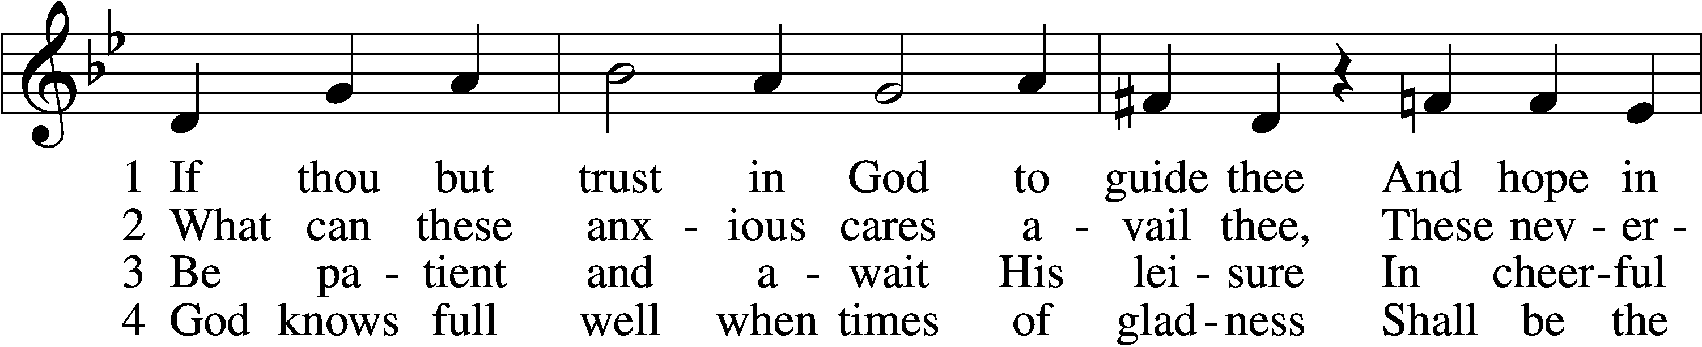
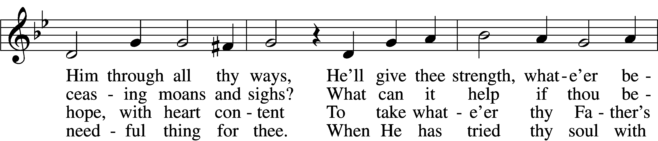
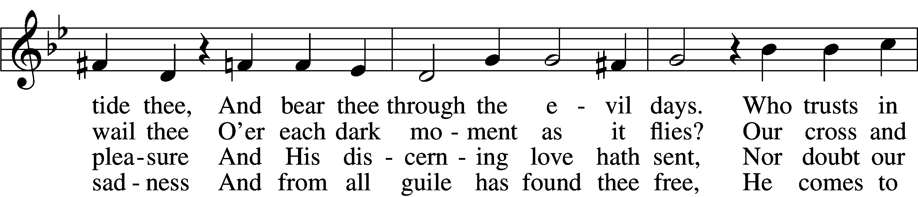
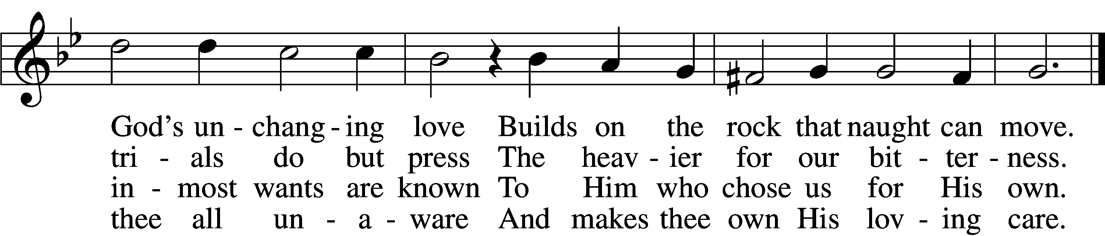
7 Sing, pray, and keep His ways unswerving,
Perform thy duties faithfully,
And trust His Word; though undeserving,
Thou yet shalt find it true for thee.
God never yet forsook in need
The soul that trusted Him indeed.
Text: tr. Catherine Winkworth, 1827–78, alt. Text and tune: Georg Neumark, 1621–81 Text and tune: Public domain

The sign of the cross T may be made by all in remembrance of their Baptism.

Invocation
P In the name of the Father and of the T Son and of the Holy Spirit.
C Amen.

Exhortation LSB 203
P Our help is in the name of the Lord,
C who made heaven and earth.

P If You, O Lord, kept a record of sins, O Lord, who could stand?
C But with You there is forgiveness; therefore You are feared.

P Since we are gathered to hear God’s Word, call upon Him in prayer and praise, and receive the body and blood of our Lord Jesus Christ in the fellowship of this altar, let us first consider our unworthiness and confess before God and one another that we have sinned in thought, word, and deed, and that we cannot free ourselves from our sinful condition. Together as His people let us take refuge in the infinite mercy of God, our heavenly Father, seeking His grace for the sake of Christ, and saying: God, be merciful to me, a sinner.

Silence for reflection on God’s Word and for self-examination.
Confession of Sins LSB 203
C Almighty God, have mercy upon us, forgive us our sins, and lead us to everlasting life. Amen.

Absolution LSB 203
P Almighty God in His mercy has given His Son to die for you and for His sake forgives you all your sins. As a called and ordained servant of Christ, and by His authority, I therefore forgive you all your sins in the name of the Father and of the T Son and of the Holy Spirit.
C Amen.

+SERVICE OF THE WORD+

Introit Psalm 147:8–11; antiphon: v. 7
Sing to the Lord with thanksgiving;
make melody to our God on the lyre!
He covers the heavens with clouds; he prepares rain for the earth;
he makes grass grow on the hills.
He gives to the beasts their food,
and to the young ravens that cry.
His delight is not in the strength of the horse,
nor his pleasure in the legs of a man,
but the Lord takes pleasure in those who fear him,
in those who hope in his steadfast love.
Glory be to the Father and to the Son
and to the Holy Spirit;
as it was in the beginning,
is now, and will be forever. Amen.
Sing to the Lord with thanksgiving;
make melody to our God on the lyre!

Kyrie LSB 204
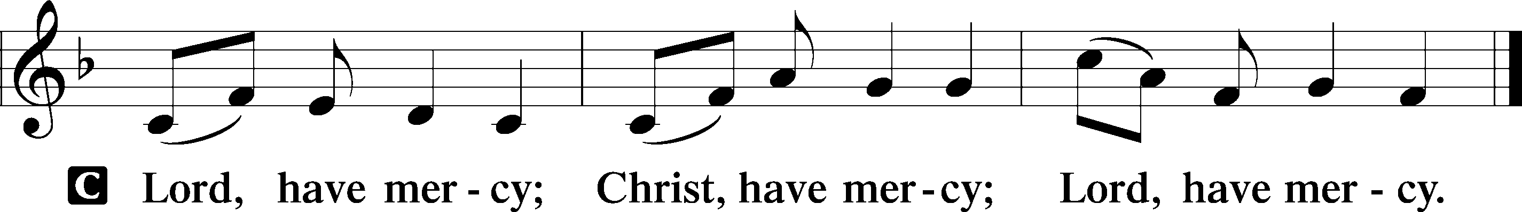

Gloria in Excelsis LSB 204
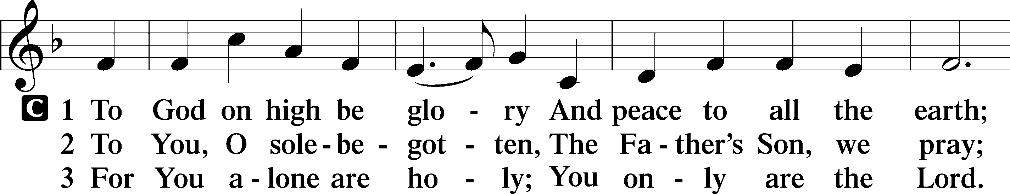
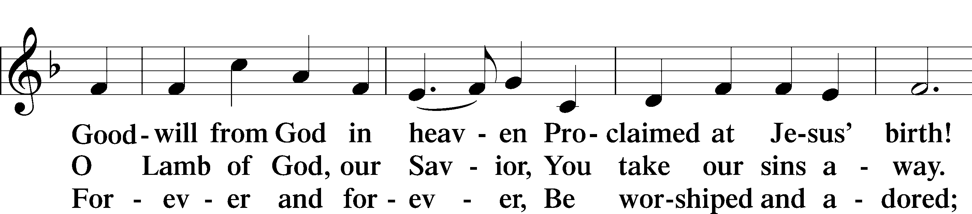
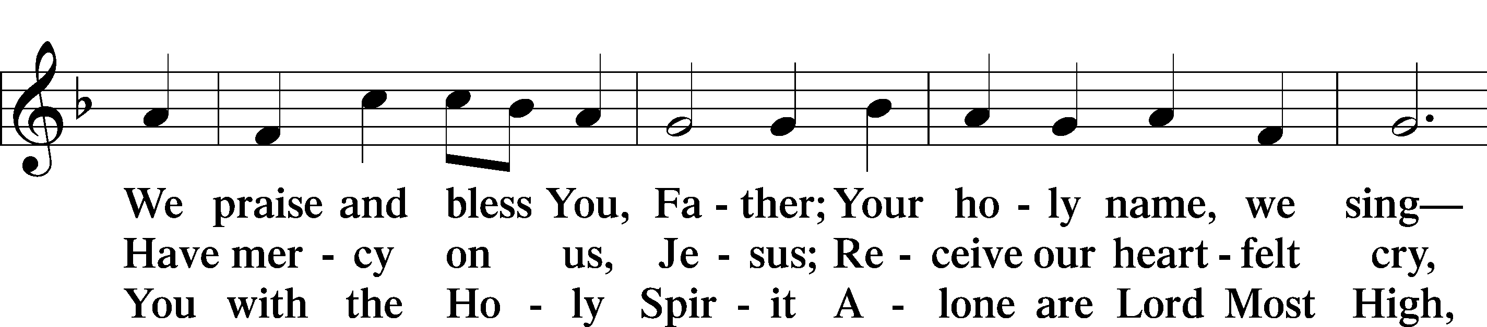
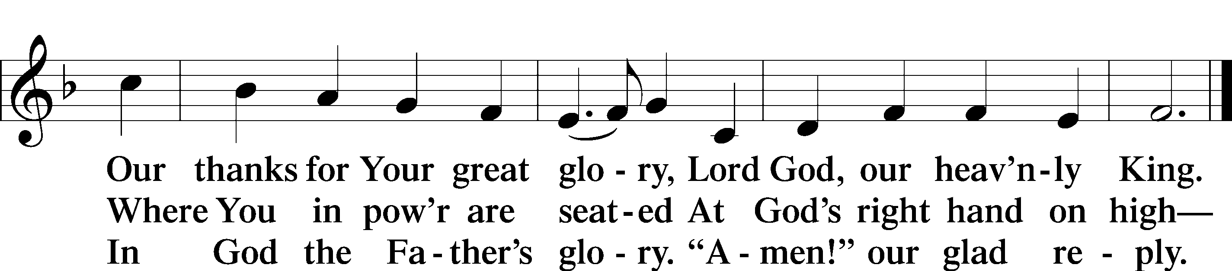
Text: Stephen P. Starke

Salutation and Collect of the Day
P The Lord be with you.
C And also with you.

P Let us pray.
C Almighty and merciful God, it is by Your grace that we live as Your people who offer acceptable service. Grant that we may walk by faith, and not by sight, in the way that leads to eternal life; through Jesus Christ, Your Son, our Lord, who lives and reigns with You and the Holy Spirit, one God,
now and forever. Amen.

Sit

Old Testament Reading Genesis 15:1–6
1After these things the word of the Lord came to Abram in a vision: “Fear not, Abram, I am your shield; your reward shall be very great.” 2But Abram said, “O Lord God, what will you give me, for I continue childless, and the heir of my house is Eliezer of Damascus?” 3And Abram said, “Behold, you have given me no offspring, and a member of my household will be my heir.” 4And behold, the word of the Lord came to him: “This man shall not be your heir; your very own son shall be your heir.” 5And he brought him outside and said, “Look toward heaven, and number the stars, if you are able to number them.” Then he said to him, “So shall your offspring be.” 6And he believed the Lord, and he counted it to him as righteousness.
A This is the Word of the Lord.
C Thanks be to God.

Gradual Psalm 34:9, 19, alt.
Fear the Lord, you his saints,
for those who fear him lack nothing!
Many are the afflictions of the righteous,
but the Lord delivers him out of them all.

Epistle Hebrews 11:1–16
1Now faith is the assurance of things hoped for, the conviction of things not seen. 2For by it the people of old received their commendation. 3By faith we understand that the universe was created by the word of God, so that what is seen was not made out of things that are visible.
4By faith Abel offered to God a more acceptable sacrifice than Cain, through which he was commended as righteous, God commending him by accepting his gifts. And through his faith, though he died, he still speaks. 5By faith Enoch was taken up so that he should not see death, and he was not found, because God had taken him. Now before he was taken he was commended as having pleased God. 6And without faith it is impossible to please him,
for whoever would draw near to God must believe that he exists and that he rewards those who seek him. 7By faith Noah, being warned by God concerning events as yet unseen, in reverent fear constructed an ark for the saving of his household. By this he condemned the world and became an heir of the righteousness that comes by faith.
8By faith Abraham obeyed when he was called to go out to a place that he was to receive as an inheritance. And he went out, not knowing where he was going. 9By faith he went to live in the land of promise, as in a foreign land, living in tents with Isaac and Jacob, heirs with him of the same promise. 10For he was looking forward to the city that has foundations, whose designer and builder is God.
11By faith Sarah herself received power to conceive, even when she was past the age, since she considered him faithful who had promised. 12Therefore from one man, and him as good as dead, were born descendants as many as the stars of heaven and as many as the innumerable grains of sand by the seashore.
13These all died in faith, not having received the things promised, but having seen them and greeted them from afar, and having acknowledged that they were strangers and exiles on the earth.
14For people who speak thus make it clear that they are seeking a homeland. 15If they had been thinking of that land from which they had gone out, they would have had opportunity to return.
16But as it is, they desire a better country, that is, a heavenly one. Therefore God is not ashamed to be called their God, for he has prepared for them a city.

A This is the Word of the Lord.
C Thanks be to God.

Stand

Alleluia and Verse

Alleluia LSB 205
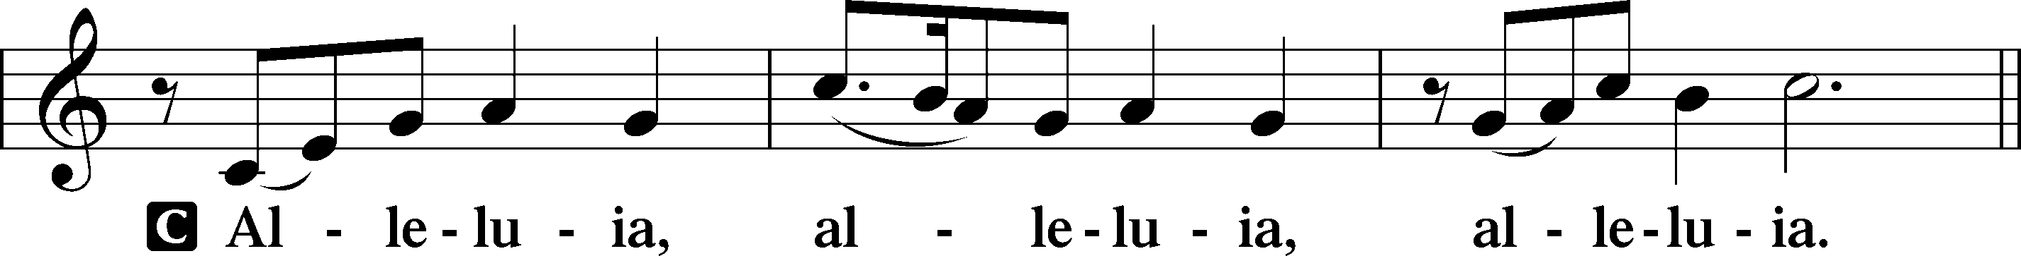

Verse LSB 205
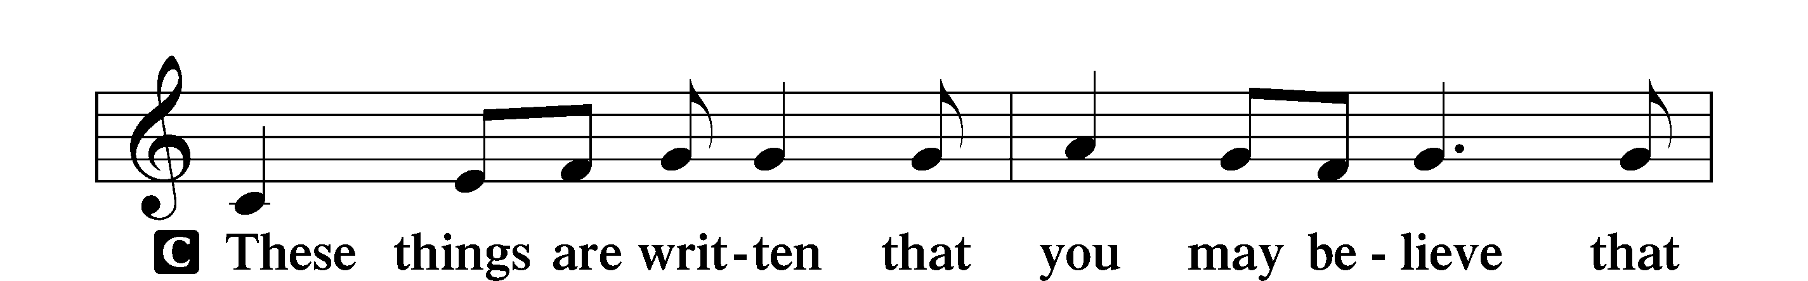
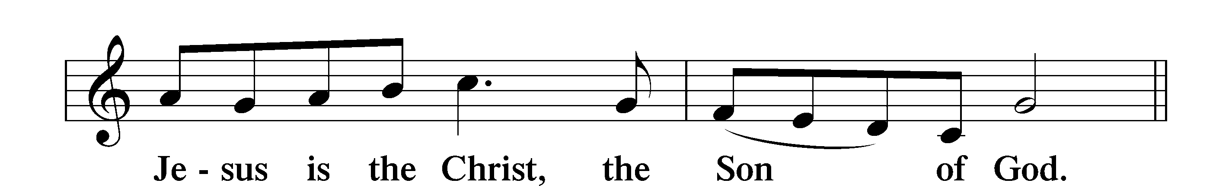

Alleluia LSB 205
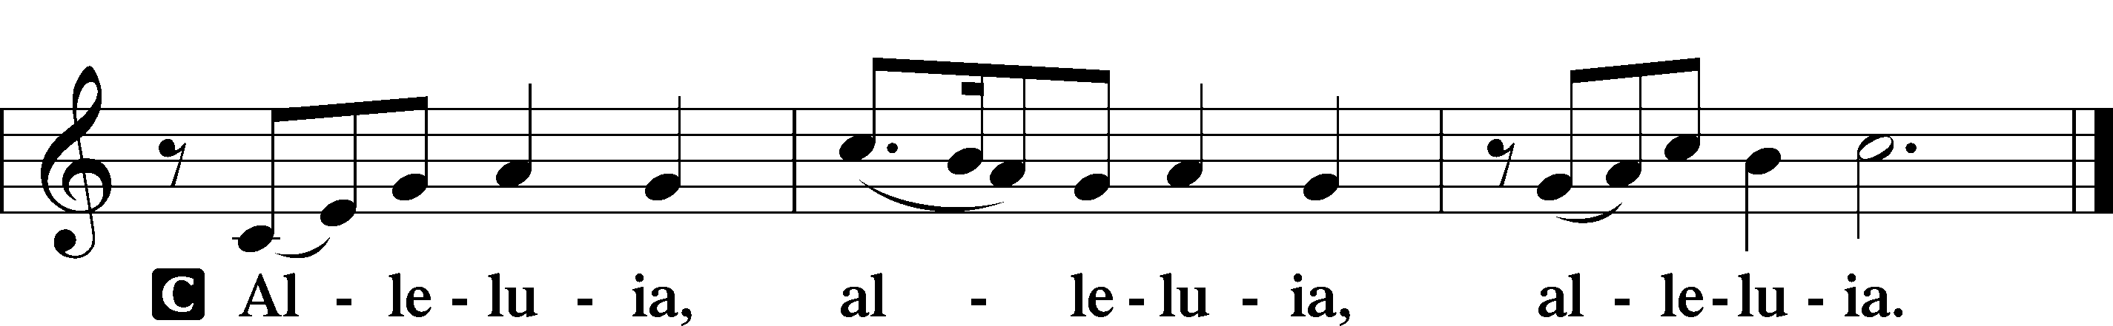

Holy Gospel Luke 12:22–34
P The Holy Gospel according to St. Luke, the twelfth chapter.
C Glory to You, O Lord.

22[Jesus] said to his disciples, “Therefore I tell you, do not be anxious about your life, what you will eat, nor about your body,
what you will put on. 23For life is more than food, and the body more than clothing. 24Consider the ravens: they neither sow nor reap, they have neither storehouse nor barn, and yet God feeds them. Of how much more value are you than the birds! 25And which of you by being anxious can add a single hour to his span of life? 26If then you are not able to do as small a thing as that, why are you anxious about the rest? 27Consider the lilies, how they grow: they neither toil nor spin, yet I tell you, even Solomon in all his glory was not arrayed like one of these. 28But if God so clothes the grass, which is alive in the field today, and tomorrow is thrown into the oven, how much more will he clothe you, O you of little faith! 29And do not seek what you are to eat and what you are to drink, nor be worried. 30For all the nations of the world seek after these things, and your Father knows that you need them. 31Instead, seek his kingdom, and these things will be added to you.
32“Fear not, little flock, for it is your Father’s good pleasure to give you the kingdom. 33Sell your possessions, and give to the needy. Provide yourselves with moneybags that do not grow old, with a treasure in the heavens that does not fail, where no thief approaches and no moth destroys. 34For where your treasure is, there will your heart be also.”

P This is the Gospel of the Lord.
C Praise to You, O Christ.

Nicene Creed
C I believe in one God,
the Father Almighty,
maker of heaven and earth
and of all things visible and invisible.

And in one Lord Jesus Christ,
the only-begotten Son of God,
begotten of His Father before all worlds,
God of God, Light of Light,
very God of very God,
begotten, not made,
being of one substance with the Father,
by whom all things were made;
who for us men and for our salvation came down from heaven
and was incarnate by the Holy Spirit of the virgin Mary
and was made man;
and was crucified also for us under Pontius Pilate.
He suffered and was buried.
And the third day He rose again according to the Scriptures
and ascended into heaven
and sits at the right hand of the Father.
And He will come again with glory to judge both the living and the dead,
whose kingdom will have no end.

And I believe in the Holy Spirit,
the Lord and giver of life,
who proceeds from the Father and the Son,
who with the Father and the Son together is worshiped and glorified,
who spoke by the prophets.
And I believe in one holy Christian and apostolic Church,
I acknowledge one Baptism for the remission of sins,
and I look for the resurrection of the dead
and the life T of the world to come. Amen.

Sit

Children’s Message

Hymn of the Day “Lord of All Hopefulness” LSB 738
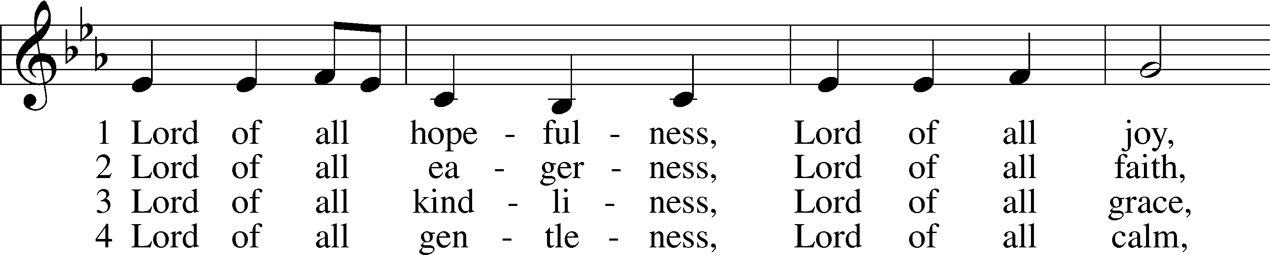
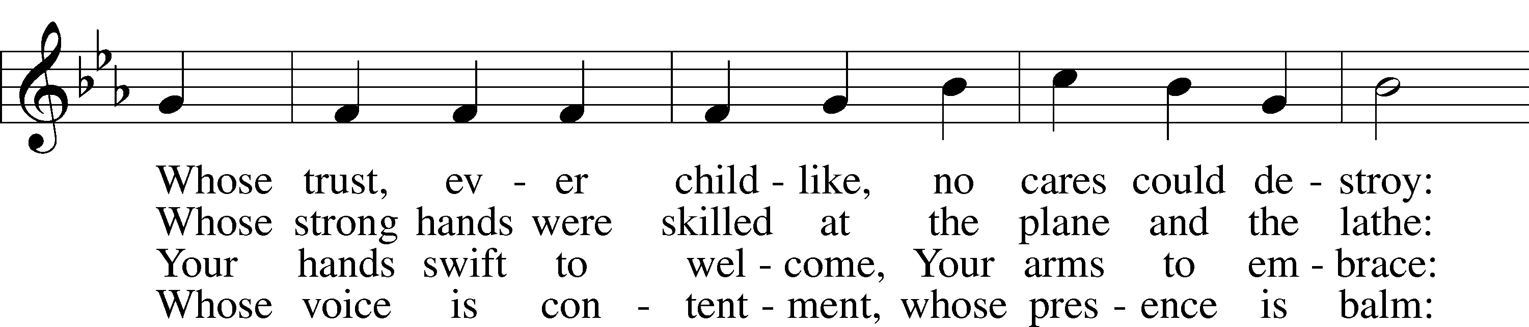
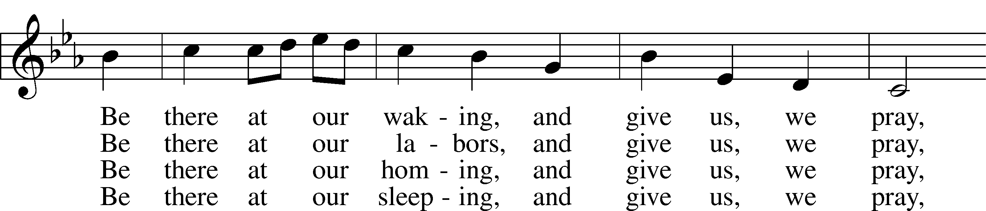
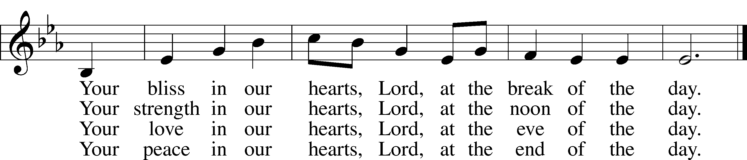
Text: Jan Struther, 1901–53 Tune: Irish
Text: © Oxford University Press. Used by permission: LSB Hymn License no. 110016438
Tune: Public domain

Sermon

Stand
Prayer of the Church
Sit
Offering

+SERVICE OF THE SACRAMENT+

Stand

Preface LSB 208
P The Lord be with you.
C And also with you.

P Lift up your hearts.
C We lift them to the Lord.

P Let us give thanks to the Lord our God.
C It is right to give Him thanks and praise.

P It is truly good, right, and salutary that we should at all times and in all places give thanks to You, O Lord, holy Father, almighty and everlasting God, for the countless blessings You so freely bestow on us and all creation. Above all, we give thanks for Your boundless love shown to us when You sent Your
only-begotten Son, Jesus Christ, into our flesh and laid on Him our sin, giving Him into death that we might not die eternally. Because He is now risen from the dead and lives and reigns to all eternity, all who believe in Him will overcome sin and death and will rise again to new life. Therefore with angels and archangels and with all the company of heaven we laud and magnify Your glorious name, evermore praising You and saying:

Sanctus LSB 208
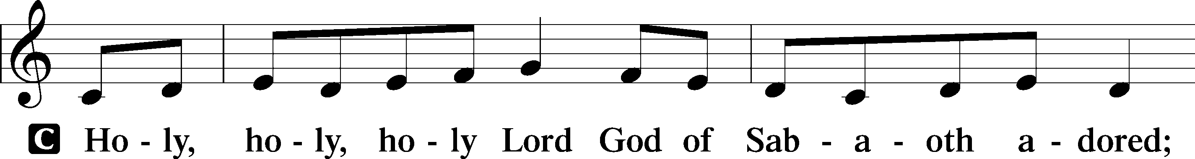
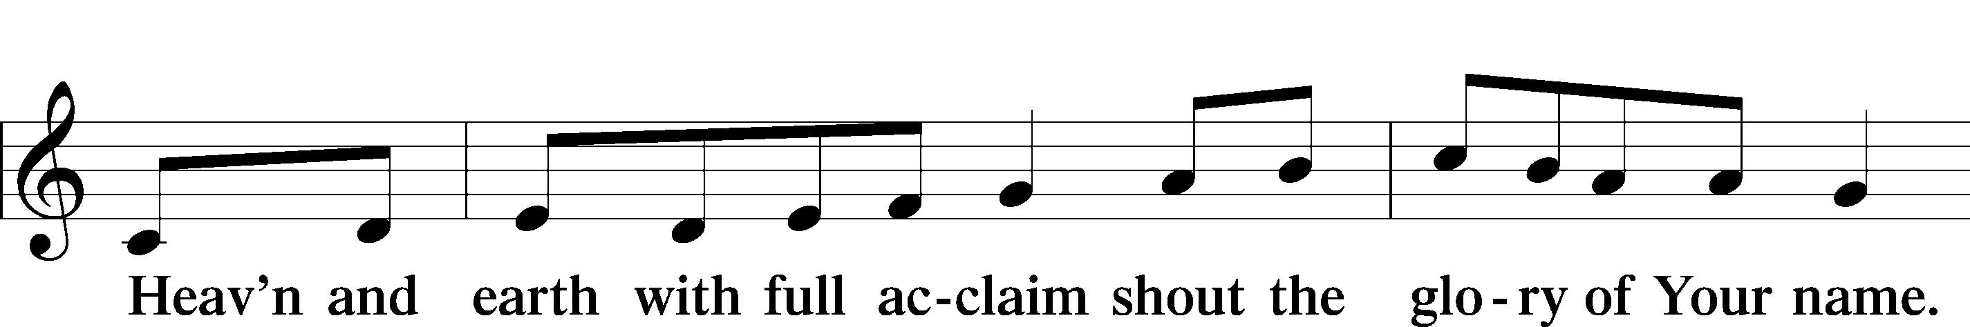
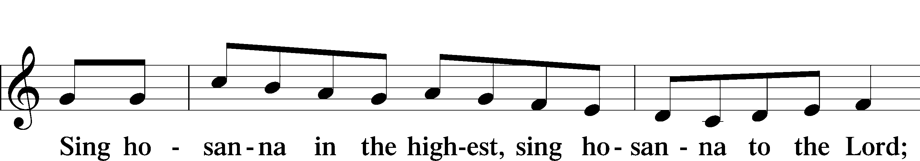
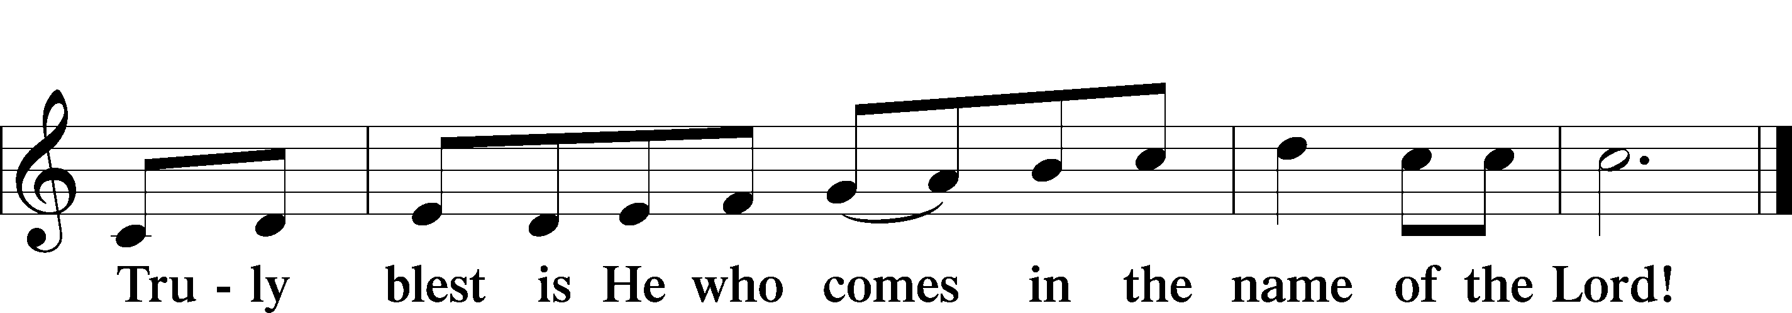
Text: Stephen P. Starke

Prayer of Thanksgiving
P Blessed are You, O Lord our God, king of all creation, for You have had mercy on us and given Your only-begotten Son that whoever believes in Him should not perish but have eternal life.

In Your righteous judgment You condemned the sin of Adam and Eve, who ate the forbidden fruit, and You justly barred them and all their children from the tree of life. Yet, in Your great mercy, You promised salvation by a second Adam, Your Son, Jesus Christ, our Lord, and made His cross a life-giving tree for all who trust in Him.

We give You thanks for the redemption You have prepared for us through Jesus Christ. Grant us Your Holy Spirit that we may faithfully eat and drink of the fruits of His cross and receive the blessings of forgiveness, life, and salvation that come to us in His body and blood.

Hear us as we pray in His name and as He has taught us:

Lord’s Prayer
C Our Father who art in heaven,
hallowed be Thy name,
Thy kingdom come,
Thy will be done on earth
as it is in heaven;
give us this day our daily bread;
and forgive us our trespasses
as we forgive those
who trespass against us;
and lead us not into temptation,
but deliver us from evil.
For Thine is the kingdom
and the power and the glory
forever and ever. Amen.

The Words of Our Lord
P Our Lord Jesus Christ, on the night when He was betrayed, took bread, and when He had given thanks, He broke it and gave it to the disciples and said: “Take, eat; this is My T body, which is given for you. This do in remembrance of Me.”

In the same way also He took the cup after supper, and when He had given thanks, He gave it to them, saying: “Drink of it, all of you; this cup is the new testament in My T blood, which is shed for you for the forgiveness of sins. This do, as often as you drink it, in remembrance of Me.”

Pax Domini
P The peace of the Lord be with you always.
C Amen.

Agnus Dei LSB 210
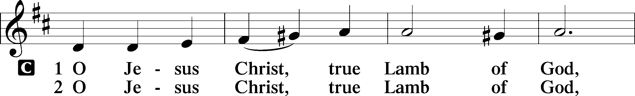
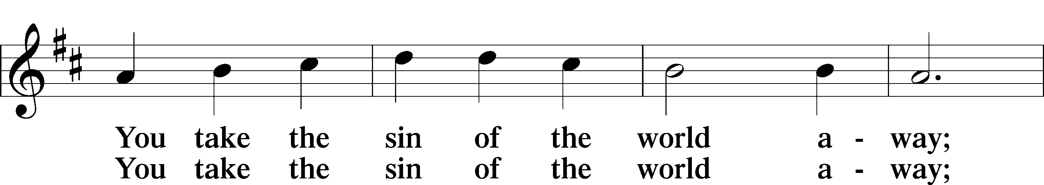
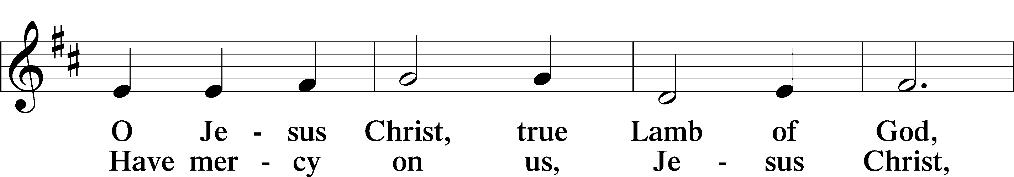
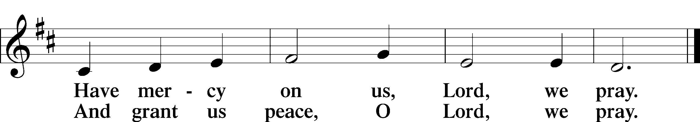
Text: Stephen P. Starke

Sit

Distribution

Distribution Hymn “At the Lamb’s High Feast We Sing” LSB 633
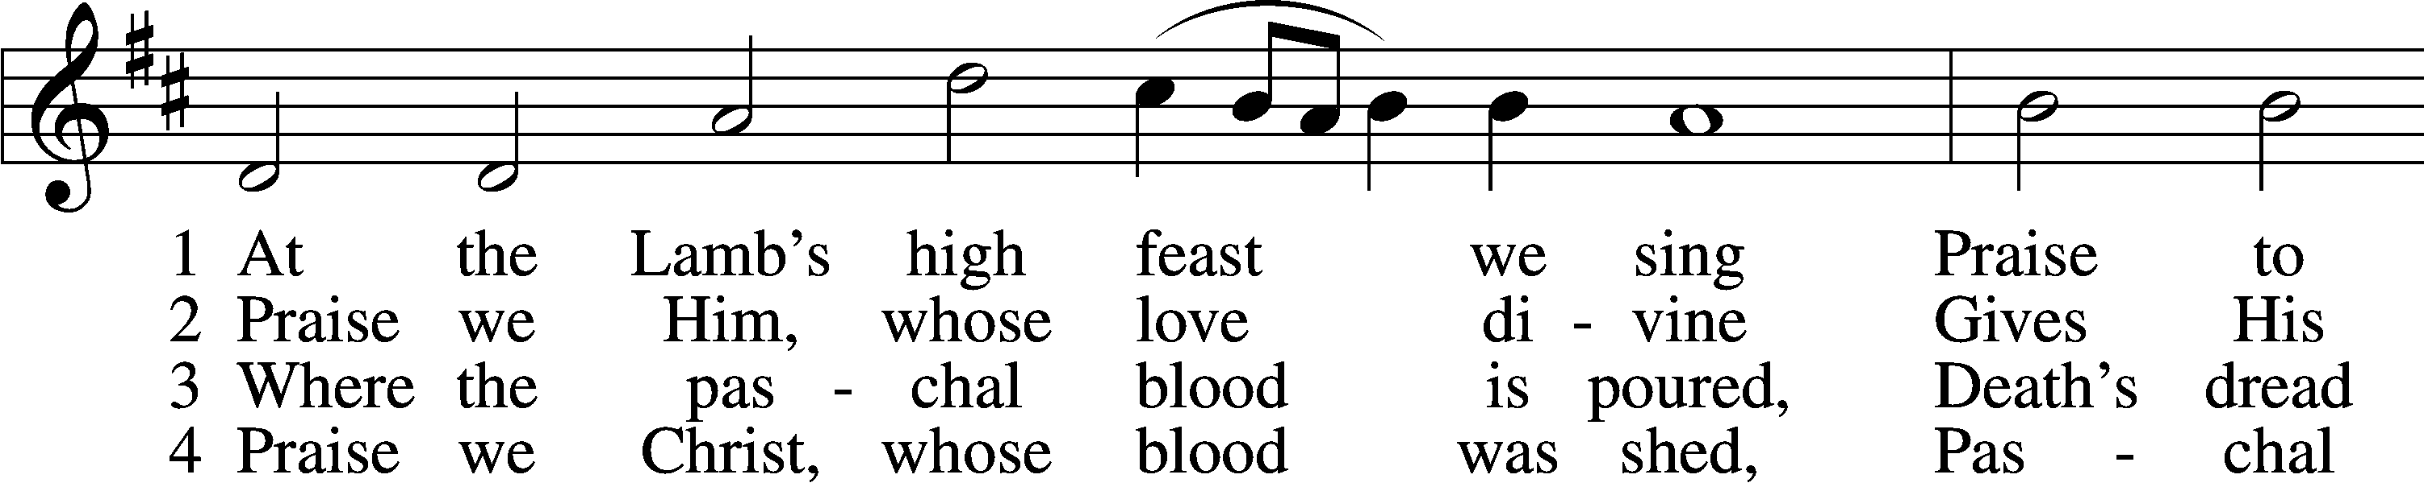
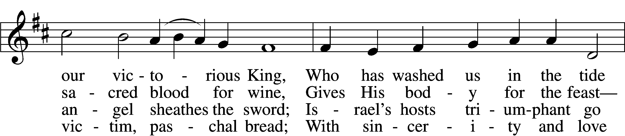
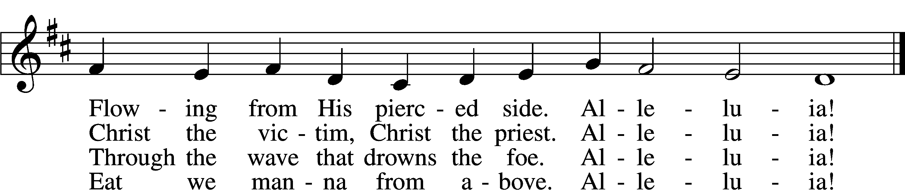

5 Mighty Victim from the sky,
Hell’s fierce pow’rs beneath You lie;
You have conquered in the fight,
You have brought us life and light.
Alleluia!

6 Now no more can death appall,
Now no more the grave enthrall;
You have opened paradise,
And Your saints in You shall rise.
Alleluia!

7 Easter triumph, Easter joy!
This alone can sin destroy;
From sin’s pow’r, Lord, set us free,
Newborn souls in You to be.
Alleluia!

D 8 Father, who the crown shall give,
Savior, by whose death we live,
Spirit, guide through all our days:
Three in One, Your name we praise.
Alleluia!
Text: Latin, c. 5th–10th cent.; tr. Robert Campbell, 1814–68, alt.
Tune: Kirchengeseng, 1566, Ivancice
Text and tune: Public domain

Stand

Nunc Dimittis LSB 211
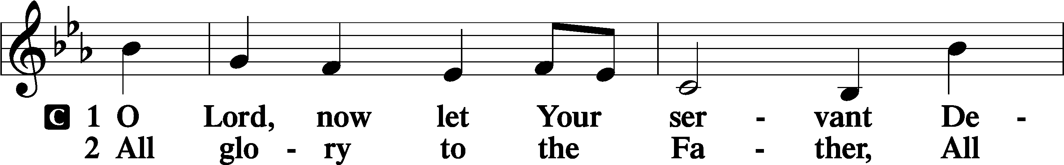
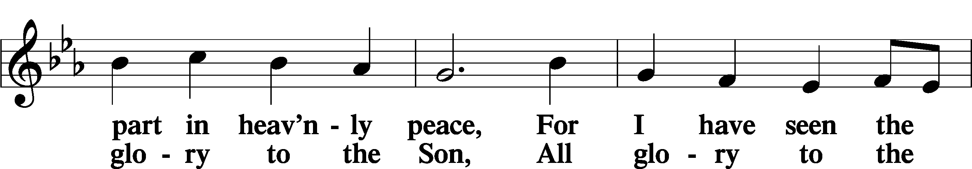
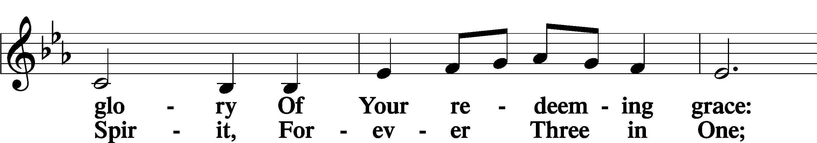
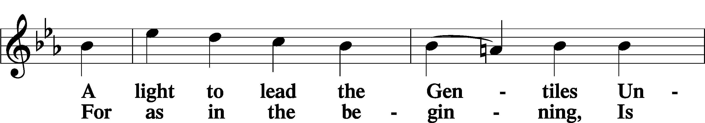
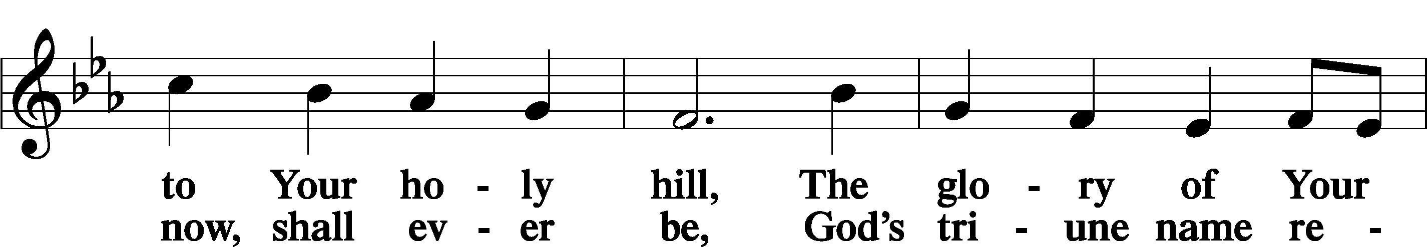
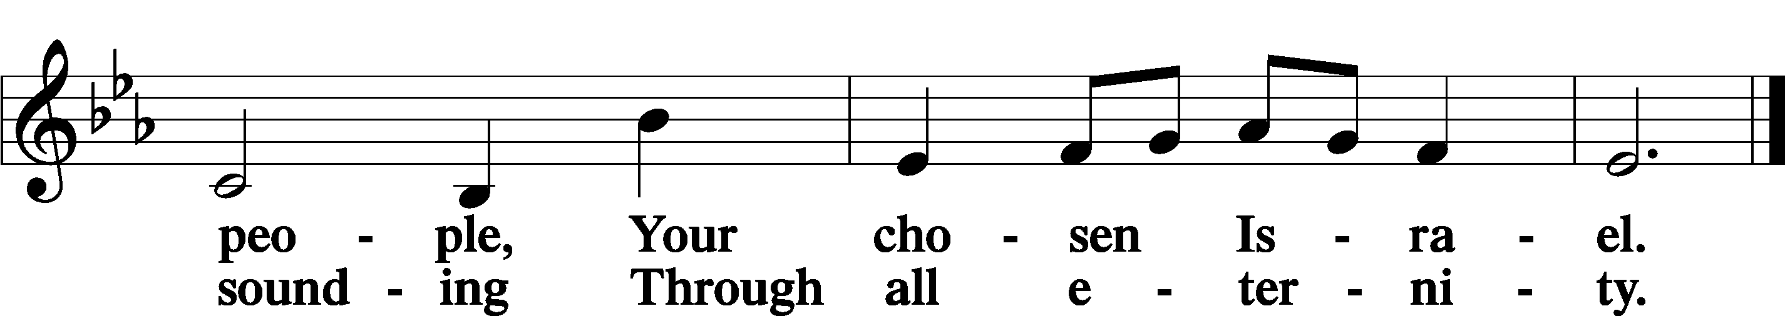

Post-Communion Collect
A Let us pray.
We give thanks to You, almighty God, that You have refreshed us through this salutary gift, and we implore You that of Your mercy You would strengthen us through the same in faith toward You and in fervent love toward one another; through Jesus Christ, Your Son, our Lord, who lives and reigns with You and the Holy Spirit, one God, now and forever.
C Amen.

Benedicamus LSB 212
A Let us bless the Lord.
C Thanks be to God.

Benediction
P The Lord bless you and keep you.
The Lord make His face shine on you and be gracious to you.
The Lord look upon you with favor and T give you peace.
C Amen.

Closing Hymn “Have No Fear, Little Flock” LSB 735
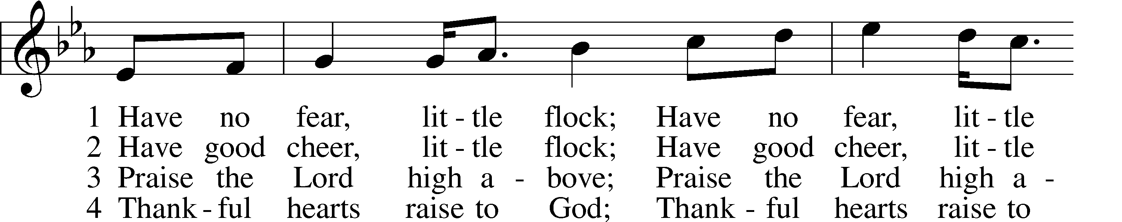
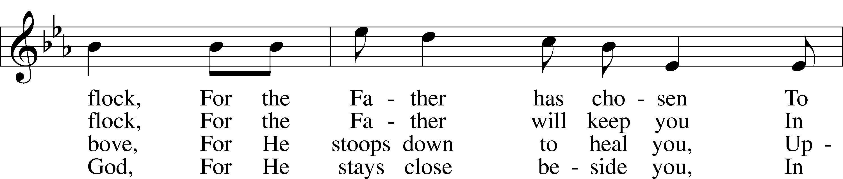
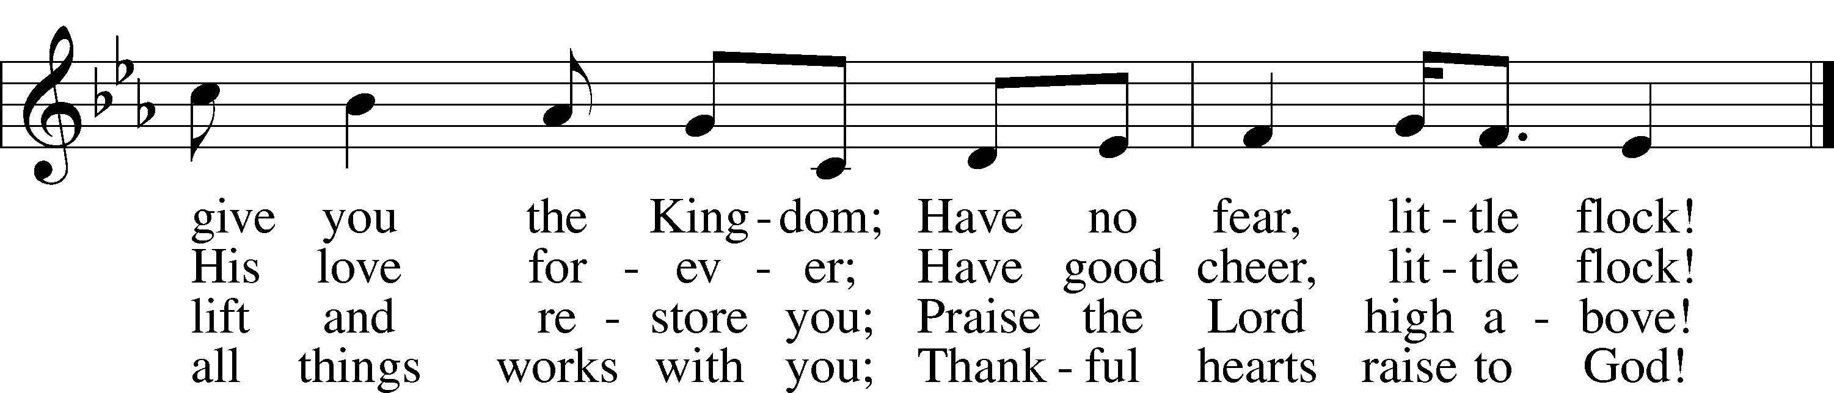
Text (sts. 2–4): Marjorie A. Jillson, 1931–2010
Text (st. 1) and tune: Heinz Werner Zimmermann, 1930
Text and tune: © 1973 Concordia Publishing House. Used by permission: LSB Hymn License no. 110016438

Acknowledgments
Divine Service, Setting Four from Lutheran Service Book
Unless otherwise indicated, Scripture quotations are from the ESV® Bible (The Holy Bible, English Standard Version®), copyright © 2001 by Crossway, a publishing ministry of Good News Publishers. Used by permission. All rights reserved.
Created by Lutheran Service Builder © 2022 Concordia Publishing House.

Serving Our Lord in His House Today:
Pastor: Rev. Bert Thompson
Organist: Rebecca Moseley
Elder: Jake Mallmann & Josh Church

Gifts from God: Luke 12:24 – “Consider the ravens: they neither sow nor reap, they have neither storehouse nor barn, and yet God feeds them.” God feeds the birds of the air – this we know, it’s just that, as one wit put it: God sometimes feeds the birds….to the cats! Yes, crosses and hardships will always come, Christ said that no disciple is above his Master. But through it all, the Lord cares for us and He calls upon us to entrust ourselves to that care. He really is our Father, and He really will guard and keep us through whatever this life has to throw at us. And in the end, we shall receive the gift of eternal life.

Quarterly Voters’ Meeting: Join us following today’s service for our Quarterly Voters’ Meeting. During the meeting we will go over the church finances and we will be voting to make a call to one of the 3 pastors that were presented at the July 24th meeting to become our next Shepherd.

VBS 2022: Vacation Bible School starts this evening, Sunday, August 7 and will take place each evening through Thursday, August 11, 2022. Registration forms are on the table in the Narthex. Dinner will be available prior to VBS this year.
Dinner will be served each night at 5pm and VBS is 6pm-8pm. Please contact
Joan Anderson or Katie Stampfli if you have questions!

Financial Statements: The mid-year financial statements have been placed in your church mailboxes. Please be sure to take them to help save on postage. If you notice any errors or discrepancies, please contact the Financial Secretary,
Linda Ecker.

LWML Fall Retreat: The Fall Retreat will take place September 23-24 at
Fond Du Lac, WI. Registration forms will be on the LWML board in the
fellowship hallway. The forms need to be submitted by August. Please join us for
a time of fellowship and programs for and by other LWML Women.

Prayer for calling a faithful pastor:
O Gracious Father, You led Your holy apostles to ordain ministers for the proclamation of Your Word and the faithful administration of the Sacraments of Christ. Grant to this congregation the guidance of the Holy Spirit to choose a suitable pastor according to Your will for the blessing of Your Church in this place; through Jesus Christ our Lord.
Main Street Living: What is it? A televised worship service produced in conjunction with LCMS churches and pastors. Main Street is not intended to be a replacement for in-person worship, but is here to provide liturgical services to those unable to attend a local congregation. The hour-long broadcast consists of 2 parts: Main Street Living, a 30 minute service led by local LCMS pastors and This is the Life, a remastered episode of the Emmy award-winning Lutheran Hour Ministries program. This can be viewed locally in WI: LaCrosse/Eau Claire-Fox 25.2/48.2 at 10:00 a.m. or any time on the internet at MainStreetLiving.com. There are brochures with additional information on the usher’s table in the Narthex.
Below is the schedule of August viewings:
August 7, 2022
Sunday mornings on FOX 25/48 LaCrosse / EauClaire
10:00 AM - “No Laughing Matter” - A woman must learn to deal with her past in order to help someone else in her present.
10:30 AM - Rev. Jacob Eichers, pastor at Faith Lutheran Church in La Crosse, presents a message titled ”The Promise, the Pit, the Trust”. This sermon is based on Genesis 15:1-6. Visit www.mainstreetliving.com for more information.

August 14, 2022
Sunday mornings on FOX 25/48 LaCrosse / EauClaire
10:00 AM - “My Husband, My Sorrow” - A man and woman must deal with whether they should consummate an adulterous affair.
10:30 AM - Rev. Mark Meier, pastor at Messiah & Grace Lutheran Churches in La Crescent &, Stockton presents a message titled ”Hear What Is Good for You”. This sermon is based on Luke 12:31. Visit www.mainstreetliving.com for more information.

August 21, 2022
Sunday mornings on FOX 25/48 LaCrosse / EauClaire
10:00 AM - “The Cup” - The dilemma a trucker must face when a good friend dies trying to protect him.
10:30 AM - Rev. Mark Triplett, pastor at St. Mark’s & St. John’s Lutheran Churches in Rushford, MN, presents a message based on Luke 13. Visit www.mainstreetliving.com for more information.

August 28, 2022
Sunday mornings on FOX 25/48 LaCrosse / EauClaire
10:00 AM - “Stranger at the Door” - Having given up a baby for adoption 22 years before, a man shows up on her steps saying he is looking for his mother.
10:30 AM - Rev. Bert Thompson, pastor at Good Shepherd Lutheran Church in Tomah, WI, presents a message titled ”Now, That's Love!”. This sermon is based on Luke 14:1-14. Visit www.mainstreetliving.com for more information.

PO Box: For mailed offerings, please use the following:
Good Shepherd Lutheran Church
P.O. Box 551
Tomah, WI 54660

Our Worship attendance last week: Sunday: 59
Wednesday: 4
Total: 63

Scripture Lessons for next week: Jeremiah 23: 16-29
Hebrews 11:17-31; 12:1-3
Luke 12:49-53

Secretary Office Hours: Monday-Friday: 8:15am-12:15pm

Our Week With Our Lord:
Today 9:00am Divine Service w/Holy Communion
(livestreamed via YouTube)
SCRIP Orders Due
10:30am Quarterly Voters’ Meeting
(voting to call our next pastor)
5:00pm Dinner served prior to VBS
6pm-8pm VBS: God’s Wonder Lab
Monday 5:00pm Dinner served prior to VBS
6pm-8pm VBS: God’s Wonder Lab
Tuesday 9:30am-11:00am Little Lambs Playgroup
@ Winnebago Park
5:00pm Dinner served prior to VBS
6pm-8pm VBS: God’s Wonder Lab
Wednesday 5:00pm Dinner served prior to VBS
6pm-8pm VBS: God’s Wonder Lab
Thursday 5pm-9pm Downtown Thursday Nights Volunteer
5:00pm Dinner served prior to VBS
6pm-8pm VBS: God’s Wonder Lab
Friday
Saturday
Sunday 9:00am Divine Service w/Holy Communion
(livestreamed via YouTube)
10:30am Adult Bible Study

*Please view the following page for weekly prayers*

HIS FLOCK AT PRAYER
Propers for the Ninth Week after Pentecost

Psalm for the Week: Psalm 33:12-22

Daily Scripture Readings:
Sunday—Matthew 7:15-21 Thursday—1 John 4:1-4
Monday— Matthew 7:12-14 Friday— Micah 3:5-12
Tuesday—Romans 4:1-8 Saturday— 1 Timothy 6:13-21
Wednesday—Ezekiel 3:17-21

Collect for the Week:
Almighty and merciful God, it is by Your grace that we live as Your people who offer acceptable service. Grant that we may walk by faith, and not by sight, in the way that leads to eternal life; through Jesus Christ, Your Son, our Lord, who lives and reigns with You and the Holy Spirit, one God, now and forever.

Hymn of the Week: “Lord of All Hopefulness” LSB 738

Congregational Petitions for this Week:
+ For those whose work is difficult or dangerous including the military away from
home, especially: Isaac Preuss, Joshua Ecker, Tania Adler, and Sarah Johnson.
+ For those who are ill or recovering, especially: Brenda Kolb, Shawn Zabinski,
Carrie Wilbanks, Jean Salzman, David Keinath, Dawn Hawkins,
Kelly Ingenthron, Nick Anderson, Gloria Graupe, Marie Drescher, Velma Lutz,
Patrick Pulley.
+ For those who are home-bound, especially: John Fox, Darlene Griffin,
Virginia Tillman, Lynda Goad, Roemelle McArdle, Sharon Herried,
Muriel Finch.
+ For those who are mourning the loss of a loved one:
- Family and friends of Al Mansfield, our brother in Christ
+ For those suffering from the pandemic, especially those in our congregation who
have been infected, those who are suffering financially, and those who work in
the medical field.

