Good Shepherd Lutheran Church
Tenth Sunday after Trinity
August 8, 2021

Pre-Service Music & Welcome
Divine Service Setting Four – Lutheran Service Book (LSB) 203

+CONFESSION AND ABSOLUTION+

Stand

Opening Hymn “Lord Jesus Christ, We Humbly Pray” LSB 623
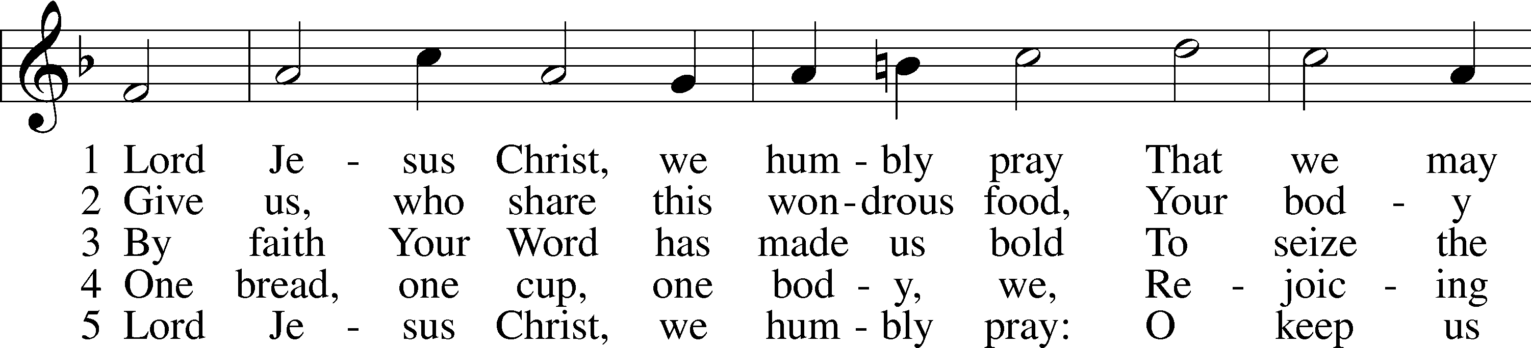
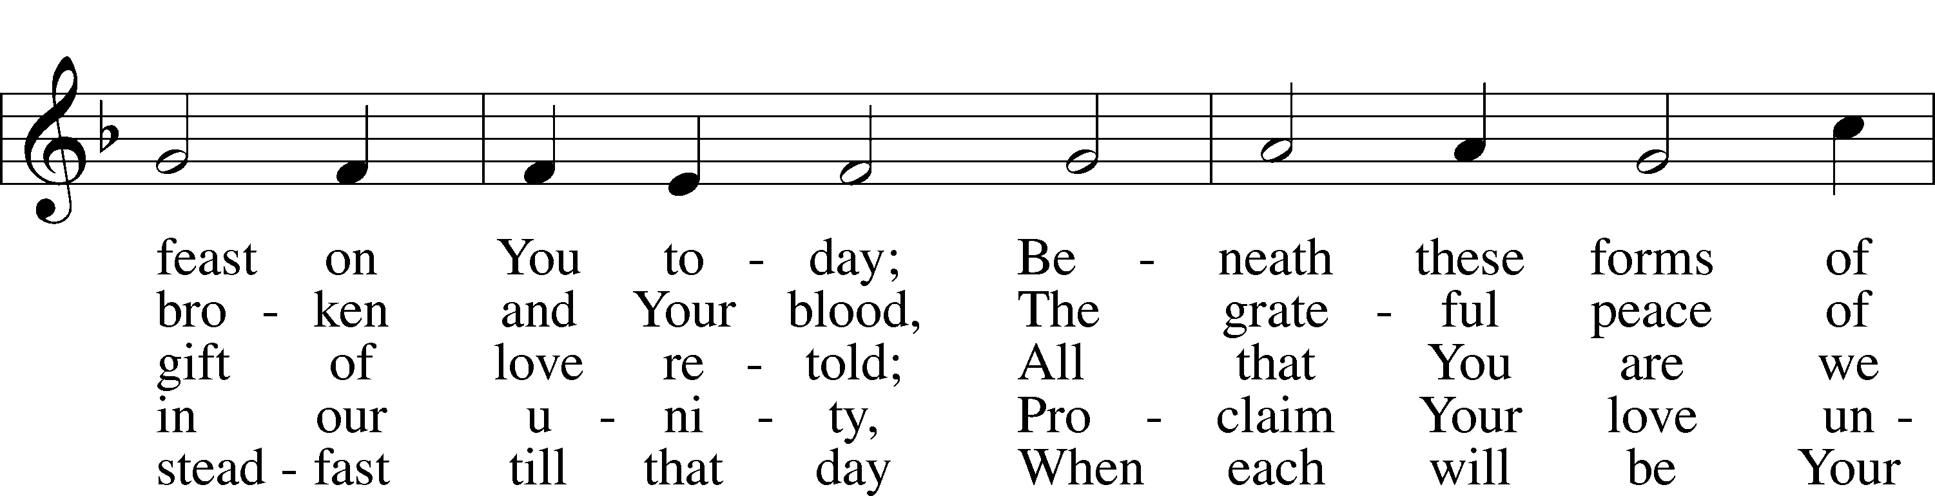
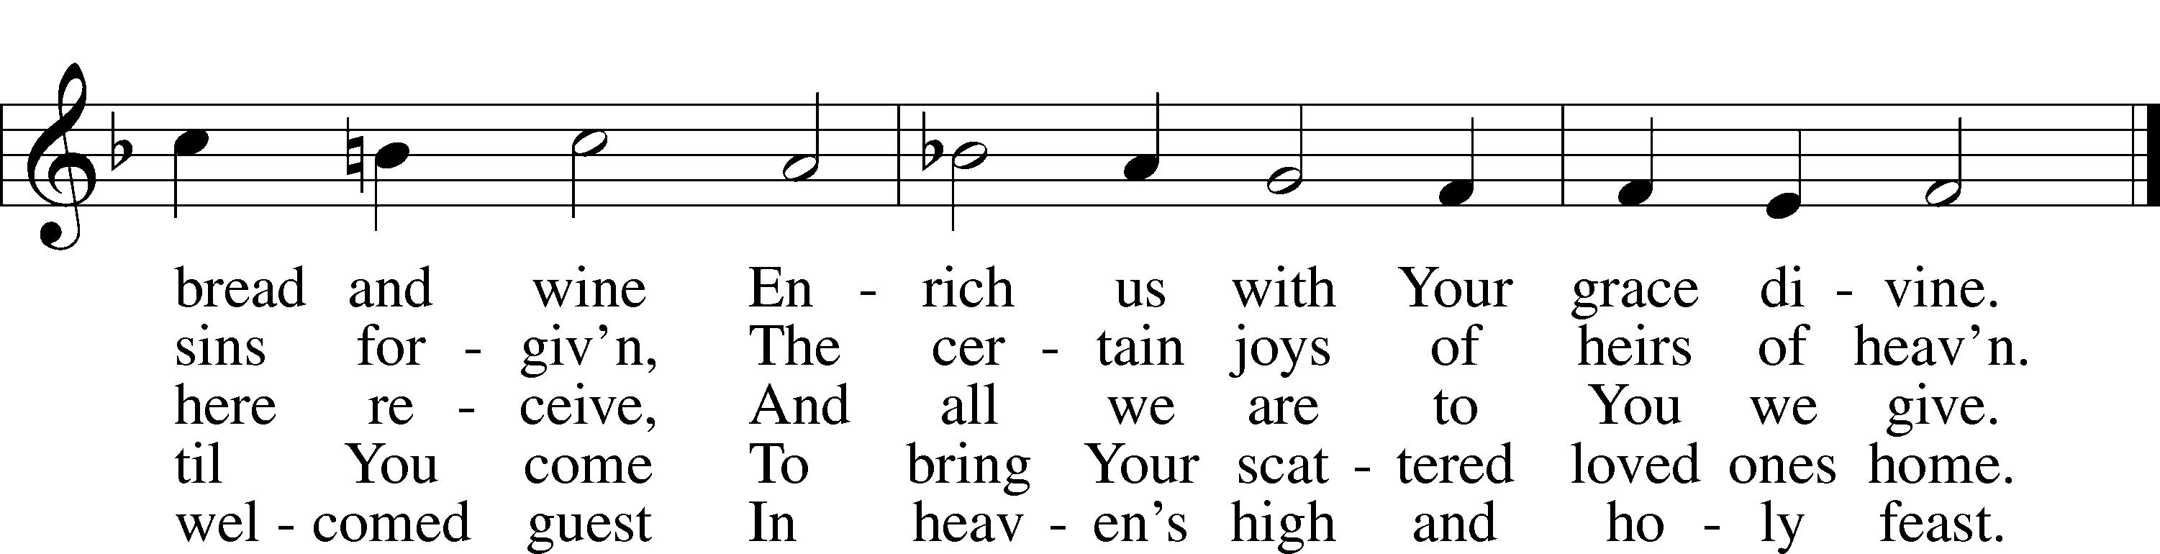
Text and tune: Public domain

The sign of the cross T may be made by all in remembrance of their Baptism.
Invocation
P In the name of the Father and of the T Son and of the Holy Spirit.
C Amen.

Exhortation LSB 203
P Our help is in the name of the Lord,
C who made heaven and earth.

P If You, O Lord, kept a record of sins, O Lord, who could stand?
C But with You there is forgiveness; therefore You are feared.

P Since we are gathered to hear God’s Word, call upon Him in prayer and praise, and receive the body and blood of our Lord Jesus Christ in the fellowship of this altar, let us first consider our unworthiness and confess before God and one another that we have sinned in thought, word, and deed, and that we cannot free ourselves from our sinful condition. Together as His people let us take refuge in the infinite mercy of God, our heavenly Father, seeking His grace for the sake of Christ, and saying: God, be merciful to me, a sinner.

Confession of Sins LSB 203
C Almighty God, have mercy upon us, forgive us our sins, and lead us to everlasting life. Amen.

Absolution LSB 203
P Almighty God in His mercy has given His Son to die for you and for His sake forgives you all your sins. As a called and ordained servant of Christ, and by His authority, I therefore forgive you all your sins in the name of the Father and of the T Son and of the Holy Spirit.
C Amen.
+SERVICE OF THE WORD+

Introit Psalm 55:1, 4–5, 16; antiphon: vv. 16a, 17b, 18a, 22a
I call to God, and he hears my voice;*
he redeems my soul in safety.
Cast your burden on the Lord,*
and he will sustain you.
Give ear to my prayer, O God,*
and hide not yourself from my plea for mercy!
My heart is in anguish within me;*
the terrors of death have fallen upon me.
Fear and trembling come upon me,*
and horror overwhelms me.
But I call to God,*
and the Lord will save me.
Glory be to the Father and to the Son*
and to the Holy Spirit;
as it was in the beginning,*
is now, and will be forever. Amen.
I call to God, and he hears my voice;*
he redeems my soul in safety.
Cast your burden on the Lord,*
and he will sustain you.

Kyrie
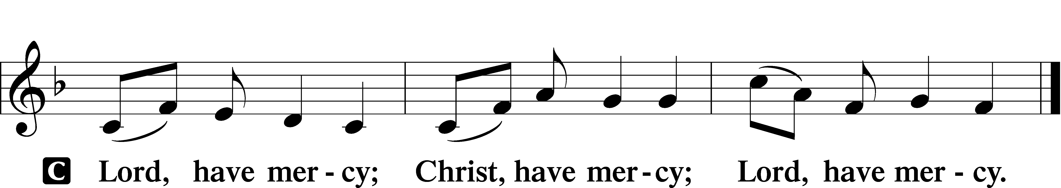

A For the peace from above and for our salvation let us pray to the Lord.

A For the peace of the whole world, for the well-being of the Church of God, and for the unity of all let us pray to the Lord.

A For this holy house and for all who offer here their worship and praise let us pray to the Lord.

A Help, save, comfort and defend us, gracious Lord.

Gloria in Excelsis LSB 204
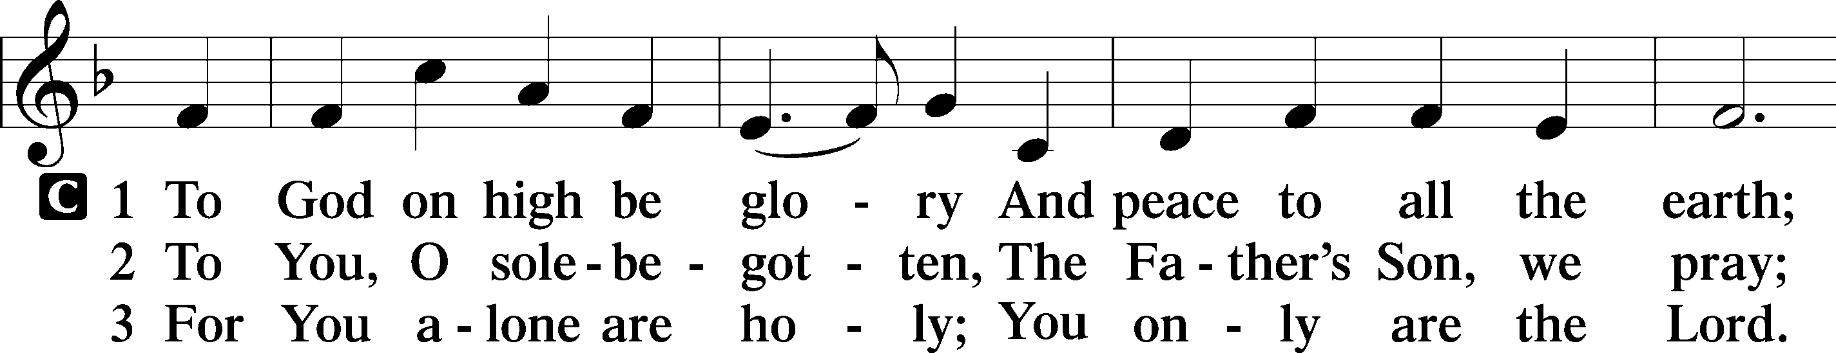
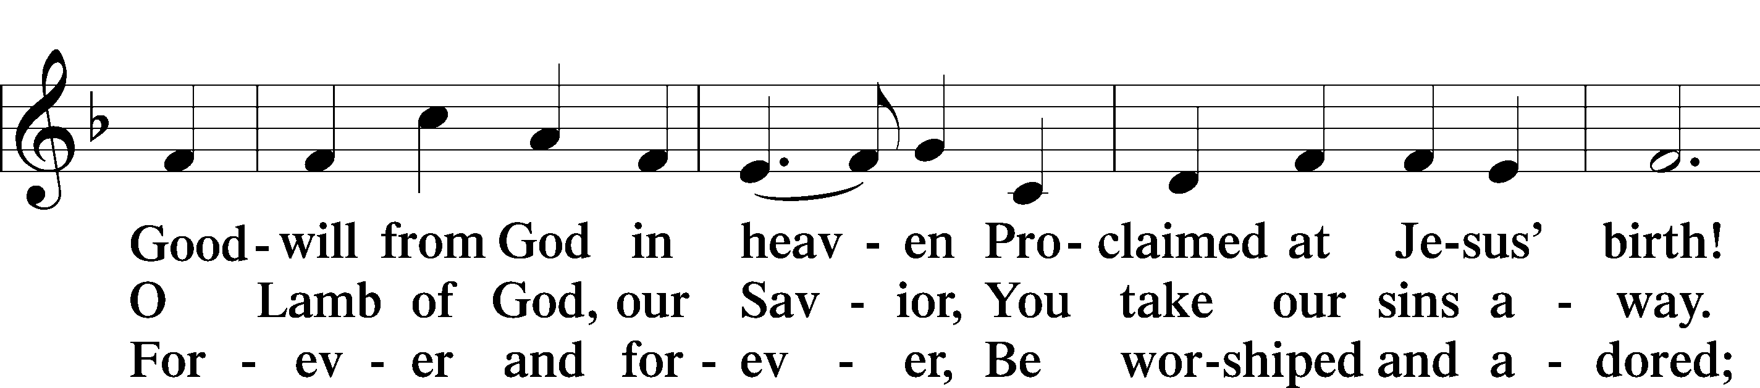
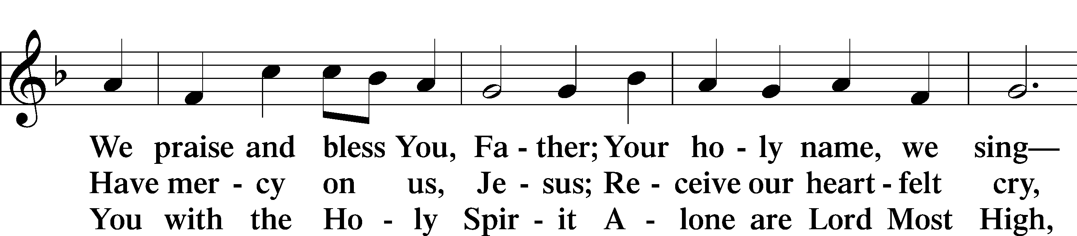
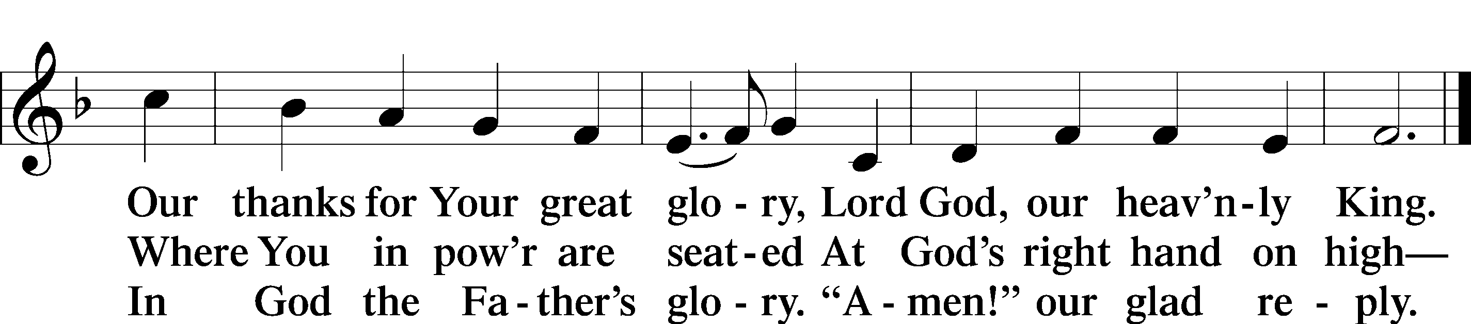

Salutation and Collect of the Day
P The Lord be with you.
C And also with you.

P Let us pray.
C O God, You declare Your almighty power above all in showing mercy and pity. Mercifully grant us such a measure of Your grace that we may obtain Your gracious promises and be made partakers of Your heavenly treasures; through Jesus Christ, Your Son, our Lord, who lives and reigns with You and the Holy Spirit, one God, now and forever. Amen.

Sit
Old Testament Reading Jeremiah 8:4–12
4“You shall say to them, Thus says the Lord:
When men fall, do they not rise again?
If one turns away, does he not return?
5Why then has this people turned away
in perpetual backsliding?
They hold fast to deceit;
they refuse to return.
6I have paid attention and listened,
but they have not spoken rightly;
no man relents of his evil,
saying, ‘What have I done?’
Everyone turns to his own course,
like a horse plunging headlong into battle.
7Even the stork in the heavens
knows her times,
and the turtledove, swallow, and crane
keep the time of their coming,
but my people know not
the just decrees of the Lord.
8“How can you say, ‘We are wise,
and the law of the Lord is with us’?
But behold, the lying pen of the scribes
has made it into a lie.
9The wise men shall be put to shame;
they shall be dismayed and taken;
behold, they have rejected the word of the Lord,
so what wisdom is in them?
10Therefore I will give their wives to others
and their fields to conquerors,
because from the least to the greatest
everyone is greedy for unjust gain;
from prophet to priest,
everyone deals falsely.
11They have healed the wound of my people lightly,
saying, ‘Peace, peace,’
when there is no peace.
12Were they ashamed when they committed abomination?
No, they were not at all ashamed;
they did not know how to blush.
Therefore they shall fall among the fallen;
when I punish them, they shall be overthrown,
says the Lord”.

A This is the Word of the Lord.
C Thanks be to God.

Gradual Psalm 17:8, 2
Keep me as the apple of your eye;*
hide me in the shadow of your wings.
From your presence let my vindication come!*
Let your eyes behold the right!

Epistle 1 Corinthians 12:1–11
1Now concerning spiritual gifts, brothers, I do not want you to be uninformed. 2You know that when you were pagans you were led astray to mute idols, however you were led. 3Therefore I want you to understand that no one speaking in the Spirit of God ever says “Jesus is accursed!” and no one can say “Jesus is Lord” except in the Holy Spirit.
4Now there are varieties of gifts, but the same Spirit; 5and there are varieties of service, but the same Lord; 6and there are varieties of activities, but it is the same God who empowers them all in everyone. 7To each is given the manifestation of the Spirit for the common good.
8To one is given through the Spirit the utterance of wisdom, and to another the utterance of knowledge according to the same Spirit, 9to another faith by the same Spirit, to another gifts of healing by the one Spirit, 10to another the working of miracles, to another prophecy, to another the ability to distinguish between spirits, to another various kinds of tongues, to another the interpretation of tongues. 11All these are empowered by one and the same Spirit, who apportions to each one individually as he wills.

A This is the Word of the Lord.
C Thanks be to God.

Stand

Alleluia and Verse

Alleluia LSB 205
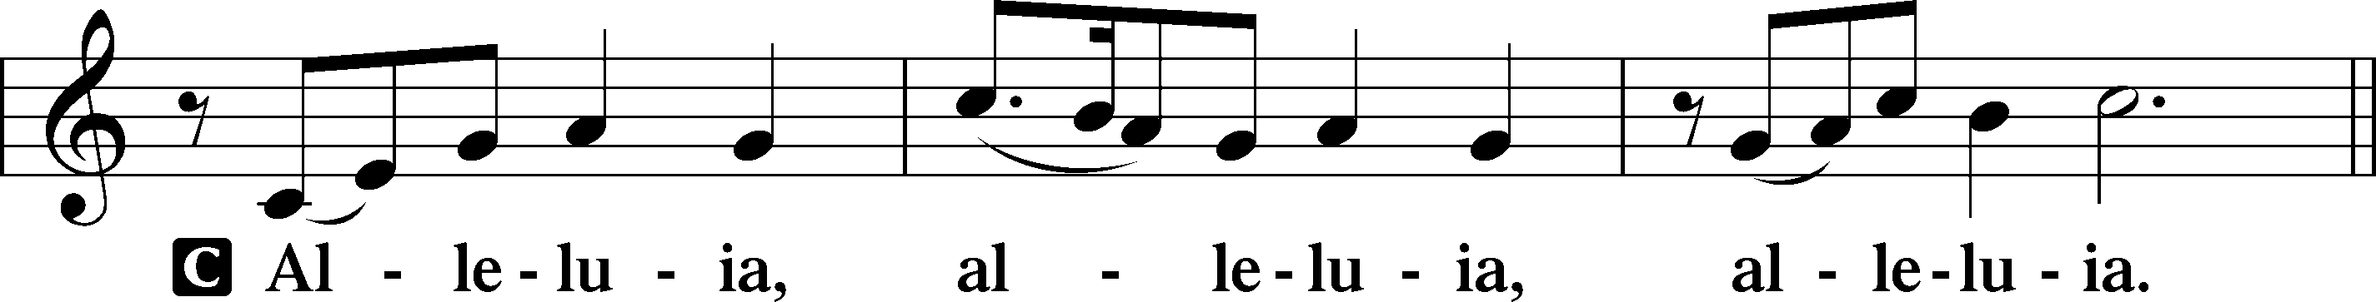

Verse LSB 205
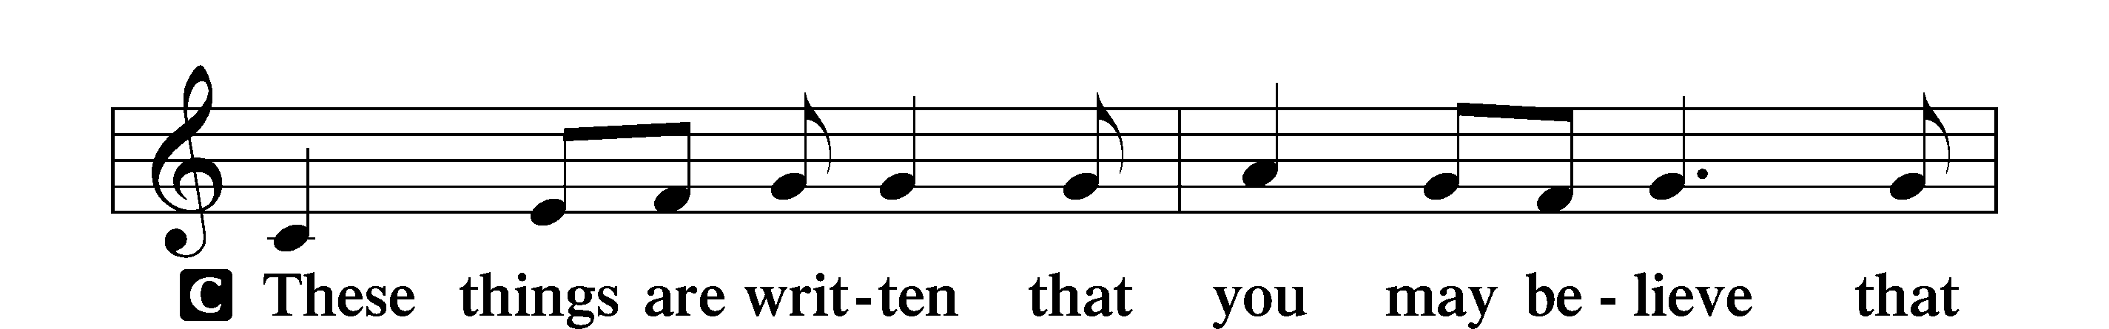
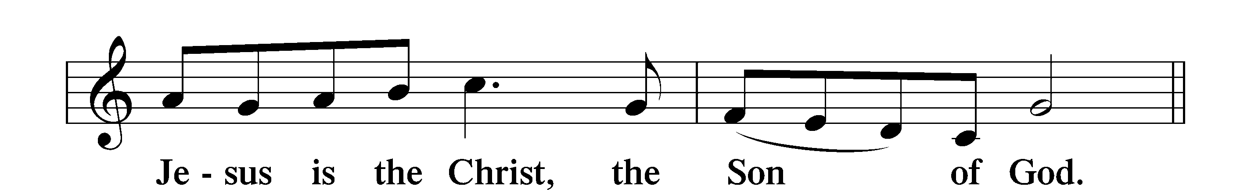

Alleluia LSB 205
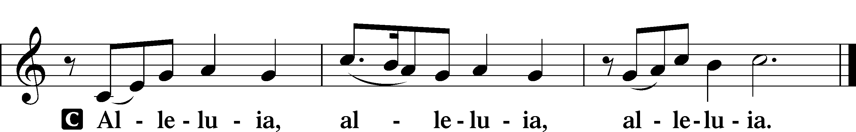

Holy Gospel Luke 19:41–48
P The Holy Gospel according to St. Luke, the nineteenth chapter.
C Glory to You, O Lord.

41When [Jesus] drew near and saw the city, he wept over it, 42saying, “Would that you, even you, had known on this day the things that make for peace! But now they are hidden from your eyes. 43For the days will come upon you, when your enemies will set up a barricade around you and surround you and hem you in on every side 44and tear you down to the ground, you and your children within you. And they will not leave one stone upon another in you, because you did not know the time of your visitation.”
45And he entered the temple and began to drive out those who sold, 46saying to them, “It is written, ‘My house shall be a house of prayer,’ but you have made it a den of robbers.”
47And he was teaching daily in the temple. The chief priests and the scribes and the principal men of the people were seeking to destroy him, 48but they did not find anything they could do, for all the people were hanging on his words.

P This is the Gospel of the Lord.
C Praise to You, O Christ.

Nicene Creed
C I believe in one God,
the Father Almighty,
maker of heaven and earth
and of all things visible and invisible.

And in one Lord Jesus Christ,
the only-begotten Son of God,
begotten of His Father before all worlds,
God of God, Light of Light,
very God of very God,
begotten, not made,
being of one substance with the Father,
by whom all things were made;
who for us men and for our salvation came down from heaven
and was incarnate by the Holy Spirit of the virgin Mary
and was made man;
and was crucified also for us under Pontius Pilate.
He suffered and was buried.
And the third day He rose again according to the Scriptures
and ascended into heaven
and sits at the right hand of the Father.

And He will come again with glory to judge both the living and the dead,
whose kingdom will have no end.

And I believe in the Holy Spirit,
the Lord and giver of life,
who proceeds from the Father and the Son,
who with the Father and the Son together is worshiped and glorified,
who spoke by the prophets.
And I believe in one holy Christian and apostolic Church,
I acknowledge one Baptism for the remission of sins,
and I look for the resurrection of the dead
and the life T of the world to come. Amen.

Sit

Children’s Message
“He was teaching daily in the temple.” Luke 19:47a
Hymn of the Day "The Church’s One Foundation” LSB 644 sts. 1–5
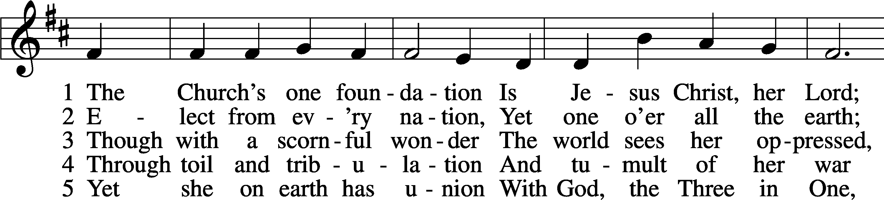
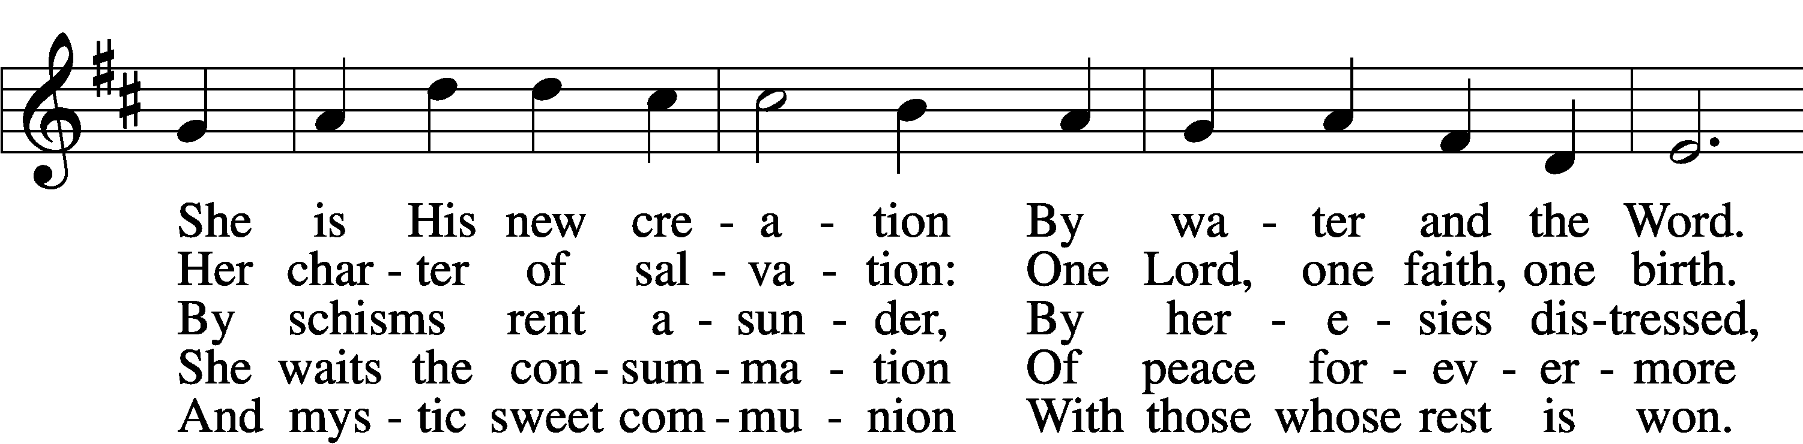
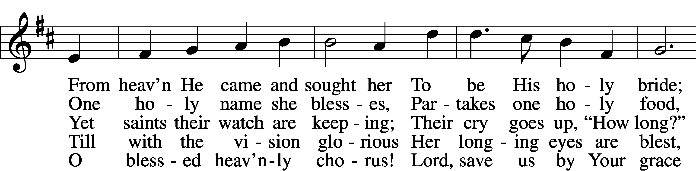
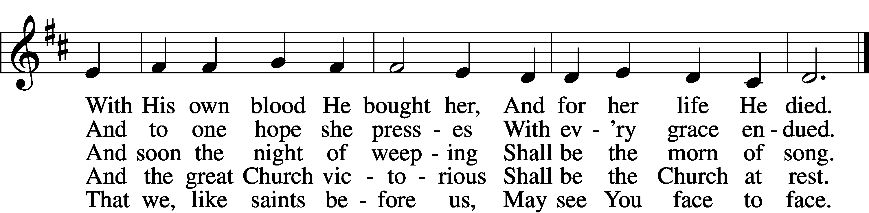
Text and tune: Public domain

Sermon

+RECEPTION OF MEMBERS BY TRANSFER+

P Beloved in the Lord, our Lord Jesus Christ said to His apostles: “Whoever confesses Me before men, I will also confess before My Father who is in heaven. But whoever denies Me before men, I will also deny before My Father who is in heaven.” Lift up your hearts, therefore, to the God of all grace and joyfully give answer to what I now ask you in the name of the Lord.

P Do you this day in the presence of God and of this congregation acknowledge the gifts that God gave you in your Baptism?
R Yes, I do.

P Do you renounce the devil and all his works and all his ways?
R Yes, I renounce them.

P Do you believe in God, the Father Almighty, in Jesus Christ, His only Son our Lord, and in the Holy Spirit?
R Yes, I believe in God the Father, Son, and Holy Spirit.

P Do you hold all the prophetic and apostolic Scriptures to be the inspired Word of God and the doctrine of the Evangelical Lutheran Church, drawn from them and confessed in the Small Catechism, to be faithful and true?
R I do.

P Do you intend to hear the Word of God and receive the Lord’s Supper faithfully?
R I do, by the grace of God.

P Do you intend to live according to the Word of God, and in faith, word, and deed to remain true to God, Father, Son, and Holy Spirit, even to death?
R I do, by the grace of God.

P Do you intend to continue steadfast in this confession and Church and to suffer all, even death, rather than fall away from it?
R I do, by the grace of God.

P Do you desire to become a member of this congregation?
R I do.

P Will you support the work our gracious Lord has given this congregation with your prayers and the gifts God has given you?
R I will, with the help of God.

P Upon this your confession of faith, I acknowledge publicly that you are members of the Evangelical Lutheran Church and of this congregation. Receive the Lord’s Supper and participate with us in all the blessings of salvation that our Lord has given to His Church, in the name of the Father and of the T Son and of the Holy Spirit.
C Amen.

P Let us pray.
Lord God, heavenly Father, we thank and praise You for Your great goodness in bringing these Your sons and daughters to the knowledge of Your Son, our Savior, Jesus Christ, and enabling them both with the heart to believe and with the mouth to confess His saving name. Grant that by Your Word and Spirit they may continue steadfast in the one true faith in the fellowship of this congregation as together we await the day when all who have fought the good fight of faith shall receive the crown of righteousness; through Jesus Christ, Your Son, our Lord, who lives and reigns with You and the Holy Spirit, one God, now and forever.
C Amen.

The pastor may extend the right hand of fellowship, greeting each by name. The rite concludes with the following blessing:

P The grace of our T Lord Jesus Christ be with you.
C Amen.

The new members return to their places.

Offering
Stand
Prayer of the Church

+SERVICE OF THE SACRAMENT+
Preface LSB 208
P The Lord be with you.
C And also with you.

P Lift up your hearts.
C We lift them to the Lord.

P Let us give thanks to the Lord our God.
C It is right to give Him thanks and praise.

P It is truly good, right, and salutary that we should at all times and in all places give thanks to You, O Lord, holy Father, almighty and everlasting God…Therefore with angels and archangels and with all the company of heaven we laud and magnify Your glorious name, evermore praising You and saying:

Sanctus LSB 208
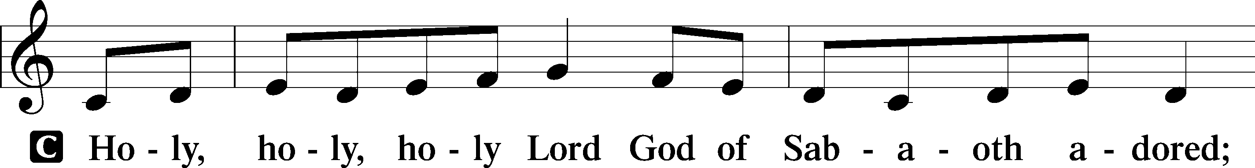
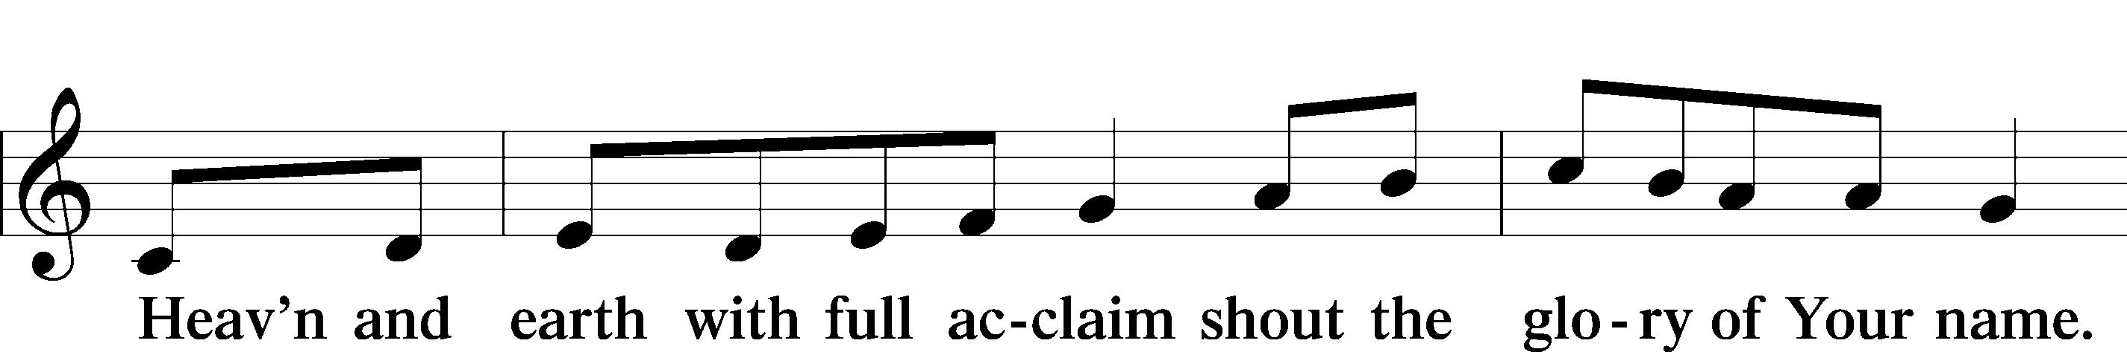
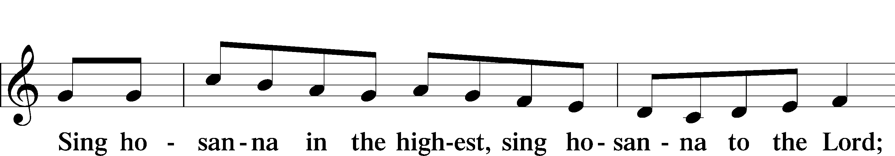
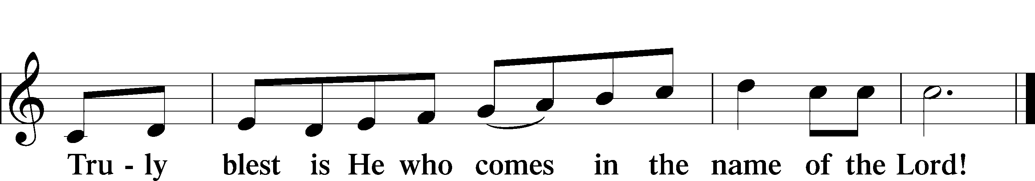
Lord’s Prayer
C Our Father who art in heaven,
hallowed be Thy name,
Thy kingdom come,
Thy will be done on earth
as it is in heaven;
give us this day our daily bread;
and forgive us our trespasses
as we forgive those
who trespass against us;
and lead us not into temptation,
but deliver us from evil.
For Thine is the kingdom
and the power and the glory
forever and ever. Amen.

The Words of Our Lord
P Our Lord Jesus Christ, on the night when He was betrayed, took bread, and when He had given thanks, He broke it and gave it to the disciples and said: “Take, eat; this is My T body, which is given for you. This do in remembrance of Me.”

In the same way also He took the cup after supper, and when He had given thanks, He gave it to them, saying: “Drink of it, all of you; this cup is the new testament in My T blood, which is shed for you for the forgiveness of sins. This do, as often as you drink it, in remembrance of Me.”

Pax Domini
P The peace of the Lord be with you always.
C Amen.

Agnus Dei LSB 210
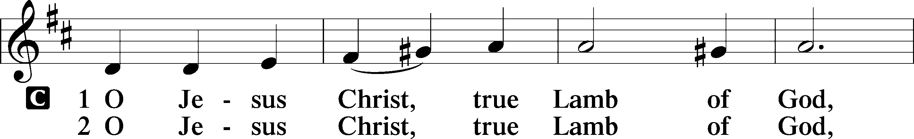
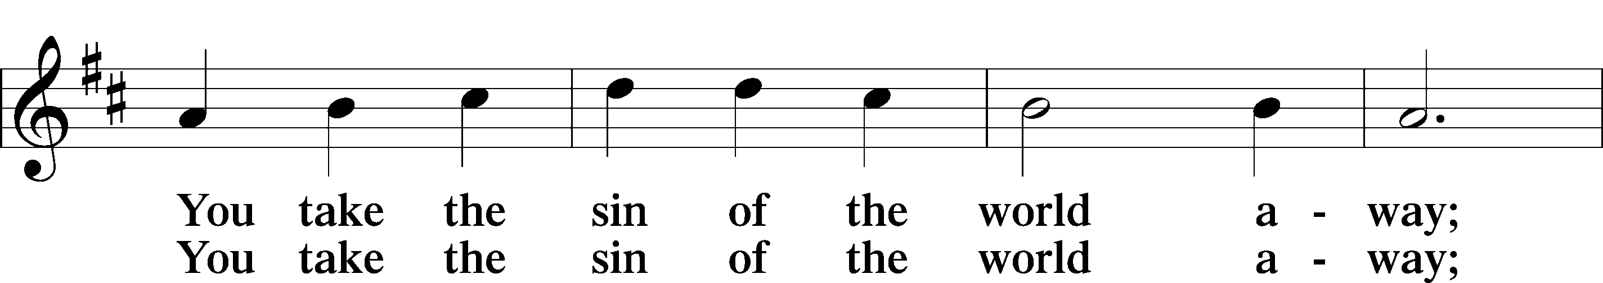
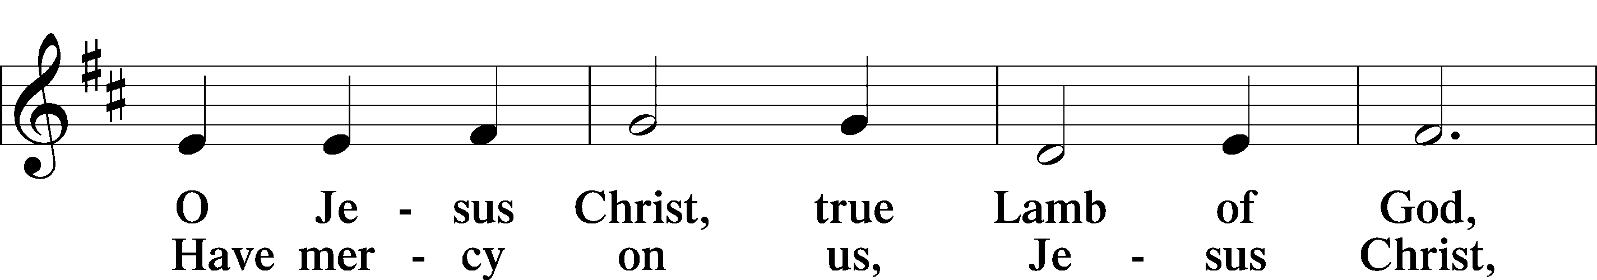
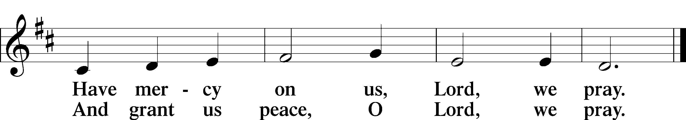

Sit

Distribution

Distribution Hymn “I Am Trusting Thee, Lord Jesus” LSB 729
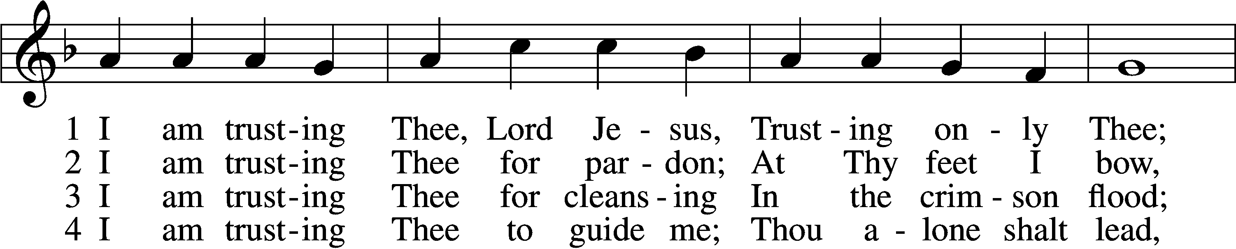
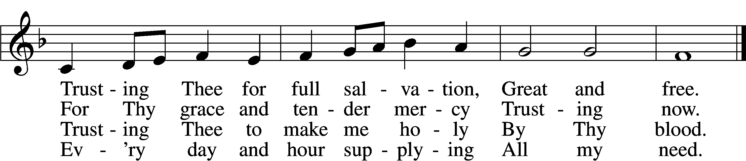

5 I am trusting Thee for power;
Thine can never fail.
Words which Thou Thyself shalt give me
Must prevail.

6 I am trusting Thee, Lord Jesus;
Never let me fall.
I am trusting Thee forever
And for all.
Text and tune: Public domain

Distribution Hymn “At the Lamb’s High Feast We Sing” LSB 633
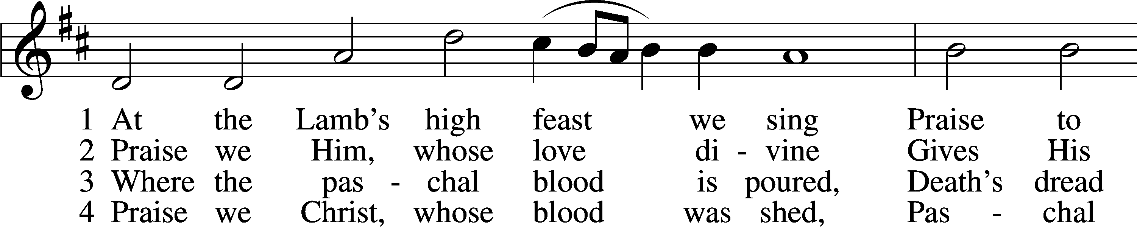
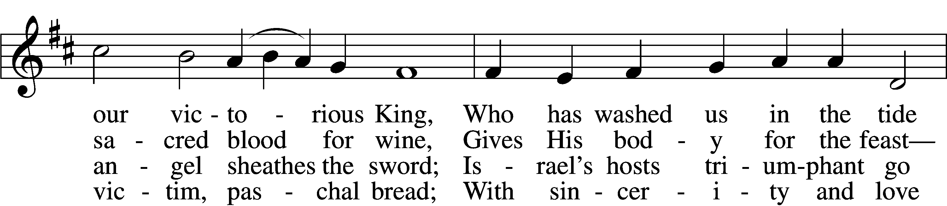
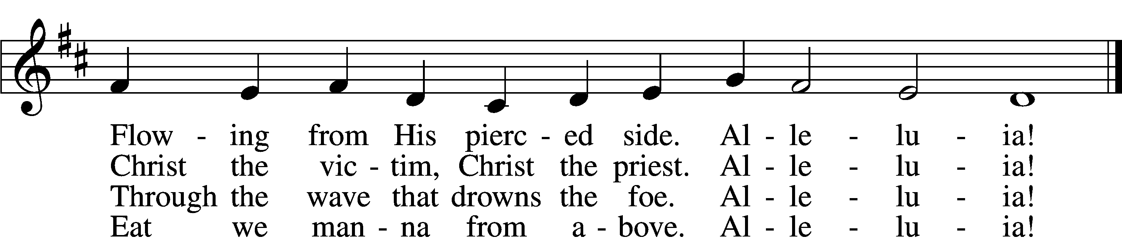

5 Mighty Victim from the sky,
Hell’s fierce pow’rs beneath You lie;
You have conquered in the fight,
You have brought us life and light.
Alleluia!

6 Now no more can death appall,
Now no more the grave enthrall;
You have opened paradise,
And Your saints in You shall rise.
Alleluia!

7 Easter triumph, Easter joy!
This alone can sin destroy;
From sin’s pow’r, Lord, set us free,
Newborn souls in You to be.
Alleluia!

D 8 Father, who the crown shall give,
Savior, by whose death we live,
Spirit, guide through all our days:
Three in One, Your name we praise.
Alleluia!
Tune and text: Public domain

Stand

Nunc Dimittis LSB 211
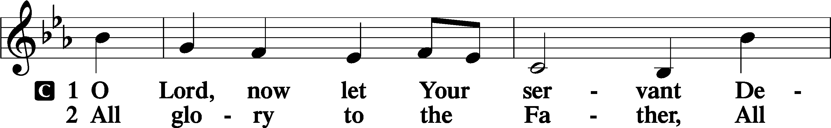
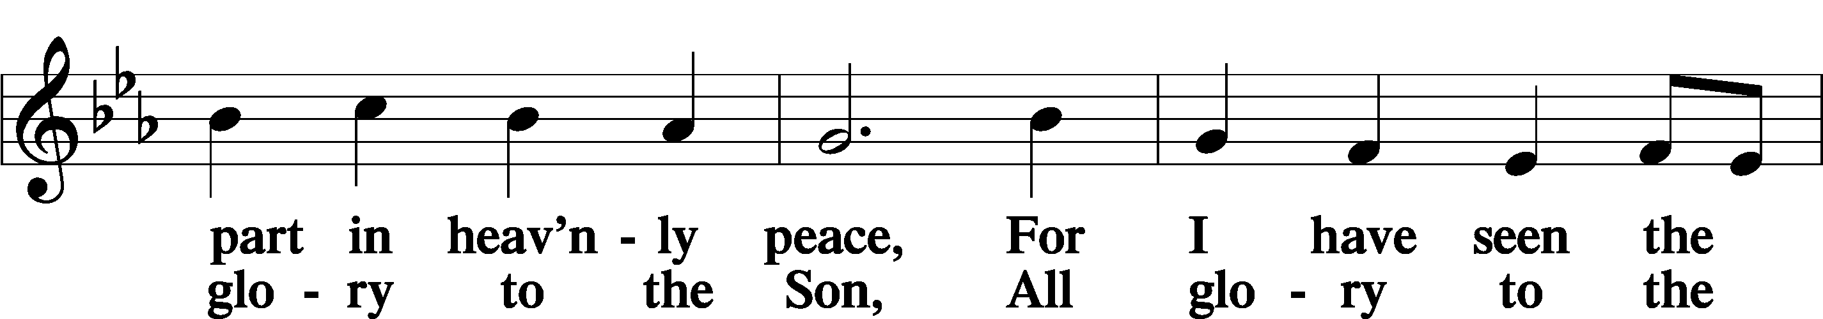
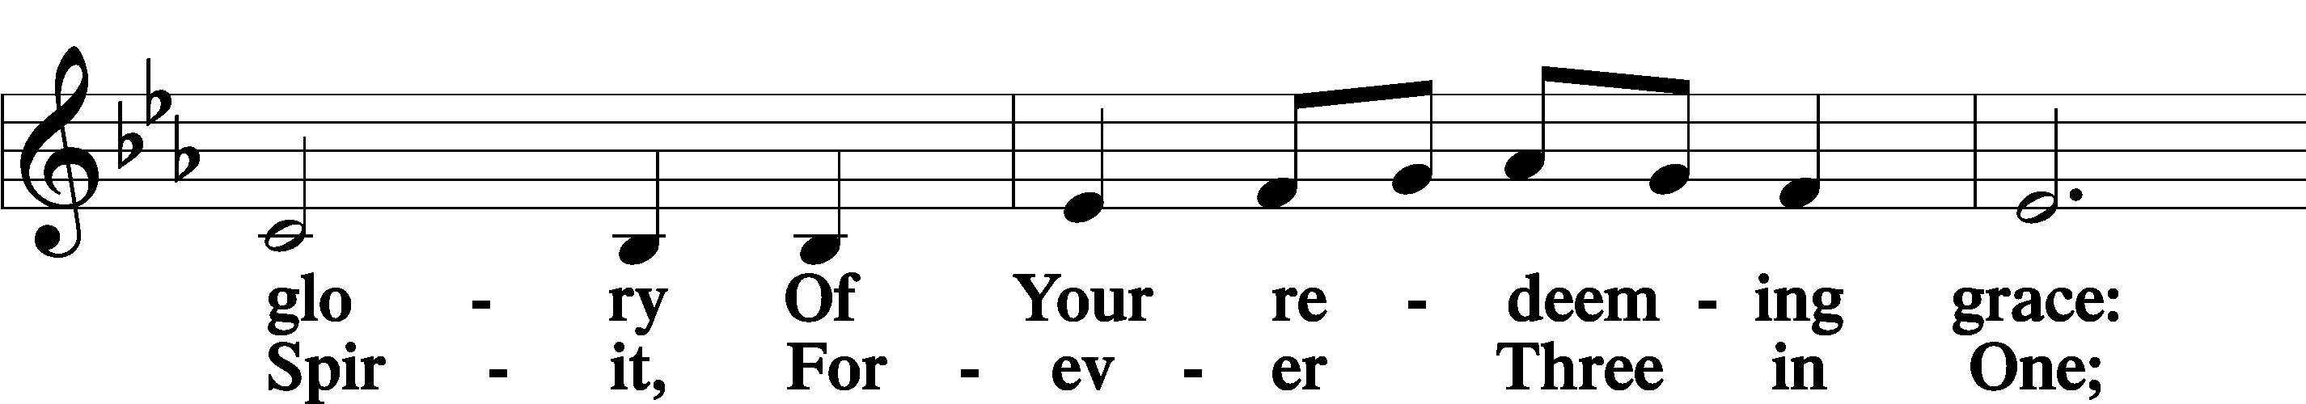
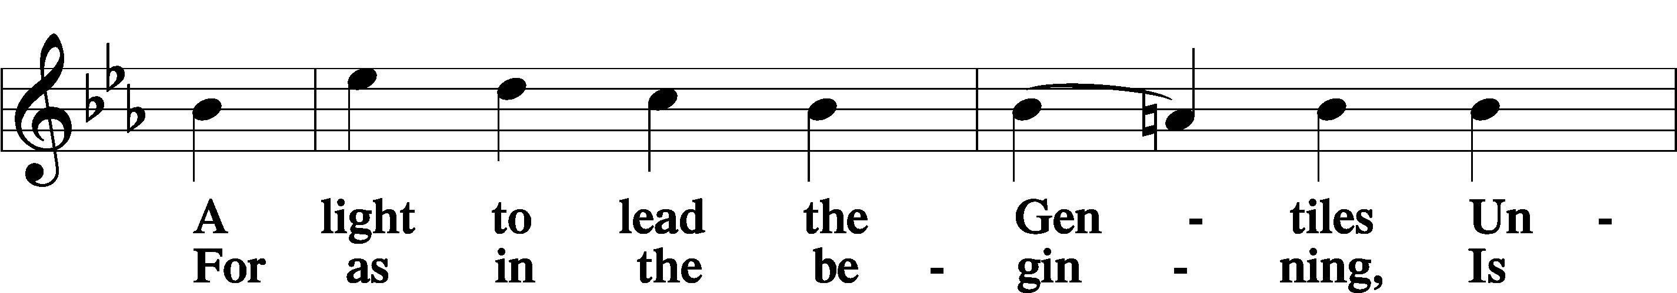
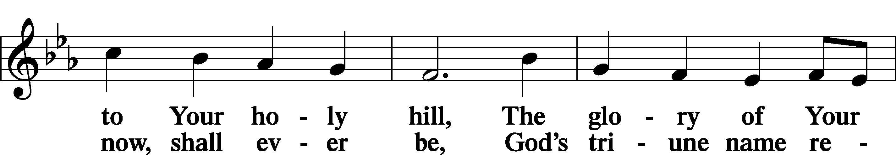
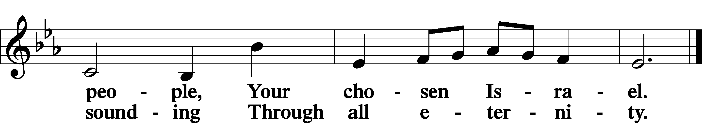

Post-Communion Collect
A Let us pray.
We give thanks to You, almighty God, that You have refreshed us through this salutary gift, and we implore You that of Your mercy You would strengthen us through the same in faith toward You and in fervent love toward one another; through Jesus Christ, Your Son, our Lord, who lives and reigns with You and the Holy Spirit, one God, now and forever.
C Amen.

Benedicamus LSB 212
A Let us bless the Lord.
C Thanks be to God.

Benediction LSB 202
P The Lord bless you and keep you.
The Lord make His face shine upon you and be gracious unto you. The Lord lift up His countenance upon you and T give you peace.
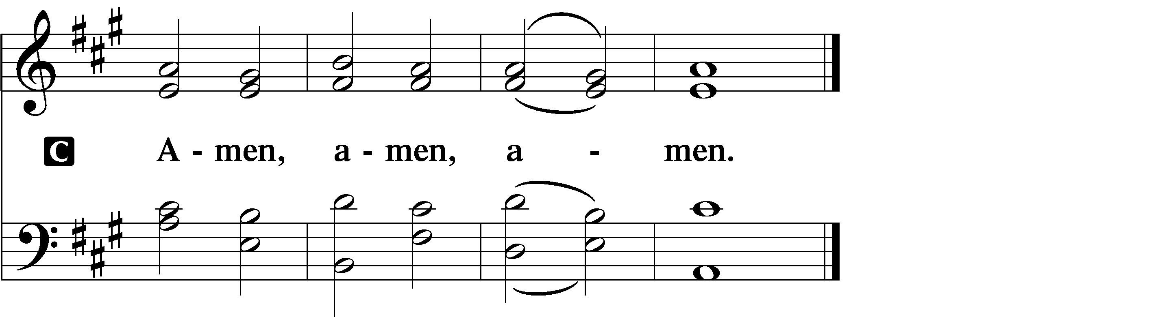

Closing Hymn “Praise the Almighty” LSB 797
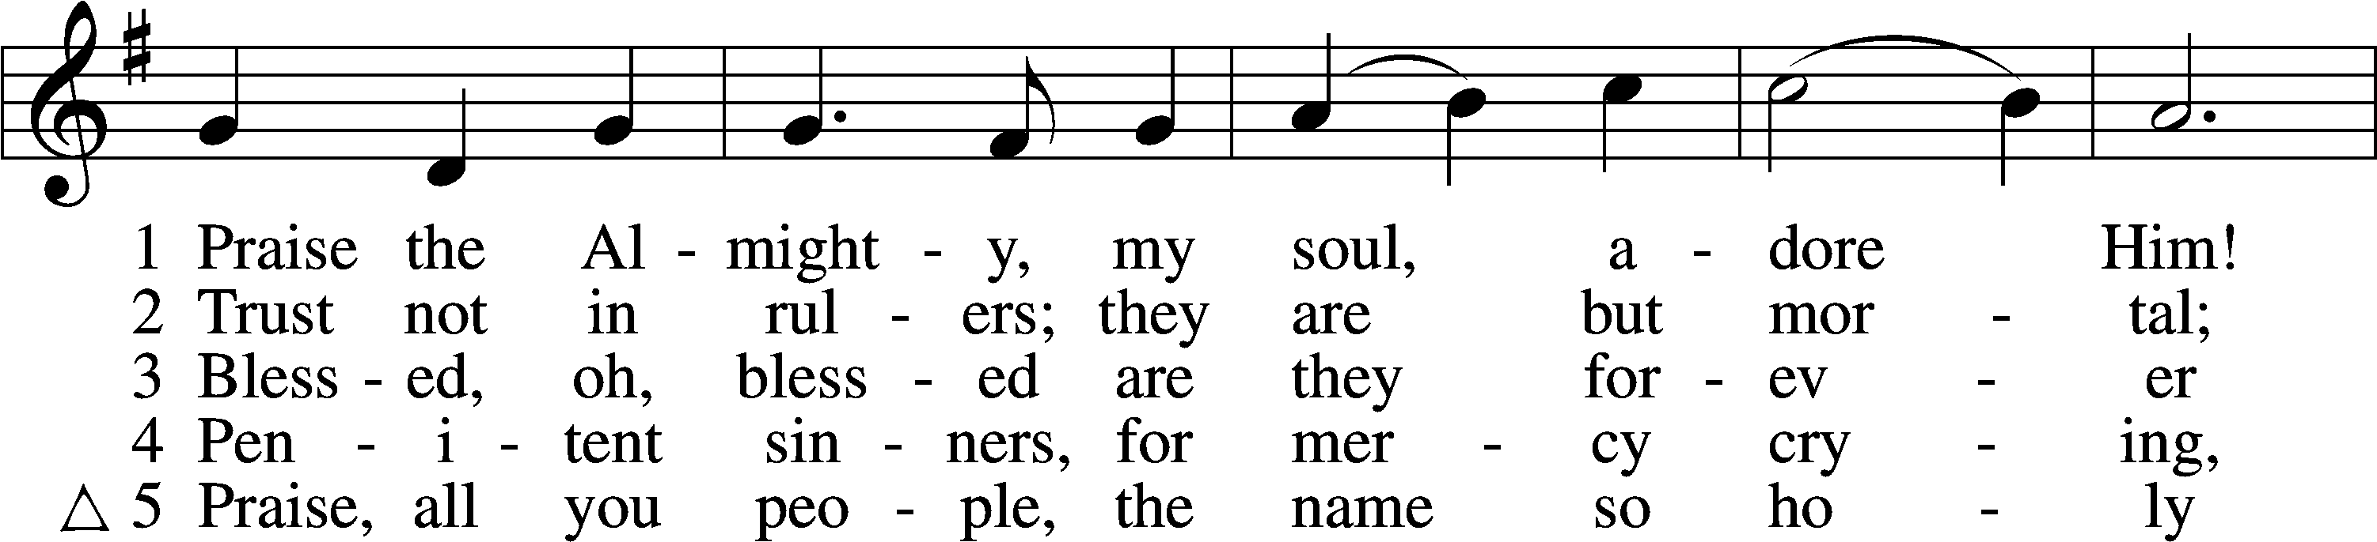
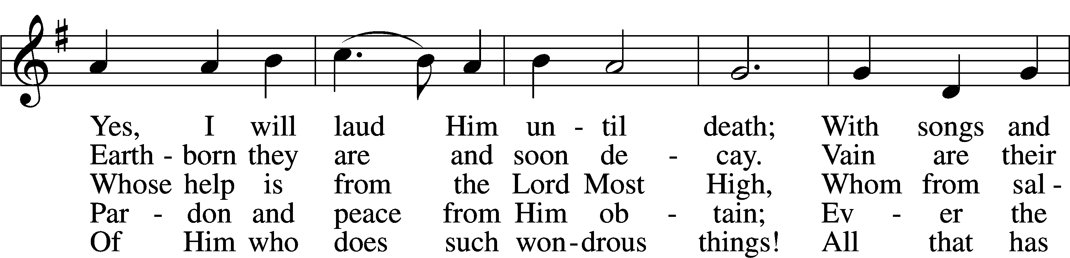
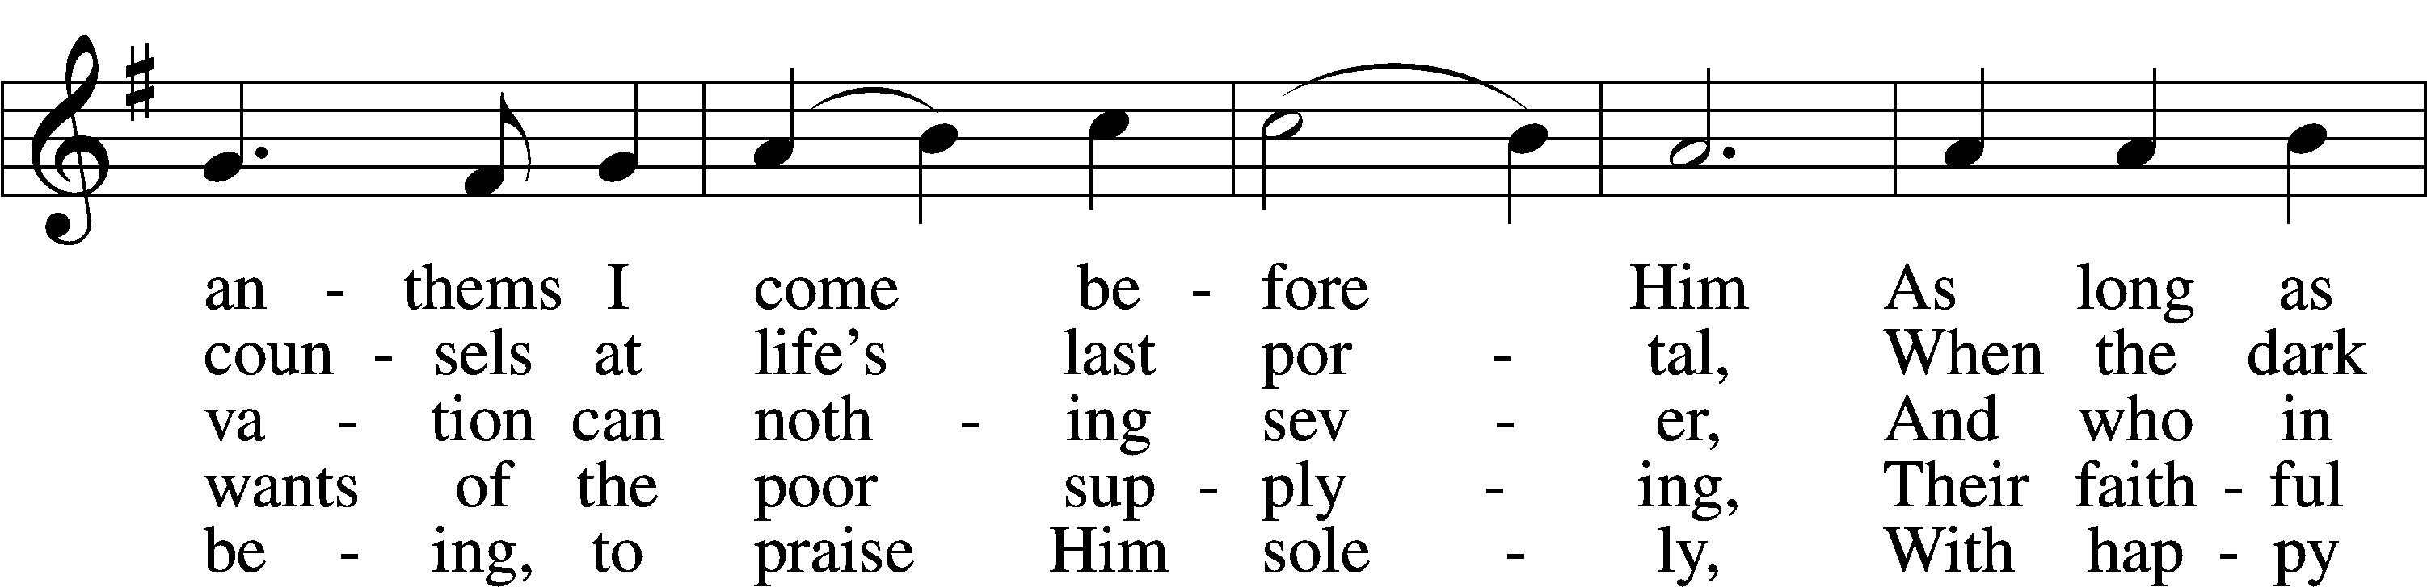
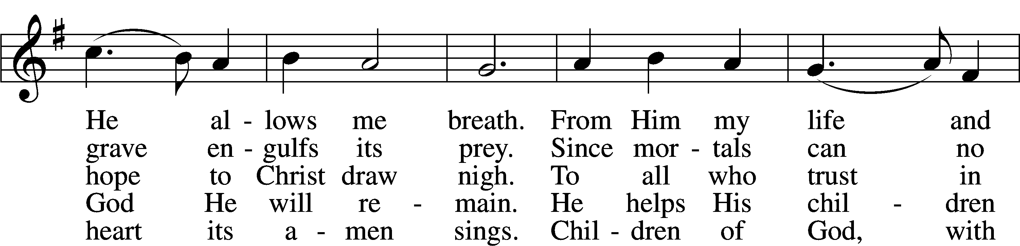
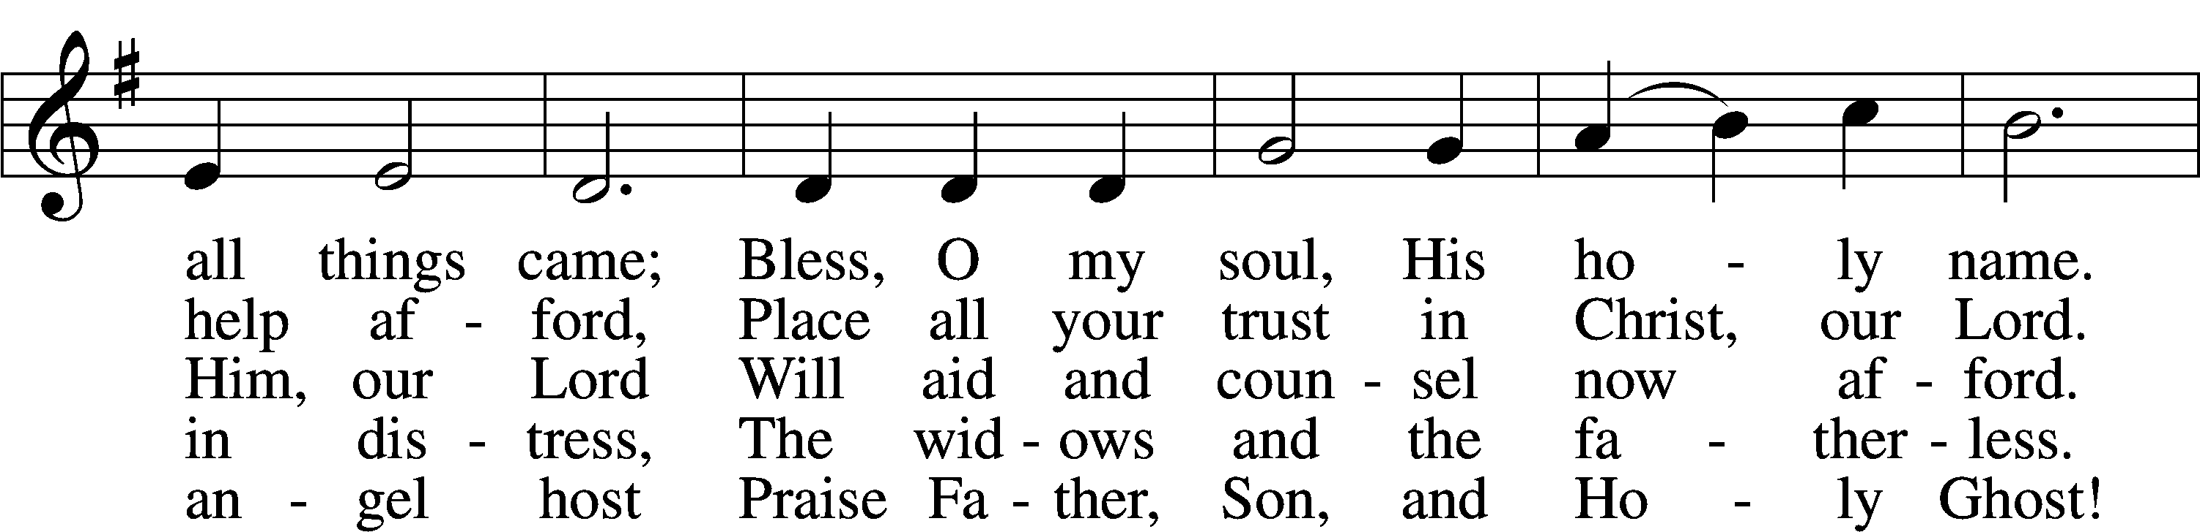
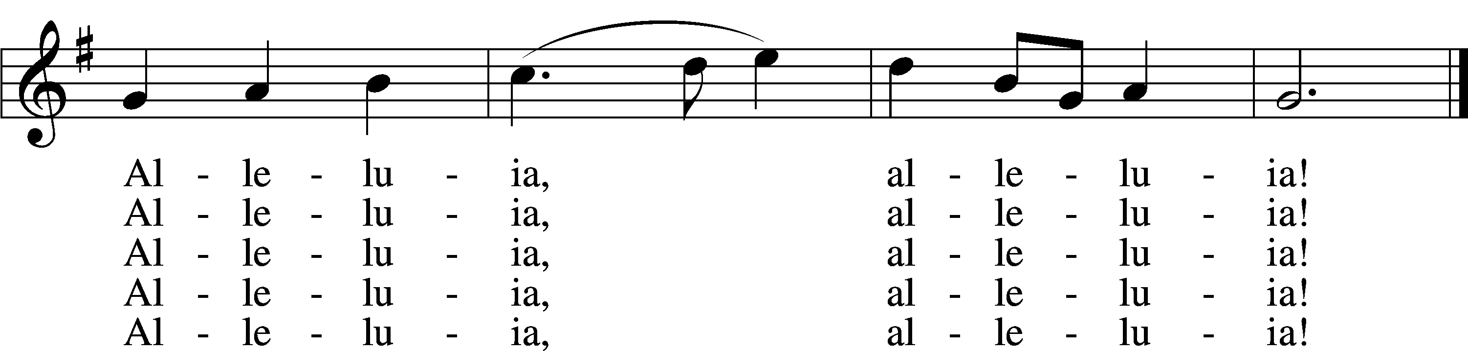
Text and tune: Public domain

Acknowledgments
Unless otherwise indicated, Scripture quotations are from the ESV® Bible (The Holy Bible, English Standard Version®), copyright © 2001 by Crossway, a publishing ministry of Good News Publishers. Used by permission. All rights reserved.
Created by Lutheran Service Builder © 2021 Concordia Publishing House.

Serving Our Lord in His House Today:
Pastor: Rev. David Wurdeman
Organist: Linda Ecker
Elders: Josh Church & Bob Pulley
Joe Engel (Wednesday)
Greeters: Dave & Barb Scardino

Gifts from God: Luke 19:45 – “And he entered the temple and began to drive out those who sold.” The House of God is a House of Prayer. It’s not a place to sell but to give. It’s not a place of profit but of sacrifice. God sets the pattern of giving and sacrifice in the self-giving work of Jesus on the cross. As He is, so we are called to be.

Church Office Closed: Please be advised the church office will be closed Monday, August 9th as the secretary is on vacation. If you need immediate assistance during this time, please contact the Congregation President,
Salz Salzman at 608-387-2636 or Head Elder, Bob Pulley at 608-372-7649.

VBS-The Lord’s Army: Another Good Shepherd VBS “The Lord’s Army” is in the record books. We had about 24 kids each night that learned of different battles in the Bible and putting on the Armor of God. We are shipping care packages to 6 deployed chaplains. If you would like to contribute, please talk to Joan or Katie.
Thank You to everyone that brought little ones to join us, we pray they had a good time and learned a lot. Thank you to everyone that donated, decorated, volunteered, and prayed for the success of the program! God has surely blessed Good Shepherd’s VBS program through you. -Good Shepherd Board of Education

Join us at Camp Good Shepherd: Everyone is invited to Camp Good Shepherd on Saturday, August 14th at Pineview Campground, Ft McCoy. The activities will begin 10:00am, lunch on your own, more activities, supper provided and campfire with VBS Songs. Please RSVP Today, so that we plan food and activities for everyone. There is a sign-up sheet on the easel board. We will sing during 9:00am worship Sunday, August 15th.
Usher Volunteers: A calling to the men of our congregation! The Elders are looking for volunteers who are willing to be an usher during our worship services. Being an usher is a great way to be involved with our worship services and is a great service to our Lord. The goal at this time is to recruit enough men to setup usher teams that will be assigned to specific weekends on the church calendar. Please sign-up on the easel board in the narthex or let an elder know that you are interested!

Volunteers Needed: Good Shepherd is participating in the Downtown Thursday Nights from July 1-August 12. Toro has paid the fees for the booth, but we need volunteers to help run the booth. What a wonderful opportunity to get our church’s name out in the community! The booth is located in the kid’s area, near the bounce house. We are selling kid friendly treats. There is a sign-up roster on the easel in the Narthex. Please contact Lorna Rosenow with any questions at 608-372-6584.

Livestream: Our Sunday Service is livestreamed weekly on our YouTube channel “Good Shepherd Lutheran Church Tomah.”

Hymnals: If you would like to use a Hymnal at home, you can sign one out from church. We also have free devotion pamphlets and Portals of Prayer.

PO Box: For mailed offerings, please use the following:
Good Shepherd Lutheran Church
P.O. Box 551
Tomah, WI 54660

Our Worship attendance last week: Sunday: 45
Wednesday: No Service, due to VBS
Total: 45

Scripture Lessons for next week: Genesis 4:1-15
Ephesians 2:1-10
Luke 18:9-14

Secretary Office Hours: Monday, August 9: Office Closed
Tuesday, August 10-Friday, August 13: 8am-1pm

Our Week With Our Lord:
Today 9:00am Divine Service w/Holy Communion
(livestreamed via YouTube)
SCRIP Orders Due
Mite Box Sunday
10:30am Adult Bible Study
Monday *Church Office Closed*
6:15pm Outreach Committee Meeting
Tuesday 6:00pm Board of Education Meeting
TBD Softball-Tournament
Wednesday 5:00pm Service of Prayer & Preaching
7:00pm Women’s Bible Study – “Chosen”
Thursday 9:30am-11:00am Little Lambs @Firemen’s Park
5:00pm-9:00pm Downtown Thursday Nights
6:00pm Elders Meeting
7:00pm Trustee Meeting
Friday 12:00pm Ladies Birthday Lunch @Dorset Valley
Restaurant, Wilton
Saturday Camp Good Shepherd, Pineview Campground @Ft. McCoy
Sunday 9:00am Divine Service w/Holy Communion
(livestreamed via YouTube)
VBS recap during service
10:30am Adult Bible Study

*Pastor Wurdeman will be on vacation August 10-August 14

*Camp Good Shepherd activities will take place on Saturday, August 14, 2021.
Refer to bulletin announcement for additional details.

*Please view following page for weekly prayers*

HIS FLOCK AT PRAYER
Propers for the Tenth Week after Trinity

Psalm for the Week: Psalm 92

Daily Scripture Readings:
Sunday—Luke 19:41-48 Thursday—Isaiah 29:10-14
Monday— Isaiah 5:1-7 Friday—Acts 4:8-12
Tuesday—John 8:21-27 Saturday— Psalm 51:1-9
Wednesday—Isaiah 1:2-6

Collect for the Week:
O God, You declare Your almighty power above all in showing mercy and pity. Mercifully grant us such a measure of Your grace that we may obtain Your gracious promises and be made partakers of Your heavenly treasures; through Jesus Christ, Your Son, our Lord, who lives and reigns with You and the Holy Spirit, one God, now and forever.

Hymn of the Week: "The Church’s One Foundation” LSB 644

Congregational Petitions for this Week:
+ For those who are ill or recovering, especially: Brenda Kolb, Paula Sopel,
Shawn Zabinski, Karen Griggel, Margaret Palmer, Ladene Zabinski,
Carrie Wilbanks, Cindy Gluch, Payton Pierce, Marie Drescher, Les Hackett,
Joyce Pulley, Tom Coman, Kelly Ingenthron, Jean Salzman, Peter Benjamin,
Pastor Jacob Sutton, Amanda Mallmann.
+ For those who are mourning the loss of a loved one:
Tracy Theurich-York, family and friends, at the loss of Jack Dallman, friend of
Tracy
+ For those who are home-bound, especially: John Fox, Darlene Griffin,
Al Mansfield, Virginia Tillman, Linda Goad, Roemelle McArdle,
Sharon Herried.
+ For those who serve in the military, especially: Isaac Preuss, Tania Adler,
Joshua Ecker.

