**Fourth Sunday in Advent**

**Rorate Coeli**

**December 24, 2023**

**Good Shepherd Lutheran Church**

1221 LaGrange Ave, Tomah, WI 54660 Phone (608)374-2444

Pastor: Noah J. Rogness T pastor.rogness@goodsheptomah.com

Visit our web site @ www.goodsheptomah.weebly.com

Lutheran Church-Missouri Synod

**Visitor Information:** Welcome to Good Shepherd, we are glad you are joining us for worship!

If you need help following along with the hymnal and the order of worship, please sit close to a member and ask questions. The ushers in the back of the sanctuary are also here to assist you in any way they can. The Nursery located at the left of the sanctuary entrance is reserved for nursing mothers.  Please join us for refreshments, Sunday School, and Bible Study in the Fellowship Hall at 10:15 a.m.

**Holy Communion:** According to God’s Word and in unity with Christ’s Church, Good Shepherd Lutheran Church practices closed communion. We do this not to offend, but because Scripture teaches that those communing together should be completely unified in their confession of the Faith. In this Sacrament we are not only joined to Christ our Head who is present in His body and blood, but are also knit together with one another as His Body, in which there should be no division of belief. We would love to see you join our congregation and communion.

If you are interested in becoming a member or have questions or concerns about this Biblical doctrine, please speak with the Pastor.

**Theme for the Fourth Week in Advent:** The coming of God in all His unveiled power at Mount Sinai was terrifying to the people of Israel. The thundering voice of the Lord puts sinners in fear of death (Deut. 18:15–19). God, therefore, raised up a prophet like Moses—the Messiah, the Christ. God came to His people veiled in human flesh. The skies poured down the Righteous One from heaven; the earth opened her womb and brought forth Salvation (Introit) through the blessed Virgin Mary, the mother of the Lord. The fruit of her womb is the very Lamb of God who takes away the sin of the world, the One whose sandal strap John was not worthy to loose (John 1:19–28). In Jesus we are delivered from fear and anxiety. In Him alone we have the peace of God which surpasses all understanding (Phil. 4:4–7).

**____________________________________________________________________________**

# **Pre-Service Music & Welcome**

**Divine Service Setting One – (LSB) 151**

When All the World Was Cursed LSB 346

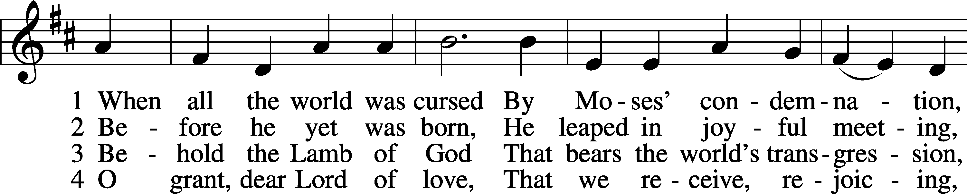

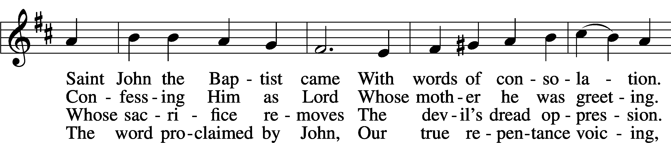

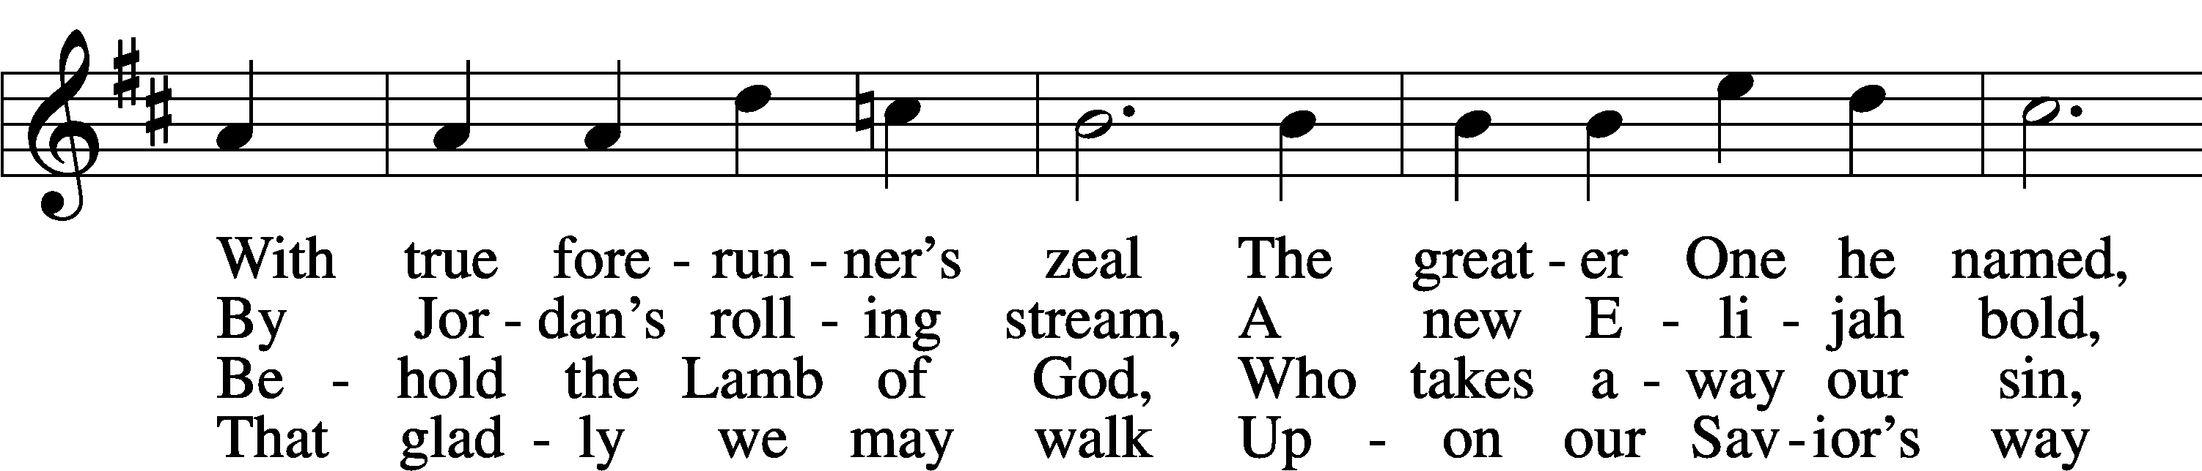

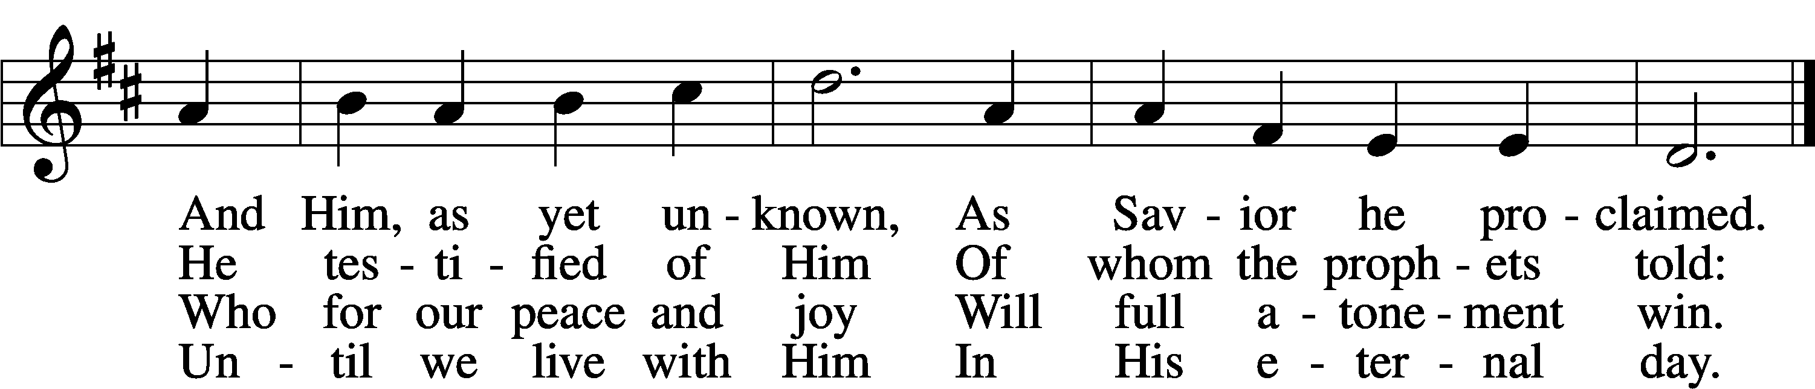

Text: Johann Gottfried Olearius, 1635–1711; tr. Paul E. Kretzmann, 1883–1965, alt.  
Tune: Ahasverus Fritsch, 1629–1701  
Text: © 1941 Concordia Publishing House. Used by permission: LSB Hymn License no. 110016438  
Tune: Public domain

Stand

# Confession and Absolution

The sign of the cross may be made by all in remembrance of their Baptism.

Invocation

P In the name of the Father and of the T Son and of the Holy Spirit.

C **Amen.**

Exhortation LSB 151

P If we say we have no sin, we deceive ourselves, and the truth is not in us.

C **But if we confess our sins, God, who is faithful and just, will forgive our sins and cleanse us from all unrighteousness.**

Silence for reflection on God’s Word and for self-examination.

Confession of Sins LSB 151

P Let us then confess our sins to God our Father.

C **Most merciful God, we confess that we are by nature sinful and unclean. We have sinned against You in thought, word, and deed, by what we have done and by what we have left undone. We have not loved You with our whole heart; we have not loved our neighbors as ourselves. We justly deserve Your present and eternal punishment. For the sake of Your Son, Jesus Christ, have mercy on us. Forgive us, renew us, and lead us, so that we may delight in Your will and walk in Your ways to the glory of Your holy name. Amen.**

Absolution LSB 151

P Almighty God in His mercy has given His Son to die for you and for His sake forgives you all your sins. As a called and ordained servant of Christ, and by His authority, I therefore forgive you all your sins in the name of the Father and of the T Son and of the Holy Spirit.

C **Amen.**

# Service of the Word

Introit Psalm 19:1, 4–6; antiphon: Isaiah 45:8a

***Antiphon***

Shower, O heavens, from above,  
 and let the clouds rain down righteousness;  
let the earth open, that salvation and righteousness may bear fruit;  
 let the earth cause them both to sprout.

The heavens declare the glory of God,  
 and the sky above proclaims his handiwork.  
**Their measuring line goes out through all the earth, and their words to the end of the world.  
 In them he has set a tent for the sun,**  
which comes out like a bridegroom leaving his chamber,  
 and, like a strong man, runs its course with joy.  
**Its rising is from the end of the heavens, and its circuit to the end of them,  
 and there is nothing hidden from its heat.**  
**Glory be to the Father and to the Son**  
 **and to the Holy Spirit;**  
**as it was in the beginning,**  
 **is now, and will be forever. Amen.**  
Shower, O heavens, from above,  
 and let the clouds rain down righteousness;  
let the earth open, that salvation and righteousness may bear fruit;  
 let the earth cause them both to sprout.

Kyrie LSB 152

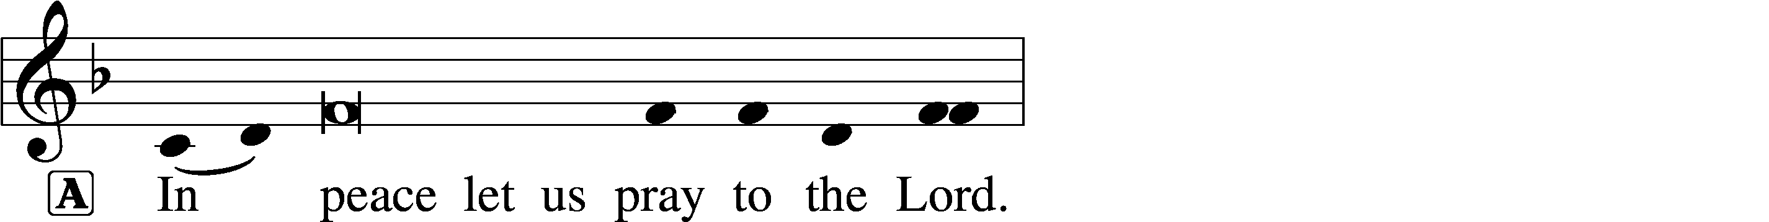

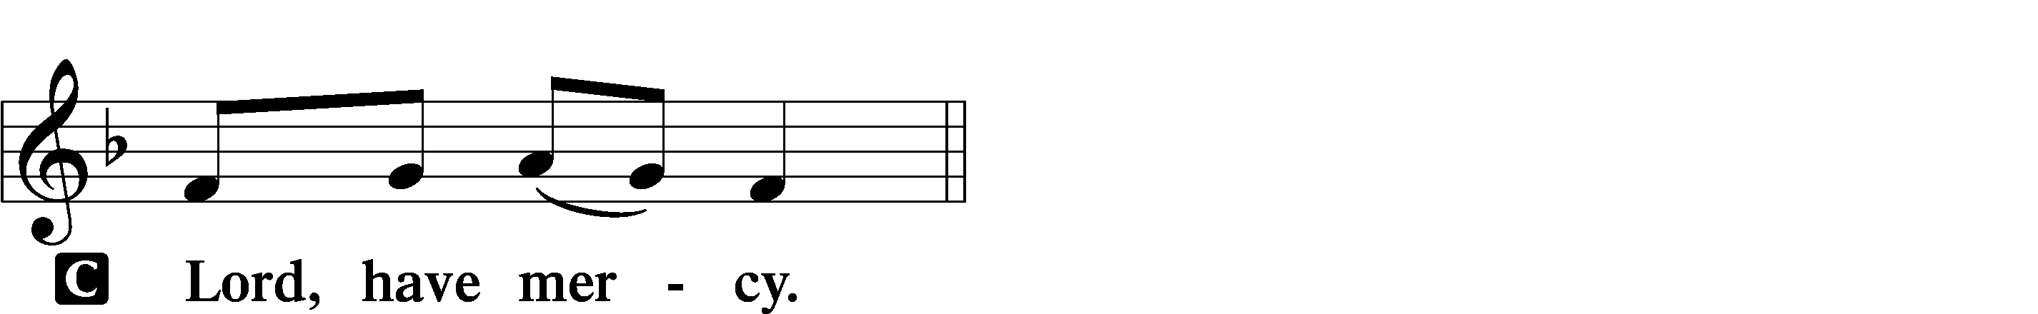

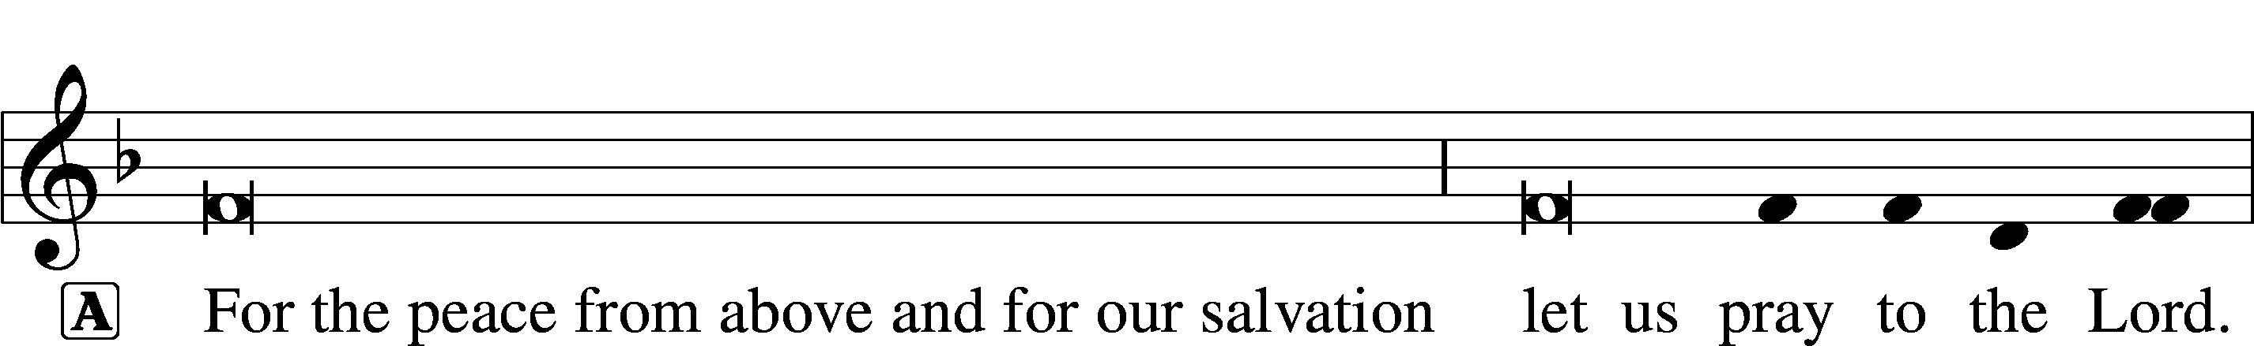

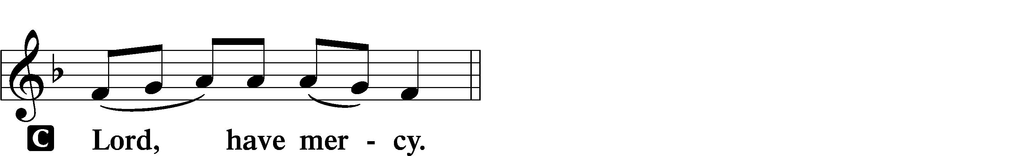

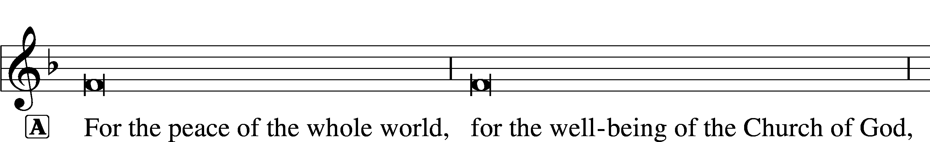

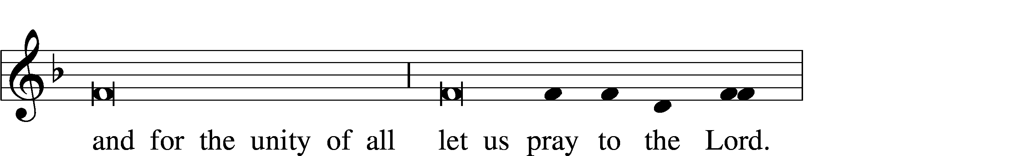

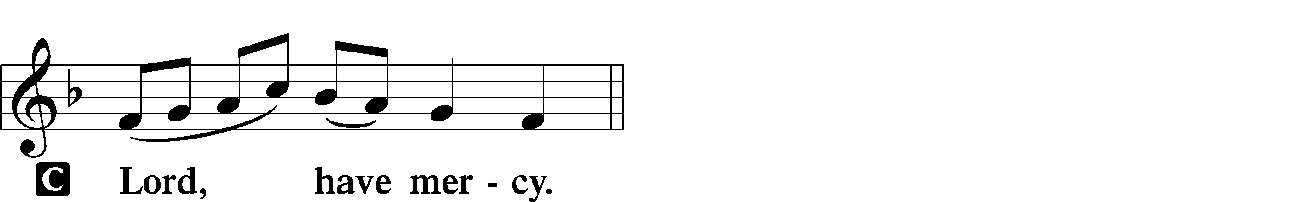

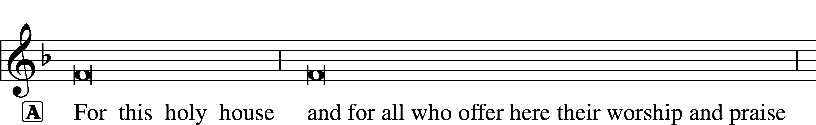

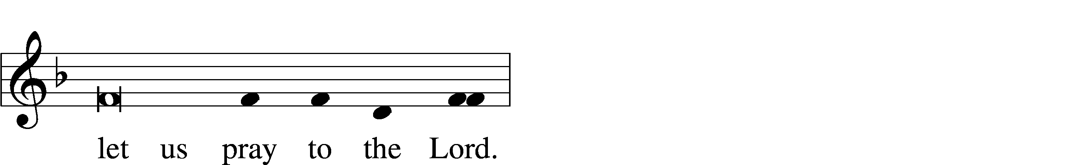

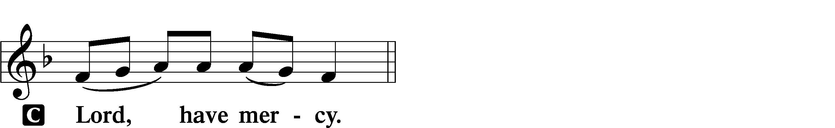

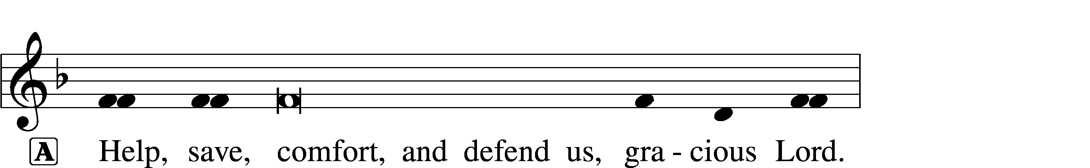

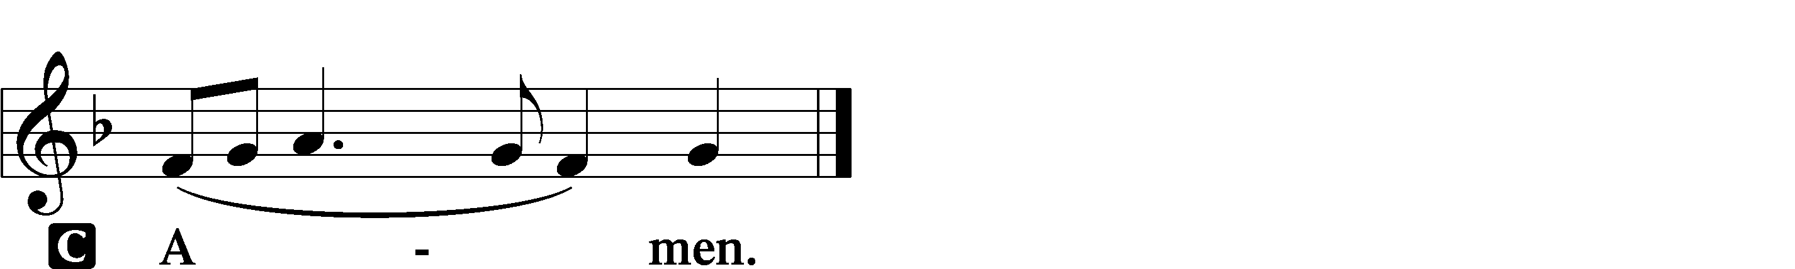

Salutation and Collect of the Day

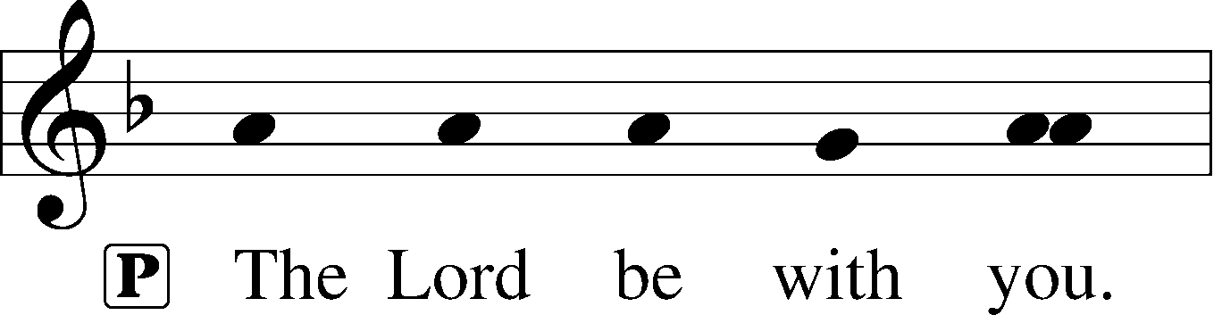

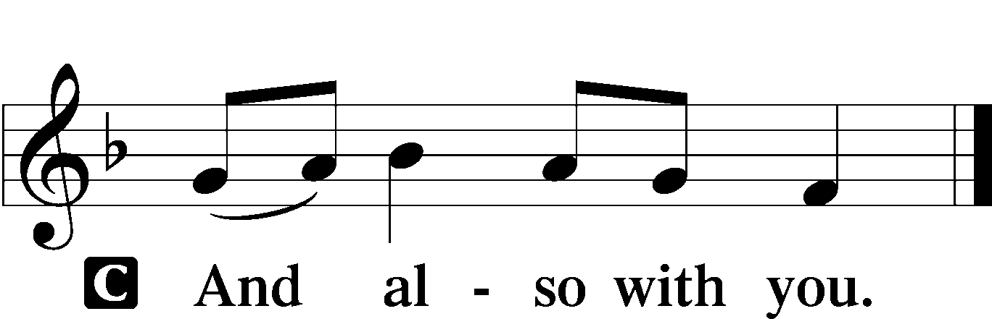

P Let us pray.

Stir up Your power, O Lord, and come and help us by Your might, that the sins which weigh us down may be quickly lifted by Your grace and mercy; for You live and reign with the Father and the Holy Spirit, one God, now and forever.

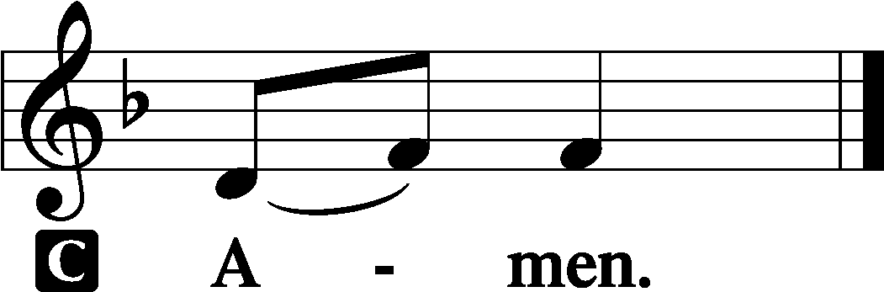

Sit

Old Testament Reading Deuteronomy 18:15–19

“The Lord your God will raise up for you a prophet like me from among you, from your brothers—it is to him you shall listen— just as you desired of the Lord your God at Horeb on the day of the assembly, when you said,

‘Let me not hear again the voice of the Lord my God or see this great fire any more, lest I die.’ And the Lord said to me, ‘They are right in what they have spoken. I will raise up for them a prophet like you from among their brothers. And I will put my words in his mouth, and he shall speak to them all that I command him. And whoever will not listen to my words that he shall speak in my name, I myself will require it of him.’”

A This is the Word of the Lord.

C **Thanks be to God.**

Gradual Psalm 145:18, 21

The Lord is near to all who call on him,  
 to all who call on him in truth.  
**My mouth will speak the praise of the Lord,  
 and let all flesh bless his holy name forever and ever.**

Epistle Philippians 4:4–7

Rejoice in the Lord always; again I will say, Rejoice. Let your reasonableness be known to everyone. The Lord is at hand; do not be anxious about anything, but in everything by prayer and supplication with thanksgiving let your requests be made known to God. And the peace of God,

which surpasses all understanding, will guard your hearts and your minds in Christ Jesus.

A This is the Word of the Lord.

C **Thanks be to God.**

Stand

Alleluia and Verse LSB 156

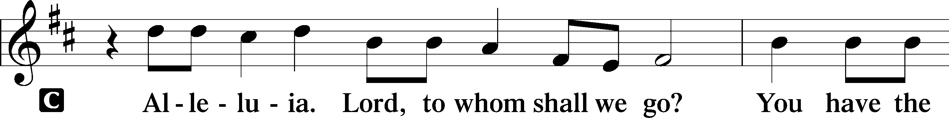

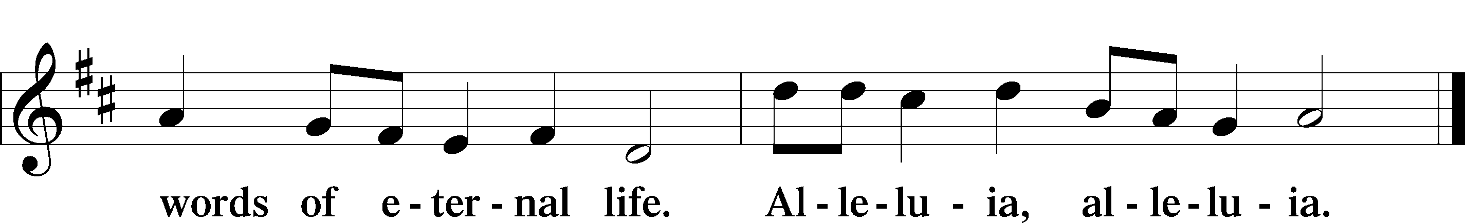

**Holy Gospel** *John 1:19–28*

P The Holy Gospel according to St. John, the first chapter.

This is the testimony of John, when the Jews sent priests and Levites from Jerusalem to ask him, “Who are you?” He confessed, and did not deny,

but confessed, “I am not the Christ.” And they asked him, “What then?

Are you Elijah?” He said, “I am not.” “Are you the Prophet?” And he answered, “No.” So they said to him, “Who are you? We need to give an answer to those who sent us. What do you say about yourself?” He said,

“I am the voice of one crying out in the wilderness, ‘Make straight the way of the Lord,’ as the prophet Isaiah said.”

(Now they had been sent from the Pharisees.) They asked him, “Then why are you baptizing, if you are neither the Christ, nor Elijah, nor the Prophet?” John answered them, “I baptize with water, but among you stands one you do not know, even he who comes after me, the strap of whose sandal I am not worthy to untie.” These things took place in Bethany across the Jordan, where John was baptizing.

P This is the Gospel of the Lord.

Sit

Children's Message

O Savior, Rend the Heavens Wide LSB 355

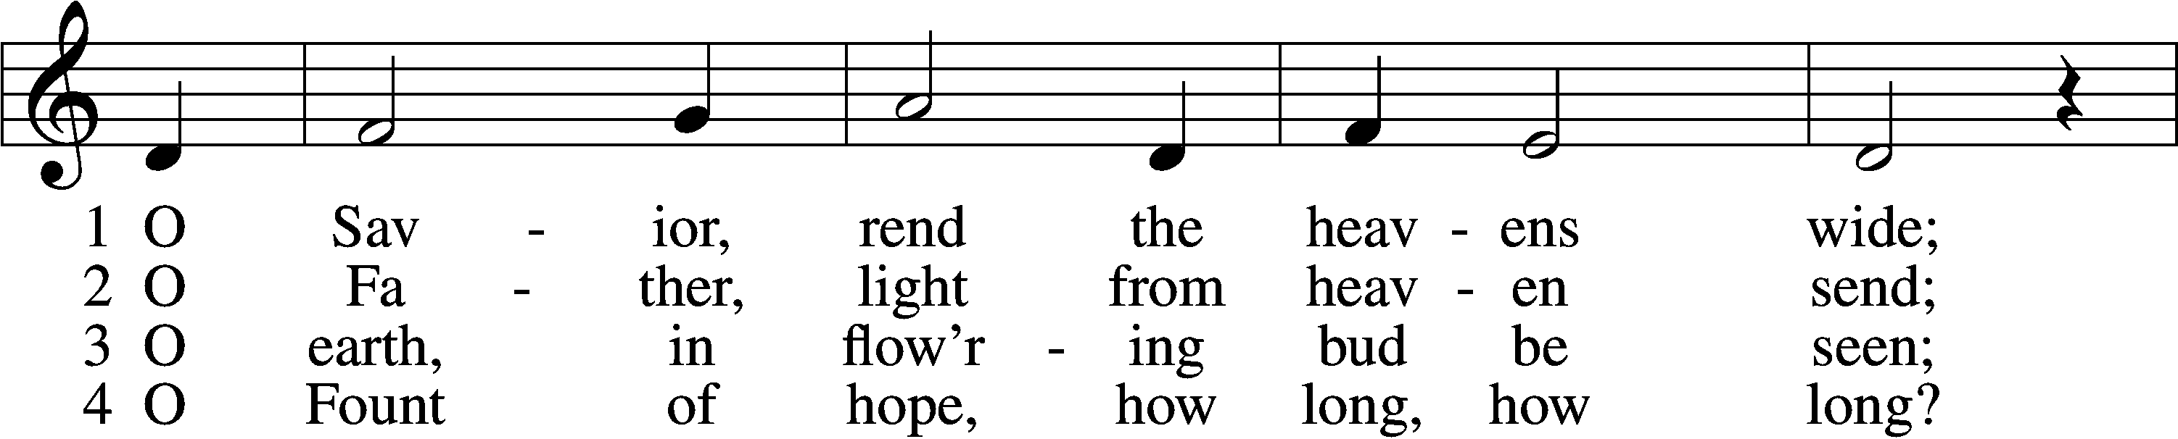

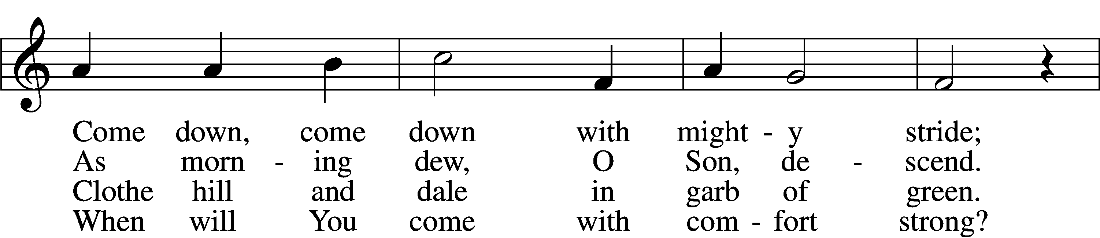

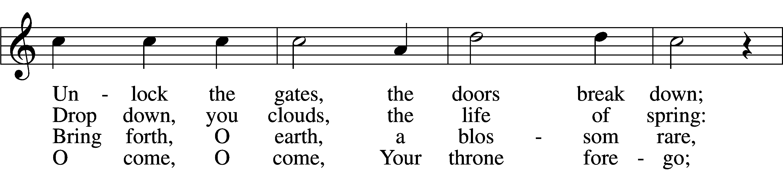

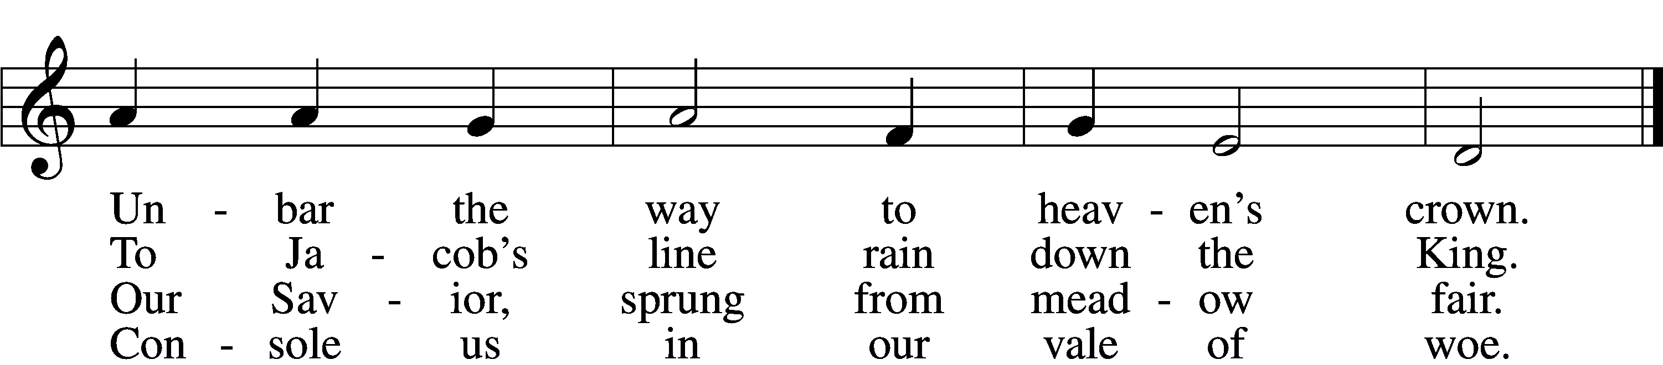

5 O Morning Star, O radiant Sun,  
When will our hearts behold Your dawn?  
O Sun, arise; without Your light  
We grope in gloom and dark of night.

6 Sin’s dreadful doom upon us lies;  
Grim death looms fierce before our eyes.  
O come, lead us with mighty hand  
From exile to our promised land.

7 There shall we all our praises bring  
And sing to You, our Savior King;  
There shall we laud You and adore  
Forever and forevermore.

Text: Friedrich von Spee, 1591–1635; tr. Martin L. Seltz, 1909–67, alt.  
Tune: Rheinfelssisch Deutsches Catholisches Gesangbuch, 1666, Augsburg  
Text: © 1969 Concordia Publishing House. Used by permission: LSB Hymn License no. 110016438  
Tune: Public domain

Sermon

Stand

Nicene Creed

C **I believe in one God,**

**the Father Almighty,**

**maker of heaven and earth**

**and of all things visible and invisible.**

**And in one Lord Jesus Christ,**

**the only-begotten Son of God,**

**begotten of His Father before all worlds,**

**God of God, Light of Light,**

**very God of very God,**

**begotten, not made,**

**being of one substance with the Father,**

**by whom all things were made;**

**who for us men and for our salvation came down from heaven**

**and was incarnate by the Holy Spirit of the virgin Mary**

**and was made man;**

**and was crucified also for us under Pontius Pilate.**

**He suffered and was buried.**

**And the third day He rose again according to the Scriptures**

**and ascended into heaven**

**and sits at the right hand of the Father.**

**And He will come again with glory to judge both the living and the dead,**

**whose kingdom will have no end.**

**And I believe in the Holy Spirit,**

**the Lord and giver of life,**

**who proceeds from the Father and the Son,**

**who with the Father and the Son together is worshiped and glorified,**

**who spoke by the prophets.**

**And I believe in one holy Christian and apostolic Church,**

**I acknowledge one Baptism for the remission of sins,**

**and I look for the resurrection of the dead**

**and the life** T **of the world to come. Amen.**

Prayer of the Church

Sit

Offering

Choir: "O Holy Child of Bethlehem" by Lloyd Larson

*Stand*

Offertory LSB 159

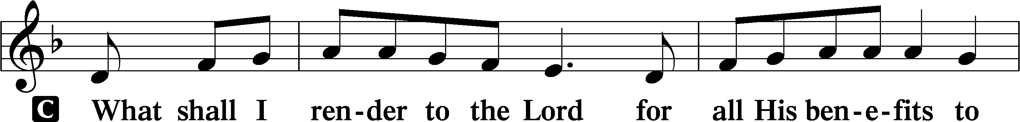

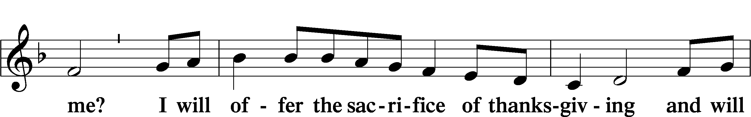

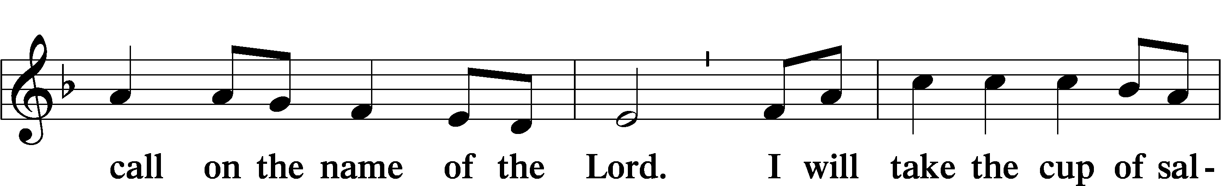

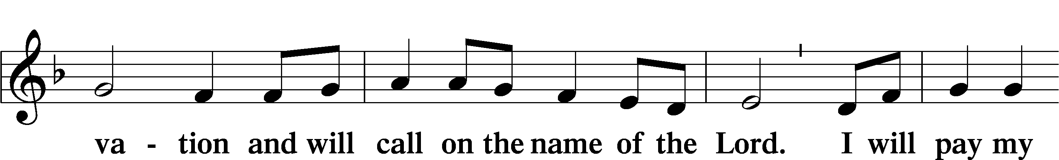

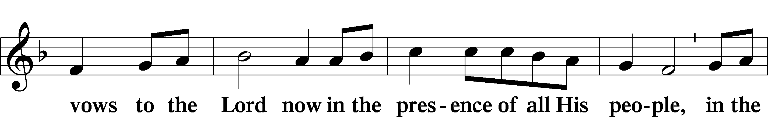

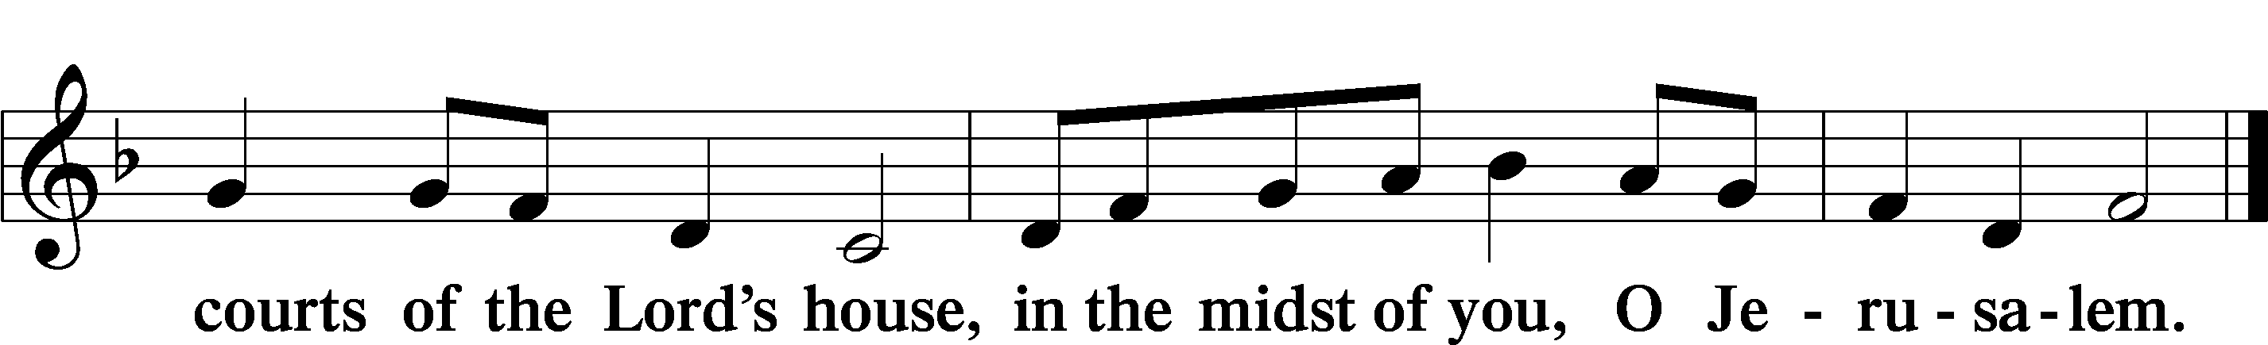

# Service of the Sacrament

Preface LSB 160

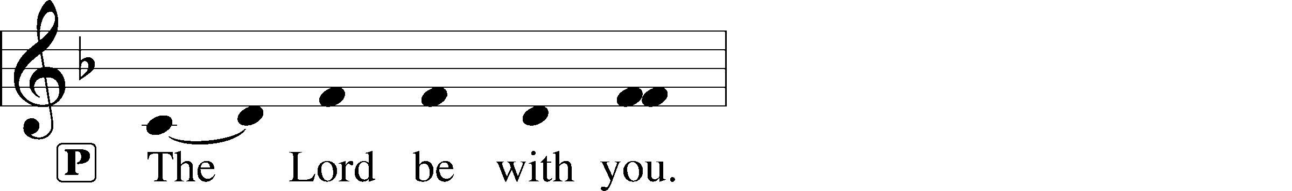

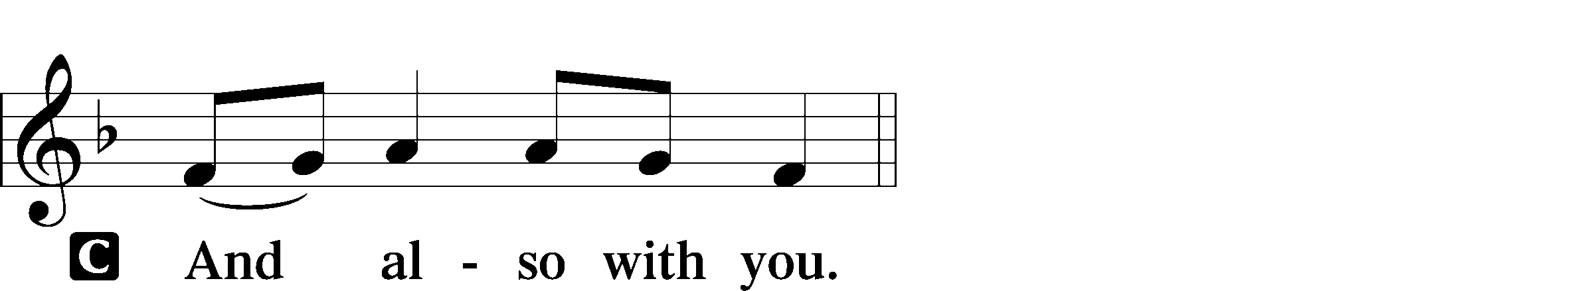

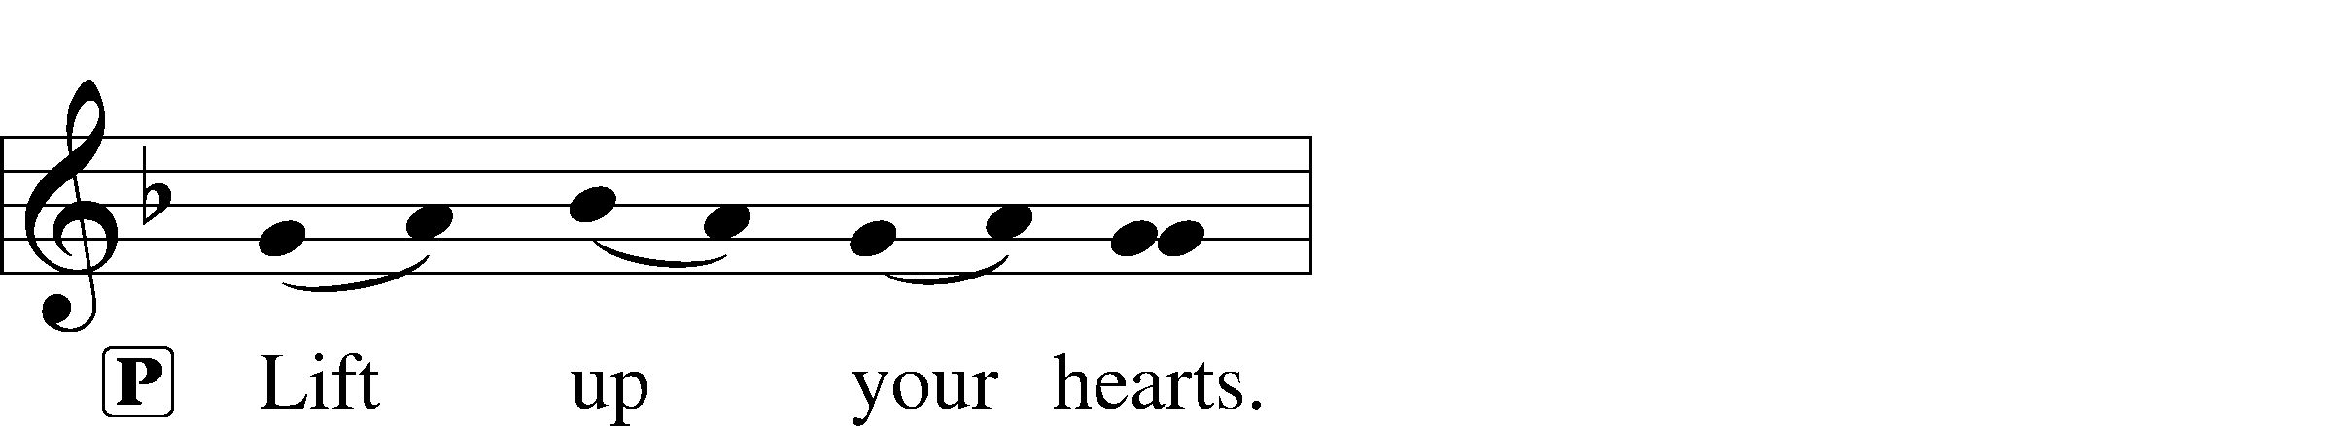



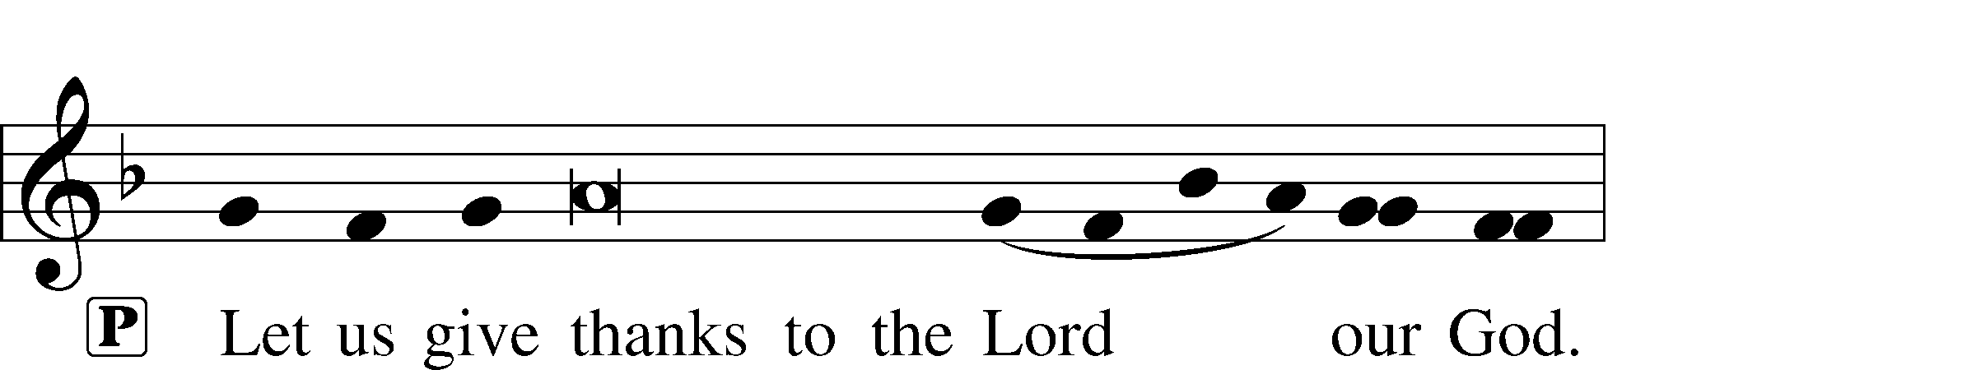

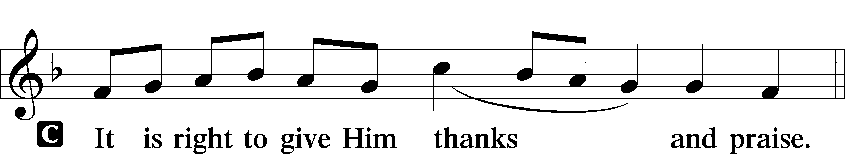

**Proper Preface**

Sanctus LSB 161

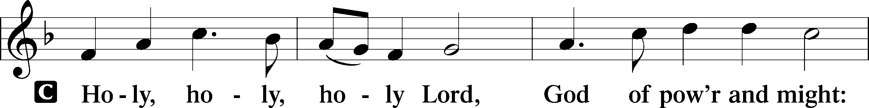

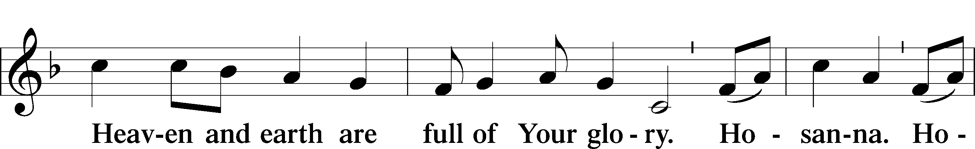

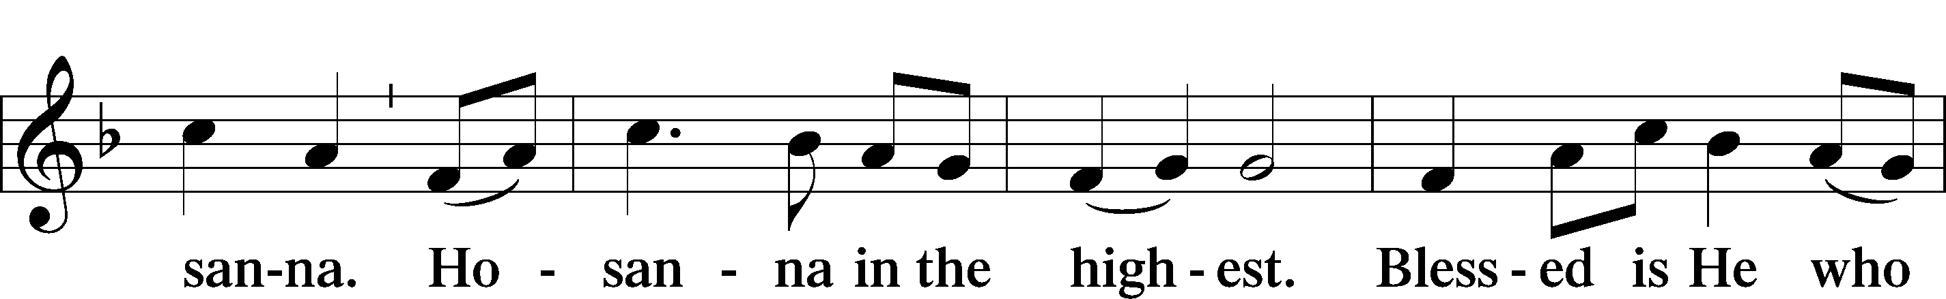

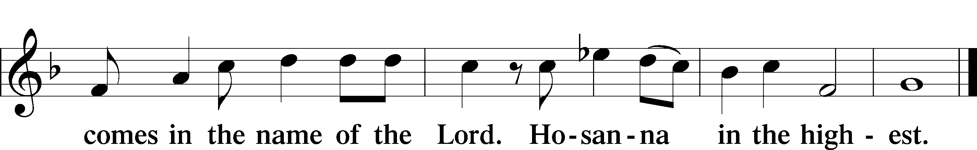

Prayer of Thanksgiving LSB 161

P Blessed are You, Lord of heaven and earth, for You have had mercy on those whom You created and sent Your only-begotten Son into our flesh to bear our sin and be our Savior. With repentant joy we receive the salvation accomplished for us by the all-availing sacrifice of His body and His blood on the cross.

Gathered in the name and the remembrance of Jesus, we beg You, O Lord, to forgive, renew, and strengthen us with Your Word and Spirit. Grant us faithfully to eat His body and drink His blood as He bids us do in His own testament. Gather us together, we pray, from the ends of the earth to celebrate with all the faithful the marriage feast of the Lamb in His kingdom, which has no end. Graciously receive our prayers; deliver and preserve us. To You alone, O Father, be all glory, honor, and worship, with the Son and the Holy Spirit, one God, now and forever.

C **Amen.**

The Words of Our Lord

P Our Lord Jesus Christ, on the night when He was betrayed, took bread, and when He had given thanks, He broke it and gave it to the disciples and said: “Take, eat; this is My T body, which is given for you. This do in remembrance of Me.”

In the same way also He took the cup after supper, and when He had given thanks, He gave it to them, saying: “Drink of it, all of you; this cup is the new testament in My T blood, which is shed for you for the forgiveness of sins. This do, as often as you drink it, in remembrance of Me.”

Proclamation of Christ

P As often as we eat this bread and drink this cup, we proclaim the Lord’s death until He comes.

C **Amen. Come, Lord Jesus.**

P O Lord Jesus Christ, only Son of the Father, in giving us Your body and blood to eat and to drink, You lead us to remember and confess Your holy cross and passion, Your blessed death, Your rest in the tomb, Your resurrection from the dead, Your ascension into heaven, and Your coming for the final judgment. So remember us in Your kingdom and teach us to pray:

Lord’s Prayer

C **Our Father who art in heaven,**

**hallowed be Thy name,**

**Thy kingdom come,**

**Thy will be done on earth**

**as it is in heaven;**

**give us this day our daily bread;**

**and forgive us our trespasses**

**as we forgive those**

**who trespass against us;**

**and lead us not into temptation,**

**but deliver us from evil.**

**For Thine is the kingdom**

**and the power and the glory**

**forever and ever. Amen.**

Pax Domini LSB 163

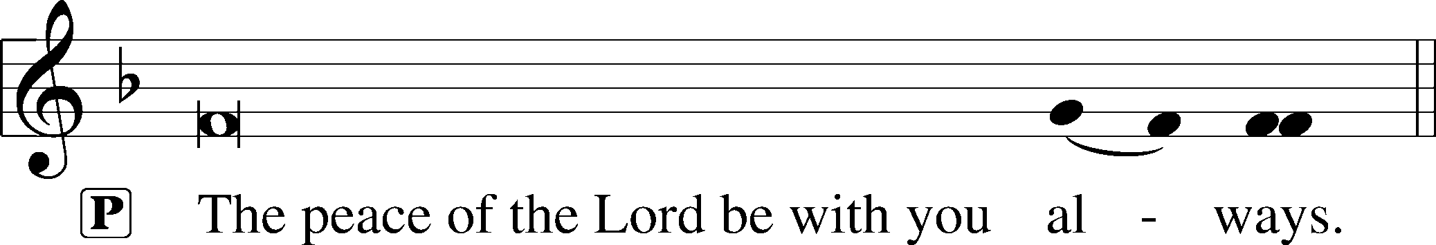

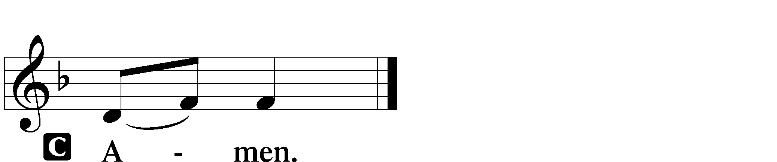

Agnus Dei LSB 163

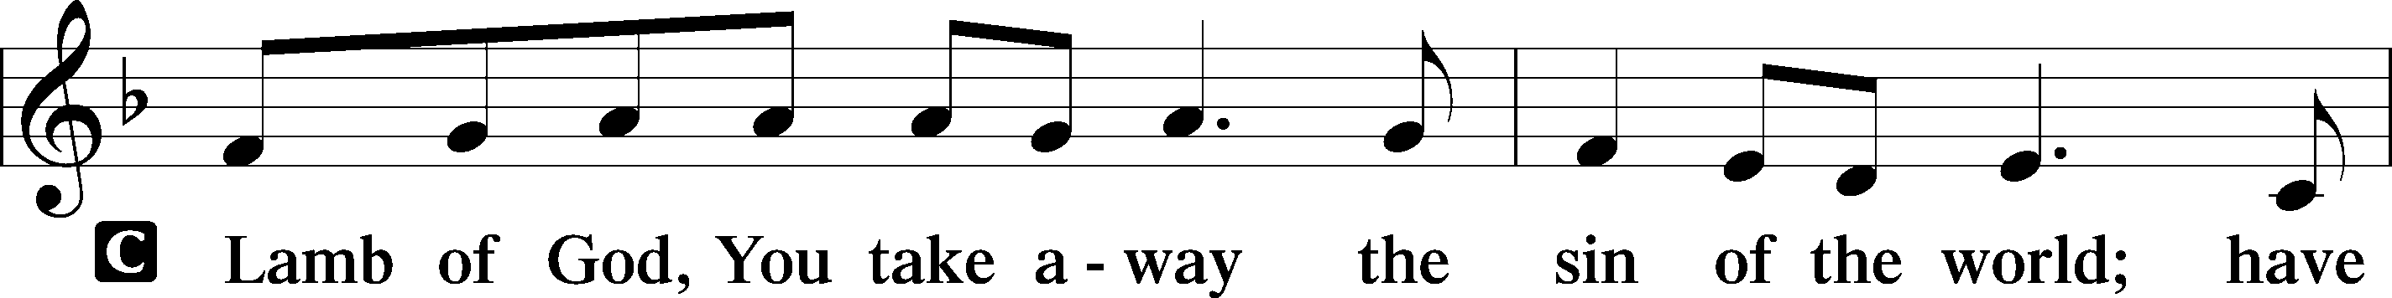

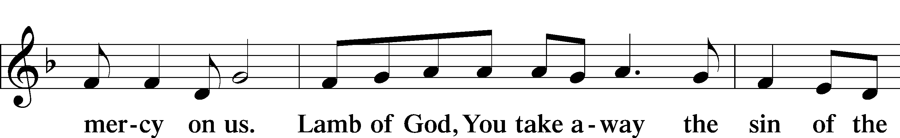

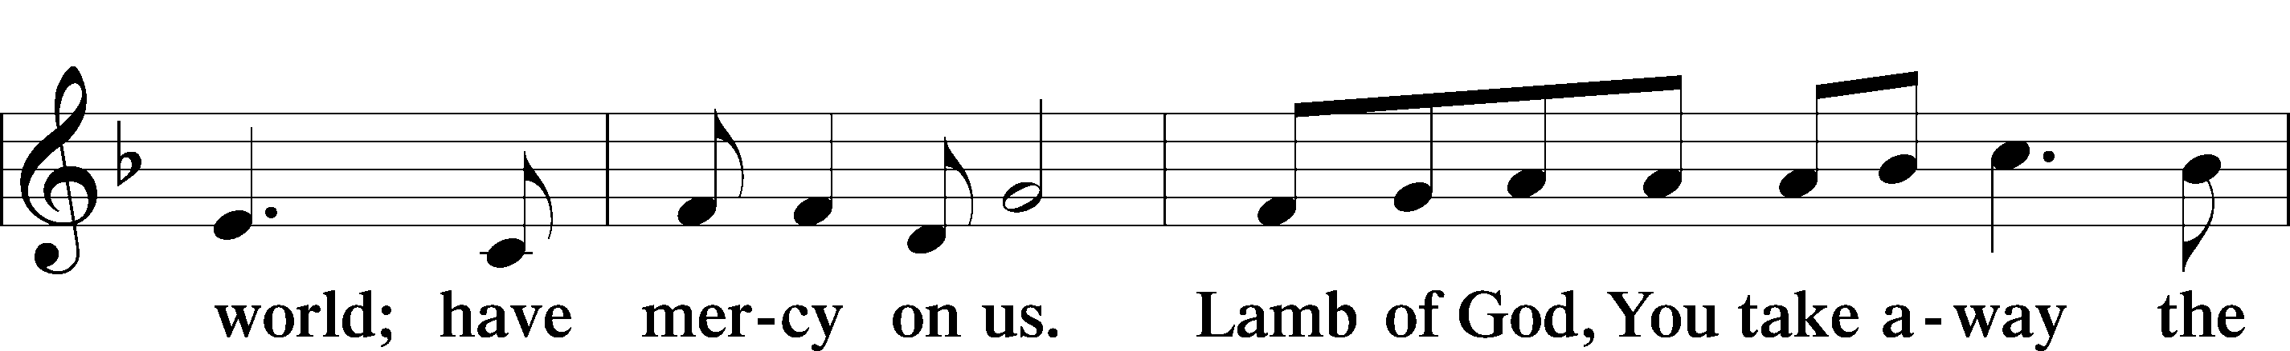

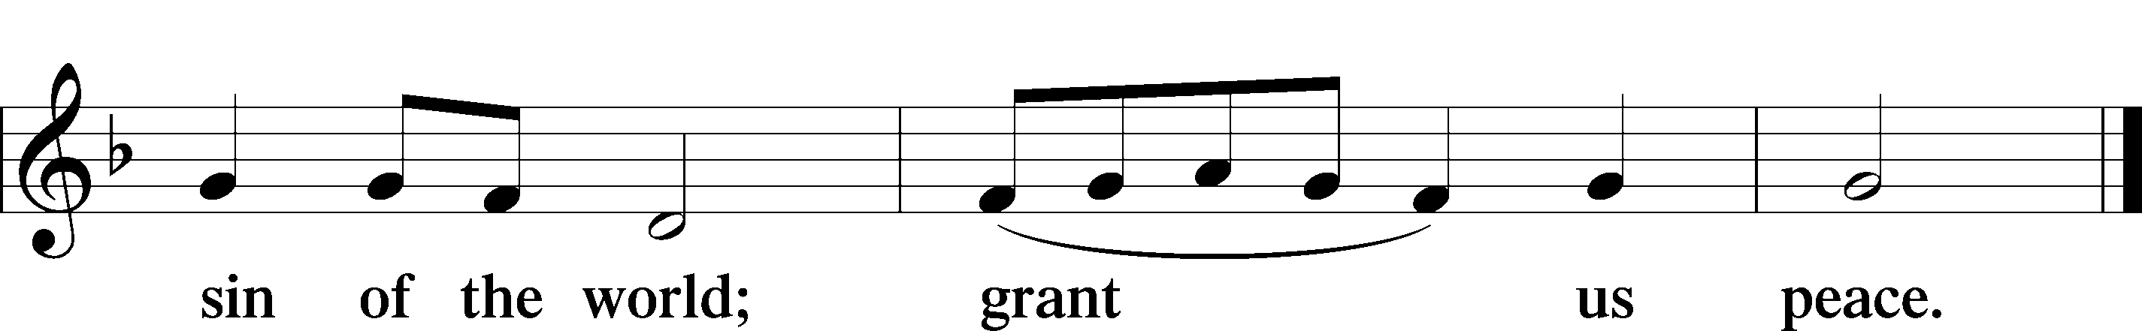

Sit

**Distribution**

Let the Earth Now Praise the Lord LSB 352

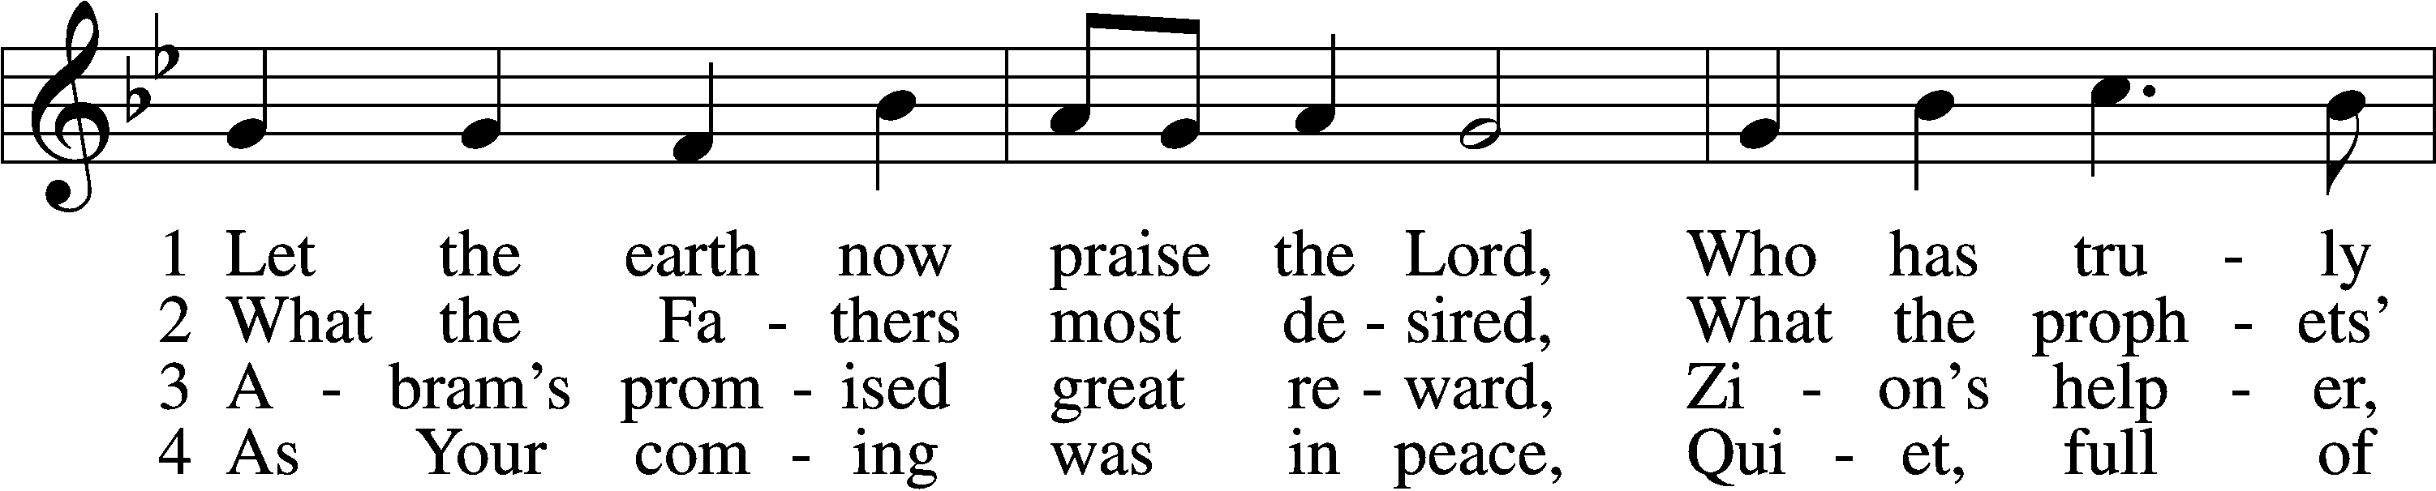

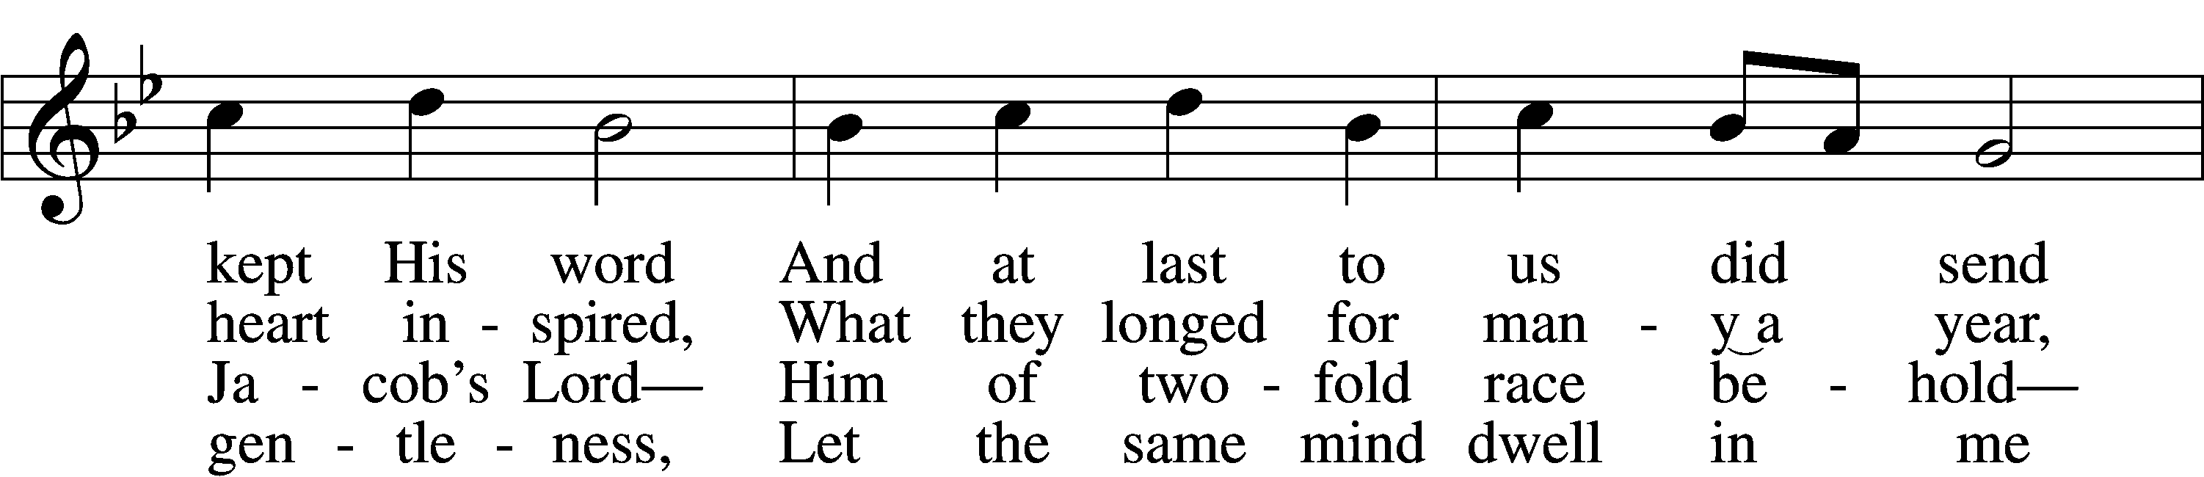

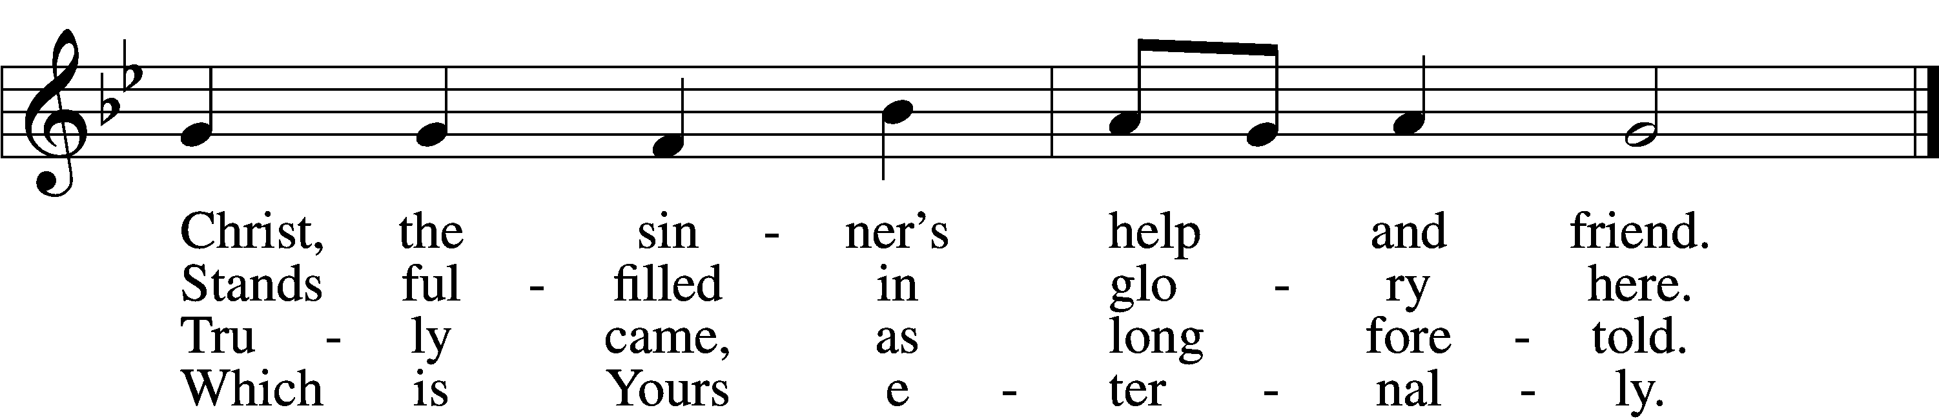

5 Bruise for me the serpent’s head  
That, set free from doubt and dread,  
I may cling to You in faith,  
Safely kept through life and death.

6 Then when You will come again  
As the glorious king to reign,  
I with joy will see Your face,  
Freely ransomed by Your grace.

Text: Heinrich Held, 1620–59; tr. Catherine Winkworth, 1827–78, alt.  
Tune: Geystliche gesangk Buchleyn, 1524, Wittenberg, ed. Johann Walter  
Text and tune: Public domain

The King Shall Come When Morning Dawns LSB 348

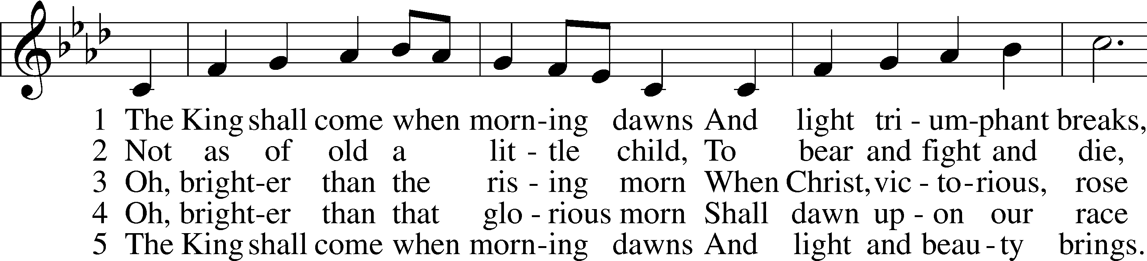

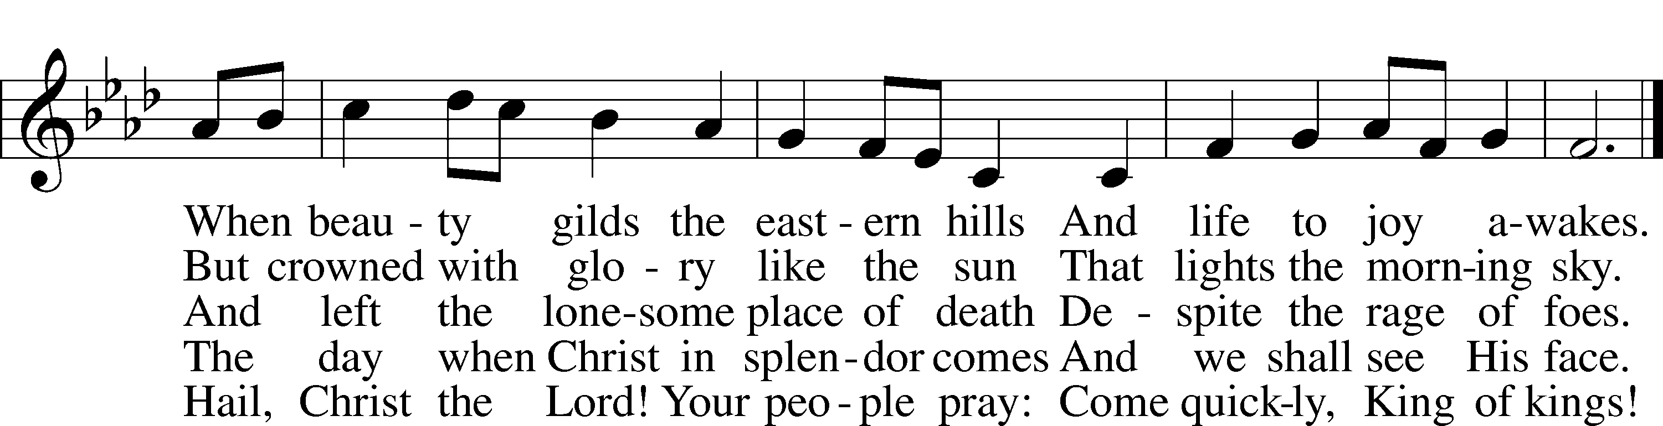

Text: John Brownlie, 1859–1925, alt.  
Tune: Repository of Sacred Music, Part Second, 1813, Harrisburg, ed. John Wyeth  
Text and tune: Public domain

Stand

Nunc Dimittis LSB 165

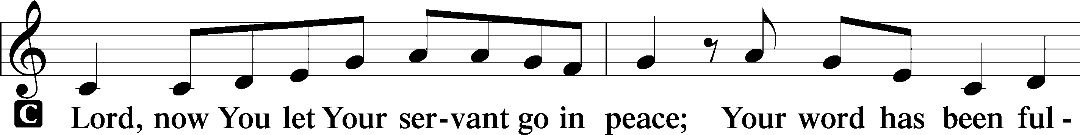

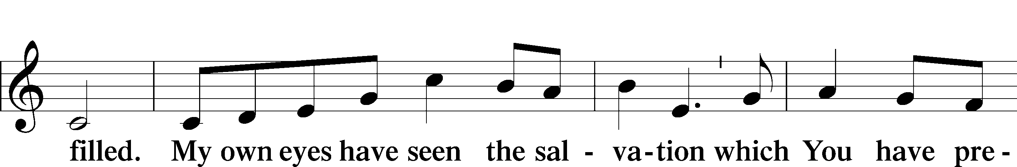

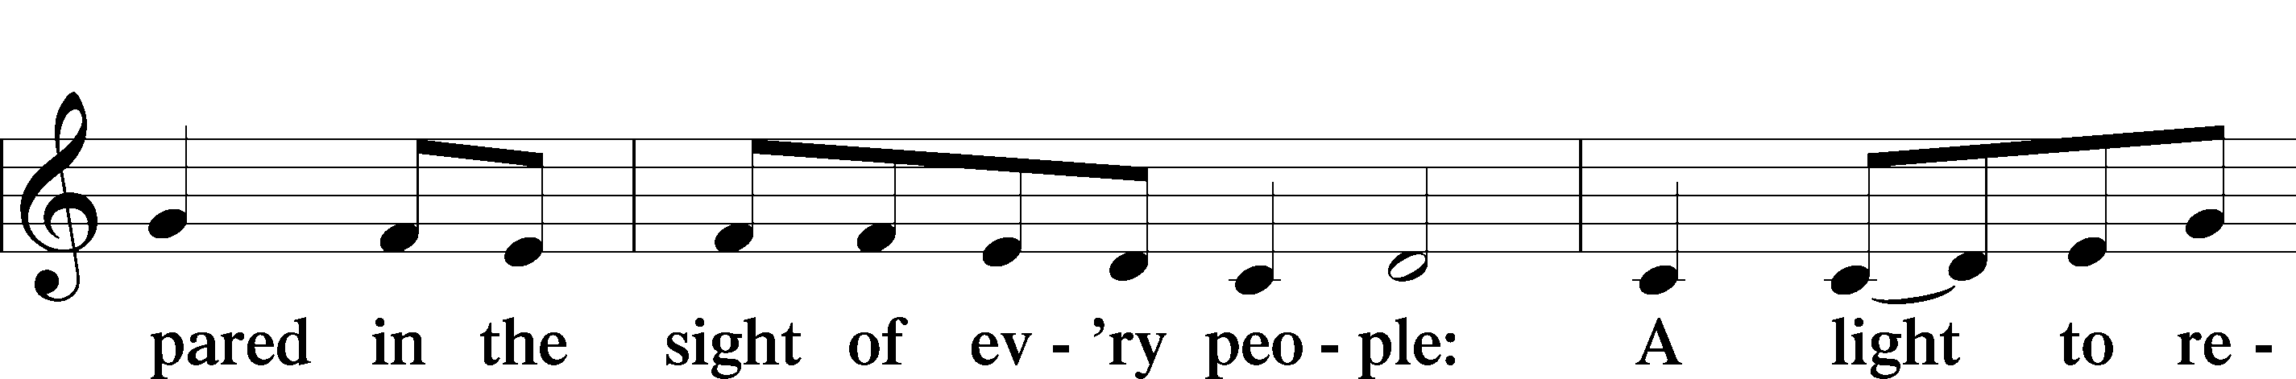

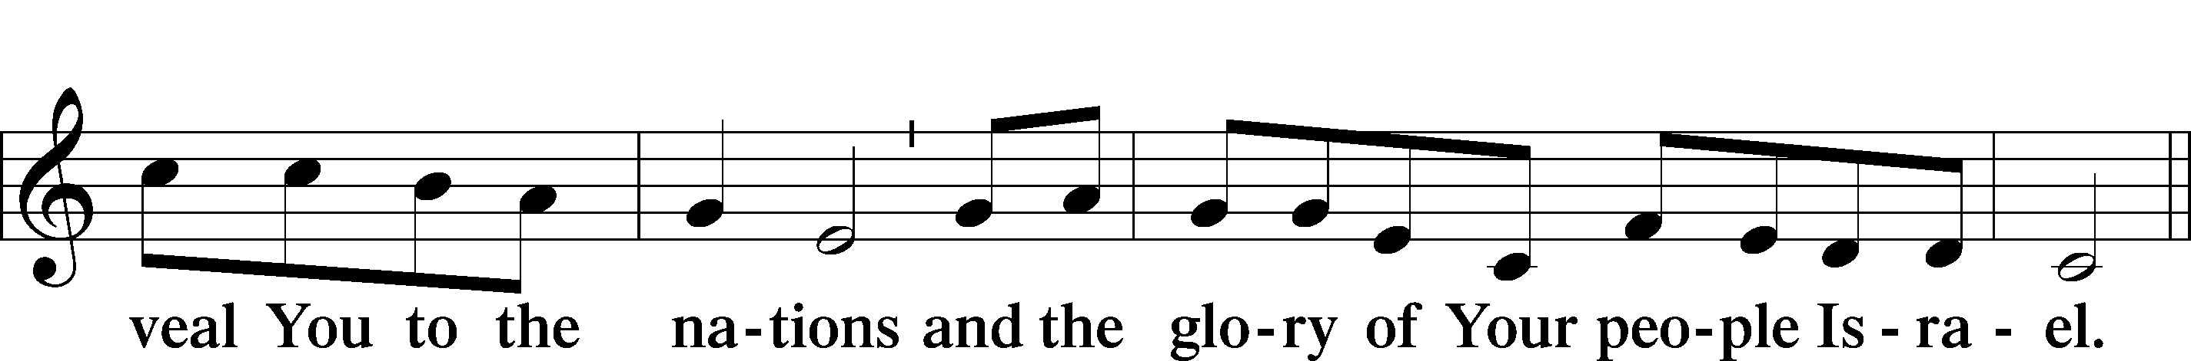

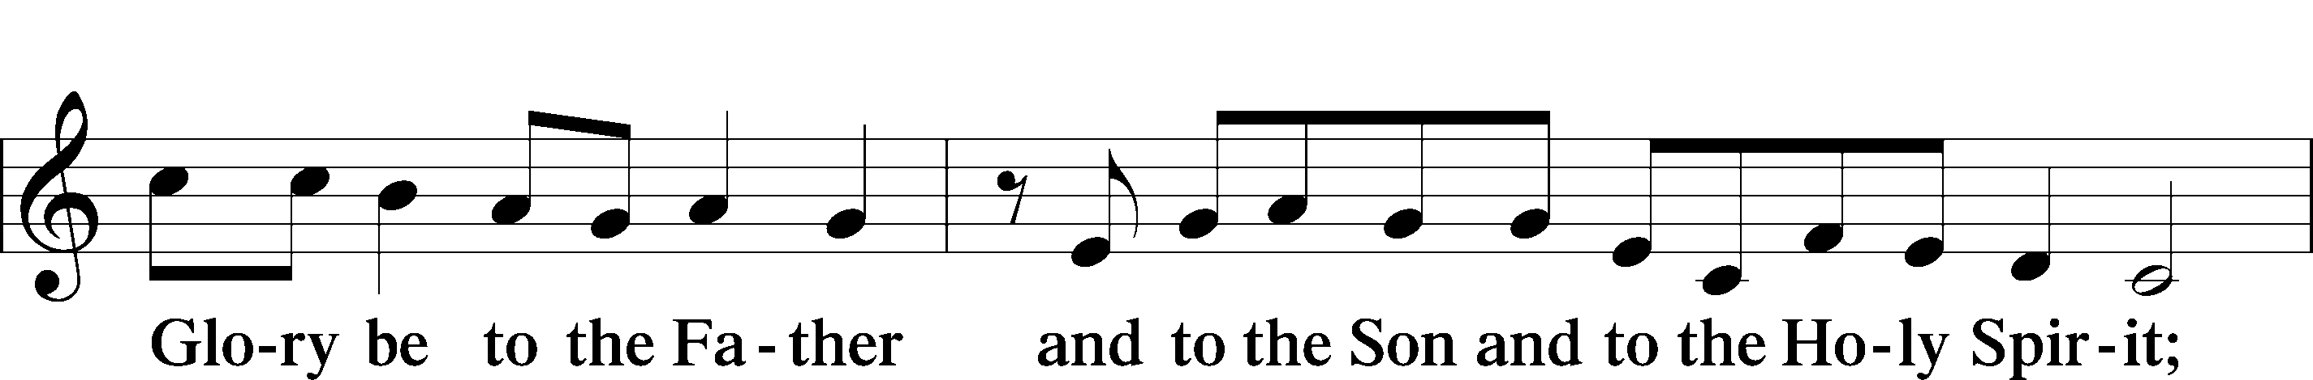

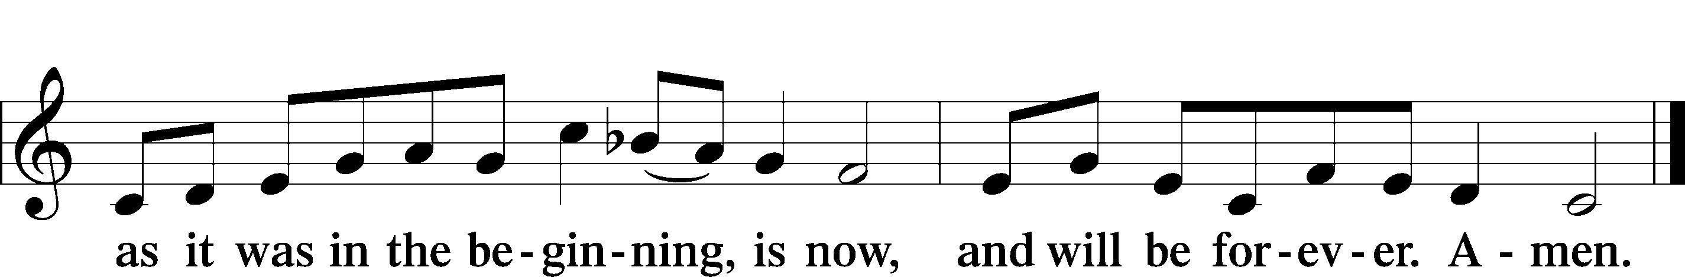

Post-Communion Collect

Benediction LSB 166

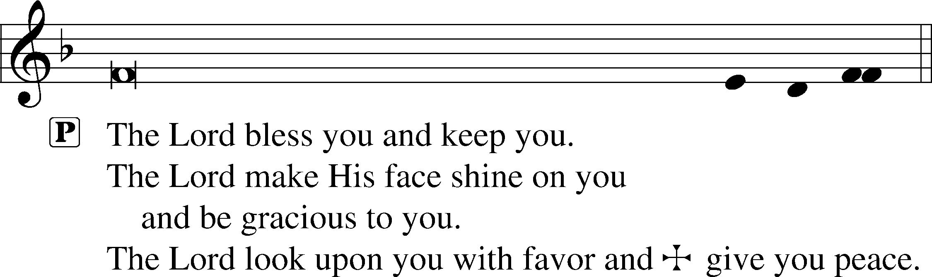

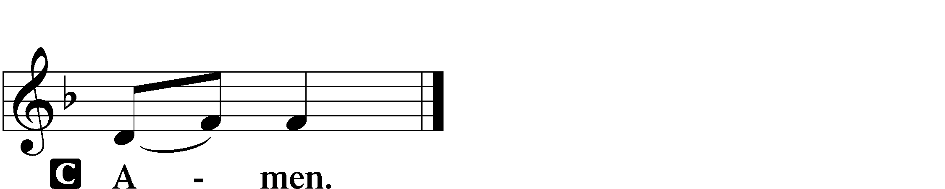

O Come, O Come, Emmanuel LSB 357

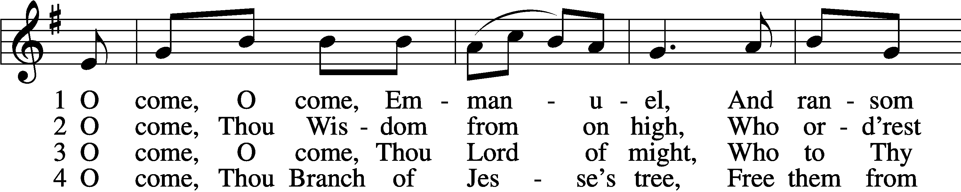

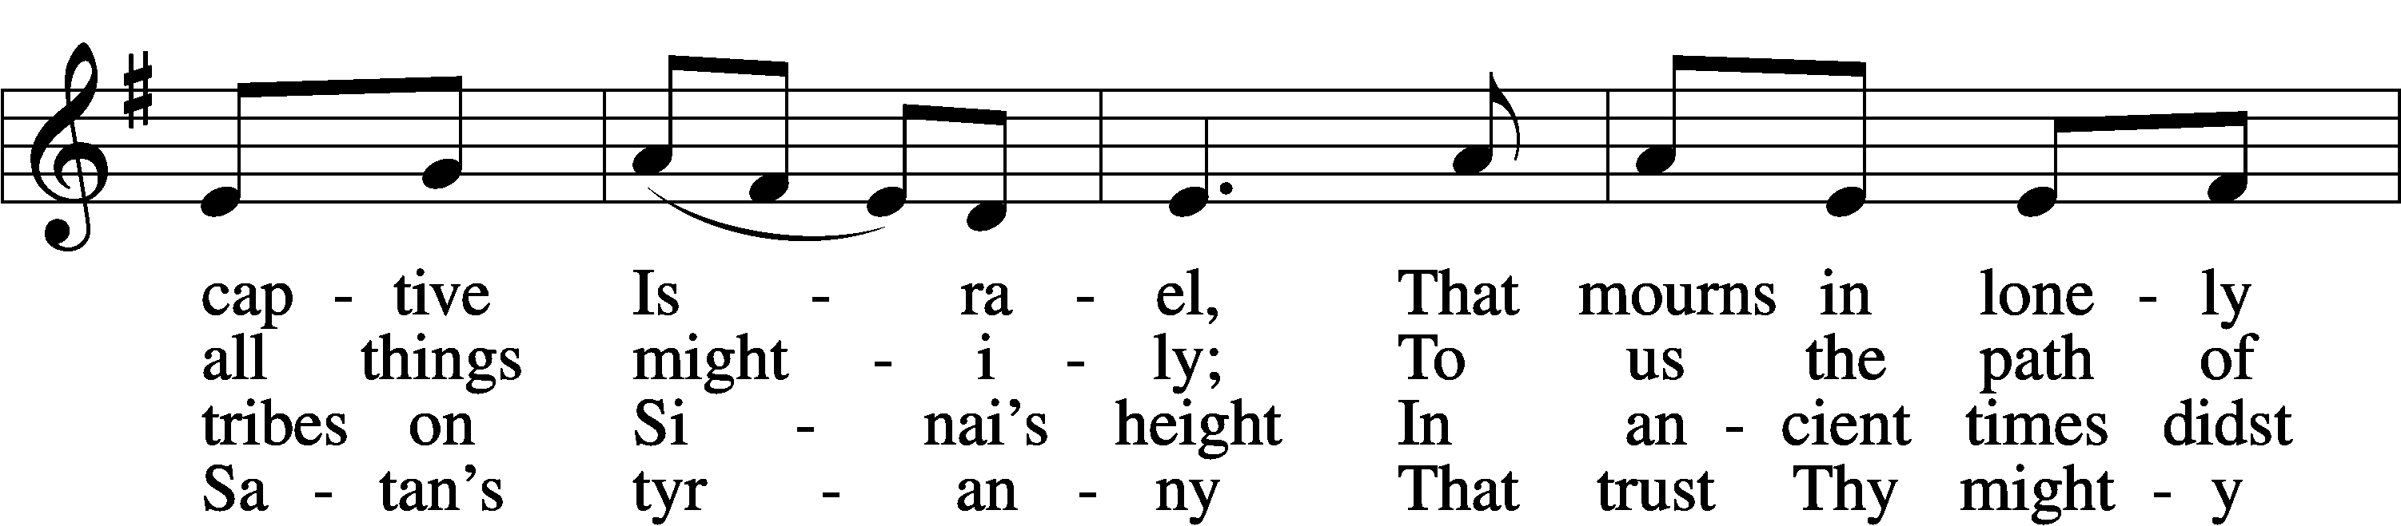

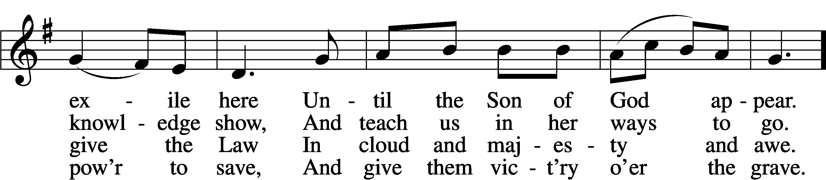

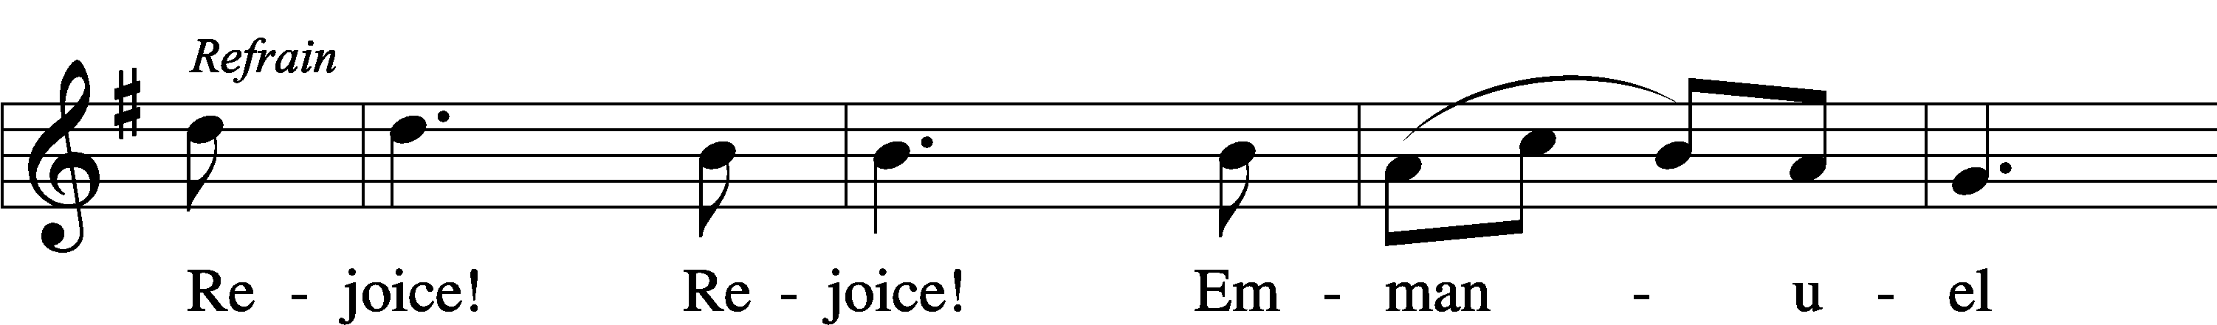

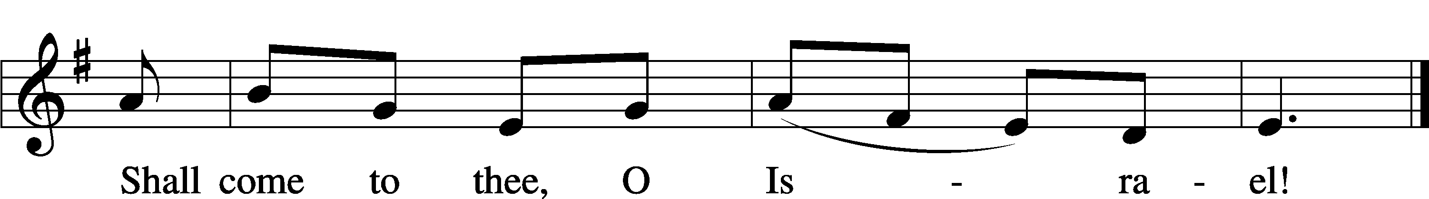

5 O come, Thou Key of David, come,  
And open wide our heav’nly home;  
Make safe the way that leads on high,  
And close the path to misery. Refrain

6 O come, Thou Dayspring from on high,  
And cheer us by Thy drawing nigh;  
Disperse the gloomy clouds of night,  
And death’s dark shadows put to flight. Refrain

7 O come, Desire of nations, bind  
In one the hearts of all mankind;  
Bid Thou our sad divisions cease,  
And be Thyself our King of Peace. Refrain

Text: Latin, c. 12th cent.; Psalteriolum Cantionum Catholicarum, 1710, Köln; tr. John Mason Neale, 1818–66, alt.  
Tune: French, 15th cent.  
Text and tune: Public domain

Acknowledgments

Unless otherwise indicated, Scripture quotations are from the ESV® Bible (The Holy Bible, English Standard Version®), copyright © 2001 by Crossway, a publishing ministry of Good News Publishers. Used by permission. All rights reserved.

Created by Lutheran Service Builder © 2023 Concordia Publishing House.

**Serving Our Lord in His House Today:**

Pastor: Rev. Noah J. Rogness

Organist: Rebecca Moseley

Elder: Dillin Lafferty

TAnnouncementsT

**Greeter Opportunity:** A new Greeter Sign-up Sheet is on the easel in the Narthex.  "Serve the Lord with gladness." (Ps.100:2a) Be the friendly, welcoming face at the door on Sundays!  If you have questions, contact Sylvia Engel.

**2024 Offering Envelopes:** Offering envelopes have been placed in your mailbox. If you did not receive a box, and would like envelopes, please contact Deb Lafferty in the church office.

**Secret Sister 2024:** Good Shepherd Secret Sister was a success in 2023 and will continue in 2024. Applications to join the fun will be on the Ushers table to be completed and turned in to Shawn Zabinski or Kathy Berg by the date on the form. Questions feel free to ask Shawn or Kathy.

**Donations for Ft. Wayne seminary Co-op:** The Good Shepherd Women’s LWML are spearheading a collection of items to be taken to the Ft. Wayne seminary Co-op to assist seminarians and their families with the cost of living during their time at the seminary. The Co-op consists of clothing, blankets, sheets, and pillowcases, nonperishable food items, and cleaning products of all kinds. There is a Thrivent card available for our use to purchase some of these items, but we are also asking for help from the congregation to provide help with this project also. Donations can be dropped off through January 14th and any help is greatly appreciated. Questions, contact Kathy Berg or

Pastor Rogness.

**Our Worship attendance last week:** Sunday: 80

Wednesday: 59

Total: 139

**Scripture Lessons for next week:** Numbers 6:22-27

Galatians 3:23-29

Luke 2:21

**Secretary Office Hours:** Thursday-Friday: 8:15am-12:15pm

*Please note, the church office will be closed, Monday, December 25 and Tuesday, December 26 in observance of Christmas. Deb will be away from the office on Wednesday, December 27 and Pastor Rogness will be away on Thursday, December 28. Christmas Blessings to you all.

***Our Week With Our Lord:***

**Today; 12/24**  **9:00am** **Divine Service w/Holy Communion**

*No Adult Bible Study or Sunday School

**7:00pm Lessons & Carols Candlelight Service**

**Monday; 12/25** Christmas Day- Office Closed

**9:00am Festival Divine Service**

**Tuesday; 12/26** Office Closed

**Wednesday; 12/27** *No Evening Church Service

*No Confirmation Class

**Sunday; 12/31** **9:00am** **Divine Service w/Holy Communion**

*No Adult Bible Study or Sunday School



