Good Shepherd Lutheran Church
The Resurrection of Our Lord
April 4, 2021

Pre-Service Music & Welcome
Divine Service Setting One – Lutheran Service Book (LSB) 151

Choir Prelude “Glory to the Risen Lord” by Mark Patterson

+CONFESSION AND ABSOLUTION+

Opening Hymn “Jesus Christ Is Risen Today” LSB 457
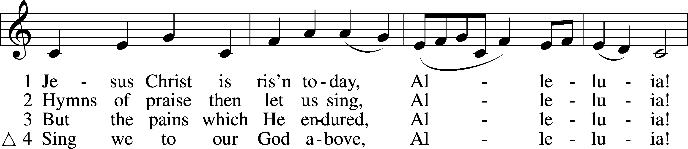
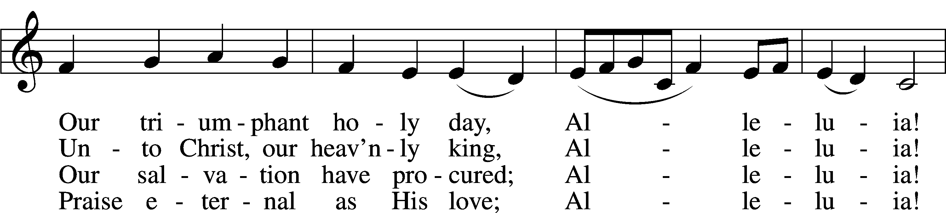
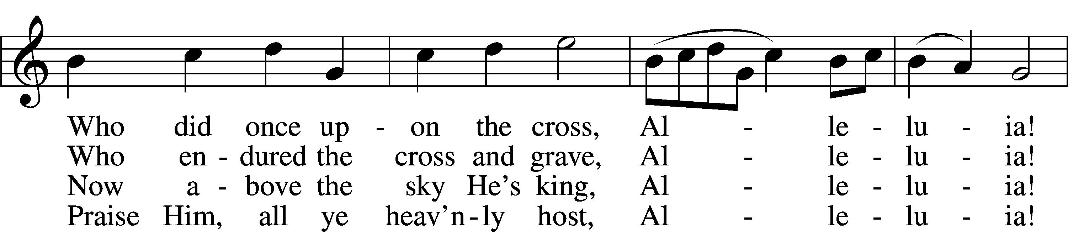
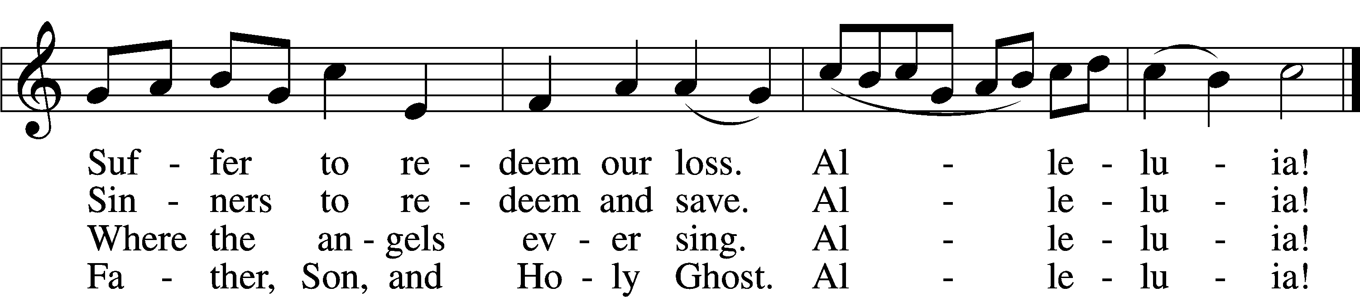
Text and tune: Public domain
Stand
The sign of the cross T may be made by all in remembrance of their Baptism.

Invocation
P In the name of the Father and of the T Son and of the Holy Spirit.
C Amen.

Exhortation LSB 151
P If we say we have no sin, we deceive ourselves, and the truth is not in us.
C But if we confess our sins, God, who is faithful and just, will forgive our sins and cleanse us from all unrighteousness.

Silence for reflection on God’s Word and for self-examination.

Confession of Sins LSB 151
P Let us then confess our sins to God our Father.
C Most merciful God, we confess that we are by nature sinful and unclean. We have sinned against You in thought, word, and deed, by what we have done and by what we have left undone. We have not loved You with our whole heart; we have not loved our neighbors as ourselves. We justly deserve Your present and eternal punishment. For the sake of Your Son, Jesus Christ, have mercy on us. Forgive us, renew us, and lead us, so that we may delight in Your will and walk in Your ways to the glory of Your holy name. Amen.

Absolution LSB 151
P Almighty God in His mercy has given His Son to die for you and for His sake forgives you all your sins. As a called and ordained servant of Christ, and by His authority, I therefore forgive you all your sins in the name of the Father and of the T Son and of the Holy Spirit.
C Amen.
+SERVICE OF THE WORD+

Introit Psalm 8:1, 5–6, 9; antiphon: Luke 24:5b–6b
He is risen! Alleluia!*
Why do you seek the living among the dead? Alleluia!
Remember how he told you, Alleluia,*
that the Son of Man must be crucified and on the third day rise. Alleluia!
O Lord, our Lord, how majestic is your name in all the earth!*
You have set your glory above the heavens.
Yet you have made him a little lower than the heavenly beings*
and crowned him with glory and honor.
You have given him dominion over the works of your hands;*
you have put all things under his feet.
O Lord, our Lord,*
how majestic is your name in all the earth!
Glory be to the Father and to the Son*
and to the Holy Spirit;
as it was in the beginning,*
is now, and will be forever. Amen.
He is risen! Alleluia!*
Why do you seek the living among the dead? Alleluia!
Remember how he told you, Alleluia,*
that the Son of Man must be crucified and on the third day rise. Alleluia!

Kyrie LSB 152
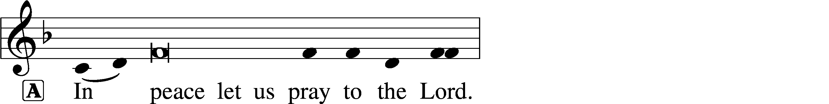
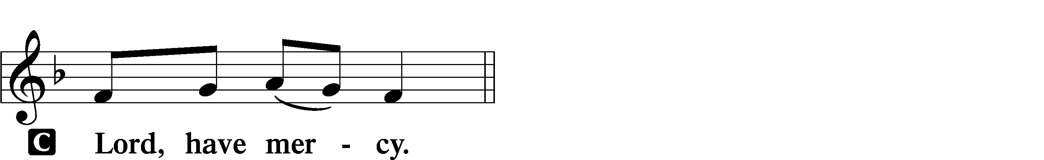
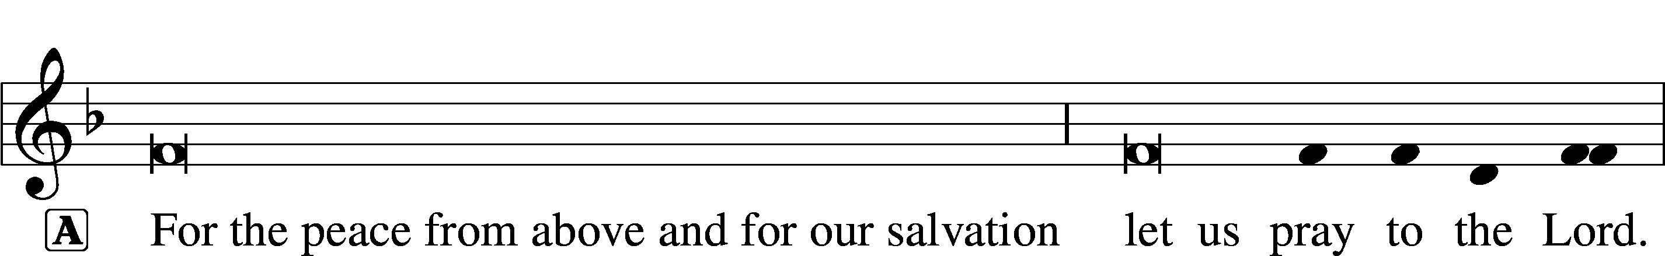
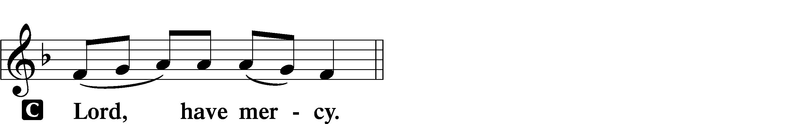
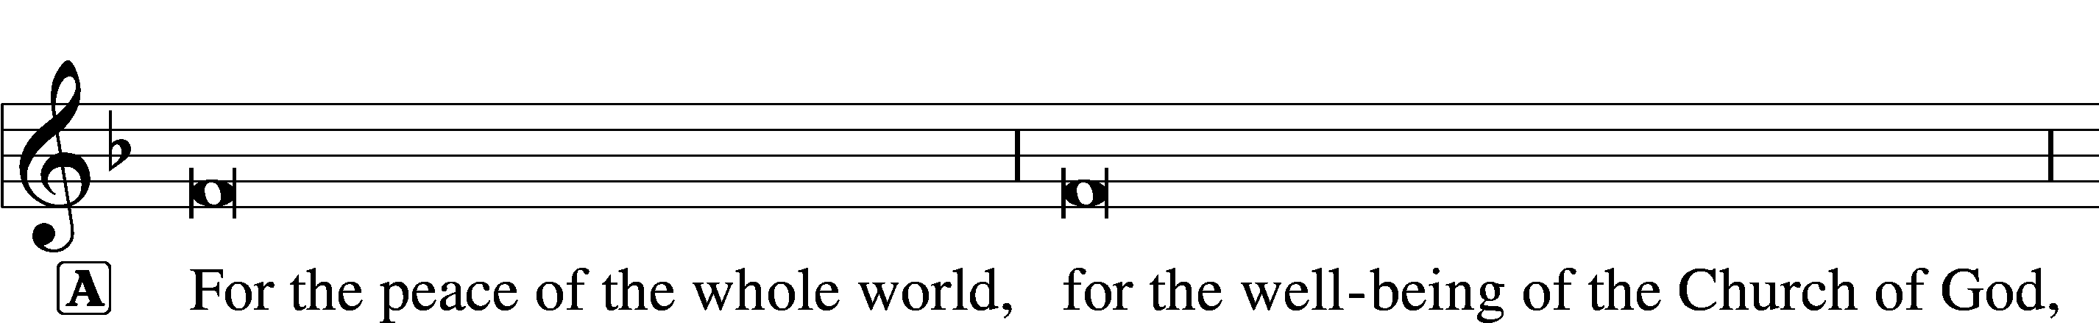
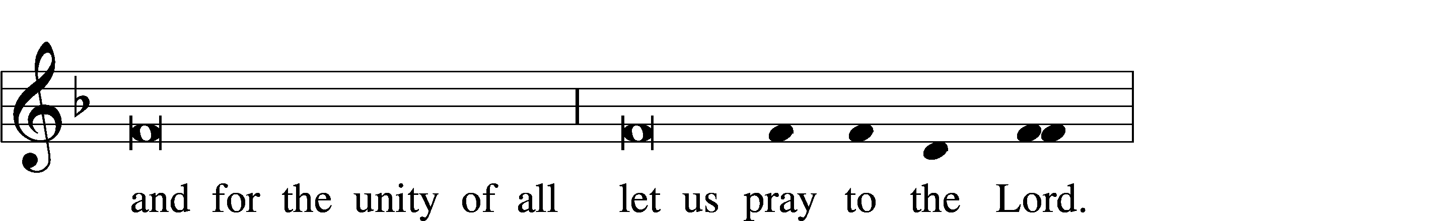
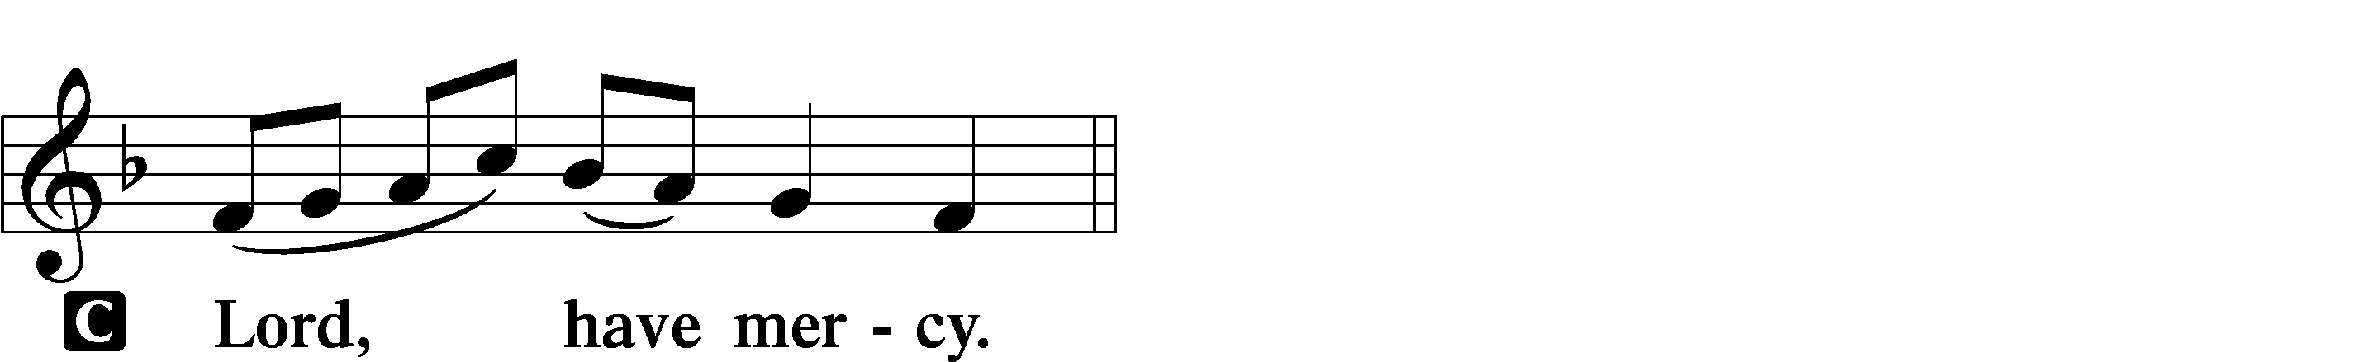
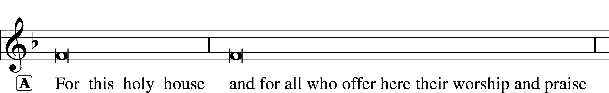
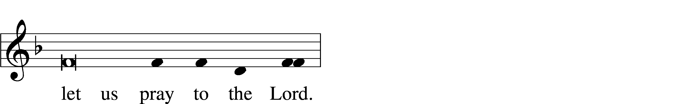
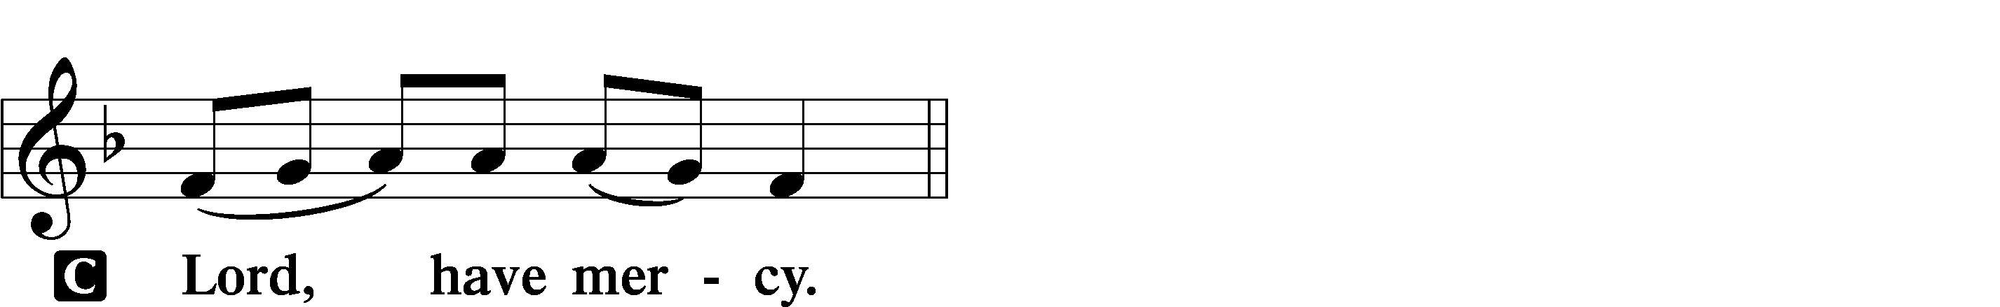

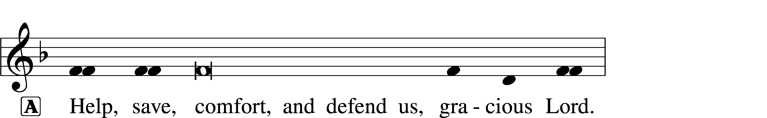
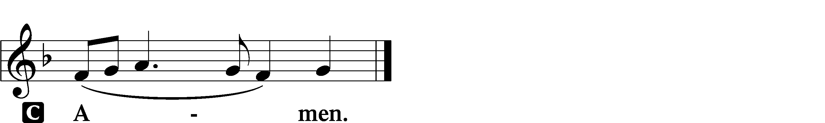

This Is the Feast LSB 155
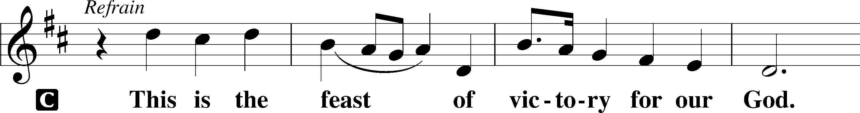
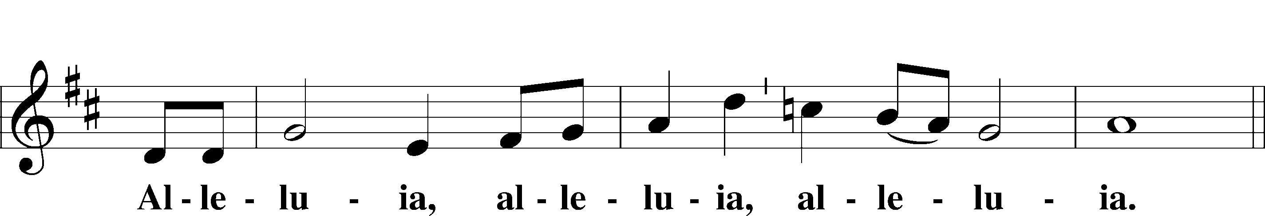
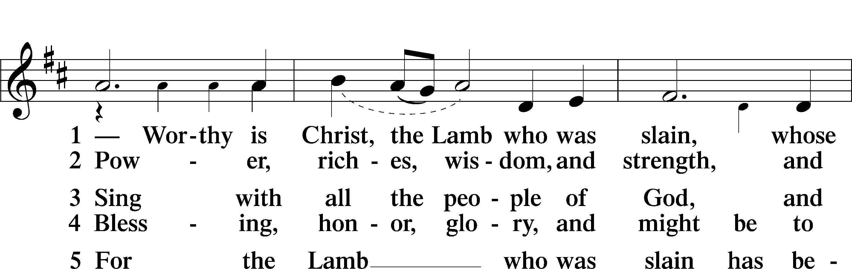
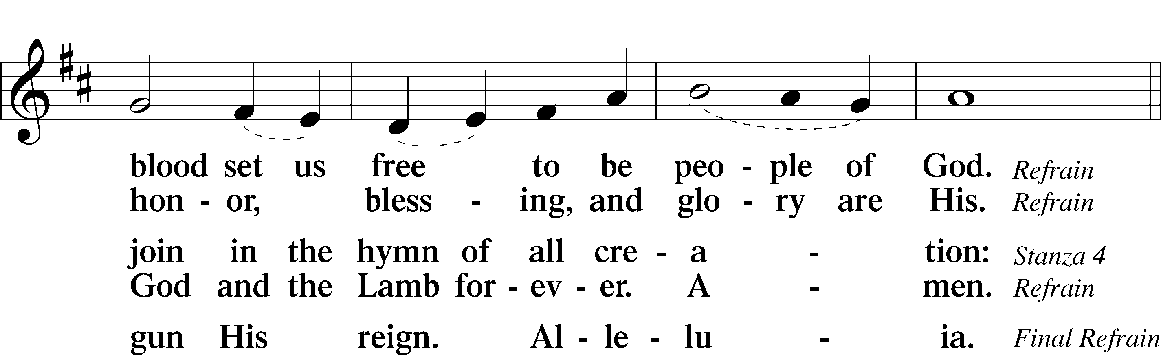
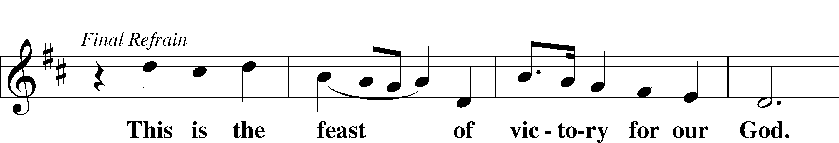
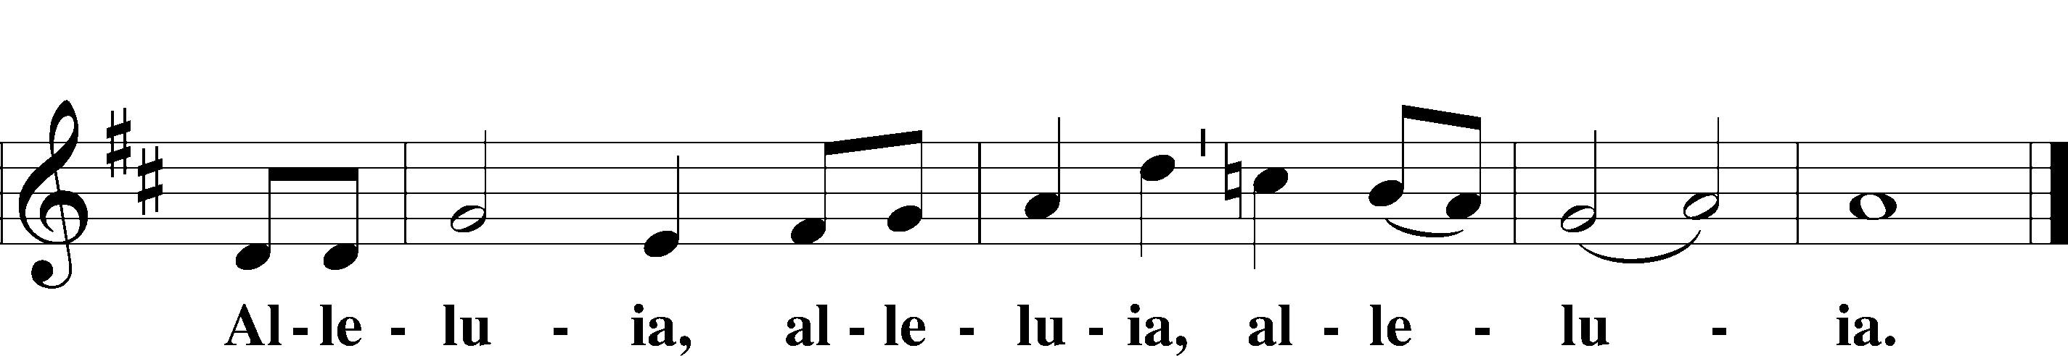

Salutation and Collect of the Day
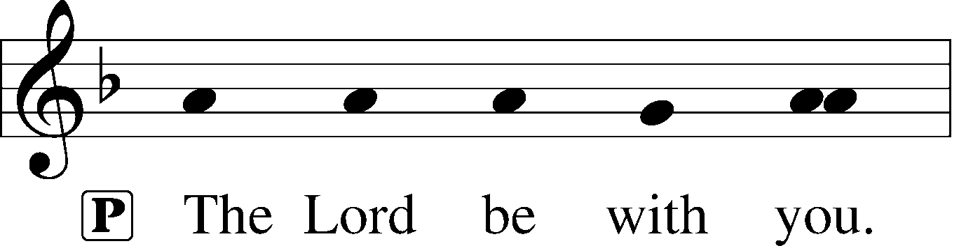
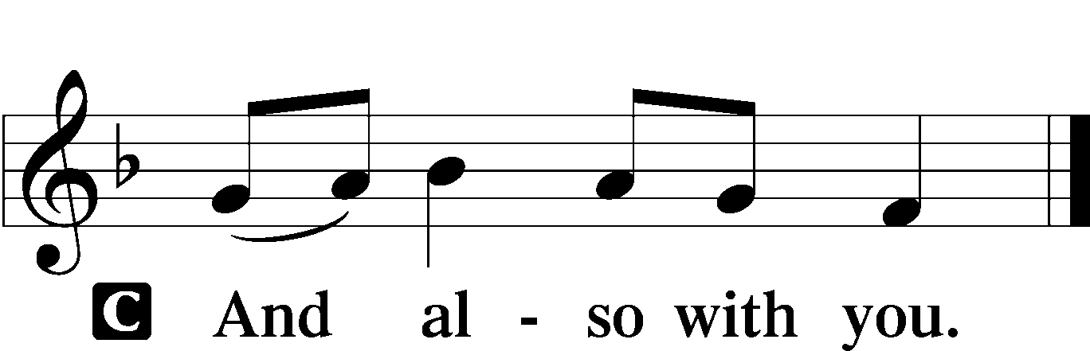

P Let us pray.
C Almighty God the Father, through Your only-begotten Son, Jesus Christ, You have overcome death and opened the gate of everlasting life to us. Grant that we, who celebrate with joy the day of our Lord’s resurrection, may be raised from the death of sin by Your life-giving Spirit; through Jesus Christ, our Lord, who lives and reigns with You and the Holy Spirit, one God, now and forever. Amen.

Sit

Old Testament Reading Job 19:23–27
23“Oh that my words were written!
Oh that they were inscribed in a book!
24Oh that with an iron pen and lead
they were engraved in the rock forever!
25For I know that my Redeemer lives,
and at the last he will stand upon the earth.
26And after my skin has been thus destroyed,
yet in my flesh I shall see God,
27whom I shall see for myself,
and my eyes shall behold, and not another.
My heart faints within me!”

A This is the Word of the Lord.
C Thanks be to God.

Gradual Psalm 118:24, 1
This is the day that the Lord has made;*
let us rejoice and be glad in it.
Oh give thanks to the Lord, for he is good;*
for his steadfast love endures forever!

Epistle 1 Corinthians 5:6–8
6Your boasting is not good. Do you not know that a little leaven leavens the whole lump? 7Cleanse out the old leaven that you may be a new lump, as you really are unleavened. For Christ, our Passover lamb, has been sacrificed. 8Let us therefore celebrate the festival, not with the old leaven, the leaven of malice and evil, but with the unleavened bread of sincerity and truth.

A This is the Word of the Lord.
C Thanks be to God.

Gospel Procession
Please stand. During the Easter Season, we will hear the Holy Gospel proclaimed from the midst of the congregation, remembering that our crucified and risen Lord Jesus Christ is here in our very mist right now! (Matthew 18:20). Please turn to face the processional cross as Pastor moves toward the center of the sanctuary with the Gospel. As we prepare to hear God’s Word, the choir will sing a festive musical setting of the Alleluia, then the congregation will speak together the Easter verse below, then we will all sing the festive setting of the Alleluia together. At last, we’ll hear the eternal Gospel of Jesus Christ proclaimed!

952 Alleluia (Choir)
V Alleluia, alleluia! Alleluia, alleluia!

Verse (Spoken by congregation) LSB 156
C Christ, our Passover lamb, has been sacrificed. Let us therefore celebrate the festival with the unleavened bread of sincerity and truth!

952 Alleluia (Congregation)
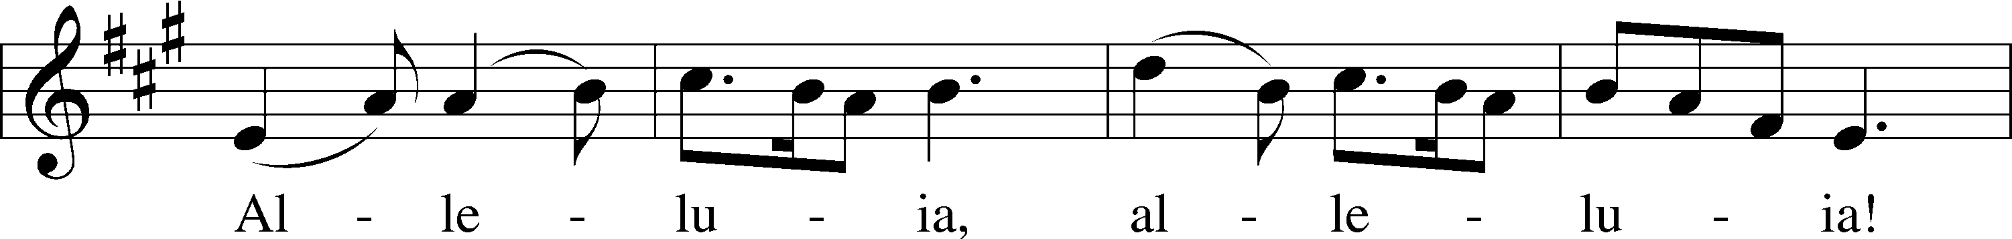
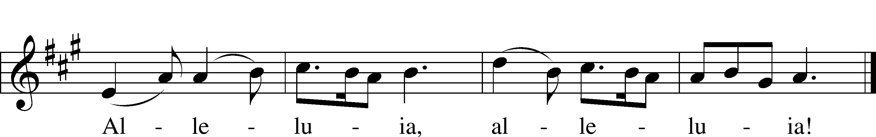
Text: Public domain
Tune: © 1985 Fintan O’Carroll and Christopher Walker, admin. OCP Publications. Used by permission: LSB Hymn License no. 110016438

Holy Gospel Mark 16:1–8
P The Holy Gospel according to St. Mark, the sixteenth chapter.

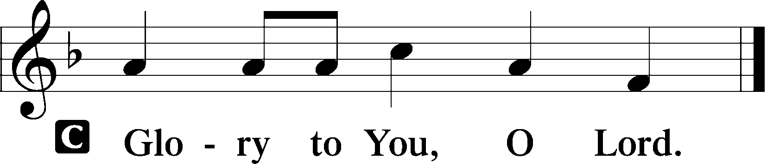

1When the Sabbath was past, Mary Magdalene and Mary the mother of James and Salome bought spices, so that they might go and anoint him. 2And very early on the first day of the week, when the sun had risen, they went to the tomb. 3And they were saying to one another, “Who will roll away the stone for us from the entrance of the tomb?” 4And looking up, they saw that the stone had been rolled back—it was very large. 5And entering the tomb, they saw a young man sitting on the right side, dressed in a white robe, and they were alarmed. 6And he said to them, “Do not be alarmed. You seek Jesus of Nazareth, who was crucified. He has risen; he is not here. See the place where they laid him. 7But go, tell his disciples and Peter that he is going before you to Galilee. There you will see him, just as he told you.” 8And they went out and fled from the tomb, for trembling and astonishment had seized them, and they said nothing to anyone, for they were afraid.

P This is the Gospel of the Lord.

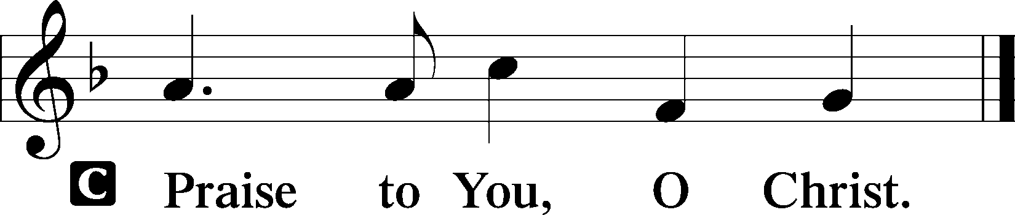

As Pastor returns to the chancel, we confess in the unity the teaching of Christ as explained in the Creeds.

Nicene Creed
C I believe in one God,
the Father Almighty,
maker of heaven and earth
and of all things visible and invisible.

And in one Lord Jesus Christ,
the only-begotten Son of God,
begotten of His Father before all worlds,
God of God, Light of Light,
very God of very God,
begotten, not made,
being of one substance with the Father,
by whom all things were made;
who for us men and for our salvation came down from heaven
and was incarnate by the Holy Spirit of the virgin Mary
and was made man;
and was crucified also for us under Pontius Pilate.
He suffered and was buried.
And the third day He rose again according to the Scriptures
and ascended into heaven
and sits at the right hand of the Father.
And He will come again with glory to judge both the living and the dead,
whose kingdom will have no end.

And I believe in the Holy Spirit,
the Lord and giver of life,
who proceeds from the Father and the Son,
who with the Father and the Son together is worshiped and glorified,
who spoke by the prophets.
And I believe in one holy Christian and apostolic Church,
I acknowledge one Baptism for the remission of sins,
and I look for the resurrection of the dead
and the life T of the world to come. Amen.

Sit

Children’s Message
“I know that my Redeemer lives!” Job 19:25

Hymn of the Day “Alleluia! Jesus Is Risen” LSB 474
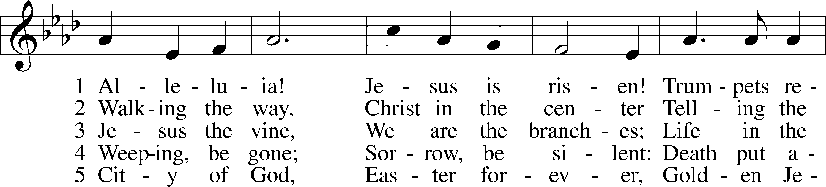
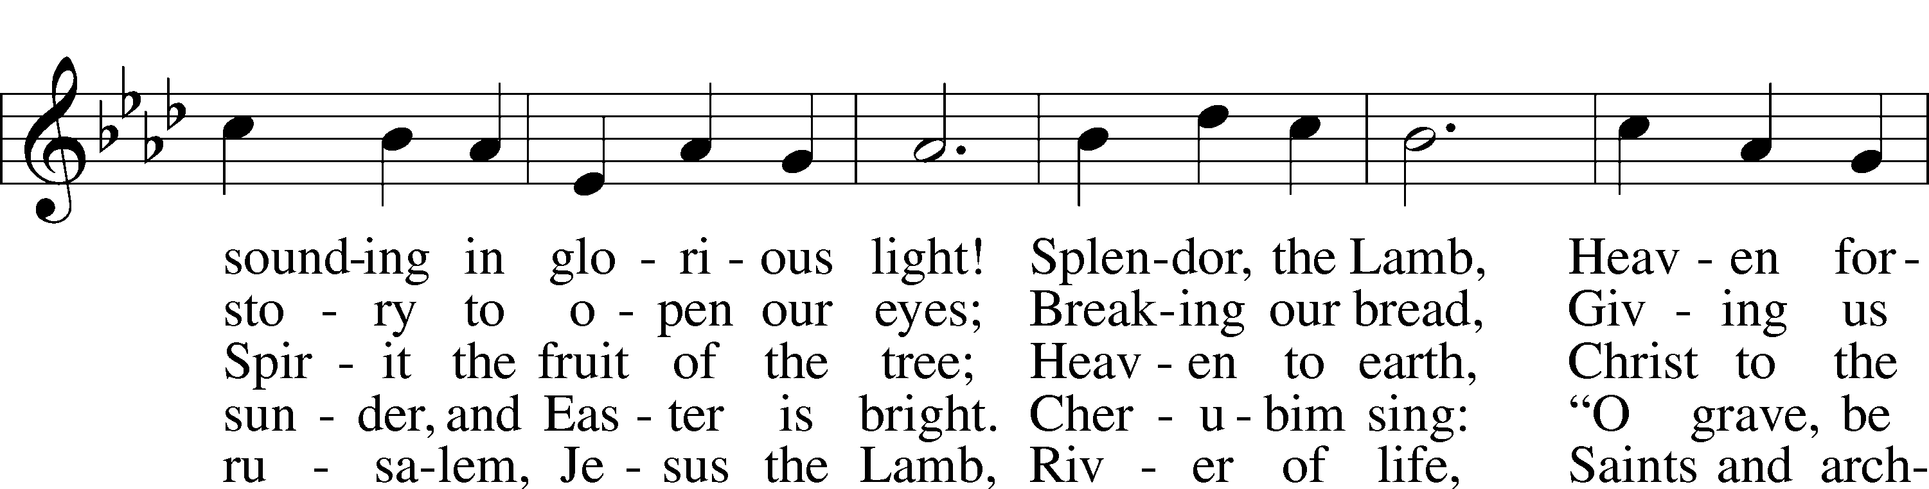
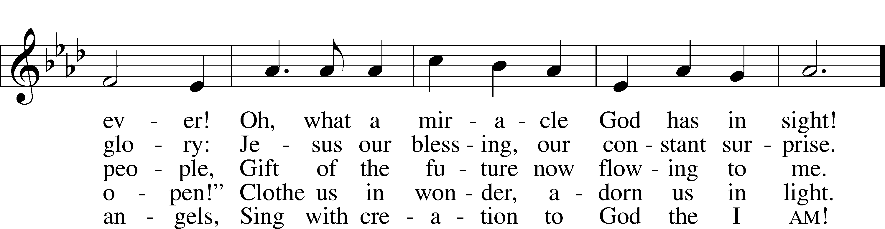
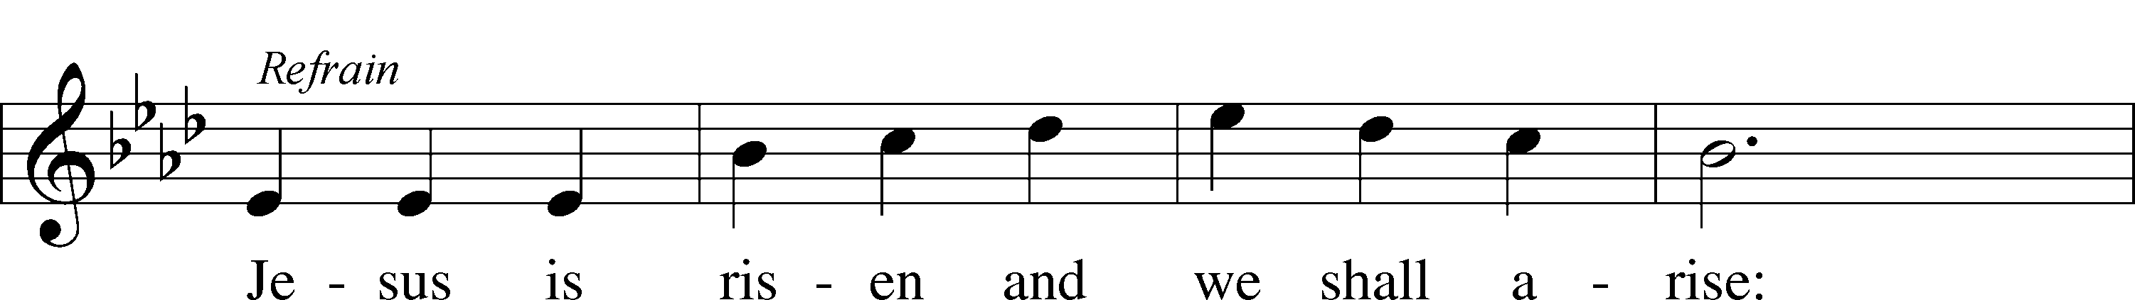
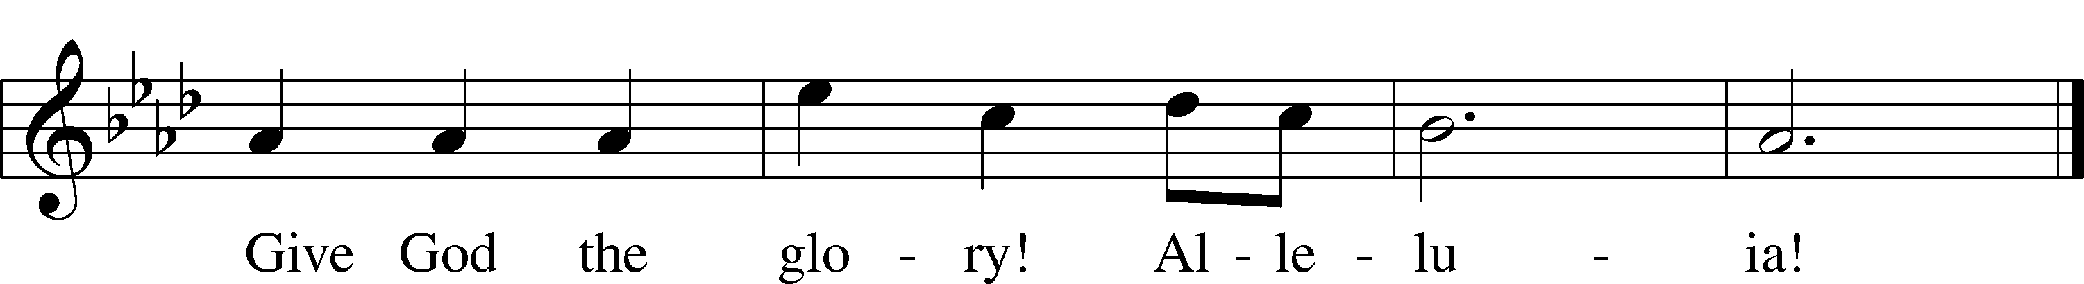
Text: © 1995 Augsburg Fortress. Used by permission: LSB Hymn License no. 110016438
Tune: © 1968 Augsburg Publishing House. Used by permission: LSB Hymn License no. 110016438

Sermon

Stand

Offertory LSB 159
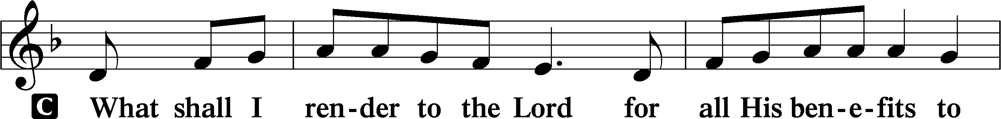
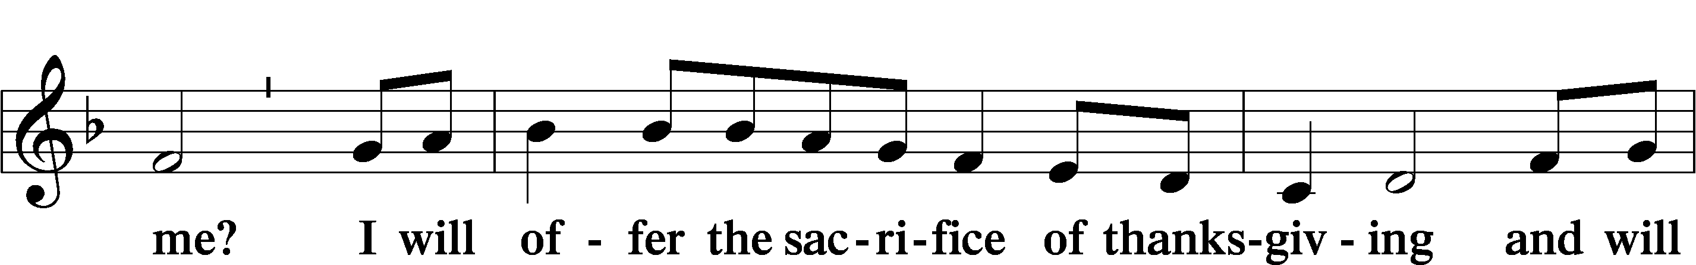
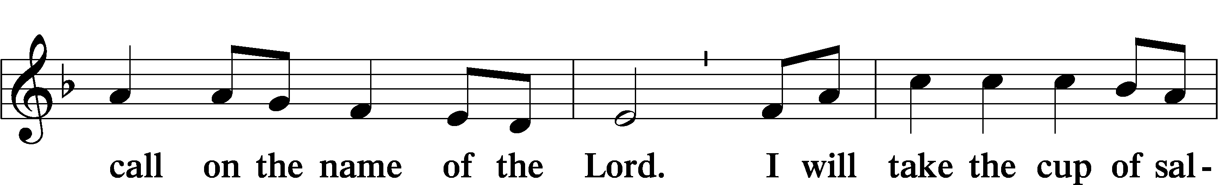
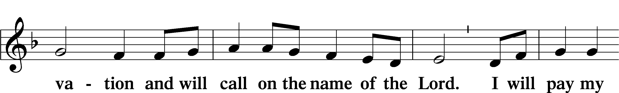
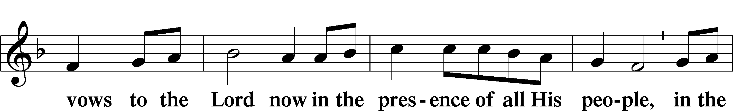
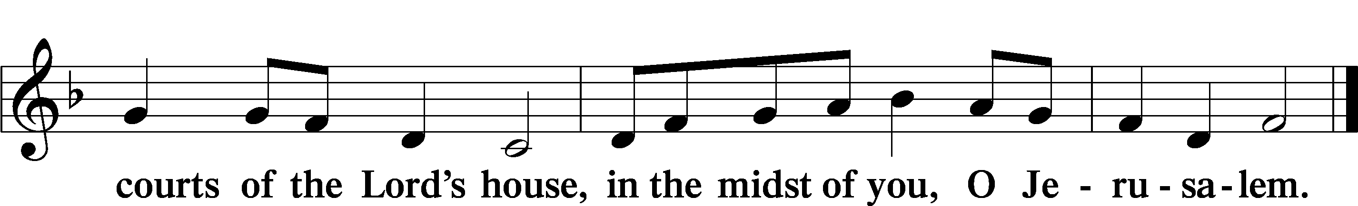

Sit

Announcements

We have returned to passing our offering plates and worship attendance forms! Please take a moment to fill out the attendance form, located at the inside of each row, and pass towards the outside of each row. There is hand sanitizer clipped to the log for your use. If you sanitize please do this after passing the offering plate so that the sanitizer doesn’t tarnish the metal.

Offering

Stand

Prayer of the Church

+SERVICE OF THE SACRAMENT+

Preface LSB 160
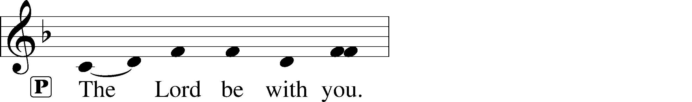
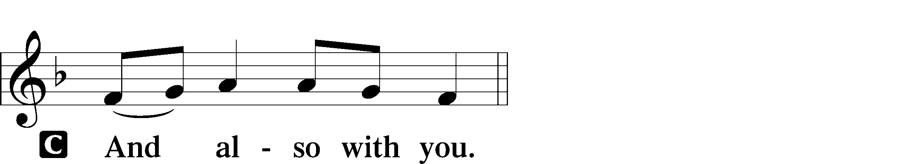
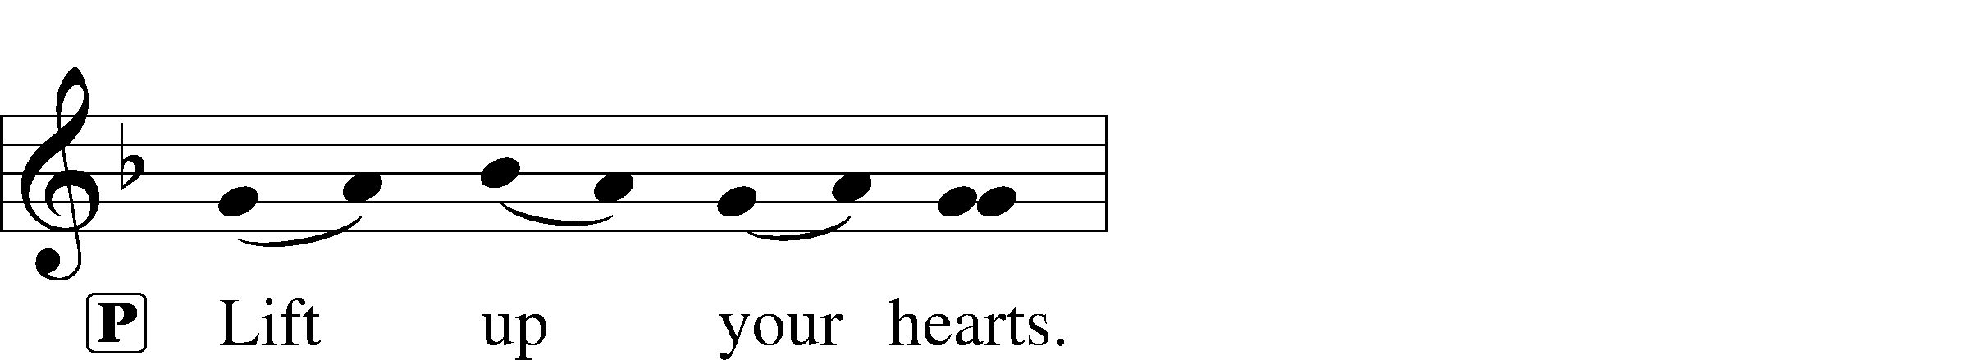
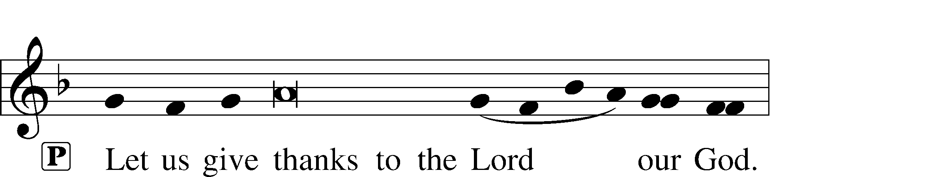
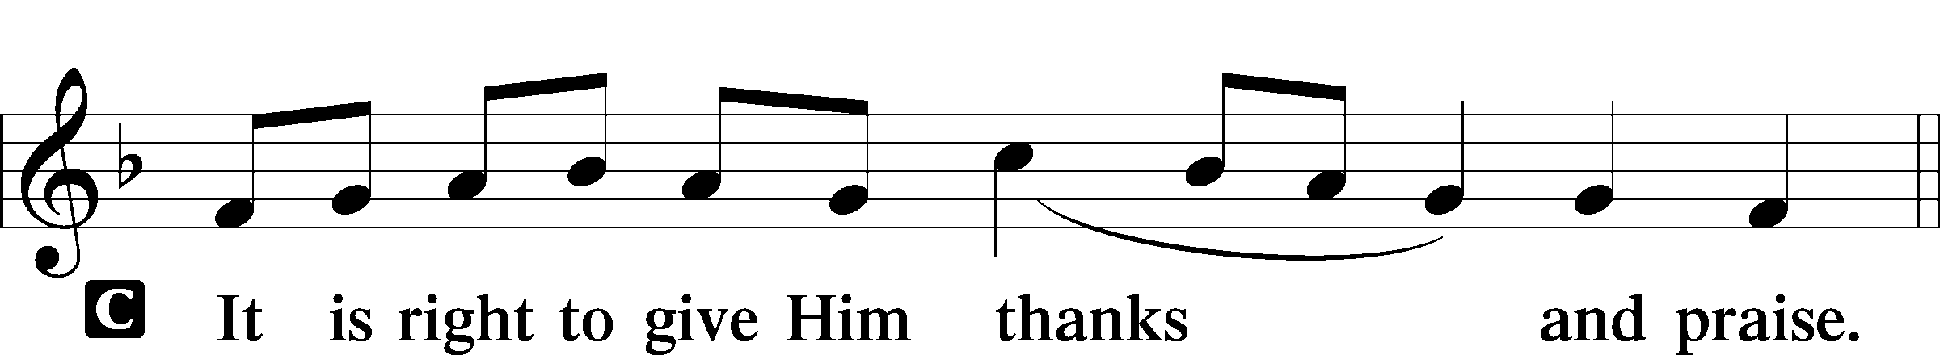

Proper Preface
P It is truly good, right, and salutary that we should at all times and in all places give thanks to You, holy Lord, almighty Father, everlasting God. And most especially are we bound to praise You on this day for the glorious resurrection of Your Son, Jesus Christ, the very Paschal Lamb, who was sacrificed for us and bore the sins of the world. By His dying He has destroyed death, and by His rising again He has restored to us everlasting life. Therefore with Mary Magdalene, Peter and John, and with all the witnesses of the resurrection, with angels and archangels, and with all the company of heaven we laud and magnify Your glorious name, evermore praising You and saying:

Sanctus LSB 161
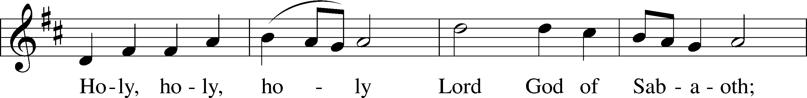
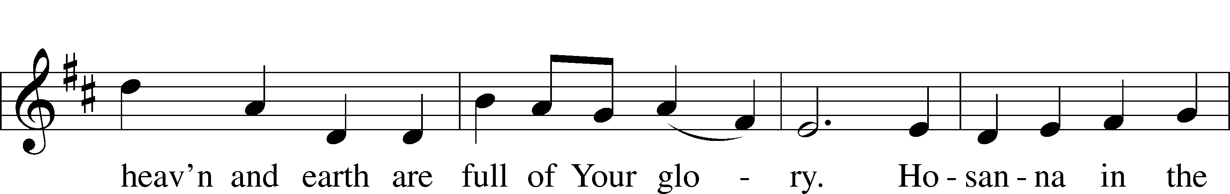
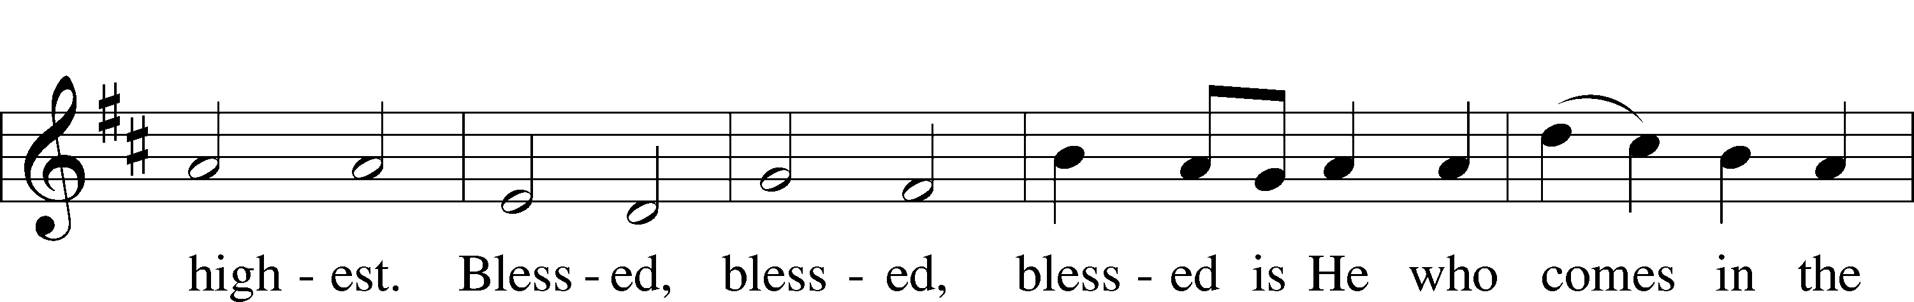
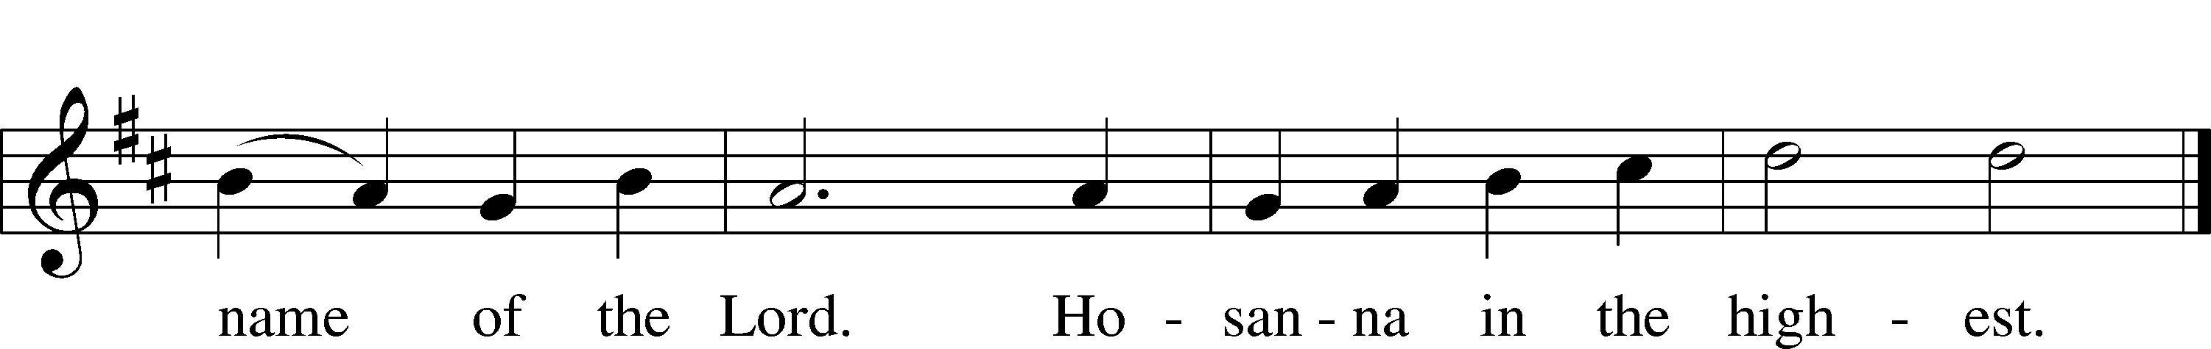
Text: © 1975 International Consultation on English Texts. Used by permission: LSB Hymn License no. 110016438
Tune: © 2006 Concordia Publishing House. Used by permission: LSB Hymn License no. 110016438

Lord’s Prayer
C Our Father who art in heaven,
hallowed be Thy name,
Thy kingdom come,
Thy will be done on earth
as it is in heaven;
give us this day our daily bread;
and forgive us our trespasses
as we forgive those
who trespass against us;
and lead us not into temptation,
but deliver us from evil.
For Thine is the kingdom
and the power and the glory
forever and ever. Amen.

The Words of Our Lord
P Our Lord Jesus Christ, on the night when He was betrayed, took bread, and when He had given thanks, He broke it and gave it to the disciples and said: “Take, eat; this is My T body, which is given for you. This do in remembrance of Me.”

In the same way also He took the cup after supper, and when He had given thanks, He gave it to them, saying: “Drink of it, all of you; this cup is the new testament in My T blood, which is shed for you for the forgiveness of sins. This do, as often as you drink it, in remembrance of Me.”

Pax Domini LSB 163
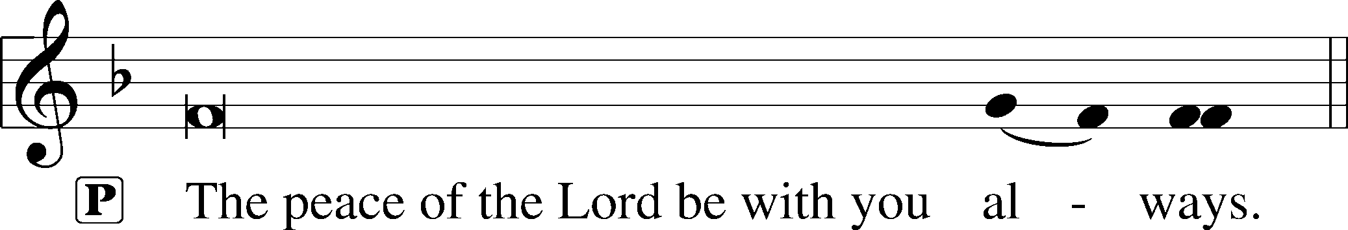
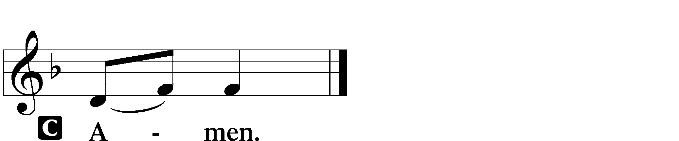

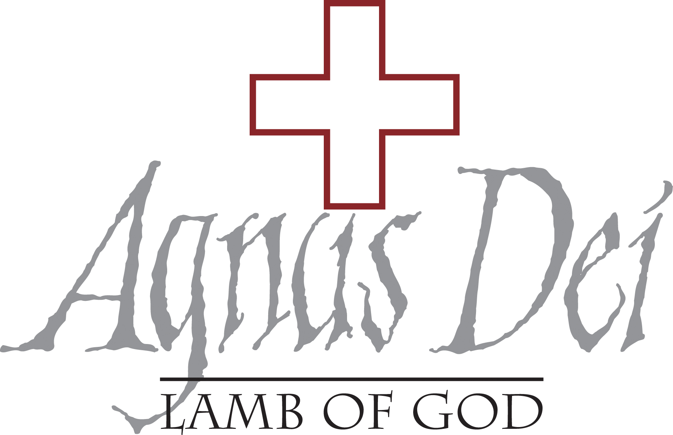
Agnus Dei LSB 163
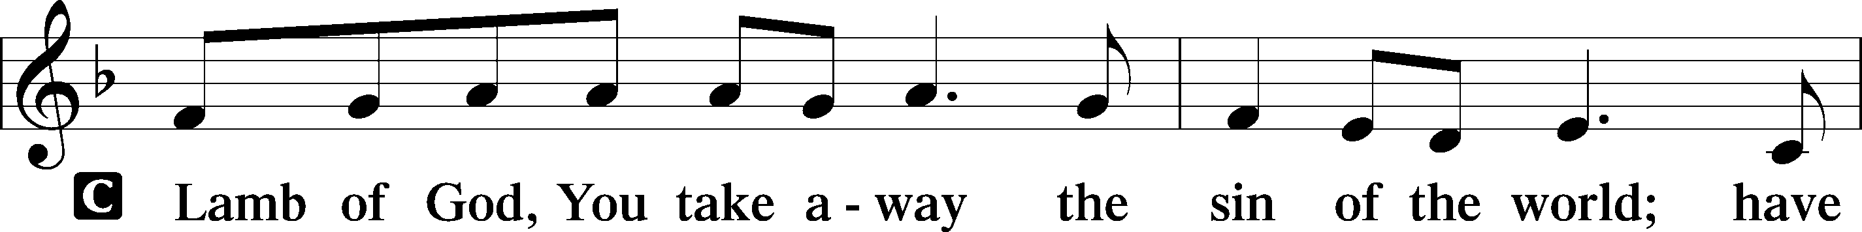
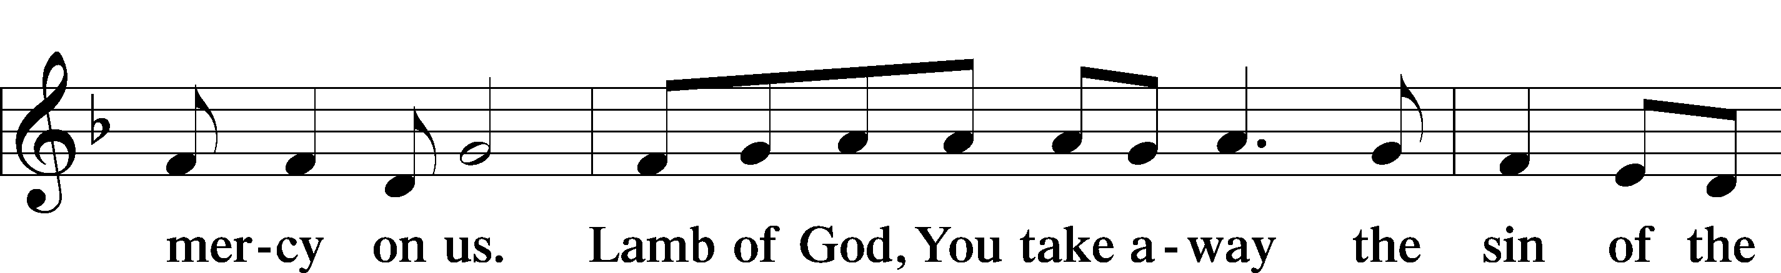
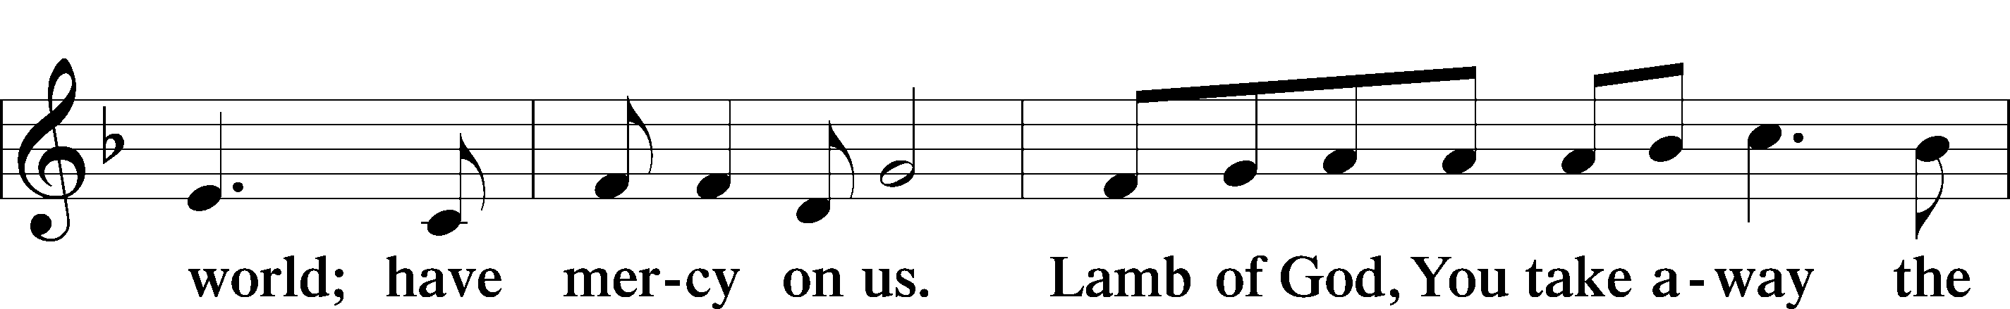
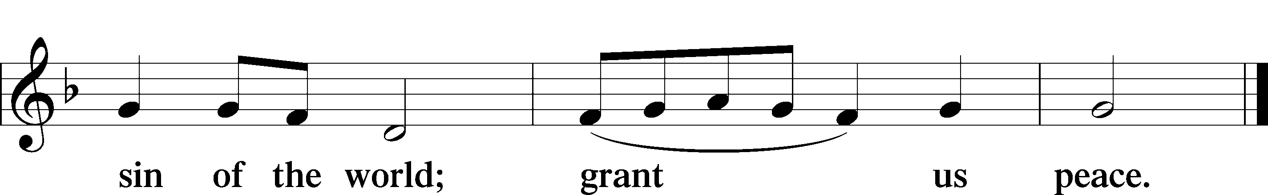

Sit

Distribution

Distribution Hymn “I Know That My Redeemer Lives” LSB 461
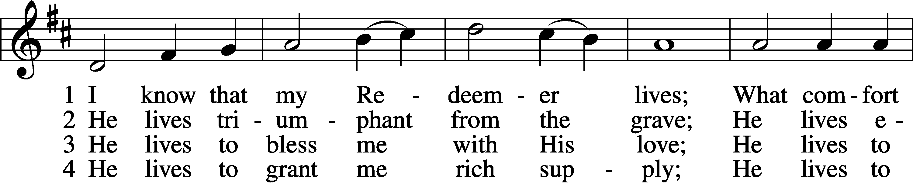
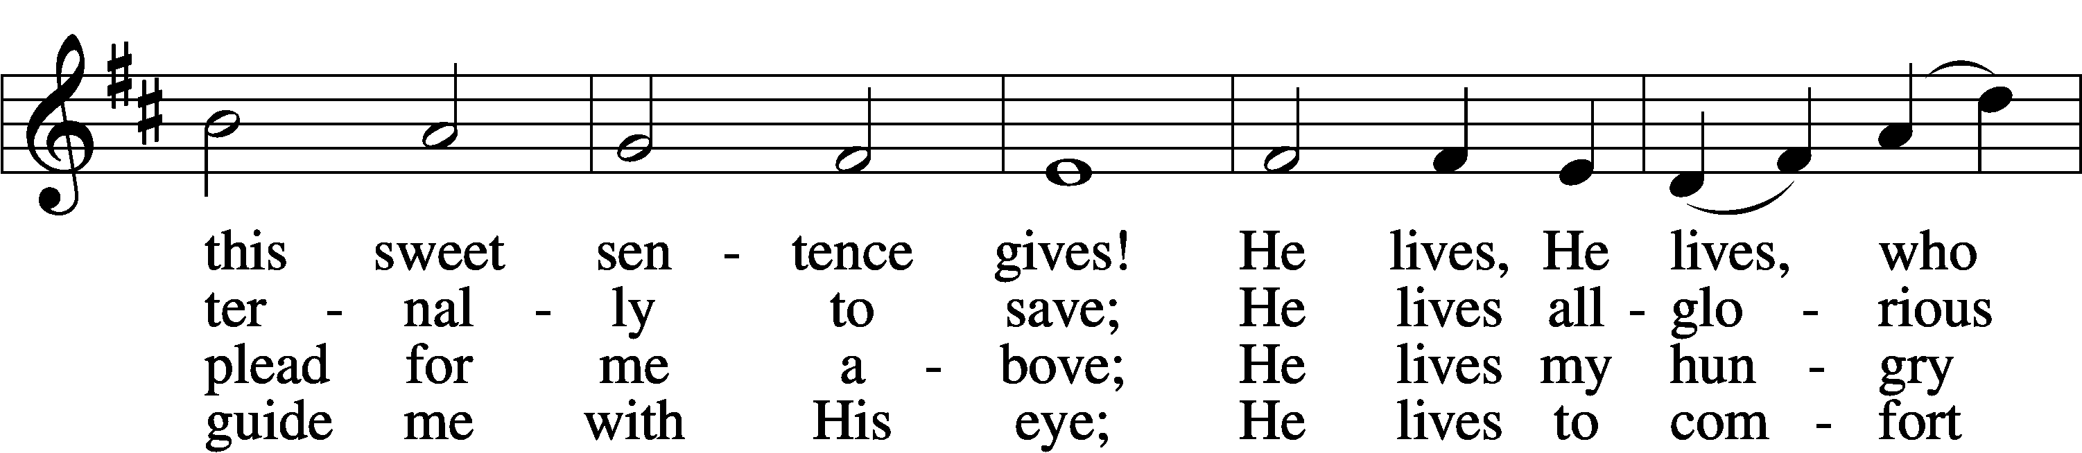
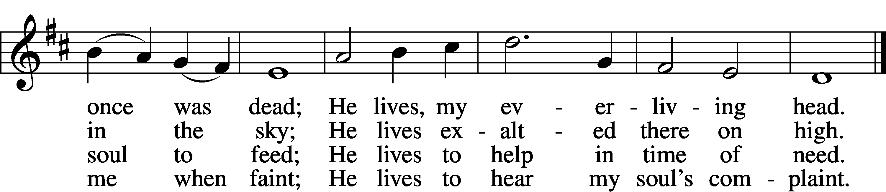

5 He lives to silence all my fears;
He lives to wipe away my tears;
He lives to calm my troubled heart;
He lives all blessings to impart.

6 He lives, my kind, wise, heav’nly friend;
He lives and loves me to the end;
He lives, and while He lives, I’ll sing;
He lives, my Prophet, Priest, and King.

7 He lives and grants me daily breath;
He lives, and I shall conquer death;
He lives my mansion to prepare;
He lives to bring me safely there.

8 He lives, all glory to His name!
He lives, my Jesus, still the same;
Oh, the sweet joy this sentence gives:
I know that my Redeemer lives!
Tune and text: Public domain

Distribution Hymn “Good Christian Friends, Rejoice and Sing” LSB475
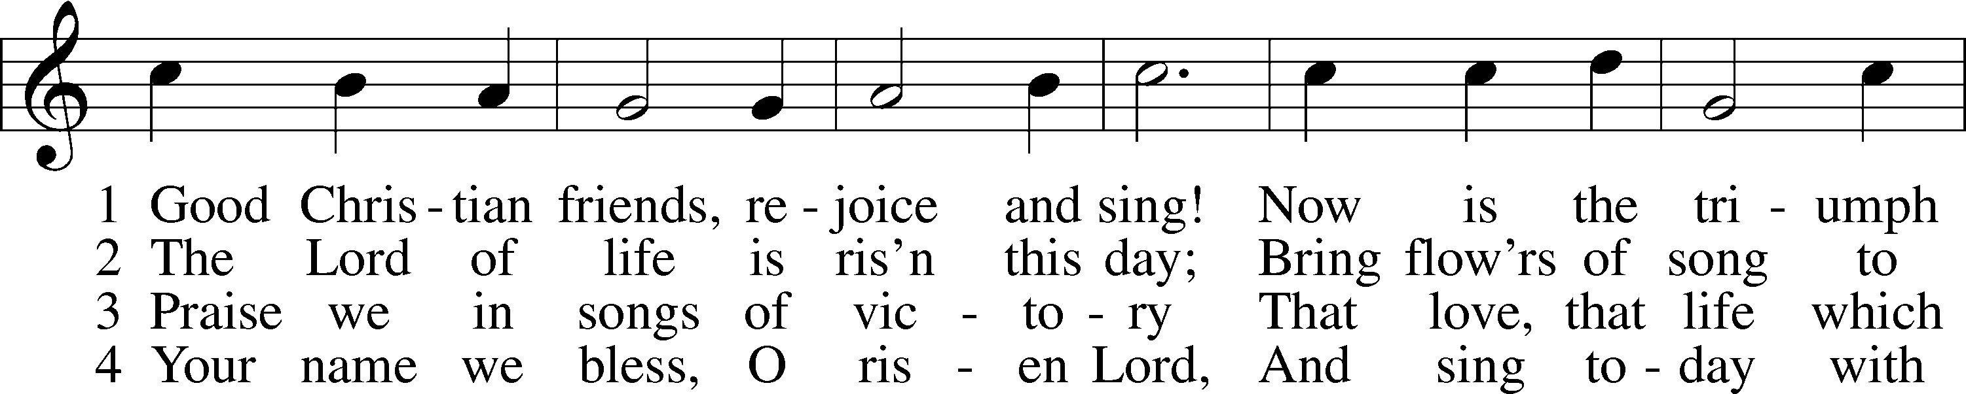
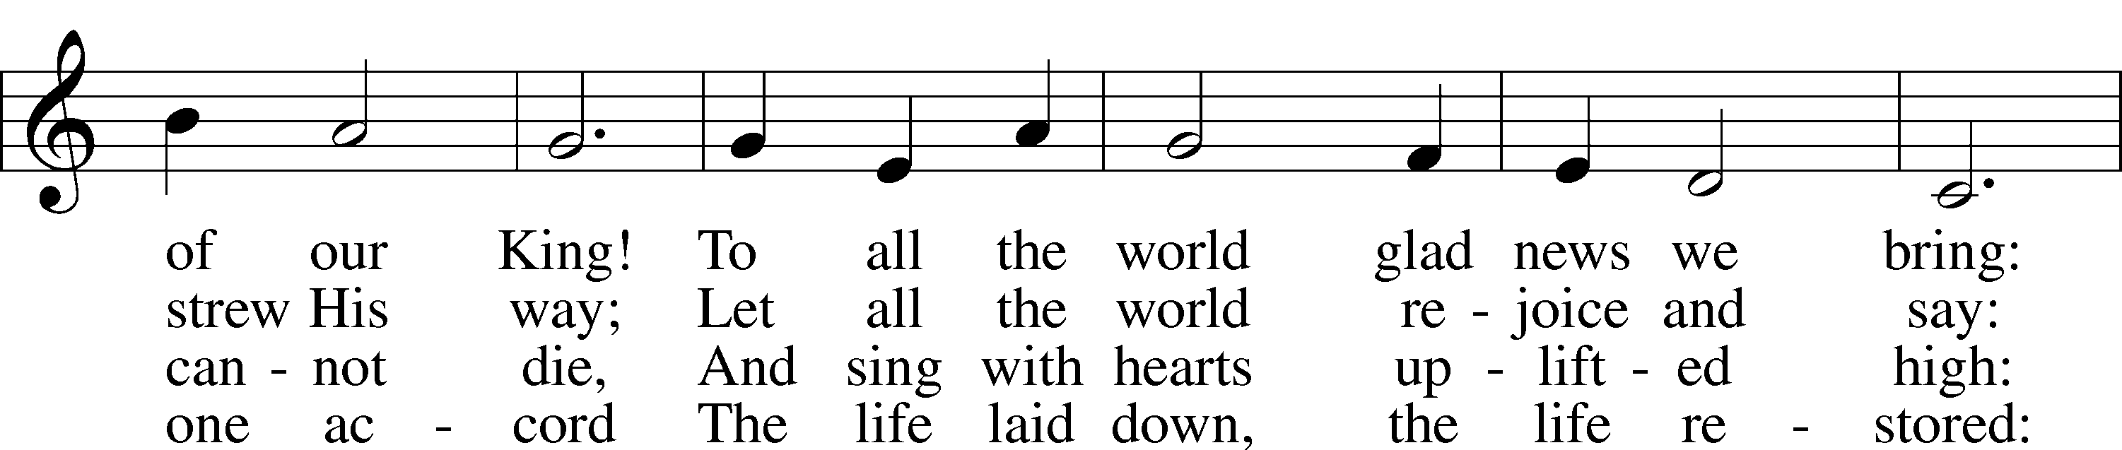
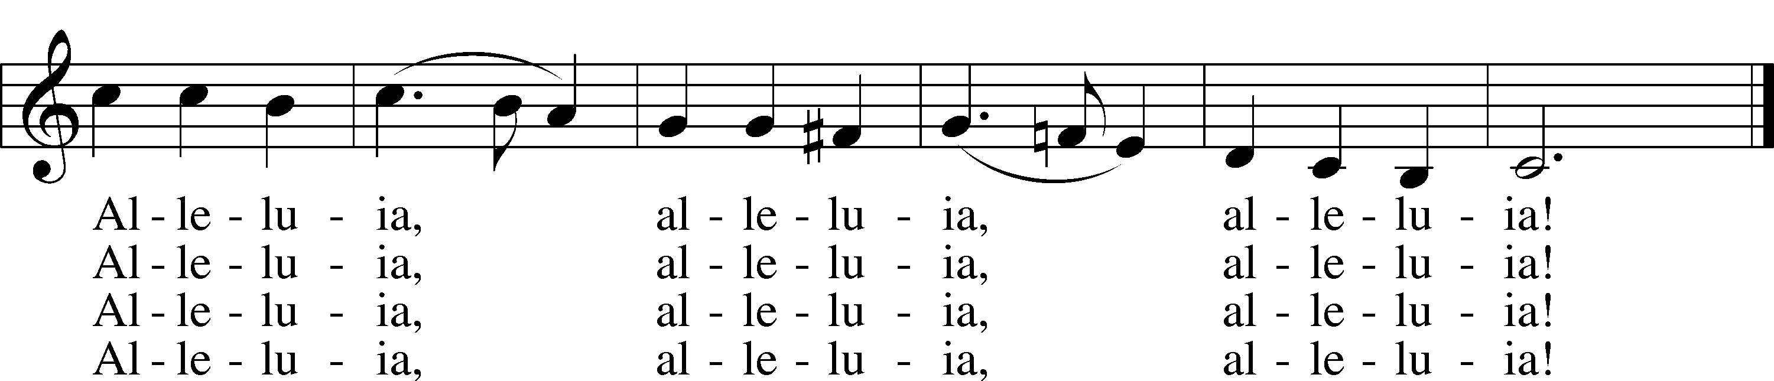
Text: © 1958, renewed 1986 Hymns Ancient and Modern Ltd., admin. Hope Publishing Co. Used by permission: LSB Hymn License no. 110016438
Tune: Public domain

Stand

Nunc Dimittis LSB 165
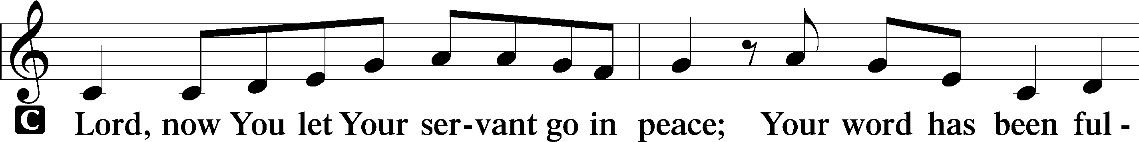
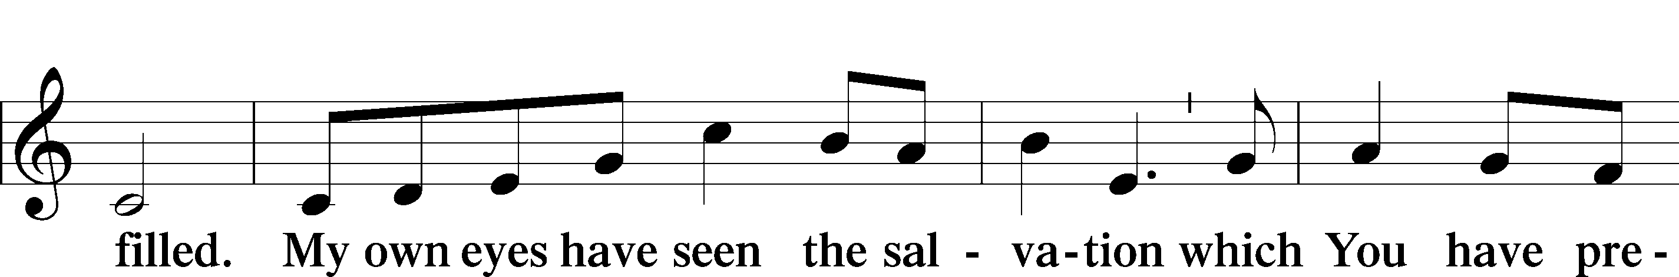
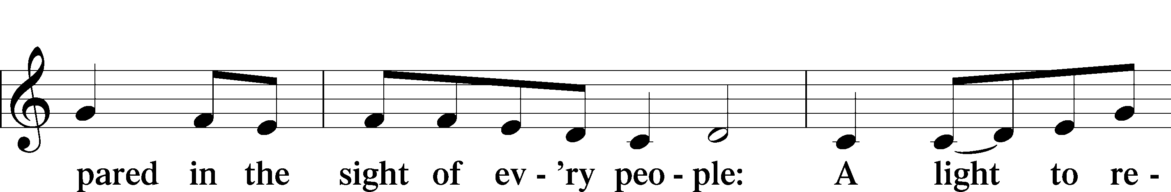
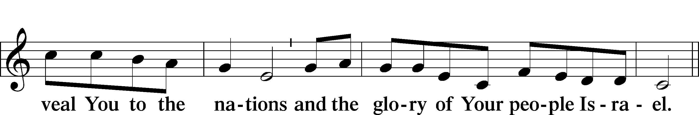
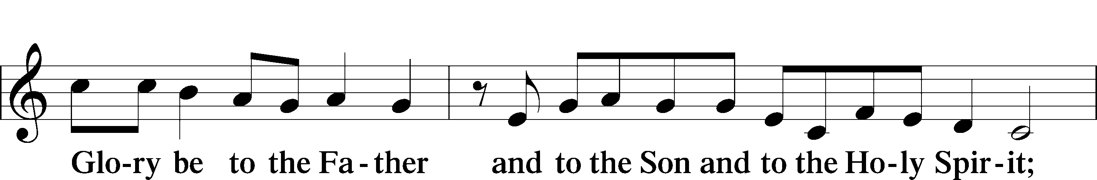
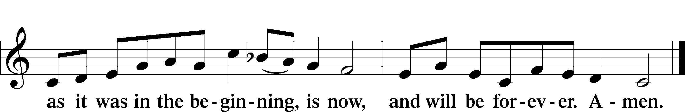

Post-Communion Collect
A Let us pray.
We give thanks to You, almighty God, that You have refreshed us through this salutary gift, and we implore You that of Your mercy You would strengthen us through the same in faith toward You and in fervent love toward one another; through Jesus Christ, Your Son, our Lord, who lives and reigns with You and the Holy Spirit, one God, now and forever.
C Amen.

Benediction LSB 166
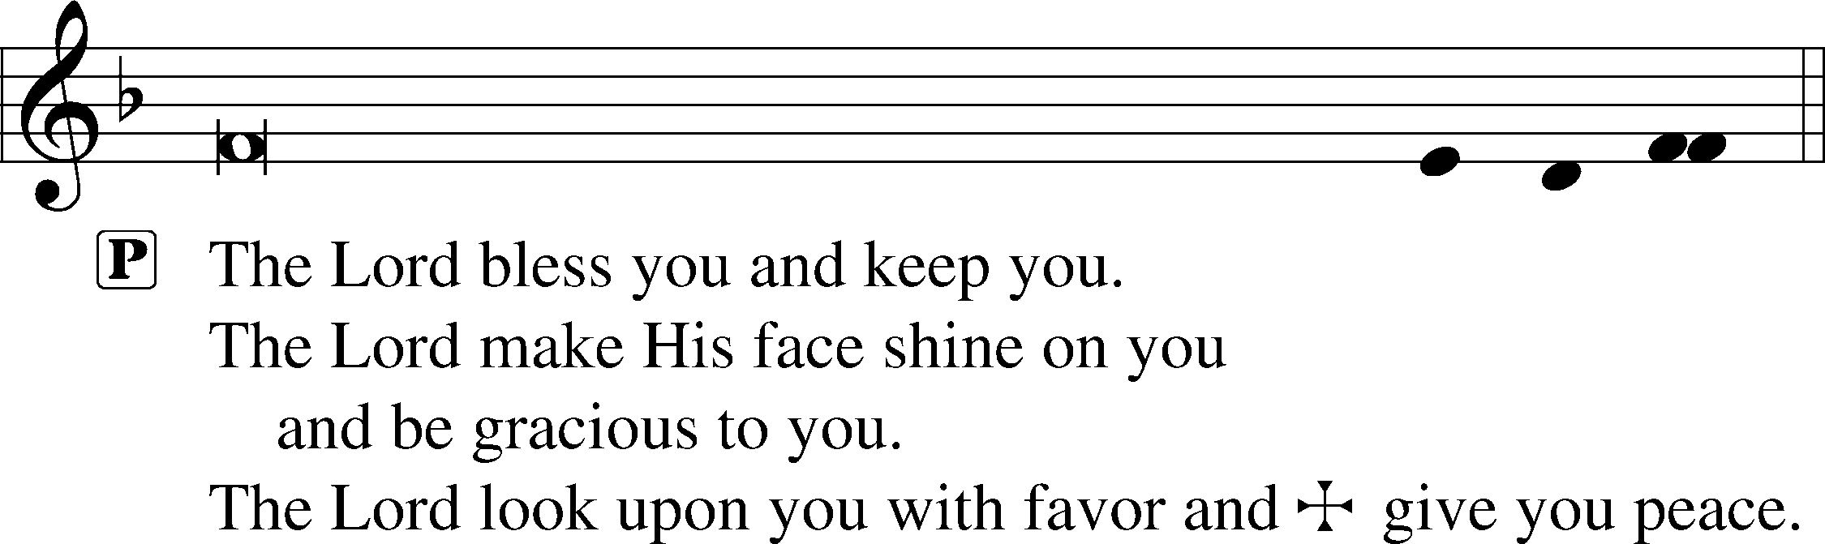
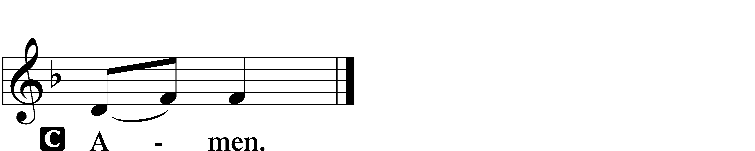

Closing Hymn “Now All the Vault of Heaven Resounds” LSB 465
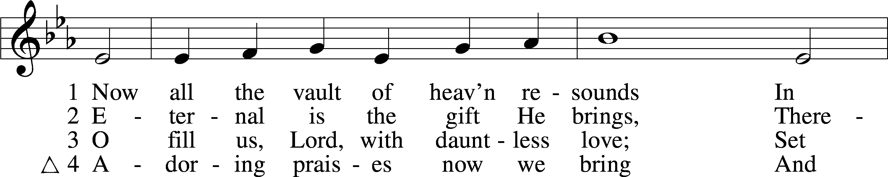
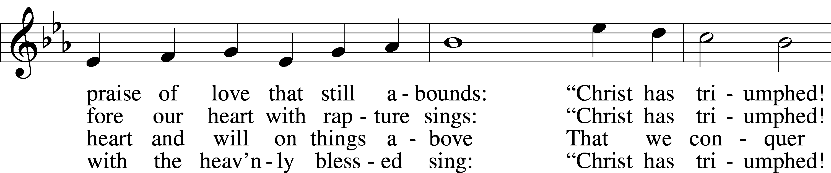
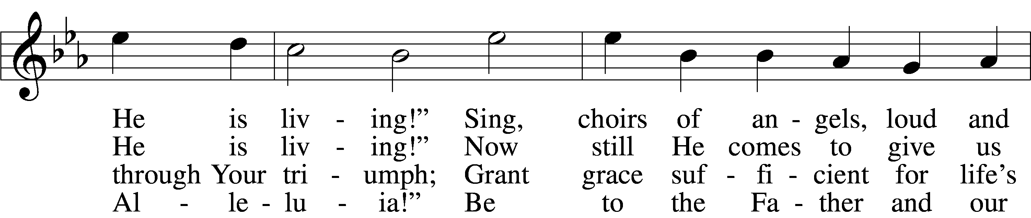
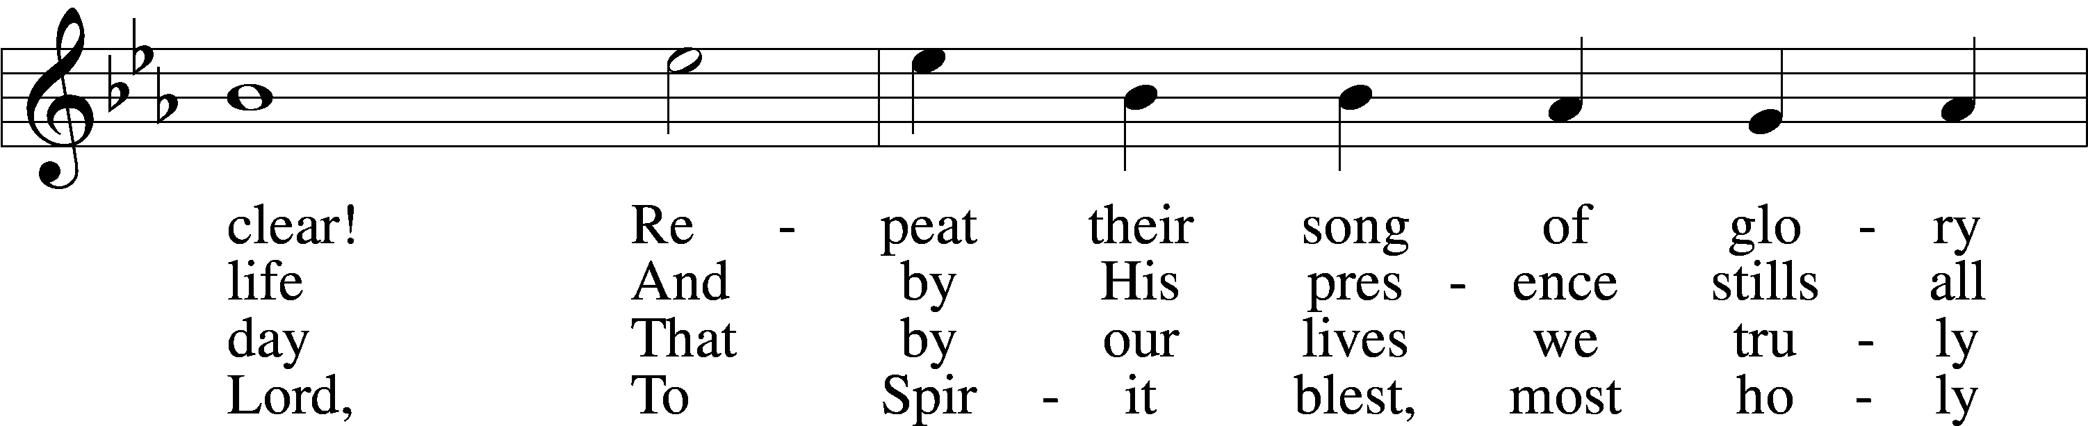
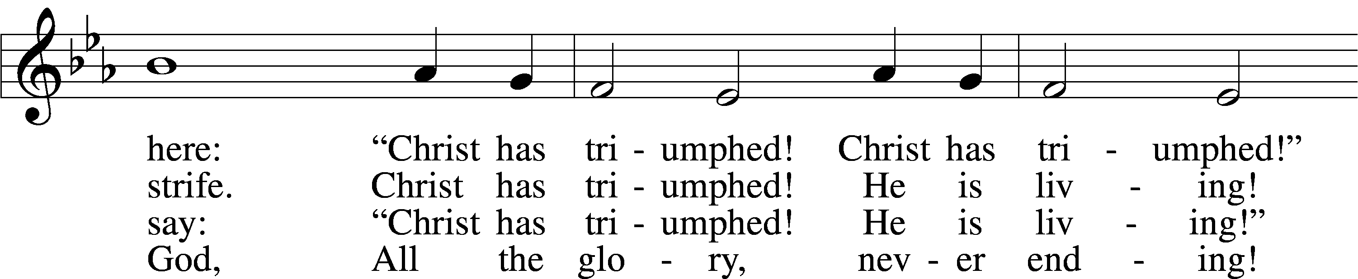
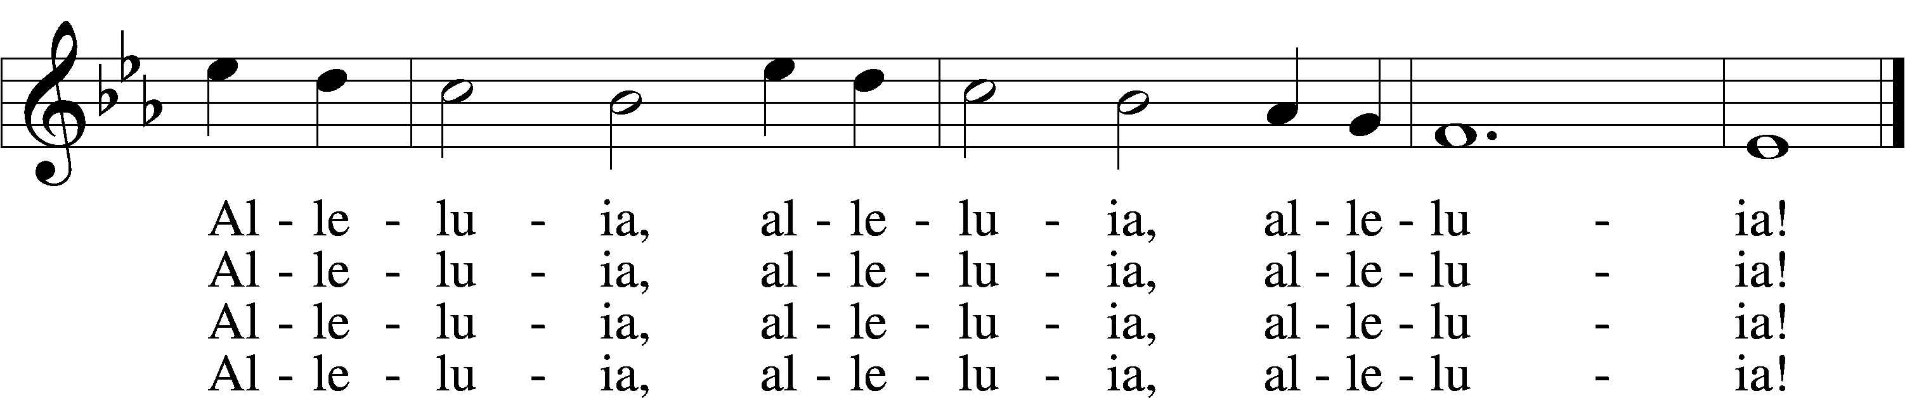
Text: © 1958 Augsburg Publishing House. Used by permission: LSB Hymn License no. 110016438
Tune: Public domain

Acknowledgments
Unless otherwise indicated, Scripture quotations are from the ESV® Bible (The Holy Bible, English Standard Version®), copyright © 2001 by Crossway, a publishing ministry of Good News Publishers. Used by permission. All rights reserved.
Created by Lutheran Service Builder © 2021 Concordia Publishing House.

Serving Our Lord in His House Today:
Pastor: Rev. David Wurdeman
Organist: Rebecca Moseley
Elders: Josh Church & Bob Pulley
Music: Adult Choir

Gifts from God: John 20:1 – “Now on the first day of the week …” All is made new by the Resurrection of Jesus! Even the day of worship has transitioned from the Old Testament’s Saturday Sabbath to the Lord’s Day of the New Testament. For the Lord has made all things new. He has begun a new week for a new creation in rising from the dead as the New Adam. We are also made new in Him – a new heart, a new life, new desires, and a new outlook toward God. All this comes from our Risen Lord’s grace. Especially after the sort of year we’ve had since last Easter. It’s sure good news to hear that the Lord makes all things start afresh.

Services: We are back to a single Sunday service! Next Sunday and the following weeks, our regular Sunday schedule will be 9:00 a.m. worship and 10:15 a.m. education hour. Wednesday Services will be at 5:00 p.m. with the same content as the previous Sunday. If you are uncomfortable or unable to attend Sunday worship, please reach out to Pastor to coordinate a home visit or to schedule a communion service at church during the week.

Upcoming Sunday Bible Study: We are starting a new Sunday Bible Study called “Lutheranism 101.” It’s based on a new book from Concordia Publishing House. Lutheranism 101 gives you a quick, usable, and comprehensive overview of our faith and practice at Good Shepherd. In a conversational atmosphere, we’ll discuss some common topics of modern Christianity including: our Relationship with God, Lutheran Spirituality, living as Christians in a non-Christian country, and why there so many denominations. Whether you’re a life-long member or a guest, all are welcome. More details to come. -Pastor Wurdeman

New Ladies Bible Study: We are starting a Ladies Bible Study “Chosen” by Donna Snow here at Good Shepherd. Chosen is based on the book of Esther and talks about how each of us are chosen for a purpose. The study will cost $14.99, it is an 8-16 week study, (depending on how much we discuss). We are looking at Wednesday night at 7:00pm, but will work with what works best for all that want to attend. If you are interested please contact Joan Anderson at 608-343-8164 and let her know by
April 10th so that enough books are ordered. We will plan to begin April 14th at 7:00pm. See you then!

Livestream: Our Sunday Service is livestreamed weekly on our YouTube channel “Good Shepherd Lutheran Church Tomah.”

Hymnals: If you would like to use a Hymnal at home, you can sign one out from church. We also have free devotion pamphlets and Portals of Prayer.

PO Box: For mailed offerings, please use the following:
Good Shepherd Lutheran Church
P.O. Box 551
Tomah, WI. 54660

Our Worship attendance last week: Sunday: 60
Holy Week Totals: Not Available

Scripture Lessons for next week: Ezekiel 37:1-14
1 John 5:4-10
John 20:19-31

Secretary Office Hours: Monday-Friday: 8am-12pm

Our Week With Our Lord:
Today 9:00am Easter Breakfast
10:30am Divine Service w/Holy Communion
(livestreamed via YouTube)
*No Education Hour*
Monday *Office Closed*
Tuesday 10:00am Visitation for Judy Rapp
11:00am Funeral for Judy Rapp
*Luncheon to follow funeral
Wednesday 1:00pm Committal Service for Judy Rapp
Oakdale Cemetery, Oakdale
5:00pm Divine Service w/Holy Communion *No Confirmation Class*
Thursday 6:00pm Board of Elders Meeting
6:00pm Trustee Meeting
Friday
Saturday
Sunday 9:00am Divine Service w/Holy Communion
(livestreamed via YouTube)
10:15am Adult Bible Study & Sunday School
Mite Box Sunday
SCRIP Orders Due

HIS FLOCK AT PRAYER
Propers for the Week of Easter

Psalm for the Week: Psalm 118:15-29
Daily Scripture Readings:
Sunday—Mark 16:1-7 Thursday—John 20:11-18
Monday—Luke 24:13-35 Friday—Psalm 16
Tuesday—Luke 24:36-48 Saturday—Psalm 118:14-24
Wednesday—John 20:1-10

Collect for the Week:
Almighty God the Father, through Your only-begotten Son, Jesus Christ, You have overcome death and opened the gate of everlasting life to us. Grant that we, who celebrate with joy the day of our Lord’s resurrection, may be raised from the death of sin by Your life-giving Spirit; through Jesus Christ, our Lord, who lives and reigns with You and the Holy Spirit, one God, now and forever.
Hymn of the Week: “Alleluia! Jesus Is Risen” LSB 474

Congregational Petitions for this Week:
+ For those who are ill or recovering, especially: Karen Salzman, Brenda Kolb,
Paula Sopel, Shawn Zabinski, Karen Griggel, Margaret Palmer, Ladene Zabinski,
Carrie Wilbanks, Bob and Linda Goad, Amy Franks, Rose Benning.
+ For those who are mourning the loss of a loved one, especially:
Jerry Rapp, family and friends at the loss of Judy Rapp
Vickie Vaningan, family and friends at the loss of Calvin Koehn,
Vickie’s brother
+ For those who are home-bound, especially: John Fox, Darlene Griffin,
Al Mansfield, Virginia Tillman, Linda Goad, Roemelle McArdle,
Sharon Herried.
+ For those who serve in the military, especially: Isaac Preuss, Tania Adler, and
Joshua Ecker.
+ For expectant mothers and the children in their womb, especially Christin Gole and Bethany Ritchart.
+ For those suffering from the pandemic, especially those in our congregation who have been infected, those who are suffering financially, and those who work in the medical field.

