Good Shepherd Lutheran Church
Triduum
The Great Vigil of Easter
April 3, 2021

About tonight’s service: Please prepare for worship with silence and prayer. We gather in darkness in the narthex with unlit candles, which will be lit later from the Paschal Candle. There is no Invocation at tonight’s Vigil. The Church views tonight’s Service as having begun on Thursday evening. Likewise, we did not have an invocation nor a benediction yesterday on Good Friday.

Tonight proclaims the Easter resurrection. We see our Good Friday Paraments change over to the Easter Paraments! There is a brief homily, but the real height of the service is the Holy Communion as announced with the ancient proclamation, “He is risen! He is risen, indeed. Alleluia!” The Vigil Service is comprised of six parts: (1) Service of Light, (2) Service of Readings, (3) Service of Holy Baptism, (4) Service of Prayer, (5) Service of the Word, and (6) Service of Holy Communion.

Holy Communion: In accordance with God’s Word and in unity with Christ’s Church, Good Shepherd Lutheran Church practices closed communion. If you are not currently a member in good standing of a Lutheran Church—Missouri Synod congregation, we kindly ask you to refrain from communing today. We do this not to offend, but because the Scriptures clearly teach that those communing together should be unified in their confession of the Faith. In this Sacrament we are not only joined to Christ our Head who is present in His body and blood, but are also knit together with one another as His Body, in which there should be no division of belief. We would love to see you join our congregation and communion. If you are interested in becoming a member or have questions or concerns about this Biblical and historic doctrine, please speak with Pastor Wurdeman.

+SERVICE OF LIGHT+

P Beloved in the Lord, on this most holy night, in which our Lord Jesus passed over from death to life, we are gathered here in vigil and prayer. This is the Passover of the Lord in which, by hearing His Word and celebrating His Sacraments, we share in His victory over death.

P Let us pray.
O God, You are like a refiner’s fire, and Your Spirit enkindles the hearts of Your faithful people with the fire of Your love. Bless, we implore You, this new flame and those who keep this joyful Easter festival that, burning with desire for life with You, we may be found rightly prepared to share in the Feast of Light which has no end; through Jesus Christ, Your Son, our Lord, who lives and reigns with You and the Holy Spirit, one God, now and forever.
C Amen.

The pastor traces the cross on the candle while saying:

P Christ Jesus, the same yesterday, today, and forever, the beginning and the ending, the Alpha and the Omega. His are time and eternity; His are the glory and dominion, now and forever. By His wounds we have healing both now and forever. May the light of Christ, who is risen in glory from the dead, scatter all the darkness of our hearts and minds.
C Amen.

P Let us pray.
Almighty and most merciful God, pour out on us Your abundant blessing that all who in true faith share this night in joyful celebration of the resurrection of our Lord Jesus Christ from the dead may be filled with Your heavenly benediction. Once we were in darkness, but now we are in the Light, even Jesus Christ, our Lord.
C Amen.

All light their candles from the paschal candle and then follow the candle bearer in procession into the darkened church.

At the entrance of the sanctuary/nave, the bearer of the paschal candle stops and says:

A The light of Christ.
C Thanks be to God.

When the candle bearer reaches the middle of the nave, he says for the second time:

A The light of Christ.
C Thanks be to God.

When the candle bearer arrives at the candle stand, he turns to face the congregation.

After all have reached their places, the candle bearer lifts the candle high and says the third time:

A The light of Christ.
C Thanks be to God.

After the candle bearer places the paschal candle in its stand, the pastor turns to face the people and chants or speaks the Easter Proclamation (Exsultet).

Exsultet

A Rejoice now, all you heav’nly choirs of angels; rejoice now, all creation; sound forth, trumpet of salvation, and proclaim the triumph of our King. Rejoice too, all the earth, in the radiance of the light now poured upon you and made brilliant by the brightness of the everlasting King; know that the ancient darkness has been forever banished. Rejoice, O Church of Christ, clothed in the brightness of this light; let all this house of God ring out with rejoicing, with the praises of all God’s faithful people.

Preface
P The Lord be with you.
C And also with you.

P Lift up your hearts.
C We lift them to the Lord.

P Let us give thanks to the Lord our God.
C It is right to give Him thanks and praise.

Proper Preface
P It is truly good, right, and salutary that we should at all times and in all places, with all our heart and mind and voice, praise You, O Lord, Holy Father, almighty everlasting God, and Your only-begotten Son, Jesus Christ. For He is the very Paschal Lamb who offered Himself for the sin of the world, who has cleansed us by the shedding of His precious blood. This is the night when You brought our fathers, the children of Israel, out of bondage in Egypt and led them through the Red Sea on dry ground. This is the night when all who believe in Christ are delivered from bondage to sin and are restored to life and immortality. This is the night when Christ, the Life, arose from the dead. The seal of the grave is broken and the morning of the new creation breaks forth out of night. Oh, how wonderful and beyond all telling is Your mercy toward us, O God, that to redeem a slave You gave Your Son. How holy is this night when all wickedness is put to flight and sin is washed away. How holy is this night when innocence is restored to the fallen and joy is given to those downcast. How blessed is the night when man is reconciled to God in Christ. Holy Father, accept now the evening sacrifices of our thanksgiving and praise. Let Christ, the true light and morning star, shine in our hearts, He who gives light to all creation, who lives and reigns with You and the Holy Spirit, one God, now and forever.
C Amen.

All may extinguish their candles at this time. The paschal candle remains lighted throughout the service. A few lights in the nave may be turned on.

Sit

+SERVICE OF READINGS+

P In this most holy night our Savior, Christ the Lord, broke the power of death and by His resurrection brought life and salvation to all creation. Let us praise the Lord, for He truly keeps His Word. The sun of righteousness has dawned upon us who have sat in darkness and in the shadow of death.

The Creation
A A reading from Genesis, chapters one and two.

In the beginning, God created the heavens and the earth. The earth was without form and void, and darkness was over the face of the deep. And the Spirit of God was hovering over the face of the waters.

And God said, “Let there be light,” and there was light. And God saw that the light was good. And God separated the light from the darkness. God called the light Day, and the darkness he called Night. And there was evening and there was morning, the first day.

And God said, “Let there be an expanse in the midst of the waters, and let it separate the waters from the waters.” And God made the expanse and separated the waters that were under the expanse from the waters that were above the expanse. And it was so. And God called the expanse Heaven. And there was evening and there was morning, the second day.

And God said, “Let the waters under the heavens be gathered together into one place, and let the dry land appear.” And it was so. God called the dry land Earth, and the waters that were gathered together he called Seas. And God saw that it was good.

And God said, “Let the earth sprout vegetation, plants yielding seed, and fruit trees bearing fruit in which is their seed, each according to its kind, on the earth.” And it was so. The earth brought forth vegetation, plants yielding seed according to their own kinds, and trees bearing fruit in which is their seed, each according to its kind. And God saw that it was good. And there was evening and there was morning, the third day.

And God said, “Let there be lights in the expanse of the heavens to separate the day from the night. And let them be for signs and for seasons, and for days and years, and let them be lights in the expanse of the heavens to give light upon the earth.” And it was so. And God made the two great lights—the greater light to rule the day and the lesser light to rule the night—and the stars. And God set them in the expanse of the heavens to give light on the earth, to rule over the day and over the night, and to separate the light from the darkness. And God saw that it was good. And there was evening and there was morning, the fourth day.

And God said, “Let the waters swarm with swarms of living creatures, and let birds fly above the earth across the expanse of the heavens.” So God created the great sea creatures and every living creature that moves, with which the waters swarm, according to their kinds, and every winged bird according to its kind. And God saw that it was good. And God blessed them, saying, “Be fruitful and multiply and fill the waters in the seas, and let birds multiply on the earth.” And there was evening and there was morning, the fifth day.

And God said, “Let the earth bring forth living creatures according to their kinds—livestock and creeping things and beasts of the earth according to their kinds.” And it was so. And God made the beasts of the earth according to their kinds and the livestock according to their kinds, and everything that creeps on the ground according to its kind. And God saw that it was good.

Then God said, “Let us make man in our image, after our likeness. And let them have dominion over the fish of the sea and over the birds of the heavens and over the livestock and over all the earth and over every creeping thing that creeps on the earth.”

So God created man in his own image,
in the image of God he created him;
male and female he created them.

And God blessed them. And God said to them, “Be fruitful and multiply and fill the earth and subdue it and have dominion over the fish of the sea and over the birds of the heavens and over every living thing that moves on the earth.” And God said, “Behold, I have given you every plant yielding seed that is on the face of all the earth, and every tree with seed in its fruit. You shall have them for food. And to every beast of the earth and to every bird of the heavens and to everything that creeps on the earth, everything that has the breath of life, I have given every green plant for food.” And it was so. And God saw everything that he had made, and behold, it was very good. And there was evening and there was morning, the sixth day.

Thus the heavens and the earth were finished, and all the host of them. And on the seventh day God finished his work that he had done, and he rested on the seventh day from all his work that he had done.
So God blessed the seventh day and made it holy, because on it God rested from all his work that he had done in creation.

A This is the Word of the Lord.
C Thanks be to God.

P Let us pray.
Almighty God, through Your Word and Spirit You most wonderfully created all things, and through the Word made flesh You brought new life to fallen humanity. Grant that in Your mercy we may be conformed to the image of Him who shares fully in our humanity, even Jesus Christ, our Lord.
C Amen.

The Flood
A A reading from Genesis, chapters seven, eight, and nine.

Then the Lord said to Noah, “Go into the ark, you and all your household, for I have seen that you are righteous before me in this generation. Take with you seven pairs of all clean animals, the male and his mate, and a pair of the animals that are not clean, the male and his mate, and seven pairs of the birds of the heavens also, male and female, to keep their offspring alive on the face of all the earth. For in seven days I will send rain on the earth forty days and forty nights, and every living thing that I have made I will blot out from the face of the ground.” And Noah did all that the Lord had commanded him.
In the six hundredth year of Noah’s life, in the second month, on the seventeenth day of the month, on that day all the fountains of the great deep burst forth, and the windows of the heavens were opened. And rain fell upon the earth forty days and forty nights. On the very same day Noah and his sons, Shem and Ham and Japheth, and Noah’s wife and the three wives of his sons with them entered the ark, they and every beast, according to its kind, and all the livestock according to their kinds, and every creeping thing that creeps on the earth, according to its kind, and every bird, according to its kind, every winged creature. They went into the ark with Noah, two and two of all flesh in which there was the breath of life. And those that entered, male and female of all flesh, went in as God had commanded him. And the Lord shut him in.
The flood continued forty days on the earth. The waters increased and bore up the ark, and it rose high above the earth. The waters prevailed and increased greatly on the earth, and the ark floated on the face of the waters.
At the end of forty days Noah opened the window of the ark that he had made and sent forth a raven. It went to and fro until the waters were dried up from the earth. Then he sent forth a dove from him, to see if the waters had subsided from the face of the ground. But the dove found no place to set her foot, and she returned to him to the ark, for the waters were still on the face of the whole earth. So he put out his hand and took her and brought her into the ark with him. He waited another seven days, and again he sent forth the dove out of the ark. And the dove came back to him in the evening, and behold, in her mouth was a freshly plucked olive leaf. So Noah knew that the waters had subsided from the earth. Then he waited another seven days and sent forth the dove, and she did not return to him anymore.
In the six hundred and first year, in the first month, the first day of the month, the waters were dried from off the earth. And Noah removed the covering of the ark and looked, and behold, the face of the ground was dry. In the second month, on the twenty-seventh day of the month, the earth had dried out. Then God said to Noah, “Go out from the ark, you and your wife, and your sons and your sons’ wives with you. Bring out with you every living thing that is with you of all flesh—birds and animals and every creeping thing that creeps on the earth—that they may swarm on the earth, and be fruitful and multiply on the earth.” So Noah went out, and his sons and his wife and his sons’ wives with him.
Then God said to Noah and to his sons with him, “Behold, I establish my covenant with you and your offspring after you, and with every living creature that is with you, the birds, the livestock, and every beast of the earth with you, as many as came out of the ark; it is for every beast of the earth. I establish my covenant with you, that never again shall all flesh be cut off by the waters of the flood, and never again shall there be a flood to destroy the earth.” And God said, “This is the sign of the covenant that I make between me and you and every living creature that is with you, for all future generations: I have set my bow in the cloud, and it shall be a sign of the covenant between me and the earth.”

A This is the Word of the Lord.
C Thanks be to God.

P Let us pray.
O Lord, You kill and You raise to life; You brought the flood upon a wicked and perverse generation, and yet You saved faithful Noah and his family in the ark. Keep us in safety in the ark of Christ’s body, the Church, that Your mercy may come to its fullness and Your salvation be preached to the ends of the earth; through Jesus Christ, our Lord.
C Amen.

Israel’s Deliverance at the Red Sea
A A reading from Exodus, chapters 14 and 15.

When Pharaoh drew near, the people of Israel lifted up their eyes, and behold, the Egyptians were marching after them, and they feared greatly. And the people of Israel cried out to the Lord. They said to Moses, “Is it because there are no graves in Egypt that you have taken us away to die in the wilderness? What have you done to us in bringing us out of Egypt? Is not this what we said to you in Egypt, ‘Leave us alone that we may serve the Egyptians’? For it would have been better for us to serve the Egyptians than to die in the wilderness.” And Moses said to the people, “Fear not, stand firm, and see the salvation of the Lord, which he will work for you today. For the Egyptians whom you see today, you shall never see again. The Lord will fight for you, and you have only to be silent.”
The Lord said to Moses, “Why do you cry to me? Tell the people of Israel to go forward. Lift up your staff, and stretch out your hand over the sea and divide it, that the people of Israel may go through the sea on dry ground. And I will harden the hearts of the Egyptians so that they shall go in after them, and I will get glory over Pharaoh and all his host, his chariots, and his horsemen. And the Egyptians shall know that I am the Lord, when I have gotten glory over Pharaoh, his chariots, and his horsemen.”
Then the angel of God who was going before the host of Israel moved and went behind them, and the pillar of cloud moved from before them and stood behind them, coming between the host of Egypt and the host of Israel. And there was the cloud and the darkness. And it lit up the night without one coming near the other all night.
Then Moses stretched out his hand over the sea, and the Lord drove the sea back by a strong east wind all night and made the sea dry land, and the waters were divided.
And the people of Israel went into the midst of the sea on dry ground, the waters being a wall to them on their right hand and on their left. The Egyptians pursued and went in after them into the midst of the sea, all Pharaoh’s horses, his chariots, and his horsemen. And in the morning watch the Lord in the pillar of fire and of cloud looked down on the Egyptian forces and threw the Egyptian forces into a panic, clogging their chariot wheels so that they drove heavily. And the Egyptians said, “Let us flee from before Israel, for the Lord fights for them against the Egyptians.”
Then the Lord said to Moses, “Stretch out your hand over the sea, that the water may come back upon the Egyptians, upon their chariots, and upon their horsemen.” So Moses stretched out his hand over the sea, and the sea returned to its normal course when the morning appeared. And as the Egyptians fled into it, the Lord threw the Egyptians into the midst of the sea. The waters returned and covered the chariots and the horsemen; of all the host of Pharaoh that had followed them into the sea, not one of them remained. But the people of Israel walked on dry ground through the sea, the waters being a wall to them on their right hand and on their left.
Thus the Lord saved Israel that day from the hand of the Egyptians, and Israel saw the Egyptians dead on the seashore. Israel saw the great power that the Lord used against the Egyptians, so the people feared the Lord, and they believed in the Lord and in his servant Moses.

Then Moses and the people of Israel sang this song to the Lord, saying,
“I will sing to the Lord, for he has triumphed gloriously;
the horse and his rider he has thrown into the sea.”

A This is the Word of the Lord.
C Thanks be to God.

P Let us pray.
O God, You once delivered Your people Israel from bondage under Pharaoh and led them by a pillar of cloud and fire through the sea to safety. Grant that we may so follow Christ that through the waters of Baptism we may daily die and rise with Him and walk in safety through the wilderness of this life until we see Your salvation; through Jesus Christ, our Lord.
C Amen.

The Valley of Dry Bones
A A reading from Ezekiel, chapter 37.

The hand of the Lord was upon me, and he brought me out in the Spirit of the Lord and set me down in the middle of the valley; it was full of bones. And he led me around among them, and behold, there were very many on the surface of the valley, and behold, they were very dry. And he said to me, “Son of man, can these bones live?” And I answered, “O Lord God, you know.” Then he said to me, “Prophesy over these bones, and say to them, O dry bones, hear the word of the Lord. Thus says the Lord God to these bones: Behold, I will cause breath to enter you, and you shall live. And I will lay sinews upon you, and will cause flesh to come upon you, and cover you with skin, and put breath in you, and you shall live, and you shall know that I am the Lord.”
So I prophesied as I was commanded. And as I prophesied, there was a sound, and behold, a rattling, and the bones came together, bone to its bone. And I looked, and behold, there were sinews on them, and flesh had come upon them, and skin had covered them. But there was no breath in them. Then he said to me, “Prophesy to the breath; prophesy, son of man, and say to the breath, Thus says the Lord God: Come from the four winds, O breath, and breathe on these slain, that they may live.” So I prophesied as he commanded me, and the breath came into them, and they lived and stood on their feet, an exceedingly great army.
Then he said to me, “Son of man, these bones are the whole house of Israel. Behold, they say, ‘Our bones are dried up, and our hope is lost; we are clean cut off.’ Therefore prophesy, and say to them, Thus says the Lord God: Behold, I will open your graves and raise you from your graves, O my people. And I will bring you into the land of Israel. And you shall know that I am the Lord, when I open your graves, and raise you from your graves, O my people. And I will put my Spirit within you, and you shall live, and I will place you in your own land. Then you shall know that I am the Lord; I have spoken, and I will do it, declares the Lord.”

A This is the Word of the Lord.
C Thanks be to God.

P Let us pray.
O God, Your Son came as the Son of Man to breathe His Word and Spirit upon the dry, dead bones of Adam’s children. Grant that we may hear Your holy Word, receive Your Spirit, and rise each day from the death of sin to live in newness of life before You; through Jesus Christ, our Lord.
C Amen.

“All Glory Be to God on High” LSB 947
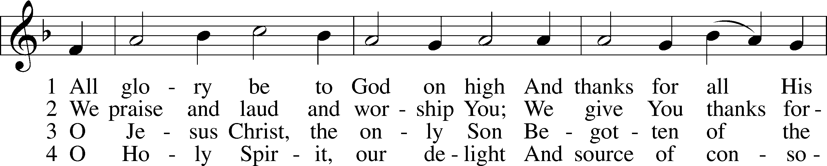
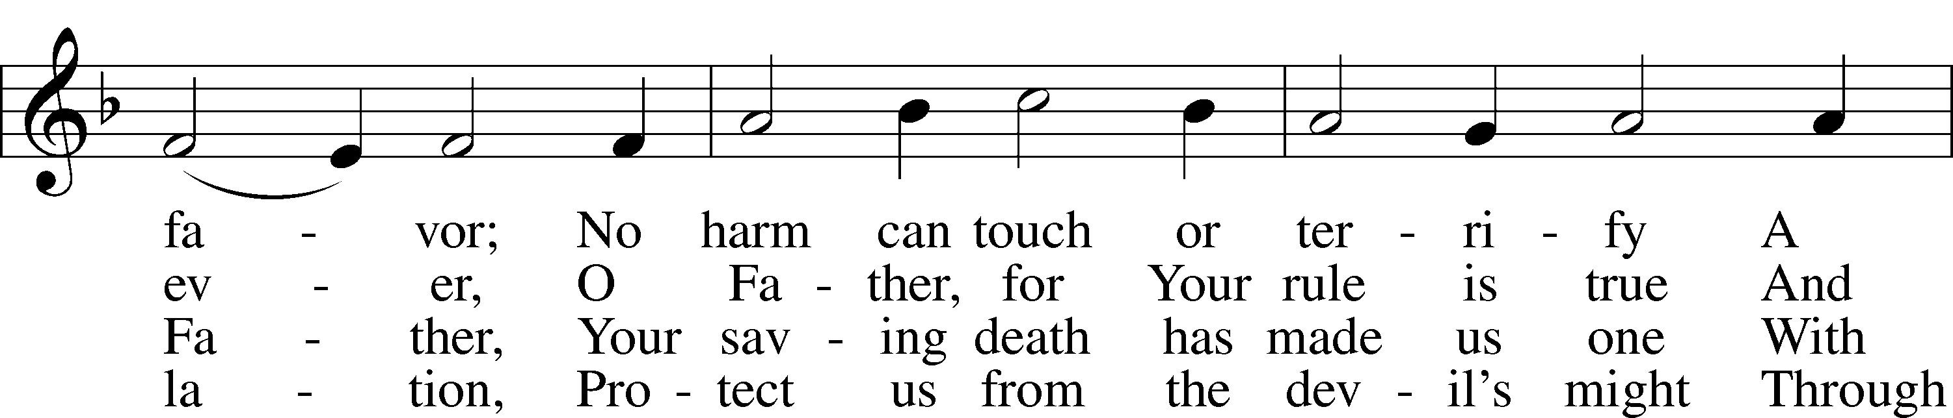
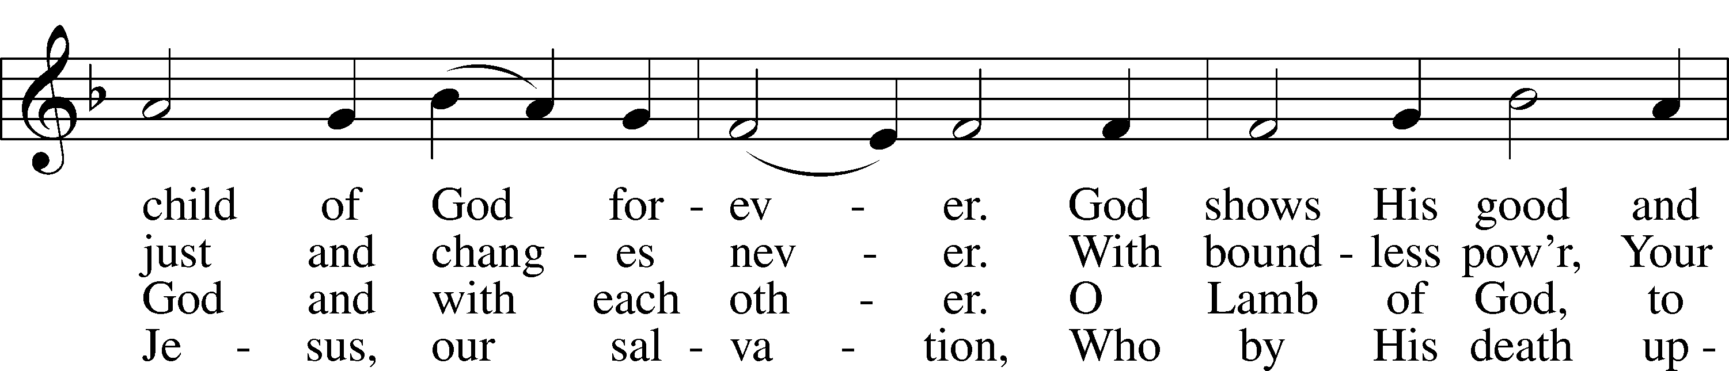
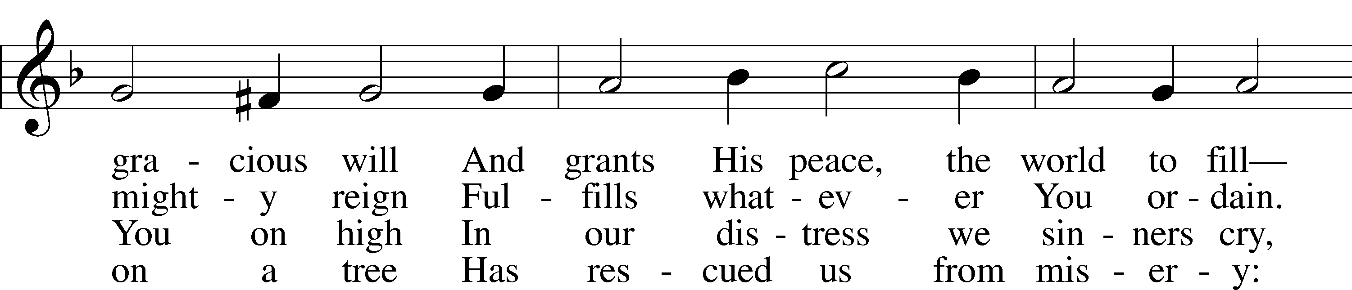
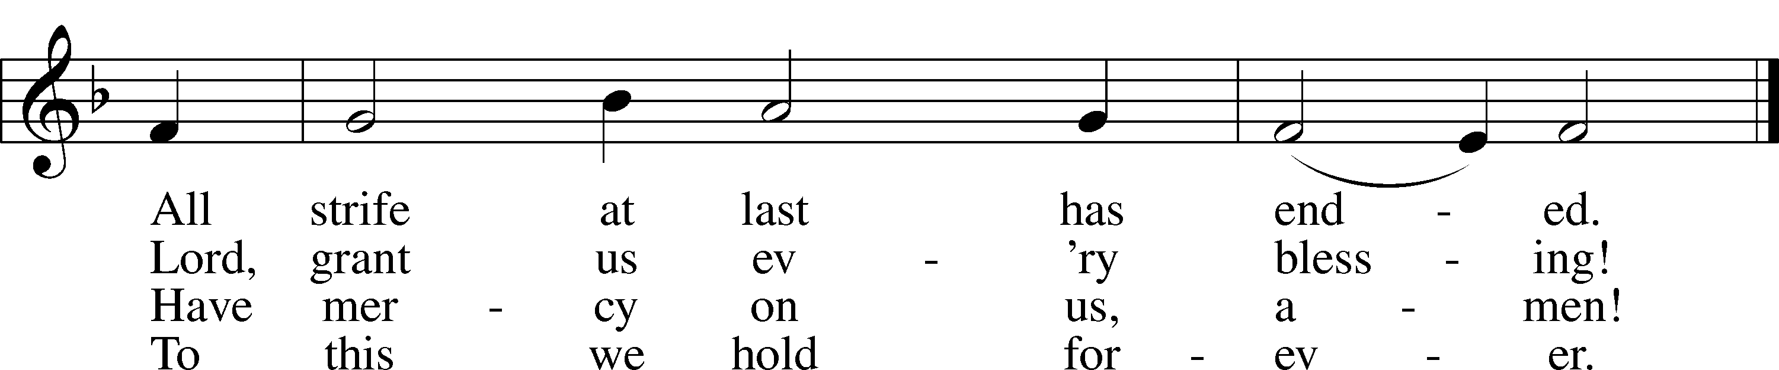

Text: © 2006 Concordia Publishing House. Used by permission: LSB Hymn License no. 110016438
Tune: Public domain

During the canticle, the candle bearer carries the paschal candle to the baptismal font, followed by the pastor(s). If there are candidates for Baptism or confirmation, or if there are new members to be received, they also gather at the font, together with their sponsors and families.

+REMEMBRANCE OF HOLY BAPTISM+

P On this holiest of nights, the whole Church of our Lord Jesus Christ recalls His death and burial, rejoicing with great joy in the Gospel of His glorious and mighty resurrection from the dead. The apostle Paul says:

Do you not know that all of us who have been baptized into Christ Jesus were baptized into His death? We were buried therefore with Him by baptism into death, in order that, just as Christ was raised from the dead by the glory of the Father, we too might walk in newness of life. For if we have been united with Him in a death like His, we shall certainly be united with Him in a resurrection like His. We know that our old self was crucified with Him in order that the body of sin might be brought to nothing, so that we would no longer be enslaved to sin. For one who has died has been set free from sin. Now if we have died with Christ, we believe that we will also live with Him. We know that Christ being raised from the dead will never die again; death no longer has dominion over Him. For the death He died He died to sin, once for all, but the life He lives He lives to God. So you also must consider yourselves dead to sin and alive to God in Christ Jesus.

P Let us pray.
Almighty and eternal God, according to Your strict judgment You condemned the unbelieving world through the flood, yet according to Your great mercy You preserved believing Noah and his family, eight souls in all. You drowned hard-hearted Pharaoh and all his host in the Red Sea, yet led Your people Israel through the water on dry ground, foreshadowing this washing of Your Holy Baptism. Through the Baptism in the Jordan of Your beloved Son, our Lord Jesus Christ, You sanctified and instituted all waters to be a blessed flood and a lavish washing away of sin.

We pray that You would behold us all according to Your boundless mercy and bless us with true faith by the Holy Spirit, that through this saving flood all sin in us, which has been inherited from Adam and which we ourselves have committed since, would be drowned and die. Grant that we be kept safe and secure in the holy ark of the Christian Church, being separated from the multitude of unbelievers and serving Your name at all times with a fervent spirit and a joyful hope, so that, with all believers in Your promise, we would be declared worthy of eternal life; through Jesus Christ, our Lord.
C Amen.

Profession of Faith

P Do you renounce the devil?
C Yes, I renounce him.
P Do you renounce all his works?
C Yes, I renounce them.
P Do you renounce all his ways?
C Yes, I renounce them.

P Do you believe in God, the Father Almighty, maker of heaven and earth?
C Yes, I believe in God, the Father Almighty, maker of heaven and earth.

P Do you believe in Jesus Christ, His only Son?
C Yes, I believe in Jesus Christ, His only Son, our Lord, who was conceived by the Holy Spirit, born of the virgin Mary, suffered under Pontius Pilate, was crucified, died and was buried; He descended into hell; the third day He rose again from the dead; He ascended into heaven and sits at the right hand of God the Father Almighty; from thence He will come to judge the living and the dead.

P Do you believe in the Holy Spirit?
C Yes, I believe in the Holy Spirit, the holy Christian Church, the communion of saints, the forgiveness of sins, the resurrection of the body, and the life everlasting.

P The almighty God and Father of our Lord Jesus Christ, who has given you the new birth of water and of the Spirit and has forgiven you all your sins, strengthen you with His grace to life T everlasting.
C Amen.

P Peace T be with you.
C Amen.

“All Who Believe and Are Baptized” LSB 601
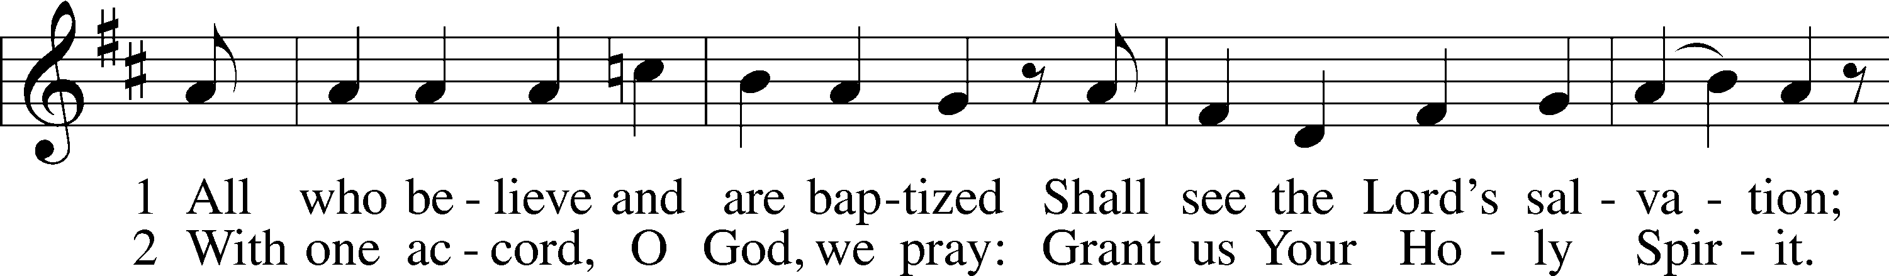
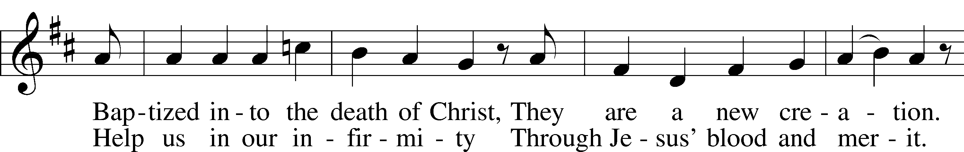
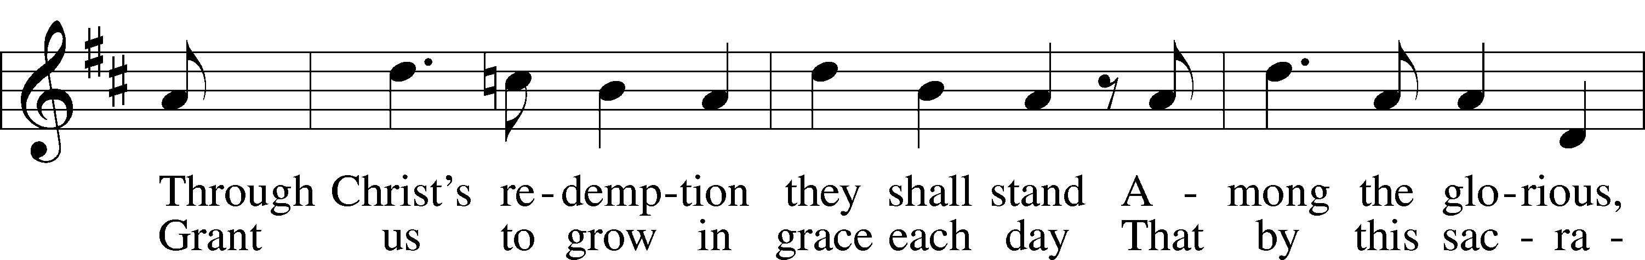
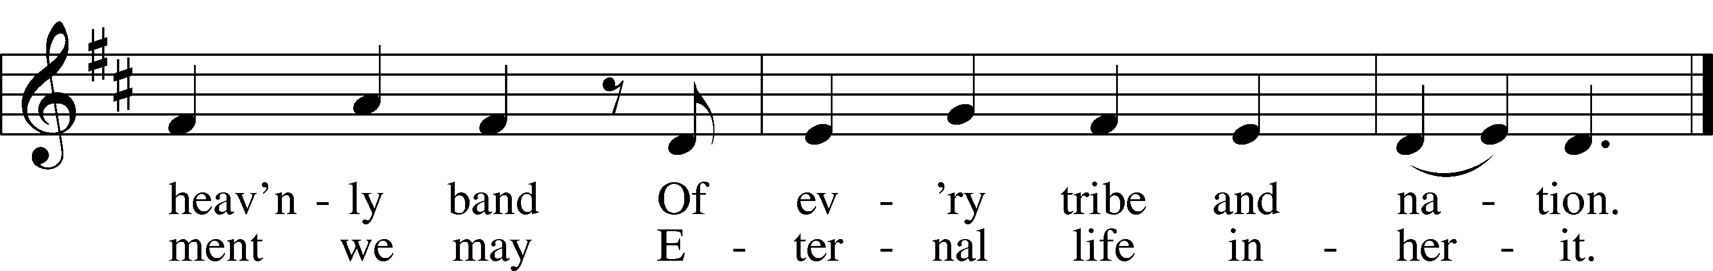
Text and tune: Public domain

+SERVICE OF PRAYER+
Stand

Litany of the Resurrection
A O Lord,
C have mercy.
A O Christ,
C have mercy.
A O Lord,
C have mercy.
A Lord Jesus Christ, Son of God,
C hear us.
A Paschal Lamb, who was offered for us and has taken away the sin of the world,
C have mercy on us.
A Who was crucified for our transgressions and raised for our justification,
C have mercy on us.
A Who foretold Your passion saying, “The Son of Man must be crucified and on the third day rise again,”
C have mercy on us.
A Who destroyed death by dying, and by rising to life again brought life and immortality to light,
C have mercy on us.
A Whose resurrection was first announced by an angel to the women,
C have mercy on us.
A Who appeared to Mary Magdalene and was worshiped by her,
C have mercy on us.
A Who revealed Yourself to the two disciples on the Emmaus road and made Yourself known to them in the Scriptures and in the breaking of the bread,
C have mercy on us.
A Who appeared to the disciples, bestowing on them Your peace and Your Spirit,
C have mercy on us.
A Who showed Your wounded hands and side to the apostle Thomas that he too might believe,
C have mercy on us.
A Who appeared to seven disciples on the Sea of Tiberias, bringing a miraculous catch of fish,
C have mercy on us.
A Who appeared to Peter and to the Twelve, to over 500 disciples, to James and to all the apostles, and to Paul on the Damascus road,
C have mercy on us.
A Who commissioned Your Church to make disciples of all nations by baptizing and teaching them,
C have mercy on us.

A By Your glorious resurrection from the dead,
C good Lord, deliver us.
A By Your victory over sin and death,
C good Lord, deliver us.
A By the majesty of Your risen body,
C good Lord, deliver us.
A We poor sinners implore You
C to hear us, Lord Jesus.
A That we may daily die and rise with You in our Baptism and walk in the freedom of Your forgiveness,
C grant us, good Lord.
A That we may set our minds on things above and not on earthly things, serving others as we have been served by You,
C grant us, good Lord.
A That we may dwell with You forever in the new creation as citizens of the heavenly Jerusalem, together with all the saints,
C grant us, good Lord.
A Christ, the Lamb of God, who takes away the sin of the world,
C have mercy on us.
A Christ, the Lamb of God, who takes away the sin of the world,
C have mercy on us.
A Christ, the Lamb of God, who takes away the sin of the world,
C grant us Your peace.
A O Lord,
C have mercy.
A O Christ,
C have mercy.
A O Lord,
C have mercy. Amen.

+SERVICE OF THE WORD+

The Vigil continues with a brief service of the Word according to one of the settings of the Divine Service, allowing for the proclamation of the Easter Gospel. The service is abbreviated in the following manner:

Easter Acclamation
P Alleluia! Christ is risen!
C He is risen indeed! Alleluia!

The altar candles may now be lighted from the paschal candle. Lights in the church are turned on, bells may be rung, the chancel may be decorated, and the altar may be prepared for the Sacrament while the congregation sings the Hymn of Praise.

This Is the Feast (Setting One) LSB 155
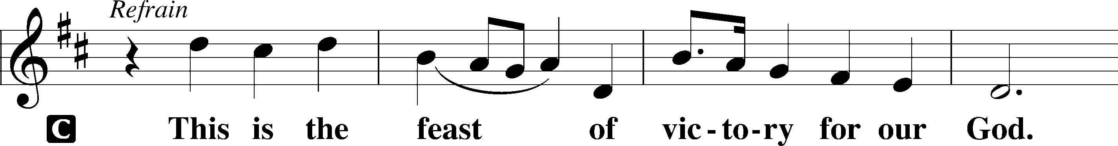
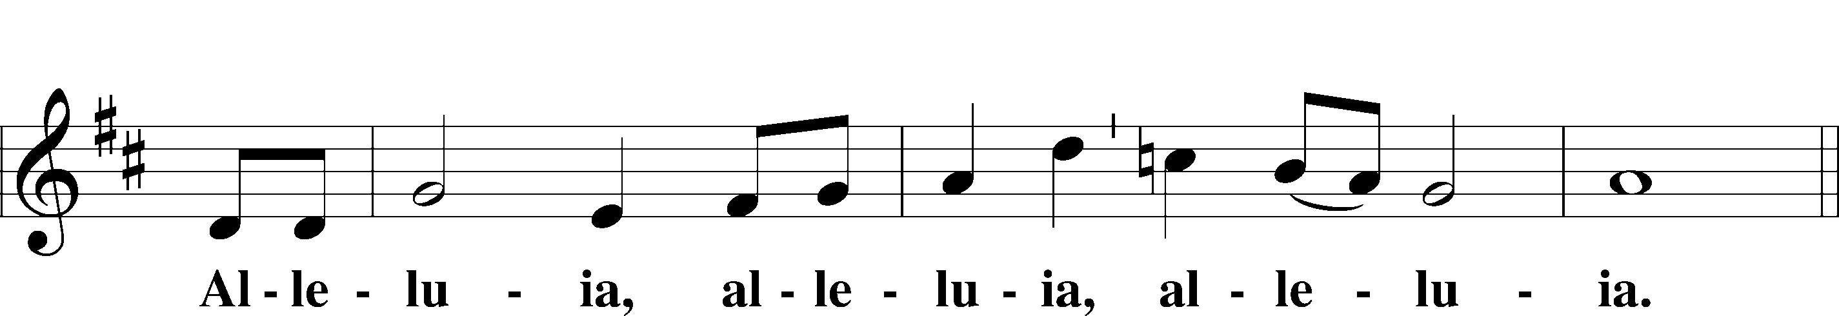
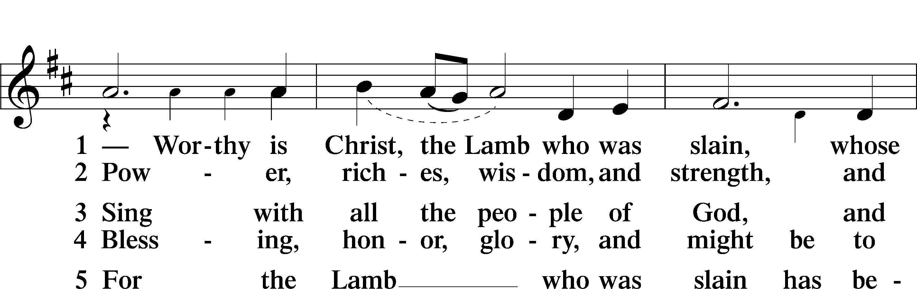
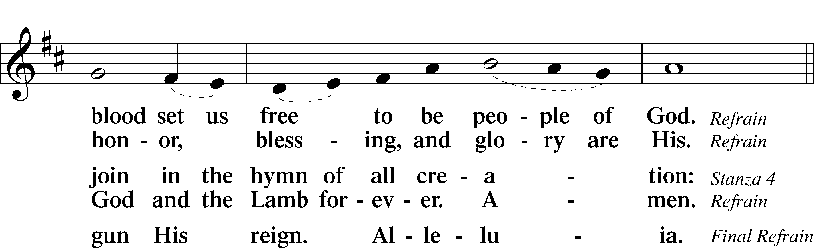
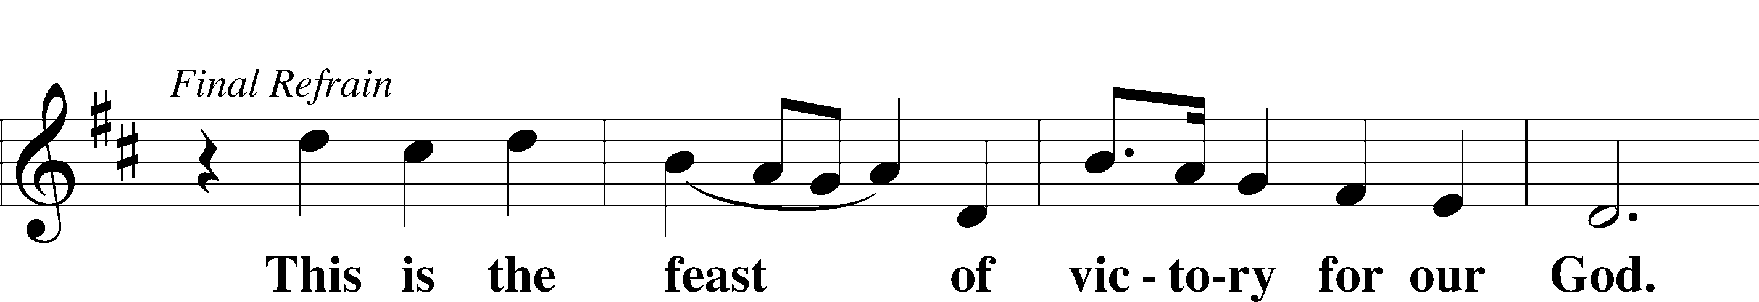
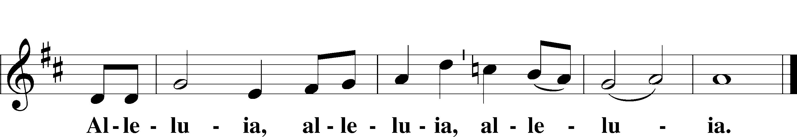

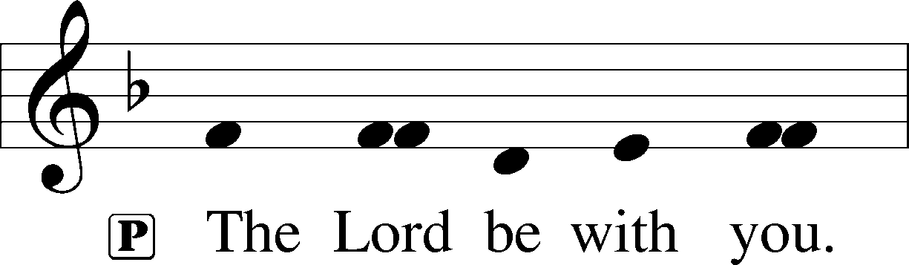
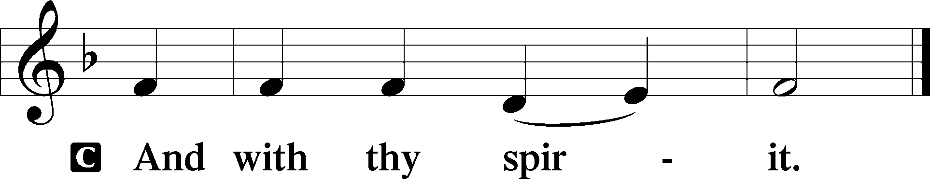

P Let us pray.
C O God, You made this most holy night to shine with the glory of the Lord’s resurrection. Preserve in us the spirit of adoption which You have given so that, made alive in body and soul, we may serve You purely; through Jesus Christ, Your Son, our Lord, who lives and reigns with You and the Holy Spirit, one God, now and forever. Amen.

P The Holy Gospel according to St. Matthew, the twenty-sixth chapter.
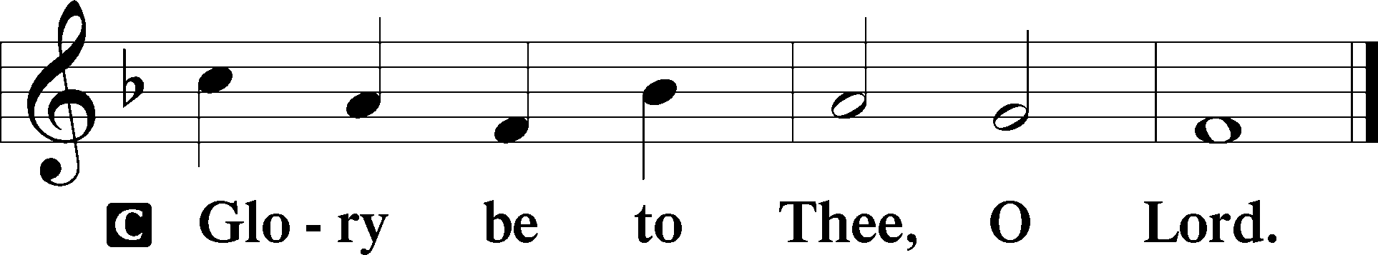

17Now on the first day of Unleavened Bread the disciples came to Jesus, saying, “Where will you have us prepare for you to eat the Passover?” 18He said, “Go into the city to a certain man and say to him, ‘The Teacher says, My time is at hand. I will keep the Passover at your house with my disciples.’” 19And the disciples did as Jesus had directed them, and they prepared the Passover.
20When it was evening, he reclined at table with the twelve. 21And as they were eating, he said, “Truly, I say to you, one of you will betray me.” 22And they were very sorrowful and began to say to him one after another, “Is it I, Lord?” 23He answered, “He who has dipped his hand in the dish with me will betray me. 24The Son of Man goes as it is written of him, but woe to that man by whom the Son of Man is betrayed!
It would have been better for that man if he had not been born.” 25Judas, who would betray him, answered, “Is it I, Rabbi?” He said to him, “You have said so.”
26Now as they were eating, Jesus took bread, and after blessing it broke it and gave it to the disciples, and said, “Take, eat; this is my body.” 27And he took a cup, and when he had given thanks he gave it to them, saying, “Drink of it, all of you, 28for this is my blood of the covenant, which is poured out for many for the forgiveness of sins. 29I tell you I will not drink again of this fruit of the vine until that day when I drink it new with you in my Father’s kingdom.”
30And when they had sung a hymn, they went out to the Mount of Olives.

P This is the Gospel of the Lord.
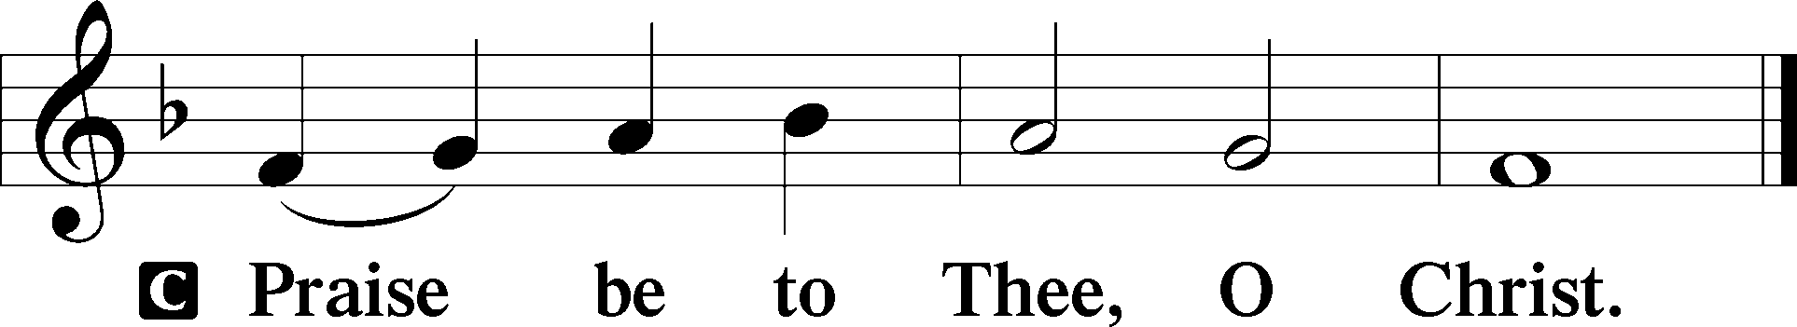

Offertory Hymn “Come, You Faithful, Raise the Strain” LSB 487
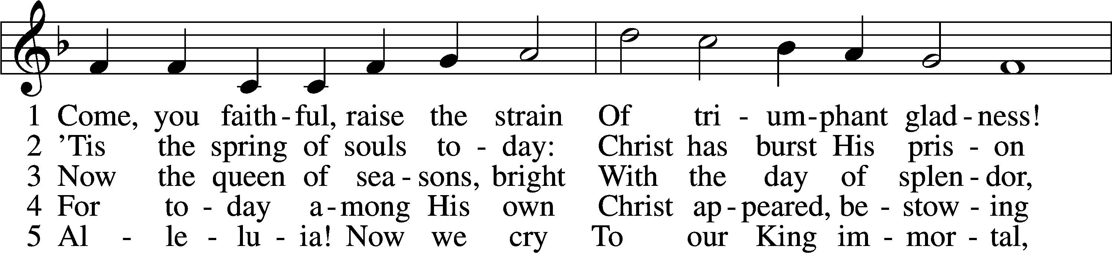
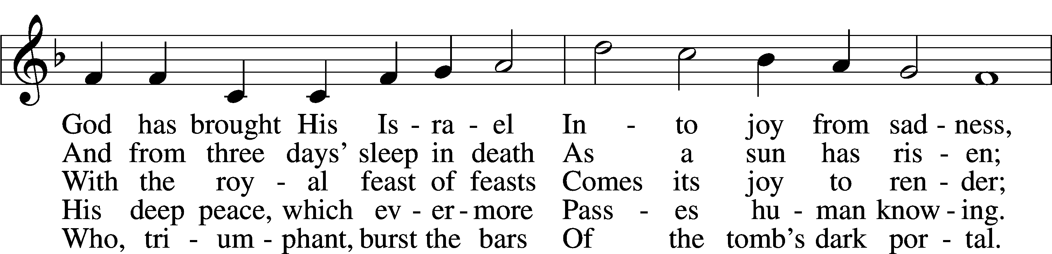
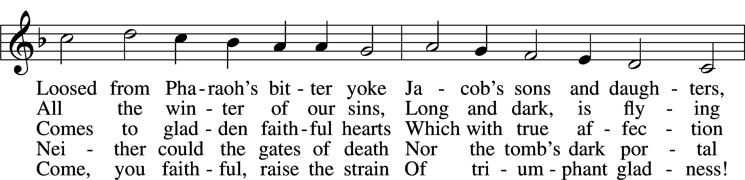
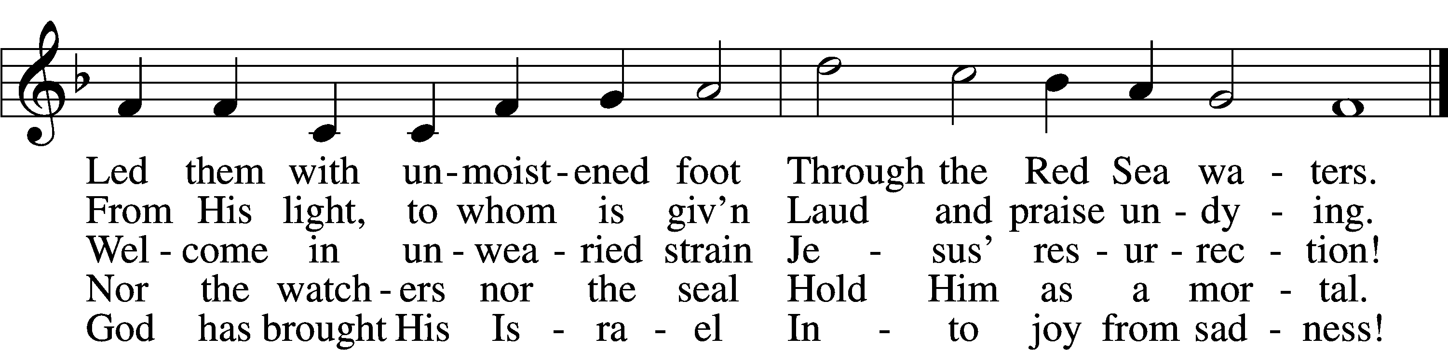
Tune and text: Public domain

Sermon: “For Thine is the kingdom, and the power, and the glory forever and ever. Amen.”

+SERVICE OF THE SACRAMENT+

Preface LSB 194
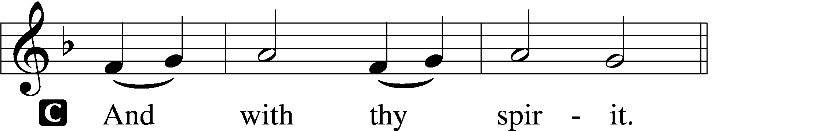

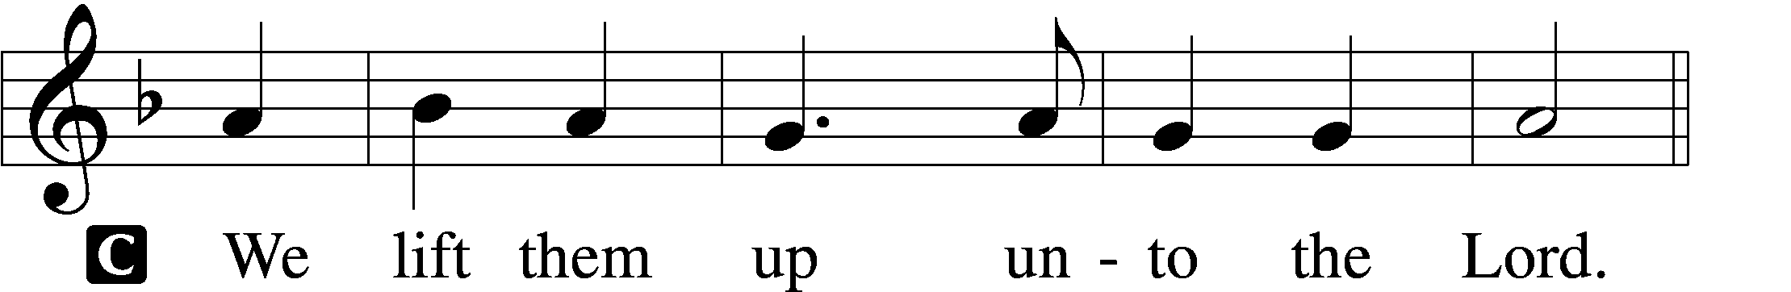

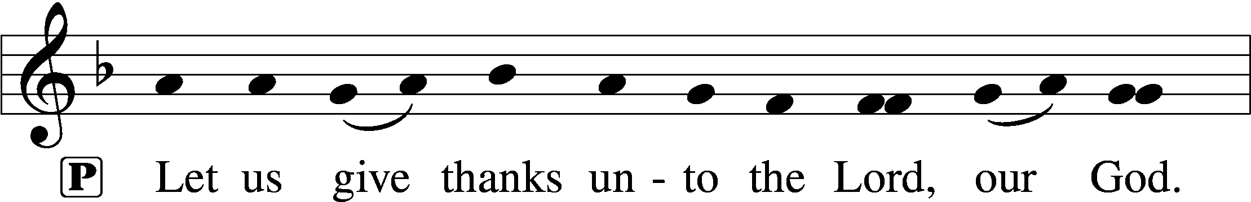
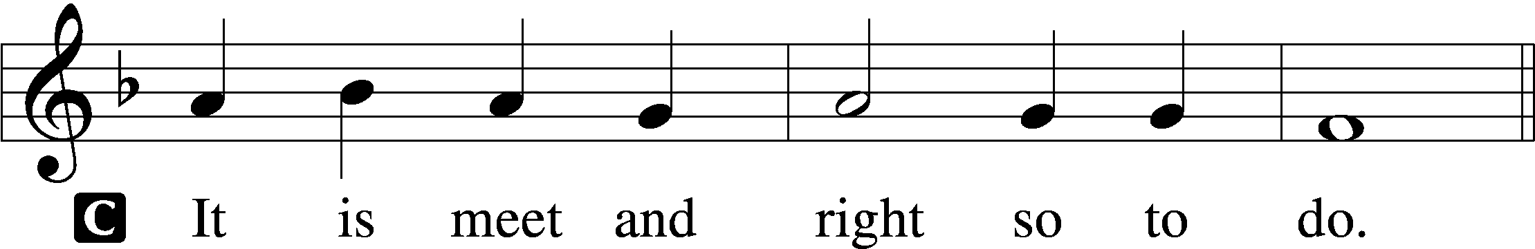

P It is truly meet, right, and salutary that we should at all times and in all places give thanks to You, holy Lord, almighty Father, everlasting God, through Jesus Christ, our Lord, who accomplished the salvation of mankind by the tree of the cross that, where death arose, there life also might rise again and that the serpent who overcame by the tree of the garden might likewise by the tree of the cross be overcome. Therefore with angels and archangels and with all the company of heaven we laud and magnify Your glorious name, evermore praising You and saying:
Sanctus LSB 195
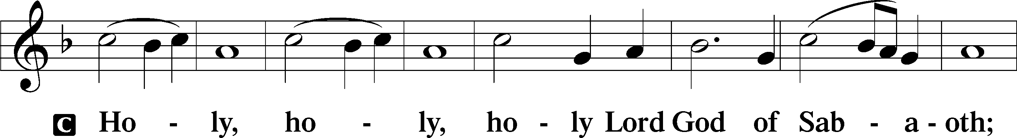
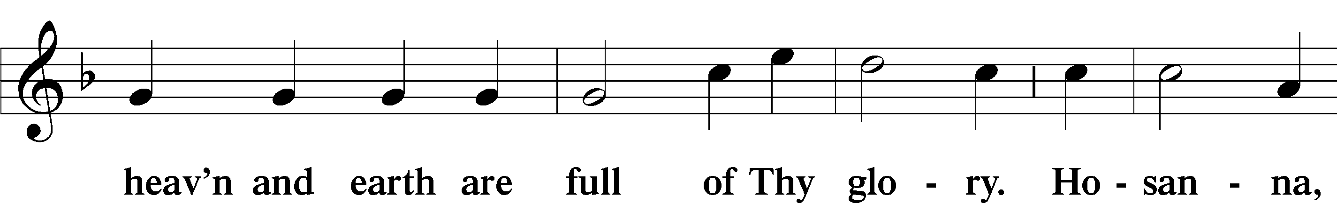
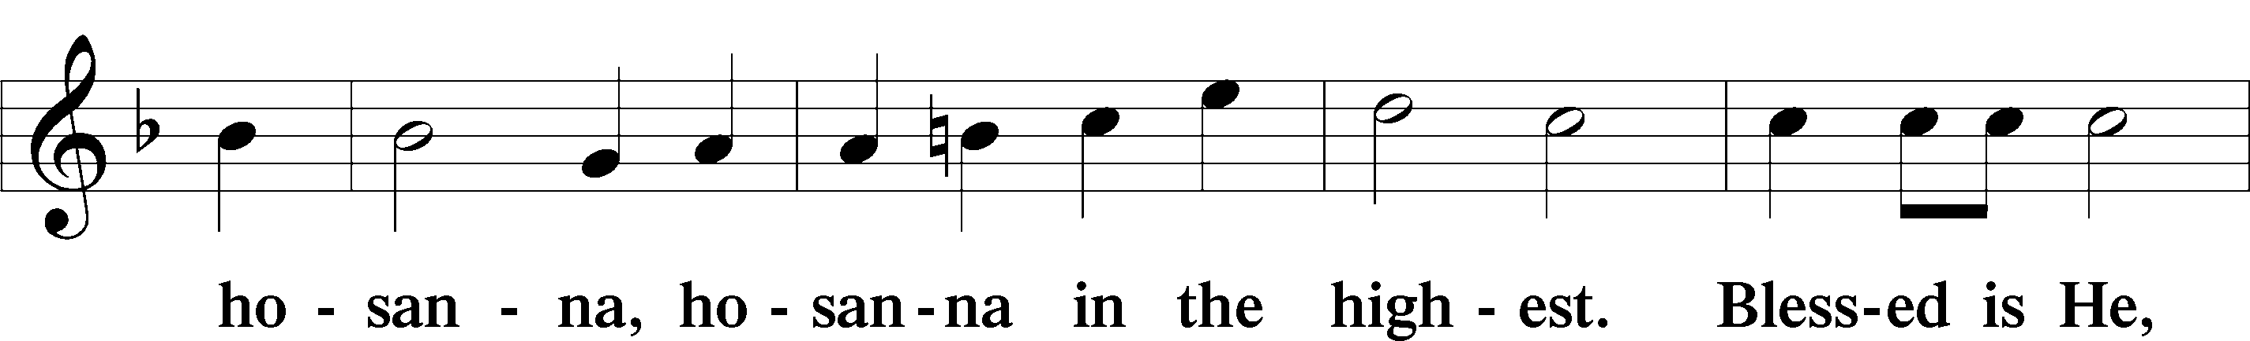
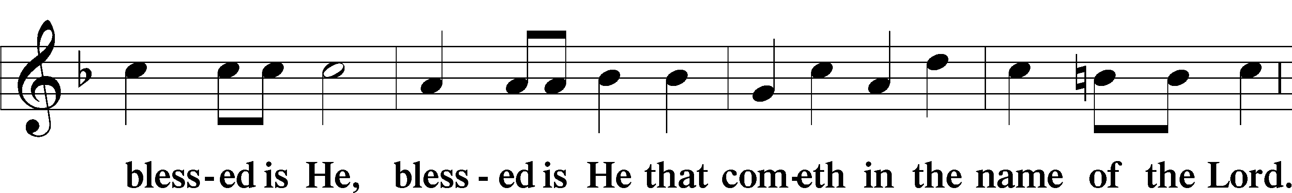
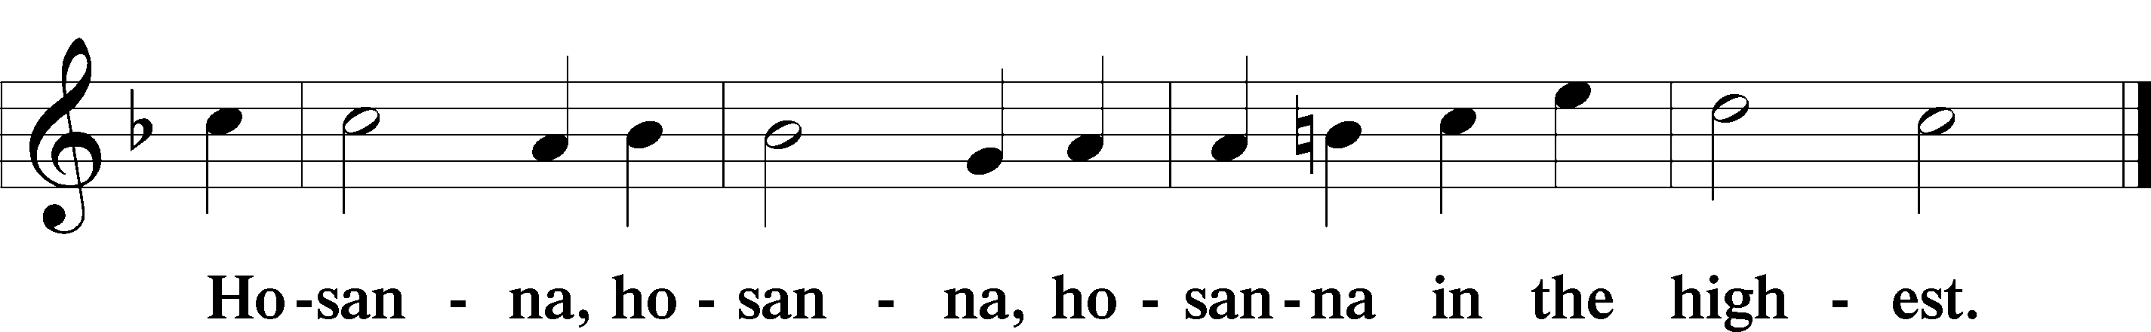

Lord’s Prayer
C Our Father who art in heaven,
hallowed be Thy name,
Thy kingdom come,
Thy will be done on earth
as it is in heaven;
give us this day our daily bread;
and forgive us our trespasses
as we forgive those
who trespass against us;
and lead us not into temptation,
but deliver us from evil.
For Thine is the kingdom
and the power and the glory
forever and ever. Amen.
The Words of Our Lord LSB 197
P Our Lord Jesus Christ, on the night when He was betrayed, took bread, and when He had given thanks, He broke it and gave it to the disciples and said: “Take, eat; this is My T body, which is given for you. This do in remembrance of Me.”

In the same way also He took the cup after supper, and when He had given thanks, He gave it to them, saying: “Drink of it, all of you; this cup is the new testament in My T blood, which is shed for you for the forgiveness of sins. This do, as often as you drink it, in remembrance of Me.”

Pax Domini LSB 197
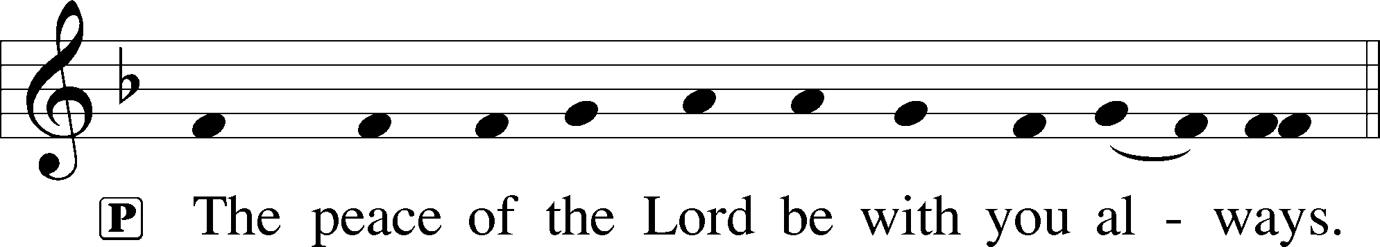

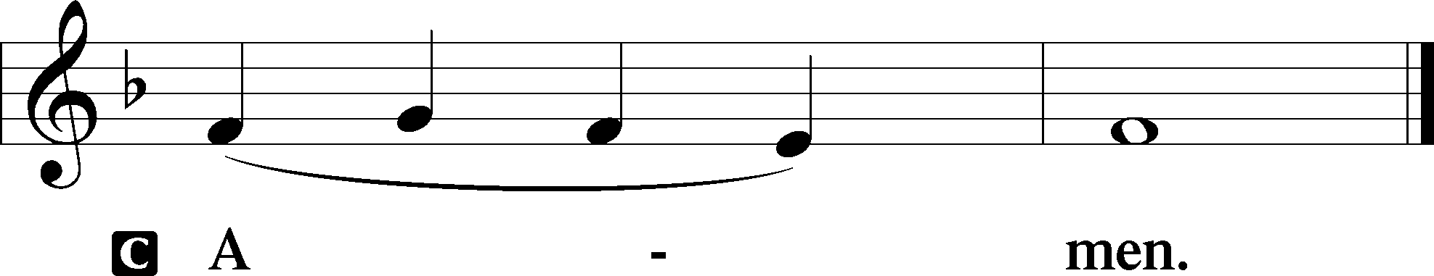

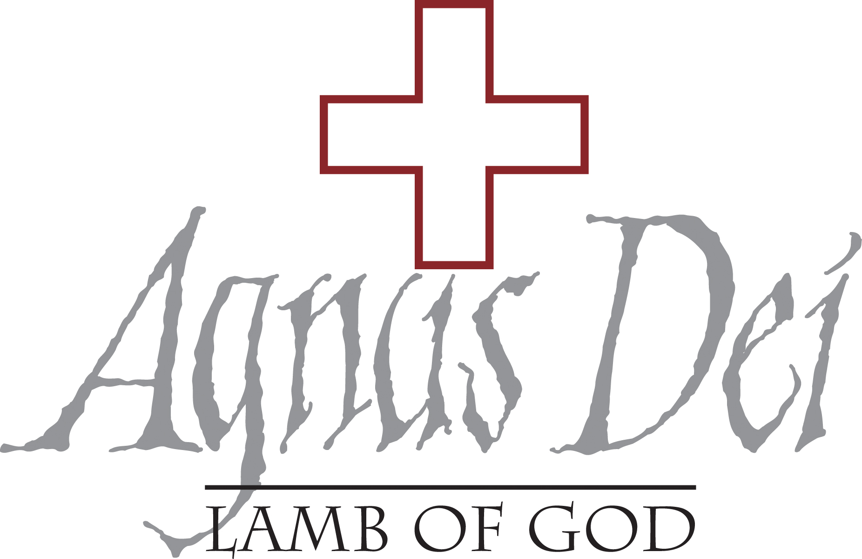

Agnus Dei LSB 198
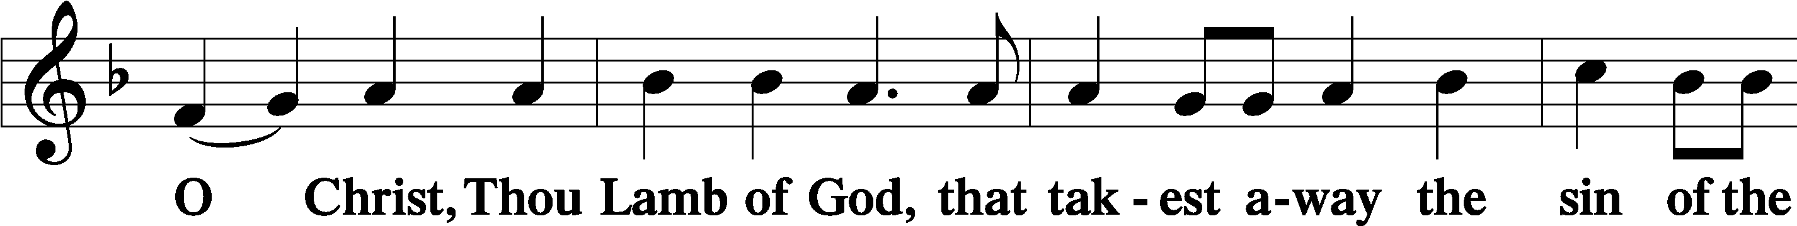
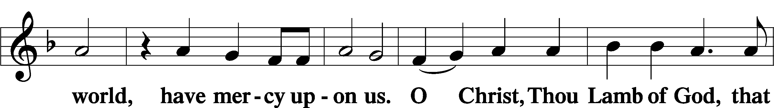
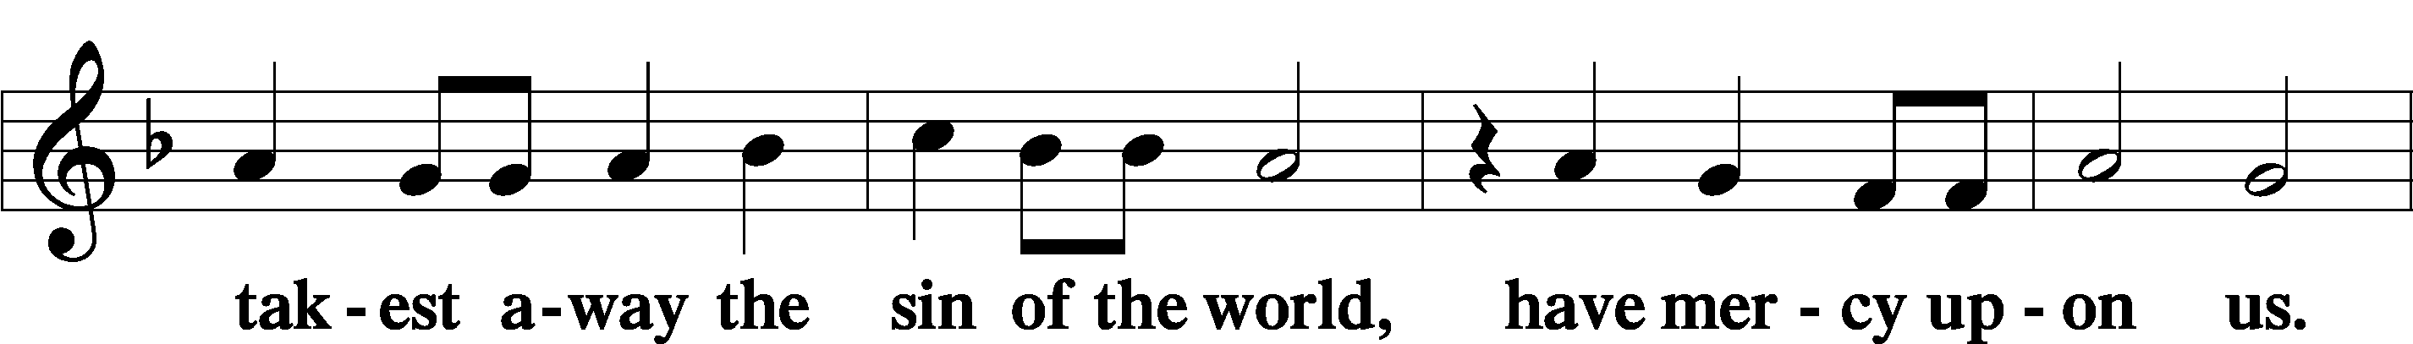
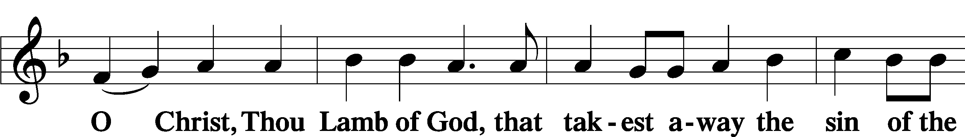
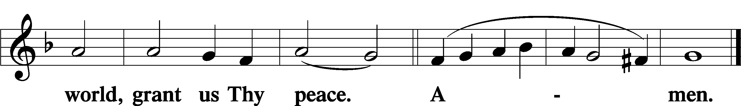

Sit

Distribution

Stand

Nunc Dimittis LSB 199

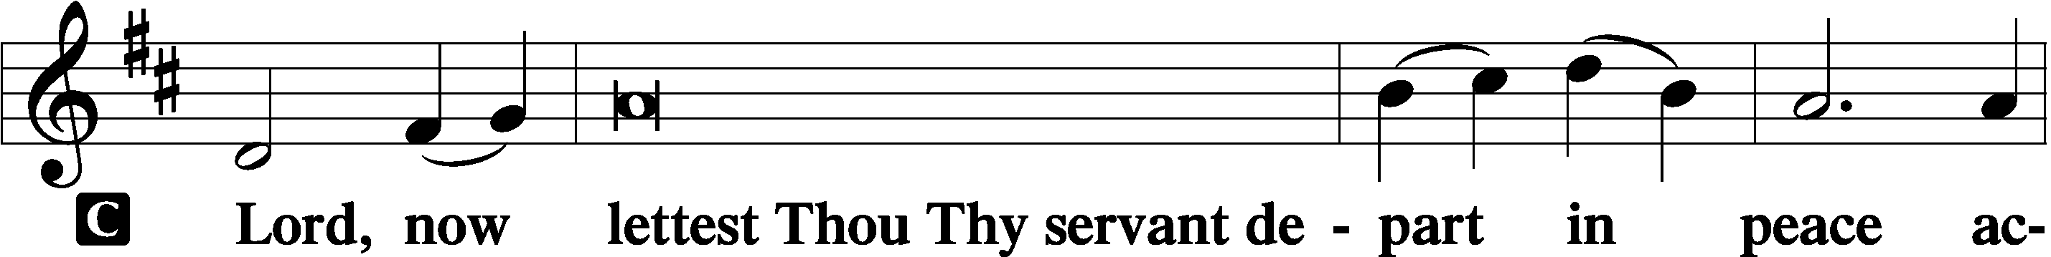

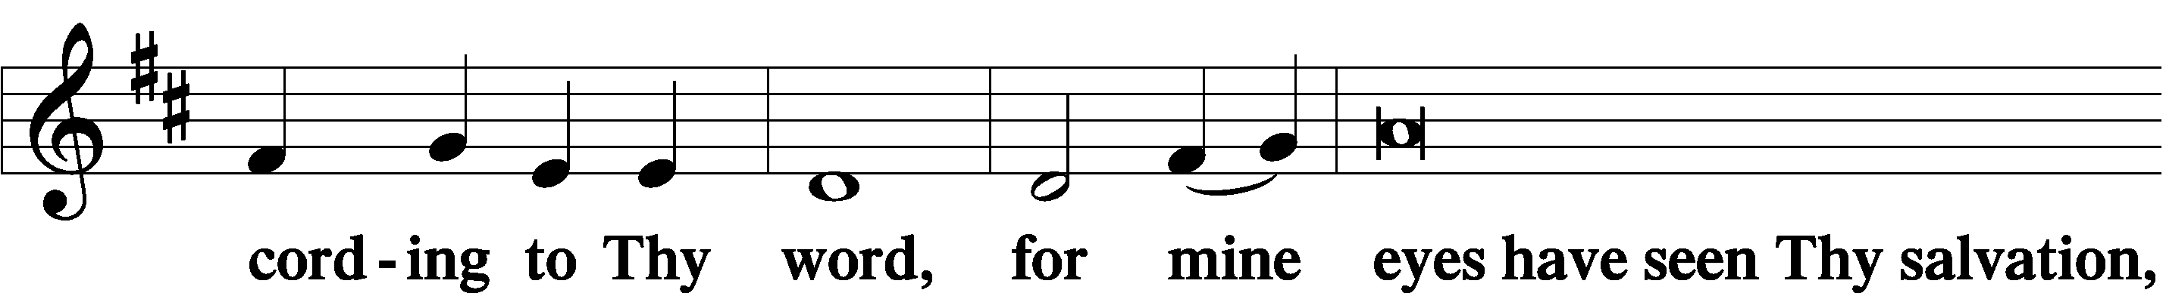

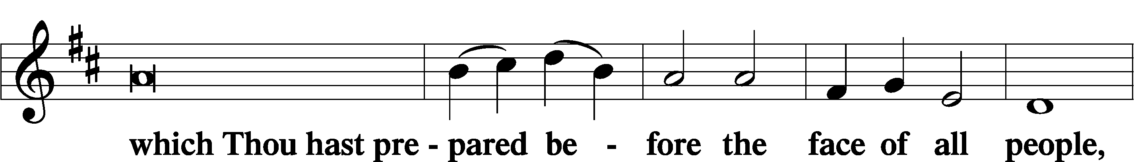

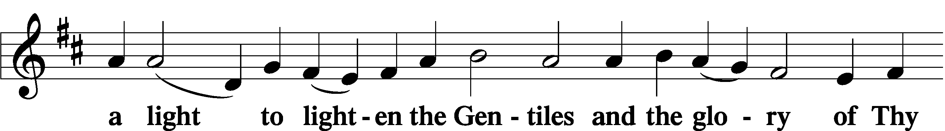

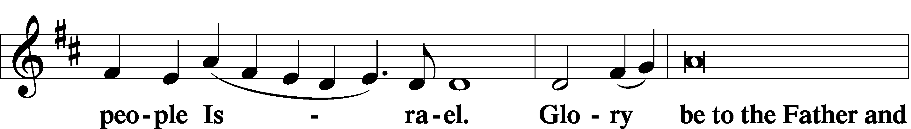

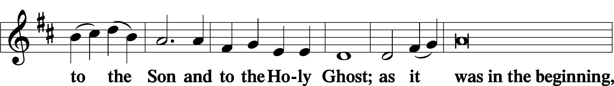

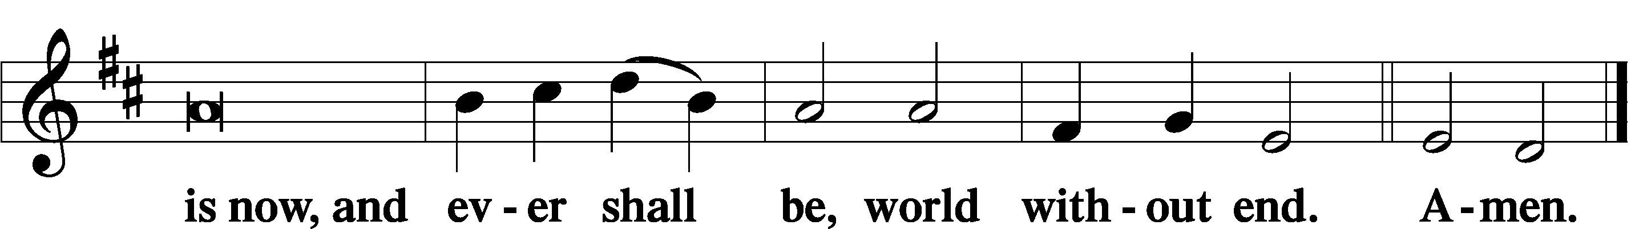

Thanksgiving LSB 200
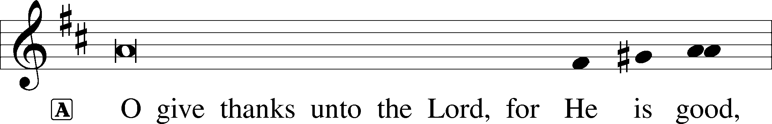

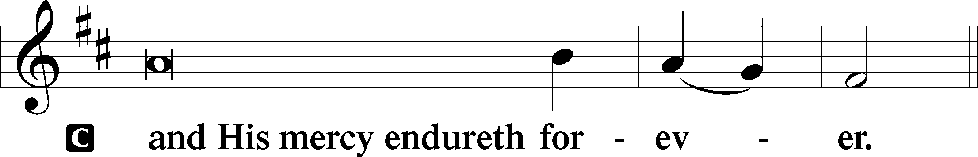

A Let us pray.
We give thanks to You, almighty God, that You have refreshed us through this salutary gift, and we implore You that of Your mercy You would strengthen us through the same in faith toward You and in fervent love toward one another; through Jesus Christ, Your Son, our Lord, who lives and reigns with You and the Holy Spirit, one God, now and forever.
C Amen.

Salutation LSB 201
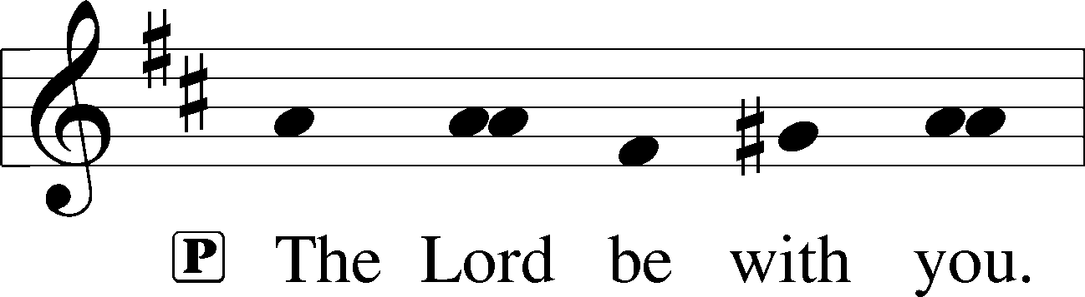

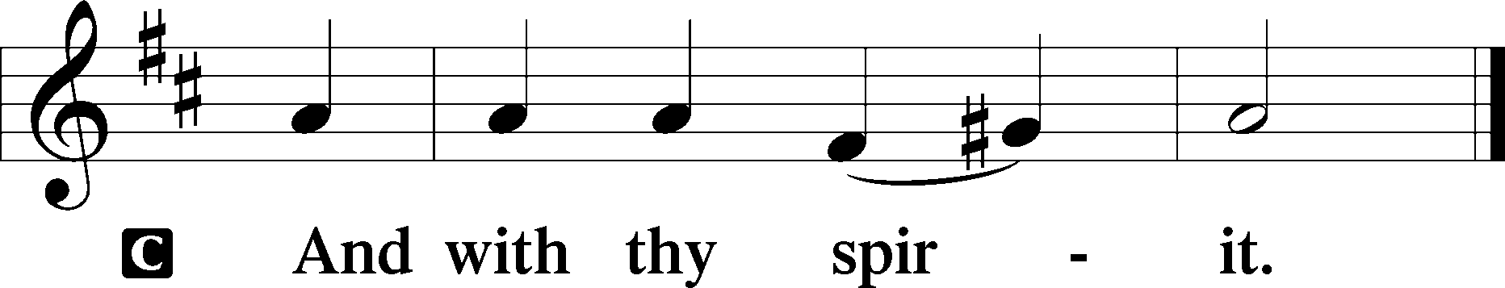

Benedicamus LSB 202
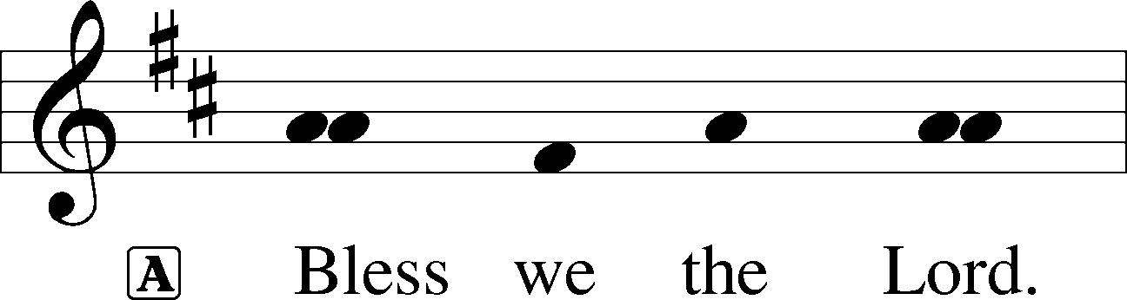

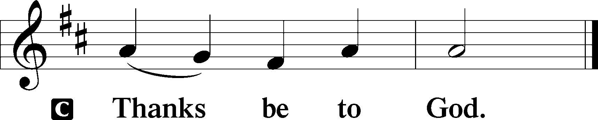

Benediction LSB 202
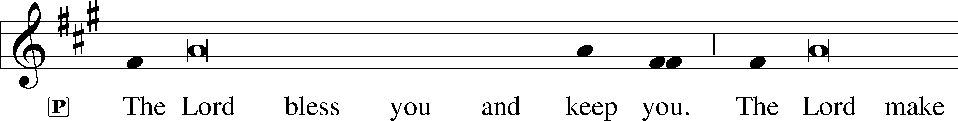
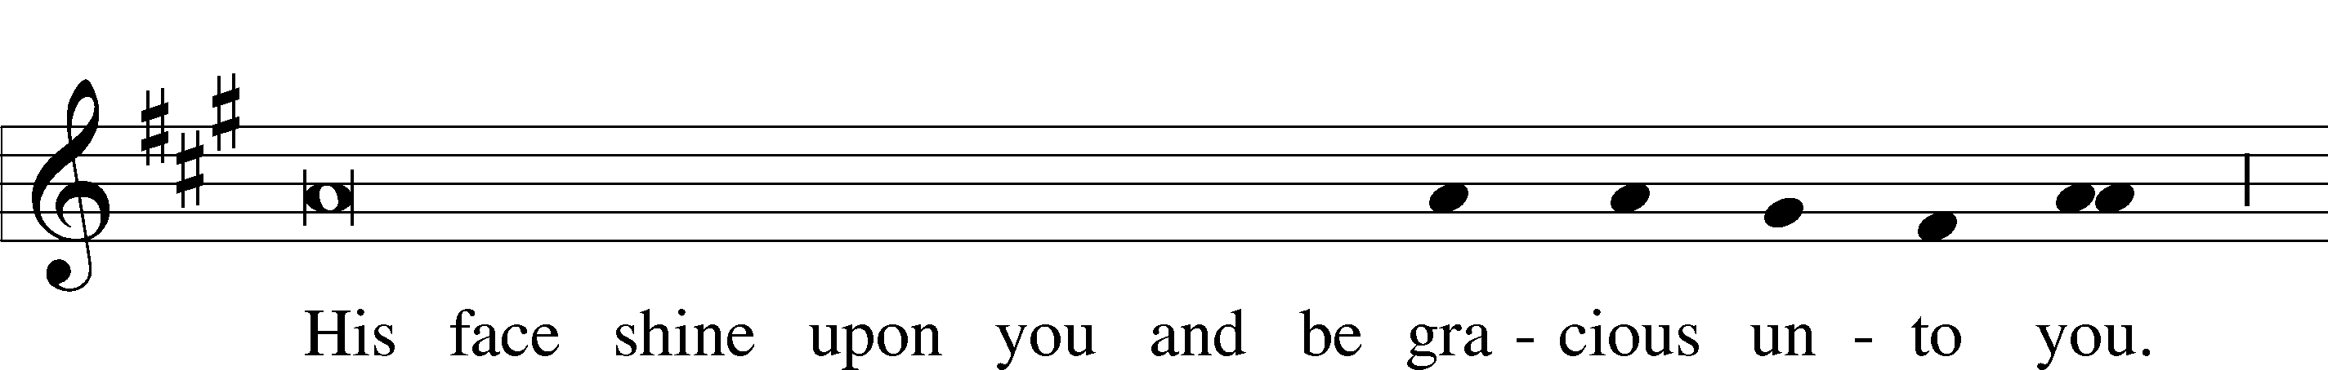
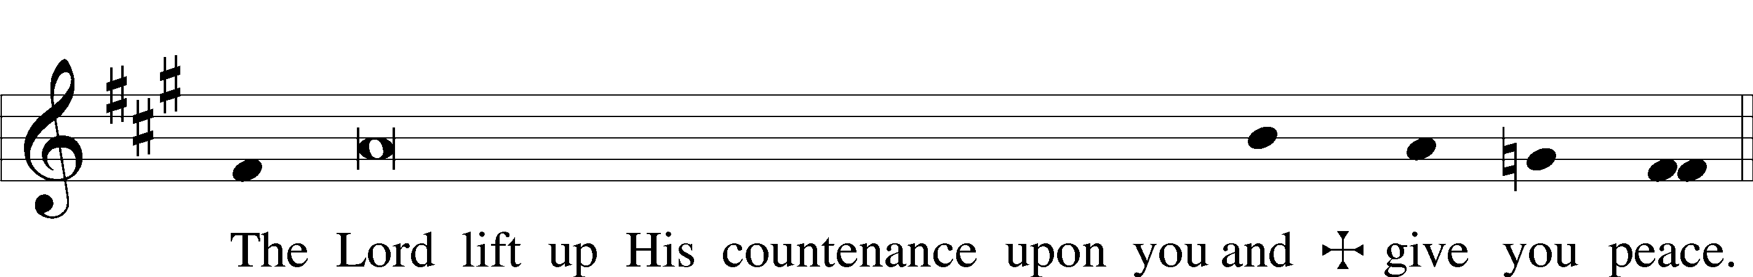

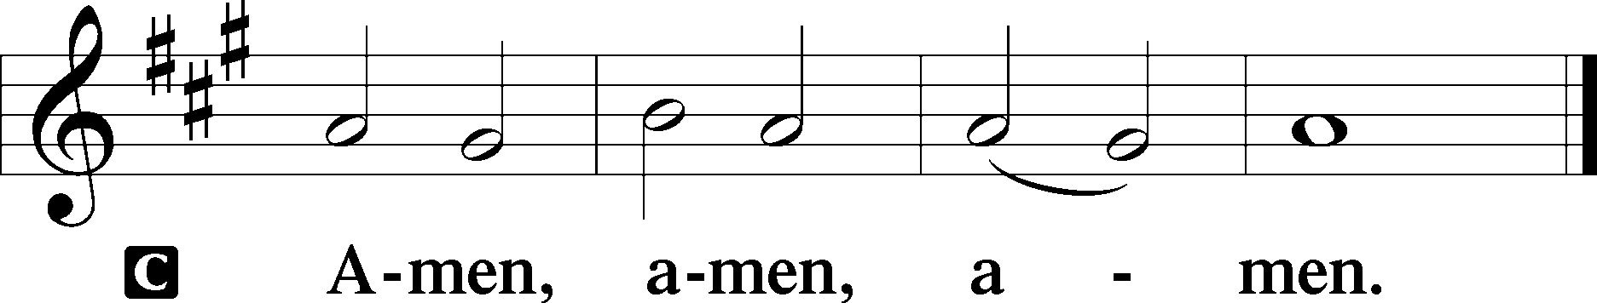

Closing Hymn “Jesus Christ is Risen Today” LSB 457
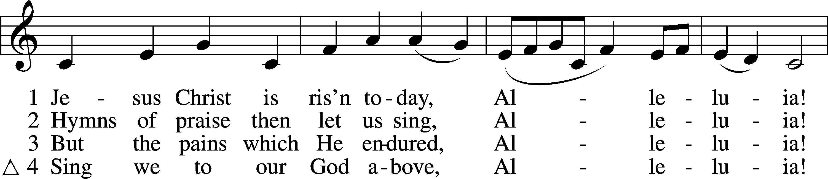
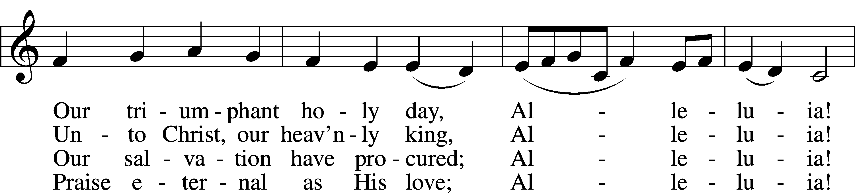
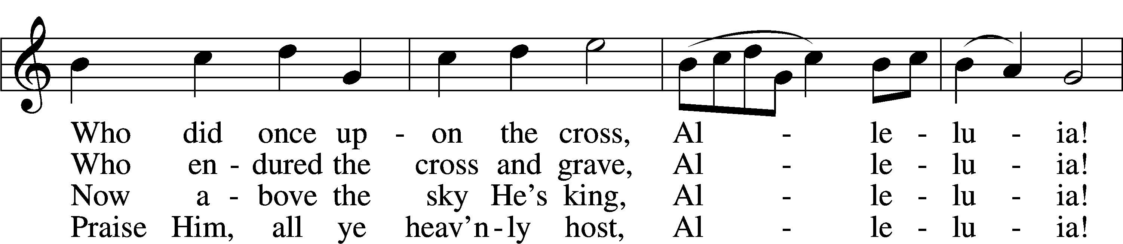
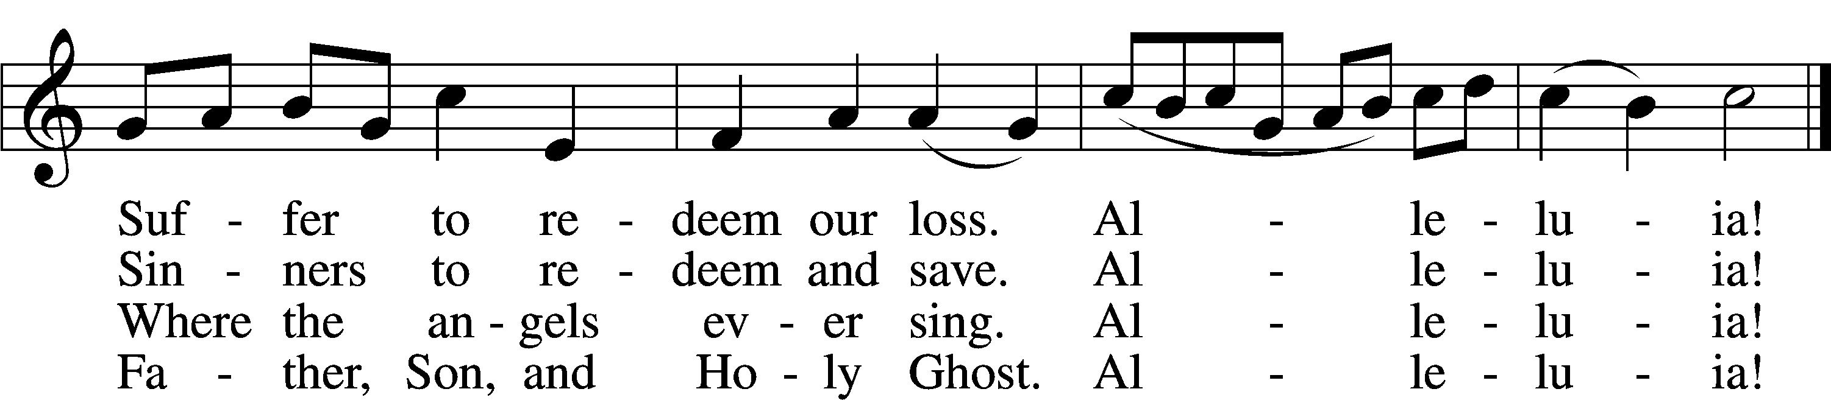
Text and tune: Public domain

Acknowledgments
Unless otherwise indicated, Scripture quotations are from the ESV® Bible (The Holy Bible, English Standard Version®), copyright © 2001 by Crossway, a publishing ministry of Good News Publishers. Used by permission. All rights reserved.
Created by Lutheran Service Builder © 2021 Concordia Publishing House.

He is risen! He is risen, indeed. Alleluia! Take a moment to listen to the beautiful post-service music that we’ve been missing the last two nights. Please join us tomorrow for our Easter Sunday service! Breakfast is at 9:00 a.m. and Divine Service is at 10:30 a.m..

Serving Our Lord in His House Today:
Pastor: Rev. David Wurdeman
Organist: Linda Ecker
Elders: Bob Pulley & Josh Church

