Good Shepherd Lutheran Church
Triduum
Good Friday Chief Service of the Three Day Vigil
April 2, 2021

About tonight’s service: Please enter in silence. There is no Pre-Service Music, Invocation, General Confession and Absolution, Introit, or Kyrie in today’s service. We begin with a preparatory prayer and then continue immediately with the readings without ornamentation. The Church views today’s service as a continuation of Maundy Thursday. It will be completed tomorrow at the Easter Vigil. That is why there was no Benediction or postlude music last night, and why there will be none today. The Benediction will be pronounced over the congregation again tomorrow night when the Resurrection of Our Lord has been proclaimed and commemorated!

Tonight’s service incorporates several elements unique to Good Friday’s service. We have the Reproaches, which use biblical language to speak from God’s perspective, showing His righteous judgment against His people. We also have the bidding prayer, which shows us a glimpse of how congregations used to pray many years ago. The bidding prayer begins with a “bid,” then there is a lengthy moment of silence. During this time, we silently pray as individuals more specifically within the “bid” we just made. Then the pastor prays a collect, a type of prayer, where he is “collecting” both the bid and our countless silent prayers together, and prays on behalf of the whole congregation to God.

+SERVICE OF THE WORD+

The congregation and pastor enter in silence.

Stand

Collect of the Day
P Let us Pray.
C O Lord, in this wondrous Sacrament You have left us a remembrance of Your passion. Grant that we may so receive the sacred mystery of Your body and blood that the fruits of Your redemption may continually be manifest in us; for You live and reign with the Father and the Holy Spirit, one God, now and forever. Amen.

Sit

Old Testament Reading Isaiah 52:13—53:12
A The Old Testament Reading for Good Friday is from Isaiah, chapters 52 and 53.

¹³Behold, my servant shall act wisely;
he shall be high and lifted up,
and shall be exalted.
¹⁴As many were astonished at you—
his appearance was so marred, beyond human semblance,
and his form beyond that of the children of mankind—
¹⁵so shall he sprinkle many nations;
kings shall shut their mouths because of him;
for that which has not been told them they see,
and that which they have not heard they understand.
¹Who has believed what they heard from us?
And to whom has the arm of the Lord been revealed?
²For he grew up before him like a young plant,
and like a root out of dry ground;
he had no form or majesty that we should look at him,
and no beauty that we should desire him.
³He was despised and rejected by men;
a man of sorrows, and acquainted with grief;
and as one from whom men hide their faces
he was despised, and we esteemed him not.
⁴Surely he has borne our griefs
and carried our sorrows;
yet we esteemed him stricken,
smitten by God, and afflicted.
⁵But he was wounded for our transgressions;
he was crushed for our iniquities;
upon him was the chastisement that brought us peace,
and with his stripes we are healed.
⁶All we like sheep have gone astray;
we have turned every one to his own way;
and the Lord has laid on him
the iniquity of us all.
⁷He was oppressed, and he was afflicted,
yet he opened not his mouth;
like a lamb that is led to the slaughter,
and like a sheep that before its shearers is silent,
so he opened not his mouth.
⁸By oppression and judgment he was taken away;
and as for his generation, who considered
that he was cut off out of the land of the living,
stricken for the transgression of my people?
⁹And they made his grave with the wicked
and with a rich man in his death,
although he had done no violence,
and there was no deceit in his mouth.
¹⁰Yet it was the will of the Lord to crush him;
he has put him to grief;
when his soul makes an offering for sin,
he shall see his offspring; he shall prolong his days;
the will of the Lord shall prosper in his hand.
¹¹Out of the anguish of his soul he shall see and be satisfied;
by his knowledge shall the righteous one, my servant,
make many to be accounted righteous,
and he shall bear their iniquities.
¹²Therefore I will divide him a portion with the many,
and he shall divide the spoil with the strong,
because he poured out his soul to death
and was numbered with the transgressors;
yet he bore the sin of many,
and makes intercession for the transgressors.

A This is the Word of the Lord.
C Thanks be to God.

Silence

Stand

P Let us pray.
Merciful and everlasting God, You did not spare Your only Son but delivered Him up for us all to bear our sins on the cross. Grant that our hearts may be so fixed with steadfast faith in Him that we fear not the power of sin, death, and the devil; through the same Jesus Christ, our Lord.
C Amen.

Silence

Sit

Epistle 2 Corinthians 5:14-21
A The Epistle is from Second Corinthians, chapter five.

¹⁴For the love of Christ controls us, because we have concluded this: that one has died for all, therefore all have died; ¹⁵and he died for all, that those who live might no longer live for themselves but for him who for their sake died and was raised.
¹⁶From now on, therefore, we regard no one according to the flesh. Even though we once regarded Christ according to the flesh, we regard him thus no longer. ¹⁷Therefore, if anyone is in Christ, he is a new creation. The old has passed away; behold, the new has come. ¹⁸All this is from God, who through Christ reconciled us to himself and gave us the ministry of reconciliation; ¹⁹that is, in Christ God was reconciling the world to himself, not counting their trespasses against them, and entrusting to us the message of reconciliation. ²⁰Therefore, we are ambassadors for Christ, God making his appeal through us. We implore you on behalf of Christ, be reconciled to God. ²¹For our sake he made him to be sin who knew no sin, so that in him we might become the righteousness of God.

A This is the Word of the Lord.
C Thanks be to God.

Silence

Stand

P Let us pray.
Almighty and everlasting God, You willed that Your Son should bear for us the pains of the cross and so remove from us the power of the adversary. Help us so to remember and give thanks for our Lord’s passion that we may receive forgiveness of sin and redemption from everlasting death; through Jesus Christ, our Lord.
C Amen.

Sit

The Passion of Our Lord Jesus Christ

Hymn “Go to Dark Gethsemane” LSB 436 sts. 1–3
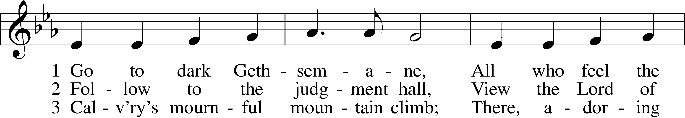
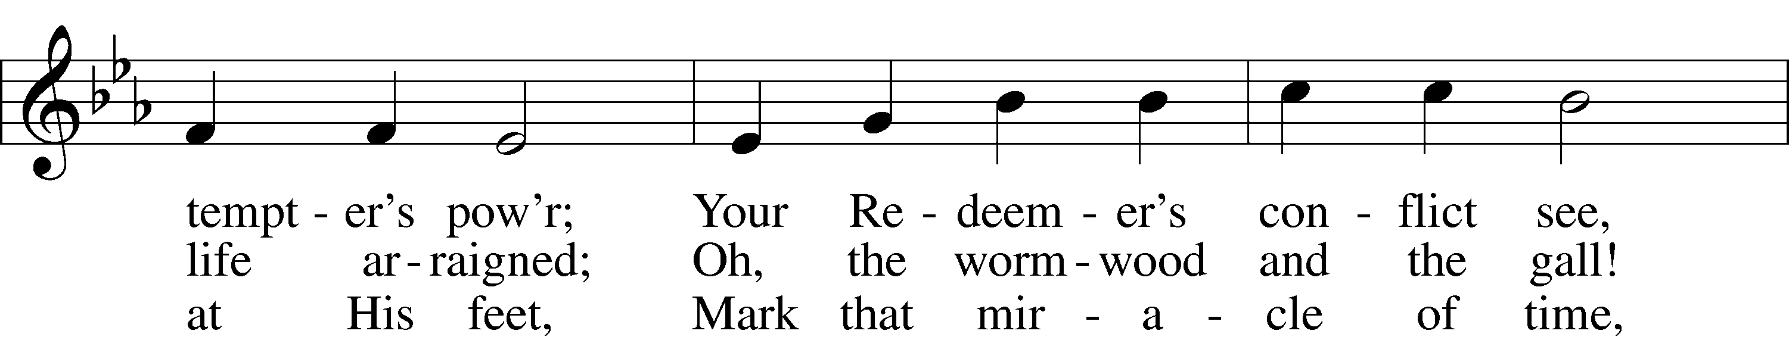
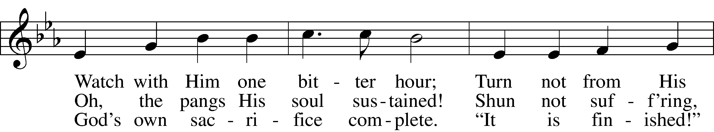
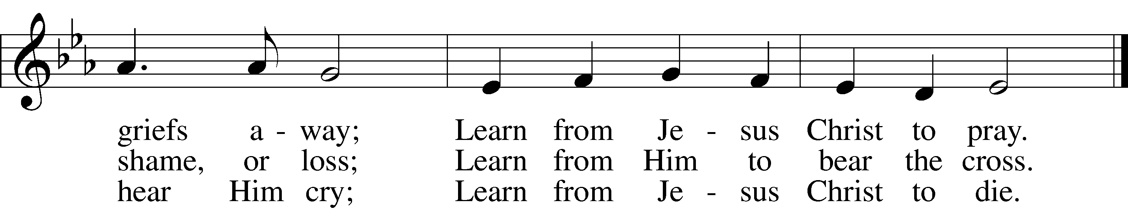
Text and tune: Public domain

P The Passion of Our Lord Jesus Christ according to St. John.

The Betrayal and Arrest of Jesus John 18:1–11
1When Jesus had spoken these words, he went out with his disciples across the Kidron Valley, where there was a garden, which he and his disciples entered. 2Now Judas, who betrayed him, also knew the place, for Jesus often met there with his disciples. 3So Judas, having procured a band of soldiers and some officers from the chief priests and the Pharisees, went there with lanterns and torches and weapons. 4Then Jesus, knowing all that would happen to him, came forward and said to them, “Whom do you seek?” 5They answered him, “Jesus of Nazareth.” Jesus said to them, “I am he.” Judas, who betrayed him, was standing with them. 6When Jesus said to them, “I am he,” they drew back and fell to the ground. 7So he asked them again, “Whom do you seek?” And they said, “Jesus of Nazareth.” 8Jesus answered, “I told you that I am he. So, if you seek me, let these men go.” 9This was to fulfill the word that he had spoken: “Of those whom you gave me I have lost not one.” 10Then Simon Peter, having a sword, drew it and struck the high priest’s servant and cut off his right ear. (The servant’s name was Malchus.) 11So Jesus said to Peter, “Put your sword into its sheath; shall I not drink the cup that the Father has given me?”

“O Sacred Head, Now Wounded” LSB 450 st. 1
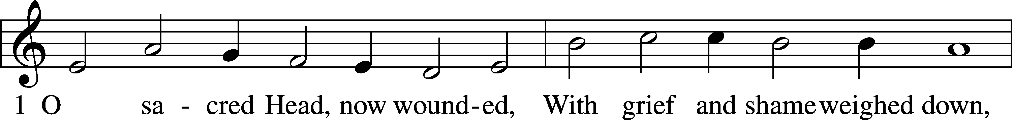
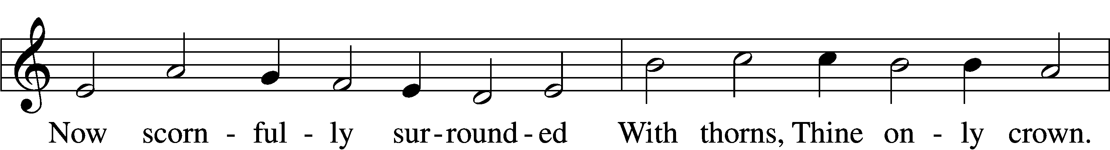
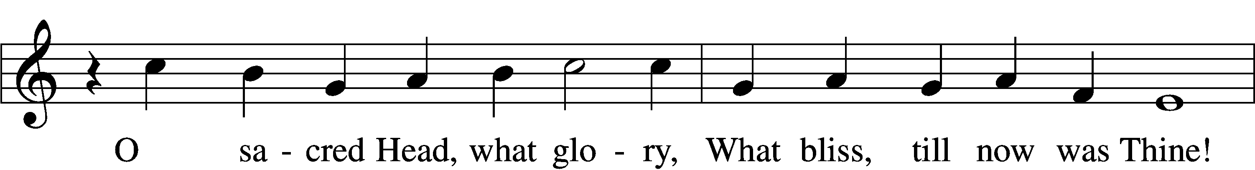
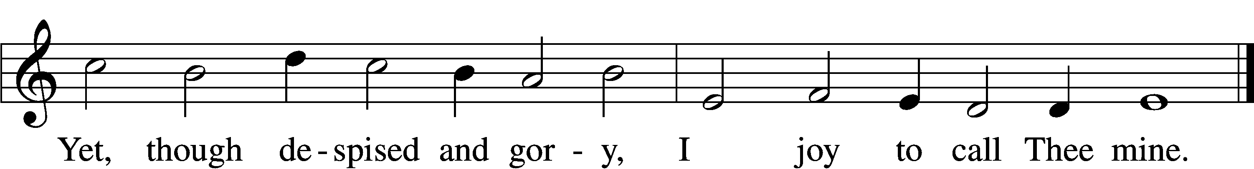

Jesus Before the High Priest and the Denial of Peter John 18:12–27
12So the band of soldiers and their captain and the officers of the Jews arrested Jesus and bound him. 13First they led him to Annas, for he was the father-in-law of Caiaphas, who was high priest that year. 14It was Caiaphas who had advised the Jews that it would be expedient that one man should die for the people.
15Simon Peter followed Jesus, and so did another disciple. Since that disciple was known to the high priest, he entered with Jesus into the court of the high priest, 16but Peter stood outside at the door. So the other disciple, who was known to the high priest, went out and spoke to the servant girl who kept watch at the door, and brought Peter in. 17The servant girl at the door said to Peter, “You also are not one of this man’s disciples, are you?” He said, “I am not.” 18Now the servants and officers had made a charcoal fire, because it was cold, and they were standing and warming themselves. Peter also was with them, standing and warming himself.
19The high priest then questioned Jesus about his disciples and his teaching. 20Jesus answered him, “I have spoken openly to the world. I have always taught in synagogues and in the temple, where all Jews come together. I have said nothing in secret. 21Why do you ask me? Ask those who have heard me what I said to them; they know what I said.” 22When he had said these things, one of the officers standing by struck Jesus with his hand, saying, “Is that how you answer the high priest?” 23Jesus answered him, “If what I said is wrong, bear witness about the wrong; but if what I said is right, why do you strike me?” 24Annas then sent him bound to Caiaphas the high priest.
25Now Simon Peter was standing and warming himself. So they said to him, “You also are not one of his disciples, are you?” He denied it and said, “I am not.” 26One of the servants of the high priest, a relative of the man whose ear Peter had cut off, asked, “Did I not see you in the garden with him?” 27Peter again denied it, and at once a rooster crowed.

“O Sacred Head, Now Wounded” LSB 450 st. 2
2 How pale Thou art with anguish,
With sore abuse and scorn!
How doth Thy face now languish
That once was bright as morn!
Grim death, with cruel rigor,
Hath robbed Thee of Thy life;
Thus Thou hast lost Thy vigor,
Thy strength, in this sad strife.
Text: © 1941 Concordia Publishing House. Used by permission: LSB Hymn License no. 110016438

Jesus Before Pilate John 18:28–40
28Then they led Jesus from the house of Caiaphas to the governor’s headquarters. It was early morning. They themselves did not enter the governor’s headquarters, so that they would not be defiled, but could eat the Passover. 29So Pilate went outside to them and said, “What accusation do you bring against this man?” 30They answered him, “If this man were not doing evil, we would not have delivered him over to you.” 31Pilate said to them, “Take him yourselves and judge him by your own law.” The Jews said to him, “It is not lawful for us to put anyone to death.” 32This was to fulfill the word that Jesus had spoken to show by what kind of death he was going to die.
33So Pilate entered his headquarters again and called Jesus and said to him, “Are you the King of the Jews?” 34Jesus answered, “Do you say this of your own accord, or did others say it to you about me?” 35Pilate answered, “Am I a Jew? Your own nation and the chief priests have delivered you over to me. What have you done?” 36Jesus answered, “My kingdom is not of this world. If my kingdom were of this world, my servants would have been fighting, that I might not be delivered over to the Jews. But my kingdom is not from the world.” 37Then Pilate said to him, “So you are a king?” Jesus answered, “You say that I am a king. For this purpose I was born and for this purpose I have come into the world—to bear witness to the truth. Everyone who is of the truth listens to my voice.” 38Pilate said to him, “What is truth?”
After he had said this, he went back outside to the Jews and told them, “I find no guilt in him. 39But you have a custom that I should release one man for you at the Passover. So do you want me to release to you the King of the Jews?” 40They cried out again, “Not this man, but Barabbas!” Now Barabbas was a robber.

“O Sacred Head, Now Wounded” LSB 450 st. 3
3 What Thou, my Lord, hast suffered
Was all for sinners’ gain;
Mine, mine was the transgression,
But Thine the deadly pain.
Lo, here I fall, my Savior!
’Tis I deserve Thy place;
Look on me with Thy favor,
And grant to me Thy grace.
Text: © 1941 Concordia Publishing House. Used by permission: LSB Hymn License no. 110016438

Jesus Prepared for Crucifixion John 19:1–15
1Then Pilate took Jesus and flogged him. 2And the soldiers twisted together a crown of thorns and put it on his head and arrayed him in a purple robe. 3They came up to him, saying, “Hail, King of the Jews!” and struck him with their hands. 4Pilate went out again and said to them, “See, I am bringing him out to you that you may know that I find no guilt in him.” 5So Jesus came out, wearing the crown of thorns and the purple robe. Pilate said to them, “Behold the man!” 6When the chief priests and the officers saw him, they cried out, “Crucify him, crucify him!” Pilate said to them, “Take him yourselves and crucify him, for I find no guilt in him.” 7The Jews answered him, “We have a law, and according to that law he ought to die because he has made himself the Son of God.” 8When Pilate heard this statement, he was even more afraid. 9He entered his headquarters again and said to Jesus, “Where are you from?” But Jesus gave him no answer. 10So Pilate said to him, “You will not speak to me? Do you not know that I have authority to release you and authority to crucify you?” 11Jesus answered him, “You would have no authority over me at all unless it had been given you from above. Therefore he who delivered me over to you has the greater sin.”
12From then on Pilate sought to release him, but the Jews cried out, “If you release this man, you are not Caesar’s friend. Everyone who makes himself a king opposes Caesar.” 13So when Pilate heard these words, he brought Jesus out and sat down on the judgment seat at a place called The Stone Pavement, and in Aramaic Gabbatha. 14Now it was the day of Preparation of the Passover. It was about the sixth hour. He said to the Jews, “Behold your King!” 15They cried out, “Away with him, away with him, crucify him!” Pilate said to them, “Shall I crucify your King?” The chief priests answered, “We have no king but Caesar.”

“O Sacred Head, Now Wounded” LSB 450 st. 4
4 My Shepherd, now receive me;
My Guardian, own me Thine.
Great blessings Thou didst give me,
O Source of gifts divine.
Thy lips have often fed me
With words of truth and love;
Thy Spirit oft hath led me
To heav’nly joys above.
Text: © 1941 Concordia Publishing House. Used by permission: LSB Hymn License no. 110016438

Stand

The Crucifixion of Jesus John 19:16–24
16So he delivered him over to them to be crucified.
So they took Jesus, 17and he went out, bearing his own cross, to the place called the place of a skull, which in Aramaic is called Golgotha. 18There they crucified him, and with him two others, one on either side, and Jesus between them. 19Pilate also wrote an inscription and put it on the cross. It read, “Jesus of Nazareth, the King of the Jews.” 20Many of the Jews read this inscription, for the place where Jesus was crucified was near the city, and it was written in Aramaic, in Latin, and in Greek. 21So the chief priests of the Jews said to Pilate, “Do not write, ‘The King of the Jews,’ but rather, ‘This man said, I am King of the Jews.’” 22Pilate answered, “What I have written I have written.”
23When the soldiers had crucified Jesus, they took his garments and divided them into four parts, one part for each soldier; also his tunic. But the tunic was seamless, woven in one piece from top to bottom, 24so they said to one another, “Let us not tear it, but cast lots for it to see whose it shall be.” This was to fulfill the Scripture which says,
“They divided my garments among them,
and for my clothing they cast lots.”
So the soldiers did these things,

Jesus’ Mother and His Death John 19:25–30
25but standing by the cross of Jesus were his mother and his mother’s sister, Mary the wife of Clopas, and Mary Magdalene. 26When Jesus saw his mother and the disciple whom he loved standing nearby, he said to his mother, “Woman, behold, your son!” 27Then he said to the disciple, “Behold, your mother!” And from that hour the disciple took her to his own home.
28After this, Jesus, knowing that all was now finished, said (to fulfill the Scripture), “I thirst.” 29A jar full of sour wine stood there, so they put a sponge full of the sour wine on a hyssop branch and held it to his mouth. 30When Jesus had received the sour wine, he said, “It is finished,” and he bowed his head and gave up his spirit.

Sit

“O Sacred Head, Now Wounded” LSB 450 st. 5
5 What language shall I borrow
To thank Thee, dearest Friend,
For this Thy dying sorrow,
Thy pity without end?
O make me Thine forever!
And should I fainting be,
Lord, let me never, never,
Outlive my love for Thee.
Text: © 1941 Concordia Publishing House. Used by permission: LSB Hymn License no. 110016438

Jesus’ Side is Pierced John 19:31–42
31Since it was the day of Preparation, and so that the bodies would not remain on the cross on the Sabbath (for that Sabbath was a high day), the Jews asked Pilate that their legs might be broken and that they might be taken away. 32So the soldiers came and broke the legs of the first, and of the other who had been crucified with him. 33But when they came to Jesus and saw that he was already dead, they did not break his legs. 34But one of the soldiers pierced his side with a spear, and at once there came out blood and water. 35He who saw it has borne witness—his testimony is true, and he knows that he is telling the truth—that you also may believe. 36For these things took place that the Scripture might be fulfilled: “Not one of his bones will be broken.” 37And again another Scripture says, “They will look on him whom they have pierced.”
38After these things Joseph of Arimathea, who was a disciple of Jesus, but secretly for fear of the Jews, asked Pilate that he might take away the body of Jesus, and Pilate gave him permission. So he came and took away his body. 39Nicodemus also, who earlier had come to Jesus by night, came bringing a mixture of myrrh and aloes, about seventy-five pounds in weight. 40So they took the body of Jesus and bound it in linen cloths with the spices, as is the burial custom of the Jews. 41Now in the place where he was crucified there was a garden, and in the garden a new tomb in which no one had yet been laid. 42So because of the Jewish day of Preparation, since the tomb was close at hand, they laid Jesus there.

“O Sacred Head, Now Wounded” LSB 450 st. 6-7
6 My Savior, be Thou near me
When death is at my door;
Then let Thy presence cheer me,
Forsake me nevermore!
When soul and body languish,
O leave me not alone,
But take away mine anguish
By virtue of Thine own!

7 Be Thou my consolation,
My shield, when I must die;
Remind me of Thy passion
When my last hour draws nigh.
Mine eyes shall then behold Thee,
Upon Thy cross shall dwell,
My heart by faith enfold Thee.
Who dieth thus dies well.

Silence

Sit

Sermon: “But deliver us from evil”

Hymn “Stricken, Smitten, and Afflicted” LSB 451

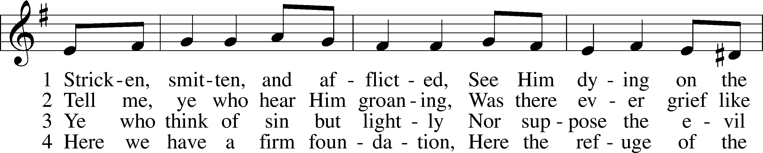
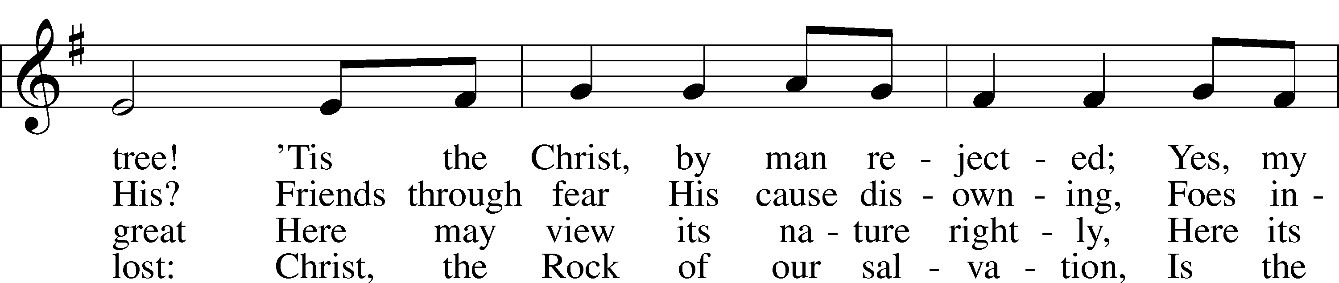
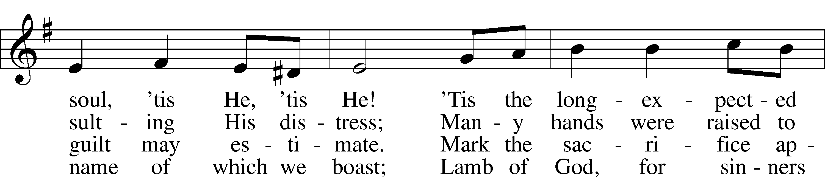
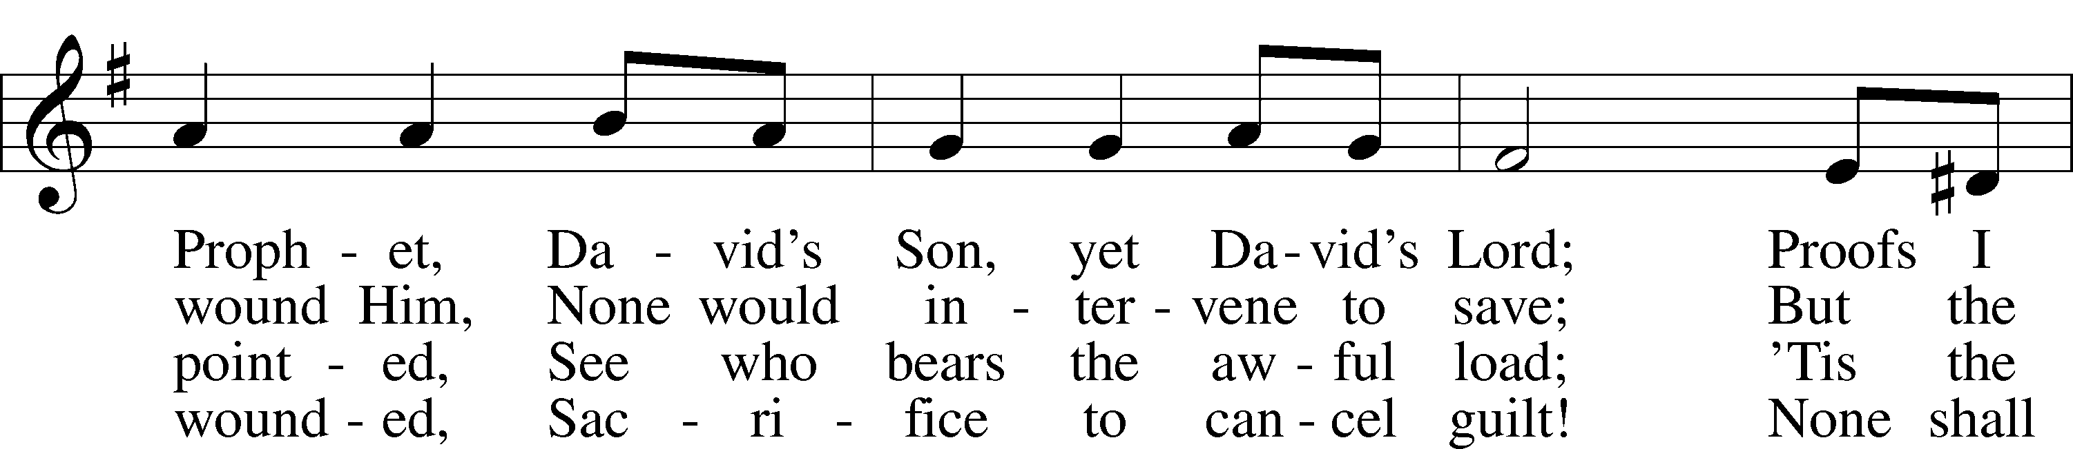
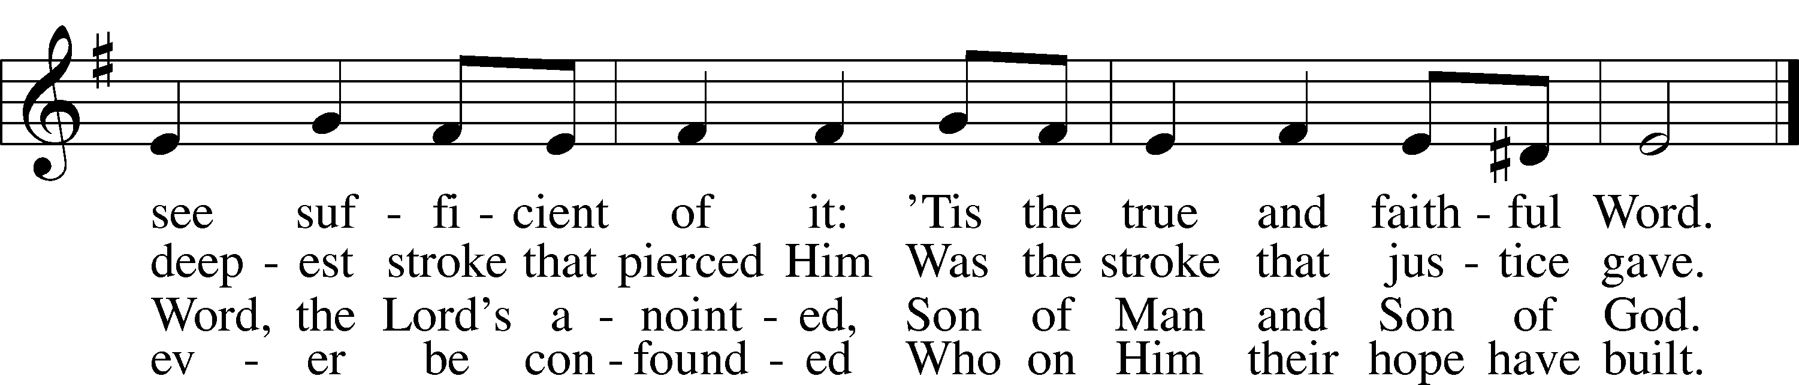
Tune and text: Public domain

Stand

Bidding Prayer
A Let us pray for the whole Christian Church, that our Lord God would defend her against all the assaults and temptations of the adversary and keep her perpetually on the true foundation, Jesus Christ:

Silence for individual prayer within the topic of this bid. For example: How are those whom you know tempted and assaulted by the adversary? Pray that God would point us all to Christ our rock and cornerstone!

P Almighty and everlasting God, since You have revealed Your glory to all nations in Jesus Christ and in the Word of His truth, keep, we ask You, in safety the works of Your mercy so that Your Church, spread throughout all the nations, may be defended against the adversary and may serve You in true faith and persevere in the confession of Your name; through Jesus Christ, our Lord.
C Amen.

A Let us pray for all the ministers of the Word, for all vocations in the Church, and for all the people of God:

Silence for individual prayer

P Almighty and everlasting God, by whose Spirit the whole body of the Church is governed and sanctified, receive the supplications and prayers which we offer before You for all Your servants in Your holy Church that every member of the same may truly serve You according to Your calling; through Jesus Christ, our Lord.
C Amen.

A Let us pray for our catechumens, that our Lord God would open their hearts and the door of His mercy that, having received the remission of all their sins by the washing of regeneration, they may be mindful of their Baptism and evermore be found in Christ Jesus, our Lord:

Silence for individual prayer

P Almighty God and Father, because You always grant growth to Your Church, increase the faith and understanding of our catechumens that, rejoicing in their new birth by the water of Holy Baptism, they may forever continue in the family of those whom You adopt as Your sons and daughters; through Jesus Christ, our Lord.
C Amen.

A Let us pray for all in authority that we may lead a quiet and peaceable life in all godliness and honesty:

Silence for individual prayer

P O merciful Father in heaven, because You hold in Your hand all the might of man and because You have ordained, for the punishment of evildoers and for the praise of those who do well, all the powers that exist in all the nations of the world, we humbly pray You graciously to regard Your servants, especially [name], our President; the Congress of the United States; [name], our Governor; and all those who make, administer, and judge our laws; that all who receive the sword as Your ministers may bear it according to Your Word; through Jesus Christ, our Lord.
C Amen.

A Let us pray our Lord God Almighty that He would deliver the world from all error, take away disease, ward off famine, set free those in bondage, and grant health to the sick and a safe journey to all who travel:

Silence for individual prayer

P Almighty and everlasting God, the consolation of the sorrowful and the strength of the weak, may the prayers of those who in any tribulation or distress cry to You graciously come before You, so that in all their necessities they may rejoice in Your manifold help and comfort; through Jesus Christ, our Lord.
C Amen.

A Let us pray for all who are outside the Church, that our Lord God would be pleased to deliver them from their error, call them to faith in the true and living God and His only Son, Jesus Christ, our Lord, and gather them into His family, the Church:

Silence for individual prayer

P Almighty and everlasting God, because You seek not the death but the life of all, hear our prayers for all who have no right knowledge of You, free them from their error, and for the glory of Your name bring them into the fellowship of Your holy Church; through Jesus Christ, our Lord.
C Amen.

A Let us pray for peace, that we may come to the knowledge of God’s holy Word and walk before Him as is fitting for Christians:

Silence for individual prayer

P Almighty and everlasting God, King of Glory, and Lord of heaven and earth, by whose Spirit all things are governed, by whose providence all things are ordered, the God of peace and the author of all concord, grant us, we implore You, Your heavenly peace and concord that we may serve You in true fear, to the praise and glory of Your name; through Jesus Christ, our Lord.
C Amen.

A Let us pray for our enemies, that God would remember them in mercy and graciously grant them such things as are both needful for them and profitable for their salvation:

Silence for individual prayer

P O almighty, everlasting God, through Your only Son, our blessed Lord, You have commanded us to love our enemies, to do good to those who hate us, and to pray for those who persecute us. We therefore earnestly implore You that by Your gracious visitation all our enemies may be led to true repentance and may have the same love and be of one accord and one mind and heart with us and with Your whole Christian Church; through Jesus Christ, our Lord.
C Amen.

A Let us pray for the fruits of the earth, that God would send down His blessing upon them and graciously dispose our hearts to enjoy them according to His own good will:

Silence for individual prayer

P O Lord, Father Almighty, by Your Word You created and You continue to bless and uphold all things. We pray You so to reveal to us Your Word, our Lord Jesus Christ that, through His dwelling in our hearts, we may by Your grace be made ready to receive Your blessing on all the fruits of the earth and whatsoever pertains to our bodily need; through Jesus Christ, our Lord.
C Amen.

A Finally, let us pray for all those things for which our Lord would have us ask, saying:
C Our Father who art in heaven,
hallowed be Thy name,
Thy kingdom come,
Thy will be done on earth as it is in heaven;
give us this day our daily bread;
and forgive us our trespasses
as we forgive those who trespass against us;
and lead us not into temptation,
but deliver us from evil.
For Thine is the kingdom and the power and the glory forever and ever. Amen.

P Behold, the life-giving cross on which was hung the salvation of the world.
C O come, let us worship Him.

P Behold, the life-giving cross on which was hung the salvation of the world.
C O come, let us worship Him.

P Behold, the life-giving cross on which was hung the salvation of the world.
C O come, let us worship Him.

Sit

Choir Solo: “Were You There” LSB 456 st. 1-3

The following Reproaches are the words of the Lord against His people, the Church, to which the congregation replies with a plea for mercy. Pastor sings from the voice of God, the assistant speaks a prayer on behalf of the congregation, then the congregation sings Lamb of God, Pure and Holy confident that Christ has paid the debt of sin and death that we owe.

Reproach
P Thus says the Lord: What have I done to you, O My people, and wherein have I offended you? Answer Me. For I have raised you up out of the prison house of sin and death, and you have delivered up your Redeemer to be scourged. For I have redeemed you from the house of bondage, and you have nailed your Savior to the cross. O My people.

A Holy Lord God, holy and mighty God, holy and most merciful Redeemer; God eternal, leave us not to bitter death. O Lord, have mercy.

“Lamb of God, Pure and Holy” LSB 434 st. 1
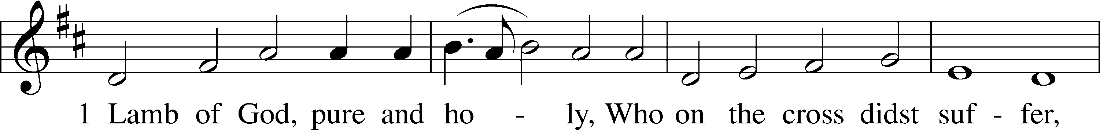
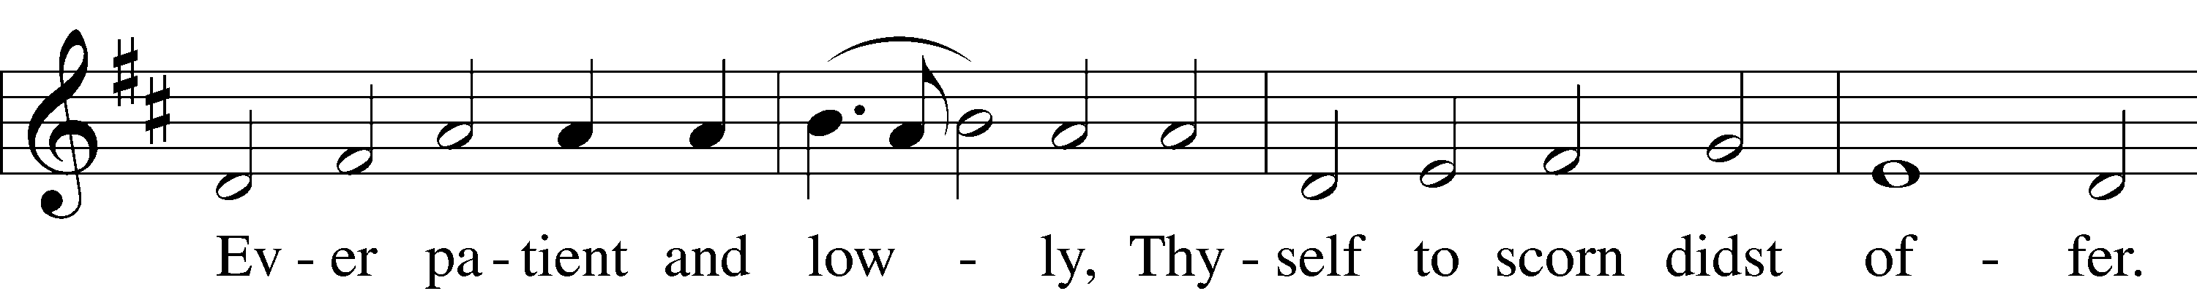
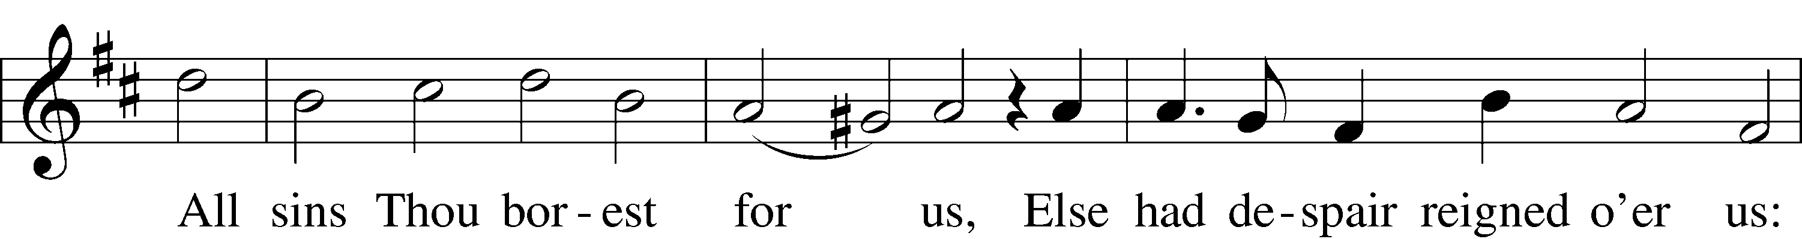
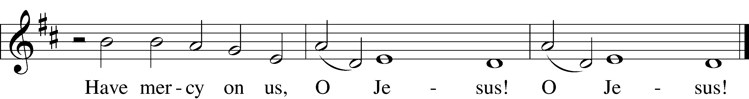
Tune and text: Public domain

Reproach
P Thus says the Lord: What have I done to you, O My people, and wherein have I offended you? Answer Me. For I have conquered all your foes, and you have given Me over and delivered Me to those who persecute Me. For I have fed you with My Word and refreshed you with living water, and you have given Me gall and vinegar to drink. O My people.

A Holy Lord God, holy and mighty God, holy and most merciful Redeemer; God eternal, allow us not to lose hope in the face of death and hell. O Lord, have mercy.

“Lamb of God, Pure and Holy” LSB 434 st. 2

2 Lamb of God, pure and holy,
Who on the cross didst suffer,
Ever patient and lowly,
Thyself to scorn didst offer.
All sins Thou borest for us,
Else had despair reigned o’er us:
Have mercy on us, O Jesus! O Jesus!
Text: Public domain

Reproach
P Thus says the Lord: What have I done to you, O My people, and wherein have I offended you? Answer Me. What more could have been done for My vineyard than I have done for it? When I looked for good grapes, why did it yield only bad? My people, is this how you thank your God? O My people.

A Holy Lord God, holy and mighty God, holy and most merciful Redeemer; God eternal, keep us steadfast in the true faith. O Lord, have mercy.

“Lamb of God, Pure and Holy” LSB 434 st. 3

3 Lamb of God, pure and holy,
Who on the cross didst suffer,
Ever patient and lowly,
Thyself to scorn didst offer.
All sins Thou borest for us,
Else had despair reigned o’er us:
Thy peace be with us, O Jesus! O Jesus!
Text: Public domain

Stand

C We adore You, | O Lord,*
and we praise and glorify Your holy resur- | rection.
For behold, by the wood | of Your cross*
joy has come into | all the world.
God be merciful to us and | bless us,*
and cause His face to shine upon us, and have mercy up- | on us.
We adore You, | O Lord,*
and we praise and glorify Your holy resur- | rection.
For behold, by the wood | of Your cross*
joy has come into | all the world.

P Let us pray.
We implore You, O Lord, that Your abundant blessing may be upon Your people who have held the passion and death of Your Son in devout remembrance, that we may receive Your pardon and the gift of Your comfort, and may increase in faith and take hold of eternal salvation; through the same Jesus Christ, Your Son, our Lord, who lives and reigns with You and the Holy Spirit, one God, now and forever.
C Amen.

“When I Survey the Wondrous Cross” LSB 425 sts. 1–4
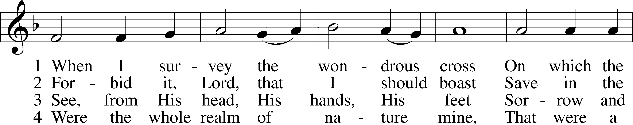
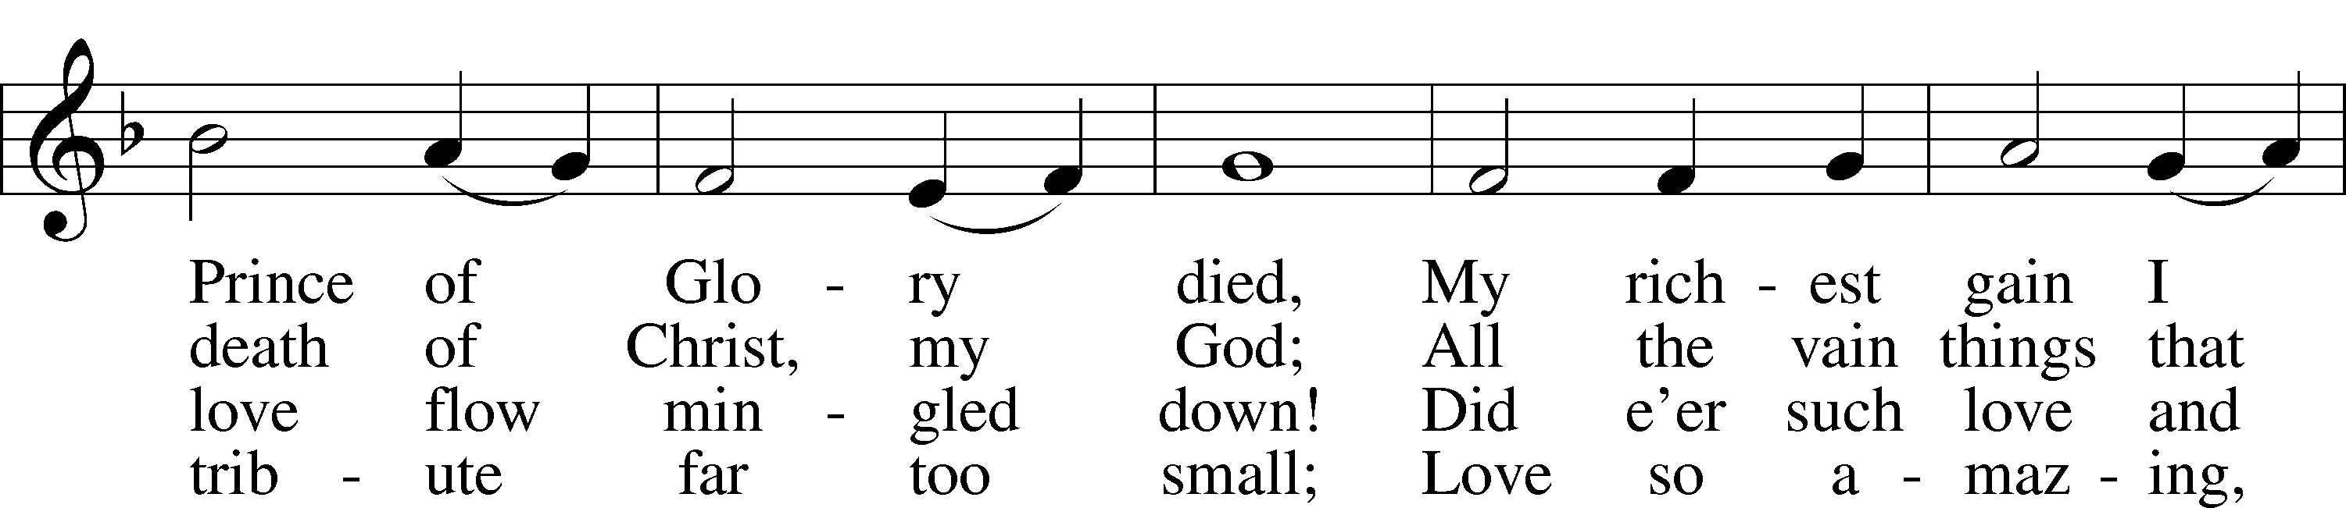
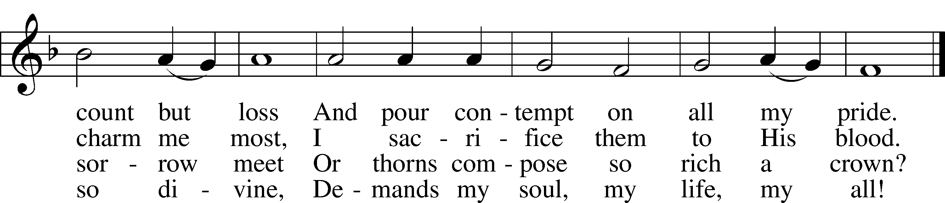
Text and tune: Public domain

Strepitus

There is silence for meditation followed by a loud noise that signifies the shutting and rending of the tomb. It is finished, and Christ will rise again! The Lights Are Dimmed

Silent Recessional: The congregation leaves the sanctuary and the building silently contemplating the sacrificial and victorious death of Christ. The Church views tomorrow night’s service as a continuation of tonight’s service and yesterday’s service. Join us tomorrow at 7:00 p.m. to hear the resurrection proclaimed at our candlelight Easter Vigil!

Acknowledgments
Unless otherwise indicated, Scripture quotations are from the ESV® Bible (The Holy Bible, English Standard Version®), copyright © 2001 by Crossway, a publishing ministry of Good News Publishers. Used by permission. All rights reserved.
Created by Lutheran Service Builder © 2021 Concordia Publishing House.

Serving Our Lord in His House Today:
Pastor: Rev. David Wurdeman
Organist: Linda Ecker
Elder: Bob Pulley & Jerry Ecker
Soloist: Todd Anderson

HOLY WEEK AND EASTER SCHEDULE
Join us for the following worship times:

Holy Saturday
Saturday, April 3, 2021
Easter Vigil 7:00 p.m.
Candlelight service
Easter:
Easter Sunday
Sunday, April 4, 2021
Breakfast, 9:00 a.m.
Divine Service 10:30 a.m.

