Good Shepherd Lutheran Church
Sixth Sunday after Pentecost
July 17, 2022

Pre-Service Music & Welcome
Divine Service Setting Four – Lutheran Service Book (LSB) 203

+CONFESSION AND ABSOLUTION+

Stand
Opening Hymn “Word of God, Come Down on Earth” LSB 545
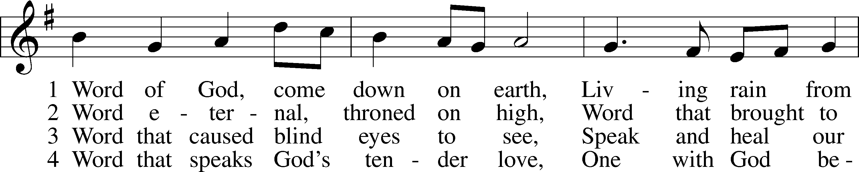
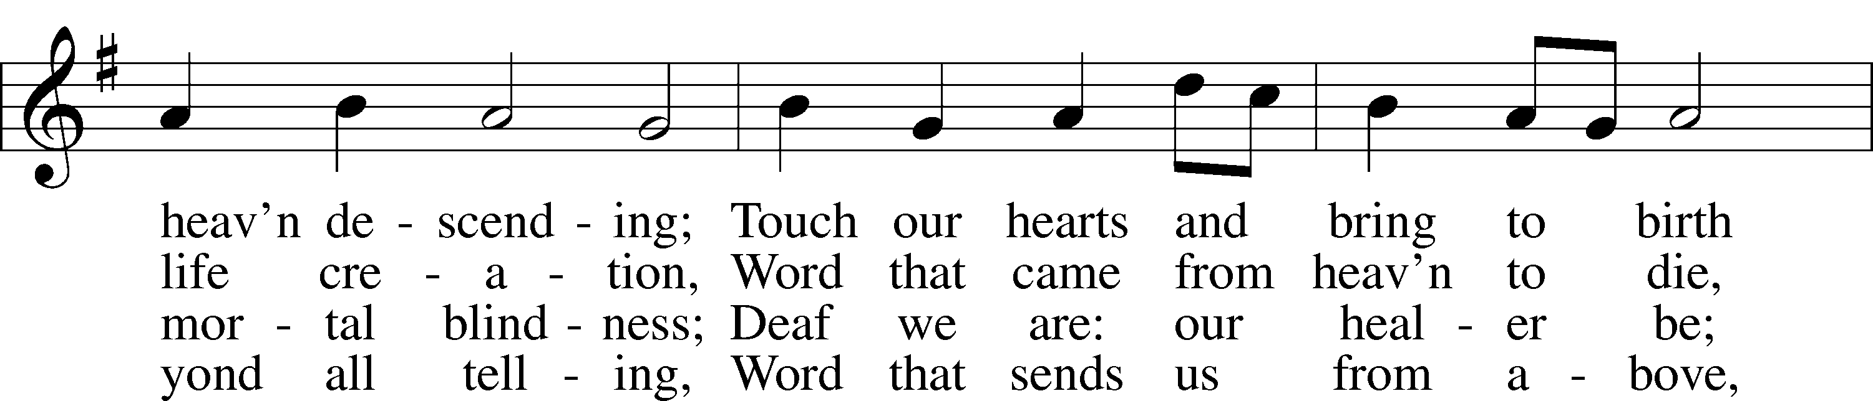
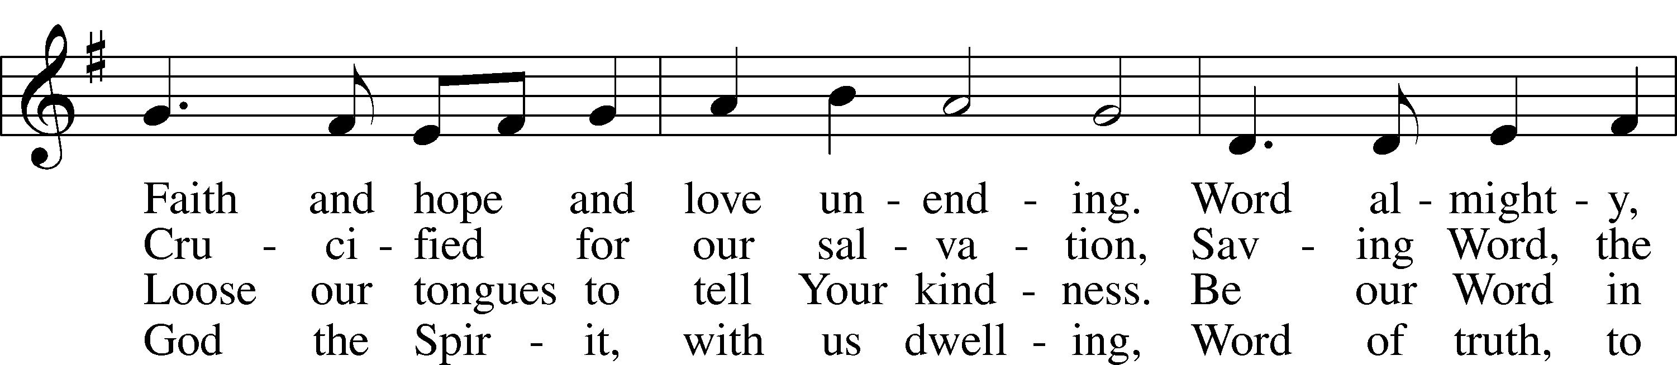
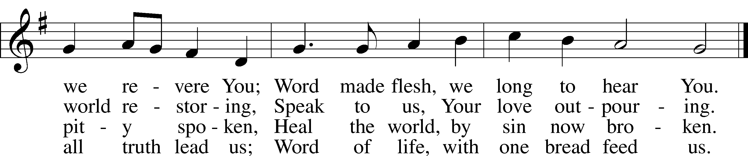
Text: James Quinn, 1919–2010
Tune: Johann Rudolph Ahle, 1625–73, alt.
Text: © 1969 OCP Publications. Used by permission: LSB Hymn License no. 110016438
Tune: Public domain

The sign of the cross T may be made by all in remembrance of their Baptism.

Invocation
P In the name of the Father and of the T Son and of the Holy Spirit.
C Amen.

Exhortation LSB 203
P Our help is in the name of the Lord,
C who made heaven and earth.

P If You, O Lord, kept a record of sins, O Lord, who could stand?
C But with You there is forgiveness; therefore You are feared.

P Since we are gathered to hear God’s Word, call upon Him in prayer and praise, and receive the body and blood of our Lord Jesus Christ in the fellowship of this altar, let us first consider our unworthiness and confess before God and one another that we have sinned in thought, word, and deed, and that we cannot free ourselves from our sinful condition. Together as His people let us take refuge in the infinite mercy of God, our heavenly Father, seeking His grace for the sake of Christ, and saying: God, be merciful to me, a sinner.

Silence for reflection on God’s Word and for self-examination.

Confession of Sins LSB 203
C Almighty God, have mercy upon us, forgive us our sins, and lead us to everlasting life. Amen.

Absolution LSB 203
P Almighty God in His mercy has given His Son to die for you and for His sake forgives you all your sins. As a called and ordained servant of Christ, and by His authority, I therefore forgive you all your sins in the name of the Father and of the T Son and of the Holy Spirit.
C Amen.

+SERVICE OF THE WORD+

Introit Psalm 119:57–60, 64; antiphon: v. 105
Your word is a lamp to my feet
and a light to my path.
The Lord is my portion;
I promise to keep your words.
I entreat your favor with all my heart;
be gracious to me according to your promise.
When I think on my ways,
I turn my feet to your testimonies;
I hasten and do not delay
to keep your commandments.
The earth, O Lord, is full of your steadfast love;
teach me your statutes!
Glory be to the Father and to the Son
and to the Holy Spirit;
as it was in the beginning,
is now, and will be forever. Amen.
Your word is a lamp to my feet
and a light to my path.

Kyrie LSB 204
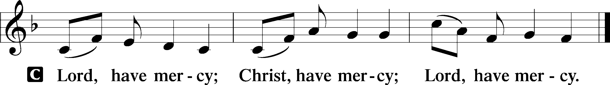

Gloria in Excelsis LSB 204
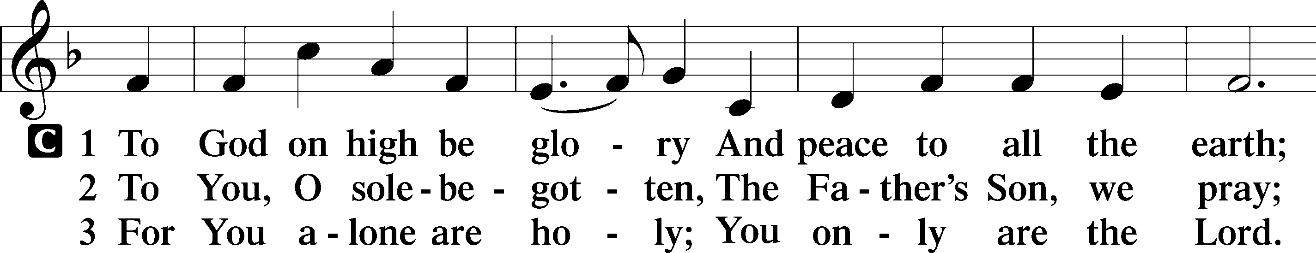
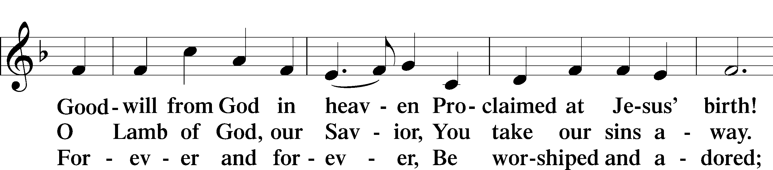
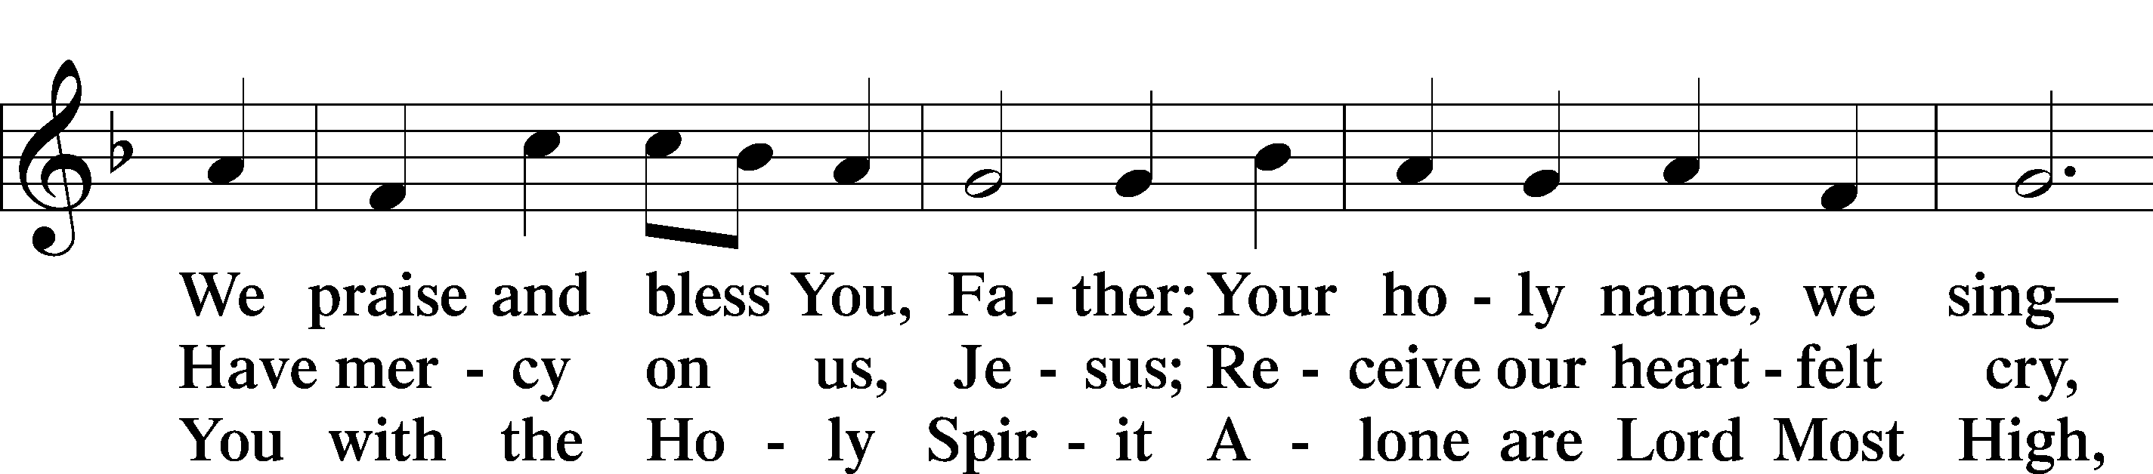
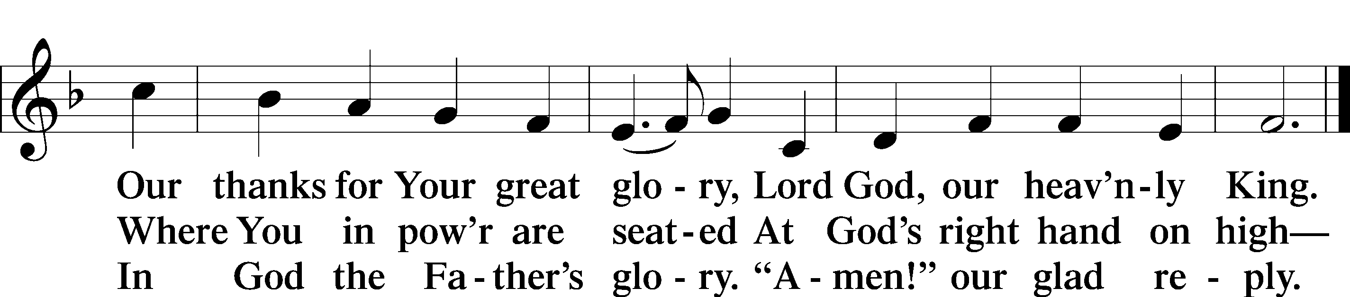
Text: Stephen P. Starke

Salutation and Collect of the Day
P The Lord be with you.
C And also with you.

P Let us pray.
C O Lord, grant us the Spirit to hear Your Word and know the one thing needful that by Your Word and Spirit we may live according to Your will; through Jesus Christ, Your Son,
our Lord, who lives and reigns with You and the Holy Spirit,
one God, now and forever. Amen.

Sit

Old Testament Reading Genesis 18:1–14
1 The Lord appeared to [Abraham] by the oaks of Mamre, as he sat at the door of his tent in the heat of the day. 2He lifted up his eyes and looked, and behold, three men were standing in front of him. When he saw them, he ran from the tent door to meet them and bowed himself to the earth 3and said, “O Lord, if I have found favor in your sight, do not pass by your servant. 4Let a little water be brought, and wash your feet, and rest yourselves under the tree, 5while I bring a morsel of bread, that you may refresh yourselves,
and after that you may pass on—since you have come to your servant.” So they said, “Do as you have said.” 6And Abraham went quickly into the tent to Sarah and said, “Quick! Three seahs of fine flour! Knead it, and make cakes.” 7And Abraham ran to the herd and took a calf, tender and good, and gave it to a young man,
who prepared it quickly. 8Then he took curds and milk and the calf that he had prepared, and set it before them. And he stood by them under the tree while they ate.
9They said to him, “Where is Sarah your wife?” And he said,
“She is in the tent.” 10The Lord said, “I will surely return to you about this time next year, and Sarah your wife shall have a son.”
And Sarah was listening at the tent door behind him. 11Now Abraham and Sarah were old, advanced in years. The way of women had ceased to be with Sarah.

12So Sarah laughed to herself, saying, “After I am worn out, and my lord is old, shall I have pleasure?” 13The Lord said to Abraham, “Why did Sarah laugh and say, ‘Shall I indeed bear a child, now that I am old?’ 14Is anything too hard for the Lord? At the appointed time I will return to you about this time next year, and Sarah shall have a son.”

A This is the Word of the Lord.
C Thanks be to God.

Gradual Romans 10:15b, 18b; Isaiah 52:7b, alt.
How beautiful are the feet of those who preach the good news,
who publish peace and bring good news of salvation.
Their voice has gone out to all the earth,
and their words to the ends of the world.

Epistle Colossians 1:21–29
21You, who once were alienated and hostile in mind, doing evil deeds, 22he has now reconciled in his body of flesh by his death,
in order to present you holy and blameless and above reproach before him, 23if indeed you continue in the faith, stable and steadfast,
not shifting from the hope of the gospel that you heard, which has been proclaimed in all creation under heaven, and of which I,
Paul, became a minister.
24Now I rejoice in my sufferings for your sake, and in my flesh I am filling up what is lacking in Christ’s afflictions for the sake of his body, that is, the church, 25of which I became a minister according to the stewardship from God that was given to me for you, to make the word of God fully known, 26the mystery hidden for ages and generations but now revealed to his saints. 27To them God chose to make known how great among the Gentiles are the riches of the glory of this mystery, which is Christ in you, the hope of glory.
28Him we proclaim, warning everyone and teaching everyone with all wisdom, that we may present everyone mature in Christ. 29For this I toil, struggling with all his energy that he powerfully works within me.

A This is the Word of the Lord.
C Thanks be to God.

Stand

Alleluia and Verse

Alleluia LSB 205
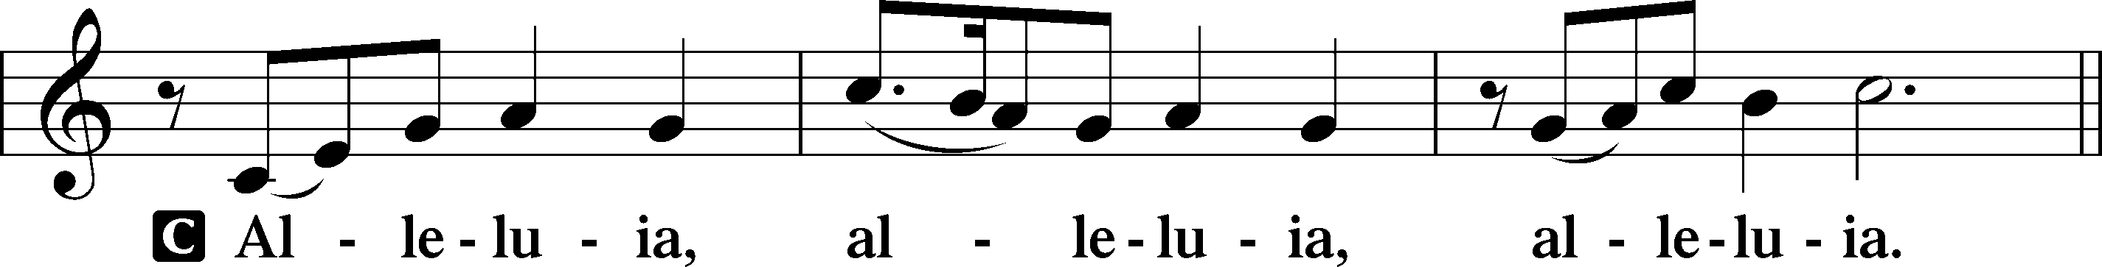

Verse LSB 205
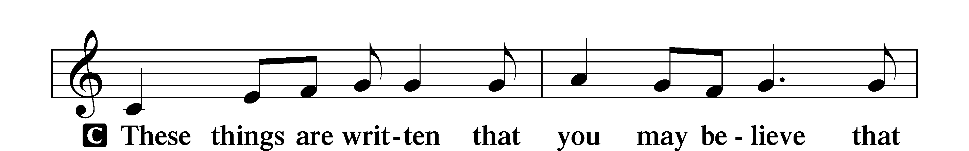
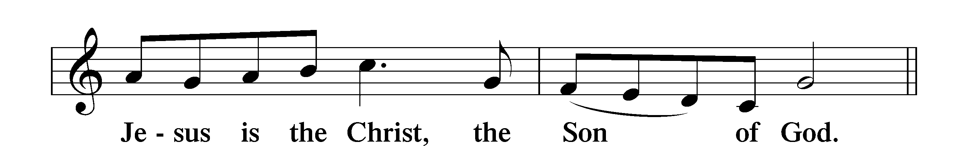

Alleluia LSB 205
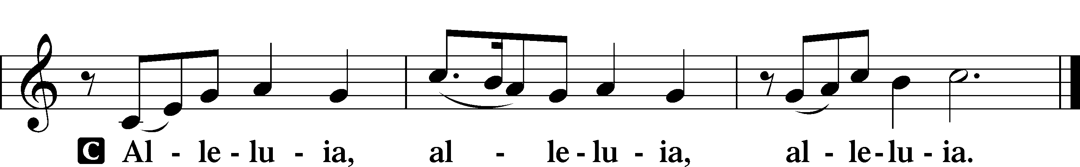

Holy Gospel Luke 10:38–42
P The Holy Gospel according to St. Luke, the tenth chapter.
C Glory to You, O Lord.

38Now as they went on their way, Jesus entered a village. And a woman named Martha welcomed him into her house. 39And she had a sister called Mary, who sat at the Lord’s feet and listened to his teaching. 40But Martha was distracted with much serving. And she went up to him and said, “Lord, do you not care that my sister has left me to serve alone? Tell her then to help me.” 41But the Lord answered her, “Martha, Martha, you are anxious and troubled about many things, 42but one thing is necessary. Mary has chosen the good portion, which will not be taken away from her.”

P This is the Gospel of the Lord.
C Praise to You, O Christ.

Nicene Creed
C I believe in one God,
the Father Almighty,
maker of heaven and earth
and of all things visible and invisible.

And in one Lord Jesus Christ,
the only-begotten Son of God,
begotten of His Father before all worlds,
God of God, Light of Light,
very God of very God,
begotten, not made,
being of one substance with the Father,
by whom all things were made;
who for us men and for our salvation came down from heaven
and was incarnate by the Holy Spirit of the virgin Mary
and was made man;
and was crucified also for us under Pontius Pilate.
He suffered and was buried.
And the third day He rose again according to the Scriptures
and ascended into heaven
and sits at the right hand of the Father.
And He will come again with glory to judge both the living and the dead,
whose kingdom will have no end.

And I believe in the Holy Spirit,
the Lord and giver of life,
who proceeds from the Father and the Son,
who with the Father and the Son together is worshiped and glorified,
who spoke by the prophets.
And I believe in one holy Christian and apostolic Church,
I acknowledge one Baptism for the remission of sins,
and I look for the resurrection of the dead
and the life T of the world to come. Amen.

Sit

Children's Message

Hymn of the Day “Speak, O Lord, Your Servant Listens” LSB 589
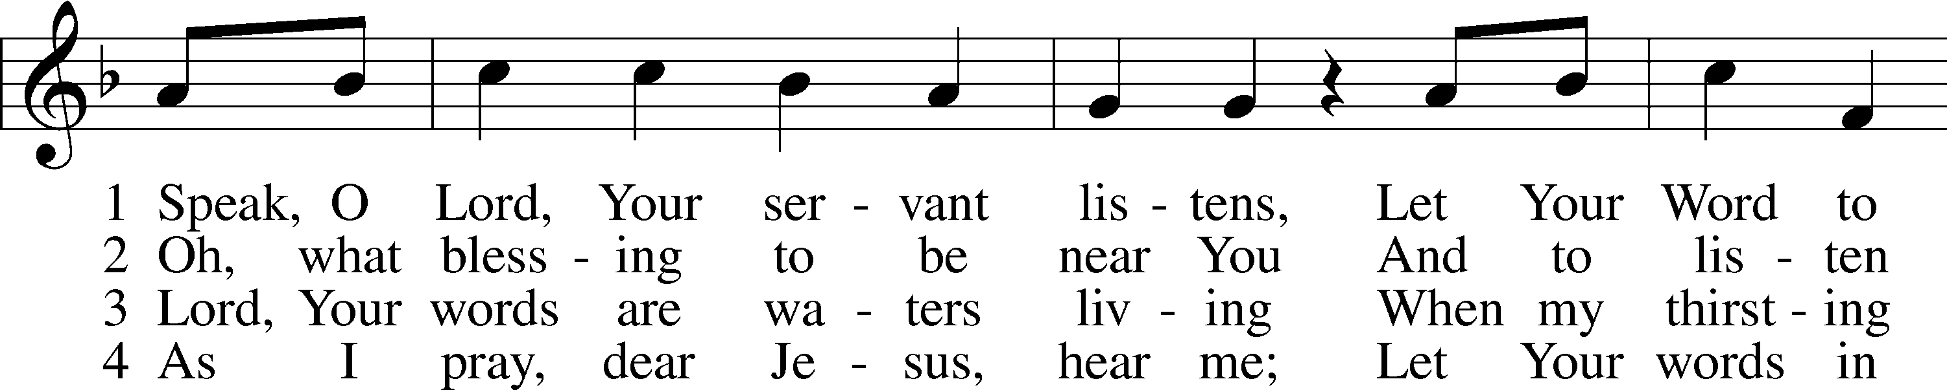
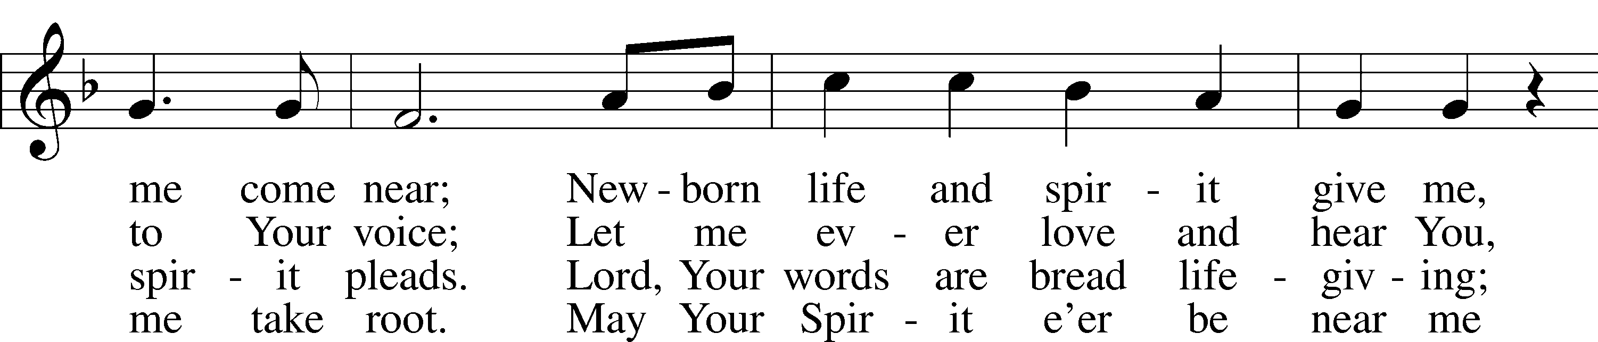
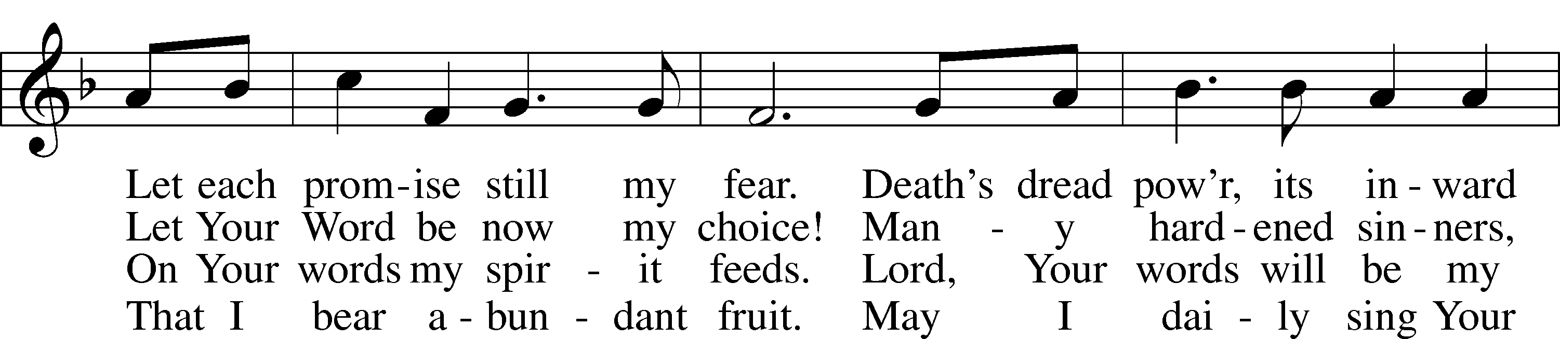
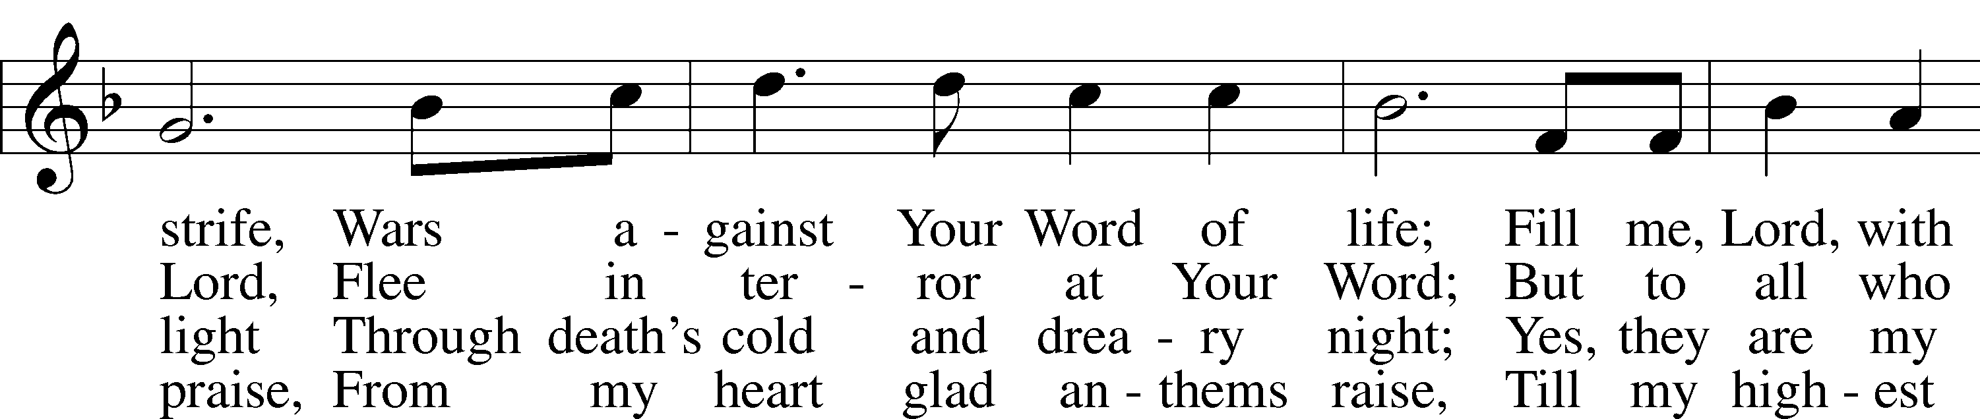
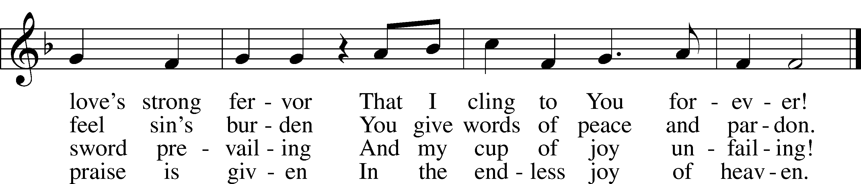
Text: Anna Sophia von Hessen-Darmstadt, 1638–83; (sts. 1–3): tr. George A. T. Rygh, 1860–1942, alt.; (st. 4): tr. Christian Worship, 1993
Tune: Johann Schop, c. 1590–1667
Text and tune: Public domain

Sermon

Stand

Prayer of the Church

Sit

Offering

+SERVICE OF THE SACRAMENT+

Stand

Preface LSB 208
P The Lord be with you.
C And also with you.

P Lift up your hearts.
C We lift them to the Lord.

P Let us give thanks to the Lord our God.
C It is right to give Him thanks and praise.

P It is truly good, right, and salutary that we should at all times and in all places give thanks to You, O Lord, holy Father, almighty and everlasting God, for the countless blessings You so freely bestow on us and all creation. Above all, we give thanks for Your boundless love shown to us when You sent Your only-begotten Son, Jesus Christ, into our flesh and laid on Him our sin, giving Him into death that we might not die eternally. Because He is now risen from the dead and lives and reigns to all eternity, all who believe in Him will overcome sin and death and will rise again to new life. Therefore with angels and archangels and with all the company of heaven we laud and magnify Your glorious name, evermore praising You and saying:

Sanctus LSB 208
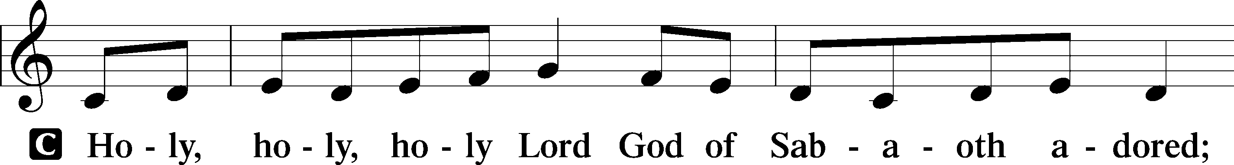
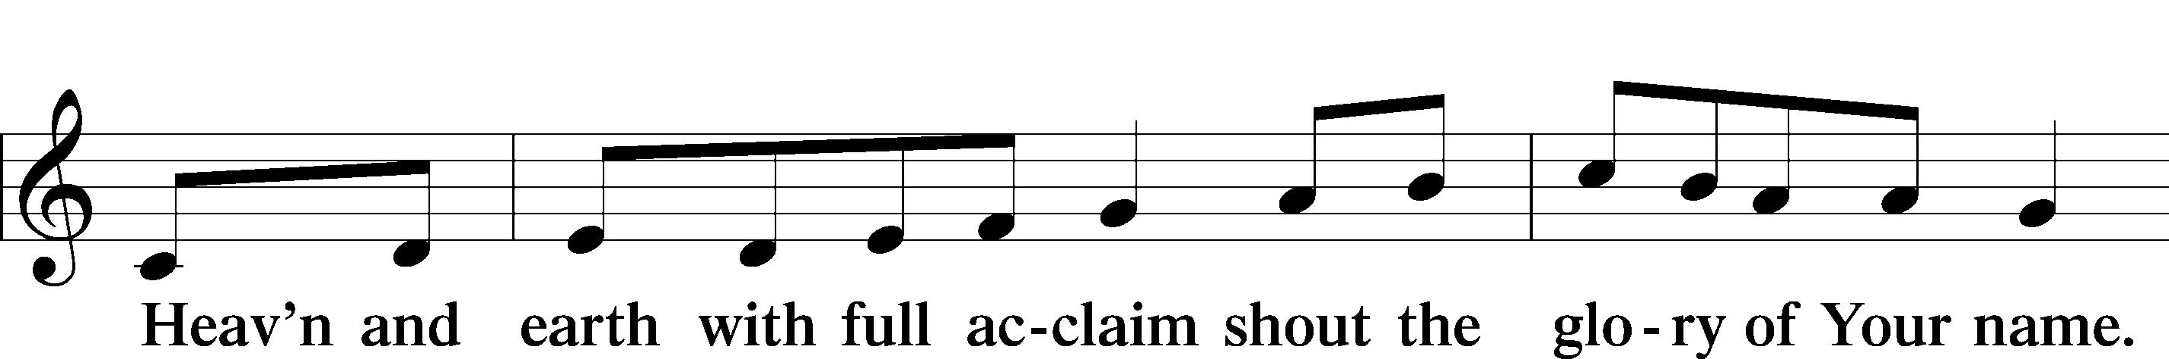
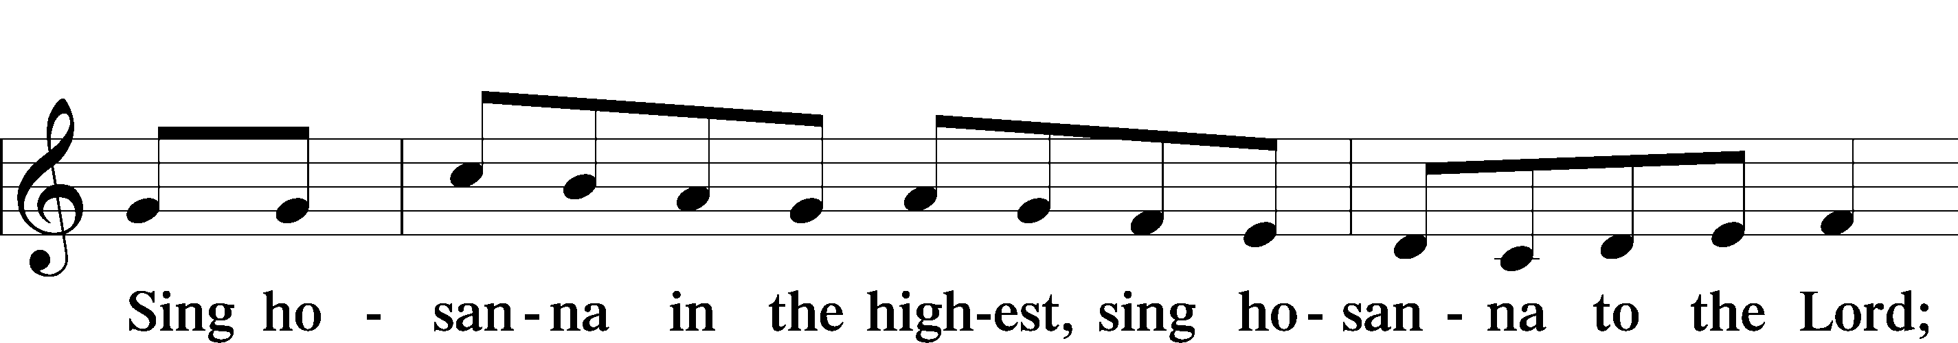
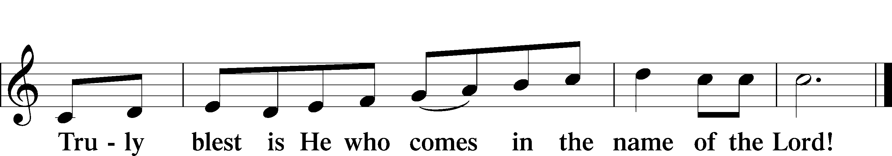
Text: Stephen P. Starke

Prayer of Thanksgiving
P Blessed are You, O Lord our God, king of all creation, for You have had mercy on us and given Your only-begotten Son that whoever believes in Him should not perish but have eternal life.

In Your righteous judgment You condemned the sin of Adam and Eve, who ate the forbidden fruit, and You justly barred them and all their children from the tree of life. Yet, in Your great mercy, You promised salvation by a second Adam, Your Son, Jesus Christ, our Lord, and made His cross a life-giving tree for all who trust in Him.

We give You thanks for the redemption You have prepared for us through Jesus Christ. Grant us Your Holy Spirit that we may faithfully eat and drink of the fruits of His cross and receive the blessings of forgiveness, life, and salvation that come to us in His body and blood.

Hear us as we pray in His name and as He has taught us:

Lord’s Prayer
C Our Father who art in heaven,
hallowed be Thy name,
Thy kingdom come,
Thy will be done on earth
as it is in heaven;
give us this day our daily bread;
and forgive us our trespasses
as we forgive those
who trespass against us;
and lead us not into temptation,
but deliver us from evil.
For Thine is the kingdom
and the power and the glory
forever and ever. Amen.

The Words of Our Lord
P Our Lord Jesus Christ, on the night when He was betrayed, took bread, and when He had given thanks, He broke it and gave it to the disciples and said: “Take, eat; this is My T body, which is given for you. This do in remembrance of Me.”

In the same way also He took the cup after supper, and when He had given thanks, He gave it to them, saying: “Drink of it, all of you; this cup is the new testament in My T blood, which is shed for you for the forgiveness of sins. This do, as often as you drink it, in remembrance of Me.”

Pax Domini
P The peace of the Lord be with you always.
C Amen.

Agnus Dei LSB 210
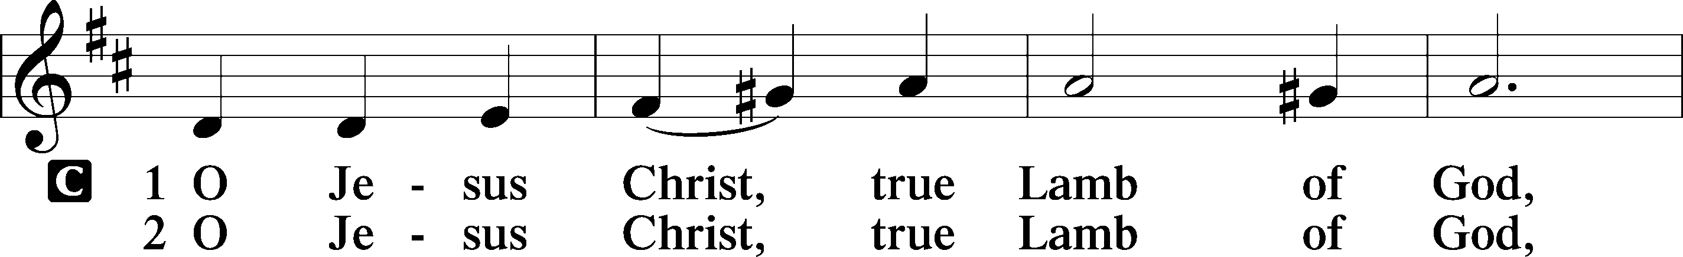
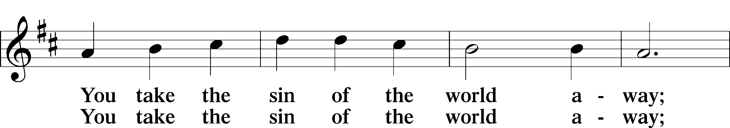
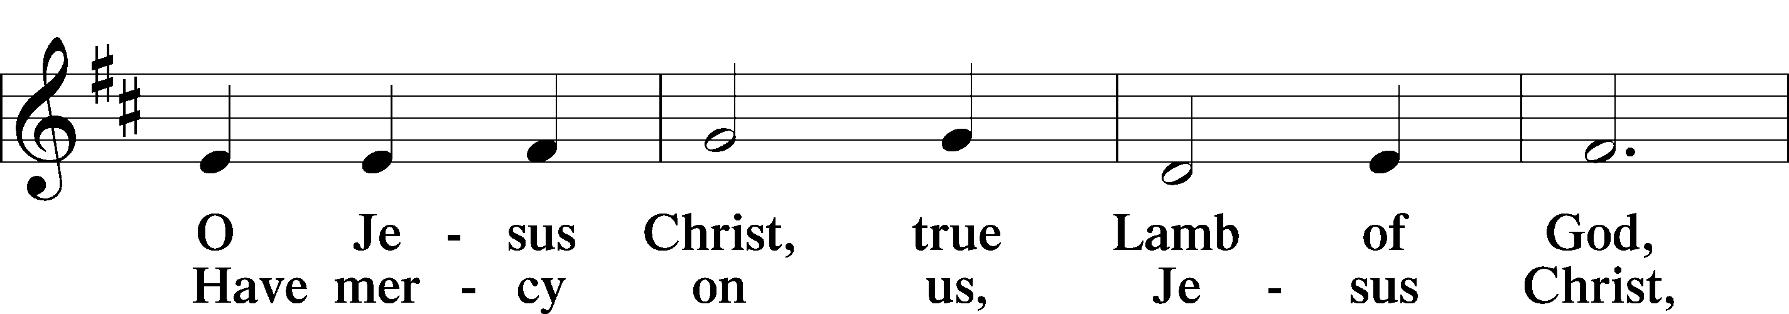
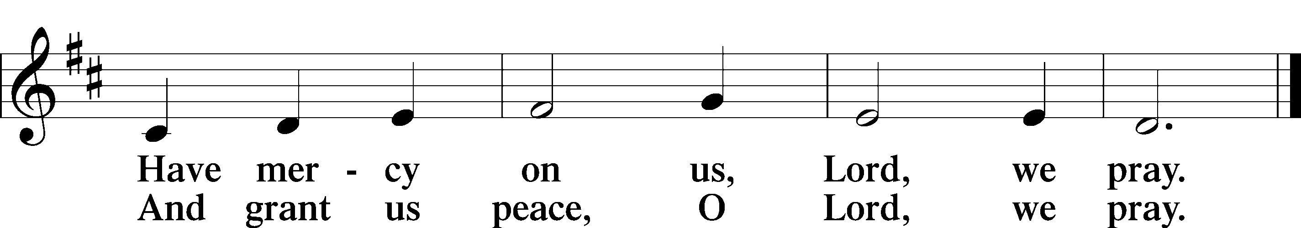
Text: Stephen P. Starke

Sit

Distribution

Distribution Hymn “Lord Jesus Christ, Life-Giving Bread” LSB 625
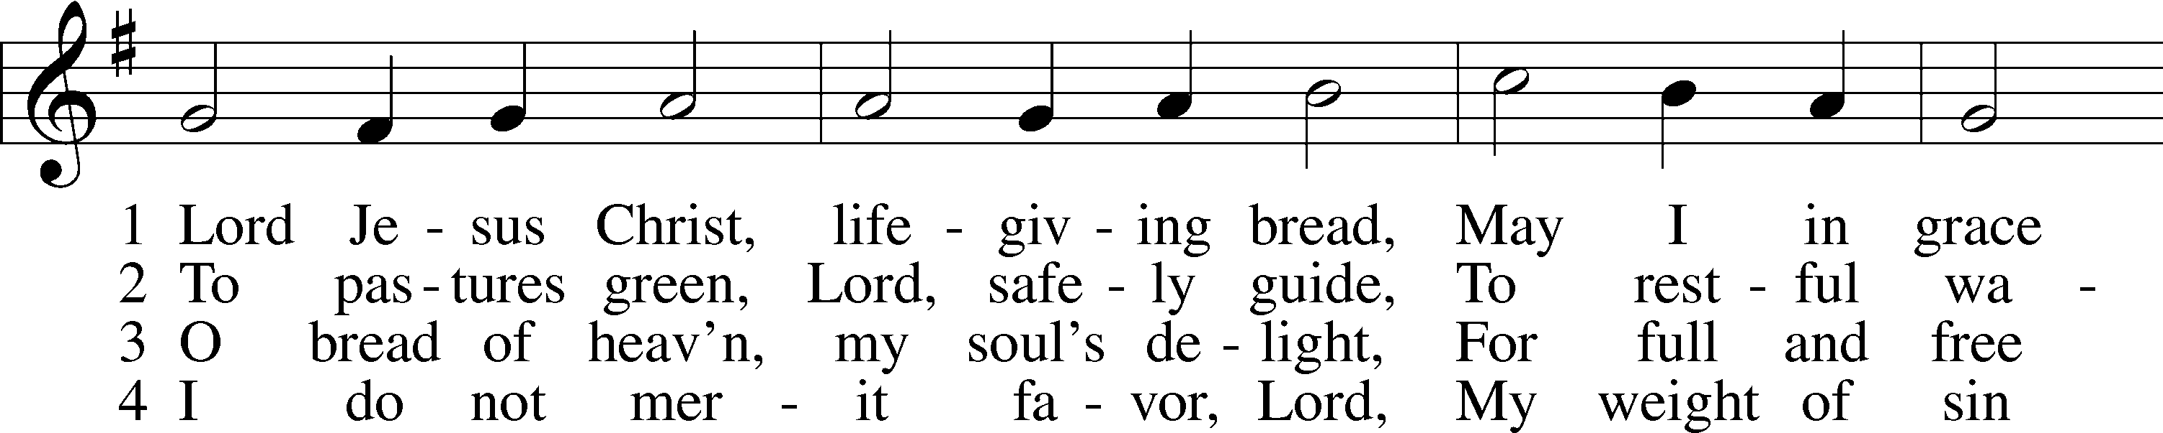
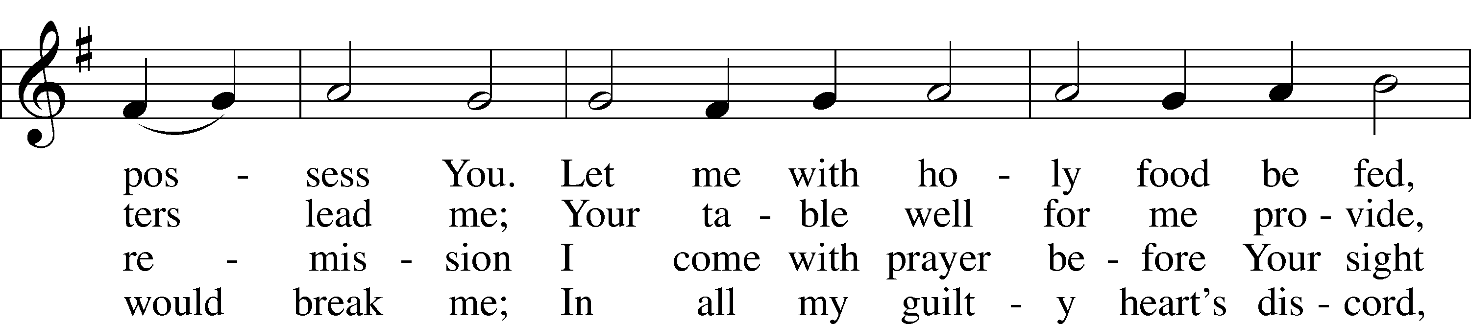
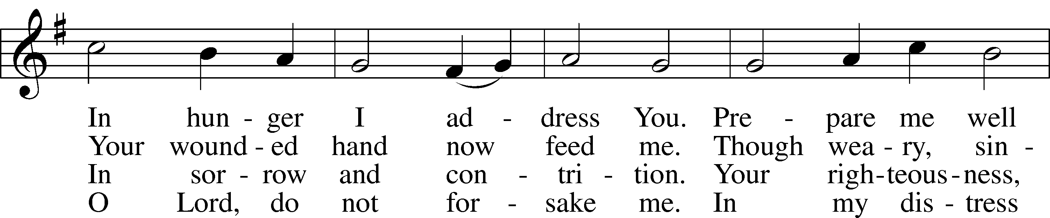
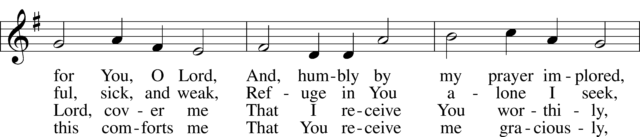
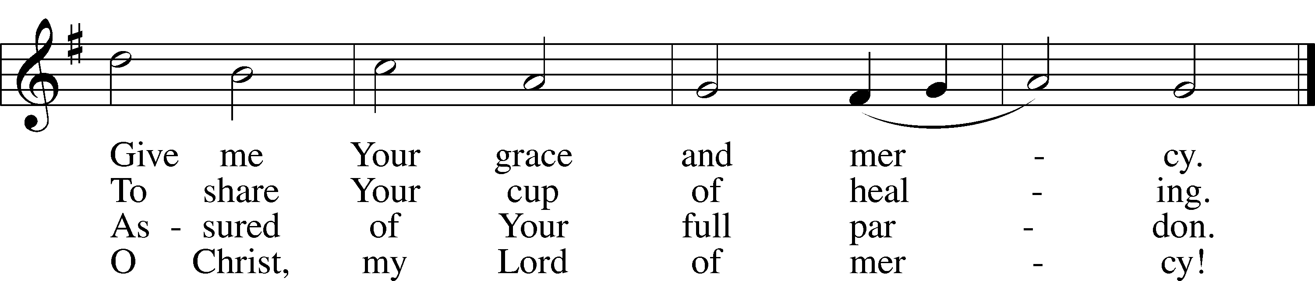
Text: Johann Rist, 1607–67; tr. Arthur T. Russell, 1806–74, alt.
Tune: Theütsch kirchen ampt, 1525, Strassburg
Text and tune: Public domain

Stand

Nunc Dimittis LSB 211
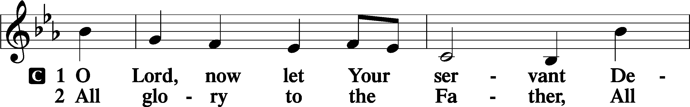
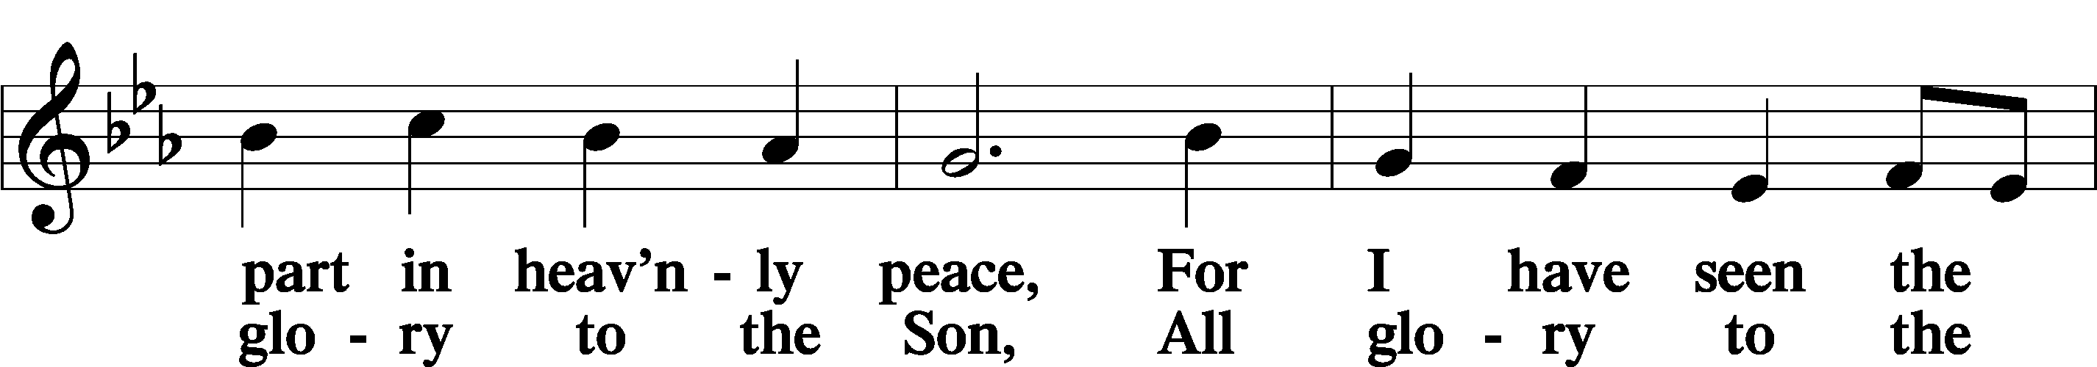
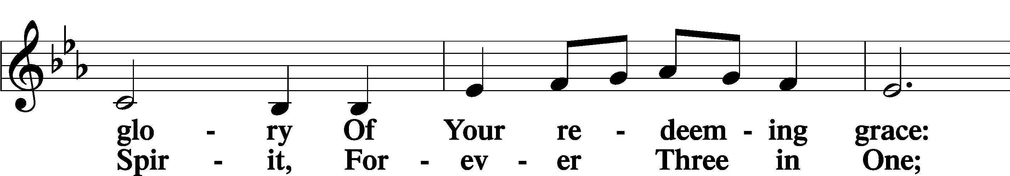
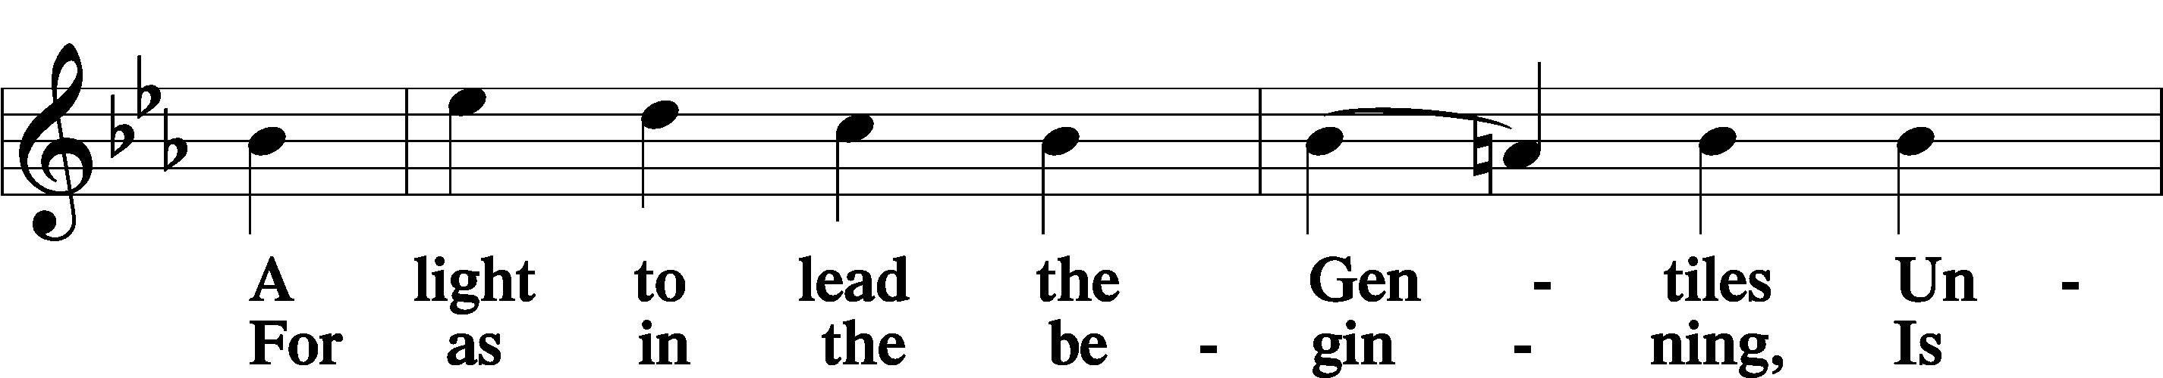
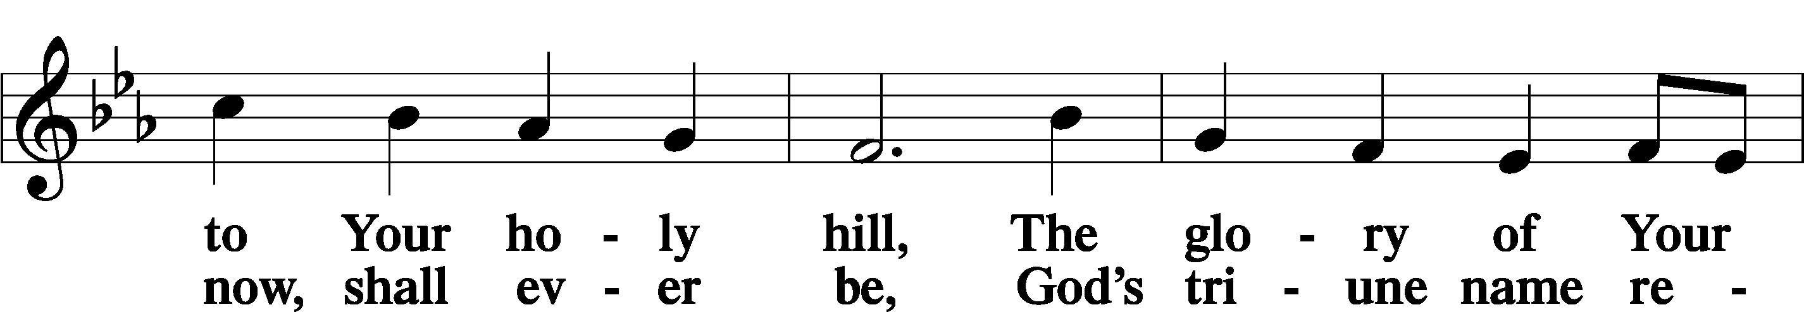
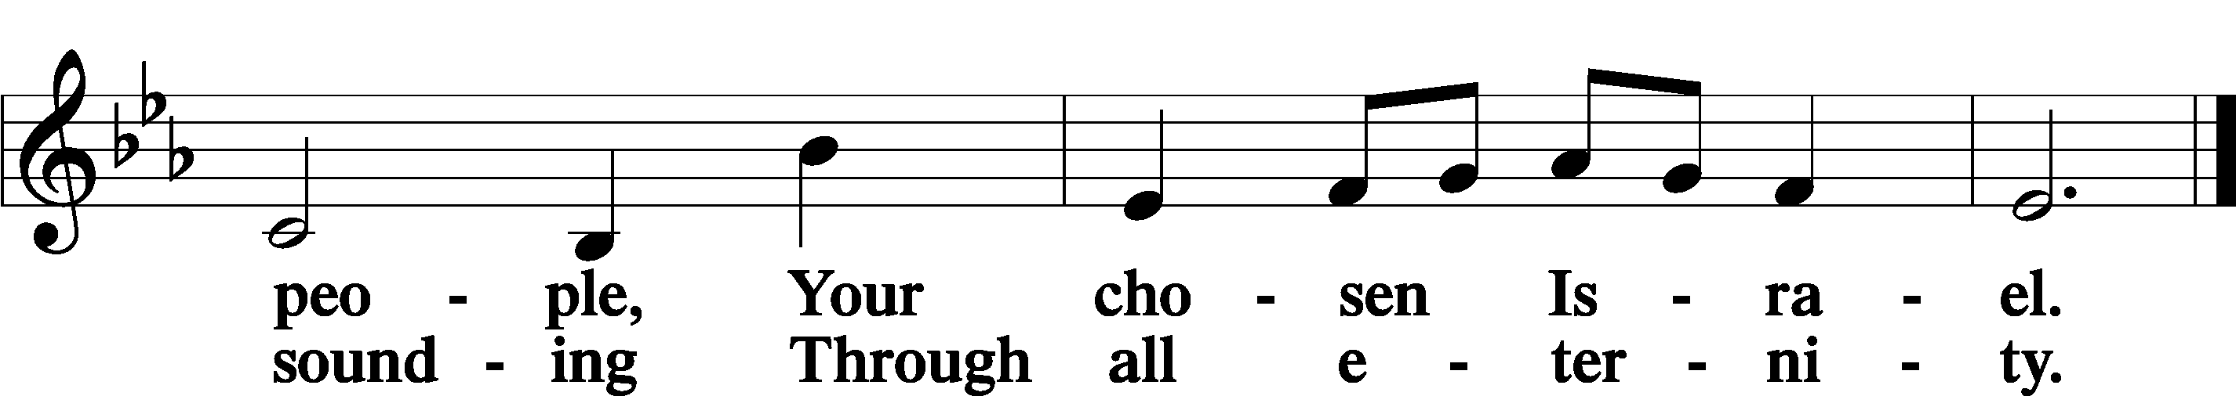

Post-Communion Collect
A Let us pray.
Gracious God, our heavenly Father, You have given us a foretaste of the feast to come in the Holy Supper of Your Son’s body and blood. Keep us firm in the true faith throughout our days of pilgrimage that, on the day of His coming, we may, together with all Your saints, celebrate the marriage feast of the Lamb in His kingdom which has no end; through Jesus Christ, Your Son, our Lord, who lives and reigns with You and the Holy Spirit, one God, now and forever.
C Amen.

Benedicamus LSB 212
A Let us bless the Lord.
C Thanks be to God.

Benediction
P The Lord bless you and keep you.
The Lord make His face shine on you and be gracious to you.
The Lord look upon you with favor and T give you peace.
C Amen.

Closing Hymn “Almighty Father, Bless the Word” LSB 923
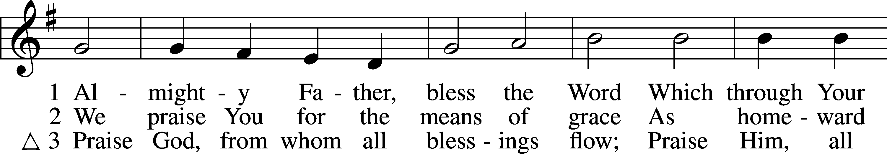
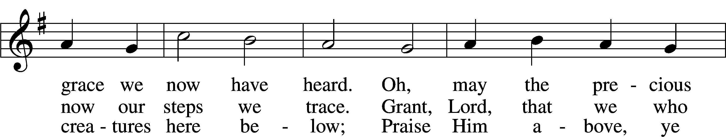
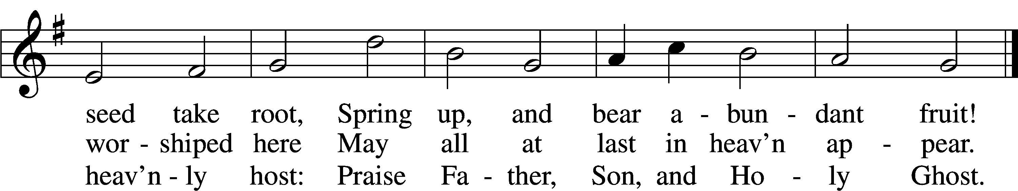
Text (sts. 1–2): Church Poetry, 1823, Philadelphia, alt.; (st. 3): Thomas Ken, 1637–1711
Tune: Trente quatre Pseaumes de David, 1551, Geneva, ed. Louis Bourgeois
Text and tune: Public domain

Acknowledgments
Unless otherwise indicated, Scripture quotations are from the ESV® Bible (The Holy Bible, English Standard Version®), copyright © 2001 by Crossway, a publishing ministry of Good News Publishers. Used by permission. All rights reserved.
Created by Lutheran Service Builder © 2022 Concordia Publishing House.

Serving Our Lord in His House Today:
Pastor: Rev. Bert Thompson
Organist: Linda Ecker
Elder: Bob Pulley
Joe Engel (Wednesday)

Gifts from God: Luke 10:40b – “Lord, do you not care that my sister has left me to serve alone?” Martha is doing the right thing but in the wrong order. Her service to the Lord is good, but she has let it get ahead of hearing His Word. Mary has placed the Word first, which is good. Is there any doubt that she will rise once she has heard the Word and get to serving as well? Isn’t that what hearing the Word always leads us to do? We listen, then respond. We believe, and thus we act!

Pastoral Call Committee Update: Please join us July 24, 2022, after the 9:00 a.m. church service. The call committee will be holding an information meeting and providing information on the candidates that are being presented for consideration. There will be a Congregation Vote held on Sunday, August 7, 2022, to make a call to one of these pastors to become our next Shepherd.

LWML Fall Retreat: The Fall Retreat will take place September 23-24 at
Fond Du Lac, WI. Registration forms will be on the LWML board in the
fellowship hallway. The forms need to be submitted by August. Please join us for
a time of fellowship and programs for and by other LWML Women.

Prayer for calling a faithful pastor:
O Gracious Father, You led Your holy apostles to ordain ministers for the proclamation of Your Word and the faithful administration of the Sacraments of Christ. Grant to this congregation the guidance of the Holy Spirit to choose a suitable pastor according to Your will for the blessing of Your Church in this place; through Jesus Christ our Lord.

Main Street Living: What is it? A televised worship service produced in conjunction with LCMS churches and pastors. Main Street is not intended to be a replacement for in-person worship, but is here to provide liturgical services to those unable to attend a local congregation. The hour-long broadcast consists of 2 parts: Main Street Living, a 30 minute service led by local LCMS pastors and This is the Life, a remastered episode of the Emmy award-winning Lutheran Hour Ministries program. This can be viewed locally in WI: LaCrosse/Eau Claire-Fox 25.2/48.2 at 10:00 a.m. or any time on the internet at MainStreetLiving.com. There are brochures with additional information on the usher’s table in the Narthex.

Prayer Chain/Prayer Ministry: Did you know Good Shepherd Lutheran Church has a prayer chain? One of the blessings we have is to pray for our brothers and sisters in Christ. If you are interested in becoming a member of the prayer chain,
or would like additional information regarding the prayer chain, please contact
Deb Lafferty or an Elder. There is a sign-up sheet on the easel in the Narthex.

Assist Uvalde, TX: Our Synod has an LCMS Church in Uvalde TX, Trinity Lutheran. If you would like to donate to a Memorial Fund to assist families of their community, please go online to www.txlcms.org/help-for-uvalde. Donations will be directed to Trinity and they in turn will get it to the appropriate fund.
Livestream: Our Sunday Service is livestreamed weekly on our YouTube channel “Good Shepherd Lutheran Church Tomah.”

Altar Guild: The church is looking for volunteers to assist with altar guild duties. If you are interested in assisting with this task there is a sign-up sheet on the easel in the Narthex. If you have questions, please speak with an Elder. Please sign up for the service(s) that work with your schedule. Thank you for your gracious service to the church.

PO Box: For mailed offerings, please use the following:
Good Shepherd Lutheran Church
P.O. Box 551
Tomah, WI 54660

Our Worship attendance last week: Sunday: 72
Wednesday: 7
Total: 79

Scripture Lessons for next week: Genesis 18:(17-19) 20-33
Colossians 2:6-15 (16-19)
Luke 11:1-13

Secretary Office Hours: Monday-Friday: 8:15am-12:15pm
Our Week With Our Lord:
Today 9:00am Divine Service w/Holy Communion
(livestreamed via YouTube)
10:30am Adult Bible Study
Monday 6:00pm Elders Meeting
Tuesday 9:30am-11:00am Little Lambs Playgroup
@ Warrens Park
6:00pm Board of Directors Meeting
Wednesday 6:00pm Children’s Chapel
7:00pm Divine Service (No Communion)
Thursday 5pm-9pm Downtown Thursday Nights Volunteer
Friday 12:00pm Newsletter Article Submission Deadline
Saturday
Sunday 9:00am Divine Service w/Holy Communion
(livestreamed via YouTube)
10:30am Pastoral Call Information Meeting

*Please view the following page for weekly prayers*

HIS FLOCK AT PRAYER
Propers for the Sixth Week after Pentecost

Psalm for the Week: Psalm 27:(1-6) 7-14

Daily Scripture Readings:
Sunday— Luke 5:1-11 Thursday—Acts 26:12-18
Monday— John 1:35-42 Friday—Ephesians 3:5-12
Tuesday—Matthew 16:13-19 Saturday—Psalm 119:41-50
Wednesday—Exodus 4:10-15

Collect for the Week:
O Lord, grant us the Spirit to hear Your Word and know the one thing needful that
by Your Word and Spirit we may live according to Your will; through Jesus Christ,
Your Son, our Lord, who lives and reigns with You and the Holy Spirit, one God,
now and forever.

Hymn of the Week: “Speak, O Lord, Your Servant Listens” LSB 589

Congregational Petitions for this Week:
+ For those whose work is difficult or dangerous including the military away from
home, especially: Isaac Preuss, Joshua Ecker, Tania Adler, and Sarah Johnson.
+ For those who are ill or recovering, especially: Brenda Kolb, Paula Sopel,
Shawn Zabinski, Karen Griggel, Carrie Wilbanks, Jean Salzman, Ro Scrivner,
David Keinath, Maddox Rinch, Dawn Hawkins, Kelly Ingenthron,
Nick Anderson, Al Mansfield, Gloria Graupe, Marie Drescher.
+ For those who are home-bound, especially: John Fox, Darlene Griffin,
Al Mansfield, Virginia Tillman, Lynda Goad, Roemelle McArdle,
Sharon Herried, Muriel Finch.
+ For those who are mourning the loss of a loved one:
Jeremy Knutson and family, at the loss of Jeremy’s step-sister.
+ For those suffering from the pandemic, especially those in our congregation who
have been infected, those who are suffering financially, and those who work in
the medical field.

