Good Shepherd Lutheran Church
Seventh Sunday after Trinity
July 18, 2021

Pre-Service Music & Welcome
Divine Service Setting Four – Lutheran Service Book (LSB) 203

+CONFESSION AND ABSOLUTION+

Stand
Opening Hymn “Praise the One Who Breaks the Darkness” LSB 849
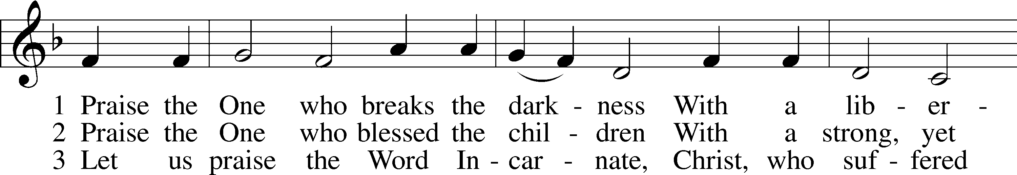
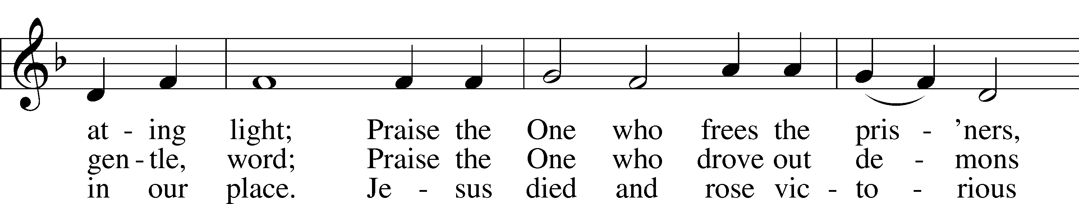
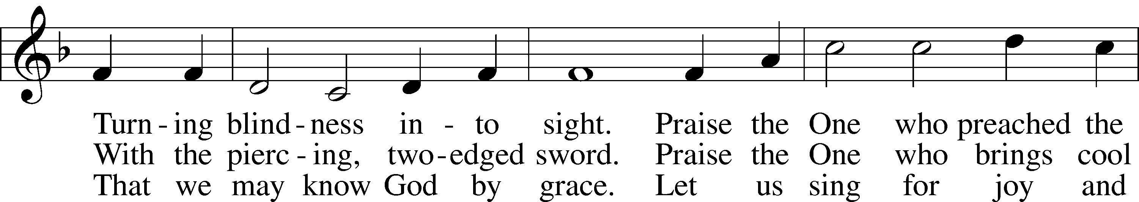
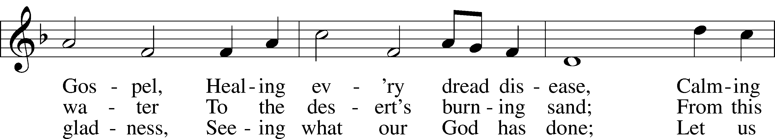
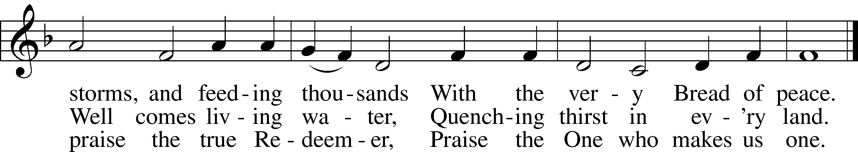
Tune: Public domain
Text: © 1987 Hope Publishing Co. Used by permission: LSB Hymn License no. 110016438

The sign of the cross T may be made by all in remembrance of their Baptism.
Invocation
P In the name of the Father and of the T Son and of the Holy Spirit.
C Amen.

Exhortation LSB 203
P Our help is in the name of the Lord,
C who made heaven and earth.

P If You, O Lord, kept a record of sins, O Lord, who could stand?
C But with You there is forgiveness; therefore You are feared.
P Since we are gathered to hear God’s Word, call upon Him in prayer and praise, and receive the body and blood of our Lord Jesus Christ in the fellowship of this altar, let us first consider our unworthiness and confess before God and one another that we have sinned in thought, word, and deed, and that we cannot free ourselves from our sinful condition. Together as His people let us take refuge in the infinite mercy of God, our heavenly Father, seeking His grace for the sake of Christ, and saying: God, be merciful to me, a sinner.

Confession of Sins LSB 203
C Almighty God, have mercy upon us, forgive us our sins, and lead us to everlasting life. Amen.

Prayer for Forgiveness
P Almighty God, merciful Father, in Holy Baptism You declared us to be Your children and gathered us into Your one, holy Church, in which You daily and richly forgive us our sins and grant us new life through Your Spirit. Be in our midst, enliven our faith, and graciously receive our prayer and praise; through Your Son, Jesus Christ, our Lord.
C Amen.
+SERVICE OF THE WORD+

Introit Psalm 47:3, 6–8; antiphon: vv. 1–2
Clap your hands, all peoples!*
Shout to God with loud songs of joy!
For the Lord, the Most High, is to be feared,*
a great king over all the earth.
He subdued peoples under us,*
and nations under our feet.
Sing praises to God, sing praises!*
Sing praises to our King, sing praises!
For God is the King of all the earth;*
sing praises with a psalm!
God reigns over the nations;*
God sits on his holy throne.
Glory be to the Father and to the Son*
and to the Holy Spirit;
as it was in the beginning,*
is now, and will be forever. Amen.
Clap your hands, all peoples!*
Shout to God with loud songs of joy!
For the Lord, the Most High, is to be feared,*
a great king over all the earth.

Kyrie LSB 204
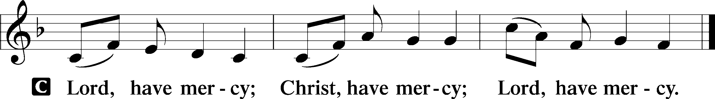

Gloria in Excelsis LSB 204
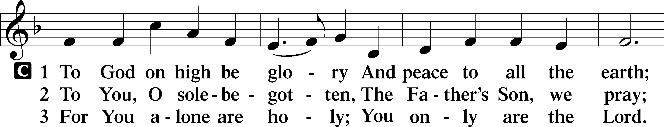
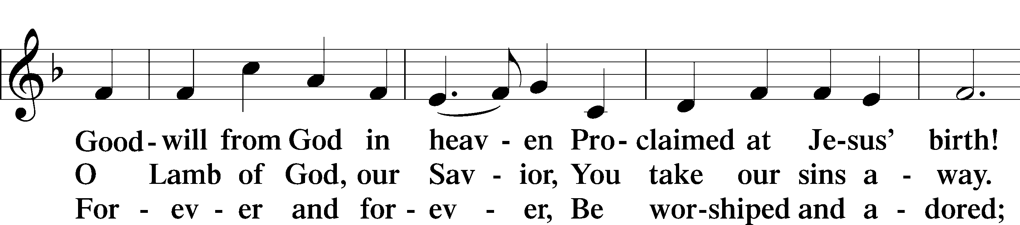
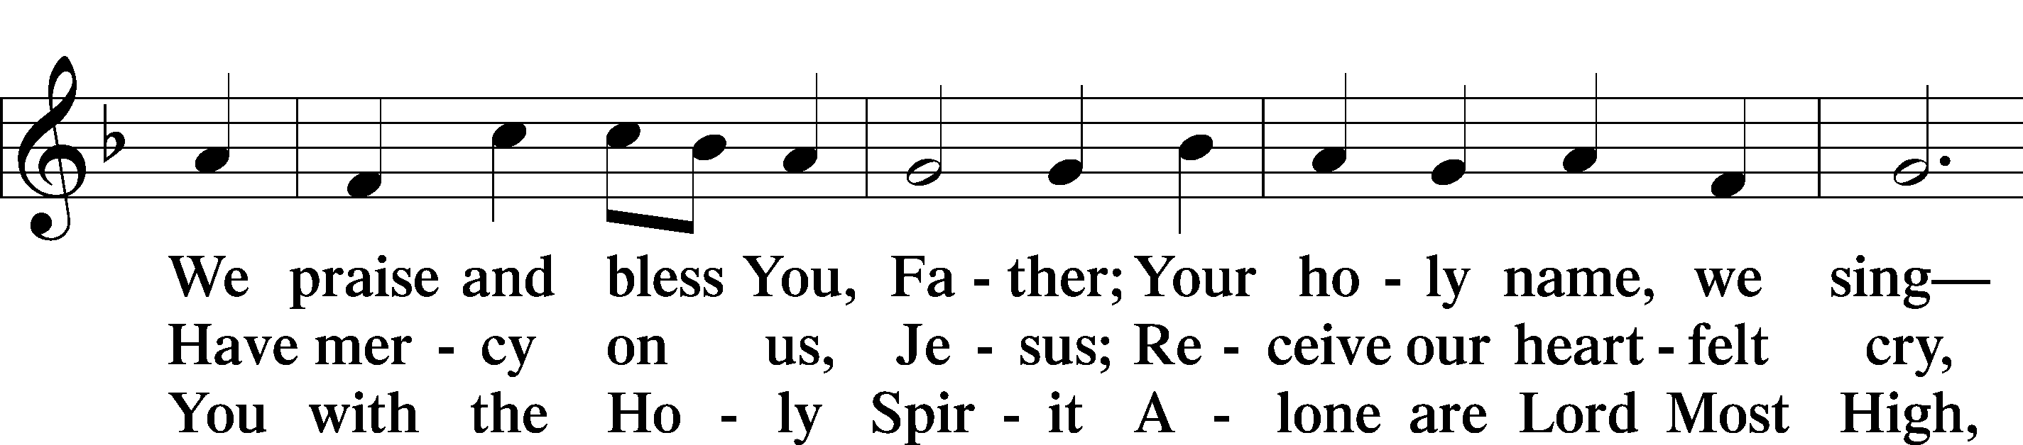
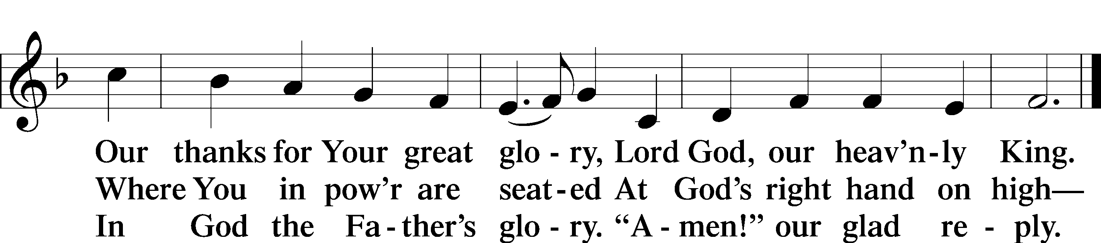

Salutation and Collect of the Day
P The Lord be with you.
C And also with you.

P Let us pray.
C O God, whose never-failing providence orders all things both in heaven and earth, we humbly implore You to put away from us all hurtful things and to give us those things that are profitable for us; through Jesus Christ, Your Son, our Lord, who lives and reigns with You and the Holy Spirit, one God, now and forever. Amen.

Sit

Old Testament Reading Genesis 2:7–17
7Then the Lord God formed the man of dust from the ground and breathed into his nostrils the breath of life, and the man became a living creature. 8And the Lord God planted a garden in Eden, in the east, and there he put the man whom he had formed. 9And out of the ground the Lord God made to spring up every tree that is pleasant to the sight and good for food. The tree of life was in the midst of the garden, and the tree of the knowledge of good and evil.
10A river flowed out of Eden to water the garden, and there it divided and became four rivers. 11The name of the first is the Pishon. It is the one that flowed around the whole land of Havilah, where there is gold. 12And the gold of that land is good; bdellium and onyx stone are there. 13The name of the second river is the Gihon. It is the one that flowed around the whole land of Cush. 14And the name of the third river is the Tigris, which flows east of Assyria. And the fourth river is the Euphrates.
15The Lord God took the man and put him in the garden of Eden to work it and keep it. 16And the Lord God commanded the man, saying, “You may surely eat of every tree of the garden, 17but of the tree of the knowledge of good and evil you shall not eat, for in the day that you eat of it you shall surely die.”

A This is the Word of the Lord.
C Thanks be to God.

Gradual Psalm 34:11, 5
Come, O children, listen to me;*
I will teach you the fear of the Lord.
Those who look to him are radiant,*
and their faces shall never be ashamed.

Epistle Romans 6:19–23
19I am speaking in human terms, because of your natural limitations. For just as you once presented your members as slaves to impurity and to lawlessness leading to more lawlessness, so now present your members as slaves to righteousness leading to sanctification.
20When you were slaves of sin, you were free in regard to righteousness. 21But what fruit were you getting at that time from the things of which you are now ashamed? The end of those things is death. 22But now that you have been set free from sin and have become slaves of God, the fruit you get leads to sanctification and its end, eternal life. 23For the wages of sin is death, but the free gift of God is eternal life in Christ Jesus our Lord.

A This is the Word of the Lord.
C Thanks be to God.

Stand

Alleluia and Verse

Alleluia LSB 205
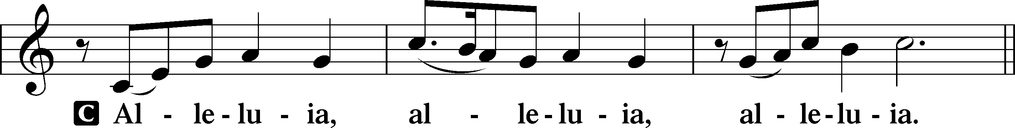

Verse LSB 205
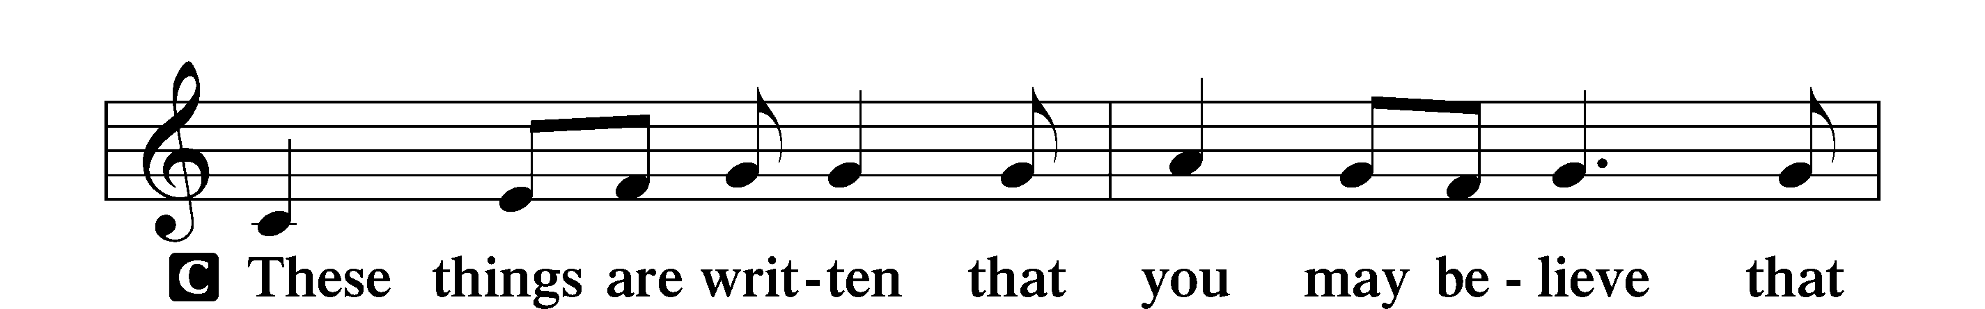
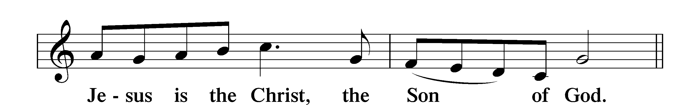

Alleluia LSB 205
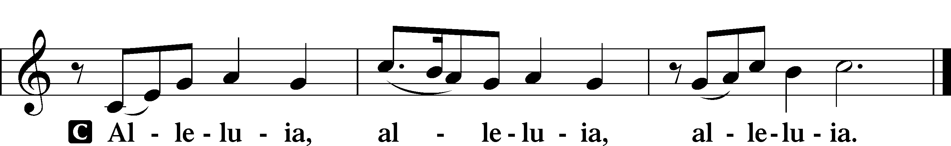

Holy Gospel Mark 8:1–9
P The Holy Gospel according to St. Mark, the eighth chapter.
C Glory to You, O Lord.

1In those days, when again a great crowd had gathered, and they had nothing to eat, [Jesus] called his disciples to him and said to them, 2“I have compassion on the crowd, because they have been with me now three days and have nothing to eat. 3And if I send them away hungry to their homes, they will faint on the way. And some of them have come from far away.” 4And his disciples answered him, “How can one feed these people with bread here in this desolate place?” 5And he asked them, “How many loaves do you have?” They said, “Seven.” 6And he directed the crowd to sit down on the ground. And he took the seven loaves, and having given thanks, he broke them and gave them to his disciples to set before the people; and they set them before the crowd. 7And they had a few small fish. And having blessed them, he said that these also should be set before them. 8And they ate and were satisfied. And they took up the broken pieces left over, seven baskets full. 9And there were about four thousand people. And he sent them away.

P This is the Gospel of the Lord.
C Praise to You, O Christ.

Nicene Creed
C I believe in one God,
the Father Almighty,
maker of heaven and earth
and of all things visible and invisible.

And in one Lord Jesus Christ,
the only-begotten Son of God,
begotten of His Father before all worlds,
God of God, Light of Light,
very God of very God,
begotten, not made,
being of one substance with the Father,
by whom all things were made;
who for us men and for our salvation came down from heaven
and was incarnate by the Holy Spirit of the virgin Mary
and was made man;
and was crucified also for us under Pontius Pilate.
He suffered and was buried.
And the third day He rose again according to the Scriptures
and ascended into heaven
and sits at the right hand of the Father.
And He will come again with glory to judge both the living and the dead,
whose kingdom will have no end.

And I believe in the Holy Spirit,
the Lord and giver of life,
who proceeds from the Father and the Son,
who with the Father and the Son together is worshiped and glorified,
who spoke by the prophets.
And I believe in one holy Christian and apostolic Church,
I acknowledge one Baptism for the remission of sins,
and I look for the resurrection of the dead
and the life T of the world to come. Amen.

Sit
Children’s Message

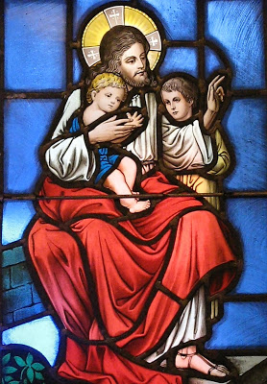

Hymn of the Day “O God, O Lord of Heaven and Earth” LSB 834
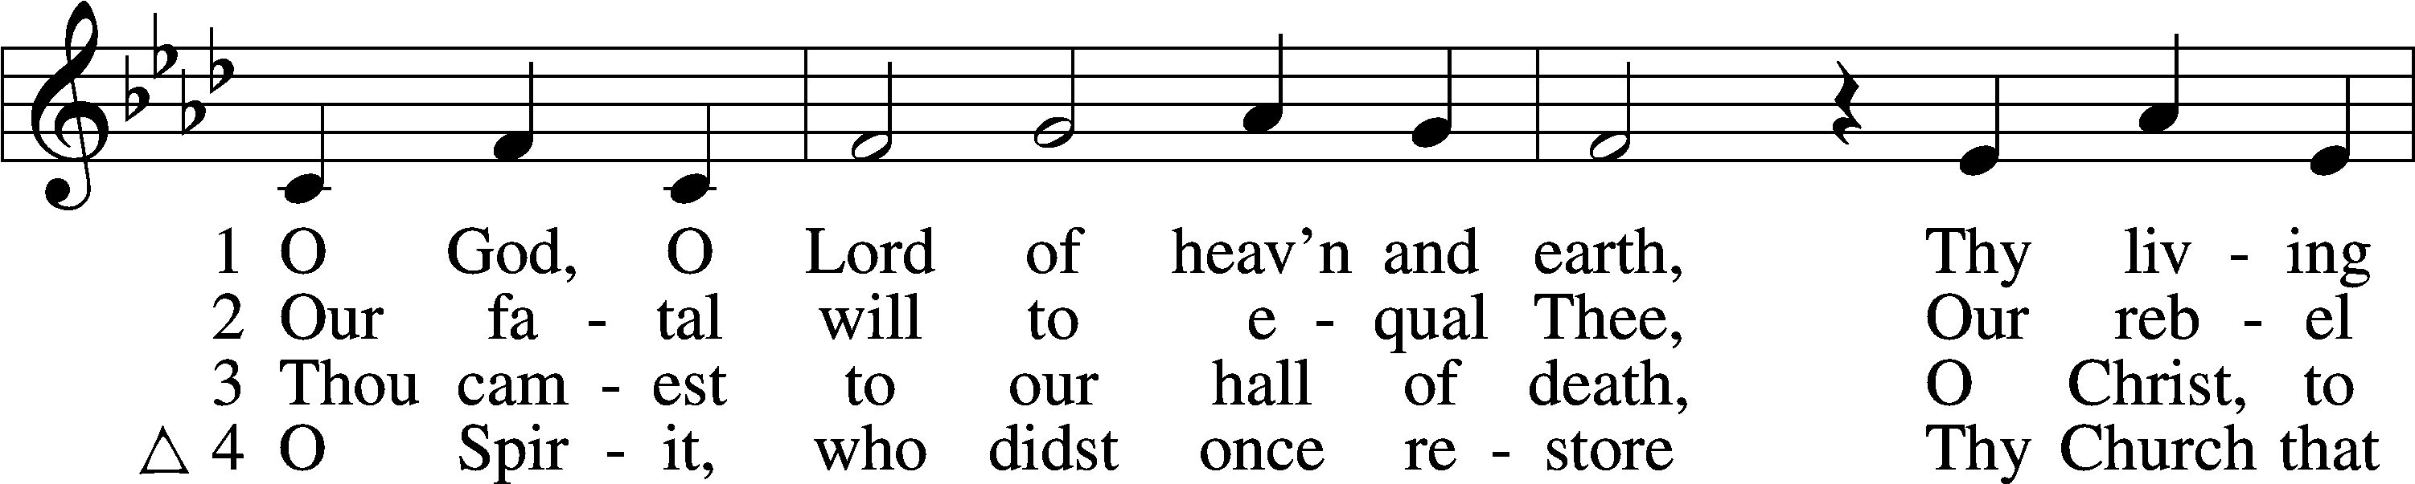
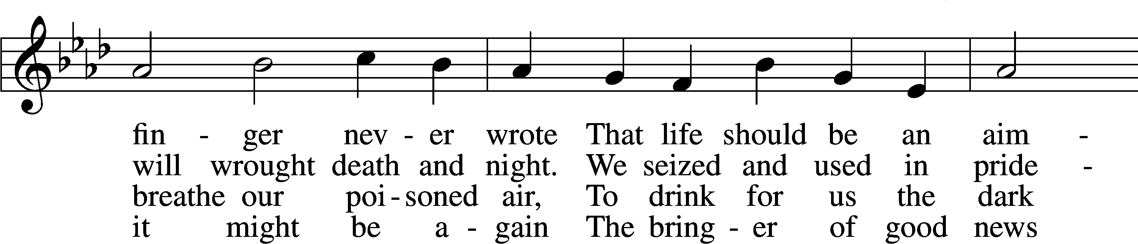
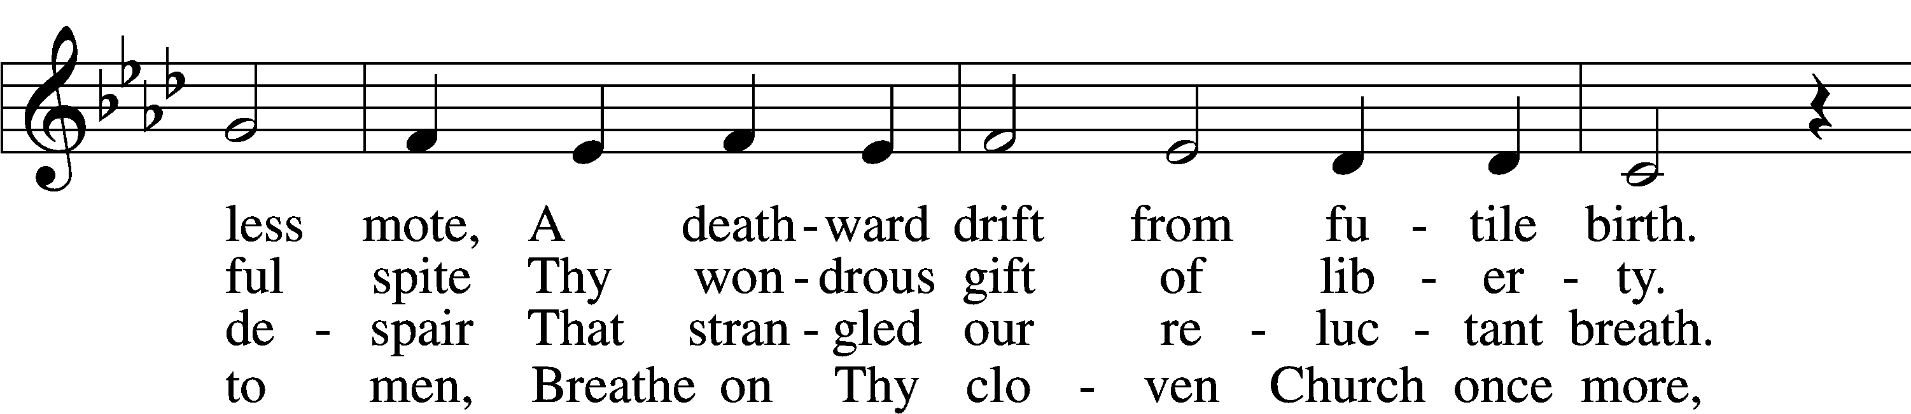
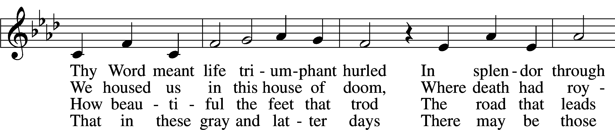
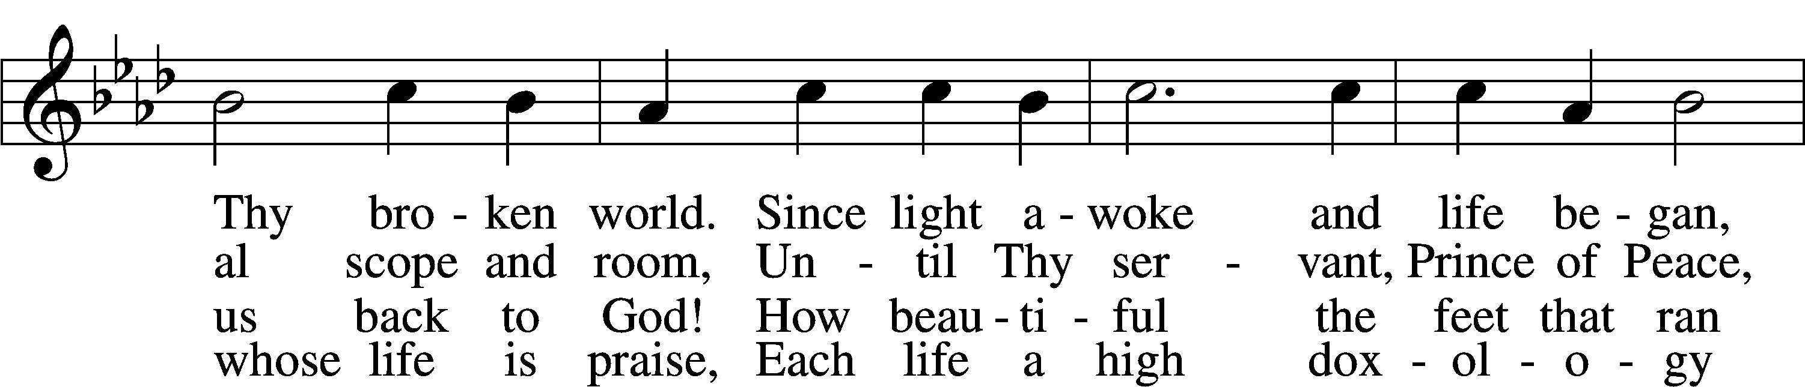
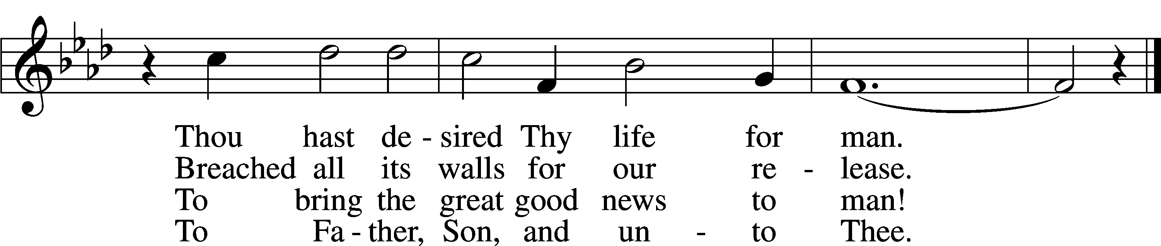
Tune and text: © 1967 Augsburg Fortress. Used by permission: LSB Hymn License no. 110016438

Sermon

Offering

Stand

Prayer of the Church

+SERVICE OF THE SACRAMENT+

Preface LSB 208
P The Lord be with you.
C And also with you.

P Lift up your hearts.
C We lift them to the Lord.

P Let us give thanks to the Lord our God.
C It is right to give Him thanks and praise.

P It is truly good, right, and salutary that we should at all times and in all places give thanks to You, O Lord, holy Father, almighty and everlasting God, for the countless blessings You so freely bestow on us and all creation. Above all, we give thanks for Your boundless love shown to us when You sent Your only-begotten Son, Jesus Christ, into our flesh and laid on Him our sin, giving Him into death that we might not die eternally. Because He is now risen from the dead and lives and reigns to all eternity, all who believe in Him will overcome sin and death and will rise again to new life. Therefore with angels and archangels and with all the company of heaven we laud and magnify Your glorious name, evermore praising You and saying:

Sanctus LSB 208
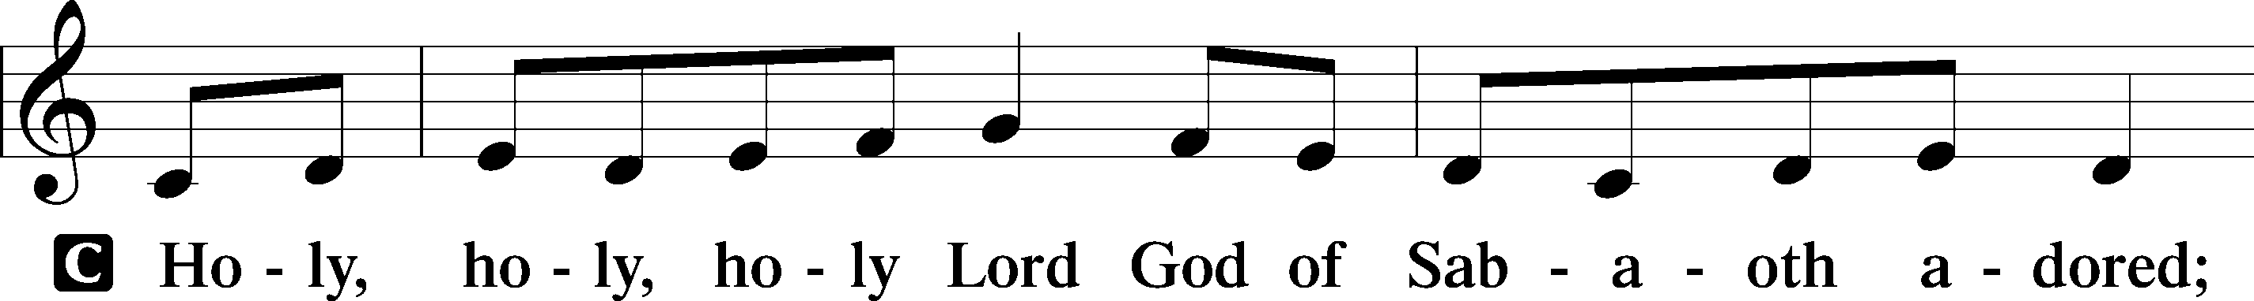
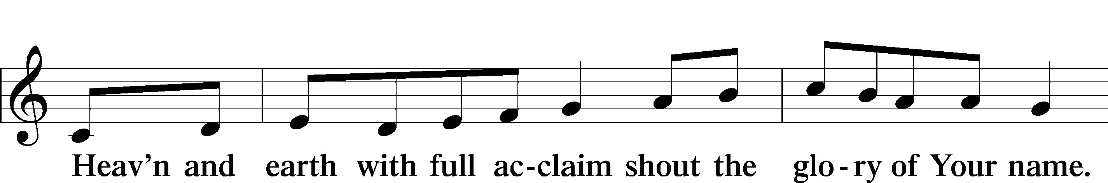
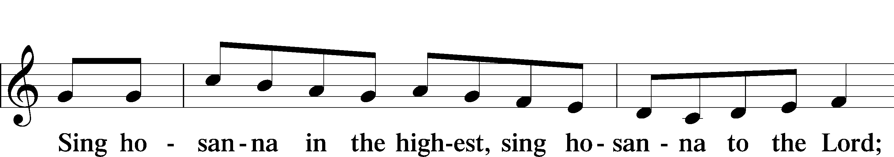
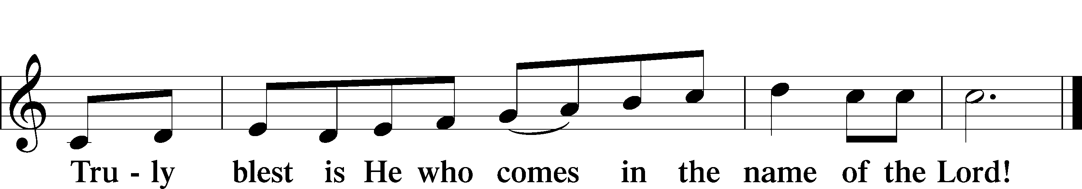

Lord’s Prayer
C Our Father who art in heaven,
hallowed be Thy name,
Thy kingdom come,
Thy will be done on earth
as it is in heaven;
give us this day our daily bread;
and forgive us our trespasses
as we forgive those
who trespass against us;
and lead us not into temptation,
but deliver us from evil.
For Thine is the kingdom
and the power and the glory
forever and ever. Amen.

The Words of Our Lord
P Our Lord Jesus Christ, on the night when He was betrayed, took bread, and when He had given thanks, He broke it and gave it to the disciples and said: “Take, eat; this is My T body, which is given for you. This do in remembrance of Me.”

In the same way also He took the cup after supper, and when He had given thanks, He gave it to them, saying: “Drink of it, all of you; this cup is the new testament in My T blood, which is shed for you for the forgiveness of sins. This do, as often as you drink it, in remembrance of Me.”

Pax Domini
P The peace of the Lord be with you always.
C Amen.

Agnus Dei LSB 210
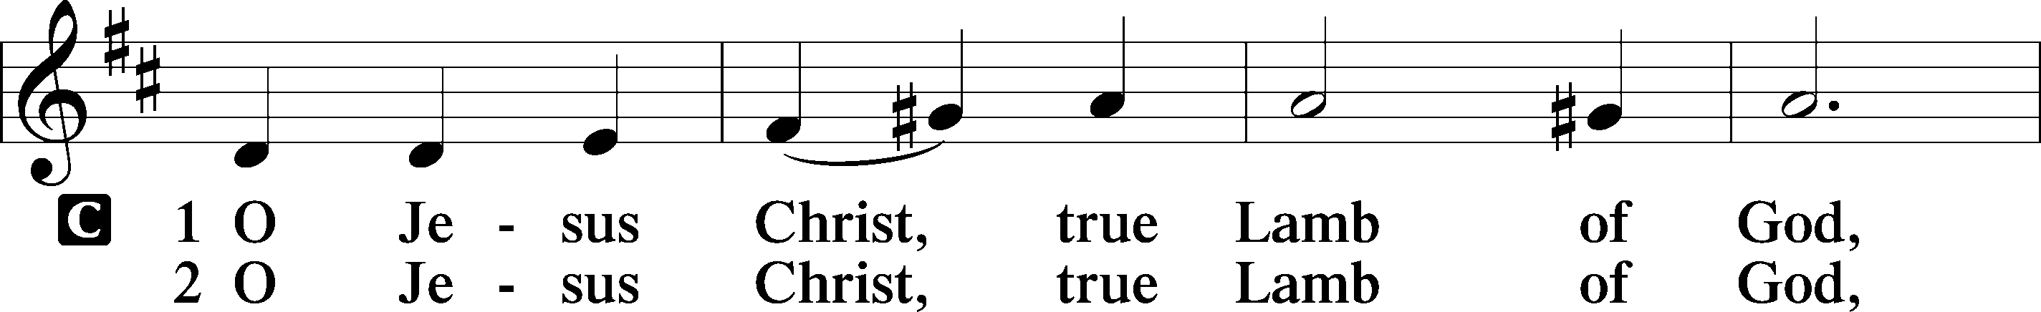
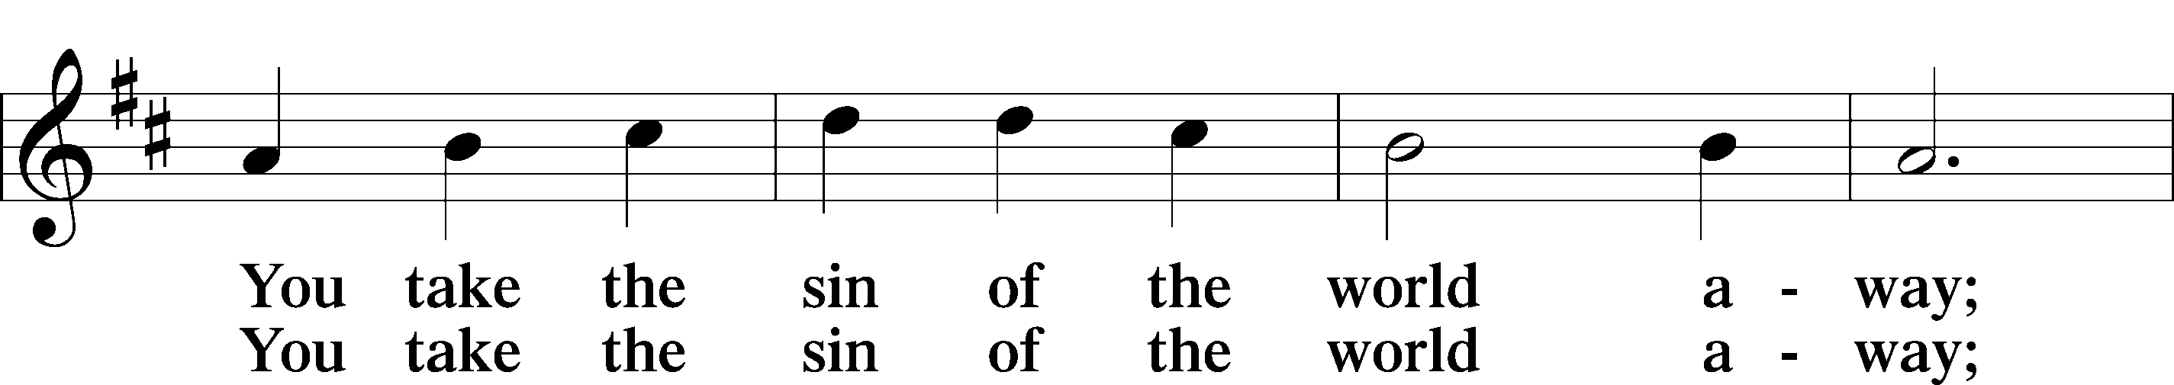
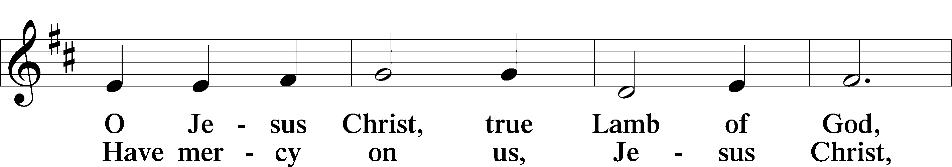
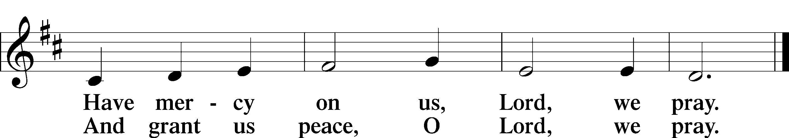

Sit

Distribution

Distribution Hymn “Beautiful Savior” LSB 537
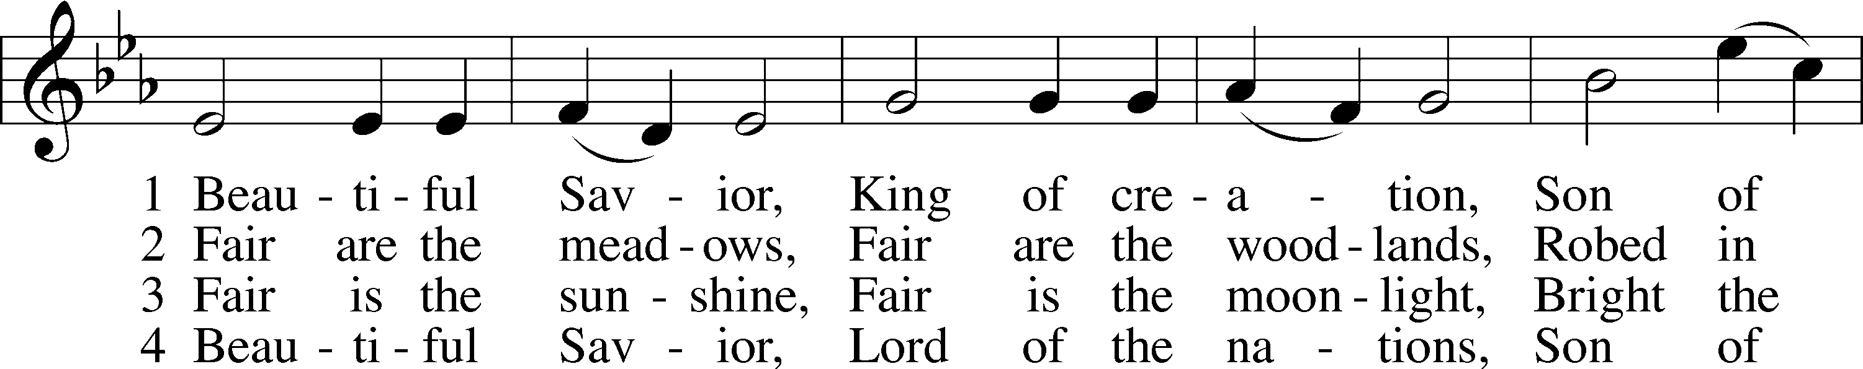
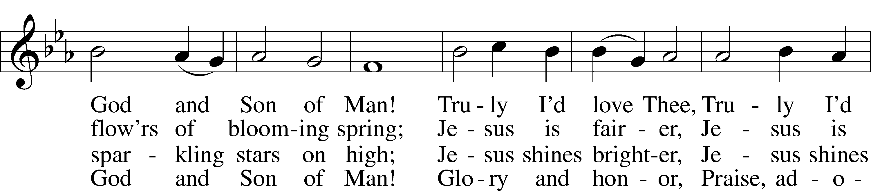
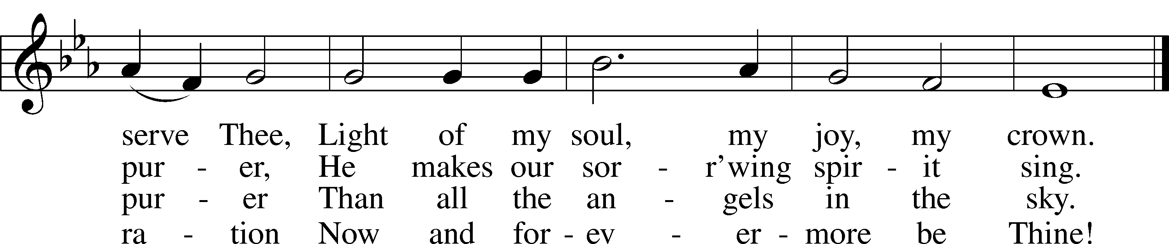
Tune and text: Public domain

Distribution Hymn “Thine the Amen, Thine the Praise” LSB 680
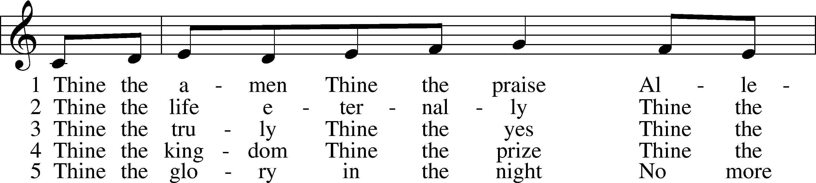
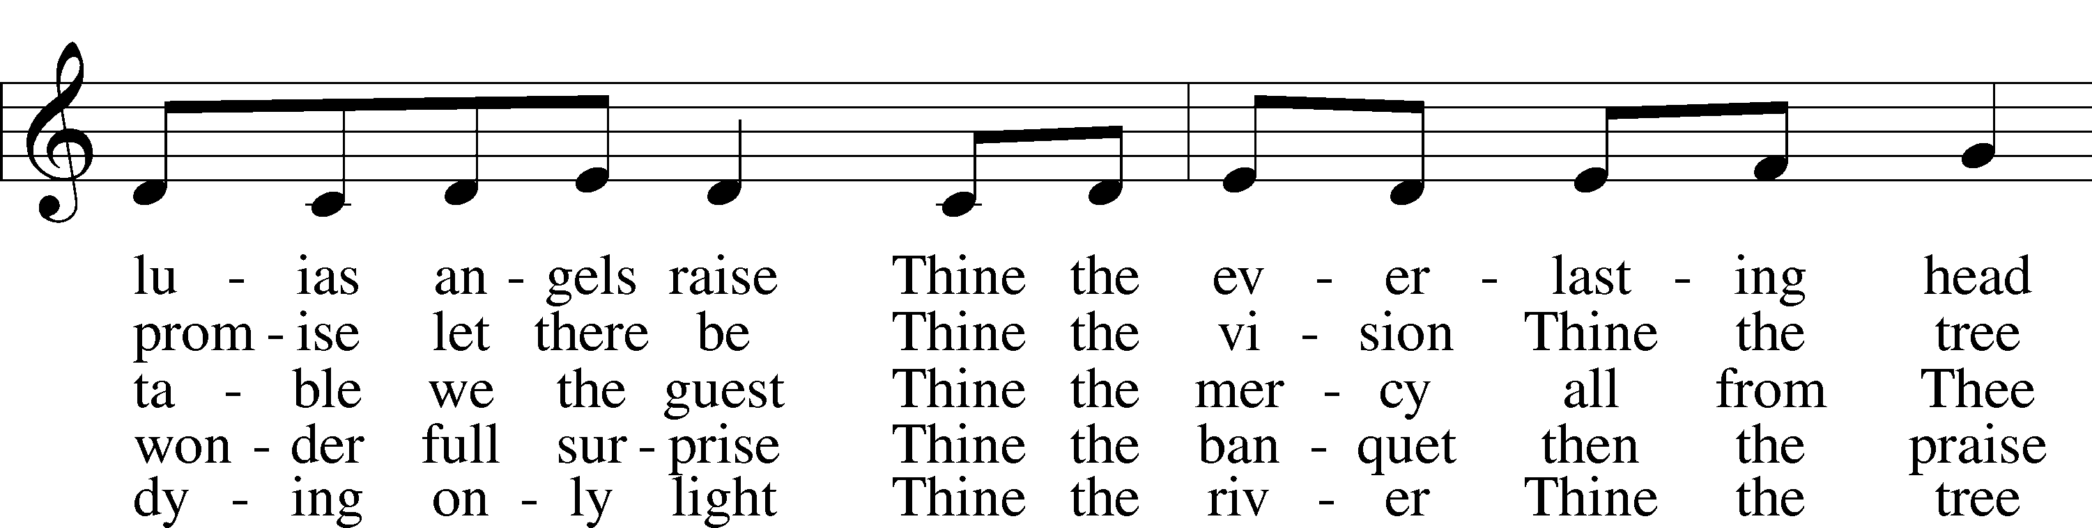
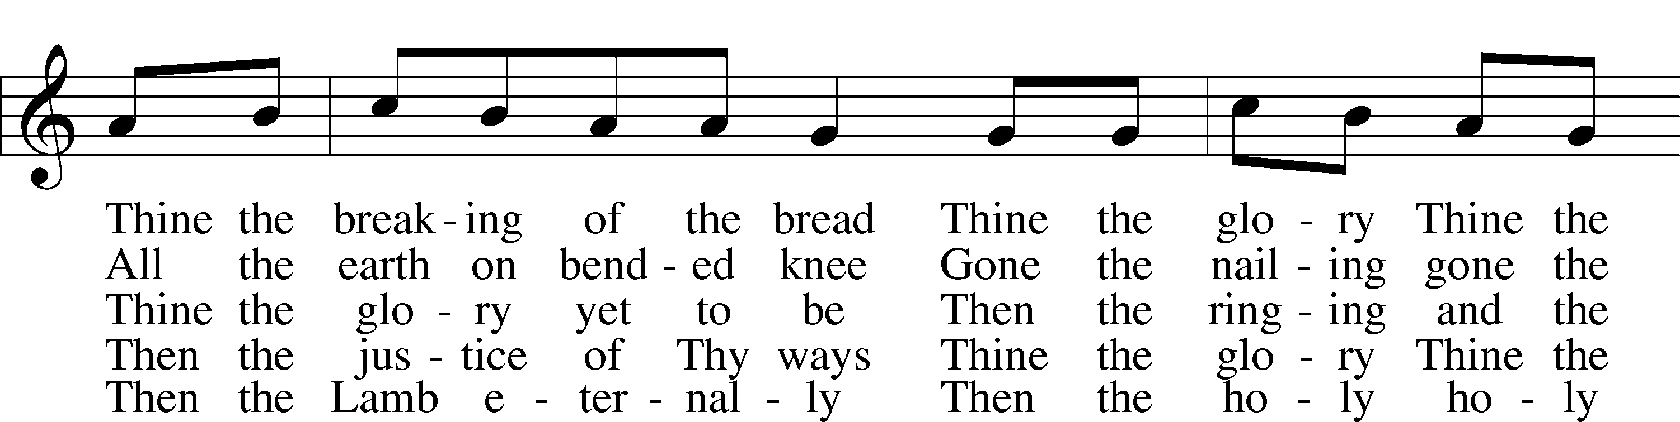
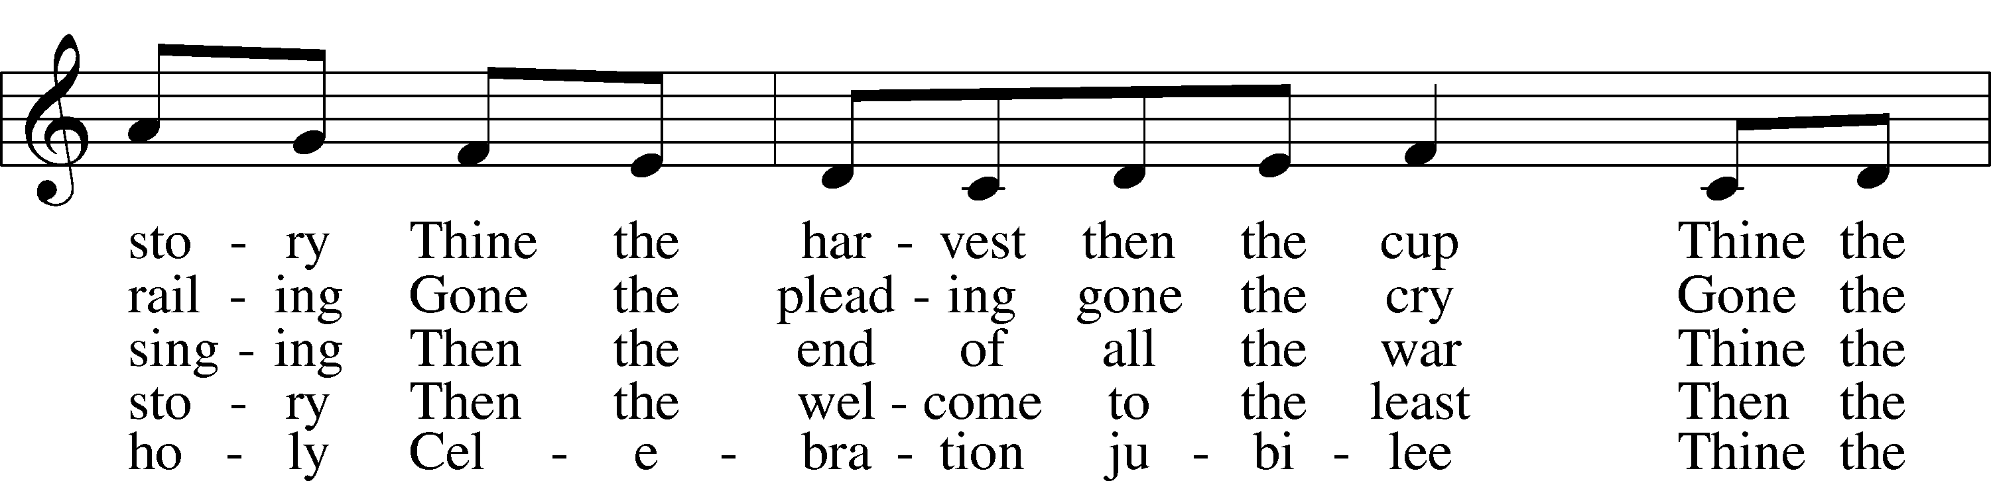
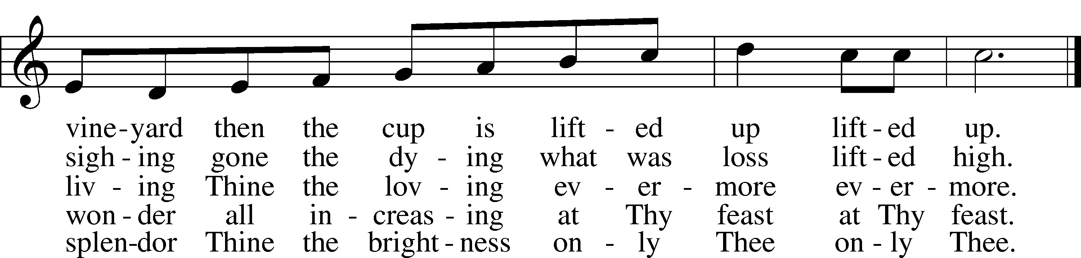
Text and tune: © 1983 Augsburg Publishing House. Used by permission: LSB Hymn License no. 110016438

Stand

Nunc Dimittis LSB 211
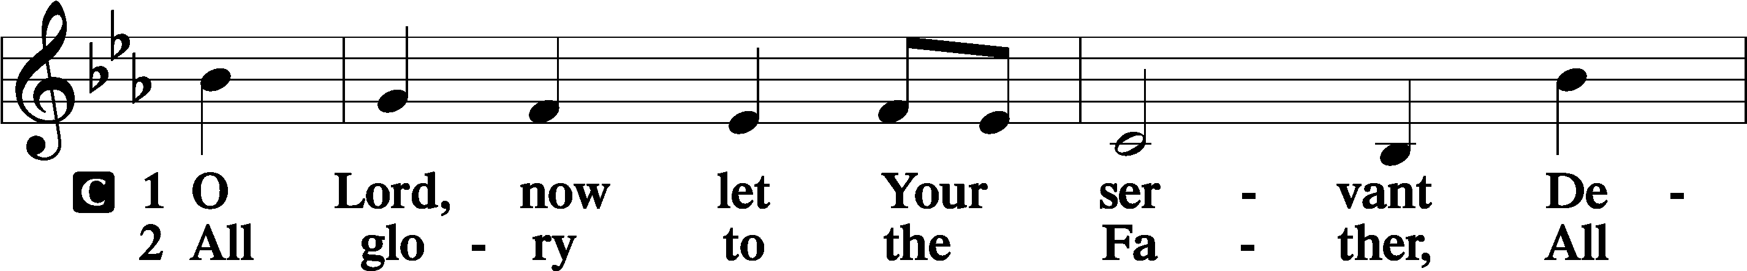
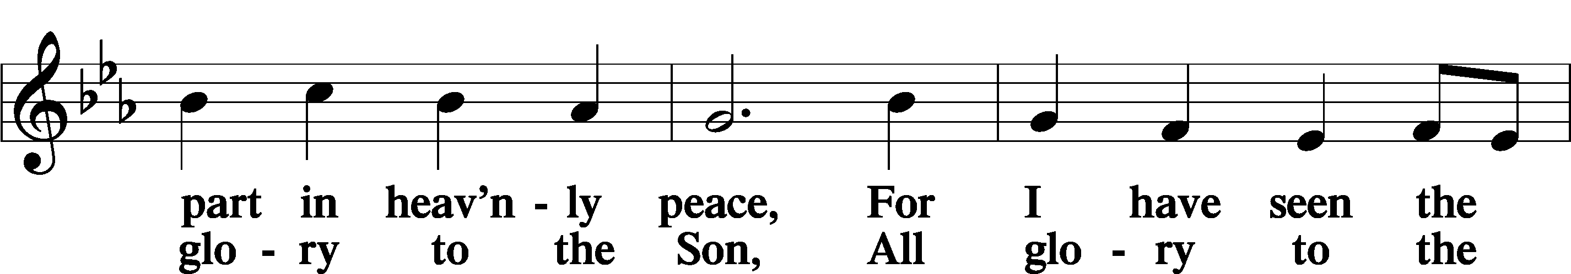
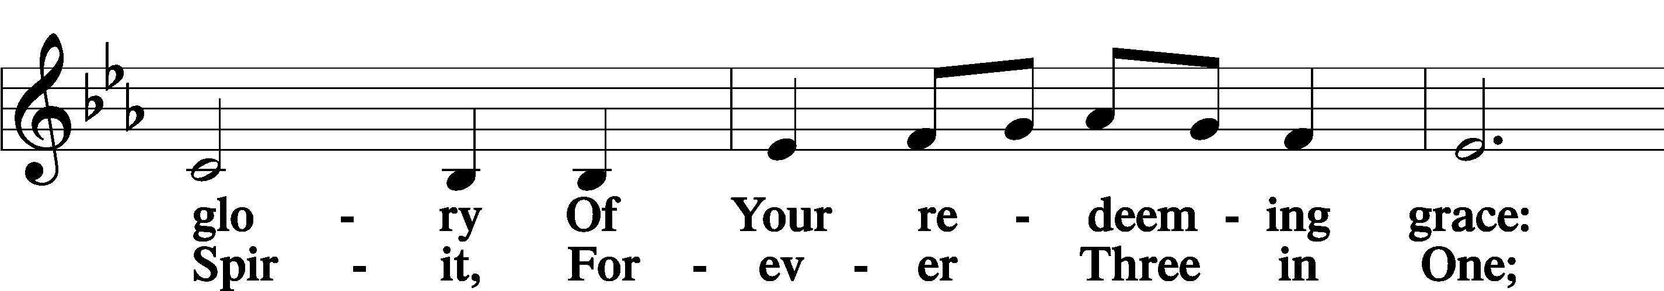
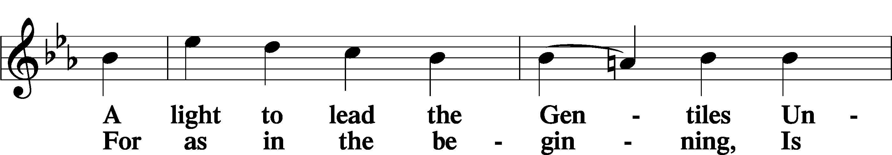
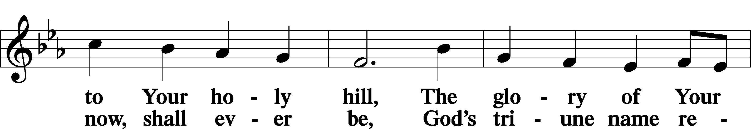
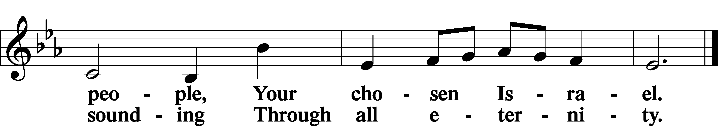

Post-Communion Collect
A Let us pray.
We give thanks to You, almighty God, that You have refreshed us through this salutary gift, and we implore You that of Your mercy You would strengthen us through the same in faith toward You and in fervent love toward one another; through Jesus Christ, Your Son, our Lord, who lives and reigns with You and the Holy Spirit, one God, now and forever.
C Amen.

Benedicamus LSB 212
A Let us bless the Lord.
C Thanks be to God.

Benediction
P The Lord bless you and keep you.
The Lord make His face shine on you and be gracious to you.
The Lord look upon you with favor and T give you peace.
C Amen.

Closing Hymn “O Living Bread from Heaven” LSB 642
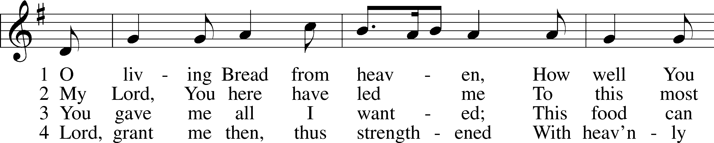
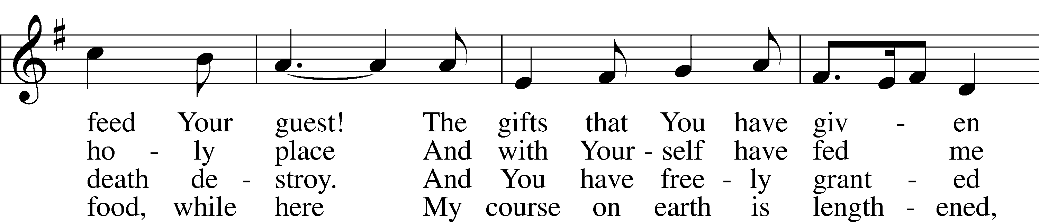
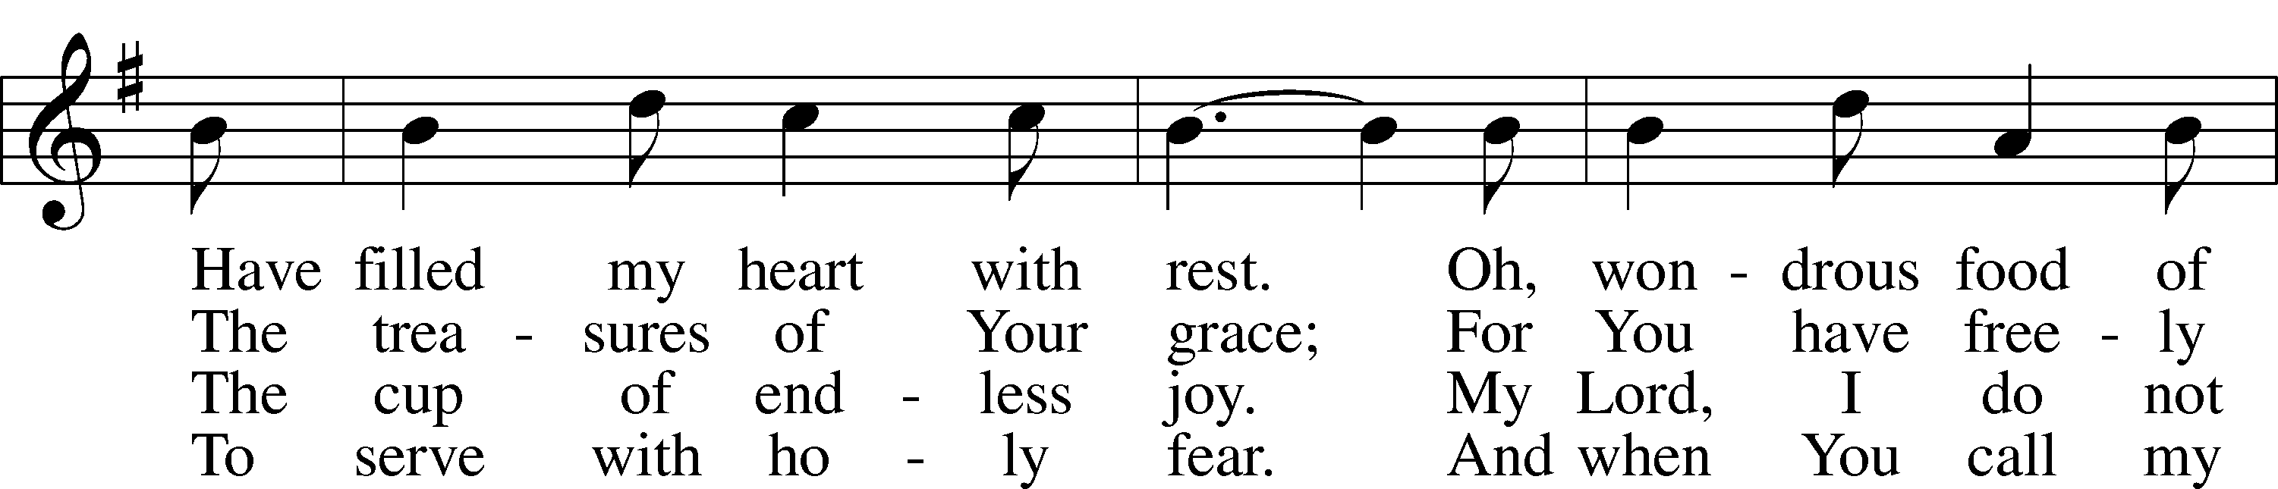
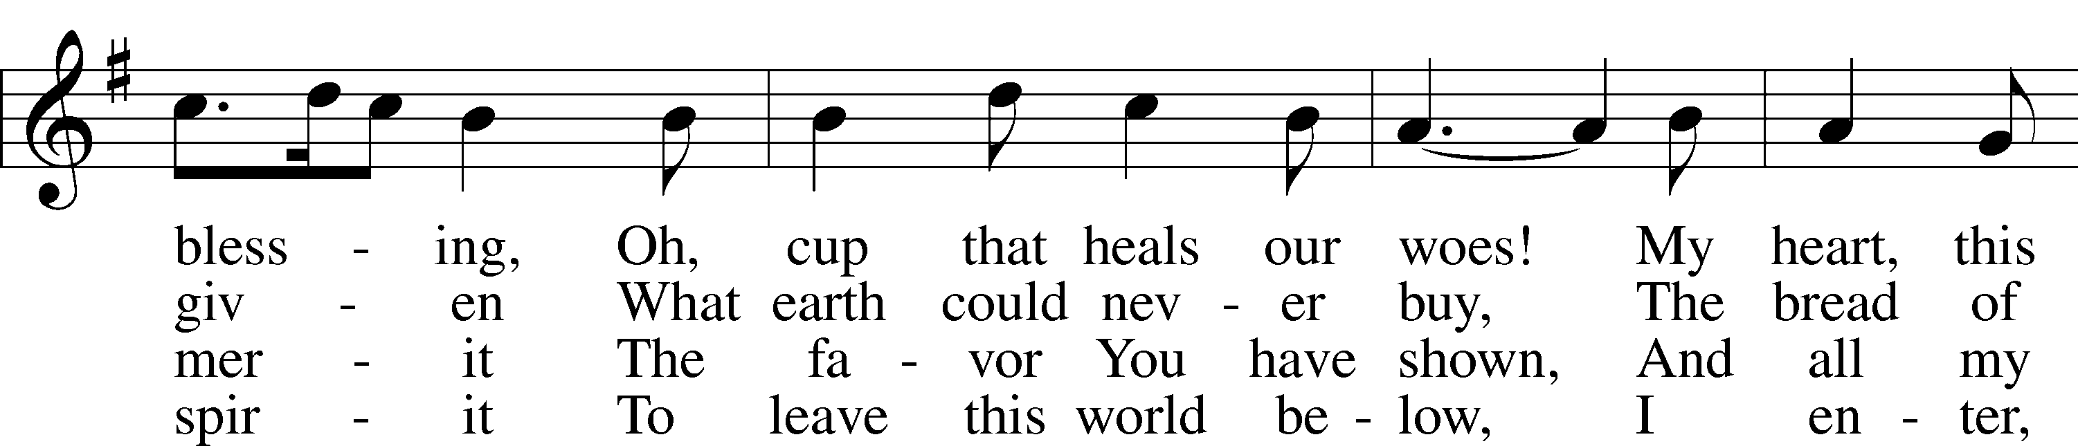
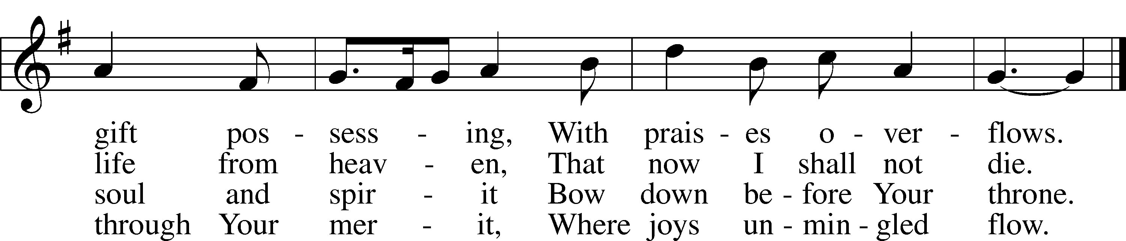
Tune and text: Public domain
Acknowledgments
Unless otherwise indicated, Scripture quotations are from the ESV® Bible (The Holy Bible, English Standard Version®), copyright © 2001 by Crossway, a publishing ministry of Good News Publishers. Used by permission. All rights reserved.
Created by Lutheran Service Builder © 2021 Concordia Publishing House.

Serving Our Lord in His House Today:
Pastor: Rev. David Wurdeman
Organist: Linda Ecker
Elders: Jake Mallmann & Bob Pulley
Joe Engel

Gifts from God: Romans 6:22 – “But now that you have been set free from sin and have become slaves of God, the fruit you get leads to sanctification and its end, eternal life.” The fruits of faith in Christ are the good works of a faithful Christian life. We have received grace upon grace in the free forgiveness of our sins, and so we are now free to go forth and bear fruit in serving our neighbor in the home, the church, and society.

VBS Work Night: We need your help! Join us this Thursday, July 22nd at 6:00 p.m. as we prepare for our VBS program, The Lord's Army! Pizza will be provided.

Offering Statements: The mid-year offering statements have been placed in your church mailbox for pick-up. If you have questions, or notice any discrepancies, please contact the financial secretary, Linda Ecker at 254-630-5620.

Sunday morning Greeters: We are looking for members to serve the church on Sunday morning by being a Greeter. It is a BLESSING to meet all those worshipping, guests and members alike! Call Sylvia Engel at 608-343-9645 if you would be interested in participating in this Hospitality Ministry or have any questions.
Little Lambs: We are asking for snacks for the Little Lambs Play Group. If you are interested in donating, we ask that you please provide individually wrapped pre-packaged snack items. If you have questions, please contact Amanda Mallmann.

Volunteers Needed: Good Shepherd will be participating in the Downtown Thursday Nights from July 1-August 12. Toro has paid the fees for the booth, but we need volunteers to help run the booth. What a wonderful opportunity to get our church’s name out in the community! The booth will be located in the kid’s area, near the bounce house. We will be selling kid friendly treats. There is a sign-up roster on the easel in the Narthex. Please contact Lorna Rosenow with any questions at 608-372-6584.

Livestream: Our Sunday Service is livestreamed weekly on our YouTube channel “Good Shepherd Lutheran Church Tomah.”

Hymnals: If you would like to use a Hymnal at home, you can sign one out from church. We also have free devotion pamphlets and Portals of Prayer.

PO Box: For mailed offerings, please use the following:
Good Shepherd Lutheran Church
P.O. Box 551
Tomah, WI. 54660

Our Worship attendance last week: Sunday: 36
Wednesday: 9
Total: 45

Scripture Lessons for next week: Genesis 9:14-21
Ephesians 3:14-21
Mark 6:45-56

Secretary Office Hours: Monday-Friday: 8am-12pm

Our Week With Our Lord:
Today 9:00am Divine Service w/Holy Communion
(livestreamed via YouTube)
10:30am Adult Bible Study
Monday 6:15pm Outreach Committee Meeting
Tuesday 6:00pm Board of Directors Meeting
7:30pm Church Softball @Glendale Field
Wednesday 5:00pm Service of Prayer and Preaching 7:00pm Women’s Bible Study – “Chosen”
Thursday 9:30am-11:00am Little Lambs @The Inclusion Park
5:00pm-9:00pm Downtown Thursday Nights
6:00pm-9:00pm VBS Work Night- Pizza provided
Friday 12:00pm Newsletter Deadline
Saturday
Sunday 9:00am Divine Service w/Holy Communion
(livestreamed via YouTube)
10:30am Adult Bible Study

*See following page for weekly prayers*

HIS FLOCK AT PRAYER
Propers for the Seventh Week after Trinity

Psalm for the Week: Psalm 33:1-11

Daily Scripture Readings:
Sunday—Mark 8:1-9 Thursday—2 Corinthians 9:8-11
Monday— Psalm 37:1-6 Friday—Psalm 37:21-26
Tuesday—1 Kings 17:12-16 Saturday— Proverbs 30:5-9
Wednesday—Psalm 145:14-21

Collect for the Week:
O God, whose never-failing providence orders all things both in heaven and earth, we humbly implore You to put away from us all hurtful things and to give us those things that are profitable for us; through Jesus Christ, Your Son, our Lord,
who lives and reigns with You and the Holy Spirit, one God, now and forever.

Hymn of the Week: “O God, O Lord of Heaven and Earth” LSB 834

Congregational Petitions for this Week:
+ For those who are ill or recovering, especially: Brenda Kolb, Paula Sopel,
Shawn Zabinski, Karen Griggel, Margaret Palmer, Ladene Zabinski,
Carrie Wilbanks, Cindy Gluch, Payton Pierce, Kathy Berg, Isaiah Mallmann,
Joan Oswald, Marie Drescher, Les Hackett, Joyce Pulley, Tom Coman,
Kelly Ingenthron, Jean Salzman, Gary Salzman, Peter Benjamin.
+ For those who are home-bound, especially: John Fox, Darlene Griffin,
Al Mansfield, Virginia Tillman, Linda Goad, Roemelle McArdle,
Sharon Herried.
+ For those who serve in the military, especially: Isaac Preuss, Tania Adler,
Joshua Ecker.

