Good Shepherd Lutheran Church
Seventh Sunday after Pentecost
July 24, 2022

Pre-Service Music & Welcome

Divine Service Setting Four – Lutheran Service Book (LSB) 203

+CONFESSION AND ABSOLUTION+

Stand

Opening Hymn “Our Father, Who from Heaven Above”
LSB 766 sts. 1–4
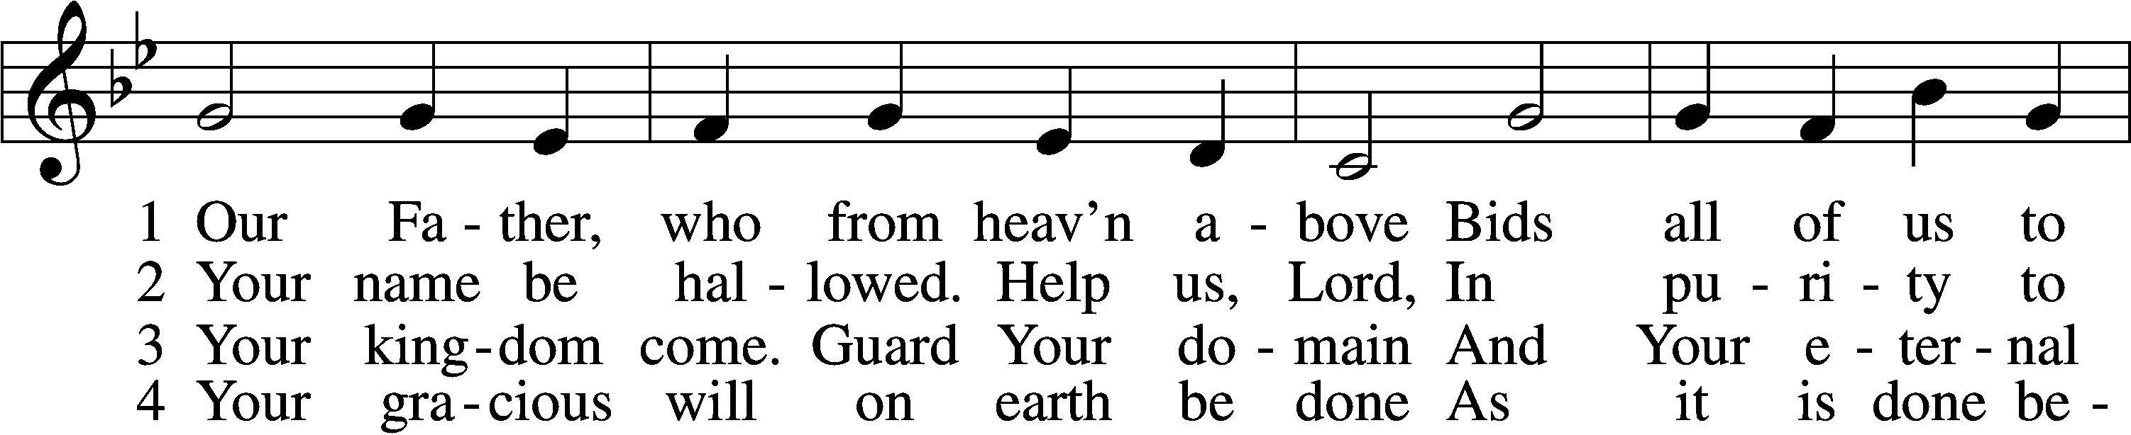
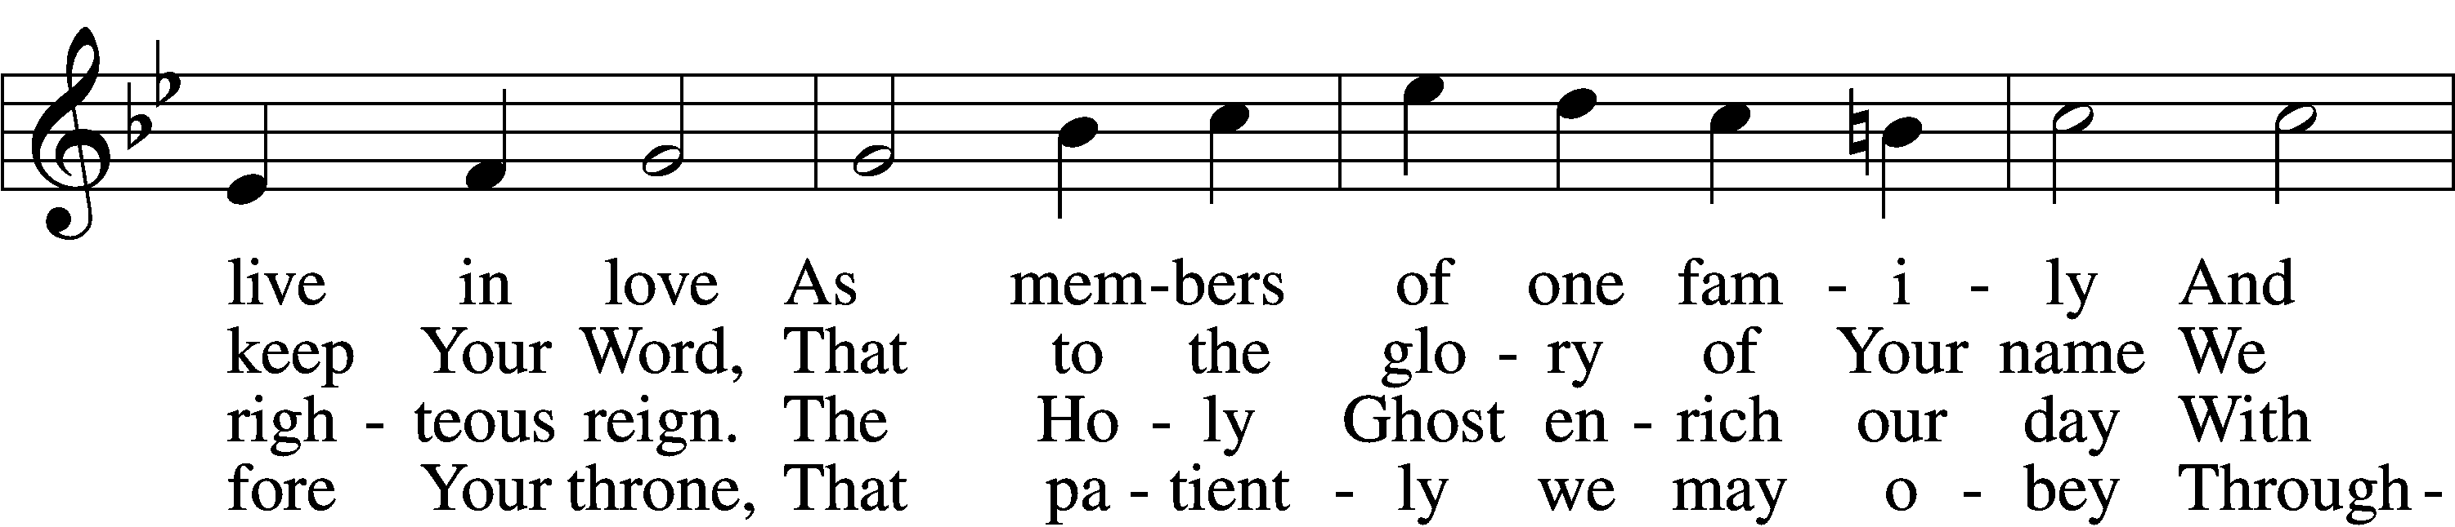
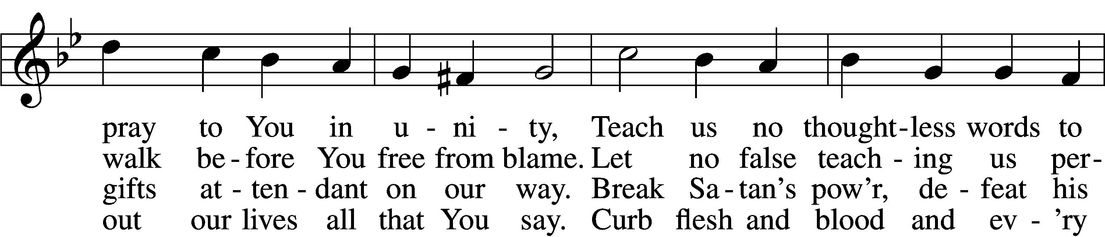
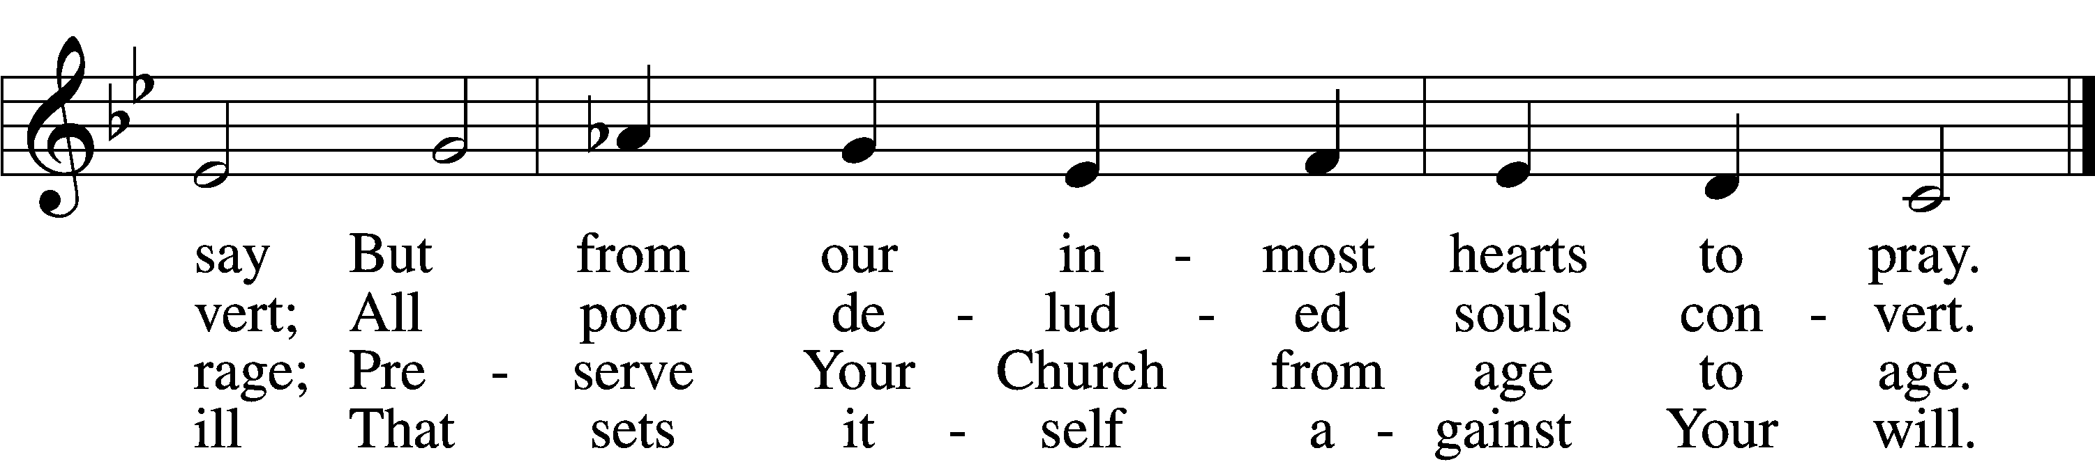
Text: Martin Luther, 1483–1546; (st. 1): tr. The Lutheran Hymnal, 1941, alt.; (sts. 2–4): tr. F. Samuel Janzow, 1913–2001, alt.
Tune: attr. Martin Luther, 1483–1546
Text (st. 1): Public domain
Text (sts. 2–4): © 1980 Concordia Publishing House. Used by permission: LSB Hymn License no. 110016438
Tune: Public domain

The sign of the cross T may be made by all in remembrance of their Baptism.

Invocation
P In the name of the Father and of the T Son and of the Holy Spirit.
C Amen.

Exhortation LSB 203
P Our help is in the name of the Lord,
C who made heaven and earth.

P If You, O Lord, kept a record of sins, O Lord, who could stand?
C But with You there is forgiveness; therefore You are feared.

P Since we are gathered to hear God’s Word, call upon Him in prayer and praise, and receive the body and blood of our Lord Jesus Christ in the fellowship of this altar, let us first consider our unworthiness and confess before God and one another that we have sinned in thought, word, and deed, and that we cannot free ourselves from our sinful condition. Together as His people let us take refuge in the infinite mercy of God, our heavenly Father, seeking His grace for the sake of Christ, and saying: God, be merciful to me, a sinner.

Silence for reflection on God’s Word and for self-examination.

Confession of Sins LSB 203
C Almighty God, have mercy upon us, forgive us our sins, and lead us to everlasting life. Amen.

Absolution LSB 203
P Almighty God in His mercy has given His Son to die for you and for His sake forgives you all your sins. As a called and ordained servant of Christ, and by His authority, I therefore forgive you all your sins in the name of the Father and of the T Son and of the Holy Spirit.
C Amen.

+SERVICE OF THE WORD+

Psalm Psalm 138
1I give you thanks, O Lord, with my whole heart;
before the gods I sing your praise;
2I bow down toward your holy temple
and give thanks to your name for your steadfast love and your faithfulness,
for you have exalted above all things
your name and your word.
3On the day I called, you answered me;
my strength of soul you increased.
4All the kings of the earth shall give you thanks, O Lord,
for they have heard the words of your mouth,
5and they shall sing of the ways of the Lord,
for great is the glory of the Lord.
6For though the Lord is high, he regards the lowly,
but the haughty he knows from afar.
7Though I walk in the midst of trouble,
you preserve my life;
you stretch out your hand against the wrath of my enemies,
and your right hand delivers me.
8The Lord will fulfill his purpose for me;
your steadfast love, O Lord, endures forever.
Do not forsake the work of your hands.
Glory be to the Father and to the Son
and to the Holy Spirit;
as it was in the beginning,
is now, and will be forever. Amen.

Kyrie LSB 204
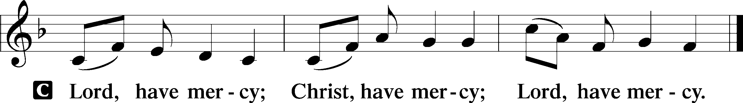

Gloria in Excelsis LSB 204
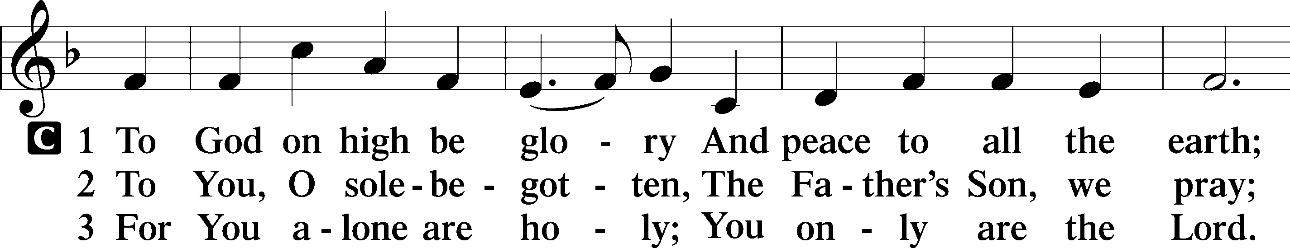
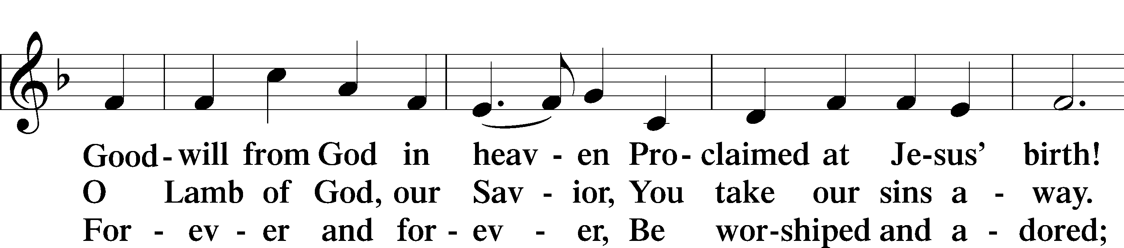
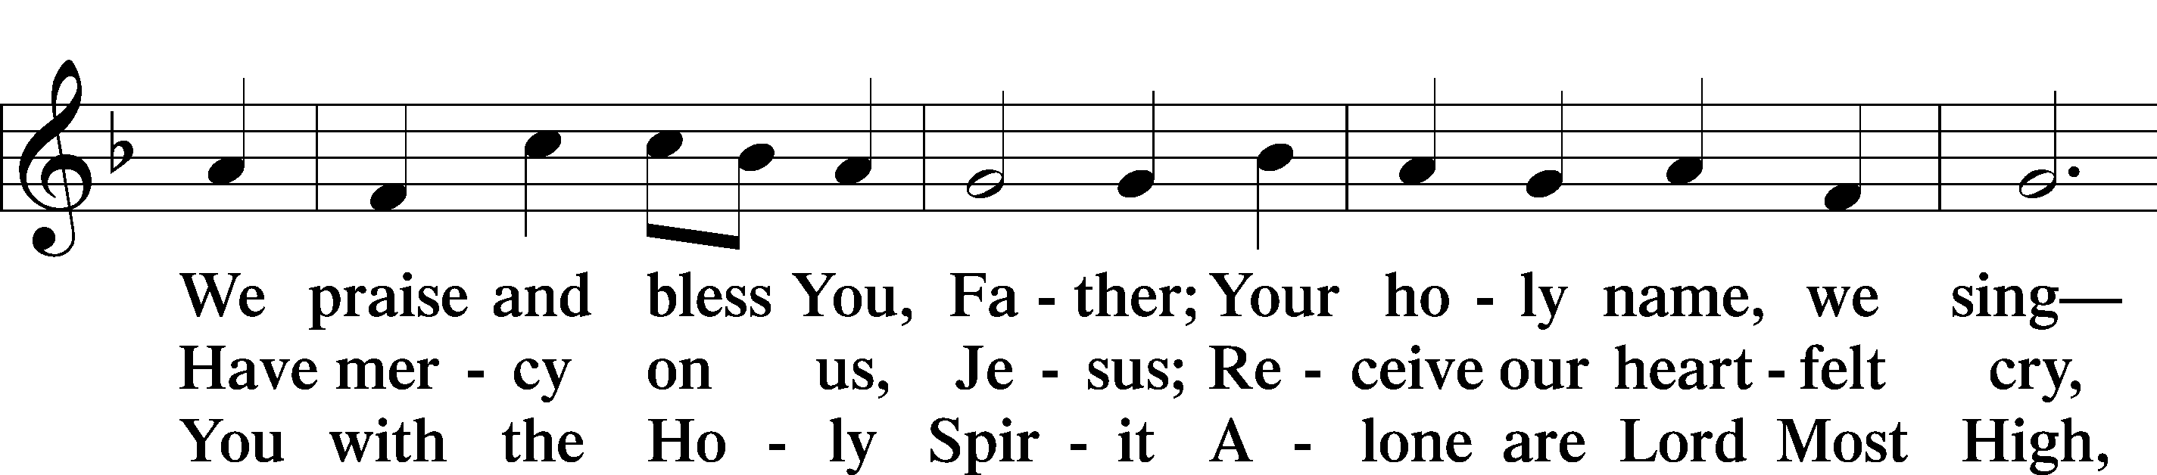
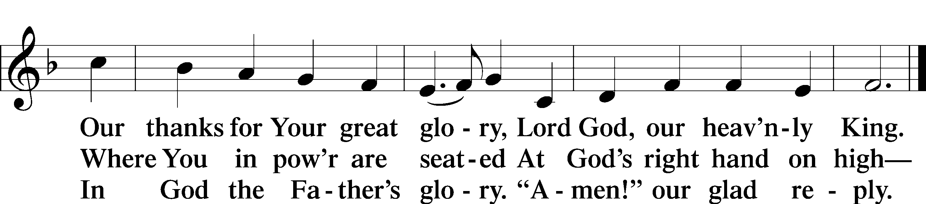
Text: Stephen P. Starke

Salutation and Collect of the Day
P The Lord be with you.
C And also with you.
P Let us pray.
C O Lord, let Your merciful ears be attentive to the prayers of Your servants, and by Your Word and Spirit teach us how to pray that our petitions may be pleasing before You; through Jesus Christ, Your Son, our Lord, who lives and reigns with You and the Holy Spirit, one God, now and forever. Amen.

Sit

Old Testament Reading Genesis 18:20–33
20Then the Lord said, “Because the outcry against Sodom and Gomorrah is great and their sin is very grave, 21I will go down to see whether they have done altogether according to the outcry that has come to me. And if not, I will know.”
22So the men turned from there and went toward Sodom,
but Abraham still stood before the Lord. 23Then Abraham drew near and said, “Will you indeed sweep away the righteous with the wicked? 24Suppose there are fifty righteous within the city. Will you then sweep away the place and not spare it for the fifty righteous who are in it? 25Far be it from you to do such a thing, to put the righteous to death with the wicked, so that the righteous fare as the wicked!
Far be that from you! Shall not the Judge of all the earth do what is just?” 26And the Lord said, “If I find at Sodom fifty righteous in the city, I will spare the whole place for their sake.”
27Abraham answered and said, “Behold, I have undertaken to speak to the Lord, I who am but dust and ashes. 28Suppose five of the fifty righteous are lacking. Will you destroy the whole city for lack of five?” And he said, “I will not destroy it if I find forty-five there.” 29Again he spoke to him and said, “Suppose forty are found there.” He answered, “For the sake of forty I will not do it.” 30Then he said, “Oh let not the Lord be angry, and I will speak. Suppose thirty are found there.” He answered, “I will not do it, if I find thirty there.”

31He said, “Behold, I have undertaken to speak to the Lord.
Suppose twenty are found there.” He answered, “For the sake of twenty I will not destroy it.” 32Then he said, “Oh let not the Lord be angry, and I will speak again but this once. Suppose ten are found there.” He answered, “For the sake of ten I will not destroy it.”
33And the Lord went his way, when he had finished speaking to Abraham, and Abraham returned to his place.

A This is the Word of the Lord.
C Thanks be to God.

Gradual Romans 10:15b, 18b; Isaiah 52:7b, alt.
How beautiful are the feet of those who preach the good news,
who publish peace and bring good news of salvation.
Their voice has gone out to all the earth,
and their words to the ends of the world.

Epistle Colossians 2:6–15
6Therefore, as you received Christ Jesus the Lord, so walk in him, 7rooted and built up in him and established in the faith, just as you were taught, abounding in thanksgiving.
8See to it that no one takes you captive by philosophy and empty deceit, according to human tradition, according to the elemental spirits of the world, and not according to Christ. 9For in him the whole fullness of deity dwells bodily, 10and you have been filled in him, who is the head of all rule and authority. 11In him also you were circumcised with a circumcision made without hands, by putting off the body of the flesh, by the circumcision of Christ, 12having been buried with him in baptism, in which you were also raised with him through faith in the powerful working of God, who raised him from the dead.
13And you, who were dead in your trespasses and the uncircumcision of your flesh, God made alive together with him, having forgiven us all our trespasses, 14by canceling the record of debt that stood against us with its legal demands. This he set aside, nailing it to the cross. 15He disarmed the rulers and authorities and put them to open shame, by triumphing over them in him.

A This is the Word of the Lord.
C Thanks be to God.

Stand

Alleluia and Verse

Alleluia LSB 205
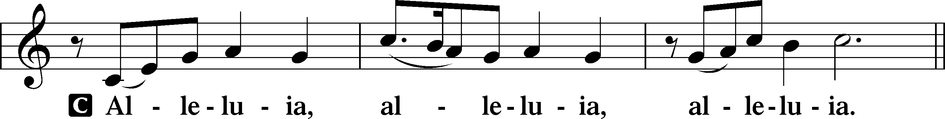

Verse LSB 205
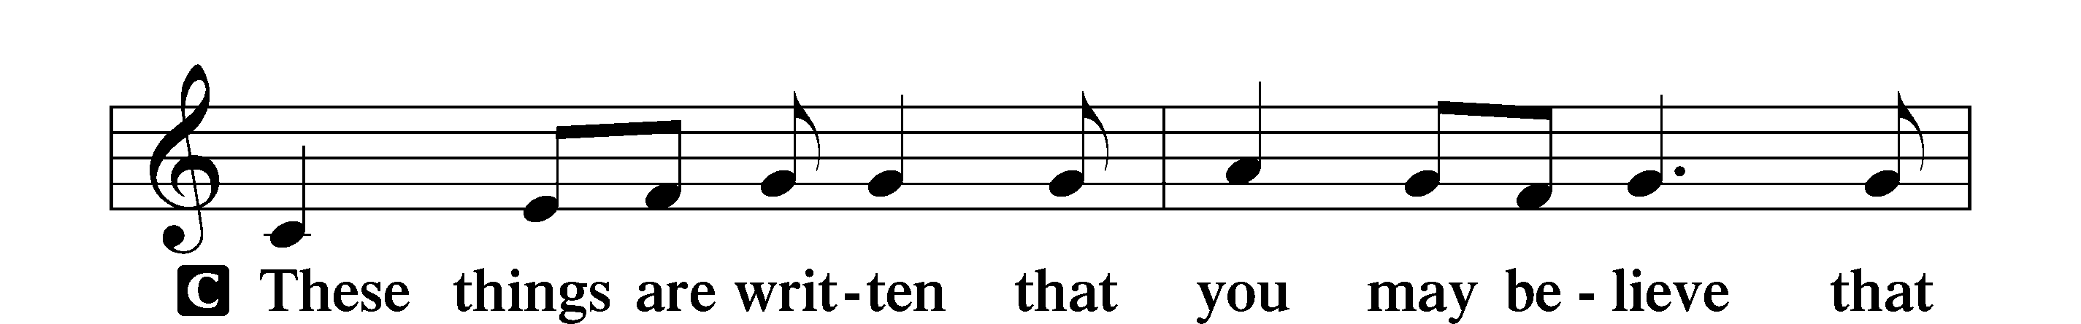
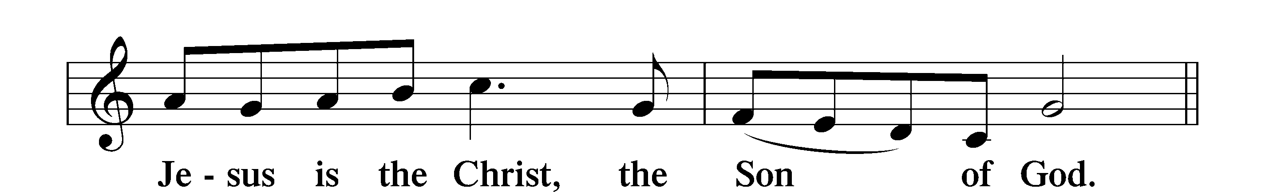

Alleluia LSB 205
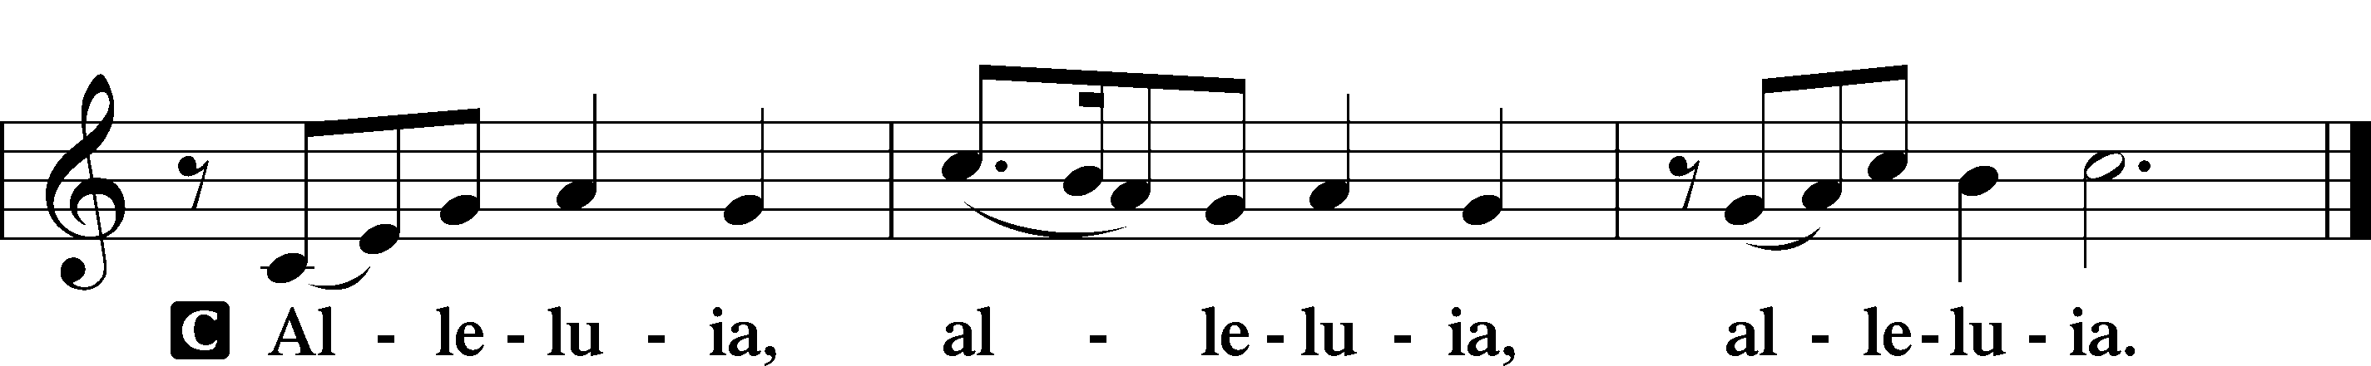

Holy Gospel Luke 11:1–13
P The Holy Gospel according to St. Luke, the eleventh chapter.
C Glory to You, O Lord.

1Now Jesus was praying in a certain place, and when he finished, one of his disciples said to him, “Lord, teach us to pray, as John taught his disciples.” 2And he said to them, “When you pray, say:
“Father, hallowed be your name.
Your kingdom come.
3Give us each day our daily bread,
4and forgive us our sins,
for we ourselves forgive everyone who is indebted to us.
And lead us not into temptation.”
5And he said to them, “Which of you who has a friend will go to him at midnight and say to him, ‘Friend, lend me three loaves, 6for a friend of mine has arrived on a journey, and I have nothing to set before him’; 7and he will answer from within, ‘Do not bother me; the door is now shut, and my children are with me in bed. I cannot get up and give you anything’? 8I tell you, though he will not get up and give him anything because he is his friend, yet because of his impudence he will rise and give him whatever he needs. 9And I tell you, ask, and it will be given to you; seek, and you will find;
knock, and it will be opened to you. 10For everyone who asks receives, and the one who seeks finds, and to the one who knocks it will be opened. 11What father among you, if his son asks for a fish, will instead of a fish give him a serpent; 12or if he asks for an egg, will give him a scorpion? 13If you then, who are evil, know how to give good gifts to your children, how much more will the heavenly Father give the Holy Spirit to those who ask him!”

P This is the Gospel of the Lord.
C Praise to You, O Christ.

Apostles’ Creed
C I believe in God, the Father Almighty,
maker of heaven and earth.

And in Jesus Christ, His only Son, our Lord,
who was conceived by the Holy Spirit,
born of the virgin Mary,
suffered under Pontius Pilate,
was crucified, died and was buried.
He descended into hell.
The third day He rose again from the dead.
He ascended into heaven
and sits at the right hand of God the Father Almighty.
From thence He will come to judge the living and the dead.

I believe in the Holy Spirit,
the holy Christian Church,
the communion of saints,
the forgiveness of sins,
the resurrection of the body,
and the life T everlasting. Amen.

Sit

Children’s Message
Hymn of the Day “Our Father, Who from Heaven Above”
LSB 766 sts. 5–9
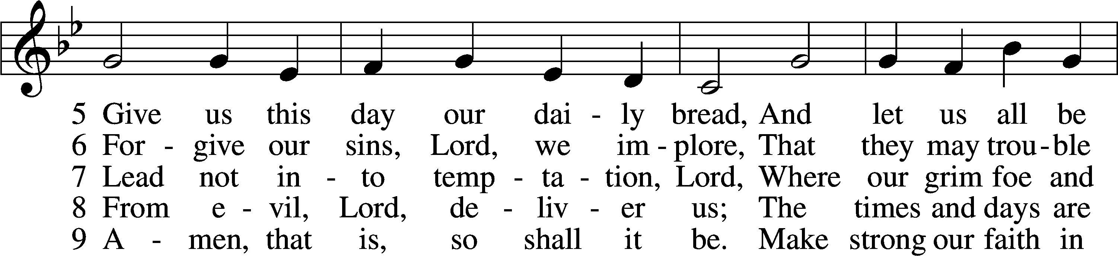
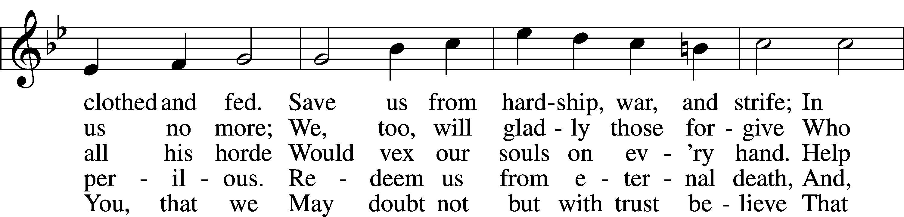
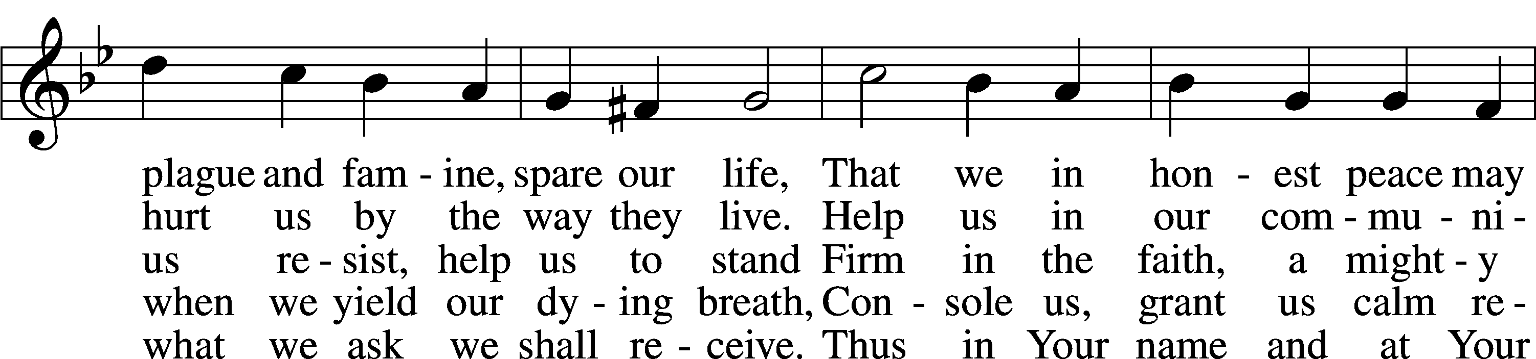
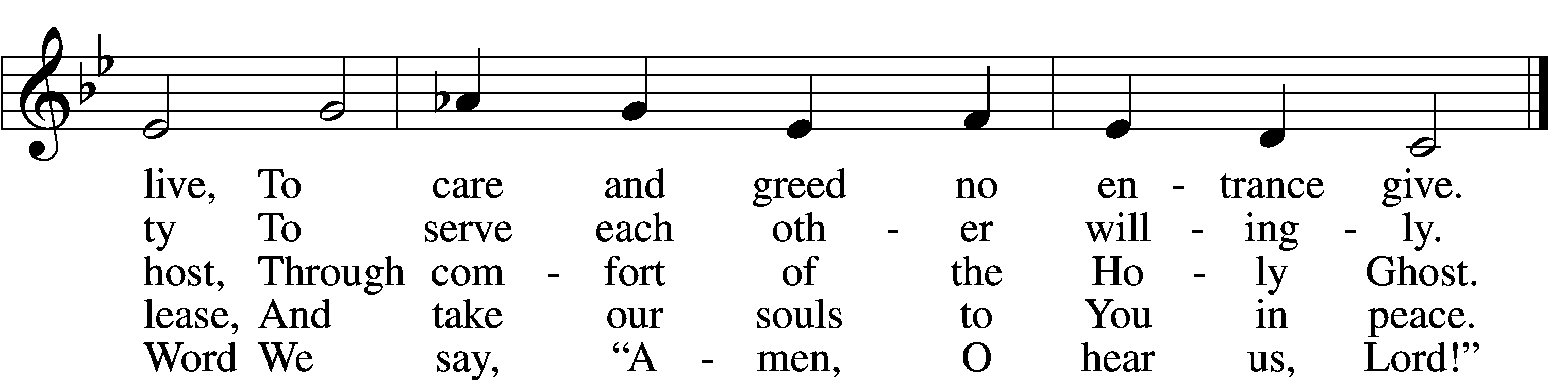
Text: Martin Luther, 1483–1546; (sts. 5, 7): tr. F. Samuel Janzow, 1913–2001, alt.; (sts. 6, 8–9): tr. The Lutheran Hymnal, 1941, alt.
Tune: attr. Martin Luther, 1483–1546
Text (sts. 5, 7): © 1980 Concordia Publishing House. Used by permission: LSB Hymn License no. 110016438
Text (sts. 6, 8–9): Public domain
Tune: Public domain

Sermon

Stand
Prayer of the Church
Sit
Offering

+SERVICE OF THE SACRAMENT+

Stand

Preface LSB 208
P The Lord be with you.
C And also with you.

P Lift up your hearts.
C We lift them to the Lord.

P Let us give thanks to the Lord our God.
C It is right to give Him thanks and praise.

P It is truly good, right, and salutary that we should at all times and in all places give thanks to You, O Lord, holy Father, almighty and everlasting God, for the countless blessings You so freely bestow on us and all creation. Above all, we give thanks for Your boundless love shown to us when You sent Your
only-begotten Son, Jesus Christ, into our flesh and laid on Him our sin, giving Him into death that we might not die eternally. Because He is now risen from the dead and lives and reigns to all eternity, all who believe in Him will overcome sin and death and will rise again to new life. Therefore with angels and archangels and with all the company of heaven we laud and magnify Your glorious name, evermore praising You and saying:

Sanctus LSB 208
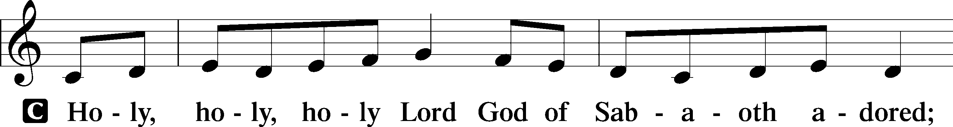
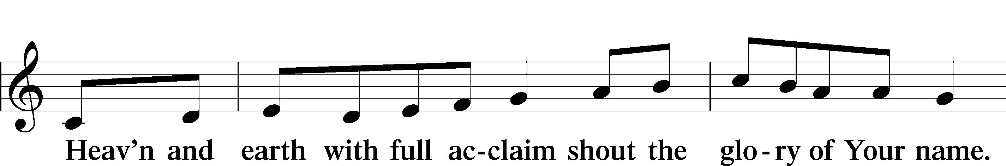
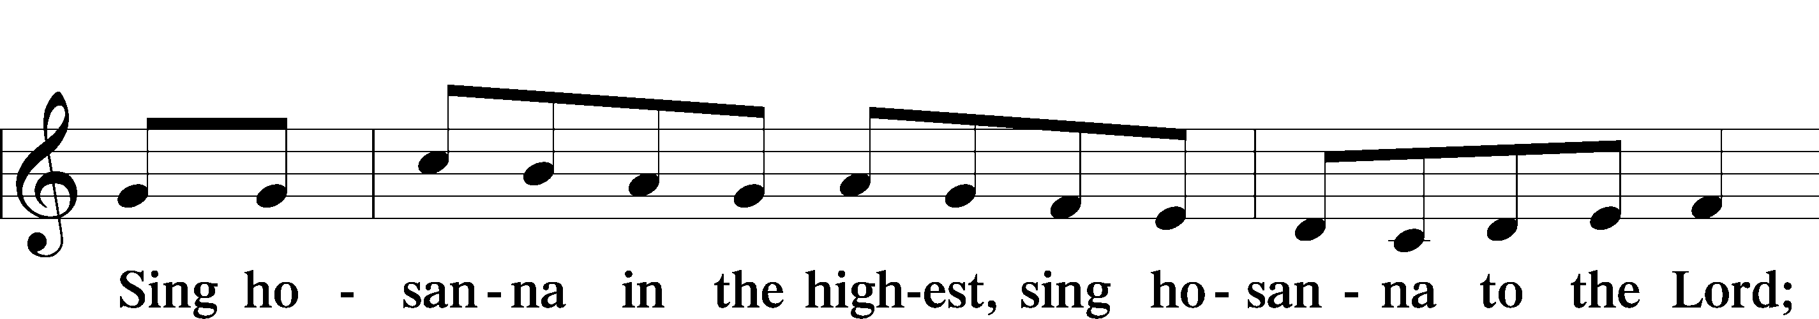
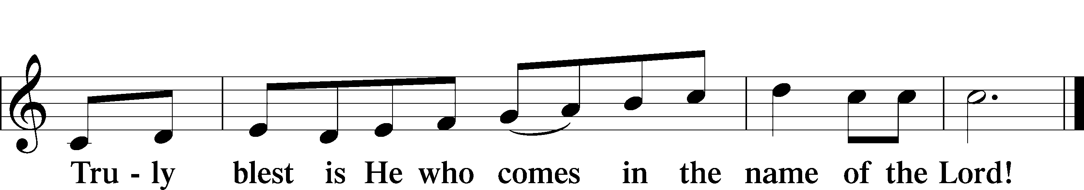
Text: Stephen P. Starke

Prayer of Thanksgiving
P Blessed are You, O Lord our God, king of all creation, for You have had mercy on us and given Your only-begotten Son that whoever believes in Him should not perish but have eternal life.

In Your righteous judgment You condemned the sin of Adam and Eve, who ate the forbidden fruit, and You justly barred them and all their children from the tree of life. Yet, in Your great mercy, You promised salvation by a second Adam, Your Son, Jesus Christ, our Lord, and made His cross a life-giving tree for all who trust in Him.

We give You thanks for the redemption You have prepared for us through Jesus Christ. Grant us Your Holy Spirit that we may faithfully eat and drink of the fruits of His cross and receive the blessings of forgiveness, life, and salvation that come to us in His body and blood.

Hear us as we pray in His name and as He has taught us:

Lord’s Prayer
C Our Father who art in heaven,
hallowed be Thy name,
Thy kingdom come,
Thy will be done on earth
as it is in heaven;
give us this day our daily bread;
and forgive us our trespasses
as we forgive those
who trespass against us;
and lead us not into temptation,
but deliver us from evil.
For Thine is the kingdom
and the power and the glory
forever and ever. Amen.

The Words of Our Lord
P Our Lord Jesus Christ, on the night when He was betrayed, took bread, and when He had given thanks, He broke it and gave it to the disciples and said: “Take, eat; this is My T body, which is given for you. This do in remembrance of Me.”

In the same way also He took the cup after supper, and when He had given thanks, He gave it to them, saying: “Drink of it, all of you; this cup is the new testament in My T blood, which is shed for you for the forgiveness of sins. This do, as often as you drink it, in remembrance of Me.”

Pax Domini
P The peace of the Lord be with you always.
C Amen.

Agnus Dei LSB 210
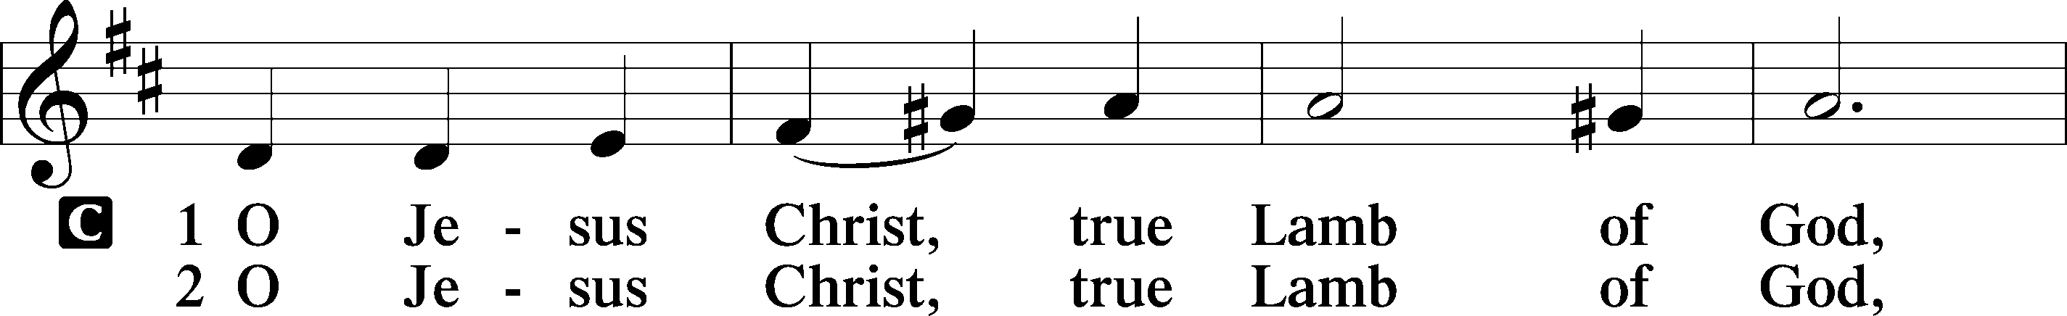
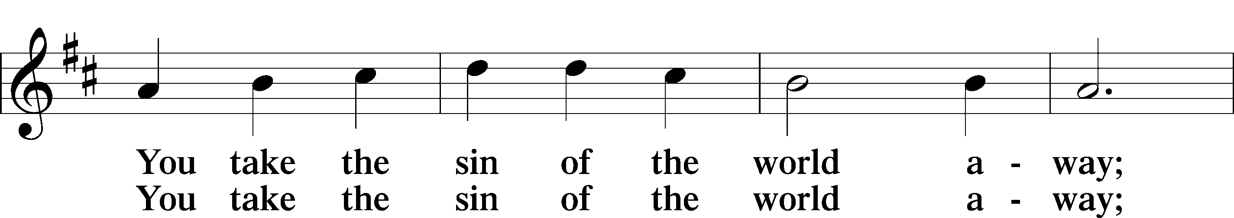
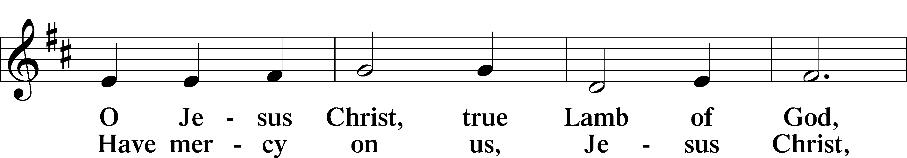
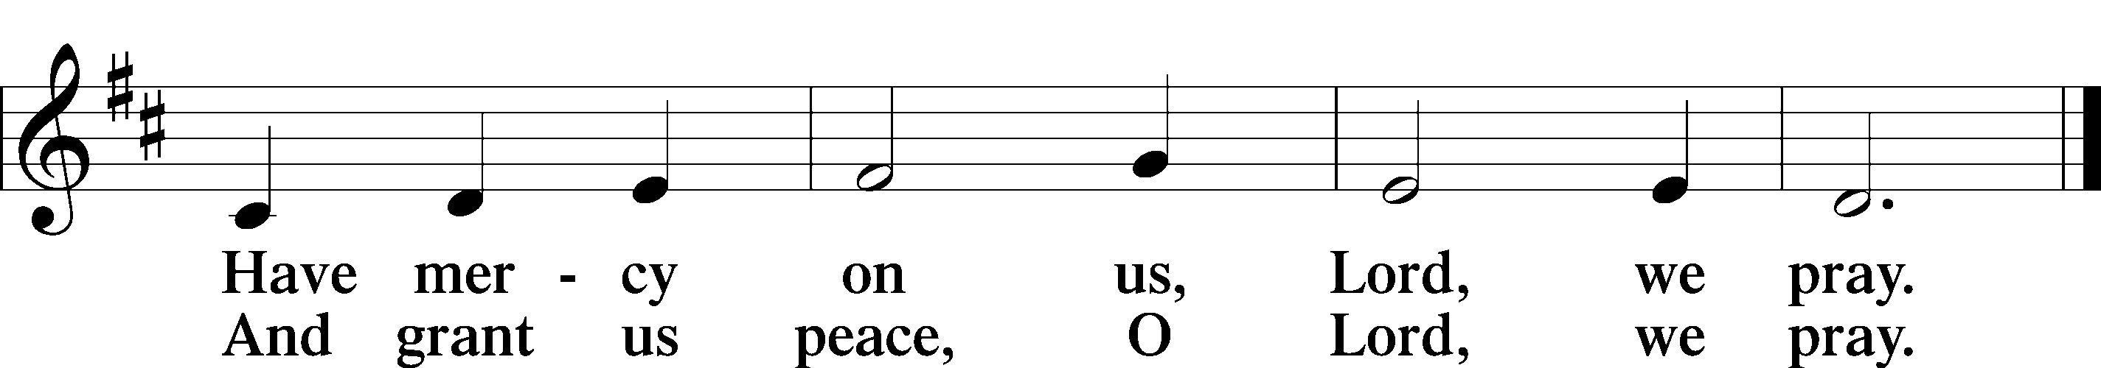
Text: Stephen P. Starke

Sit

Distribution

Distribution Hymn “I Lay My Sins on Jesus” LSB 606
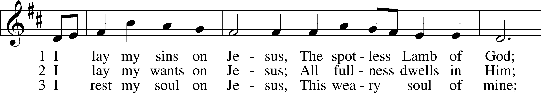
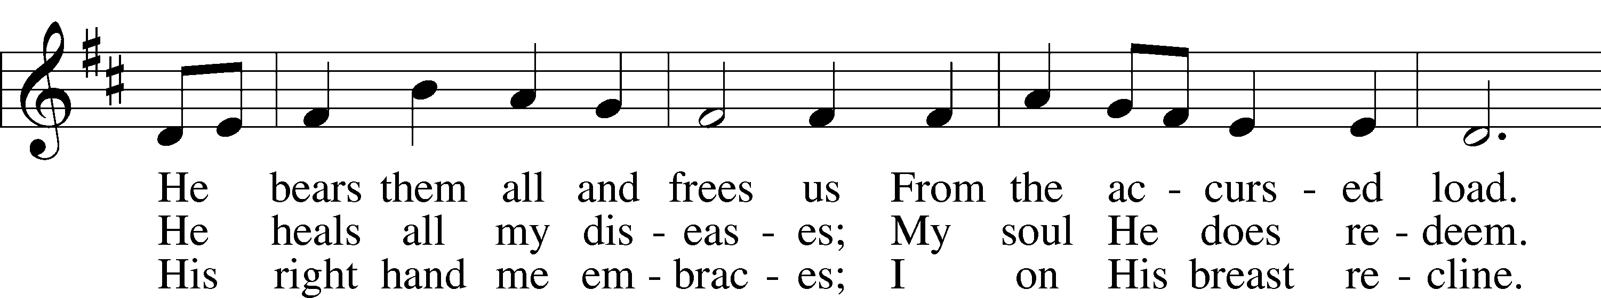
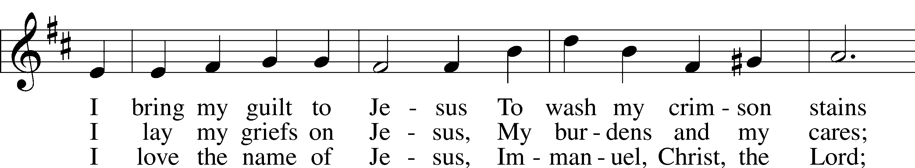
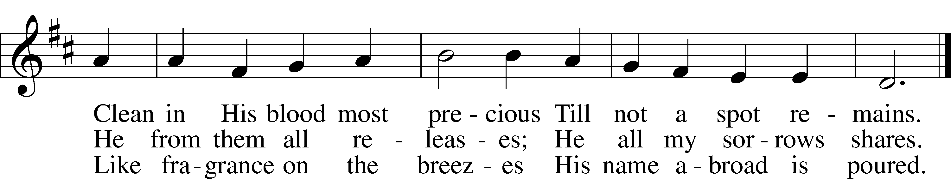
Text: Horatius Bonar, 1808–89
Tune: Neu-vermehrtes . . . Gesangbuch, 1693, 3rd ed., Meiningen
Text and tune: Public domain

Distribution Hymn “Come, My Soul, with Every Care” LSB 779
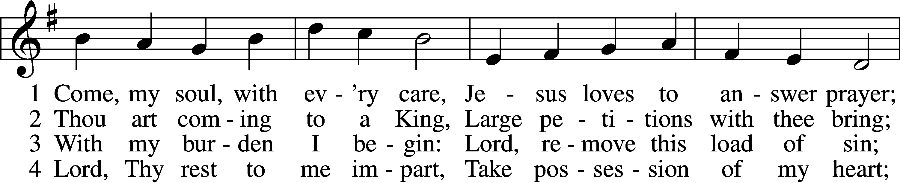
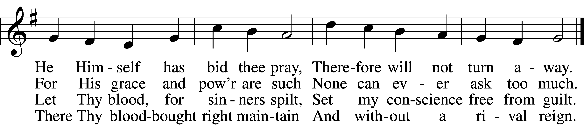

5 While I am a pilgrim here,
Let Thy love my spirit cheer;
As my guide, my guard, my friend,
Lead me to my journey’s end.

6 Show me what is mine to do;
Ev’ry hour my strength renew.
Let me live a life of faith;
Let me die Thy people’s death.
Text: John Newton, 1725–1807, alt.
Tune: Justin H. Knecht, 1752–1817
Text and tune: Public domain

Stand

Nunc Dimittis LSB 211
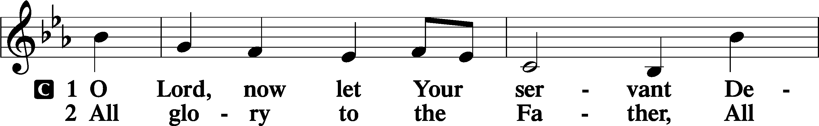
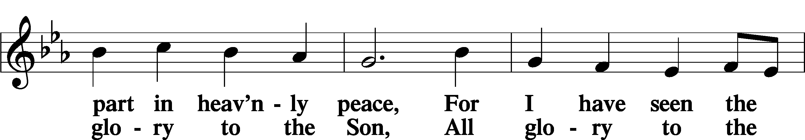
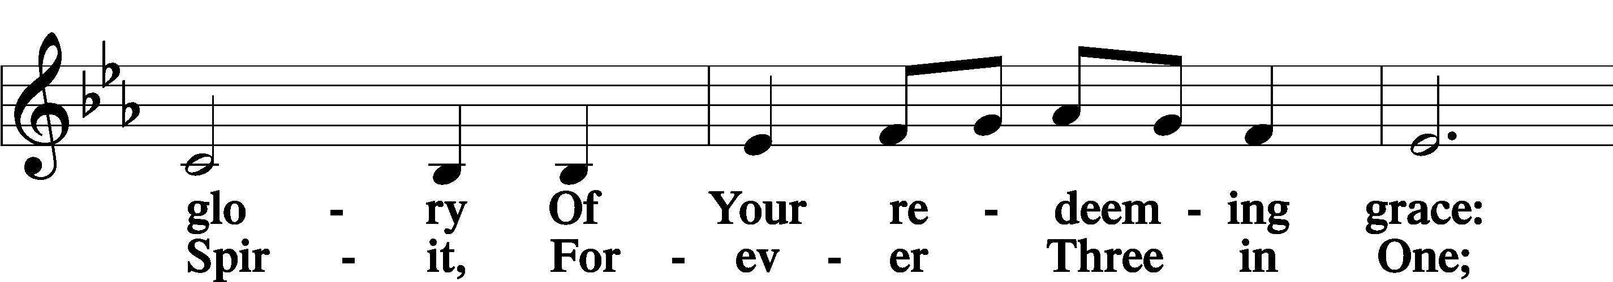
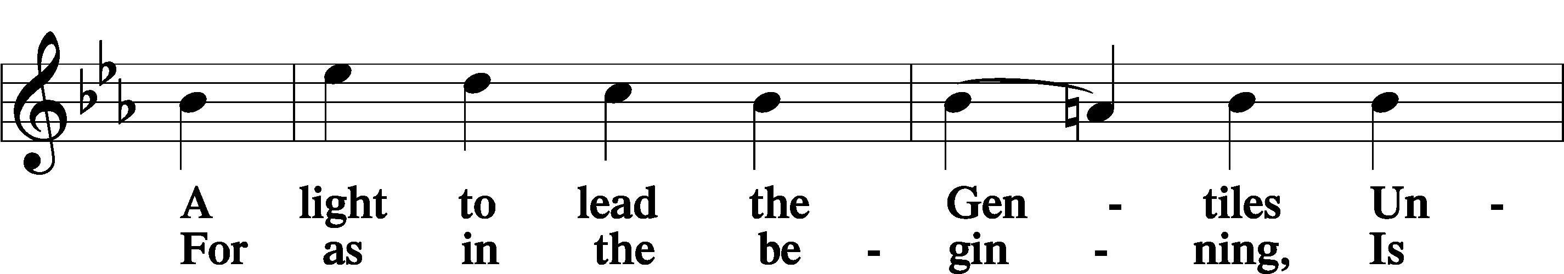
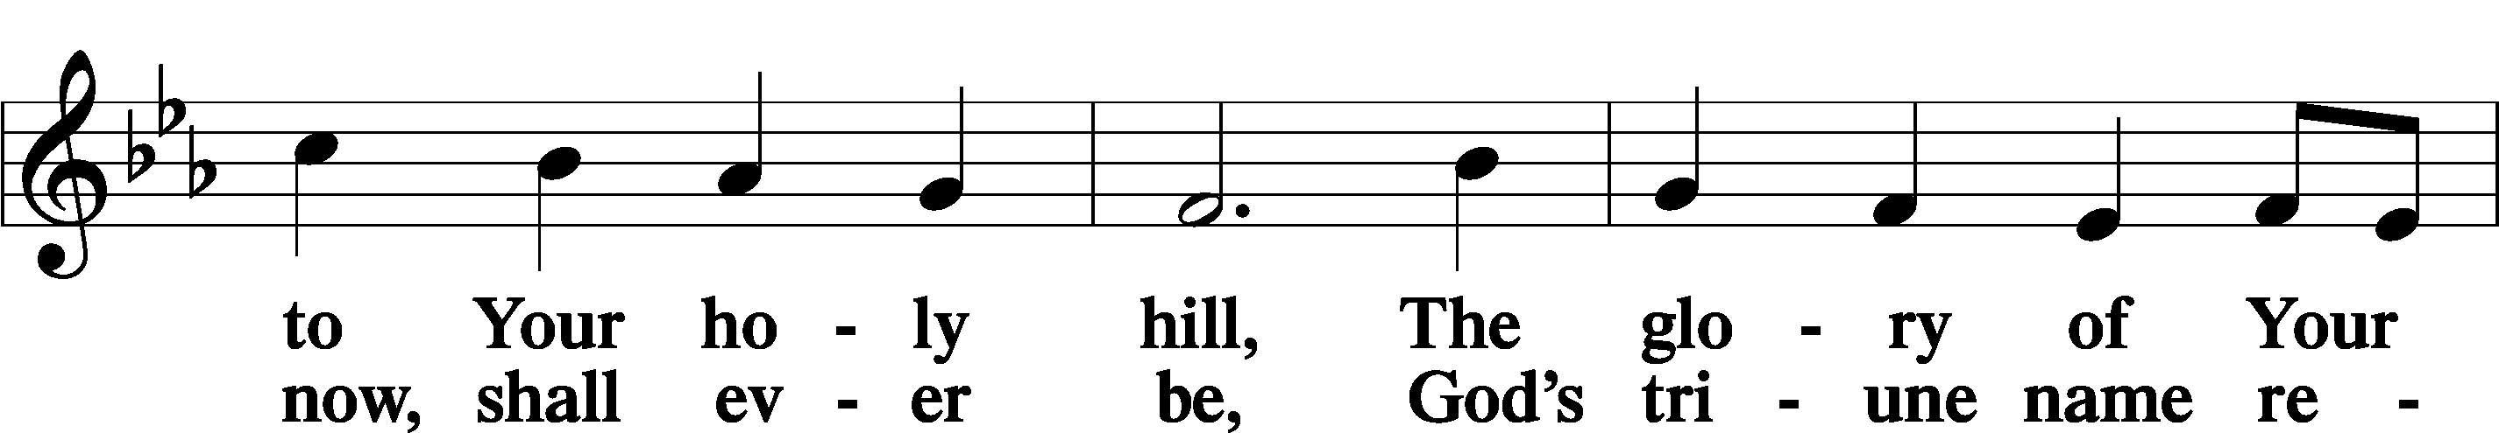
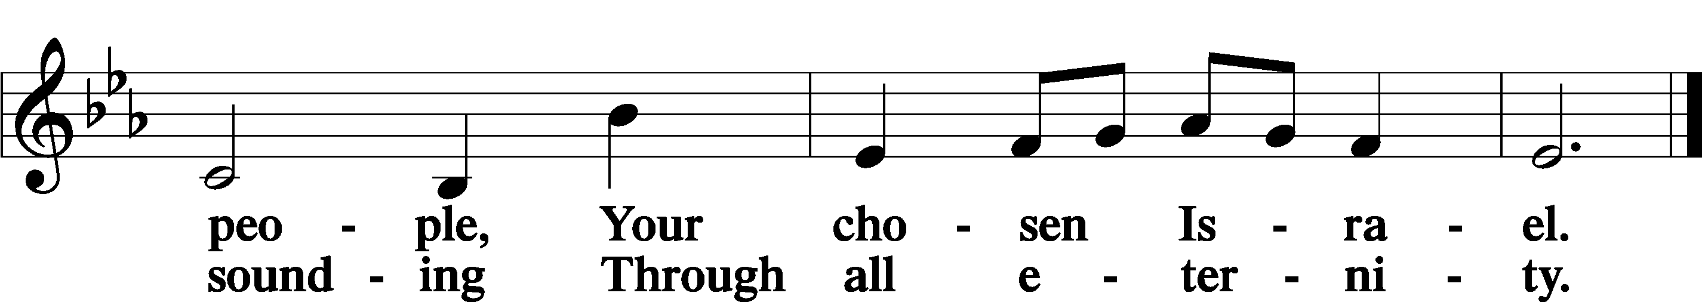

Post-Communion Collect
A Let us pray.
O God the Father, the fountain and source of all goodness,
who in loving-kindness sent Your only-begotten Son into the flesh, we thank You that for His sake You have given us pardon and peace in this Sacrament, and we ask You not to forsake Your children but always to rule our hearts and minds by Your Holy Spirit that we may be enabled constantly to serve You; through Jesus Christ, Your Son, our Lord, who lives and reigns with You and the Holy Spirit, one God, now and forever.
C Amen.

Benedicamus LSB 212
A Let us bless the Lord.
C Thanks be to God.

Benediction
P The Lord bless you and keep you.
The Lord make His face shine on you and be gracious to you.
The Lord look upon you with favor and T give you peace.
C Amen.

Closing Hymn “What a Friend We Have in Jesus” LSB 770
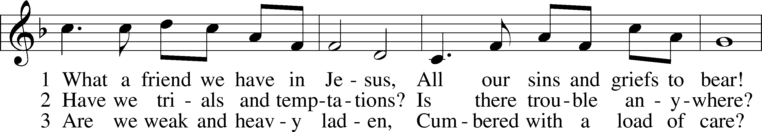
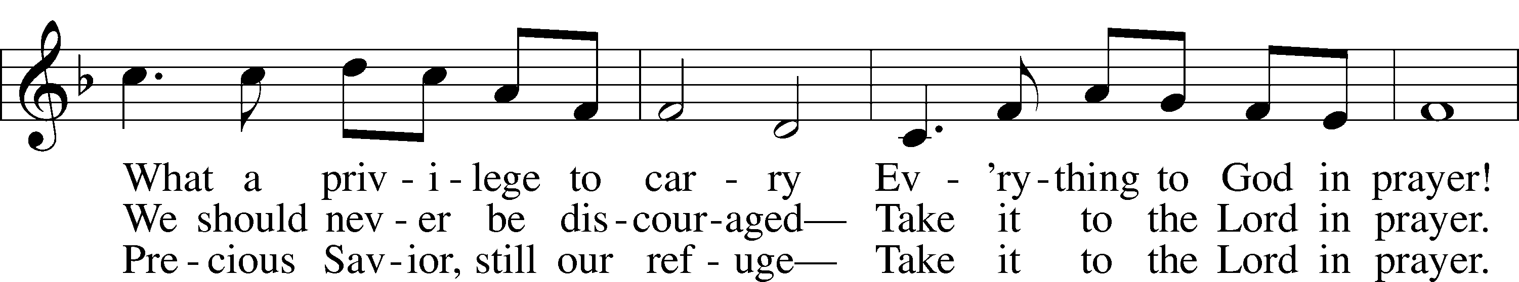
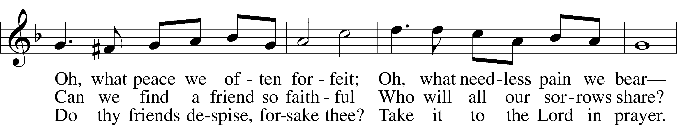
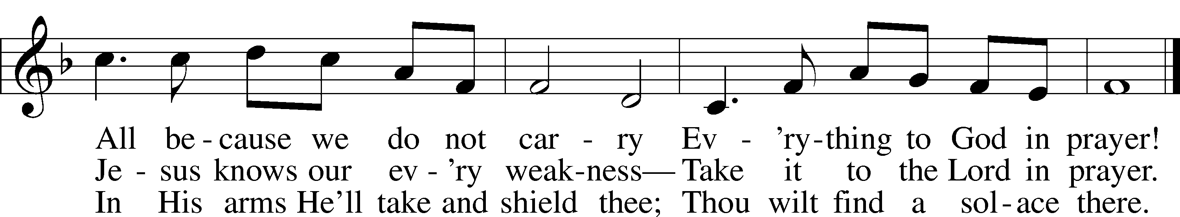
Text: Joseph M. Scriven, 1819–86
Tune: Charles C. Converse, 1832–1918
Text and tune: Public domain

Acknowledgments
Unless otherwise indicated, Scripture quotations are from the ESV® Bible (The Holy Bible, English Standard Version®), copyright © 2001 by Crossway, a publishing ministry of Good News Publishers. Used by permission. All rights reserved.
Created by Lutheran Service Builder © 2022 Concordia Publishing House.

Serving Our Lord in His House Today:
Pastor: Rev. Bert Thompson
Organist: Rebecca Moseley (Sunday)
Elder: Jake Mallmann
Joe Engel (Wednesday)

Gifts from God: Luke 11:11 – “What father among you, if his son asks for a fish, will instead of a fish give him a serpent?” A generous, giving spirit comes from knowing that you have a generous, giving Father. He will care for our needs. We are therefore free to reflect His generosity in our lives. We can be generous in raising our children, supporting the Church, and serving our neighbor in the community. In these three areas – home, Church, and society – the Lord has called us to show His grace and generosity to those around us.

Pastoral Call Committee Update: Please join us today after the worship service. The call committee will be holding an information meeting and providing information on the candidates that are being presented for consideration. There will be a Quarterly Voters’ Meeting held on Sunday, August 7, 2022, during this meeting we will be voting to make a call to one of these pastors to become our next Shepherd.

Financial Statements: The mid-year financial statements have been placed in your church mailboxes. Please be sure to take them to help save on postage. If you notice any errors or discrepancies, please contact the Financial Secretary,
Linda Ecker.

LWML Fall Retreat: The Fall Retreat will take place September 23-24 at
Fond Du Lac, WI. Registration forms will be on the LWML board in the
fellowship hallway. The forms need to be submitted by August. Please join us for
a time of fellowship and programs for and by other LWML Women.

Prayer for calling a faithful pastor:
O Gracious Father, You led Your holy apostles to ordain ministers for the proclamation of Your Word and the faithful administration of the Sacraments of Christ. Grant to this congregation the guidance of the Holy Spirit to choose a suitable pastor according to Your will for the blessing of Your Church in this place; through Jesus Christ our Lord.

Main Street Living: What is it? A televised worship service produced in conjunction with LCMS churches and pastors. Main Street is not intended to be a replacement for in-person worship, but is here to provide liturgical services to those unable to attend a local congregation. The hour-long broadcast consists of 2 parts: Main Street Living, a 30 minute service led by local LCMS pastors and This is the Life, a remastered episode of the Emmy award-winning Lutheran Hour Ministries program. This can be viewed locally in WI: LaCrosse/Eau Claire-Fox 25.2/48.2 at 10:00 a.m. or any time on the internet at MainStreetLiving.com. There are brochures with additional information on the usher’s table in the Narthex.

Prayer Chain/Prayer Ministry: Did you know Good Shepherd Lutheran Church has a prayer chain? One of the blessings we have is to pray for our brothers and sisters in Christ. If you are interested in becoming a member of the prayer chain,
or would like additional information regarding the prayer chain, please contact
Deb Lafferty or an Elder. There is a sign-up sheet on the easel in the Narthex.

Altar Guild: The church continues to look for volunteers to assist with altar guild duties. If you are interested in assisting with this task there is a sign-up sheet on the easel in the Narthex. If you have questions, please speak with an Elder. Please sign up for the service(s) that work with your schedule. Thank you for your gracious service to the church.

PO Box: For mailed offerings, please use the following:
Good Shepherd Lutheran Church
P.O. Box 551
Tomah, WI 54660

Our Worship attendance last week: Sunday: 40
Wednesday: 0
Total: 40

Scripture Lessons for next week: Ecclesiastes 1:2, 12-14; 2:18-26
Colossians 3:1-11
Luke 12:13-21

Secretary Office Hours: Monday-Friday: 8:15am-12:15pm
Our Week With Our Lord:
Today 9:00am Divine Service w/Holy Communion
(livestreamed via YouTube)
10:30am Pastoral Call Information Meeting
Monday
Tuesday 9:30am-11:00am Little Lambs Playgroup
@ Warrens Park
1:00pm Ladies Bible Study @church
6:00pm VBS Worknight
8:00pm Church Softball @Buds Field
Wednesday 7:00pm Divine Service (No Communion)
Thursday 11:30am YAH/LWML B-day Lunch
@Discovery Center Café, Warrens
Friday
Saturday
Sunday 9:00am Divine Service w/Holy Communion
(livestreamed via YouTube)
10:30am Adult Bible Study

*Please view the following page for weekly prayers*

HIS FLOCK AT PRAYER
Propers for the Seventh Week after Pentecost

Psalm for the Week: Psalm 138

Daily Scripture Readings:
Sunday— Matthew 5:20-26 Thursday—James 2:10-17
Monday— Romans 3:23-28 Friday—Isaiah 58:5-8
Tuesday—Matthew 5:17-19 Saturday—Isaiah 58:9-11
Wednesday—Psalm 15

Collect for the Week:
O Lord, let Your merciful ears be attentive to the prayers of Your servants, and by
Your Word and Spirit teach us how to pray that our petitions may be pleasing
before You; through Jesus Christ, Your Son, our Lord, who lives and reigns with
You and the Holy Spirit, one God, now and forever.

Hymn of the Week: “Our Father, Who from Heaven Above” LSB 766

Congregational Petitions for this Week:
+ For those whose work is difficult or dangerous including the military away from
home, especially: Isaac Preuss, Joshua Ecker, Tania Adler, and Sarah Johnson.
+ For those who are ill or recovering, especially: Brenda Kolb, Paula Sopel,
Shawn Zabinski, Carrie Wilbanks, Jean Salzman, Ro Scrivner, David Keinath,
Maddox Rinch, Dawn Hawkins, Kelly Ingenthron, Nick Anderson, Al Mansfield,
Gloria Graupe, Marie Drescher.
+ For those who are home-bound, especially: John Fox, Darlene Griffin,
Al Mansfield, Virginia Tillman, Lynda Goad, Roemelle McArdle,
Sharon Herried, Muriel Finch.
+ For those who are mourning the loss of a loved one:
- Jeremy Knutson and family, at the loss of Jeremy’s step-sister.
- Lisa, Tony and Josh Church, at the loss of Karen Griggel, Lisa’s mother
+ For those suffering from the pandemic, especially those in our congregation who
have been infected, those who are suffering financially, and those who work in
the medical field.

