Good Shepherd Lutheran Church
Eighth Sunday after Trinity
July 25, 2021

Pre-Service Music & Welcome
Divine Service Setting Five – Lutheran Service Book (LSB) 213

+CONFESSION AND ABSOLUTION+

Opening Hymn “Awake, My Soul, and with the Sun” LSB 868
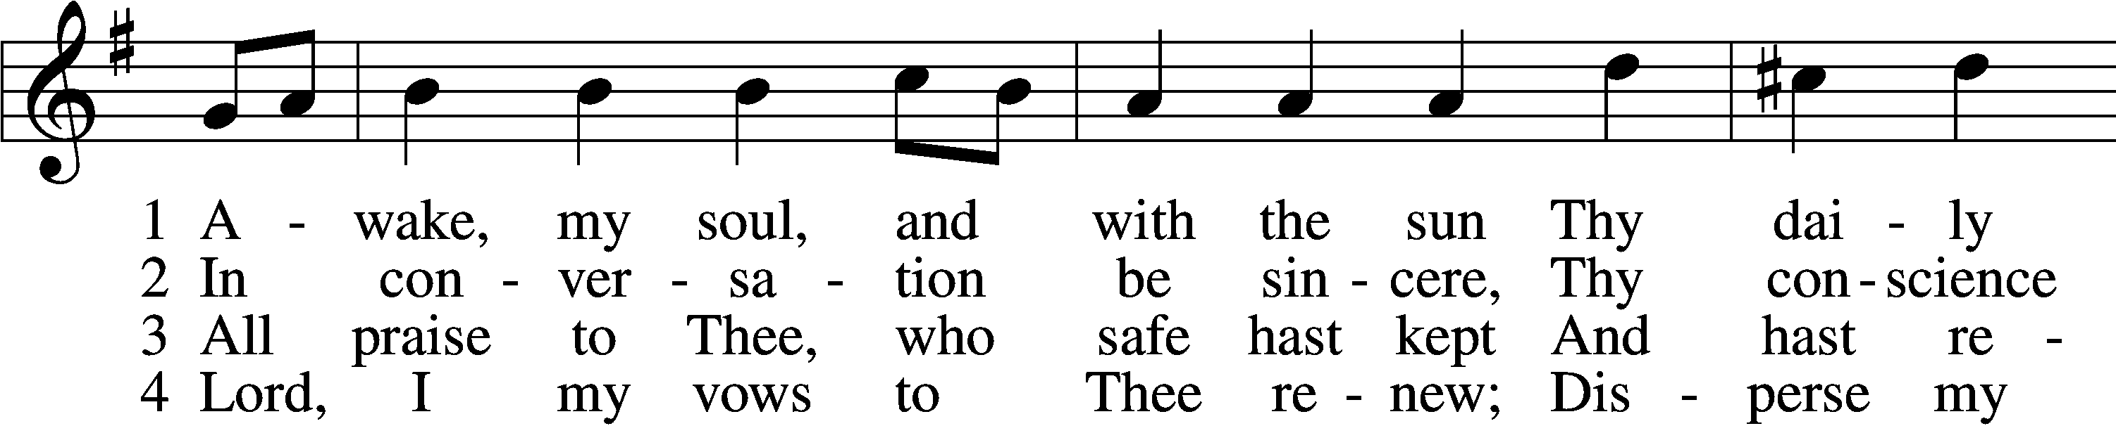
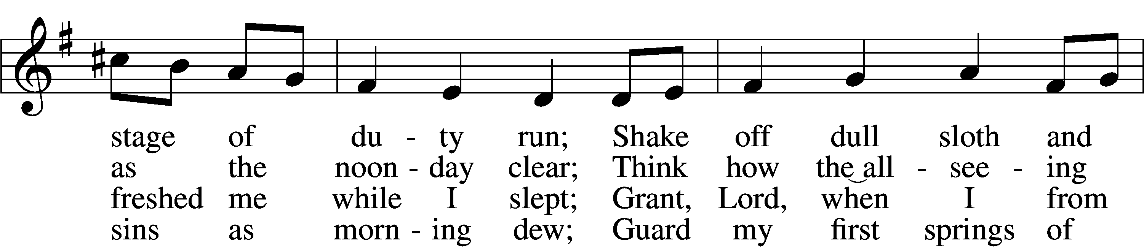
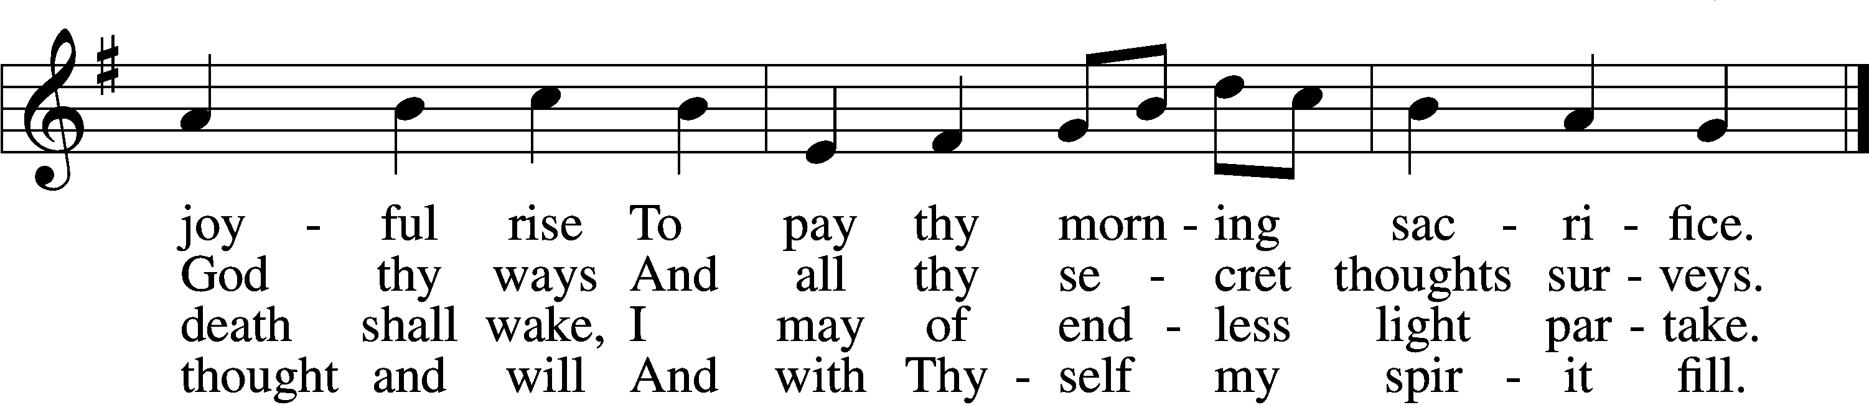

5 Direct, control, suggest this day
All I design or do or say
That all my pow’rs with all their might
In Thy sole glory may unite.

D 6 Praise God, from whom all blessings flow;
Praise Him, all creatures here below;
Praise Him above, ye heav’nly host:
Praise Father, Son, and Holy Ghost.
Tune and text: Public domain

Stand

The sign of the cross T may be made by all in remembrance of their Baptism.

P In the name of the Father and of the T Son and of the Holy Spirit.
C Amen.

P Beloved in the Lord! Let us draw near with a true heart and confess our sins unto God our Father, beseeching Him in the name of our Lord Jesus Christ to grant us forgiveness.

P Our help is in the name of the Lord,
C who made heaven and earth.
P I said, I will confess my transgressions unto the Lord,
C and You forgave the iniquity of my sin.

Silence for reflection on God’s Word and for self-examination.

P O almighty God, merciful Father,
C I, a poor, miserable sinner, confess unto You all my sins and iniquities with which I have ever offended You and justly deserved Your temporal and eternal punishment. But I am heartily sorry for them and sincerely repent of them, and I pray You of Your boundless mercy and for the sake of the holy, innocent, bitter sufferings and death of Your beloved Son, Jesus Christ, to be gracious and merciful to me, a poor, sinful being.

P Upon this your confession, I, by virtue of my office, as a called and ordained servant of the Word, announce the grace of God unto all of you, and in the stead and by the command of my Lord Jesus Christ I forgive you all your sins in the name of the Father and of the T Son and of the Holy Spirit.
C Amen.

+SERVICE OF THE WORD+

Introit Psalm 48:1, 3, 11, 14; antiphon: vv. 9–10
We have thought on your steadfast love, O God,*
in the midst of your temple.
As your name, O God, so your praise reaches to the ends of the earth.*
Your right hand is filled with righteousness.
Great is the Lord and greatly to be praised*
in the city of our God, his holy mountain.
Within her citadels*
God has made himself known as a fortress.
Let Mount Zion be glad!*
Let the daughters of Judah rejoice because of your judgments!
This is God, our God forever and ever.*
He will guide us forever.
Glory be to the Father and to the Son*
and to the Holy Spirit;
as it was in the beginning,*
is now, and will be forever. Amen.
We have thought on your steadfast love, O God,*
in the midst of your temple.
As your name, O God, so your praise reaches to the ends of the earth.*
Your right hand is filled with righteousness.

Kyrie — II LSB 944 sts. 1e–3e
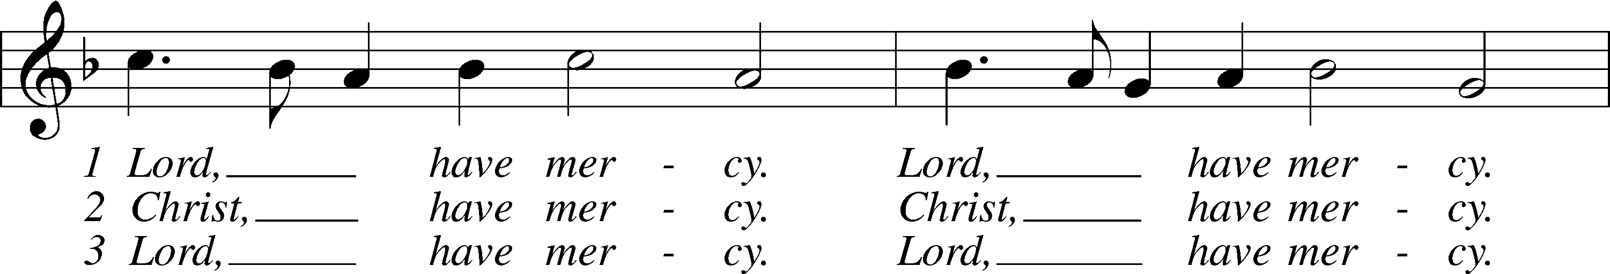
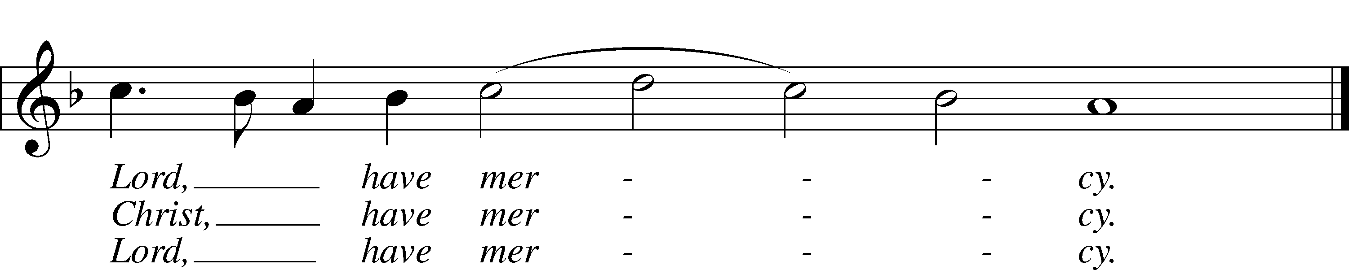
Text and tune: Public domain

Gloria in Excelsis “All Glory Be to God on High” LSB 947
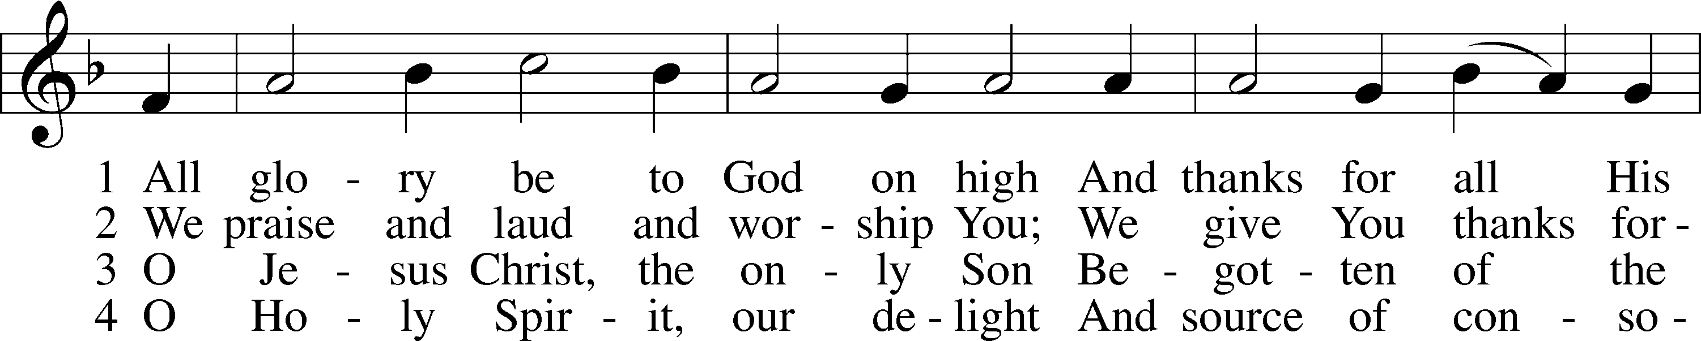
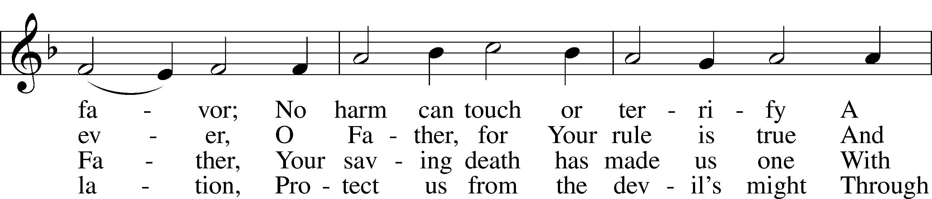
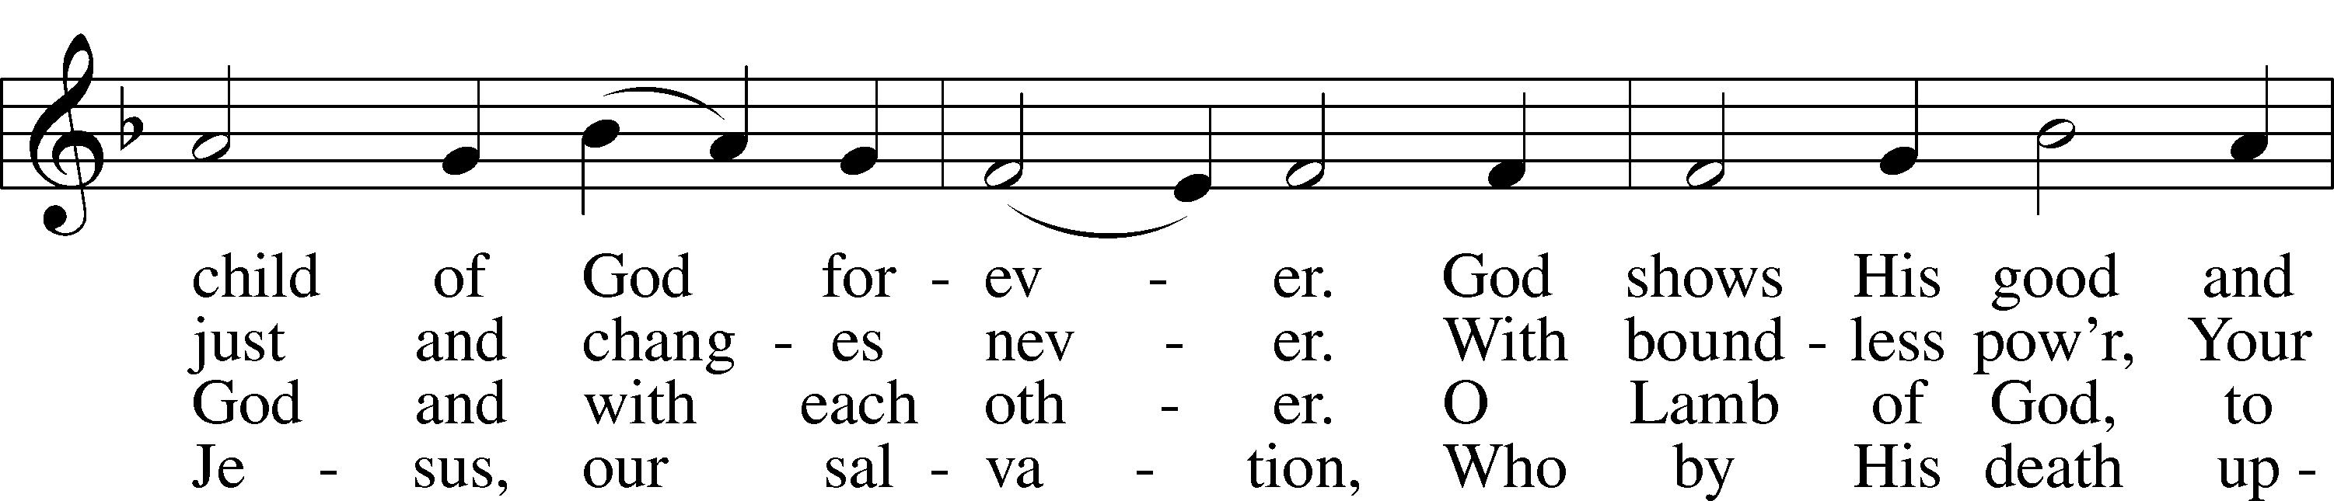
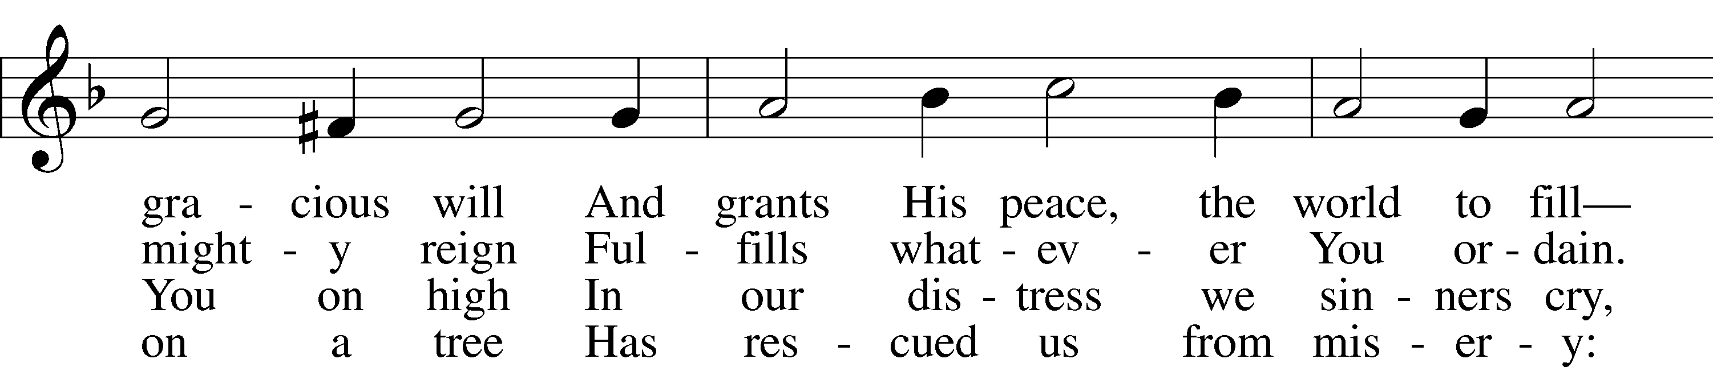
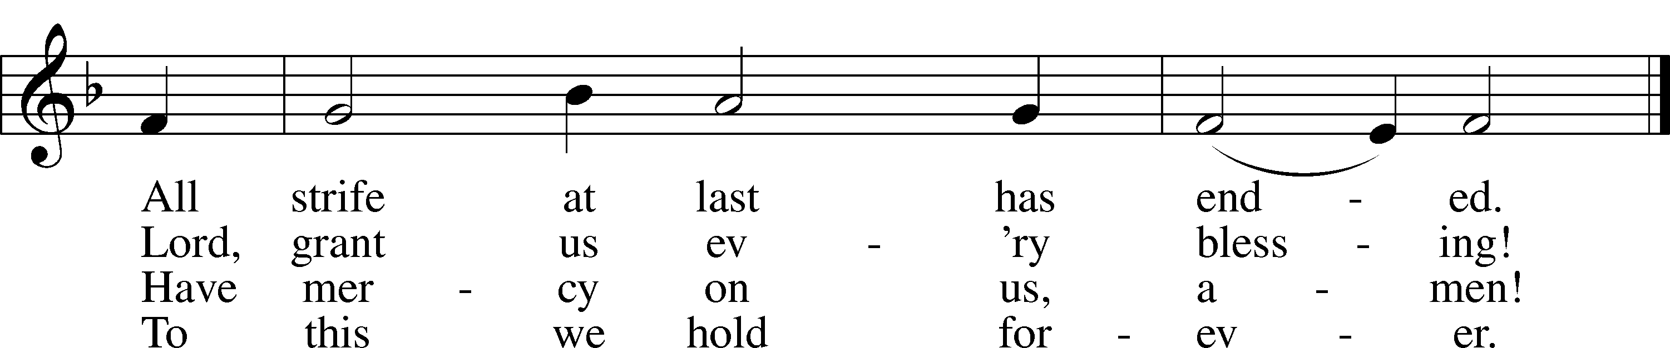
Text: © 2006 Concordia Publishing House. Used by permission: LSB Hymn License no. 110016438
Tune: Public domain

Salutation and Collect of the Day
P The Lord be with you.
C And also with you.

P Let us pray.
C Grant to us, Lord, the Spirit to think and do always such things as are right, that we, who cannot do anything that is good without You, may be enabled by You to live according to Your will; through Jesus Christ, Your Son, our Lord, who lives and reigns with You and the Holy Spirit, one God, now and forever. Amen.

Sit

Old Testament Reading Genesis 9:14–21
¹⁴When I bring clouds over the earth and the bow is seen in the clouds, ¹⁵I will remember my covenant that is between me and you and every living creature of all flesh. And the waters shall never again become a flood to destroy all flesh. ¹⁶When the bow is in the clouds, I will see it and remember the everlasting covenant between God and every living creature of all flesh that is on the earth.” ¹⁷God said to Noah, “This is the sign of the covenant that I have established between me and all flesh that is on the earth.”
¹⁸The sons of Noah who went forth from the ark were Shem, Ham, and Japheth. (Ham was the father of Canaan.) ¹⁹These three were the sons of Noah, and from these the people of the whole earth were dispersed.
²⁰Noah began to be a man of the soil, and he planted a vineyard. ²¹He drank of the wine and became drunk and lay uncovered in his tent.

A This is the Word of the Lord.
C Thanks be to God.

Gradual Lamentations 3:22–24
22The steadfast love of the Lord never ceases;
his mercies never come to an end;
23they are new every morning;
great is your faithfulness.
24“The Lord is my portion,” says my soul,
“therefore I will hope in him.”

Epistle Ephesians 3:14–21
¹⁴For this reason I bow my knees before the Father, ¹⁵from whom every family in heaven and on earth is named, ¹⁶that according to the riches of his glory he may grant you to be strengthened with power through his Spirit in your inner being, ¹⁷so that Christ may dwell in your hearts through faith—that you, being rooted and grounded in love, ¹⁸may have strength to comprehend with all the saints what is the breadth and length and height and depth, ¹⁹and to know the love of Christ that surpasses knowledge, that you may be filled with all the fullness of God.
²⁰Now to him who is able to do far more abundantly than all that we ask or think, according to the power at work within us, ²¹to him be glory in the church and in Christ Jesus throughout all generations, forever and ever. Amen.

A This is the Word of the Lord.
C Thanks be to God.

Hymn of the Day “Let Us Ever Walk with Jesus” LSB 685
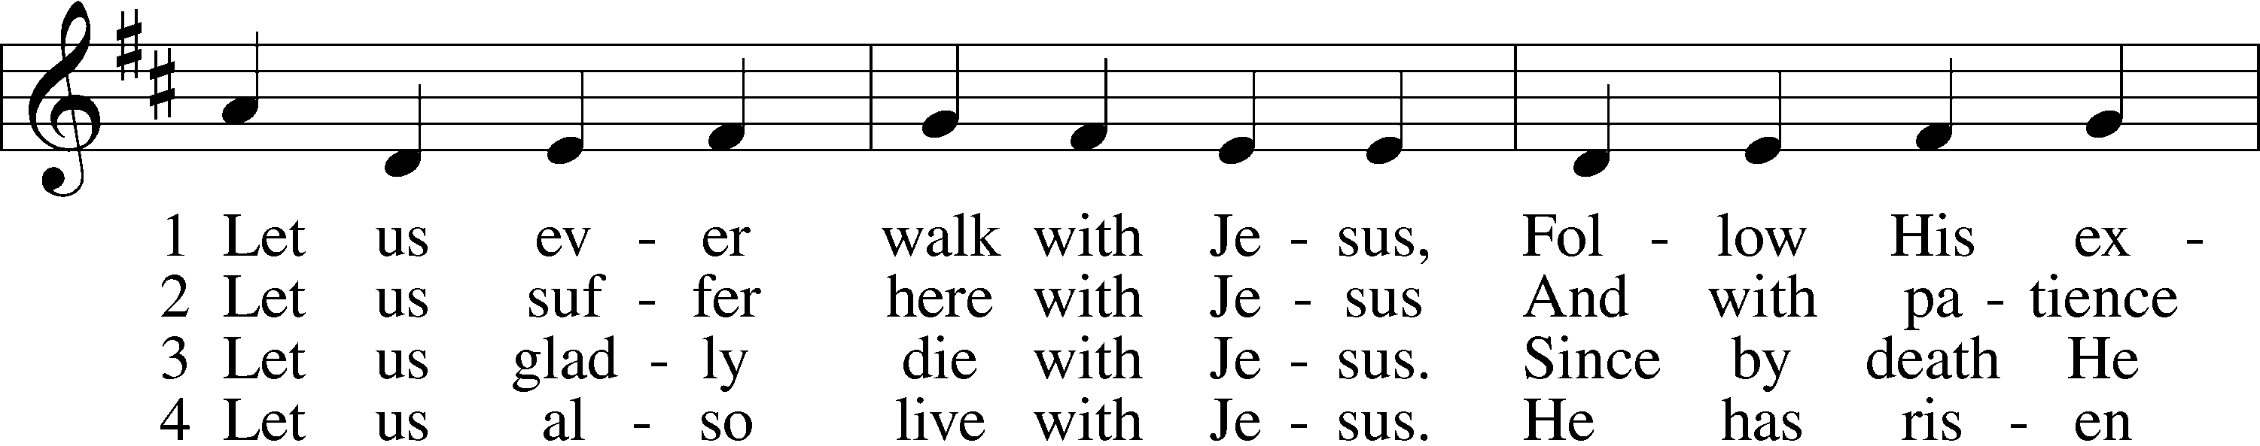
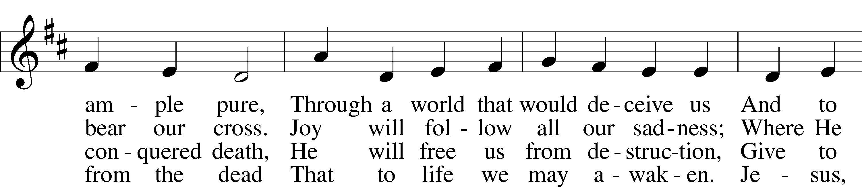
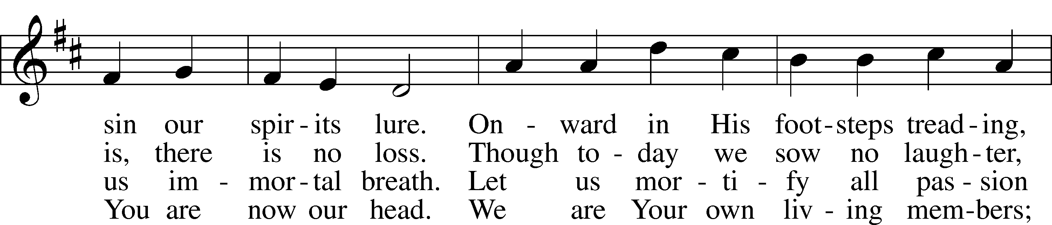
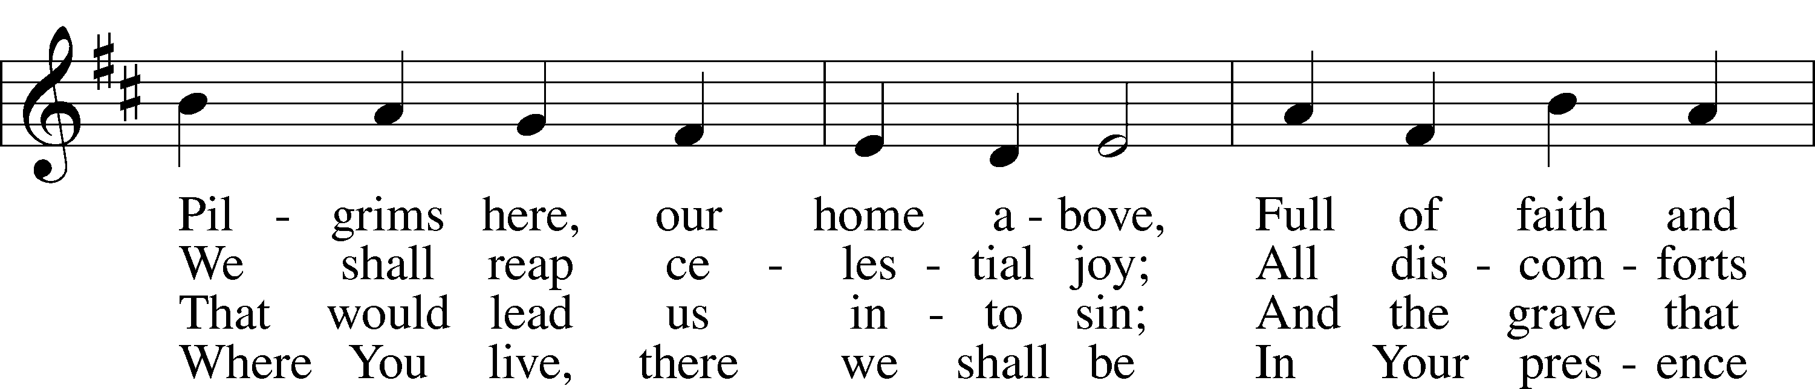
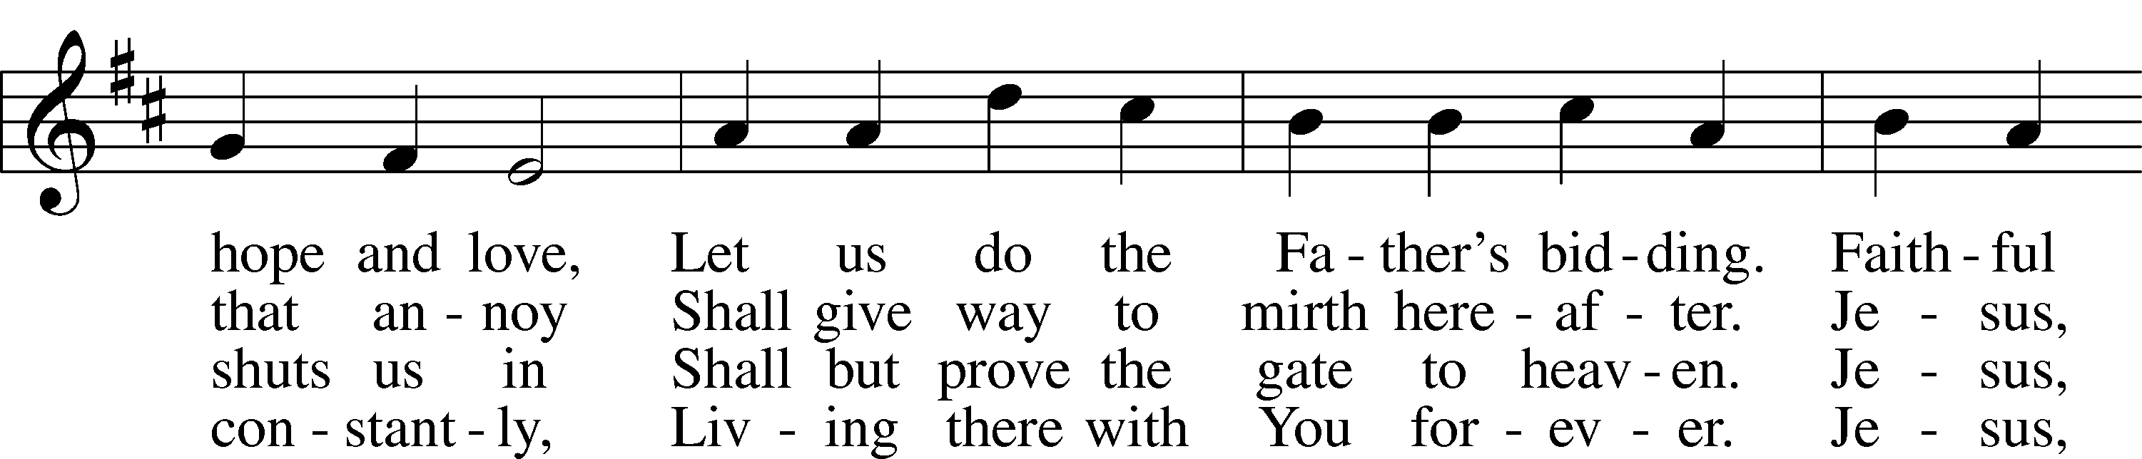
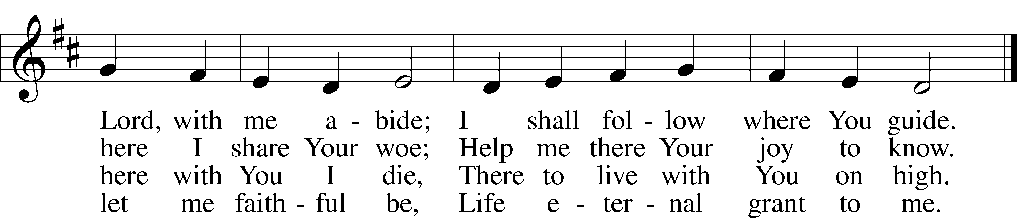
Text: © 1978 Lutheran Book of Worship. Used by permission: LSB Hymn License no. 110016438
Tune: Public domain

Stand

Holy Gospel Mark 6:45–56
P The Holy Gospel according to St. Mark, the sixth chapter.
C Glory to You, O Lord.

⁴⁵Immediately [Jesus] made his disciples get into the boat and go before him to the other side, to Bethsaida, while he dismissed the crowd. ⁴⁶And after he had taken leave of them, he went up on the mountain to pray. ⁴⁷And when evening came, the boat was out on the sea, and he was alone on the land. ⁴⁸And he saw that they were making headway painfully, for the wind was against them. And about the fourth watch of the night he came to them, walking on the sea. He meant to pass by them, ⁴⁹but when they saw him walking on the sea they thought it was a ghost, and cried out, ⁵⁰for they all saw him and were terrified. But immediately he spoke to them and said, “Take heart; it is I. Do not be afraid.” ⁵¹And he got into the boat with them, and the wind ceased. And they were utterly astounded, ⁵²for they did not understand about the loaves, but their hearts were hardened.
⁵³When they had crossed over, they came to land at Gennesaret and moored to the shore. ⁵⁴And when they got out of the boat, the people immediately recognized him ⁵⁵and ran about the whole region and began to bring the sick people on their beds to wherever they heard he was. ⁵⁶And wherever he came, in villages, cities, or countryside, they laid the sick in the marketplaces and implored him that they might touch even the fringe of his garment. And as many as touched it were made well.

P This is the Gospel of the Lord.
C Praise to You, O Christ.

Hymn “We All Believe in One True God” LSB 953
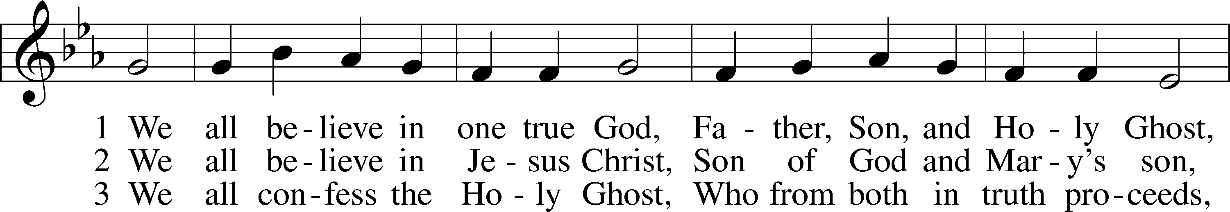
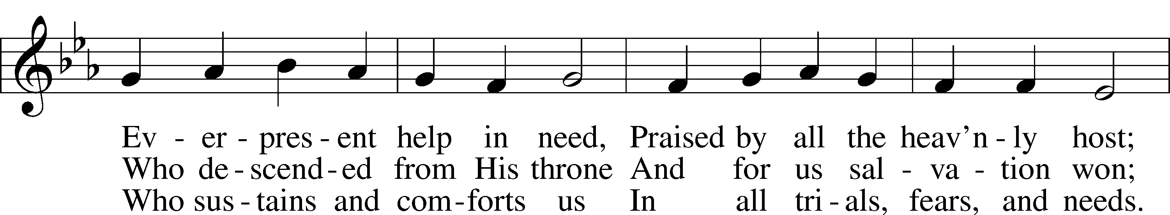
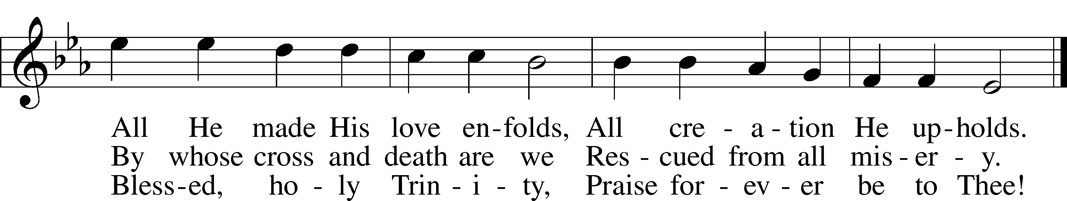
Text and tune: Public domain

Sit

Sermon

Offering

Stand
Prayer of the Church
P Friends in Christ, I urge you all to lift up your hearts to God and pray with me as Christ our Lord has taught us and freely promised to hear us.

God, our Father in heaven, look with mercy on us, Your needy children on earth, and grant us grace that Your holy name be hallowed by us and all the world through the pure and true teaching of Your Word and the fervent love shown forth in our lives. Graciously turn from us all false doctrine and evil living whereby Your precious name is blasphemed and profaned. Lord, in Your mercy,
C hear our prayer.
P May Your kingdom come to us and expand. Bring all transgressors and those who are blinded and bound in the devil’s kingdom to know Jesus Christ, Your Son, by faith that the number of Christians may be increased. Lord, in Your mercy,
C hear our prayer.
P Strengthen us by Your Spirit according to Your will, both in life and in death, in the midst of both good and evil things, that our own wills may be crucified daily and sacrificed to Your good and gracious will. Into Your merciful hands we commend [name(s)] and all who are in need, praying for them at all times: Thy will be done. Lord, in Your mercy,
C hear our prayer.
P Grant us our daily bread, preserve us from greed and selfish cares, and help us trust in You to provide for all our needs. Lord, in Your mercy,
C hear our prayer.
P Forgive us our sins as we also forgive those who sin against us so that our hearts may be at peace and may rejoice in a good conscience before You, and that no sin may ever frighten or alarm us. Lord, in Your mercy,
C hear our prayer.
P Lead us not into temptation, O Lord, but help us by Your Spirit to subdue our flesh, to turn from the world and its ways, and to overcome the devil with all his wiles. Lord, in Your mercy,
C hear our prayer.
P And lastly, O heavenly Father, deliver us from all evil of both body and soul, now and forever. Lord, in Your mercy,
C hear our prayer.
P We trust, O Lord, in Your great mercy to hear and answer us; through Jesus Christ, our Lord.
C Amen.

+SERVICE OF THE SACRAMENT+

Preface LSB 216
P The Lord be with you.
C And also with you.

P Lift up your hearts.
C We lift them to the Lord.

P Let us give thanks to the Lord our God.
C It is right to give Him thanks and praise.

P It is truly good, right, and salutary that we should at all times and in all places give thanks to You, O Lord our God, king of all creation, for You have had mercy on us and given Your only-begotten Son that whoever believes in Him should not perish but have eternal life. Grant us Your Spirit, gracious Father, that we may give heed to the testament of Your Son in true faith and, above all, firmly take to heart the words with which Christ gives to us His body and blood for our forgiveness. By Your grace, lead us to remember and give thanks for the boundless love which He manifested to us when, by pouring out His precious blood, He saved us from Your righteous wrath and from sin, death, and hell. Grant that we may receive the bread and wine, that is, His body and blood, as a gift, guarantee, and pledge of His salvation. Graciously receive our prayers; deliver and preserve us. To You alone, O Father, be all glory, honor, and worship, with the Son and the Holy Spirit, one God, now and forever.
C Amen.

Lord’s Prayer
C Our Father who art in heaven,
hallowed be Thy name,
Thy kingdom come,
Thy will be done on earth
as it is in heaven;
give us this day our daily bread;
and forgive us our trespasses
as we forgive those
who trespass against us;
and lead us not into temptation,
but deliver us from evil.
For Thine is the kingdom
and the power and the glory
forever and ever. Amen.

P In the name of our Lord and Savior Jesus Christ, at His command, and with His own words, we receive His testament:

The Words of Our Lord LSB 217
P Our Lord Jesus Christ, on the night when He was betrayed, took bread, and when He had given thanks, He broke it and gave it to the disciples and said: “Take, eat; this is My T body, which is given for you. This do in remembrance of Me.”

In the same way also He took the cup after supper, and when He had given thanks, He gave it to them, saying: “Drink of it, all of you; this cup is the new testament in My T blood, which is shed for you for the forgiveness of sins. This do, as often as you drink it, in remembrance of Me.”

Sanctus LSB 161
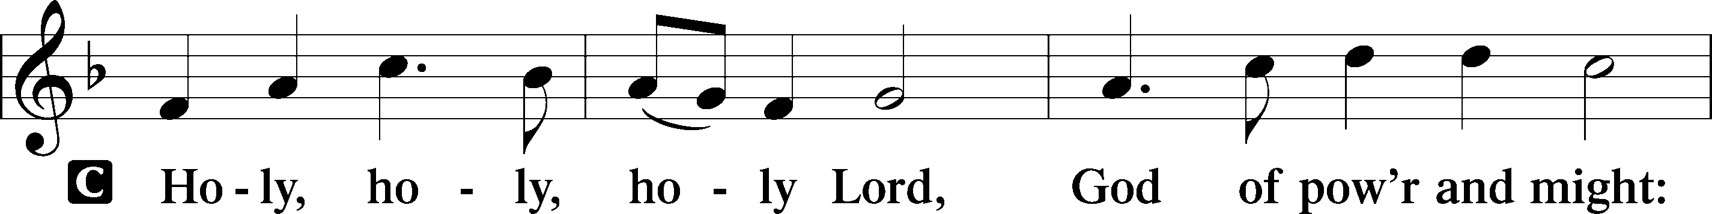
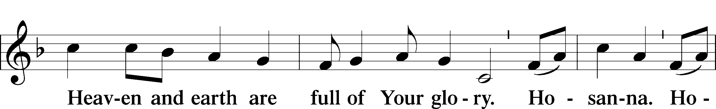
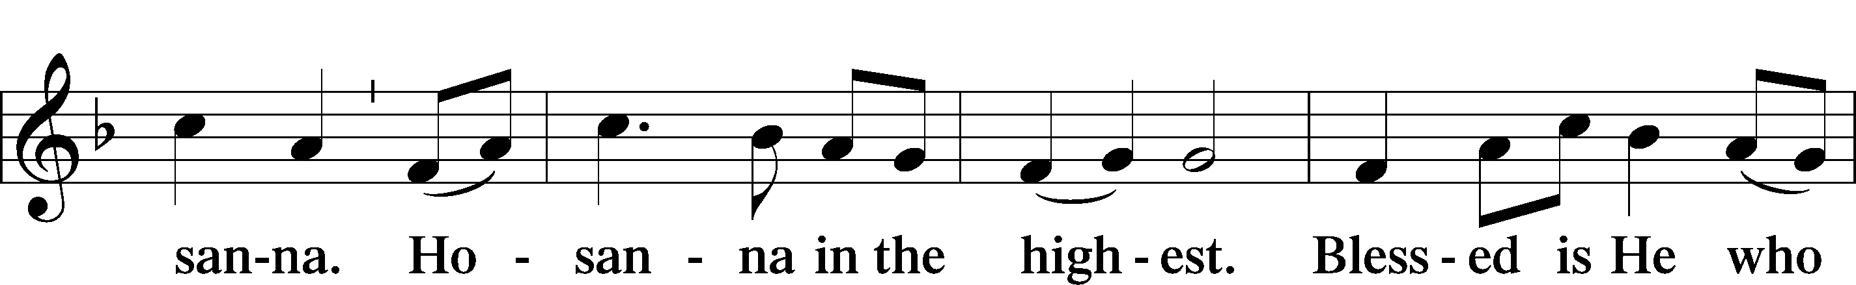
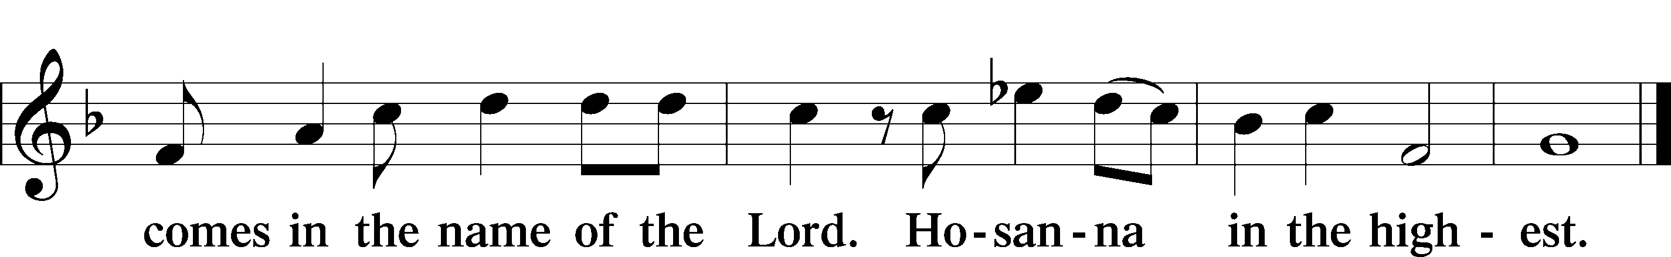

Pax Domini
P The peace of the Lord be with you always.
C Amen.

Hymn “The Lamb” LSB 547 sts. 1, ref, 2
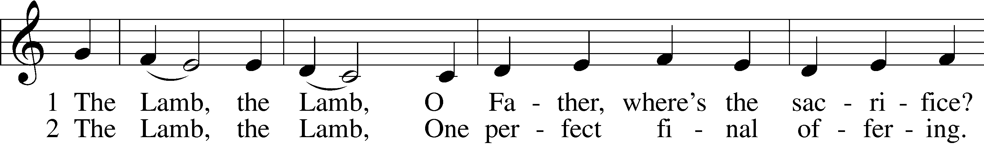
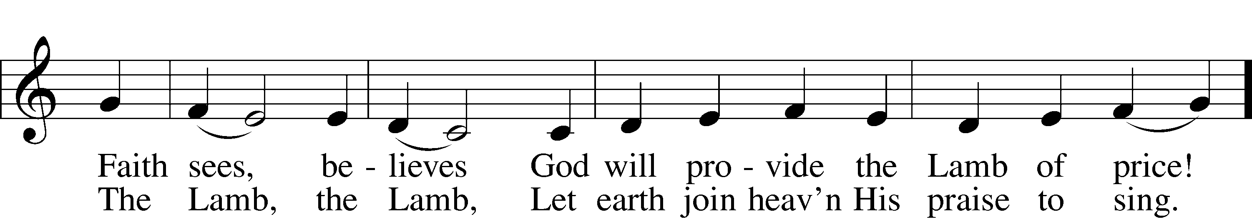
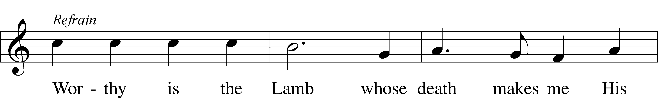
Text and tune: © 1987 and 1997 MorningStar Music Publishers. Used by permission: LSB Hymn License no. 110016438

Sit

Distribution

Distribution Hymn “The Lamb” LSB 547 sts. ref, 3–5
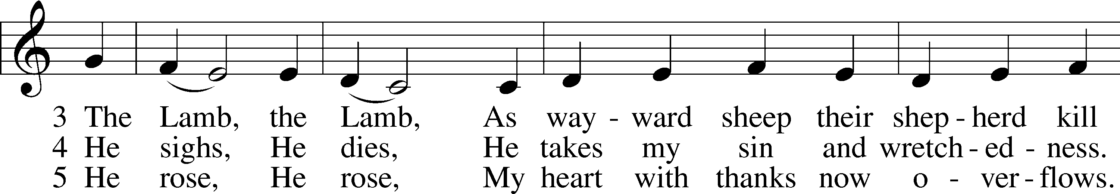
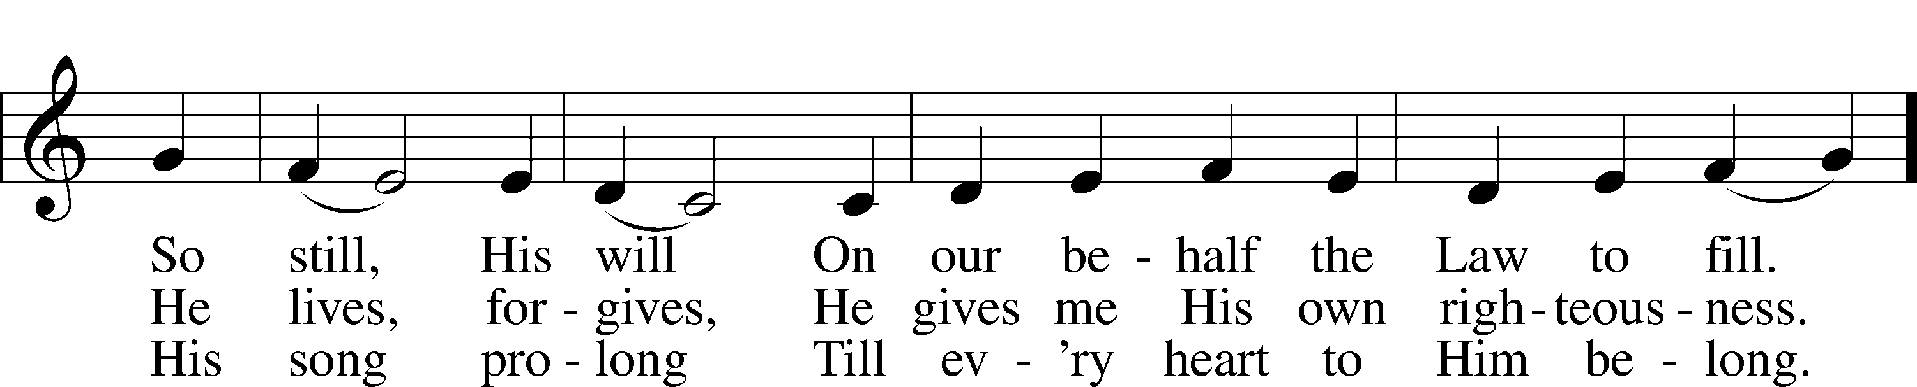
Text and tune: © 1987 and 1997 MorningStar Music Publishers. Used by permission: LSB Hymn License no. 110016438

Distribution Hymn “I Come, O Savior, to Thy Table” LSB 618
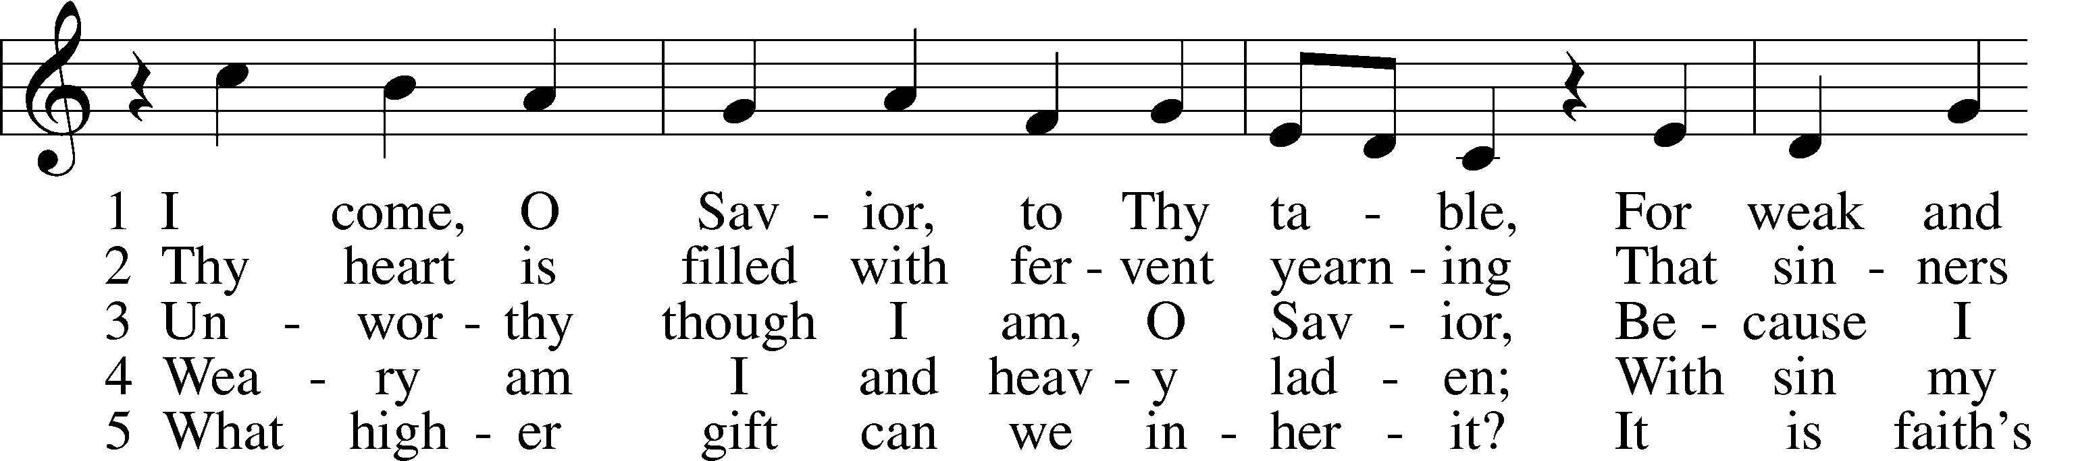
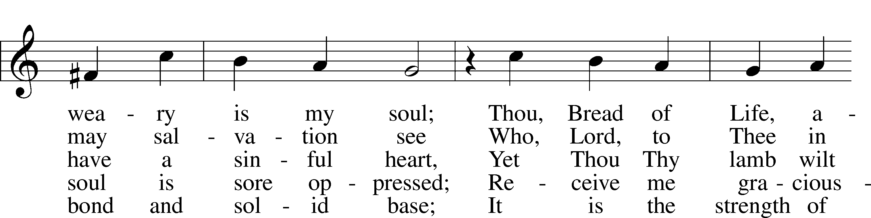
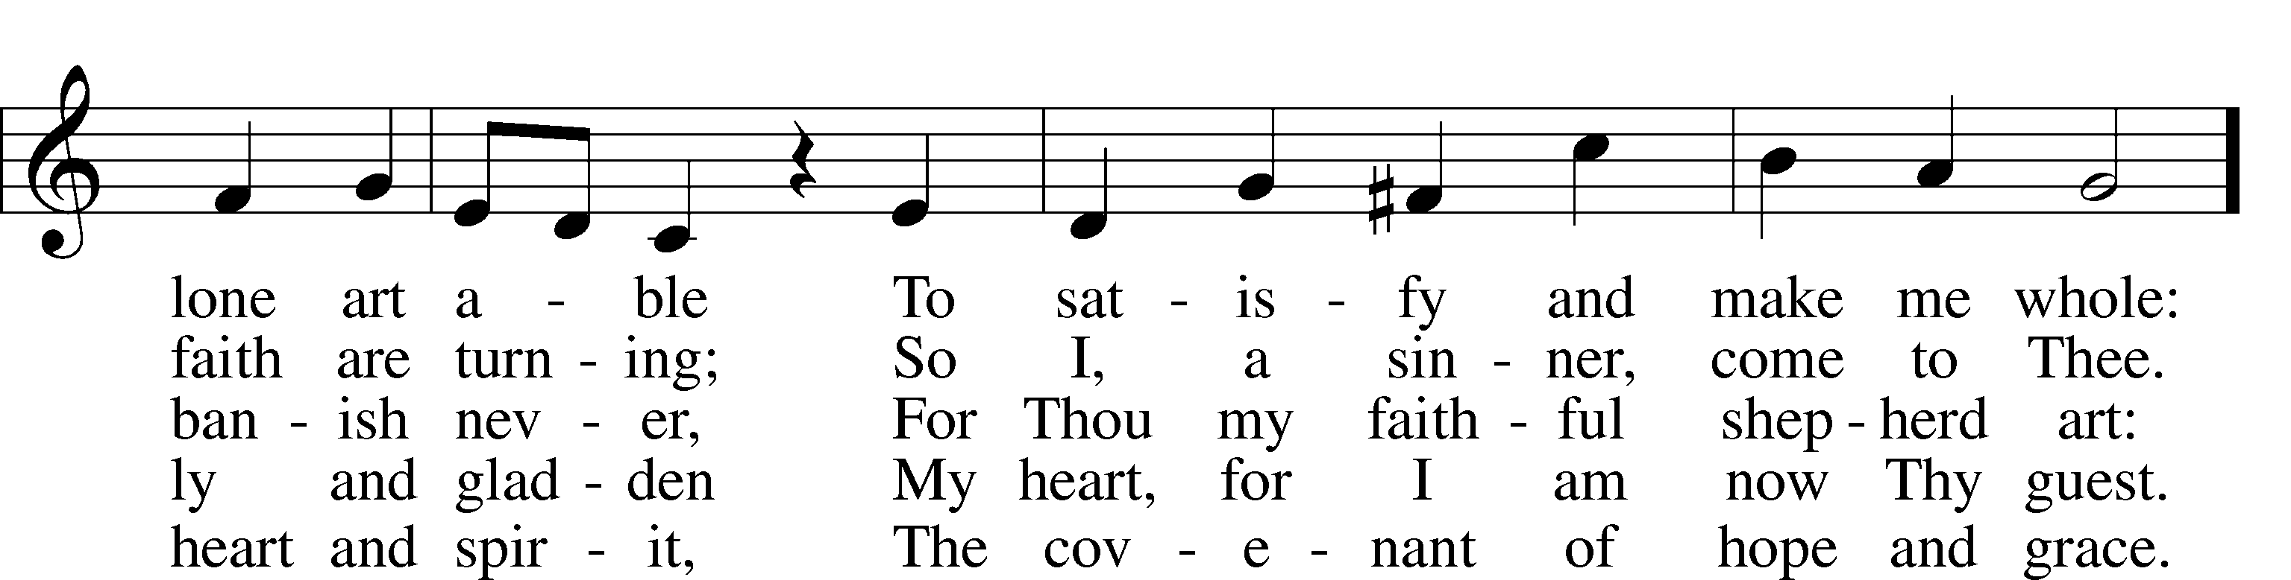
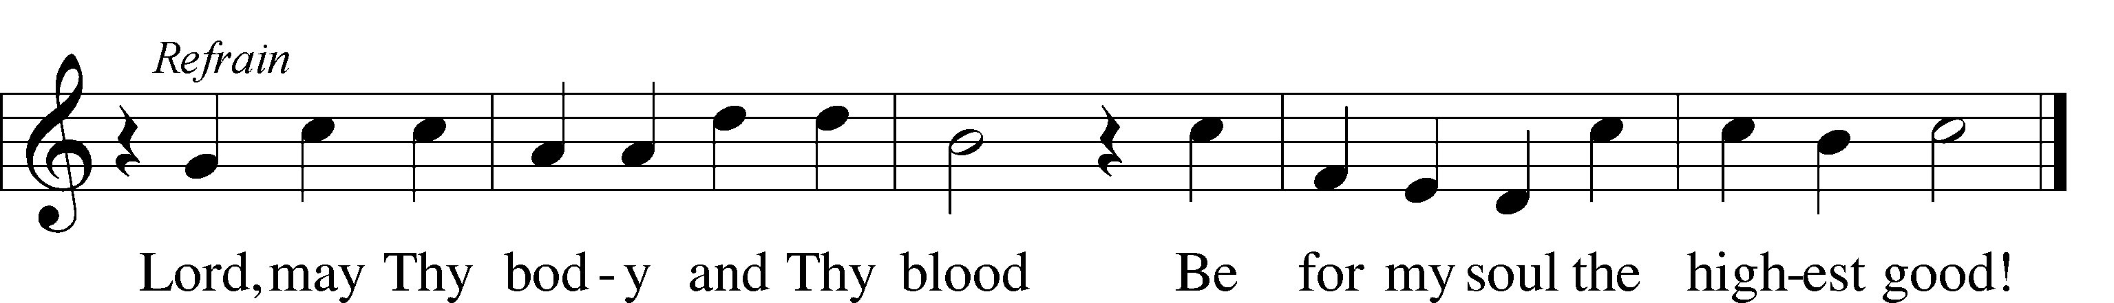
Tune: Public domain
Text: © 1941 Concordia Publishing House. Used by permission: LSB Hymn License no. 110016438

Stand

Hymn “May God Bestow on Us His Grace” LSB 824
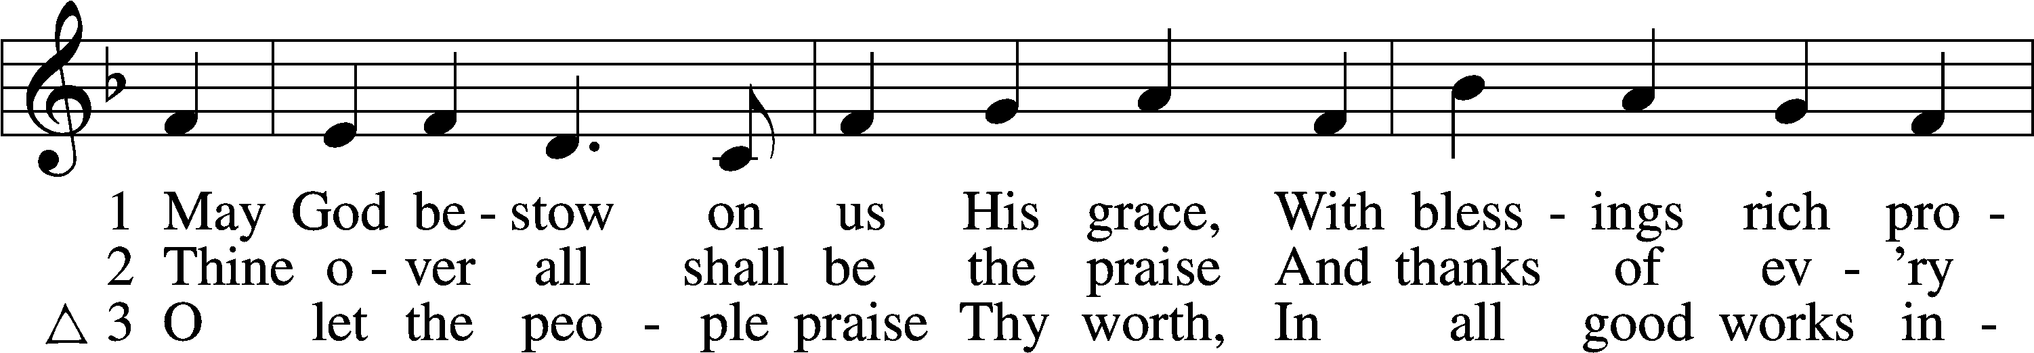
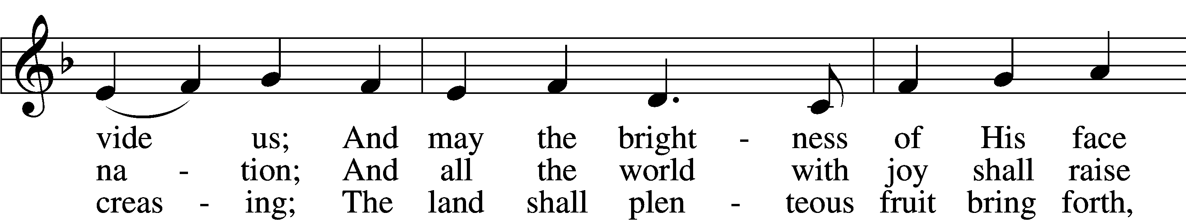
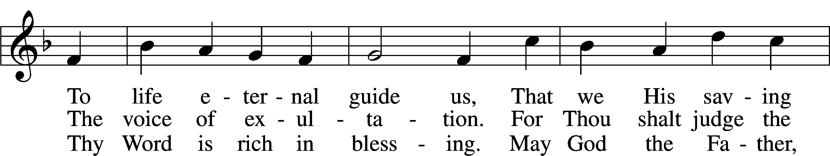
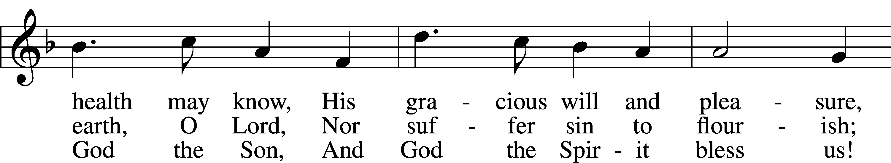
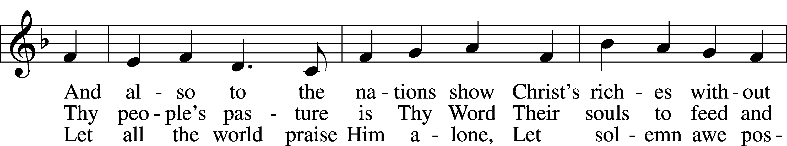
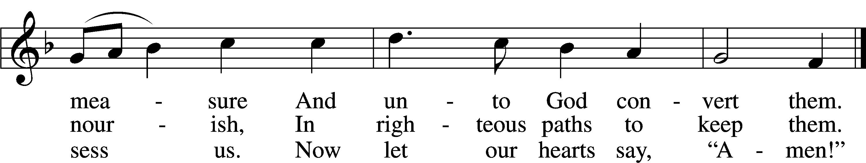
Tune: © 2004 David Lee. Used by permission: LSB Hymn License no. 110016438
Text: Public domain

Post-Communion Collect
A Let us pray.
We give thanks to You, almighty God, that You have refreshed us through this salutary gift, and we implore You that of Your mercy You would strengthen us through the same in faith toward You and in fervent love toward one another; through Jesus Christ, Your Son, our Lord, who lives and reigns with You and the Holy Spirit, one God, now and forever.
C Amen.

Benedicamus LSB 218
A Let us bless the Lord.
C Thanks be to God.

Benediction
P The Lord bless you and keep you.
The Lord make His face shine on you and be gracious to you.
The Lord look upon you with favor and T give you peace.
C Amen.

Closing Hymn “Praise the One Who Breaks the Darkness” LSB 849
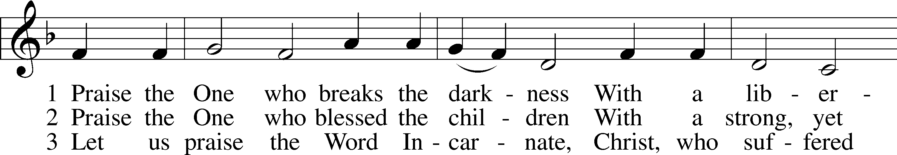
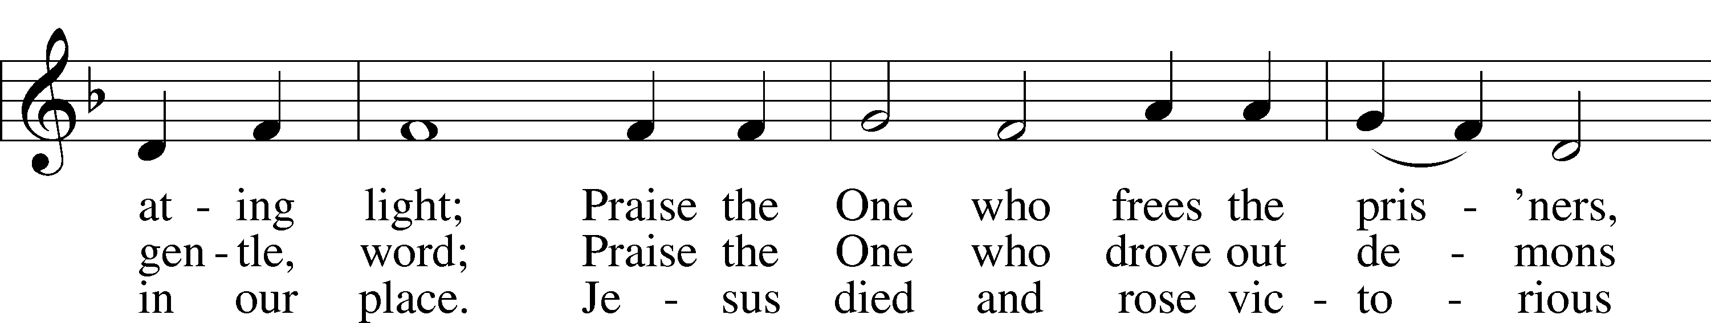
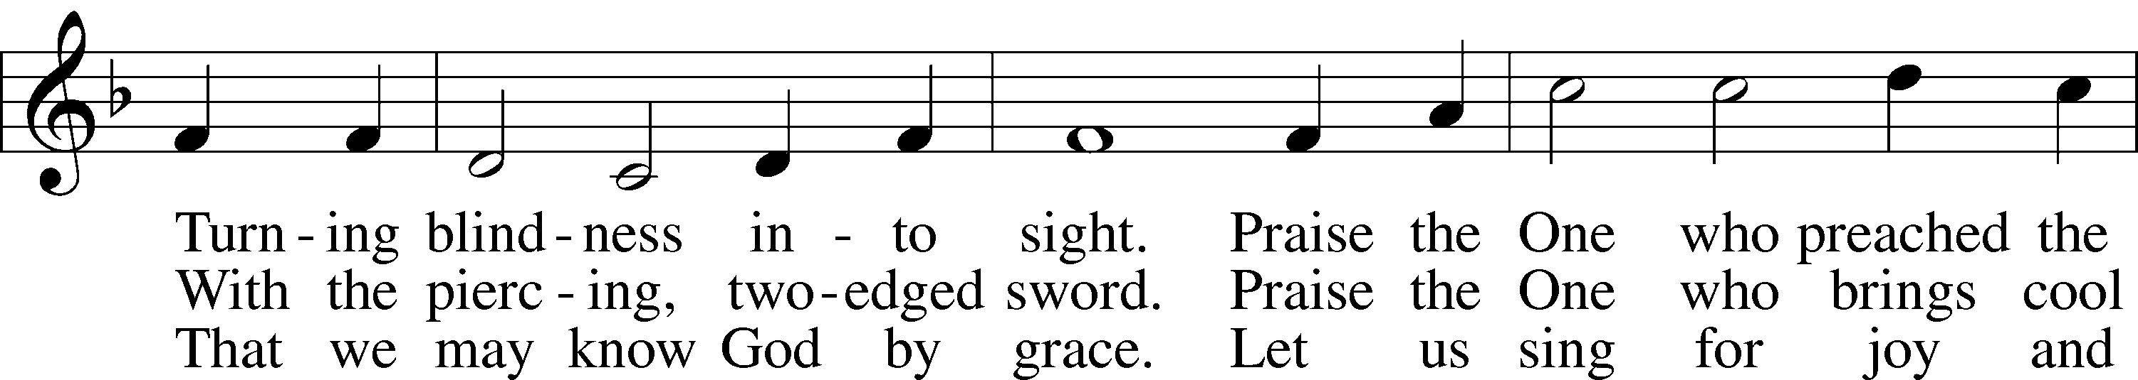
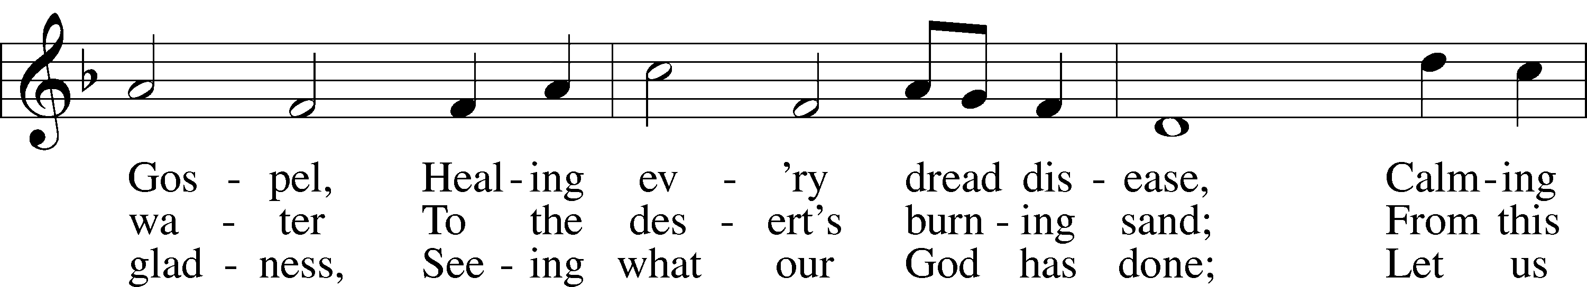
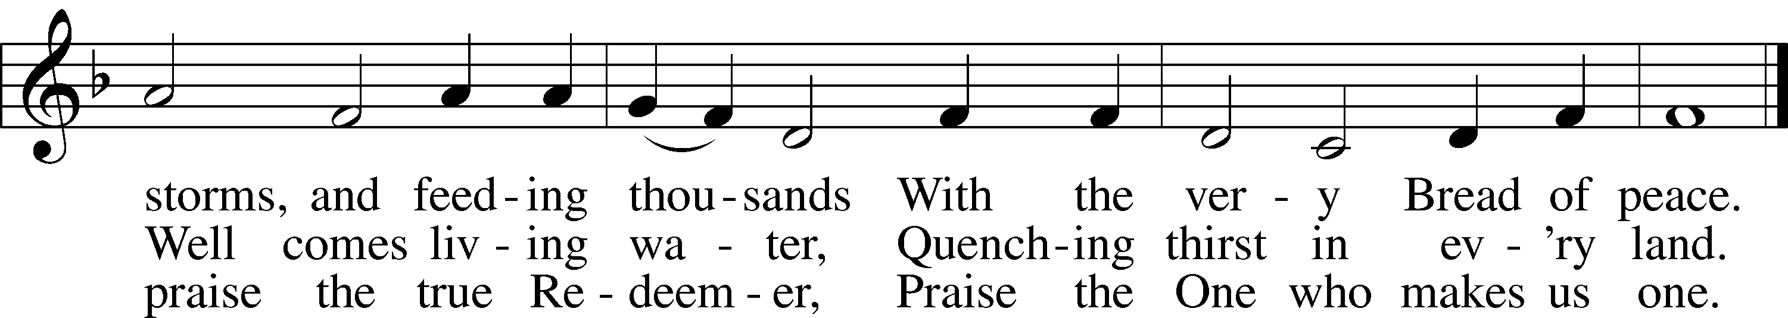
Tune: Public domain
Text: © 1987 Hope Publishing Co. Used by permission: LSB Hymn License no. 110016438

Acknowledgments
Divine Service, Setting Five from Lutheran Service Book
Unless otherwise indicated, Scripture quotations are from the ESV® Bible (The Holy Bible, English Standard Version®), copyright © 2001 by Crossway, a publishing ministry of Good News Publishers. Used by permission. All rights reserved.
Created by Lutheran Service Builder © 2021 Concordia Publishing House.

Serving Our Lord in His House Today:
Pastor: Rev. James Cumming
Organist: Rebecca Moseley
Elders: Josh Church & Jerry Ecker
Joe Engel (Wednesday)
Greeters: Tom & Cathy Salzwedel

Gifts from God: Ephesians 3:20 – “Now to him who is able to do far more abundantly than all that we ask or think …” We often shortchange God by failing to remember what Paul says here: God can do far more than what we can think or ask. His power, and His love, are without bound and without measure. So why do we fear to follow His word? Isn’t it in fact fear that keeps us back from a life of joyous generosity and open-handedness? But God is able to do far more abundantly! So let us not be afraid to take the Lord at his Word and live according to it.

Altar Flowers: Are placed today by Tom and Cathy Salzwedel in celebration of their 43rd wedding anniversary. May God continue to bless your marriage.

VBS-The Lord’s Army: VBS starts next Sunday, August 1, 2021 for 5 fun nights! Plan to join us Sunday, August 1-Thursday, August 5. Registration opens at 5:30 pm, VBS begins at 6:00 pm- 8:00 pm. No supper beforehand this year.

VBS Work Night: We will have another work night Thursday, July 29, 2021 beginning at 6:00pm.

Usher Volunteers: A calling to the men of our congregation! The Elders are looking for volunteers who are willing to be an usher during our worship services. Being an usher is a great way to be involved with our worship services and is a great service to our Lord. The goal at this time is to recruit enough men to setup usher teams that will be assigned to specific weekends on the church calendar. Please sign-up on the easel board in the narthex or let an elder know that you are interested!

Sunday morning Greeters: We are looking for members to serve the church on Sunday morning by being a Greeter. It is a BLESSING to meet all those worshipping, guests and members alike! Call Sylvia Engel at 608-343-9645 if you would be interested in participating in this Hospitality Ministry or have any questions.

Offering Statements: The mid-year offering statements have been placed in your church mailbox for pick-up. If you have questions, or notice any discrepancies, please contact the financial secretary, Linda Ecker at 254-630-5620.

Volunteers Needed: Good Shepherd will be participating in the Downtown Thursday Nights from July 1-August 12. Toro has paid the fees for the booth, but we need volunteers to help run the booth. What a wonderful opportunity to get our church’s name out in the community! The booth will be located in the kid’s area, near the bounce house. We will be selling kid friendly treats. There is a sign-up roster on the easel in the Narthex. Please contact Lorna Rosenow with any questions at 608-372-6584.

Livestream: Our Sunday Service is livestreamed weekly on our YouTube channel “Good Shepherd Lutheran Church Tomah.”

Hymnals: If you would like to use a Hymnal at home, you can sign one out from church. We also have free devotion pamphlets and Portals of Prayer.

PO Box: For mailed offerings, please use the following:
Good Shepherd Lutheran Church
P.O. Box 551
Tomah, WI. 54660

Our Worship attendance last week: Sunday: 48
Wednesday: 6
Total: 54

Scripture Lessons for next week: 2 Samuel 22:26-34
1 Corinthians 10:6-13
Luke 16:1-9

Secretary Office Hours: Monday-Friday: 8am-12pm
Our Week With Our Lord:
Today 9:00am Divine Service w/Holy Communion
(livestreamed via YouTube)
10:30am Adult Bible Study
Monday
Tuesday 2:00pm Ladies Bible Study @church
6:30pm Church Softball @Buds Field
Wednesday 5:00pm Service of Prayer and Preaching 7:00pm Women’s Bible Study – “Chosen”
Thursday 9:30am-11:00am Little Lambs @The Inclusion Park
5:00pm-9:00pm Downtown Thursday Nights
6:00 pm VBS Work Night
Friday
Saturday
Sunday 9:00am Divine Service w/Holy Communion
(livestreamed via YouTube)
10:30am Adult Bible Study

*Please view following page for weekly prayers*

HIS FLOCK AT PRAYER
Propers for the Eighth Week after Trinity

Psalm for the Week: Psalm 26

Daily Scripture Readings:
Sunday—Mark 6:45-56 Thursday—1 John 4:1-4
Monday— Matthew 7:12-14 Friday—Micah 3:5-12
Tuesday—Romans 4:1-8 Saturday— 1 Timothy 6:13-21
Wednesday—Ezekiel 3:17-21

Collect for the Week:
Grant to us, Lord, the Spirit to think and do always such things as are right, that we, who cannot do anything that is good without You, may be enabled by You to live according to Your will; through Jesus Christ, Your Son, our Lord, who lives and reigns with You and the Holy Spirit, one God, now and forever.

Hymn of the Week: “Let Us Ever Walk with Jesus” LSB 685

Congregational Petitions for this Week:
+ For those who are ill or recovering, especially: Brenda Kolb, Paula Sopel,
Shawn Zabinski, Karen Griggel, Margaret Palmer, Ladene Zabinski,
Carrie Wilbanks, Cindy Gluch, Payton Pierce, Kathy Berg, Isaiah Mallmann,
Joan Oswald, Marie Drescher, Les Hackett, Joyce Pulley, Tom Coman,
Kelly Ingenthron, Jean Salzman, Gary Salzman, Peter Benjamin, Ruth Heller.
+ For those who are mourning the loss of a loved one:
Ruby Schmidt, family and friends, at the loss of Alyce Herbison, Ruby’s
sister-in-law
+ For those who are home-bound, especially: John Fox, Darlene Griffin,
Al Mansfield, Virginia Tillman, Linda Goad, Roemelle McArdle,
Sharon Herried.
+ For those who serve in the military, especially: Isaac Preuss, Tania Adler,
Joshua Ecker.

