Good Shepherd Lutheran Church
Sixth Sunday of Easter
May 14, 2023

Pre-Service Music & Welcome
Divine Service Setting One – Lutheran Service Book (LSB) 151

+CONFESSION AND ABSOLUTION+

Opening Hymn “Christ the Lord Is Risen Today” LSB 469
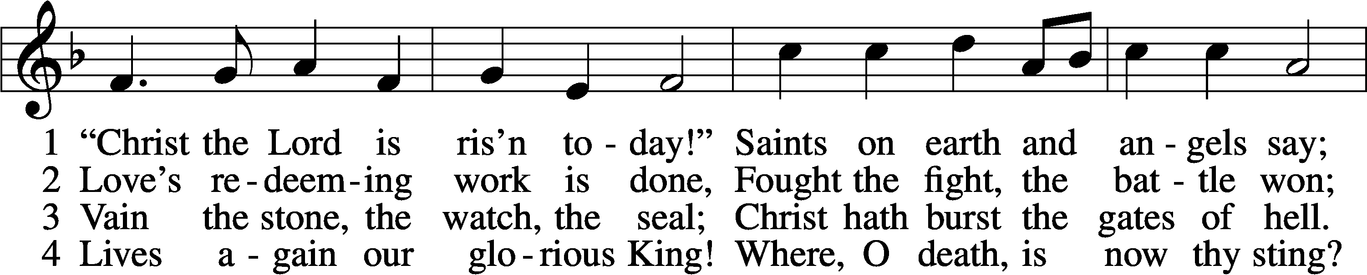
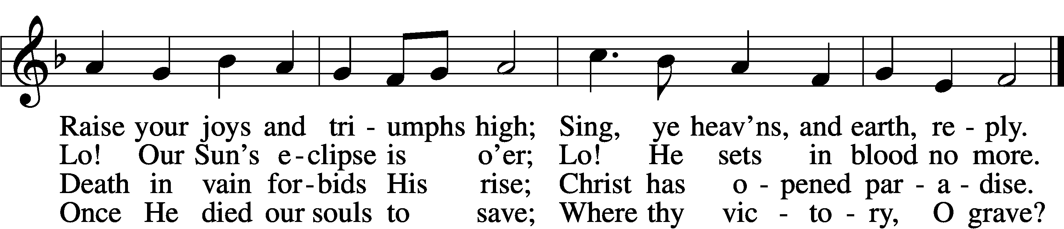

5 Soar we now where Christ has led;
Foll’wing our exalted Head.
Made like Him, like Him we rise;
Ours the cross, the grave, the skies.

6 Hail the Lord of earth and heav’n!
Praise to Thee by both be giv’n!
Thee we greet triumphant now:
Hail, the resurrection, Thou!
Text: Charles Wesley, 1707–88, alt.
Tune: French, 13th cent.
Text and tune: Public domain

Stand

The sign of the cross T may be made by all in remembrance of their Baptism.

Invocation
P In the name of the Father and of the T Son and of the Holy Spirit.
C Amen.

Exhortation LSB 151
P If we say we have no sin, we deceive ourselves, and the truth is not in us.
C But if we confess our sins, God, who is faithful and just, will forgive our sins and cleanse us from all unrighteousness.

Silence for reflection on God’s Word and for self-examination.

Confession of Sins LSB 151
P Let us then confess our sins to God our Father.
C Most merciful God, we confess that we are by nature sinful and unclean. We have sinned against You in thought,
word, and deed, by what we have done and by what we have left undone. We have not loved You with our whole heart;
we have not loved our neighbors as ourselves. We justly deserve Your present and eternal punishment. For the sake of Your Son, Jesus Christ, have mercy on us. Forgive us, renew us, and lead us, so that we may delight in Your will and walk in Your ways to the glory of Your holy name. Amen.

Absolution LSB 151
P Almighty God in His mercy has given His Son to die for you and for His sake forgives you all your sins. As a called and ordained servant of Christ, and by His authority, I therefore forgive you all your sins in the name of the Father and of the T Son and of the Holy Spirit.
C Amen.

+SERVICE OF THE WORD+

Introit Psalm 119:89–93; antiphon: v. 105
Your word is a lamp to my feet
and a light to my path.
Forever, O Lord, your word
is firmly fixed in the heavens.
Your faithfulness endures to all generations;
you have established the earth, and it stands fast.
By your appointment they stand this day,
for all things are your servants.
If your law had not been my delight,
I would have perished in my affliction.
I will never forget your precepts,
for by them you have given me life.
Glory be to the Father and to the Son
and to the Holy Spirit;
as it was in the beginning,
is now, and will be forever. Amen.
Your word is a lamp to my feet
and a light to my path.

Kyrie LSB 152
A In peace let us pray to the Lord.
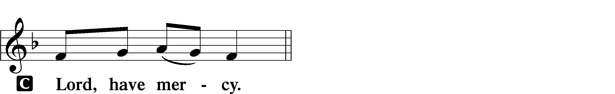

A For the peace from above and for our salvation let us pray to the Lord.
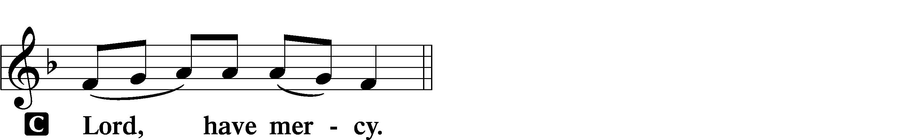

A For the peace of the whole world, for the well-being of the Church of God, and for the unity of all let us pray to the Lord.
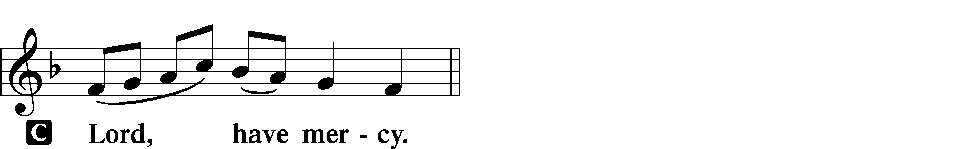

A For this holy house and for all who offer here their worship and praise let us pray to the Lord.
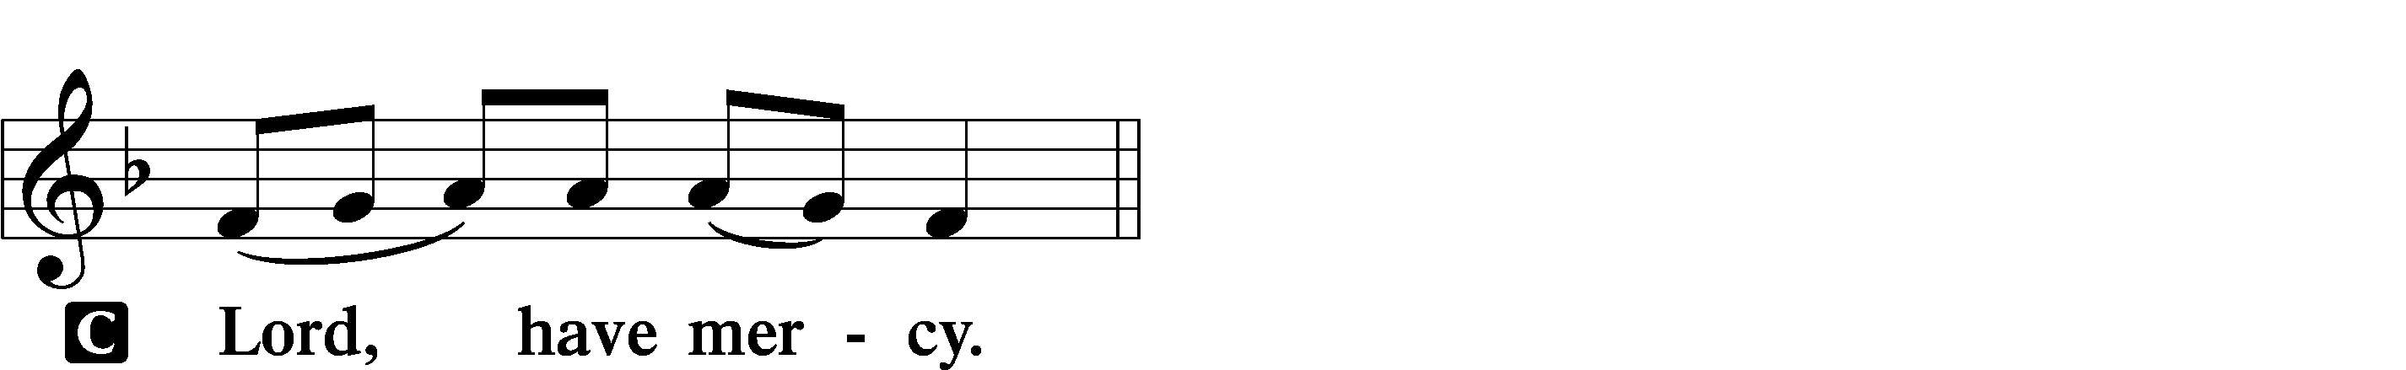

A Help, save, comfort, and defend us, gracious Lord.
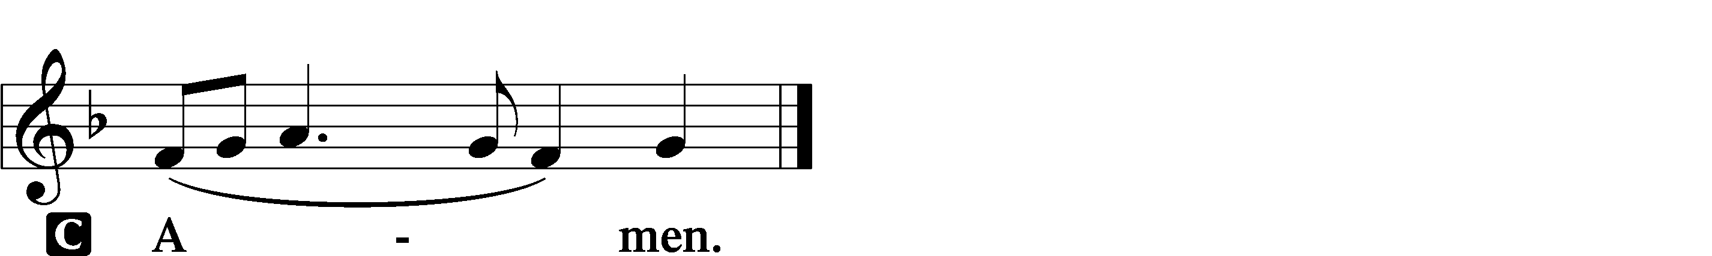

This Is the Feast LSB 155
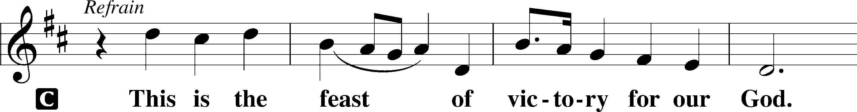
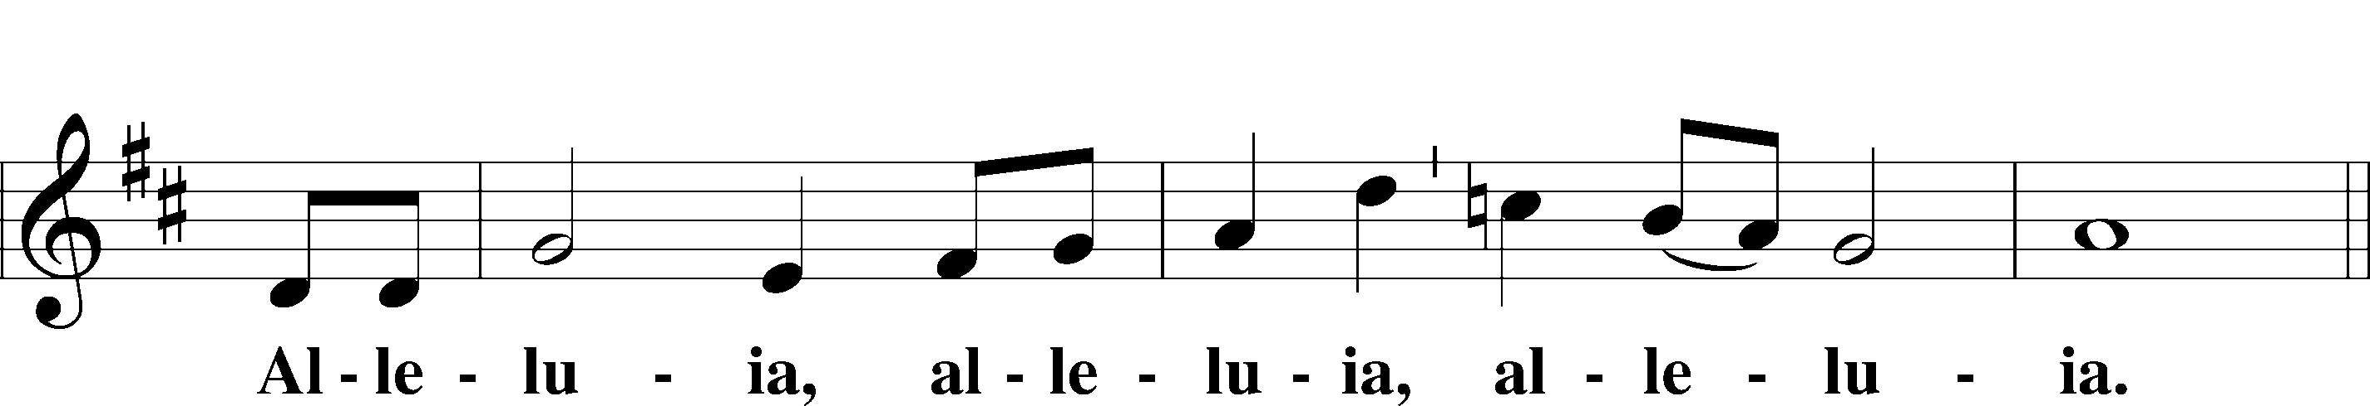
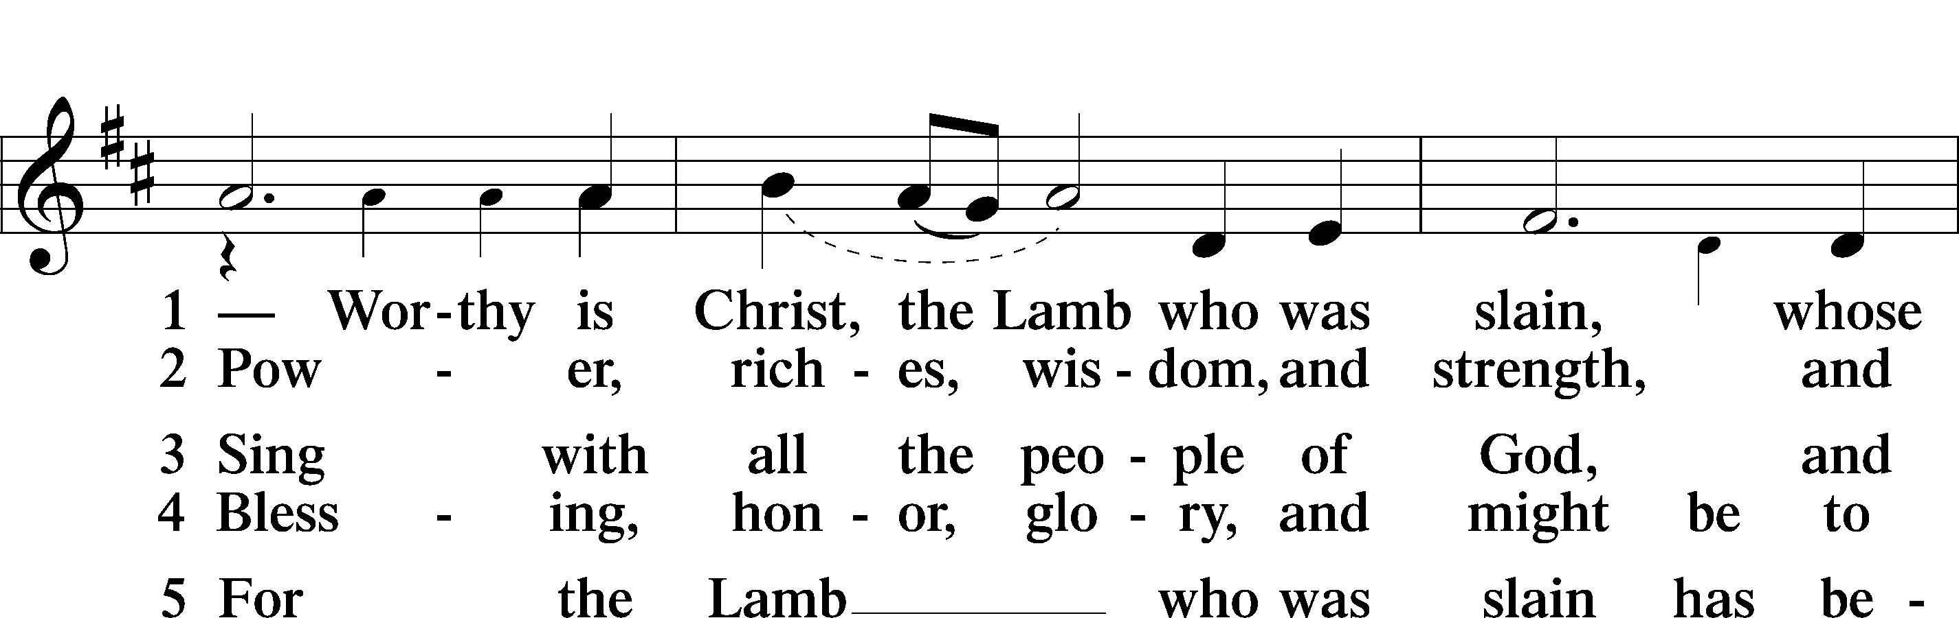
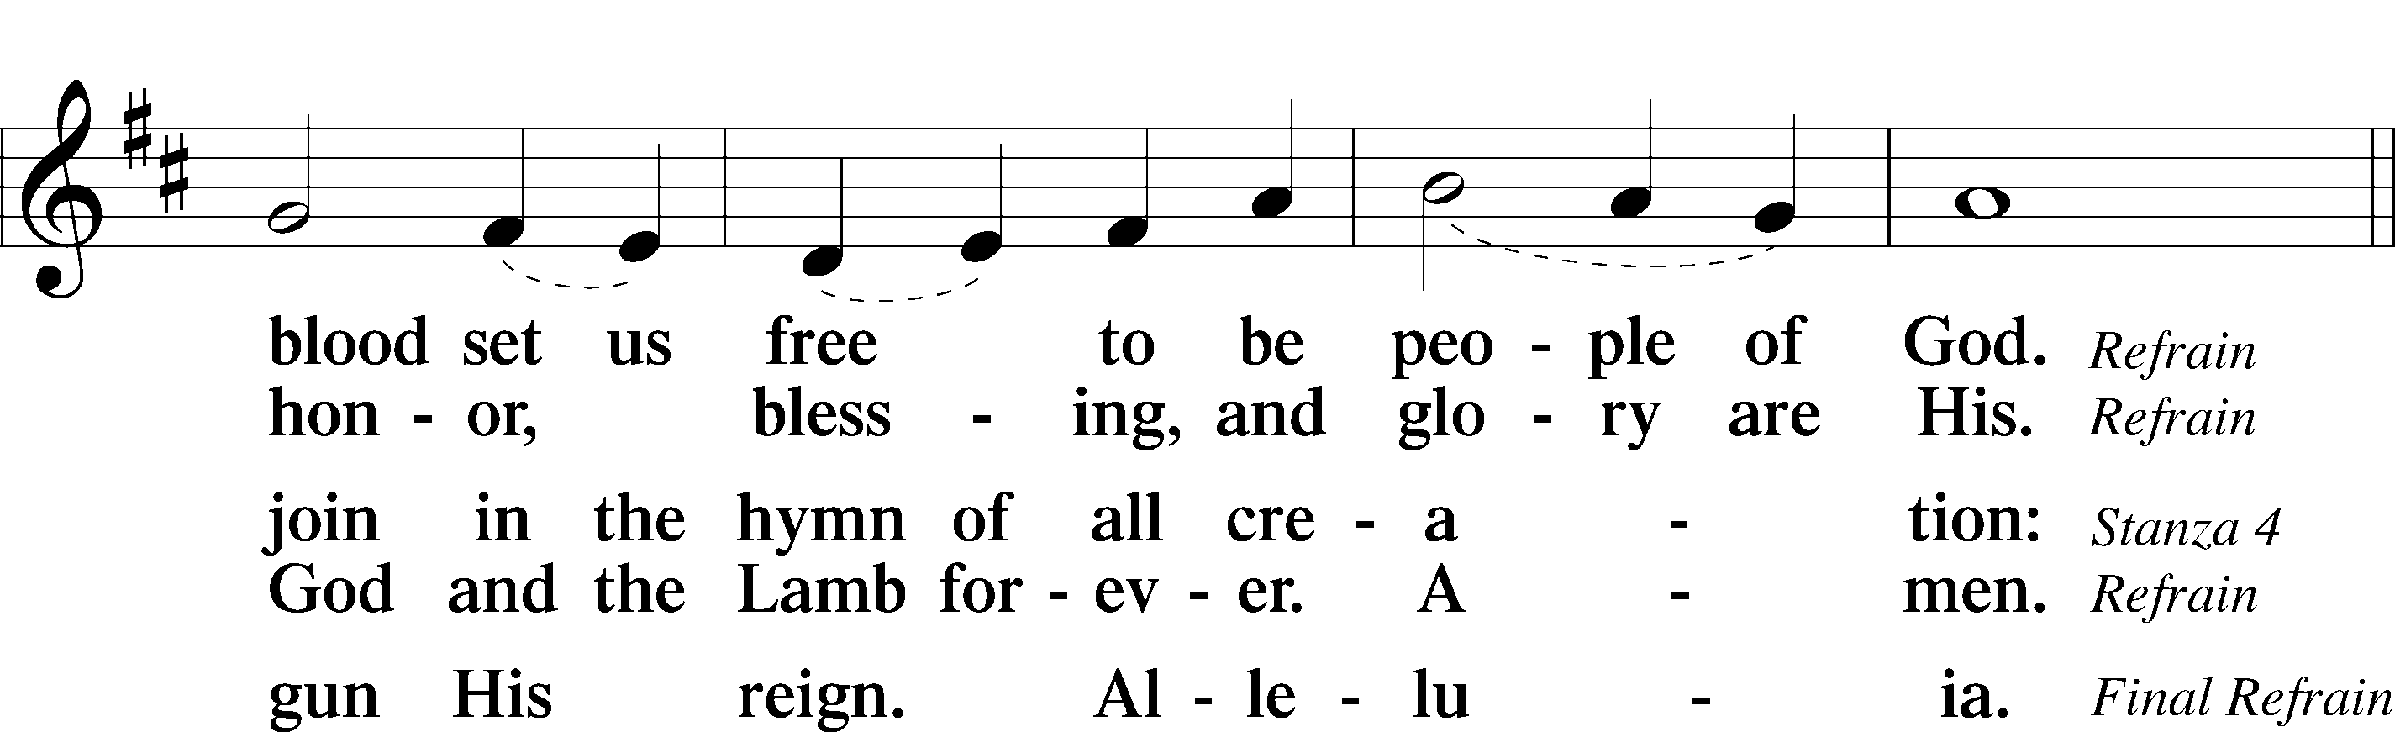
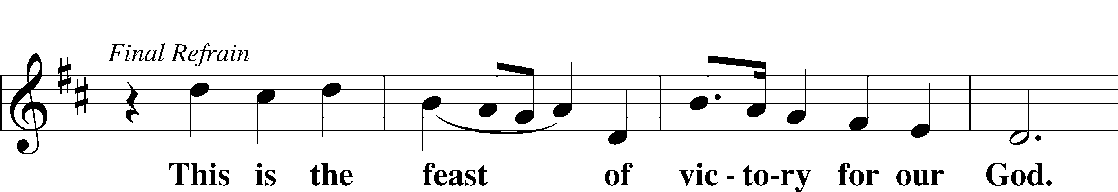
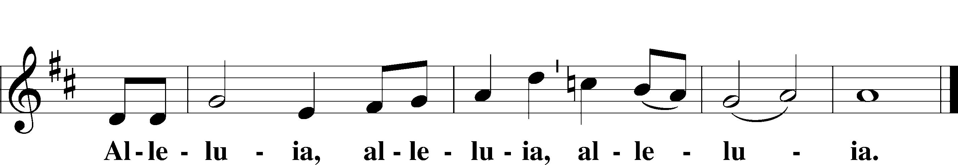

Salutation and Collect of the Day
P The Lord be with you.
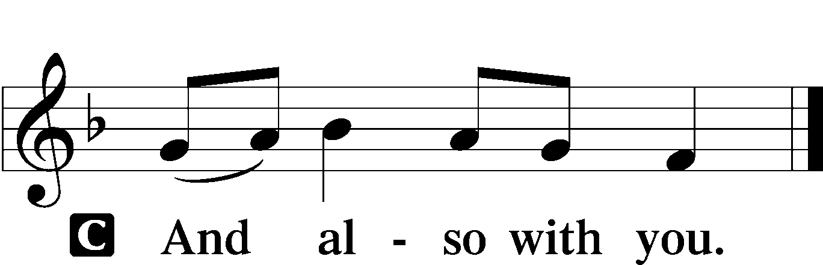

P Let us pray.
C O God, the giver of all that is good, by Your holy inspiration grant that we may think those things that are right and by Your merciful guiding accomplish them; through Jesus Christ, Your Son, our Lord, who lives and reigns with You and the Holy Spirit, one God, now and forever. Amen.

Sit

First Reading Acts 17:16–31
16While Paul was waiting for them at Athens, his spirit was provoked within him as he saw that the city was full of idols. 17So he reasoned in the synagogue with the Jews and the devout persons,
and in the marketplace every day with those who happened to be there. 18Some of the Epicurean and Stoic philosophers also conversed with him. And some said, “What does this babbler wish to say?” Others said, “He seems to be a preacher of foreign divinities”—because he was preaching Jesus and the resurrection. 19And they took hold of him and brought him to the Areopagus, saying, “May we know what this new teaching is that you are presenting? 20For you bring some strange things to our ears. We wish to know therefore what these things mean.”
21Now all the Athenians and the foreigners who lived there would spend their time in nothing except telling or hearing something new.
22So Paul, standing in the midst of the Areopagus, said: “Men of Athens, I perceive that in every way you are very religious. 23For as I passed along and observed the objects of your worship, I found also an altar with this inscription, ‘To the unknown god.’ What therefore you worship as unknown, this I proclaim to you. 24The God who made the world and everything in it, being Lord of heaven and earth, does not live in temples made by man, 25nor is he served by human hands, as though he needed anything, since he himself gives to all mankind life and breath and everything. 26And he made from one man every nation of mankind to live on all the face of the earth, having determined allotted periods and the boundaries of their dwelling place, 27that they should seek God, in the hope that they might feel their way toward him and find him. Yet he is actually not far from each one of us, 28for
“‘In him we live and move and have our being’;
as even some of your own poets have said,
“‘For we are indeed his offspring.’
29Being then God’s offspring, we ought not to think that the divine being is like gold or silver or stone, an image formed by the art and imagination of man. 30The times of ignorance God overlooked,
but now he commands all people everywhere to repent, 31because he has fixed a day on which he will judge the world in righteousness by a man whom he has appointed; and of this he has given assurance to all by raising him from the dead.”

A This is the Word of the Lord.
C Thanks be to God.

Gradual adapt. from Matthew 28:7; Hebrews 2:7; Psalm 8:6
Christ has risen from the dead.
[God the Father] has crowned him with glory and honor.
He has given him dominion over the works of his hands;
he has put all things under his feet.

Epistle 1 Peter 3:13–22
13Now who is there to harm you if you are zealous for what is good? 14But even if you should suffer for righteousness’ sake,
you will be blessed. Have no fear of them, nor be troubled, 15but in your hearts regard Christ the Lord as holy, always being prepared to make a defense to anyone who asks you for a reason for the hope that is in you; 16yet do it with gentleness and respect, having a good conscience, so that, when you are slandered, those who revile your good behavior in Christ may be put to shame. 17For it is better to suffer for doing good, if that should be God’s will, than for doing evil.
18For Christ also suffered once for sins, the righteous for the unrighteous, that he might bring us to God, being put to death in the flesh but made alive in the spirit, 19in which he went and proclaimed to the spirits in prison, 20because they formerly did not obey,
when God’s patience waited in the days of Noah, while the ark was being prepared, in which a few, that is, eight persons, were brought safely through water. 21Baptism, which corresponds to this, now saves you, not as a removal of dirt from the body but as an appeal to God for a good conscience, through the resurrection of Jesus Christ, 22who has gone into heaven and is at the right hand of God,
with angels, authorities, and powers having been subjected to him.

A This is the Word of the Lord.
C Thanks be to God.

Stand

Alleluia and Verse LSB 156
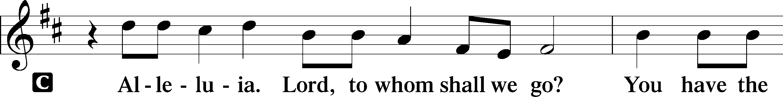
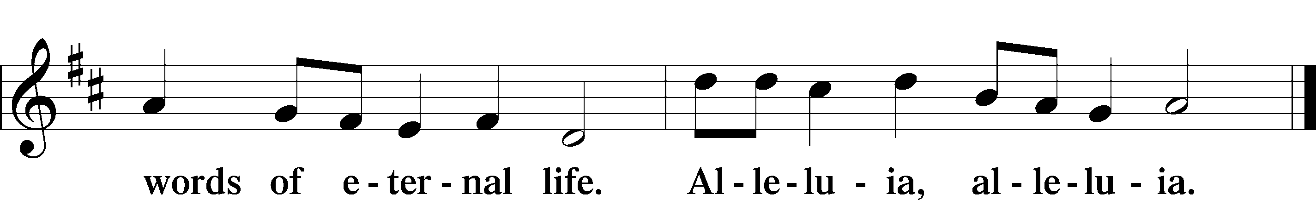

Holy Gospel John 14:15–21
P The Holy Gospel according to St. John, the fourteenth chapter.

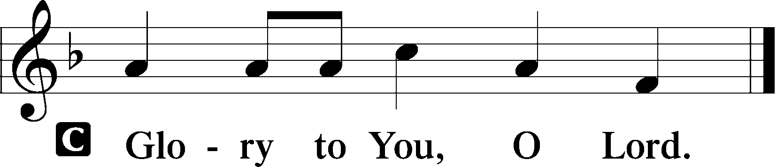

15[Jesus said:] “If you love me, you will keep my commandments. 16And I will ask the Father, and he will give you another Helper, to be with you forever, 17even the Spirit of truth, whom the world cannot receive, because it neither sees him nor knows him. You know him, for he dwells with you and will be in you.
18“I will not leave you as orphans; I will come to you. 19Yet a little while and the world will see me no more, but you will see me. Because I live, you also will live. 20In that day you will know that I am in my Father, and you in me, and I in you. 21Whoever has my commandments and keeps them, he it is who loves me. And he who loves me will be loved by my Father, and I will love him and manifest myself to him.”

P This is the Gospel of the Lord.

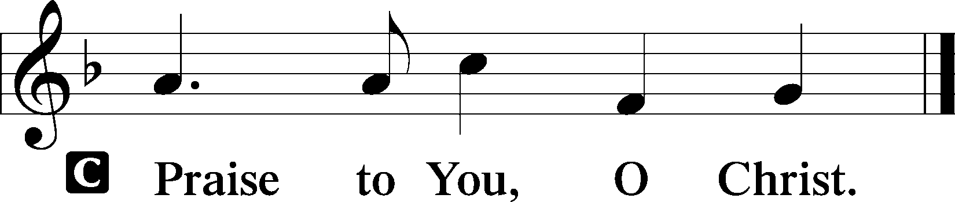

Nicene Creed
C I believe in one God,
the Father Almighty,
maker of heaven and earth
and of all things visible and invisible.

And in one Lord Jesus Christ,
the only-begotten Son of God,
begotten of His Father before all worlds,
God of God, Light of Light,
very God of very God,
begotten, not made,
being of one substance with the Father,
by whom all things were made;
who for us men and for our salvation came down from heaven
and was incarnate by the Holy Spirit of the virgin Mary
and was made man;
and was crucified also for us under Pontius Pilate.
He suffered and was buried.
And the third day He rose again according to the Scriptures
and ascended into heaven
and sits at the right hand of the Father.
And He will come again with glory to judge both the living and the dead,
whose kingdom will have no end.

And I believe in the Holy Spirit,
the Lord and giver of life,
who proceeds from the Father and the Son,
who with the Father and the Son together is worshiped and glorified,
who spoke by the prophets.
And I believe in one holy Christian and apostolic Church,
I acknowledge one Baptism for the remission of sins,
and I look for the resurrection of the dead
and the life T of the world to come. Amen.

Sit

Children's Message

Hymn of the Day “The Gifts Christ Freely Gives” LSB 602
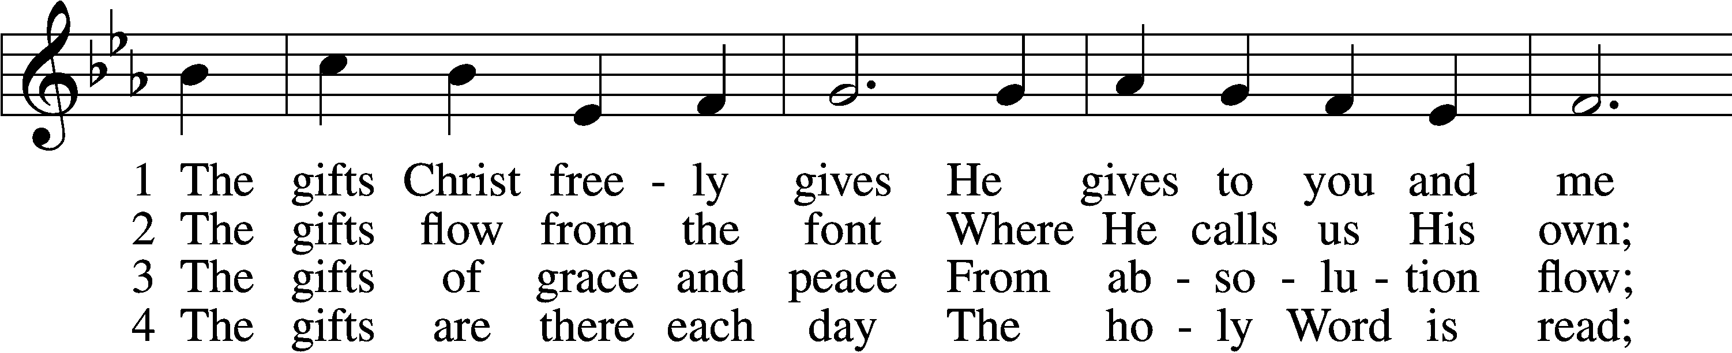
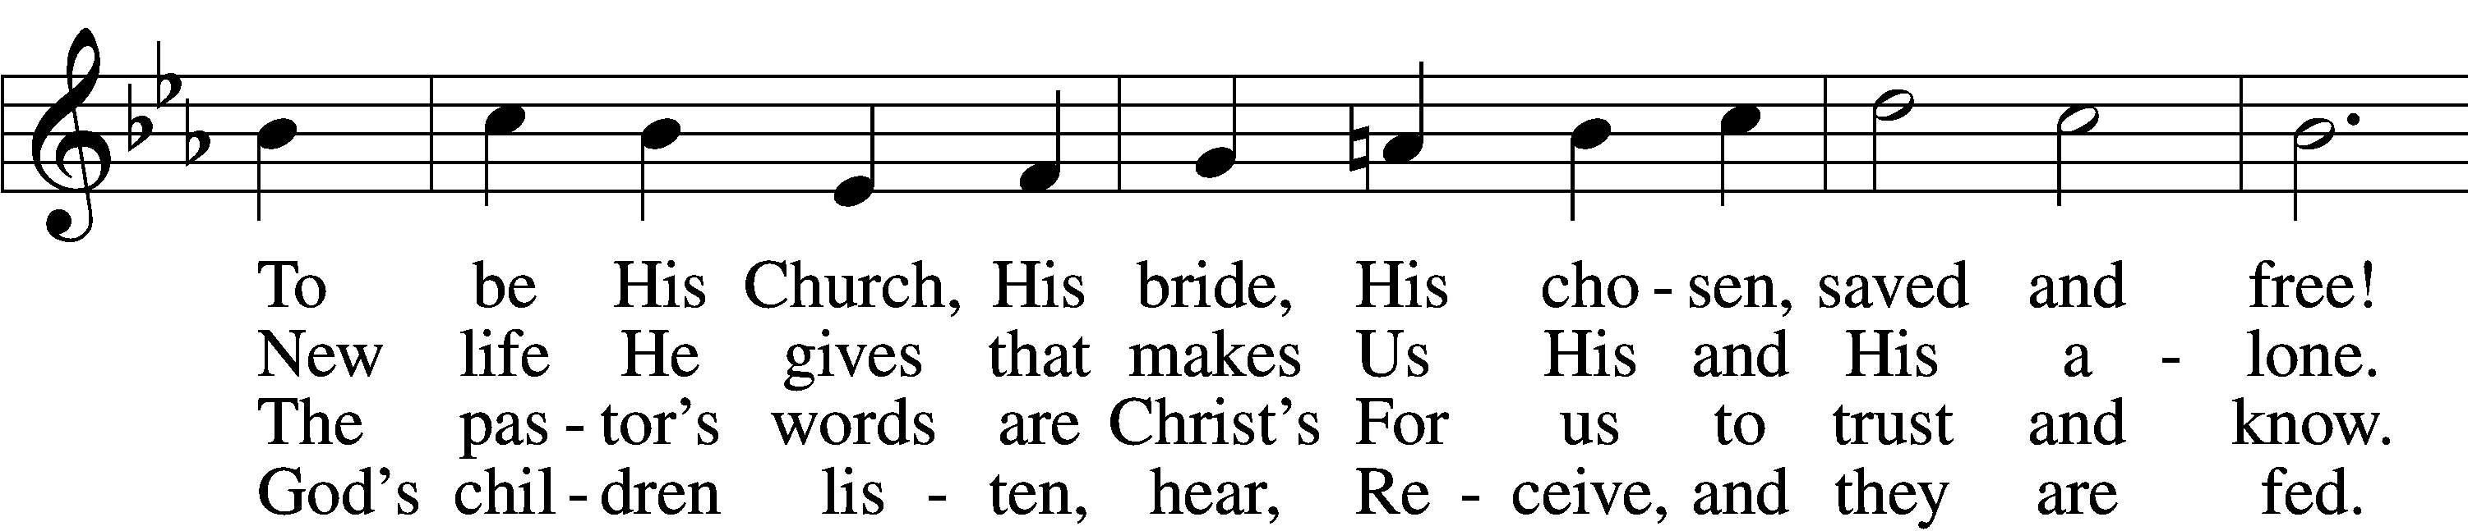
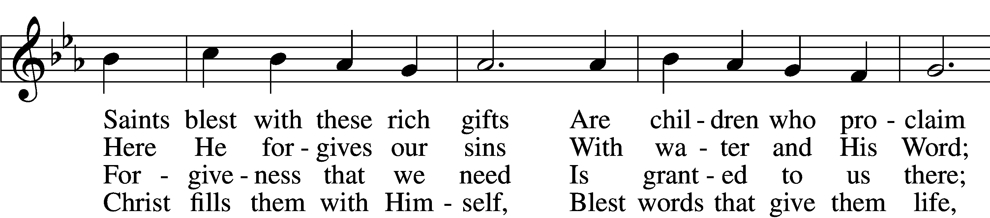
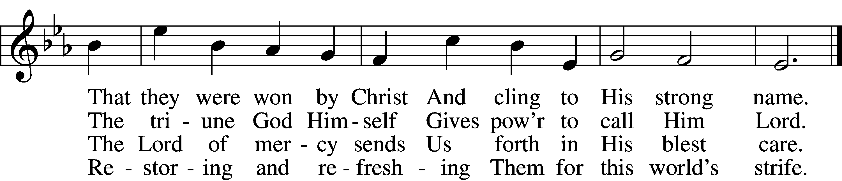

5 The gifts are in the feast,
Gifts far more than we see;
Beneath the bread and wine
Is food from Calvary.
The body and the blood
Remove our ev’ry sin;
We leave His presence in
His peace, renewed again.

6 All glory to the One
Who lavishes such love;
The triune God in love
Assures our life above.
His means of grace for us
Are gifts He loves to give;
All thanks and praise for His
Great love by which we live!
Text: Richard C. Resch, 1947
Tune: Charles J. Dale, 1842–1912, alt.
Text: © 2001 Richard C. Resch. Used by permission: LSB Hymn License no. 110016438
Tune: Public domain

Sermon

+RECEPTION OF MEMBER BY TRANSFER +

Stand
Prayer of the Church

Sit
Offering
Special Music – Solo “Thy Word Is A Lamp” LSB 973

Stand
Offertory Hymn “He Is Arisen! Glorious Word” LSB 488
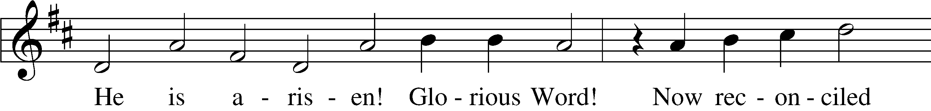
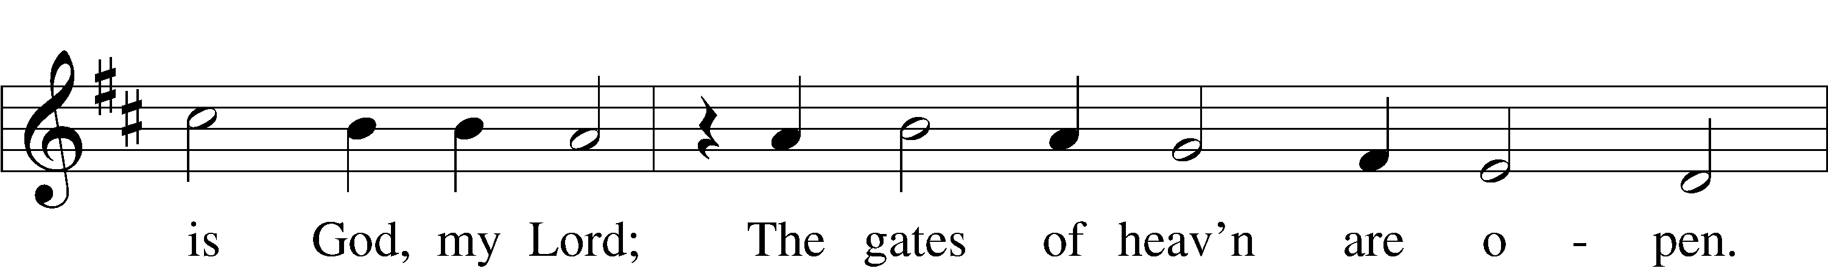
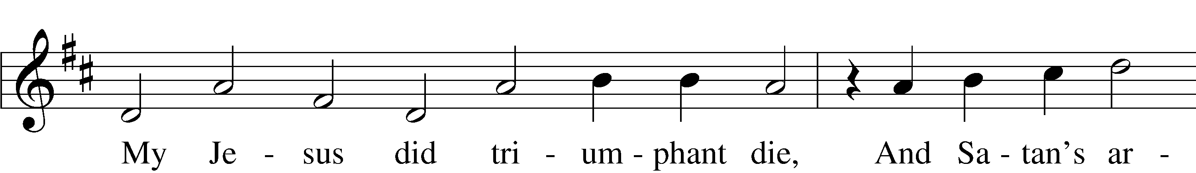
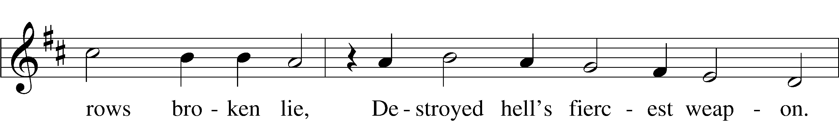
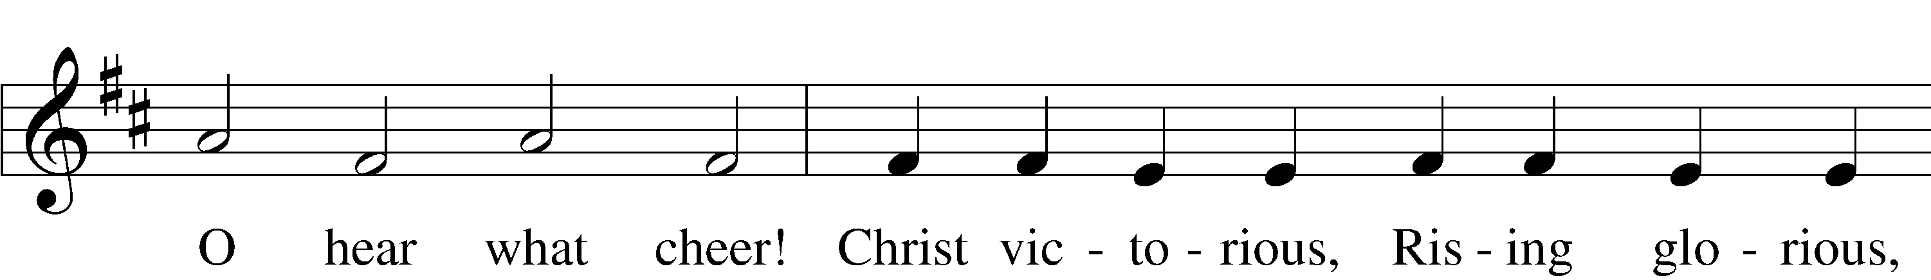
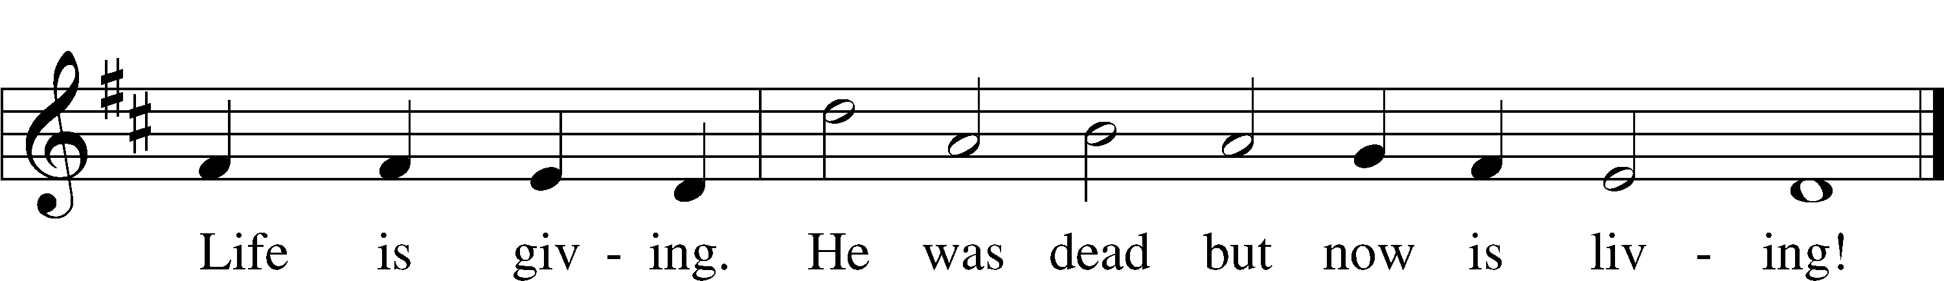
Text: Birgitte Katerine Boye, 1742–1824; tr. George A. T. Rygh, 1860–1942, alt.
Tune: Philipp Nicolai, 1556–1608
Text and tune: Public domain

+SERVICE OF THE SACRAMENT+

Preface LSB 160
P The Lord be with you.
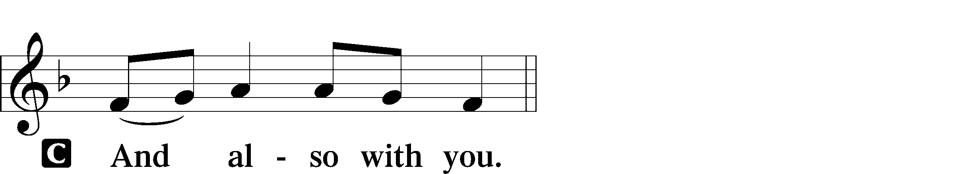

P Lift up your hearts.

P Let us give thanks to the Lord our God.
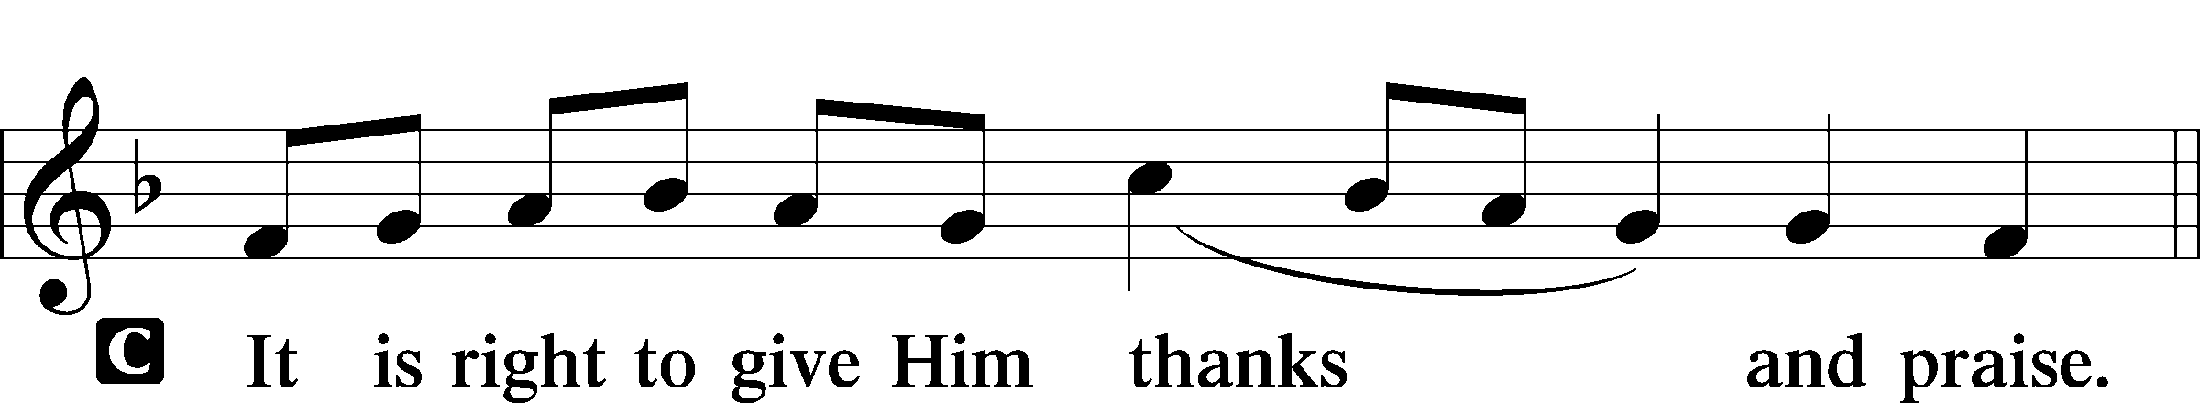

Proper Preface
P It is truly good, right, and salutary that we should at all times and in all places give thanks to You, holy Lord, almighty Father, everlasting God. And most especially are we bound to praise You on this day for the glorious resurrection of Your Son, Jesus Christ, the very Paschal Lamb, who was sacrificed for us and bore the sins of the world. By His dying He has destroyed death, and by His rising again He has restored to us everlasting life. Therefore with Mary Magdalene, Peter and John, and with all the witnesses of the resurrection, with angels and archangels, and with all the company of heaven we laud and magnify Your glorious name, evermore praising You and saying:
Sanctus LSB 161
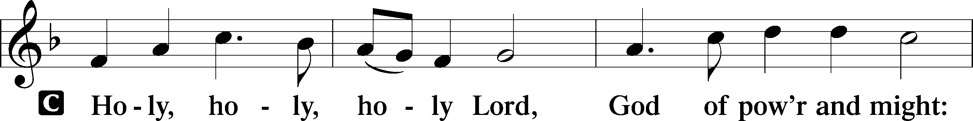
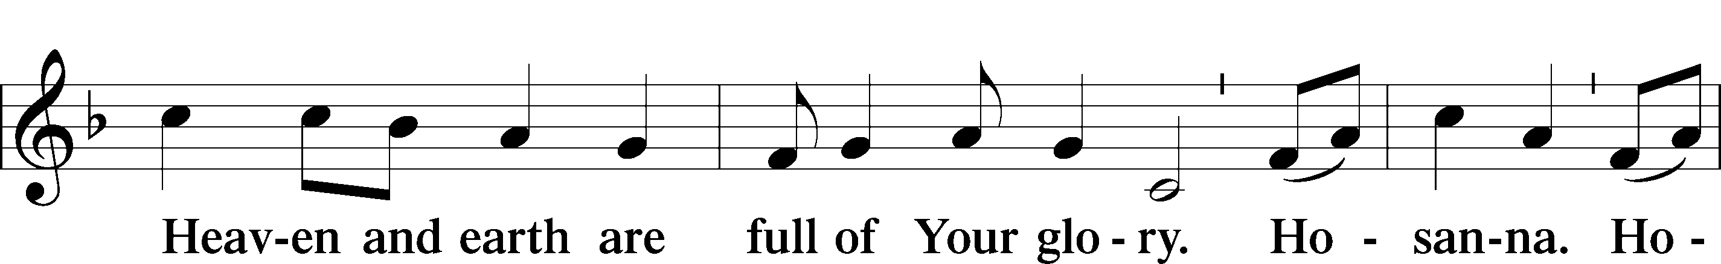
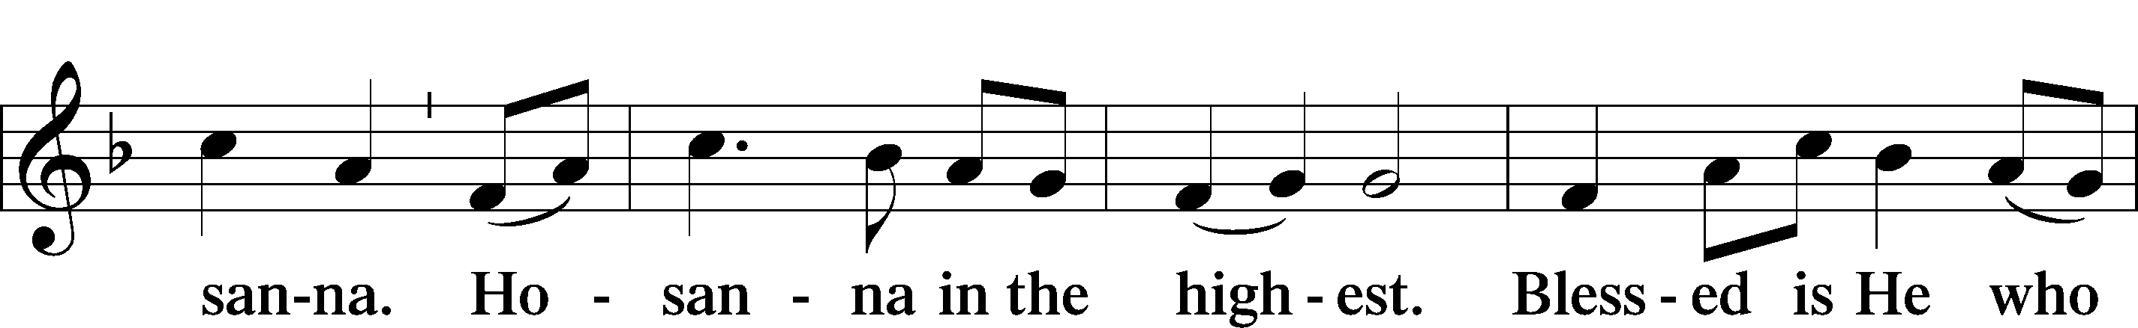
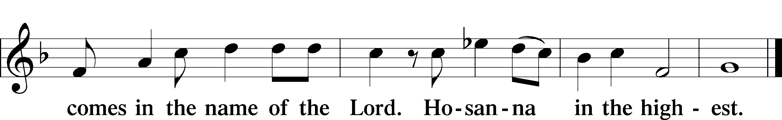

Prayer of Thanksgiving LSB 161
P Blessed are You, Lord of heaven and earth, for You have had mercy on those whom You created and sent Your only-begotten Son into our flesh to bear our sin and be our Savior. With repentant joy we receive the salvation accomplished for us by the all-availing sacrifice of His body and His blood on the cross.

Gathered in the name and the remembrance of Jesus, we beg You, O Lord, to forgive, renew, and strengthen us with Your Word and Spirit. Grant us faithfully to eat His body and drink His blood as He bids us do in His own testament. Gather us together, we pray, from the ends of the earth to celebrate with all the faithful the marriage feast of the Lamb in His kingdom, which has no end. Graciously receive our prayers; deliver and preserve us. To You alone, O Father, be all glory, honor, and worship, with the Son and the Holy Spirit, one God, now and forever.
C Amen.
Lord’s Prayer
C Our Father who art in heaven,
hallowed be Thy name,
Thy kingdom come,
Thy will be done on earth
as it is in heaven;
give us this day our daily bread;
and forgive us our trespasses
as we forgive those
who trespass against us;
and lead us not into temptation,
but deliver us from evil.
For Thine is the kingdom
and the power and the glory
forever and ever. Amen.

The Words of Our Lord
P Our Lord Jesus Christ, on the night when He was betrayed, took bread, and when He had given thanks, He broke it and gave it to the disciples and said: “Take, eat; this is My T body, which is given for you. This do in remembrance of Me.”

In the same way also He took the cup after supper, and when He had given thanks, He gave it to them, saying: “Drink of it, all of you; this cup is the new testament in My T blood, which is shed for you for the forgiveness of sins. This do, as often as you drink it, in remembrance of Me.”

Pax Domini LSB 163
P The peace of the Lord be with you always.
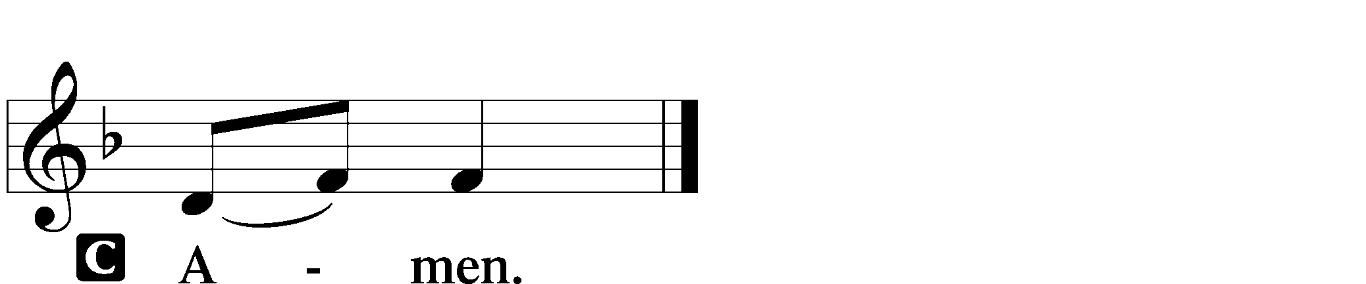
Agnus Dei LSB 163
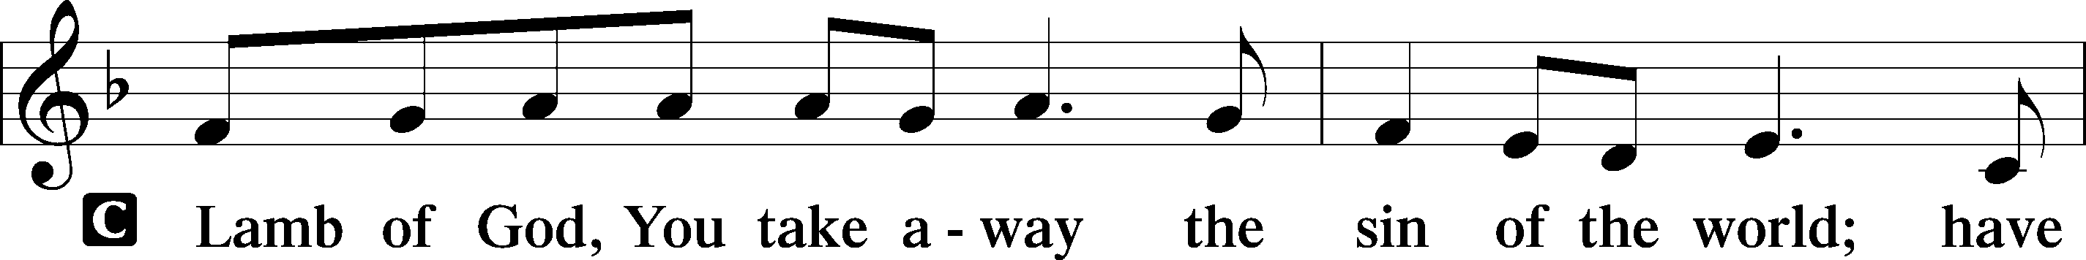
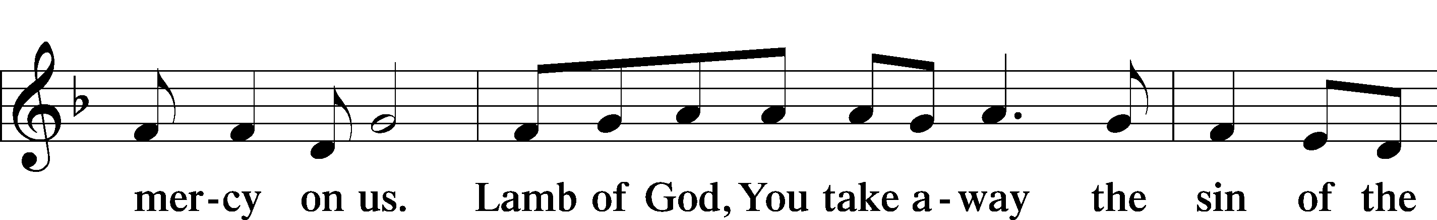
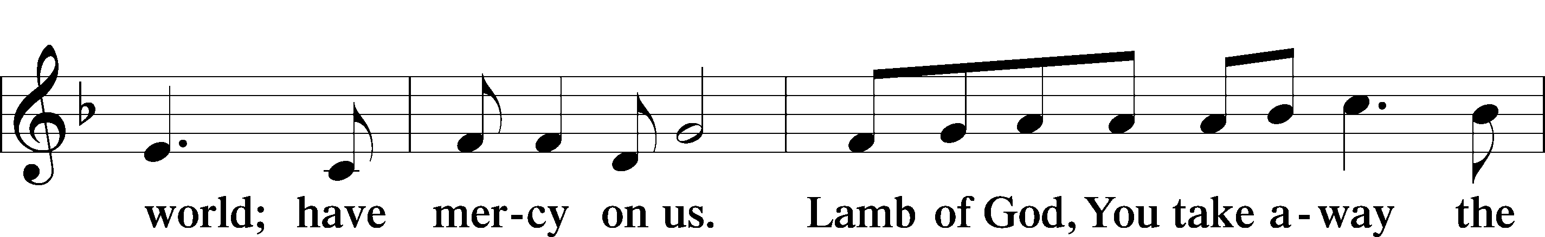
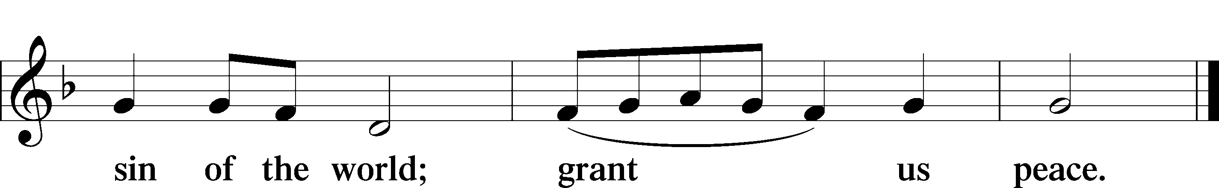

Sit

Distribution

Distribution Hymn “Lord Jesus Christ, We Humbly Pray” LSB 623
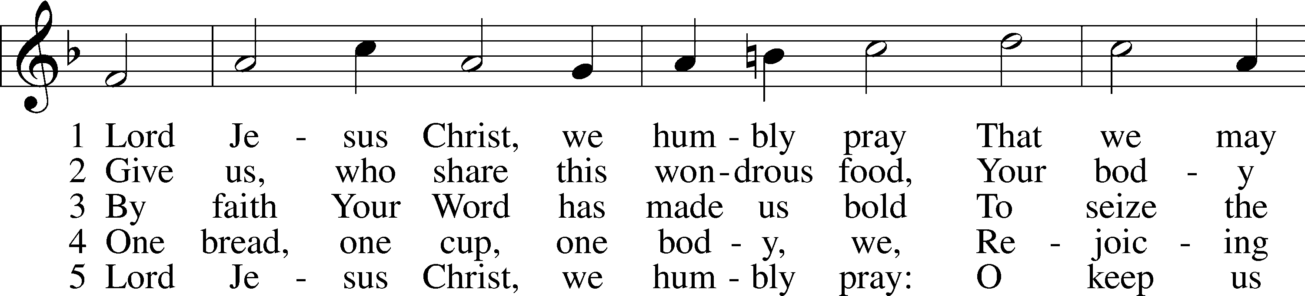
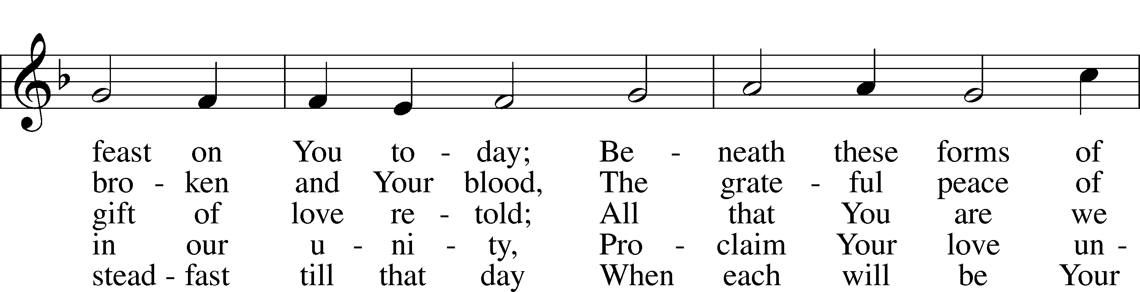
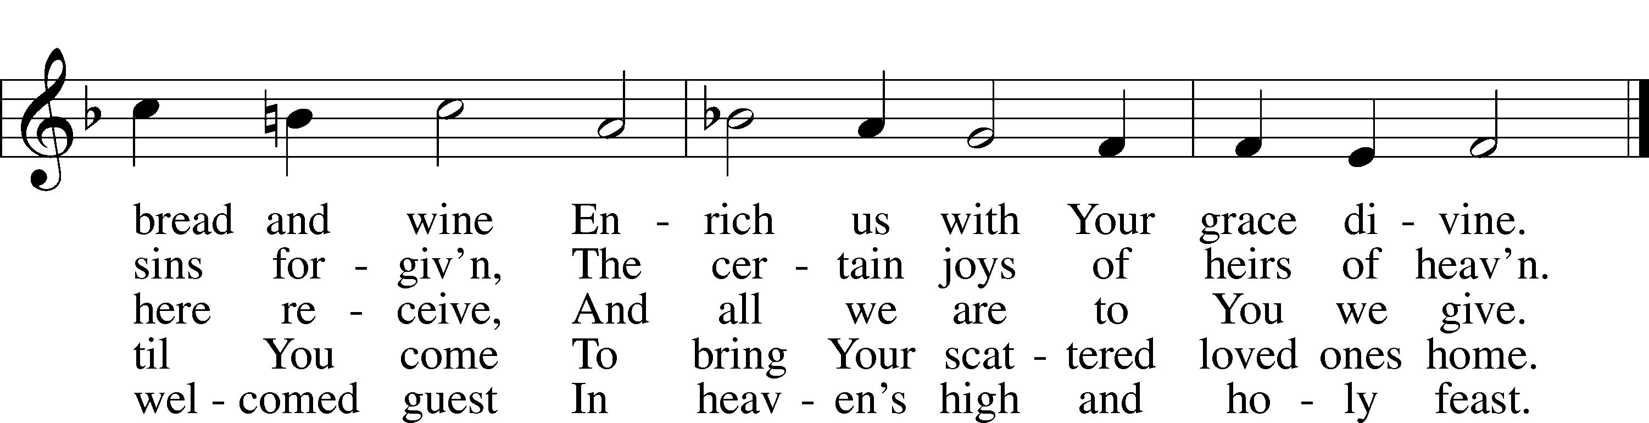
Text: Henry E. Jacobs, 1844–1932, alt.
Tune: Cantionale Germanicum, 1628, Gochsheim
Text and tune: Public domain

Distribution Hymn “Alleluia! Sing to Jesus” LSB 821
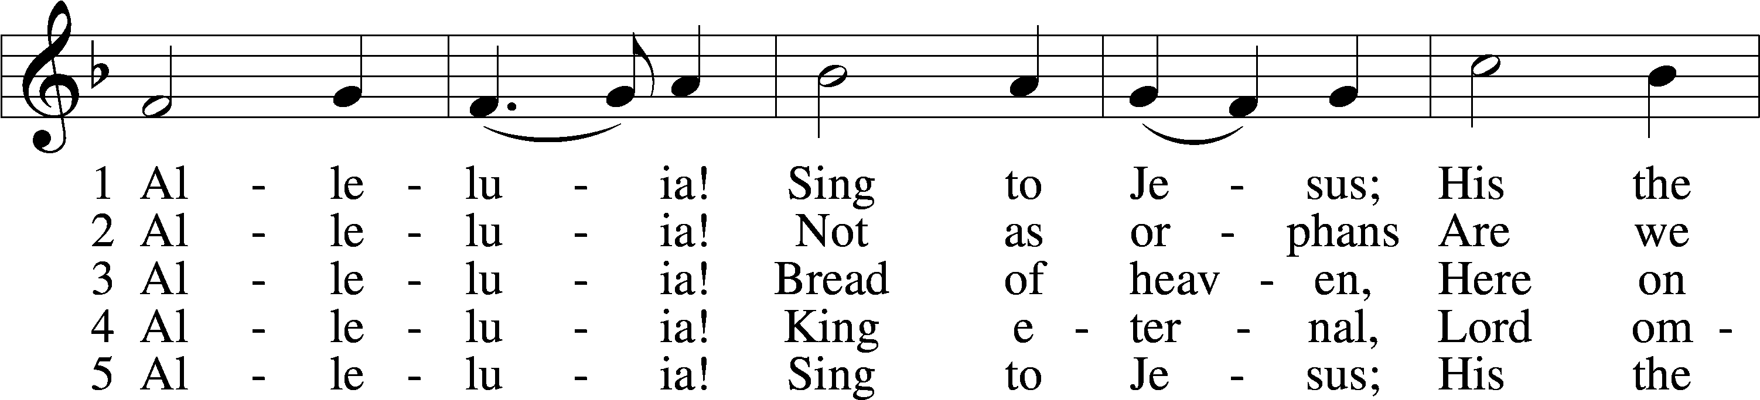
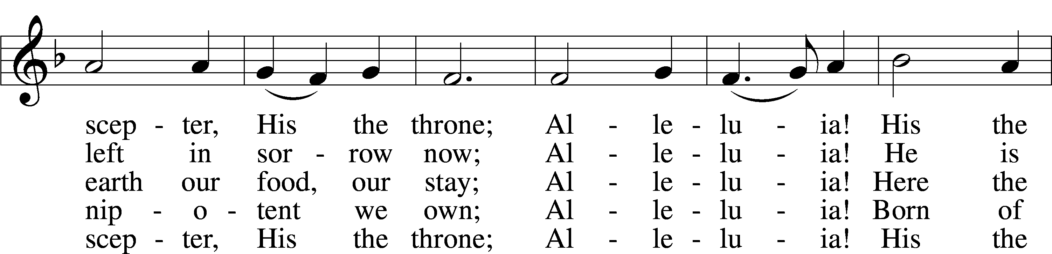
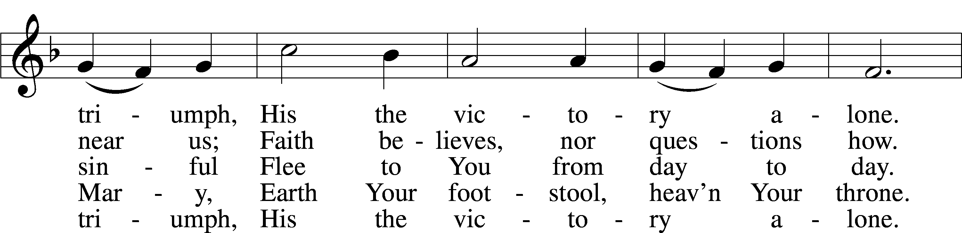
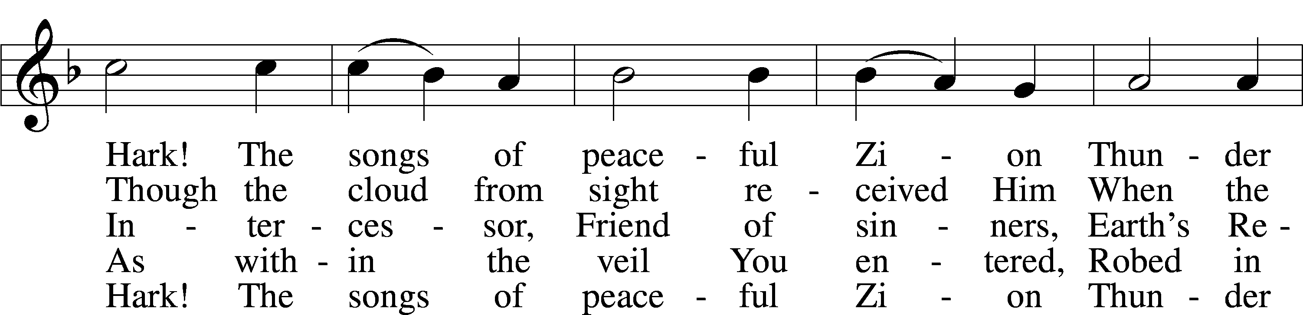
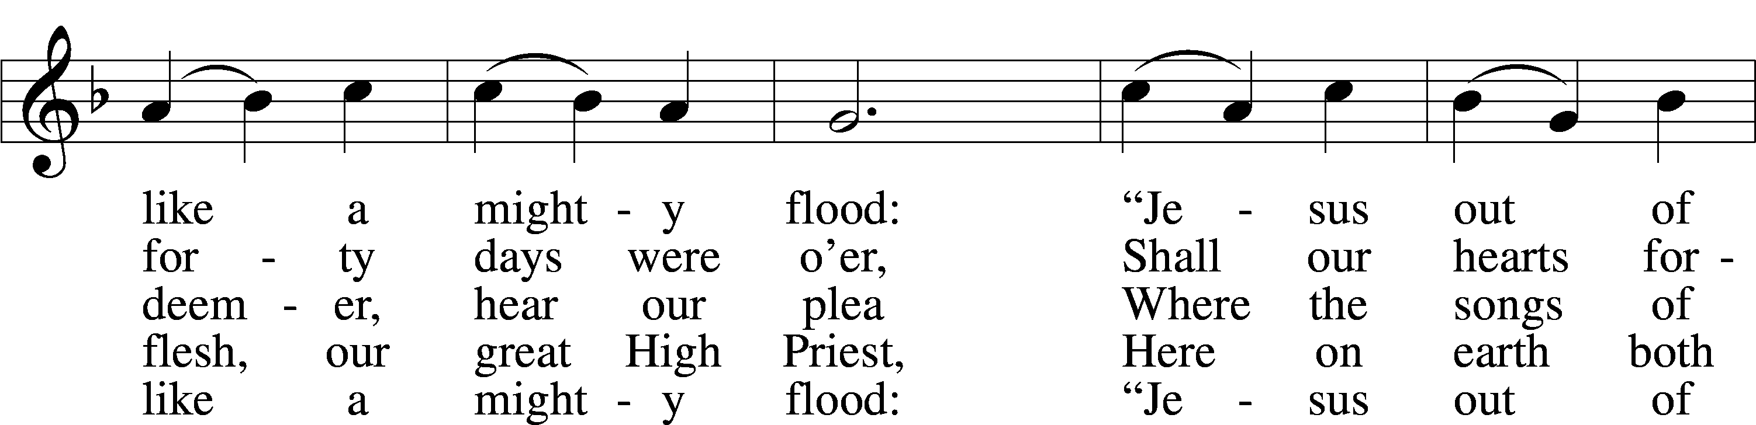
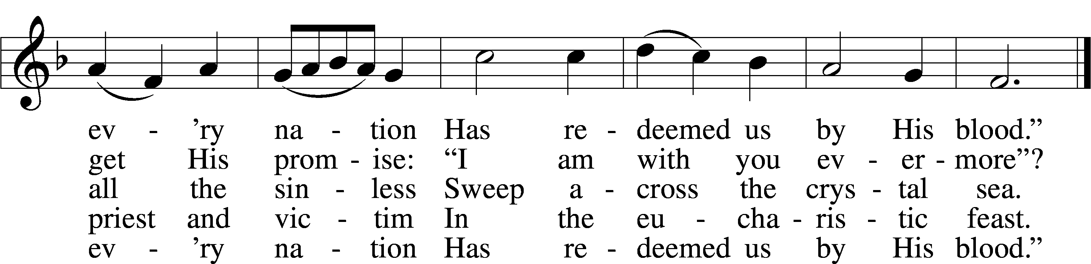
Text: William C. Dix, 1837–98, alt.
Tune: Rowland H. Prichard, 1811–87
Text and tune: Public domain

Stand
Nunc Dimittis LSB 165
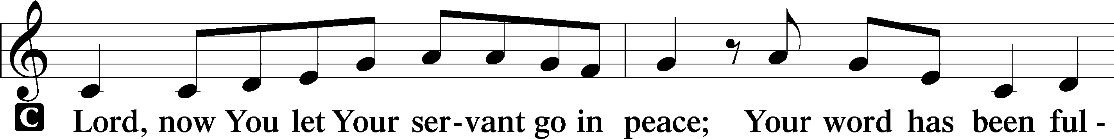
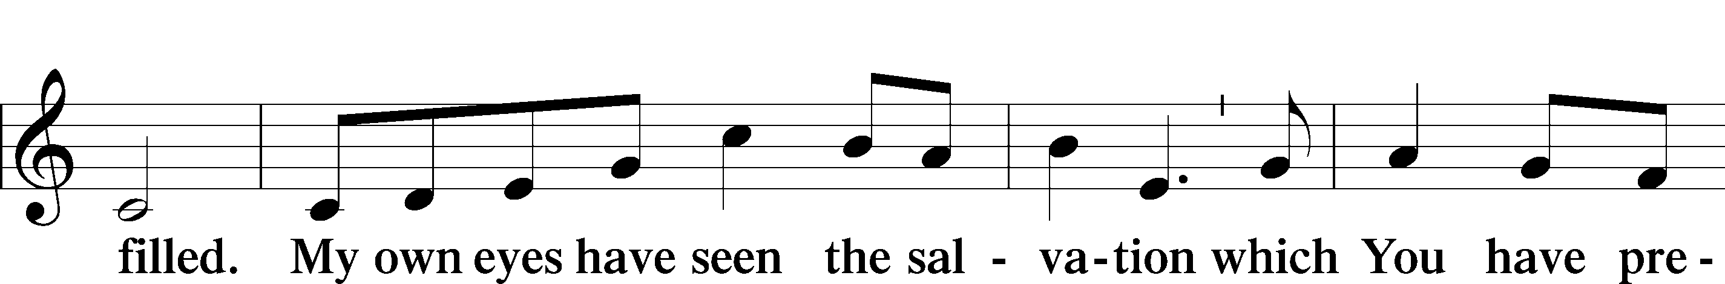
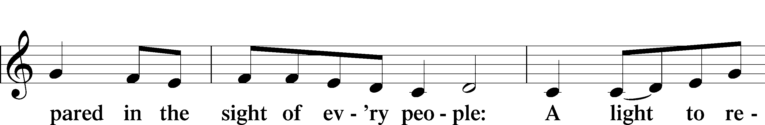
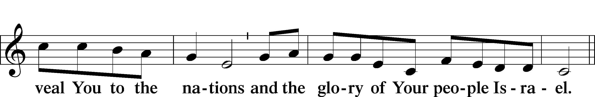
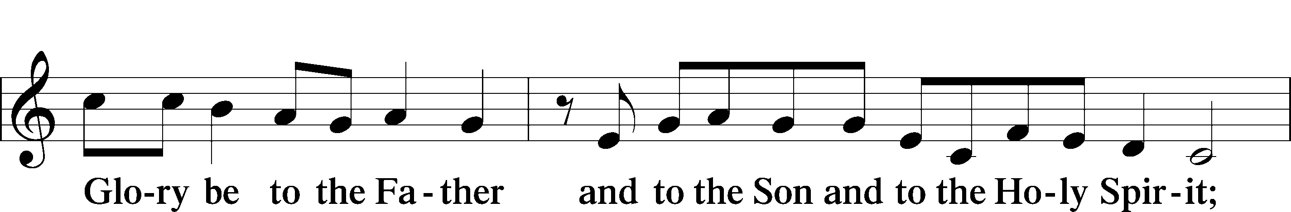
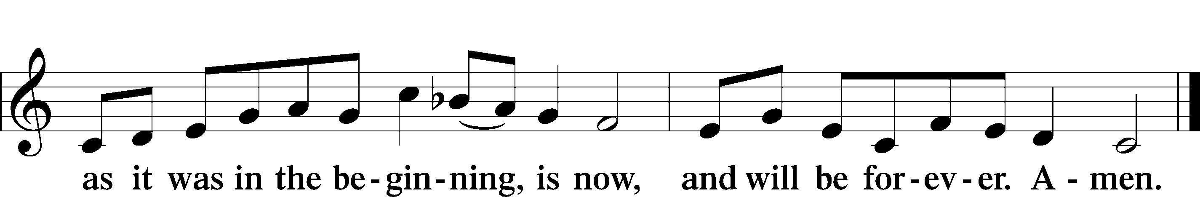

Post-Communion Collect
A Let us pray.
We give thanks to You, almighty God, that You have refreshed us through this salutary gift, and we implore You that of Your mercy You would strengthen us through the same in faith toward You and in fervent love toward one another; through Jesus Christ, Your Son, our Lord, who lives and reigns with You and the Holy Spirit, one God, now and forever.
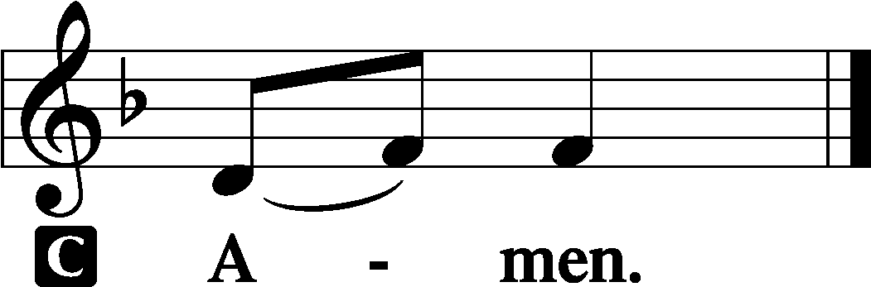

Benediction LSB 166
P The Lord bless you and keep you.
The Lord make His face shine on you and be gracious to you.
The Lord look upon you with favor and T give you peace.
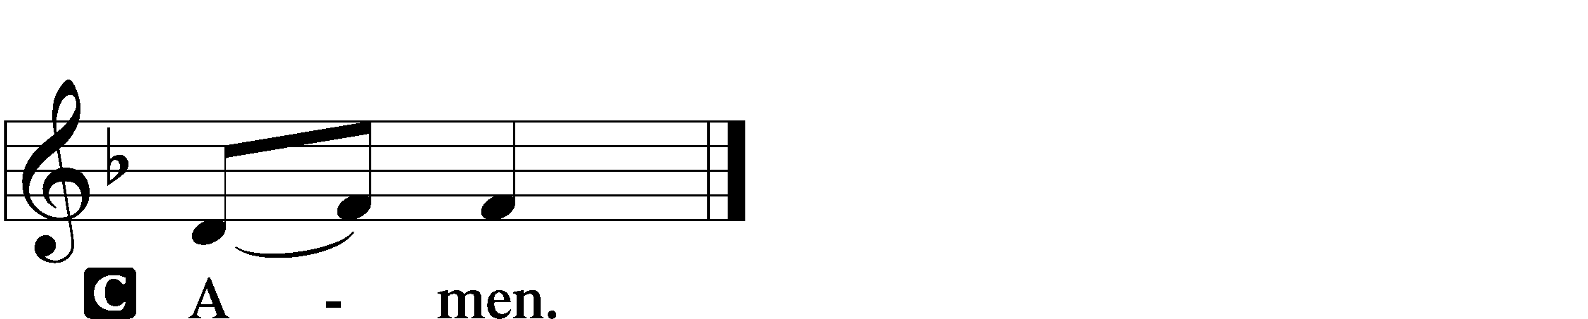

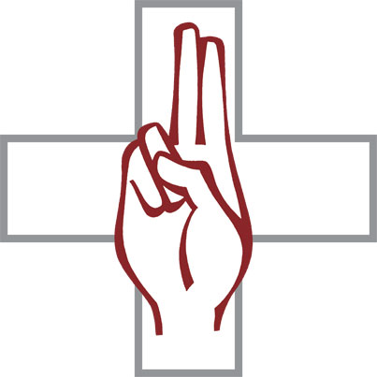

Closing Hymn “Sent Forth by God’s Blessing” LSB 643
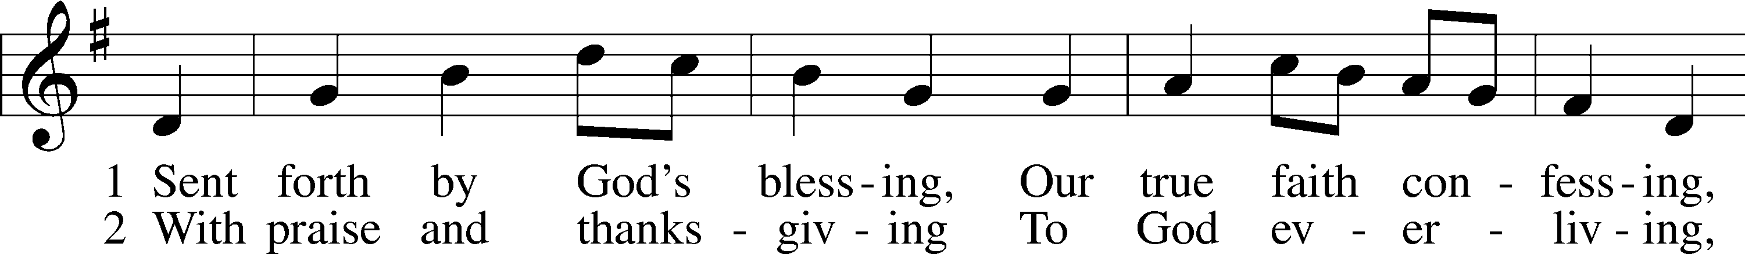
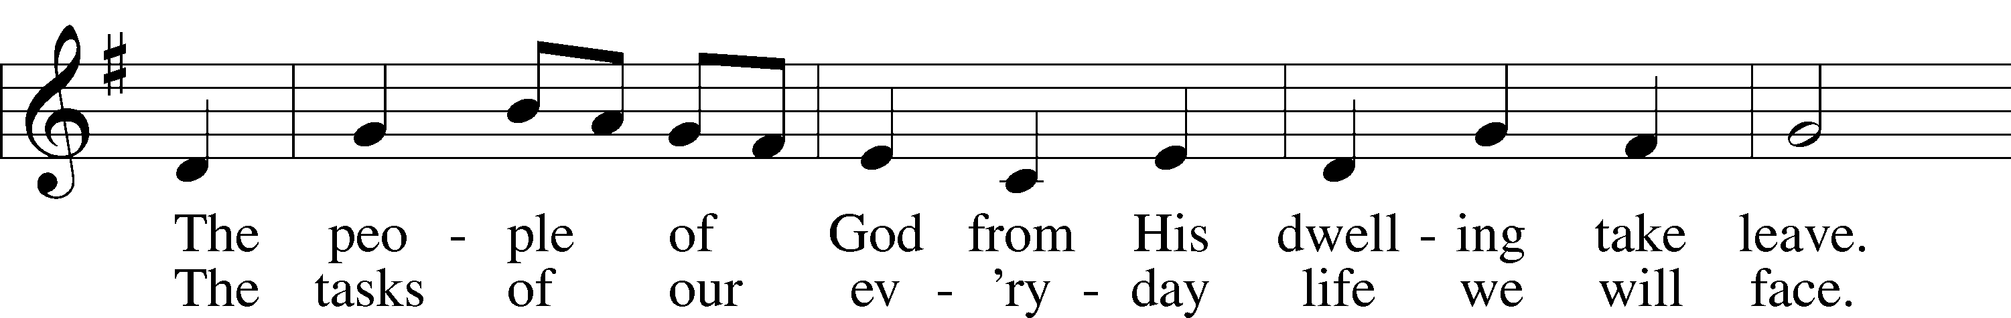
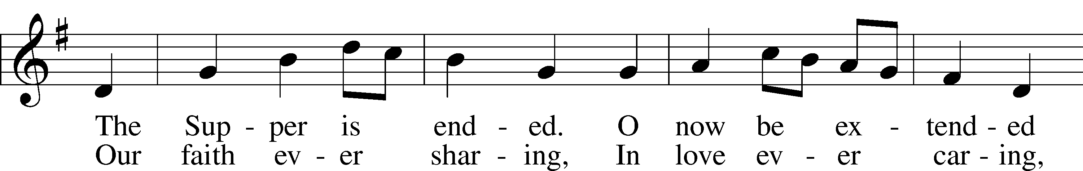
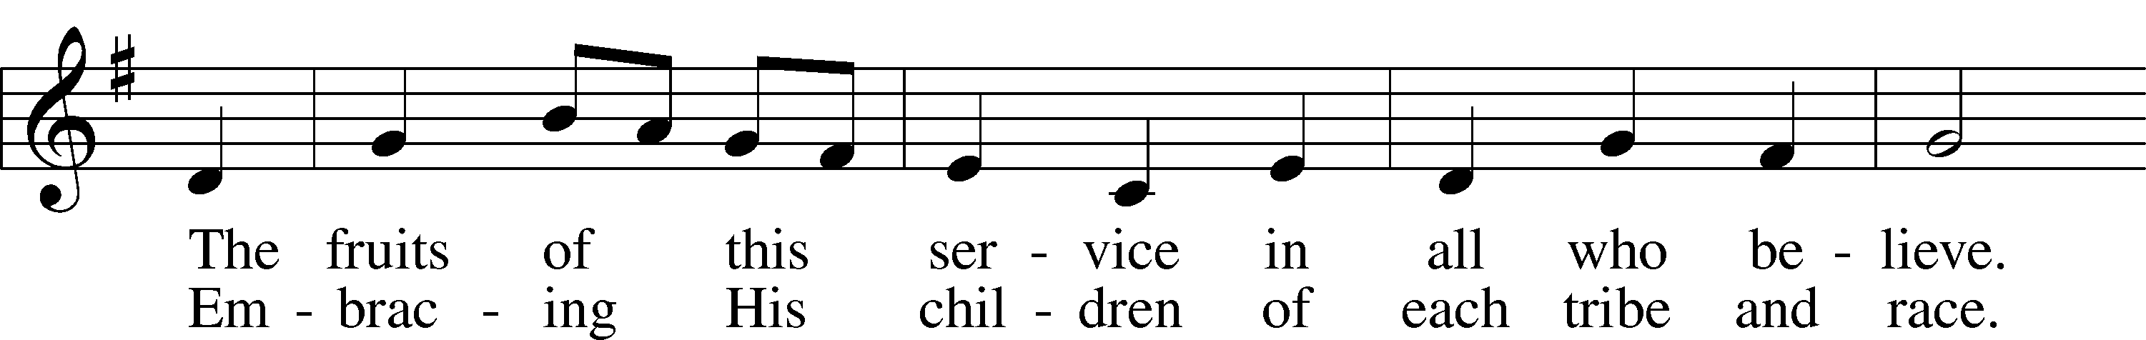
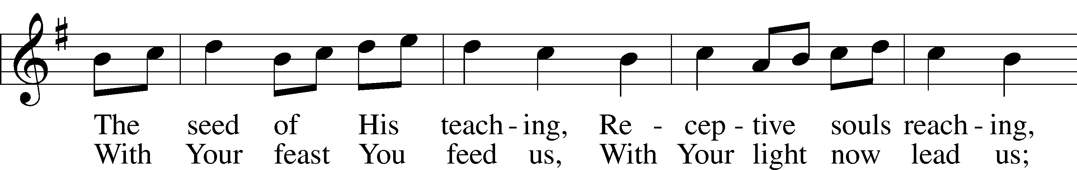
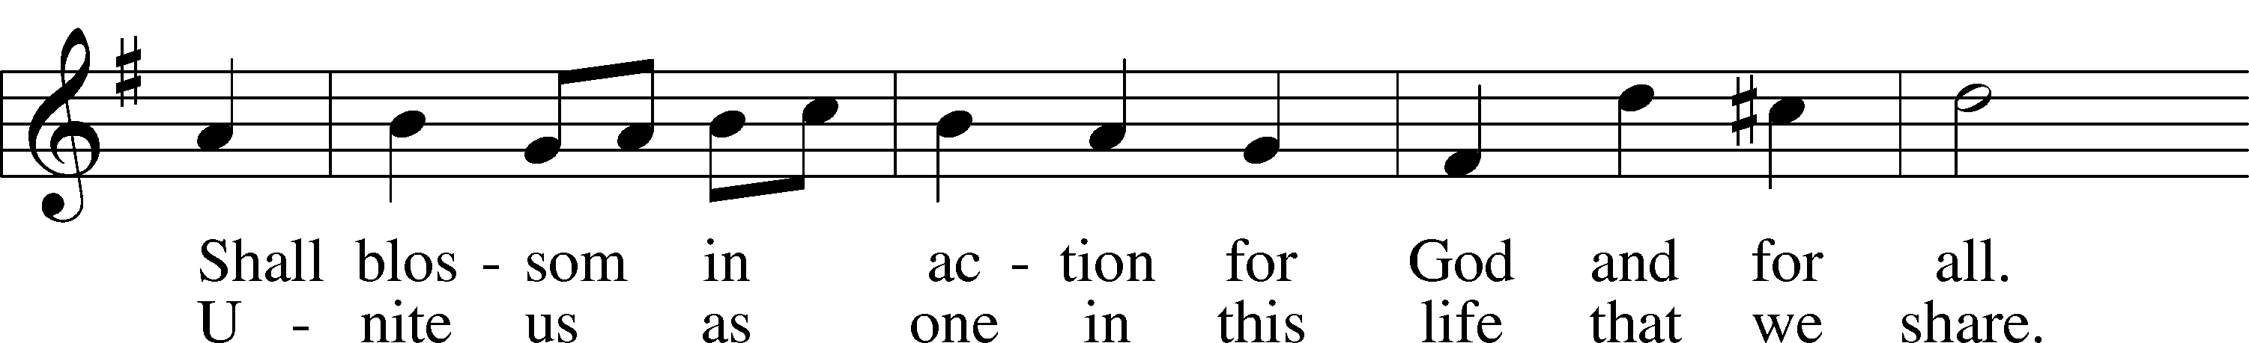
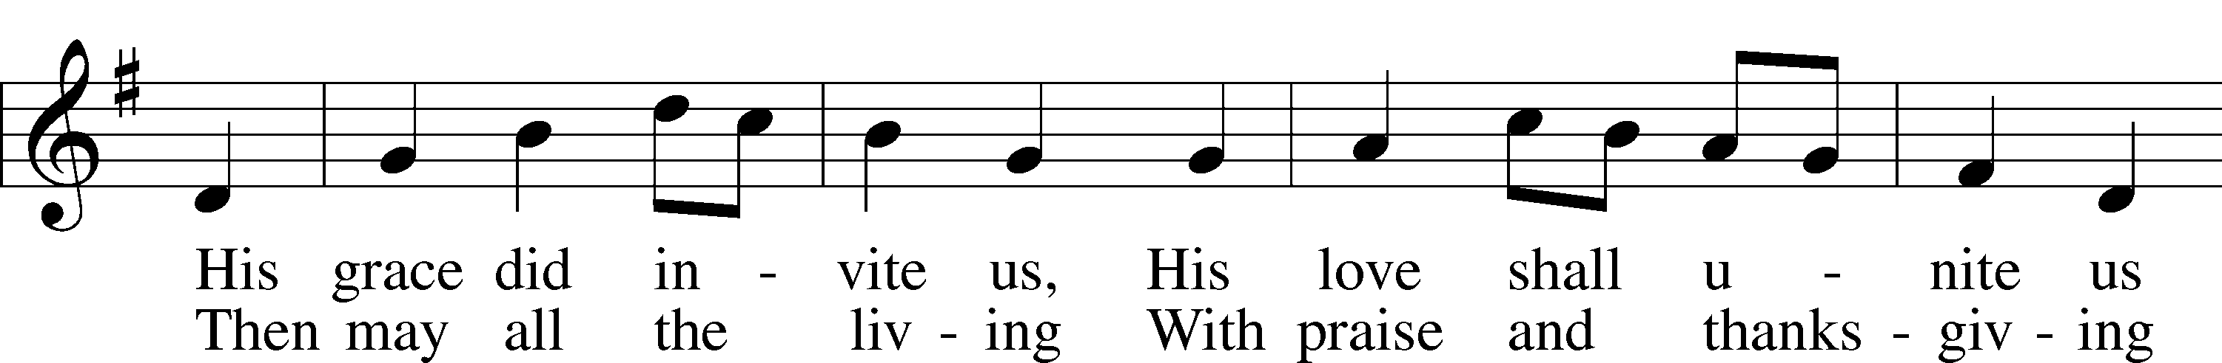
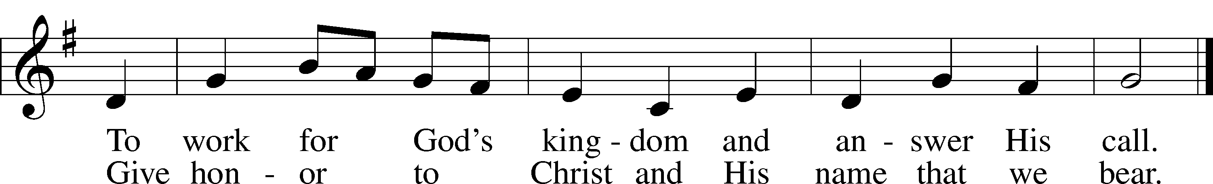
Text: Omer E. Westendorf, 1916–97, alt.
Tune: Welsh
Text: © 1964 World Library Publications. Used by permission: LSB Hymn License no. 110016438
Tune: Public domain

Acknowledgments
Unless otherwise indicated, Scripture quotations are from the ESV® Bible (The Holy Bible, English Standard Version®), copyright © 2001 by Crossway, a publishing ministry of Good News Publishers. Used by permission. All rights reserved.
Created by Lutheran Service Builder © 2023 Concordia Publishing House.

Serving Our Lord in His House Today:
Pastor: Rev. Bert Thompson
Organist: Linda Ecker
Soloist: Joan Anderson
Elders: Josh Church & Dillin Lafferty
Dillin Lafferty (Wed.)

Gifts from God: John 14:15 – “If you love me, you will keep my commandments.” Jesus is clear: our obedience to His Word comes from our love for Him. But where does that love come from? Jesus tells us that as well: “Her sins, which are many, are forgiven — for she loved much” (Luke 7:47). Christ shows us His love and gives us the forgiveness of our sins, which causes love to well up in us and thereby keep the commandments of Jesus. For after all, the summary of the Law is “love.”

Important Voters’ Meeting Today: Following the Divine Service today we will have the Congregational Voters’ Meeting. The meeting will begin at approximately 10:30 a.m. At the meeting we will be voting to extend a call to a pastor.
Please stay and attend this very important meeting.

Prayer for calling a faithful pastor:
O Gracious Father, You led Your holy apostles to ordain ministers for the proclamation of Your Word and the faithful administration of the Sacraments of Christ. Grant to this congregation the guidance of the Holy Spirit to choose a suitable pastor according to Your will for the blessing of Your Church in this place; through Jesus Christ our Lord.

Our Worship attendance last week: Sunday: 57
Wednesday: 6
Total: 63

Scripture Lessons for next week: Acts 1:12-26
1 Peter 4:12-19; 5:6-11
John 17:1-11

Secretary Office Hours: Monday-Friday: 8:15am-12:15pm

Our Week With Our Lord:
Today 9:00am Divine Service w/Holy Communion
(livestreamed via YouTube)
Mite Box Sunday
SCRIP Orders Due
10:30am Congregational Voters’ Meeting
10:30am Sunday School
Monday
Tuesday 6:00pm Board of Directors Meeting
Wednesday 6:00pm Confirmation Pizza Party
7:00pm Divine Service
Thursday The Ascension of our Lord
Friday 12:00pm Newsletter Article Submission Deadline
Saturday
Sunday 9:00am Divine Service w/Holy Communion (livestreamed via YouTube)
Confirmation Sunday
10:30am Adult Bible Study & Sunday School

*Please view the following page for weekly prayers*

HIS FLOCK AT PRAYER
Propers for the 6th Week of Easter

Psalm for the Week: Psalm 66:8-20

Daily Scripture Readings:
Sunday— John 16:23-28 Thursday—Mark 16:14-20
Monday— Matthew 6:5-8 Friday—Luke 24:50-52
Tuesday—John 15:7-11 Saturday—Psalm 110
Wednesday—1 John 5:13-15

Collect for the Week:
O God, the giver of all that is good, by Your holy inspiration grant that we may
think those things that are right and by Your merciful guiding accomplish them;
through Jesus Christ, Your Son, our Lord, who lives and reigns with You and the
Holy Spirit, one God, now and forever.

Hymn of the Week: “The Gifts Christ Freely Gives” LSB 602

Congregational Petitions for this Week:
+ For those whose work is difficult or dangerous including the military away from home, especially: Isaac Preuss, Erica Preuss, Joshua Ecker, Tania Adler.
+ For those who are ill or recovering, especially: Brenda Kolb, Shawn Zabinski,
Velma Lutz, Juliann Baxter, District President John Wille, Joyce Cain,
Jerry Quam, Randy Roehl, Peyton Foster, Dawn Hawkins, Jan Stampfli,
Margaret Palmer, Nick Anderson, Lori Winchelbeltz, Patti Hartwig,
Mario Corrente, Lorie Walker, Jeff Engel, Bob Pulley, Rayna Knutson, Fred Sole.
+ For those who are home-bound, especially: John Fox, Darlene Griffin,
Lynda Goad, Roemelle McArdle, Sharon Herried, Muriel Finch.

