Good Shepherd Lutheran Church
Seventh Sunday of Easter
May 21, 2023

Pre-Service Music & Welcome

Divine Service Setting One – Lutheran Service Book (LSB) 151

Confirmation Bible Verse selected by Alyssa Evelyn Krings:
“Cast all your anxiety on him because he cares for you.”
1 Peter 5:7 (NIV)

+CONFESSION AND ABSOLUTION+

Opening Hymn “Holy Spirit, Light Divine” LSB 496
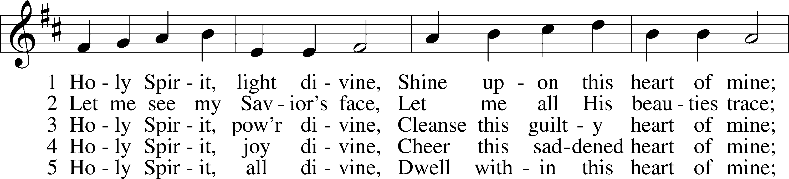
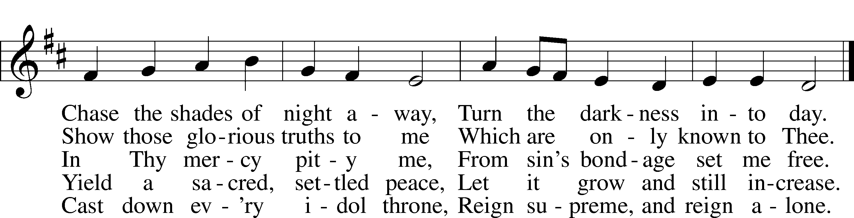
Text: Andrew Reed, 1787–1862, alt.
Tune: Orlando Gibbons, 1583–1625
Text and tune: Public domain

Stand

The sign of the cross T may be made by all in remembrance of their Baptism.

Invocation
P In the name of the Father and of the T Son and of the Holy Spirit.
C Amen.

Exhortation LSB 151
P If we say we have no sin, we deceive ourselves, and the truth is not in us.
C But if we confess our sins, God, who is faithful and just, will forgive our sins and cleanse us from all unrighteousness.

Silence for reflection on God’s Word and for self-examination.
Confession of Sins LSB 151
P Let us then confess our sins to God our Father.
C Most merciful God, we confess that we are by nature sinful and unclean. We have sinned against You in thought,
word, and deed, by what we have done and by what we have left undone. We have not loved You with our whole heart;
we have not loved our neighbors as ourselves. We justly deserve Your present and eternal punishment. For the sake of Your Son, Jesus Christ, have mercy on us. Forgive us, renew us, and lead us, so that we may delight in Your will and walk in Your ways to the glory of Your holy name. Amen.

Absolution LSB 151
P Almighty God in His mercy has given His Son to die for you and for His sake forgives you all your sins. As a called and ordained servant of Christ, and by His authority, I therefore forgive you all your sins in the name of the Father and of the T Son and of the Holy Spirit.
C Amen.

+SERVICE OF THE WORD+

Introit Psalm 100; antiphon: Psalm 101:1
I will sing of steadfast love and justice;
to you, O Lord, I will make music.
Make a joyful noise to the Lord, all the earth!
Serve the Lord with gladness! Come into his presence with singing!
Know that the Lord, he is God!
It is he who made us, and we are his; we are his people, and the sheep of his pasture.
Enter his gates with thanksgiving, and his courts with praise!
Give thanks to him; bless his name!
For the Lord is good; his steadfast love endures forever,
and his faithfulness to all generations.
Glory be to the Father and to the Son
and to the Holy Spirit;
as it was in the beginning,
is now, and will be forever. Amen.
I will sing of steadfast love and justice;
to you, O Lord, I will make music.

Kyrie LSB 152
A In peace let us pray to the Lord.
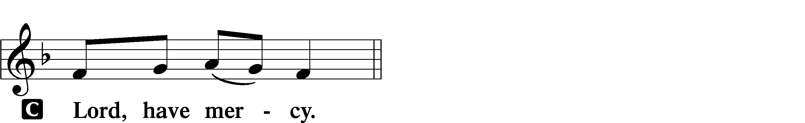

A For the peace from above and for our salvation let us pray to the Lord.
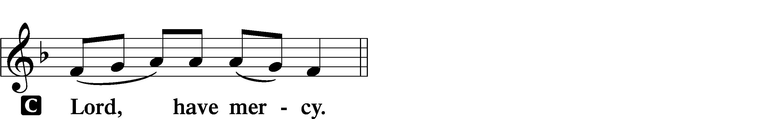
A For the peace of the whole world, for the well-being of the Church of God, and for the unity of all let us pray to the Lord.
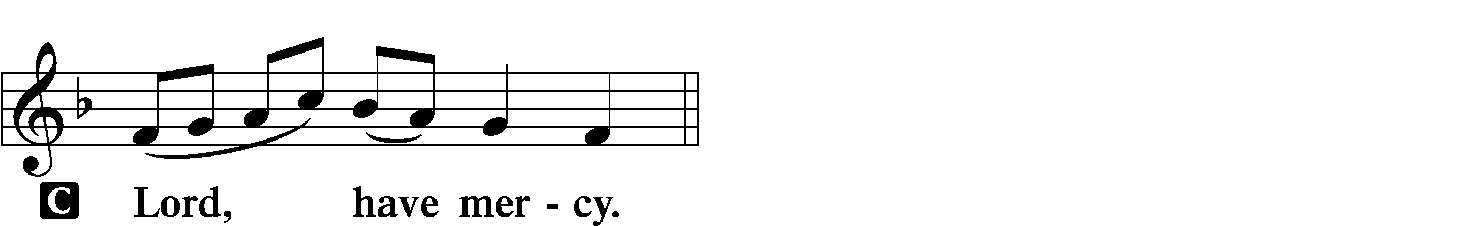

A For this holy house and for all who offer here their worship and praise let us pray to the Lord.
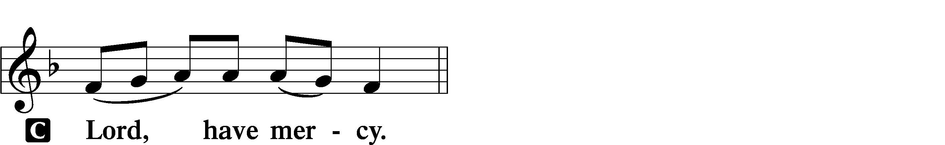

A Help, save, comfort, and defend us, gracious Lord.

This Is the Feast LSB 155
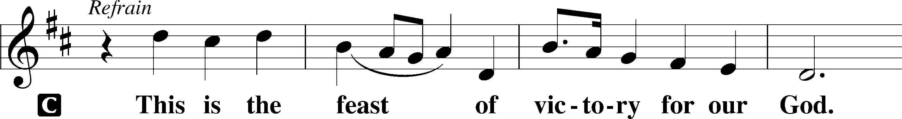
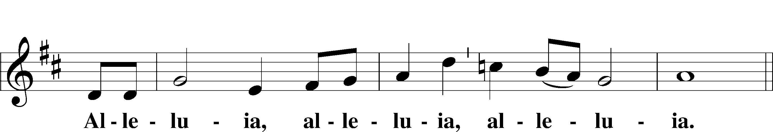
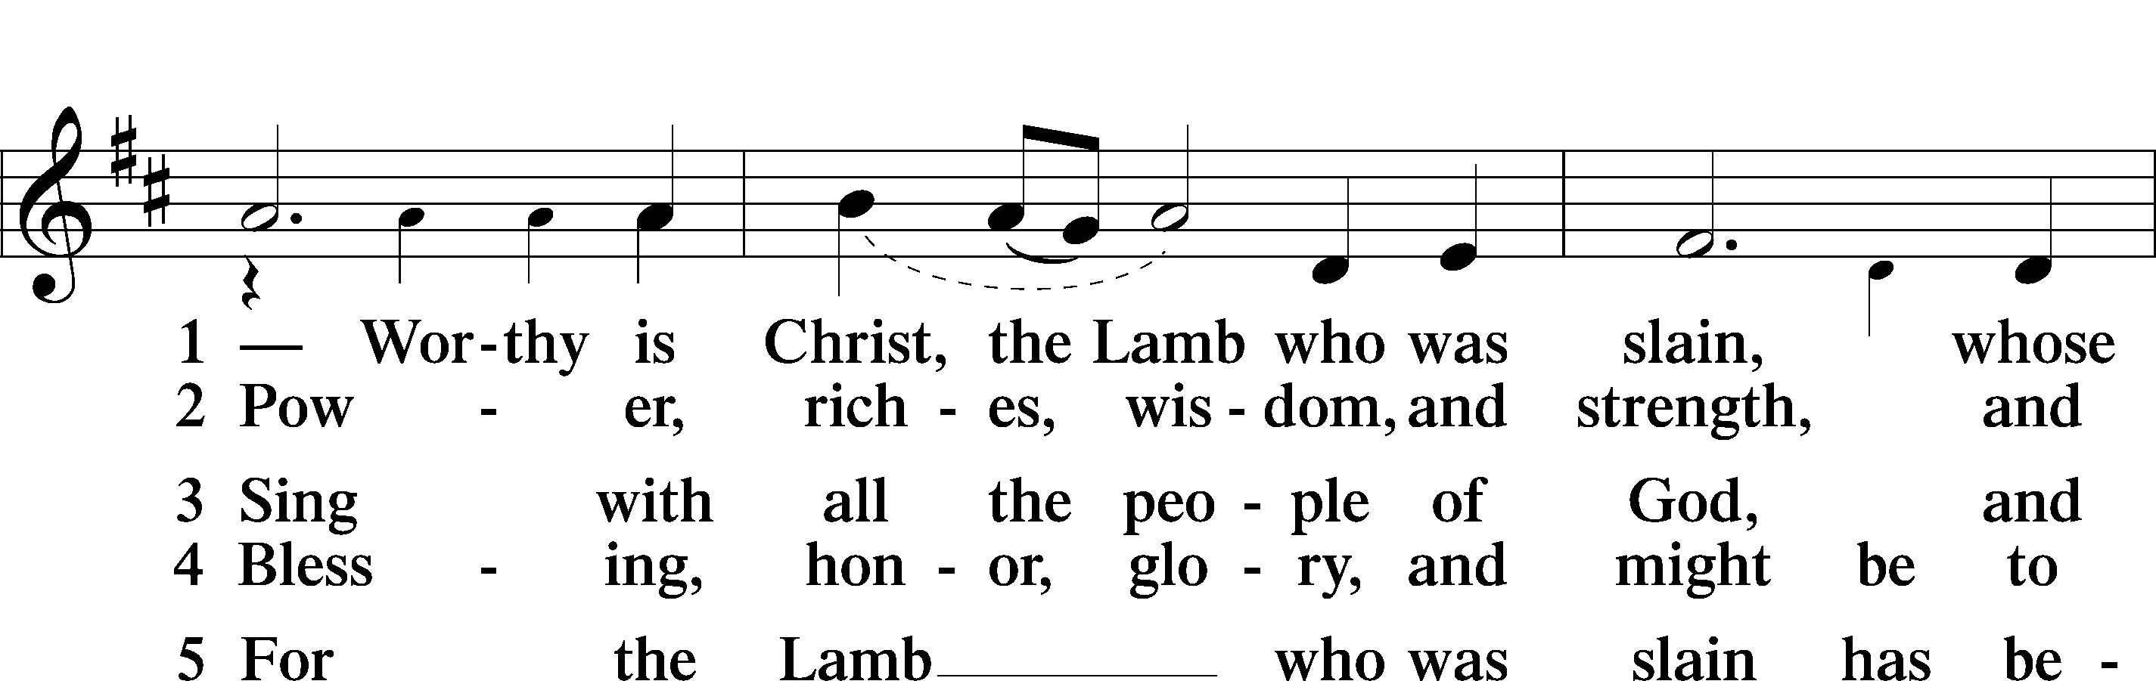
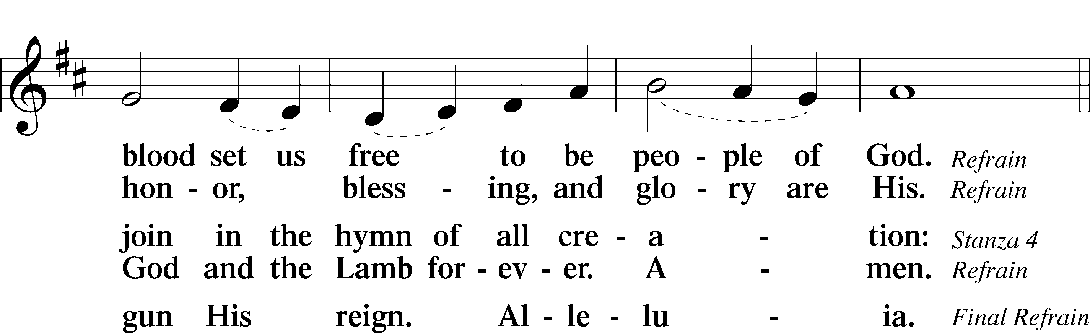
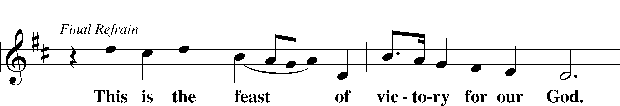
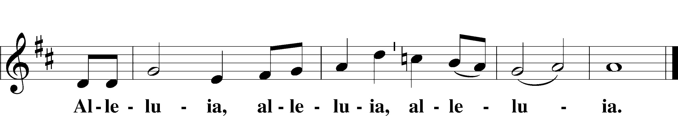

Salutation and Collect of the Day
P The Lord be with you.
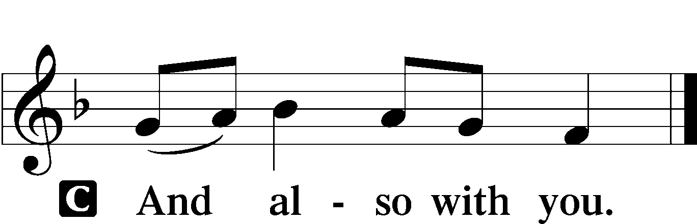

P Let us pray.
C O King of glory, Lord of hosts, uplifted in triumph far above all heavens, leave us not without consolation but send us the Spirit of truth whom You promised from the Father; for You live and reign with Him and the Holy Spirit, one God, now and forever. Amen.

Sit

First Reading Acts 1:12–26
12Then [the apostles] returned to Jerusalem from the mount called Olivet, which is near Jerusalem, a Sabbath day’s journey away.
13And when they had entered, they went up to the upper room,
where they were staying, Peter and John and James and Andrew, Philip and Thomas, Bartholomew and Matthew, James the son of Alphaeus and Simon the Zealot and Judas the son of James.
14All these with one accord were devoting themselves to prayer, together with the women and Mary the mother of Jesus, and his brothers.
15In those days Peter stood up among the brothers (the company of persons was in all about 120) and said, 16“Brothers, the Scripture had to be fulfilled, which the Holy Spirit spoke beforehand by the mouth of David concerning Judas, who became a guide to those who arrested Jesus. 17For he was numbered among us and was allotted his share in this ministry.”
18(Now this man bought a field with the reward of his wickedness, and falling headlong he burst open in the middle and all his bowels gushed out. 19And it became known to all the inhabitants of Jerusalem, so that the field was called in their own language Akeldama, that is, Field of Blood.) 20“For it is written in the Book of Psalms,
“‘May his camp become desolate,
and let there be no one to dwell in it’;
and
“‘Let another take his office.’
21So one of the men who have accompanied us during all the time that the Lord Jesus went in and out among us, 22beginning from the baptism of John until the day when he was taken up from us—one of these men must become with us a witness to his resurrection.”
23And they put forward two, Joseph called Barsabbas, who was also called Justus, and Matthias. 24And they prayed and said, “You, Lord, who know the hearts of all, show which one of these two you have chosen 25to take the place in this ministry and apostleship from which Judas turned aside to go to his own place.” 26And they cast lots for them, and the lot fell on Matthias, and he was numbered with the eleven apostles.

A This is the Word of the Lord.
C Thanks be to God.

Gradual adapt. from Matthew 28:7; Hebrews 2:7; Psalm 8:6
Christ has risen from the dead.
[God the Father] has crowned him with glory and honor.
He has given him dominion over the works of his hands;
he has put all things under his feet.

Epistle 1 Peter 4:12–19; 5:6–11
12Beloved, do not be surprised at the fiery trial when it comes upon you to test you, as though something strange were happening to you. 13But rejoice insofar as you share Christ’s sufferings, that you may also rejoice and be glad when his glory is revealed. 14If you are insulted for the name of Christ, you are blessed, because the Spirit of glory and of God rests upon you. 15But let none of you suffer as a murderer or a thief or an evildoer or as a meddler. 16Yet if anyone suffers as a Christian, let him not be ashamed, but let him glorify God in that name. 17For it is time for judgment to begin at the household of God; and if it begins with us, what will be the outcome for those who do not obey the gospel of God? 18And
“If the righteous is scarcely saved,
what will become of the ungodly and the sinner?”
19Therefore let those who suffer according to God’s will entrust their souls to a faithful Creator while doing good. . . .
6Humble yourselves, therefore, under the mighty hand of God so that at the proper time he may exalt you, 7casting all your anxieties on him, because he cares for you. 8Be sober-minded; be watchful. Your adversary the devil prowls around like a roaring lion, seeking someone to devour. 9Resist him, firm in your faith, knowing that the same kinds of suffering are being experienced by your brotherhood throughout the world. 10And after you have suffered a little while,
the God of all grace, who has called you to his eternal glory in Christ, will himself restore, confirm, strengthen, and establish you. 11To him be the dominion forever and ever. Amen.

A This is the Word of the Lord.
C Thanks be to God.

Stand

Alleluia and Verse LSB 156
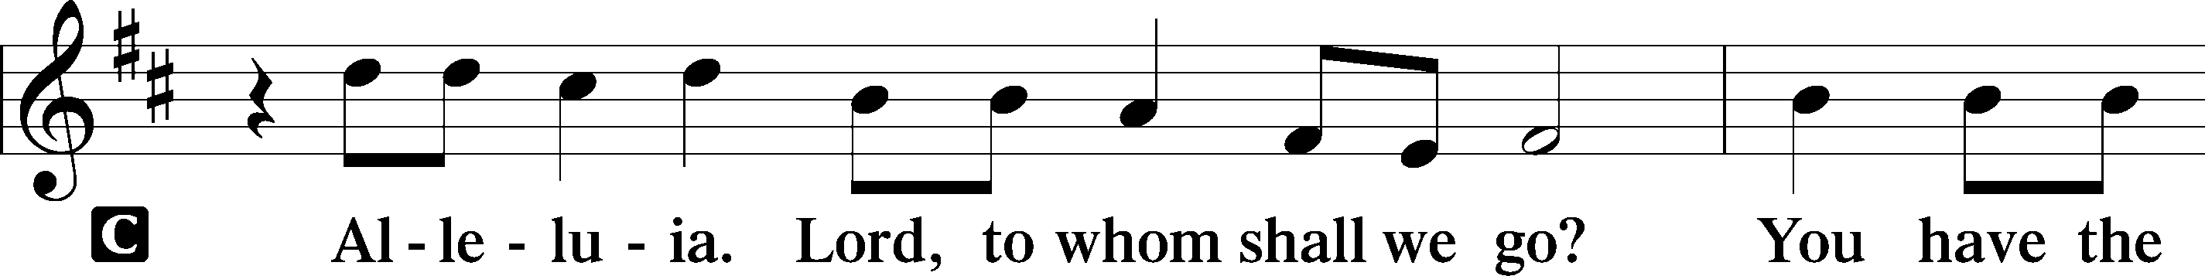
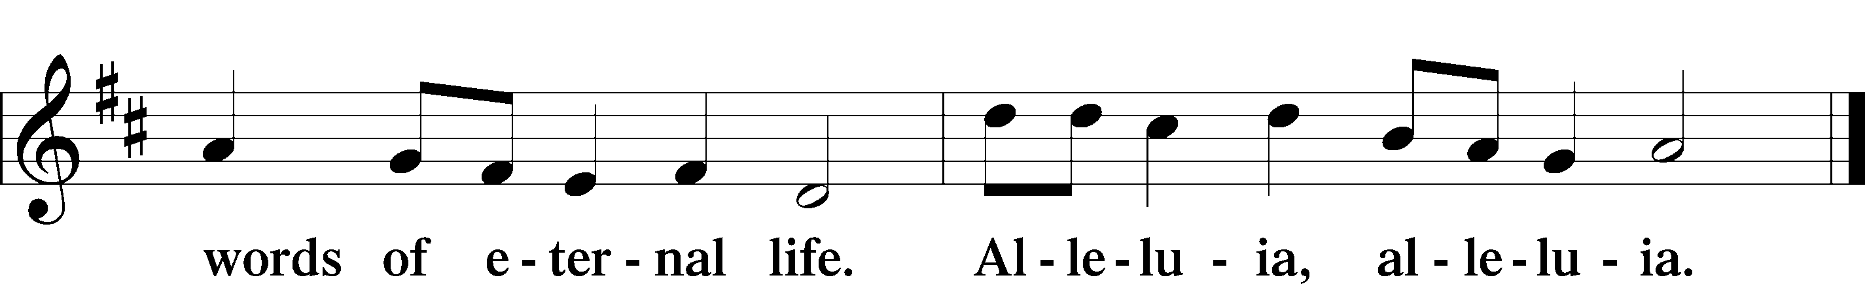

Holy Gospel John 17:1–11
P The Holy Gospel according to St. John, the seventeenth chapter.

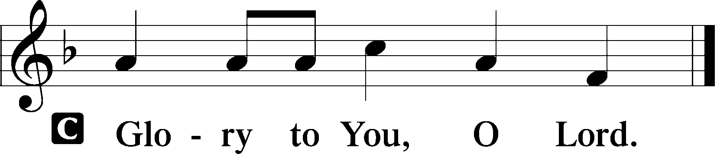

1When Jesus had spoken these words, he lifted up his eyes to heaven, and said, “Father, the hour has come; glorify your Son that the Son may glorify you, 2since you have given him authority over all flesh, to give eternal life to all whom you have given him. 3And this is eternal life, that they know you the only true God, and Jesus Christ whom you have sent. 4I glorified you on earth, having accomplished the work that you gave me to do. 5And now, Father, glorify me in your own presence with the glory that I had with you before the world existed.
6“I have manifested your name to the people whom you gave me out of the world. Yours they were, and you gave them to me, and they have kept your word. 7Now they know that everything that you have given me is from you. 8For I have given them the words that you gave me, and they have received them and have come to know in truth that I came from you; and they have believed that you sent me. 9I am praying for them. I am not praying for the world but for those whom you have given me, for they are yours. 10All mine are yours, and yours are mine, and I am glorified in them.
11And I am no longer in the world, but they are in the world, and I am coming to you. Holy Father, keep them in your name, which you have given me, that they may be one, even as we are one.”

P This is the Gospel of the Lord.

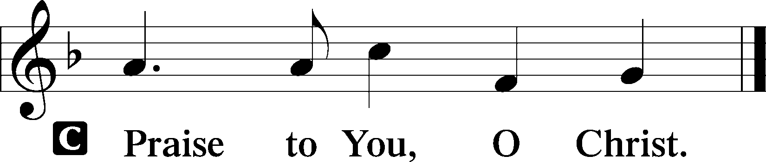

Apostles’ Creed
C I believe in God, the Father Almighty,
maker of heaven and earth.

And in Jesus Christ, His only Son, our Lord,
who was conceived by the Holy Spirit,
born of the virgin Mary,
suffered under Pontius Pilate,
was crucified, died and was buried.
He descended into hell.
The third day He rose again from the dead.
He ascended into heaven
and sits at the right hand of God the Father Almighty.
From thence He will come to judge the living and the dead.

I believe in the Holy Spirit,
the holy Christian Church,
the communion of saints,
the forgiveness of sins,
the resurrection of the body,
and the life T everlasting. Amen.

Sit
Children's Message

Hymn of the Day “Rejoice, O Pilgrim Throng” LSB 813
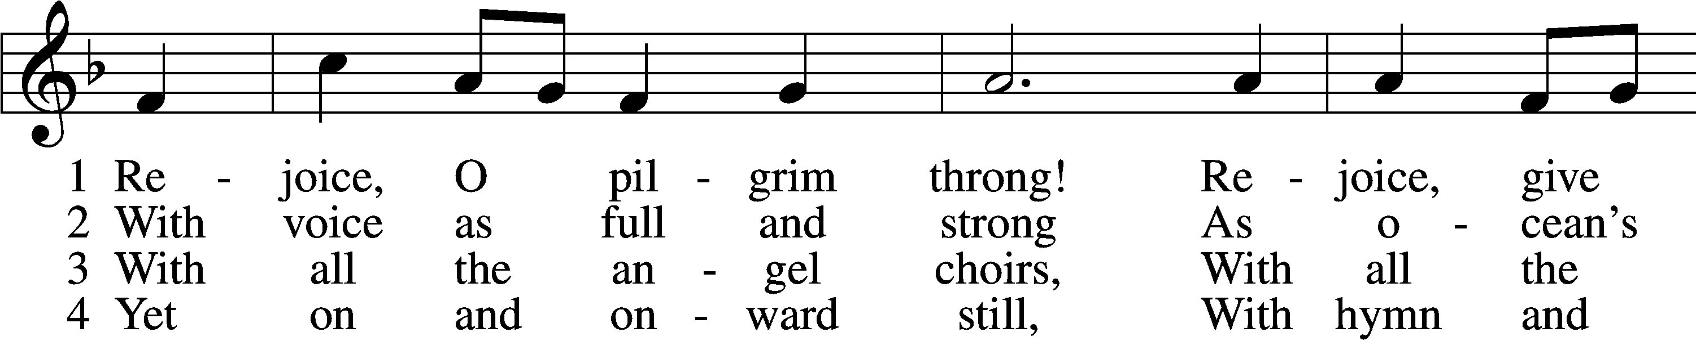
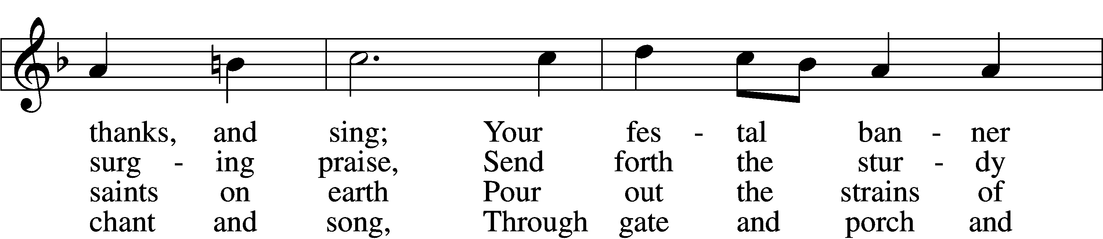
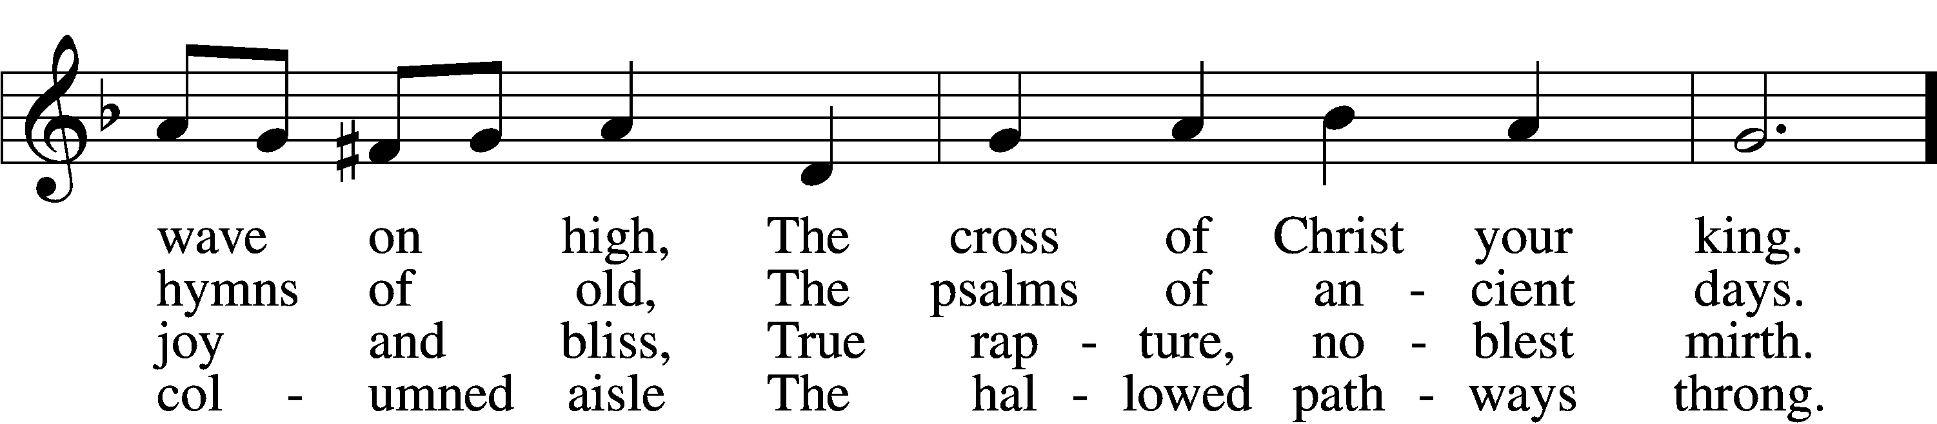
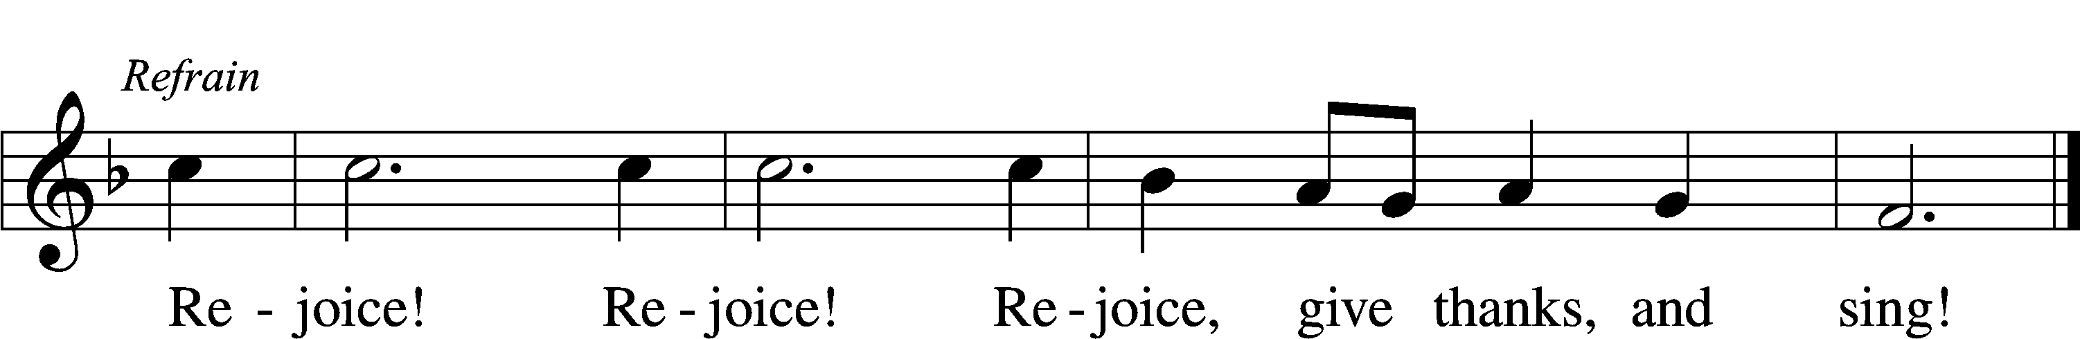

5 Still lift your standard high,
Still march in firm array,
As pilgrims through the darkness wend
Till dawns the golden day. Refrain

6 At last the march shall end;
The wearied ones shall rest;
The pilgrims find their home at last,
Jerusalem the blest. Refrain

D 7 Praise Him who reigns on high,
The Lord whom we adore:
The Father, Son, and Holy Ghost,
One God forevermore. Refrain
Text: Edward H. Plumptre, 1821–91, alt.
Tune: Arthur H. Messiter, 1834–1916
Text and tune: Public domain

Confirmand Presentation of Essay

Sermon

+RITE OF CONFIRMATION+
Confirmation LSB 272

Stand
Prayer of the Church

Sit
Offering

Stand

Offertory Hymn “He Is Arisen! Glorious Word” LSB 488
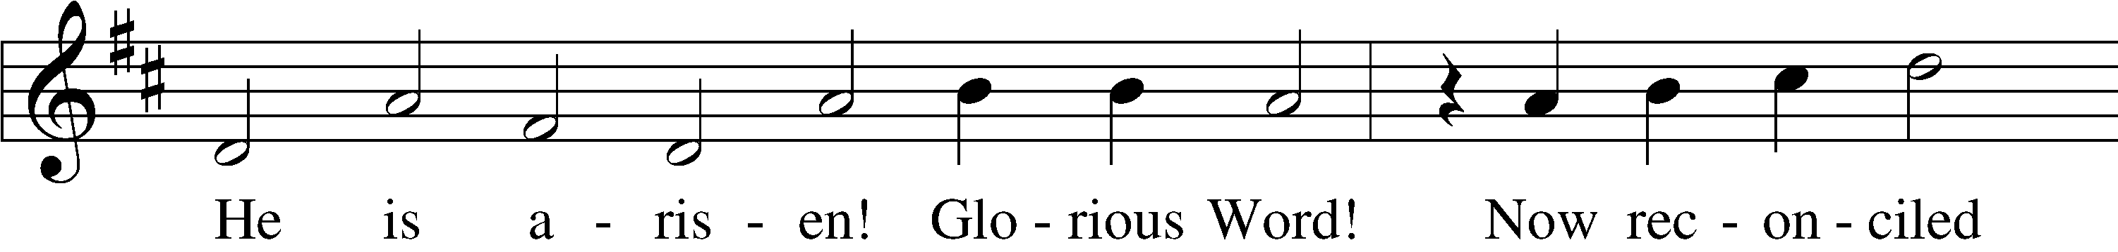
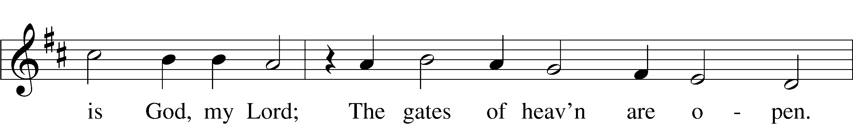
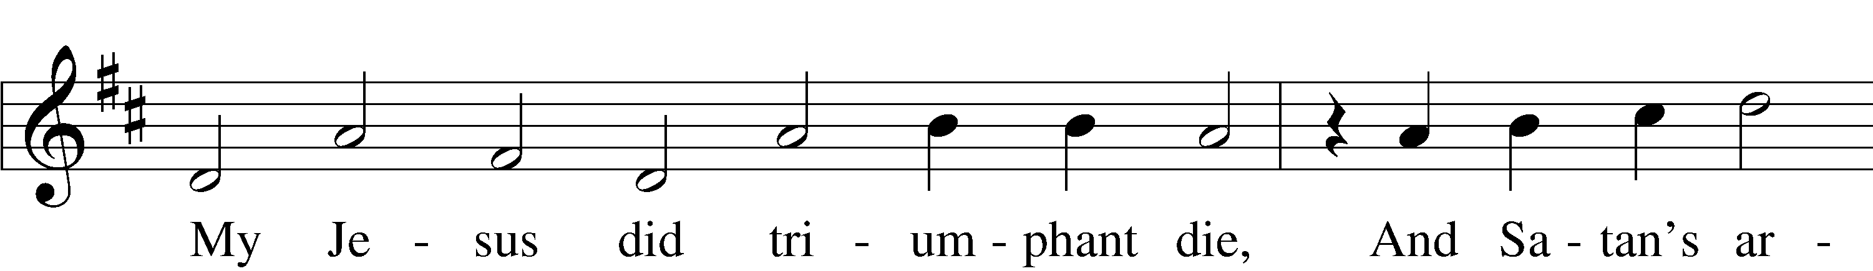
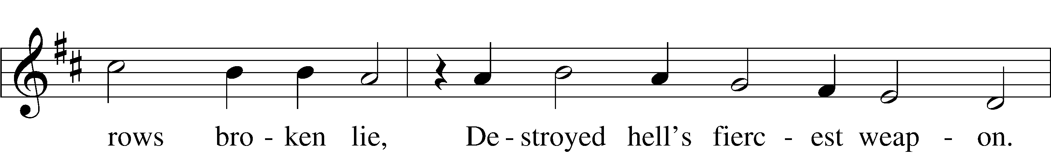
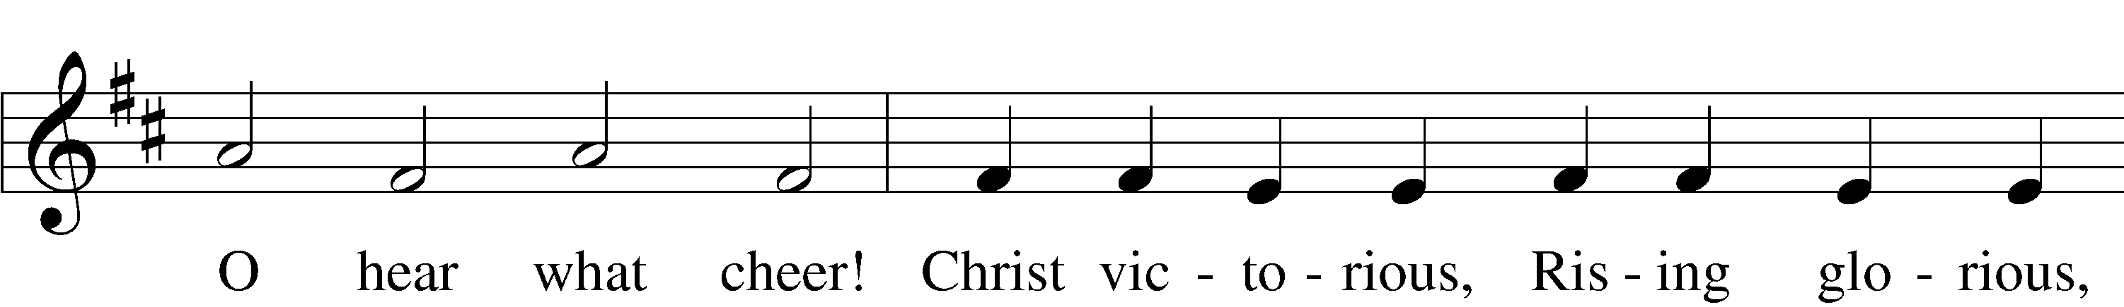
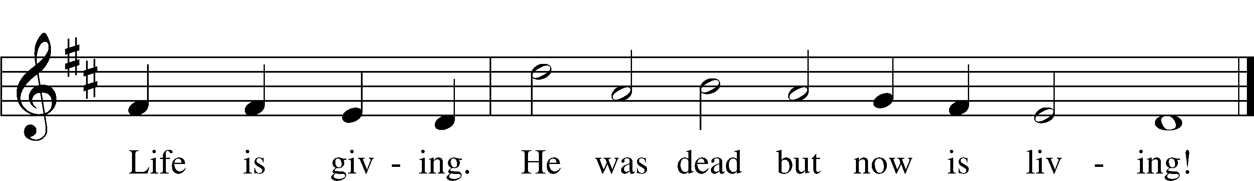
Text: Birgitte Katerine Boye, 1742–1824; tr. George A. T. Rygh, 1860–1942, alt.
Tune: Philipp Nicolai, 1556–1608
Text and tune: Public domain

+SERVICE OF THE SACRAMENT+

Preface LSB 160
P The Lord be with you.
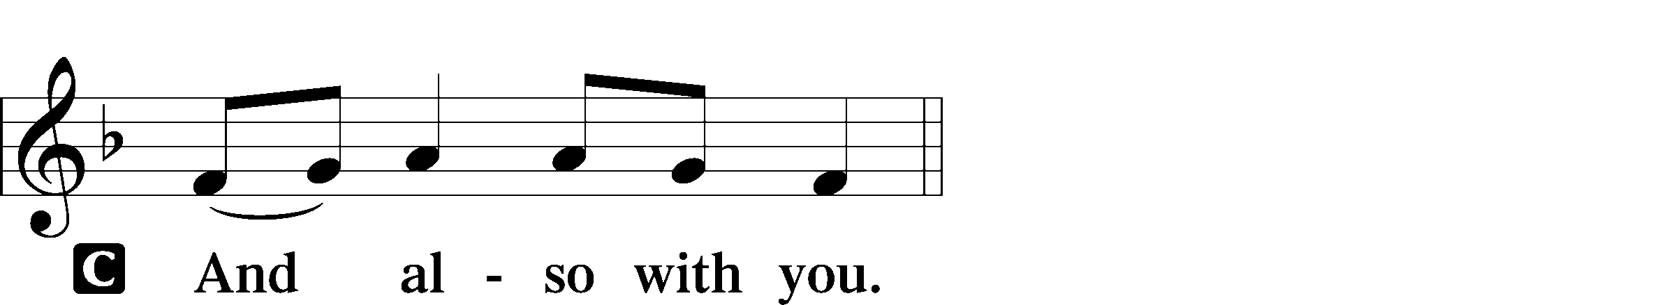

P Lift up your hearts.

P Let us give thanks to the Lord our God.
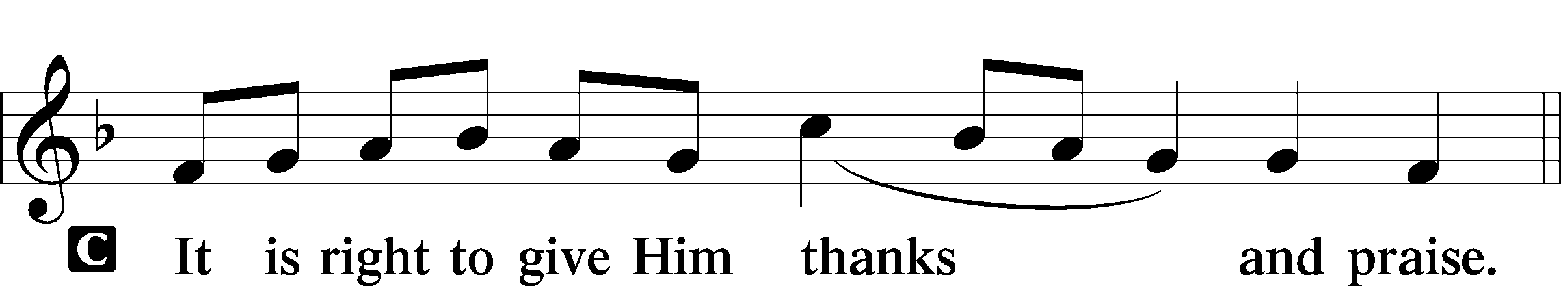

Proper Preface
P It is truly good, right, and salutary that we should at all times and in all places give thanks to You, holy Lord, almighty Father, everlasting God, through Jesus Christ, our Lord, who after His resurrection appeared openly to all His disciples and in their sight was taken up into heaven that He might make us partakers of His divine life. Therefore with angels and archangels and with all the company of heaven we laud and magnify Your glorious name, evermore praising You and saying:

Sanctus LSB 161
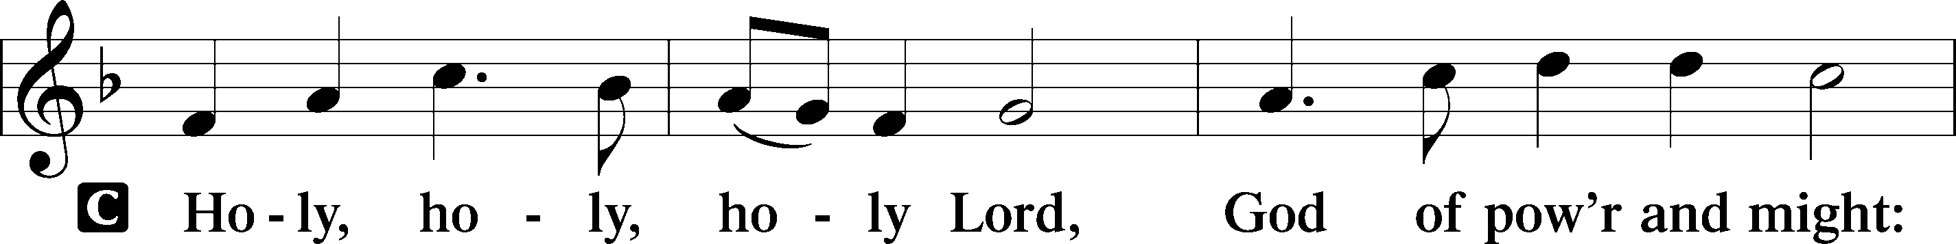
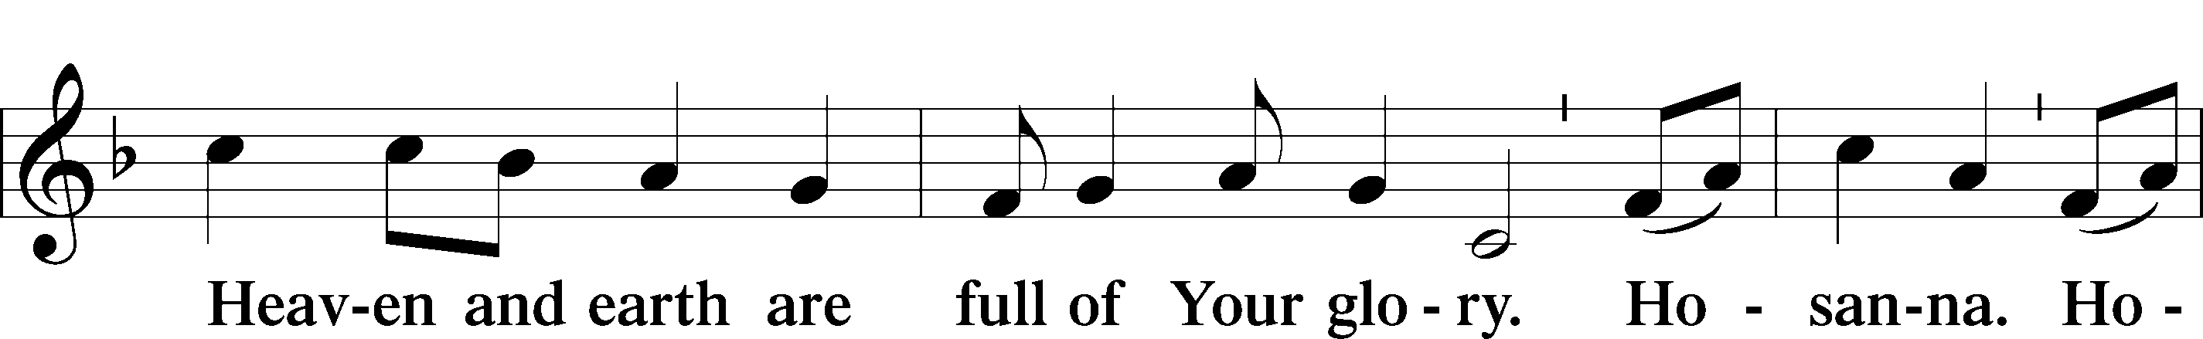
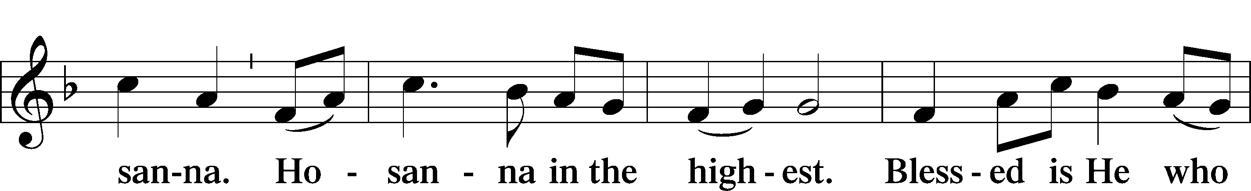
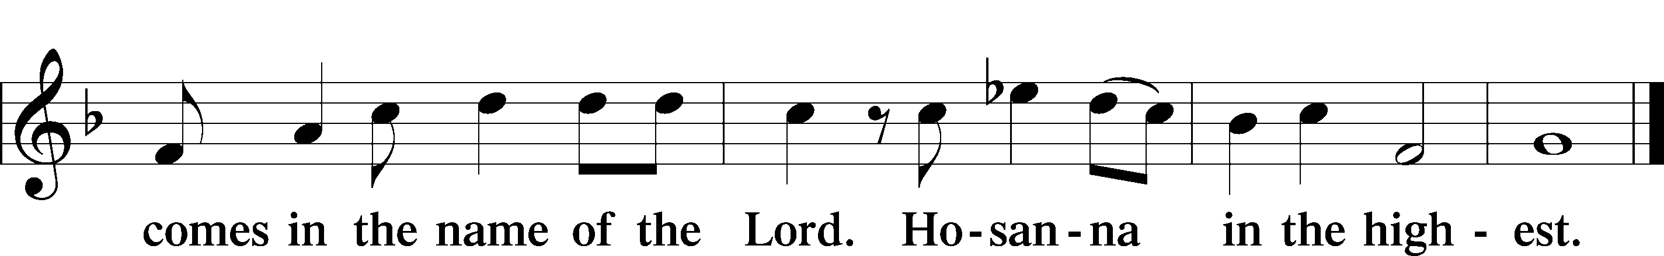

Prayer of Thanksgiving LSB 161
P Blessed are You, Lord of heaven and earth, for You have had mercy on those whom You created and sent Your only-begotten Son into our flesh to bear our sin and be our Savior. With repentant joy we receive the salvation accomplished for us by the all-availing sacrifice of His body and His blood on the cross.

Gathered in the name and the remembrance of Jesus, we beg You, O Lord, to forgive, renew, and strengthen us with Your Word and Spirit. Grant us faithfully to eat His body and drink His blood as He bids us do in His own testament. Gather us together, we pray, from the ends of the earth to celebrate with all the faithful the marriage feast of the Lamb in His kingdom, which has no end. Graciously receive our prayers; deliver and preserve us. To You alone, O Father, be all glory, honor, and worship, with the Son and the Holy Spirit, one God, now and forever.
C Amen.
Lord’s Prayer
C Our Father who art in heaven,
hallowed be Thy name,
Thy kingdom come,
Thy will be done on earth
as it is in heaven;
give us this day our daily bread;
and forgive us our trespasses
as we forgive those
who trespass against us;
and lead us not into temptation,
but deliver us from evil.
For Thine is the kingdom
and the power and the glory
forever and ever. Amen.

The Words of Our Lord
P Our Lord Jesus Christ, on the night when He was betrayed, took bread, and when He had given thanks, He broke it and gave it to the disciples and said: “Take, eat; this is My T body, which is given for you. This do in remembrance of Me.”

In the same way also He took the cup after supper, and when He had given thanks, He gave it to them, saying: “Drink of it, all of you; this cup is the new testament in My T blood, which is shed for you for the forgiveness of sins. This do, as often as you drink it, in remembrance of Me.”

Pax Domini LSB 163
P The peace of the Lord be with you always.
Agnus Dei LSB 163
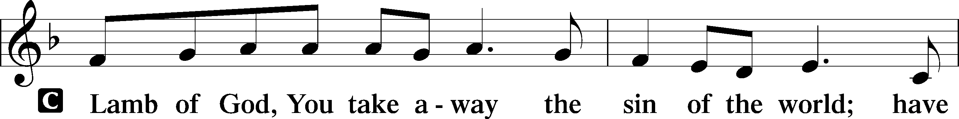
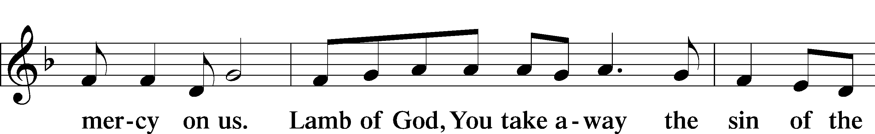
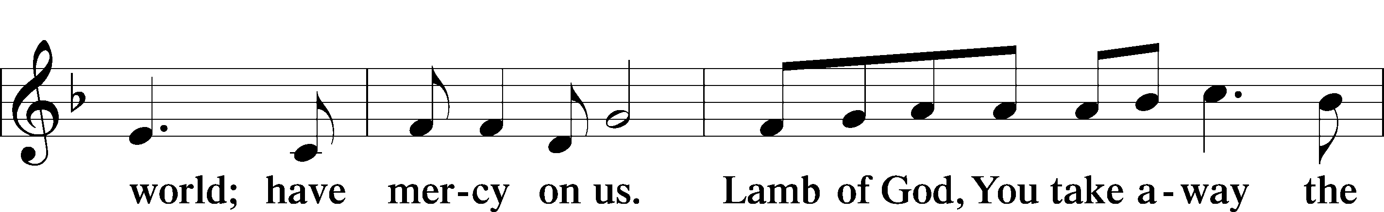
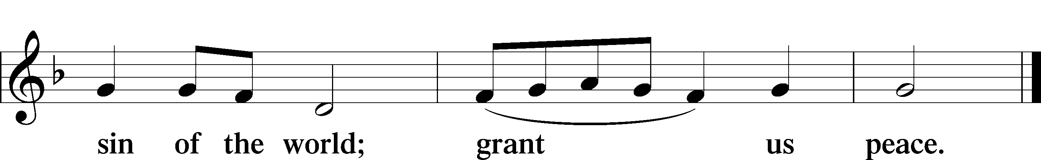

Sit

Distribution

The Confirmand and her family will commune together first. Once the family has communed, the congregation is invited to the Lord's table.

Distribution Hymn “Draw Near and Take the Body of the Lord”
LSB 637
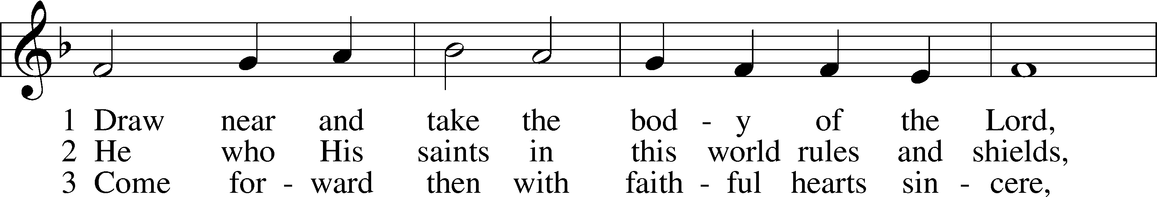
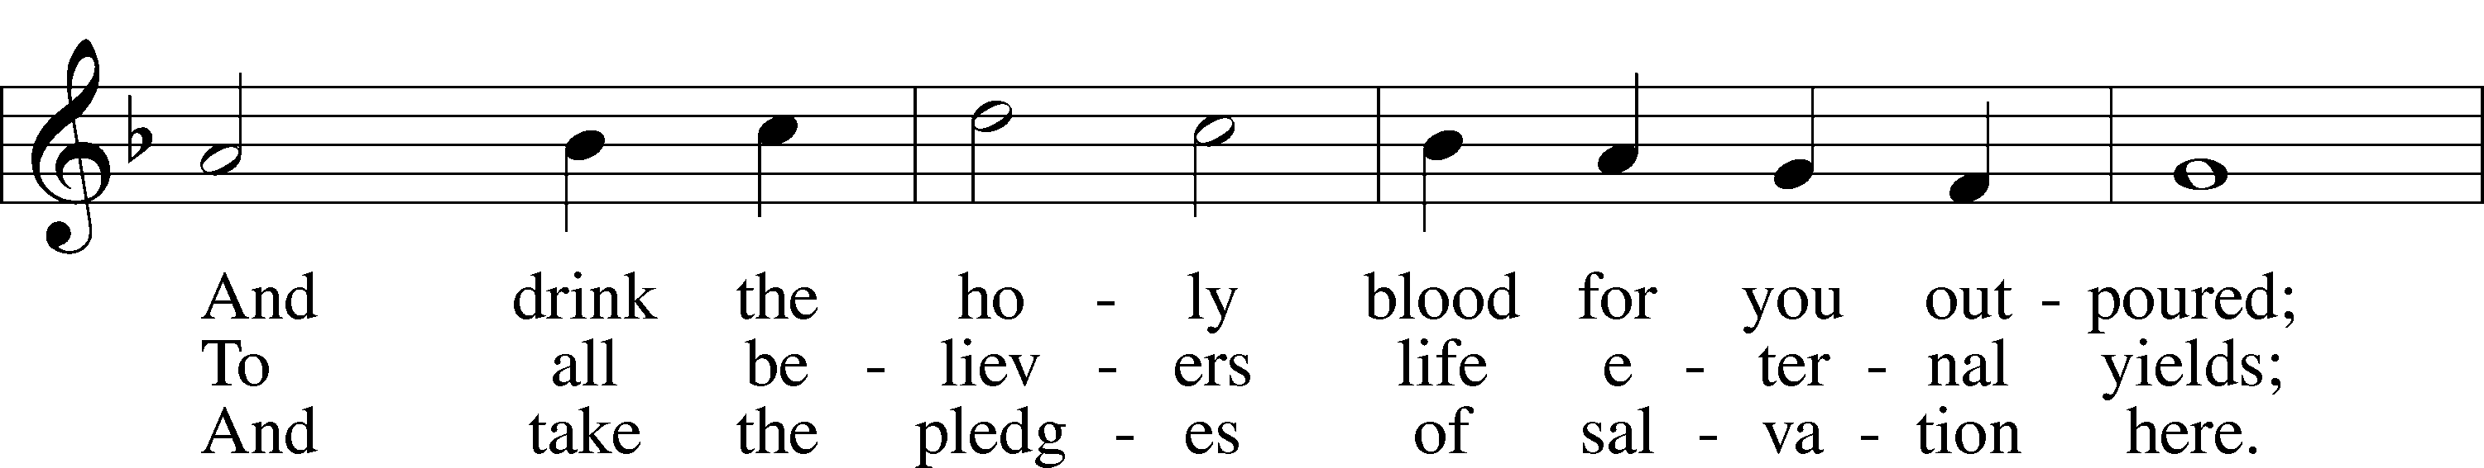
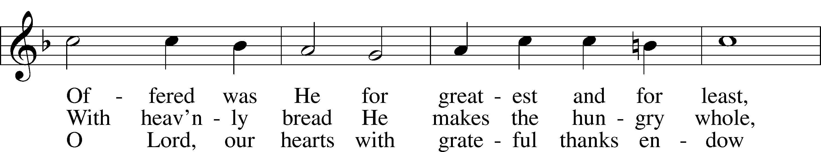
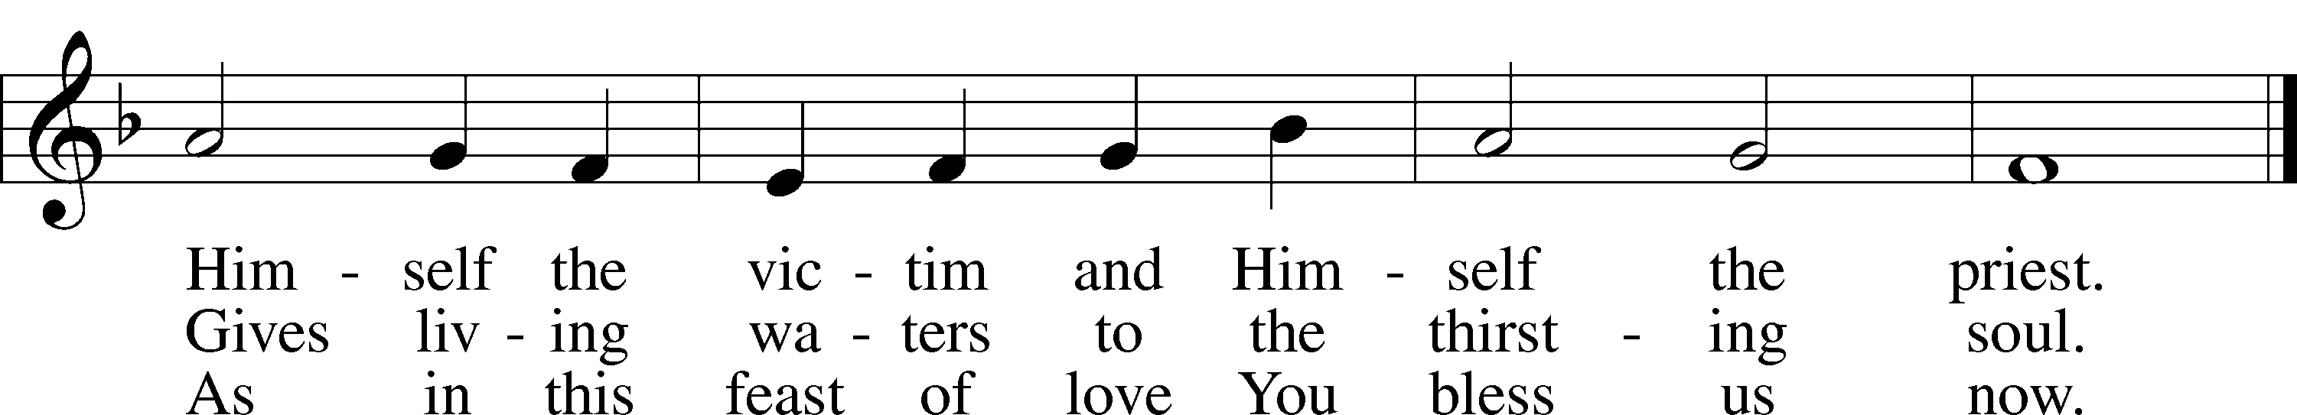
Text: Latin, 7th cent.; tr. John Mason Neale, 1818–66, alt.
Tune: Trente quatre Pseaumes de David, 1551, Geneva, ed. Louis Bourgeois
Text and tune: Public domain

Distribution Hymn “O Lord, We Praise Thee” LSB 617
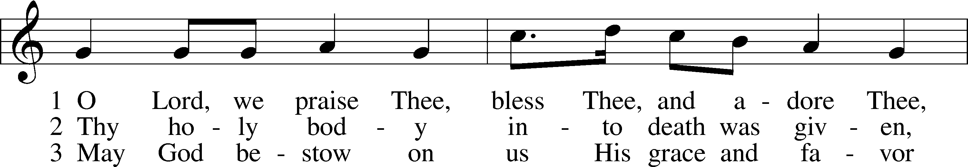
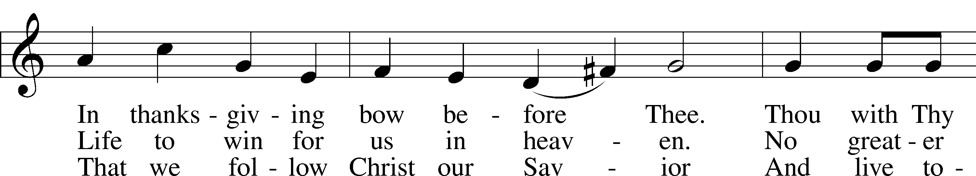
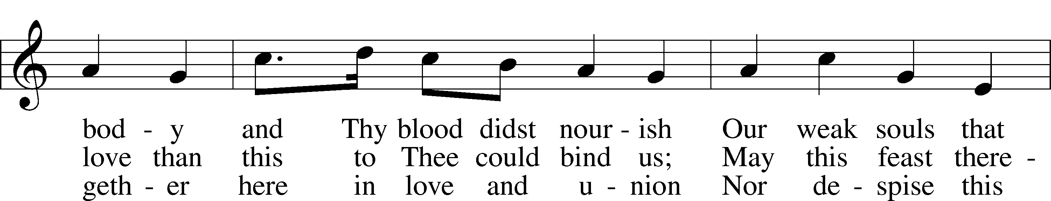
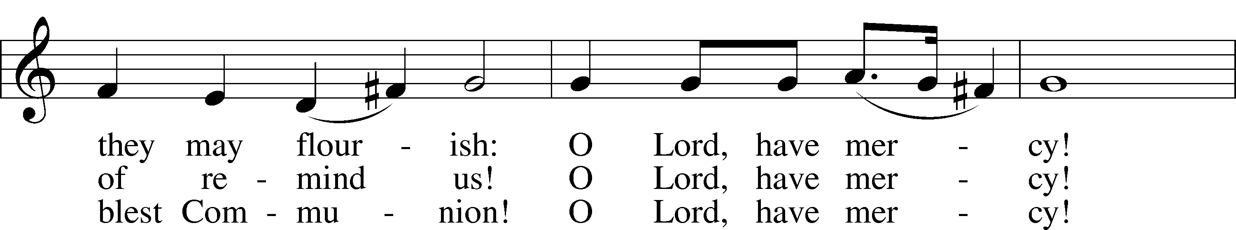
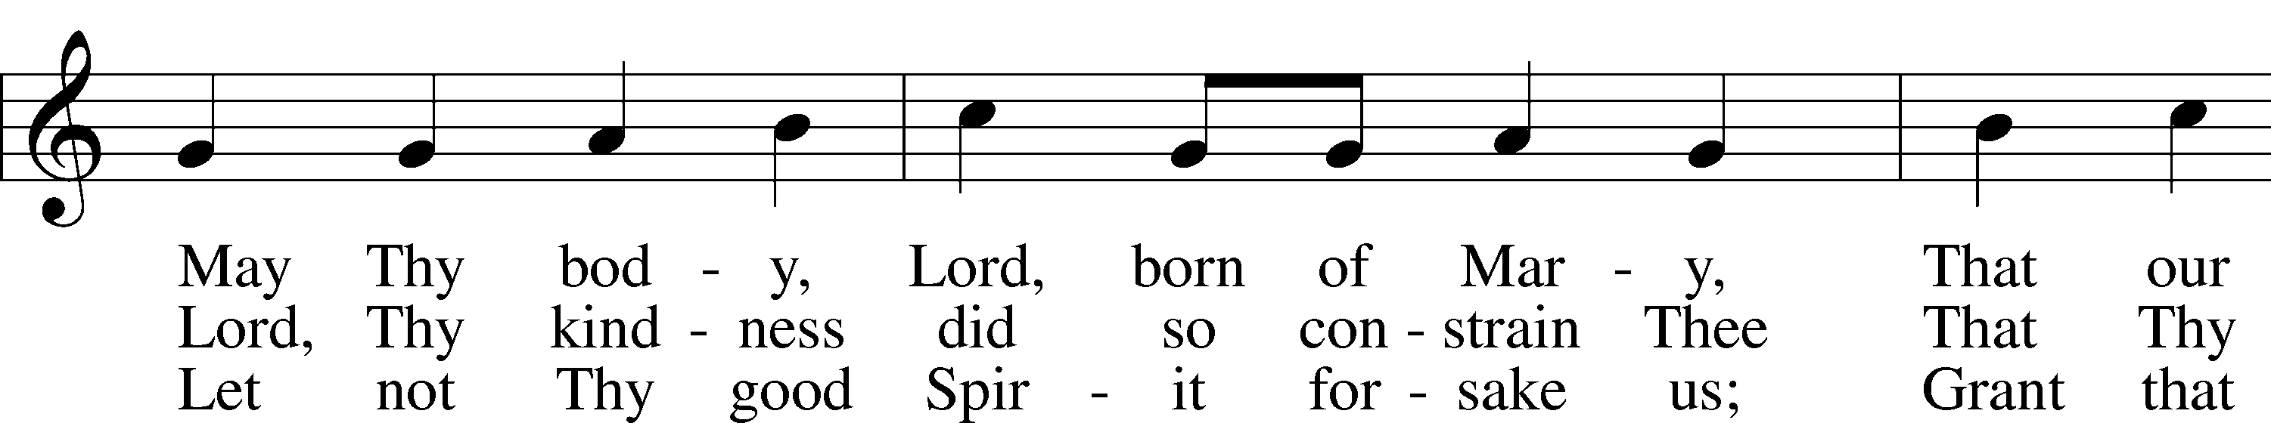
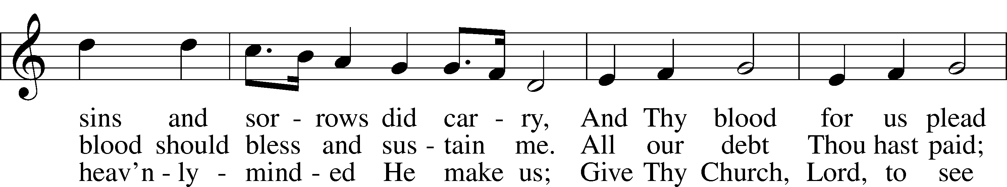
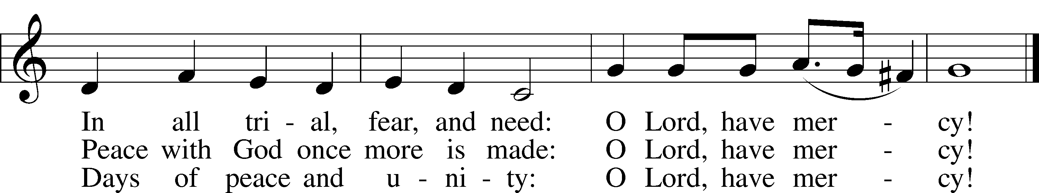
Text: tr. The Lutheran Hymnal, 1941, alt.; (st. 1): German, 14th cent.; (sts. 2–3): Martin Luther, 1483–1546
Tune: Geystliche gesangk Buchleyn, 1524, Wittenberg, ed. Johann Walter
Text: © 1941 Concordia Publishing House. Used by permission: LSB Hymn License no. 110016438
Tune: Public domain

Stand

Post-Communion Hymn “O Jesus, Blessed Lord, to Thee” LSB 632
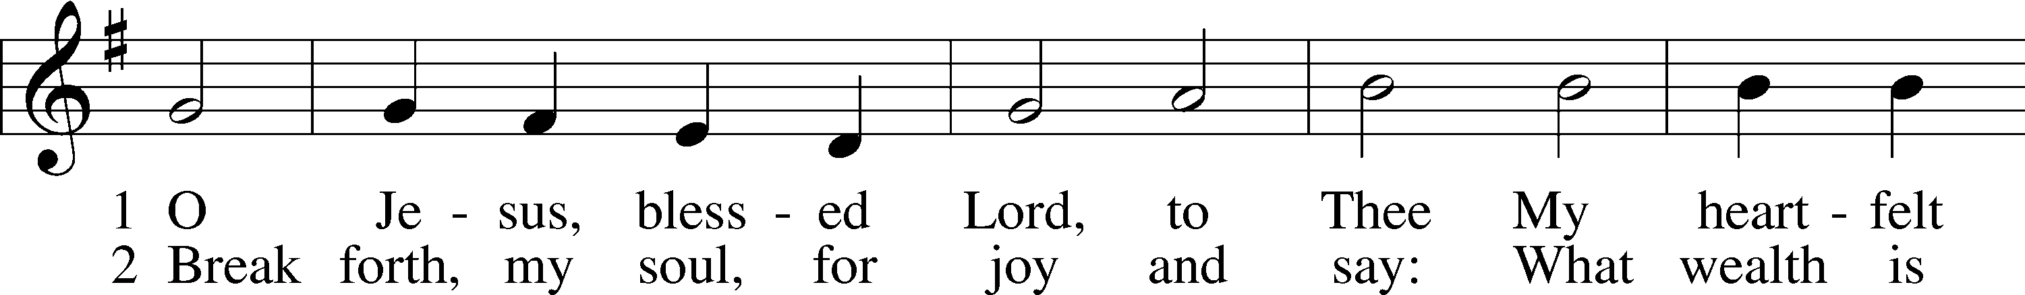
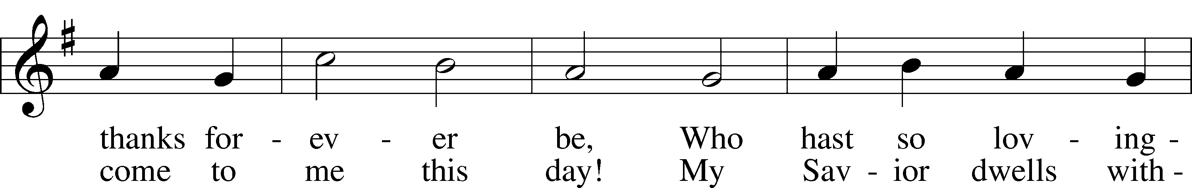
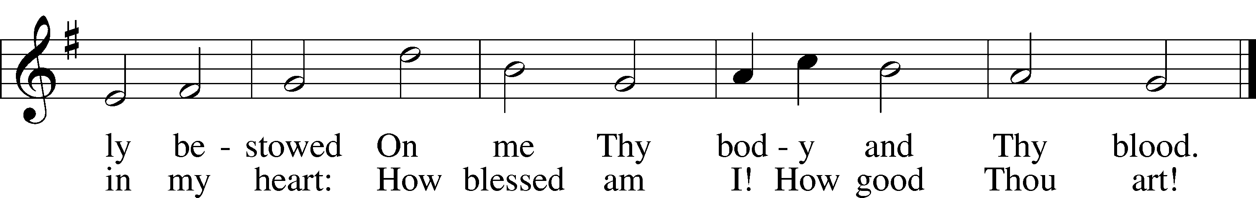
Text: Thomas Hansen Kingo, 1634–1703; tr. Arthur J. Mason, 1851–1928
Tune: Trente quatre Pseaumes de David, 1551, Geneva, ed. Louis Bourgeois
Text and tune: Public domain

Post-Communion Collect
A Let us pray.
We give thanks to You, almighty God, that You have refreshed us through this salutary gift, and we implore You that of Your mercy You would strengthen us through the same in faith toward You and in fervent love toward one another; through Jesus Christ, Your Son, our Lord, who lives and reigns with You and the Holy Spirit, one God, now and forever.
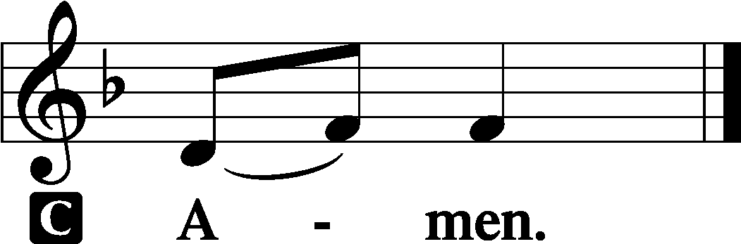

Benediction LSB 166
P The Lord bless you and keep you.
The Lord make His face shine on you and be gracious to you.
The Lord look upon you with favor and T give you peace.
Closing Hymn “In Thee Is Gladness” LSB 818
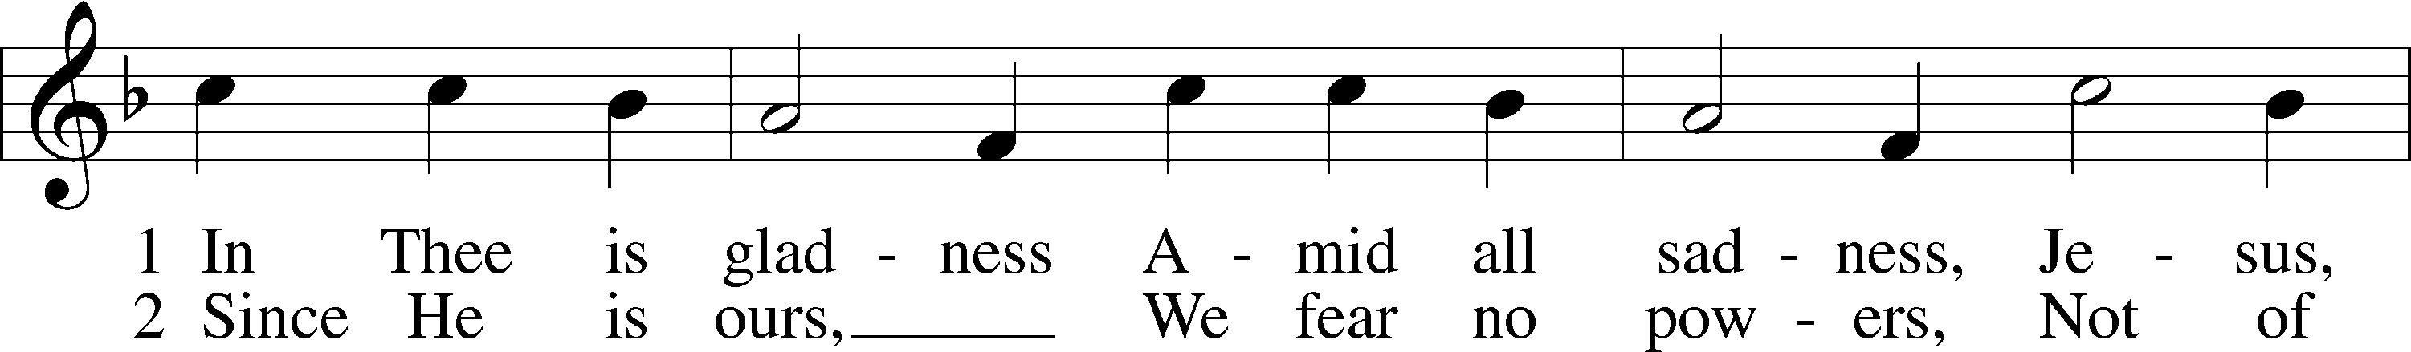
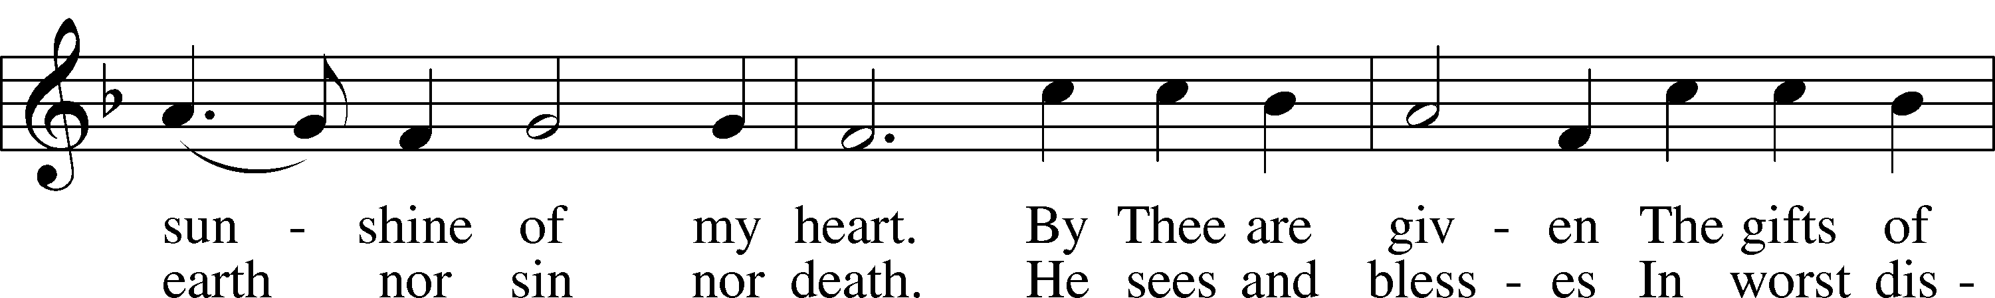
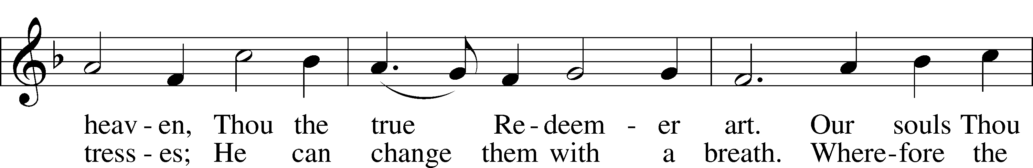
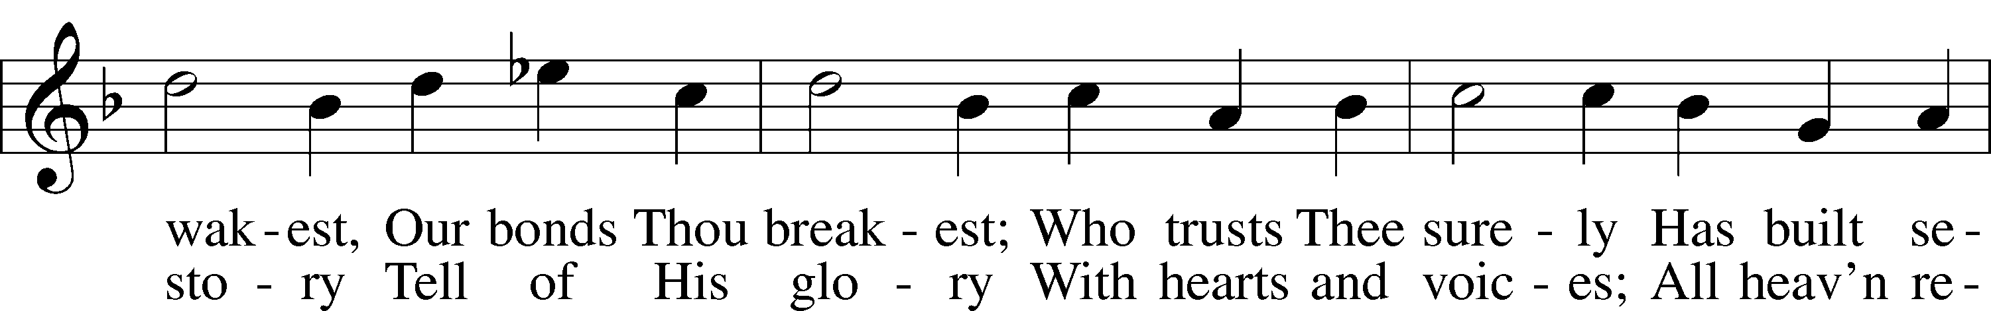
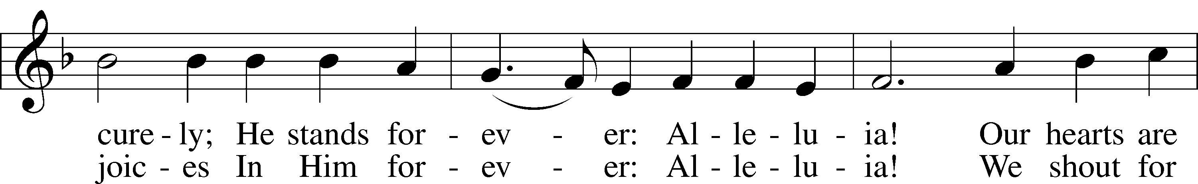
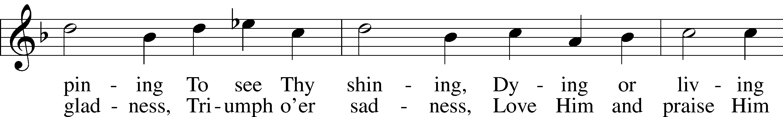
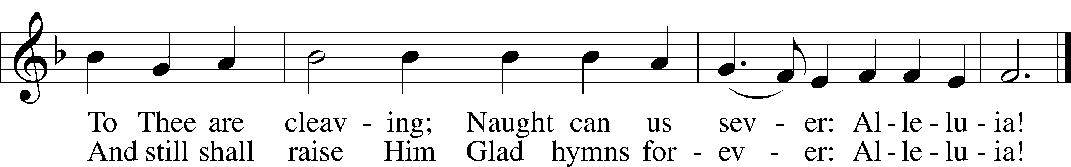
Text: Johann Lindemann, 1549–1631; tr. Catherine Winkworth, 1827–78, alt.
Tune: Giovanni Giacomo Gastoldi, c. 1556–c. 1622
Text and tune: Public domain

Acknowledgments
Unless otherwise indicated, Scripture quotations are from the ESV® Bible (The Holy Bible, English Standard Version®), copyright © 2001 by Crossway, a publishing ministry of Good News Publishers. Used by permission. All rights reserved.
Created by Lutheran Service Builder © 2023 Concordia Publishing House.

Serving Our Lord in His House Today:
Pastor: Rev. Bert Thompson
Organist: David Moseley
Elders: Josh Church & Jake Mallmann
Dillin Lafferty (Wed.)

Gifts from God: 1 Peter 5:7 – “Humble yourselves, therefore, under the mighty hand of God so that at the proper time he may exalt you, casting all your anxieties on him, because he cares for you.” We have a Father in heaven who really cares for us and loves us. That is the basis of generosity, because such knowledge spells the end of worry, which is the source of all tightfisted greed.

Confirmation: Today we rejoice to celebrate the Confirmation of Faith of our youth member, Alyssa Krings. We pray that our gracious Lord continues to bless and guide you throughout your life!

Altar Flowers: Are placed today by Good Shepherd in Celebration of our confirmand, Alyssa Krings. God’s blessings to you all on this special day.

Orphan Grain Train: If you wish to assist the Orphan Grain Train with sorting and packing at the Reedsburg location on Tuesday, May 23, 2023, please contact Sylvia Engel 608-343-9645.

Prayer for calling a faithful pastor:
O Gracious Father, You led Your holy apostles to ordain ministers for the proclamation of Your Word and the faithful administration of the Sacraments of Christ. Grant to this congregation the guidance of the Holy Spirit to choose a suitable pastor according to Your will for the blessing of Your Church in this place; through Jesus Christ our Lord.

Our Worship attendance last week: Sunday: 62
Wednesday: 5
Total: 67

Scripture Lessons for next week: Numbers 11:24-30
Acts 2:1-21
John 7:37-39

Secretary Office Hours: Monday-Friday: 8:15am-12:15pm

Our Week With Our Lord:
Today 9:00am Confirmation Sunday
Divine Service w/Holy Communion
(livestreamed via YouTube)
10:30am Adult Bible Study & Sunday School
Monday
Tuesday
Wednesday 7:00pm Divine Service
Thursday 11:30am B-day Lunch @Smitty’s
Friday
Saturday
Sunday 9:00am Divine Service w/Holy Communion (livestreamed via YouTube)
Confirmation Sunday
10:30am Adult Bible Study

*Please view the following page for weekly prayers*

HIS FLOCK AT PRAYER
Propers for the 7th Week of Easter

Psalm for the Week: Psalm 68:1-10

Daily Scripture Readings:
Sunday— John 15:26-16:4 Thursday—Isaiah 44:1-5
Monday— John 15:17-21 Friday—John 7:37-40
Tuesday—Psalm 62:1-8 Saturday—Joel 2:28-32
Wednesday—1 John 3:1-6

Collect for the Week:
O King of glory, Lord of hosts, uplifted in triumph far above all heavens, leave us
not without consolation but send us the Spirit of truth whom You promised from the
Father; for You live and reign with Him and the Holy Spirit, one God, now and
forever.

Hymn of the Week: “Rejoice, O Pilgrim Throng” LSB 813

Congregational Petitions for this Week:
+ For those whose work is difficult or dangerous including the military away from home, especially: Isaac Preuss, Erica Preuss, Joshua Ecker, Tania Adler.
+ For those who are ill or recovering, especially: Brenda Kolb, Shawn Zabinski,
Velma Lutz, Juliann Baxter, District President John Wille, Joyce Cain,
Jerry Quam, Randy Roehl, Peyton Foster, Dawn Hawkins, Jan Stampfli,
Margaret Palmer, Nick Anderson, Patti Hartwig, Mario Corrente, Lorie Walker,
Bob Pulley, Rayna Knutson.
+ For those who are home-bound, especially: John Fox, Darlene Griffin,
Lynda Goad, Roemelle McArdle, Sharon Herried, Muriel Finch.

