Good Shepherd Lutheran Church
The Day of Pentecost
May 28, 2023

Pre-Service Music & Welcome

Divine Service Setting One – Lutheran Service Book (LSB) 151

+CONFESSION AND ABSOLUTION+

Opening Hymn “Come, Holy Ghost, God and Lord” LSB 497
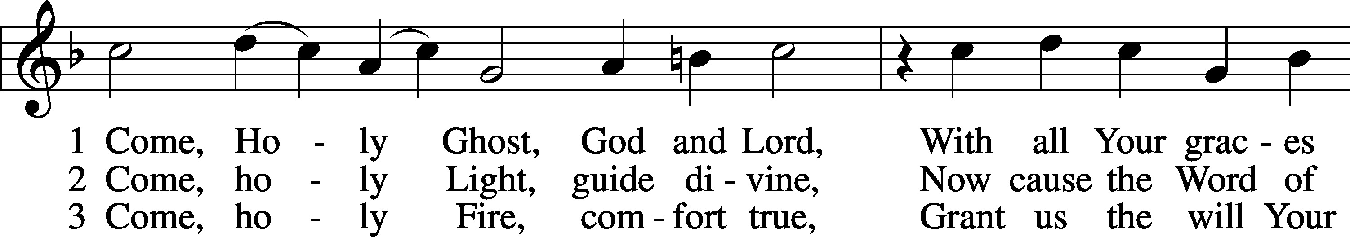
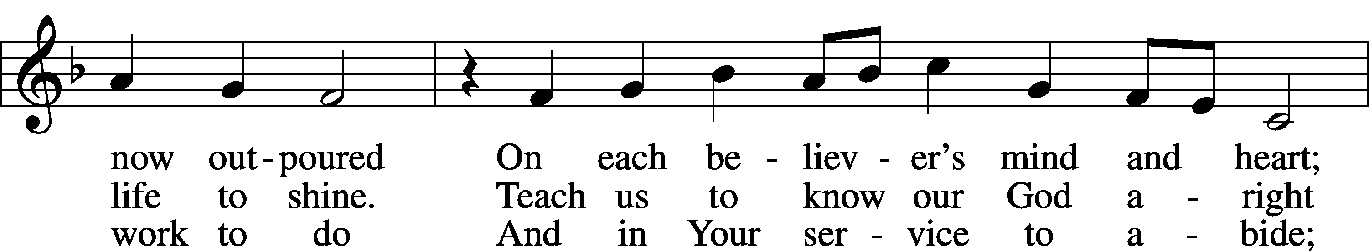
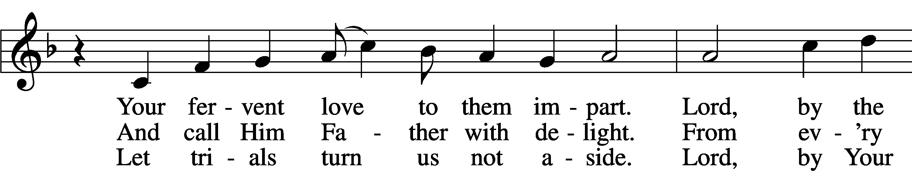
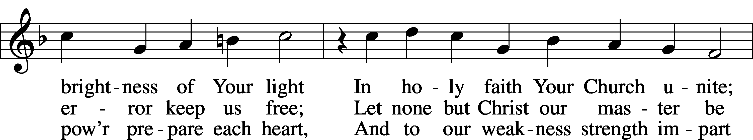
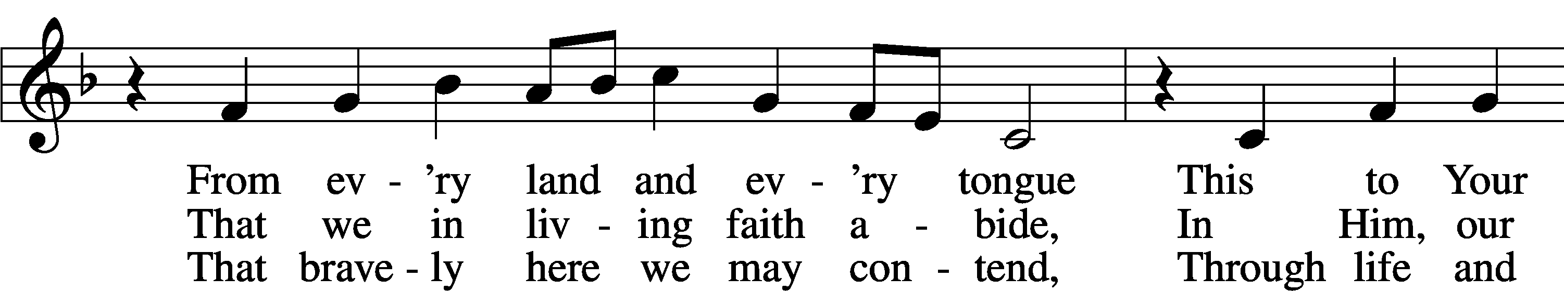
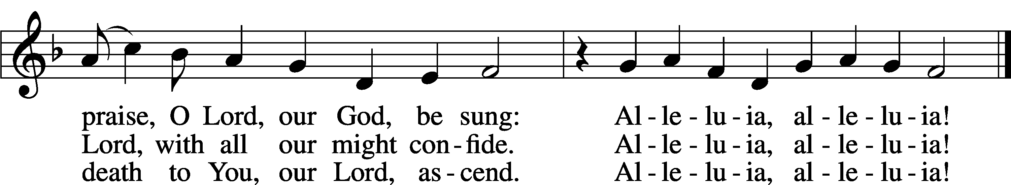
Text: tr. The Lutheran Hymnal, 1941, alt.; (st. 1): German, 15th cent.; (sts. 2–3): Martin Luther, 1483–1546
Tune: Eyn Enchiridion oder Handbüchlein, 1524, Erfurt
Text: © 1941 Concordia Publishing House. Used by permission: LSB Hymn License no. 110016438
Tune: Public domain

Stand

The sign of the cross T may be made by all in remembrance of their Baptism.

Invocation
P In the name of the Father and of the T Son and of the Holy Spirit.
C Amen.

Exhortation LSB 151
P If we say we have no sin, we deceive ourselves, and the truth is not in us.
C But if we confess our sins, God, who is faithful and just, will forgive our sins and cleanse us from all unrighteousness.

Silence for reflection on God’s Word and for self-examination.
Confession of Sins LSB 151
P Let us then confess our sins to God our Father.
C Most merciful God, we confess that we are by nature sinful and unclean. We have sinned against You in thought,
word, and deed, by what we have done and by what we have left undone. We have not loved You with our whole heart;
we have not loved our neighbors as ourselves. We justly deserve Your present and eternal punishment. For the sake of Your Son, Jesus Christ, have mercy on us. Forgive us, renew us, and lead us, so that we may delight in Your will and walk in Your ways to the glory of Your holy name. Amen.

Absolution LSB 151
P Almighty God in His mercy has given His Son to die for you and for His sake forgives you all your sins. As a called and ordained servant of Christ, and by His authority, I therefore forgive you all your sins in the name of the Father and of the T Son and of the Holy Spirit.
C Amen.

+SERVICE OF THE WORD+

Introit Psalm 104:24, 27–28, 30; antiphon: Liturgical Text
Come, Holy Spirit, fill the hearts of the faithful,
and kindle in them the fire of your love. Alleluia.
O Lord, how manifold are your works! In wisdom have you made them all;
the earth is full of your creatures.
These all look to you,
to give them their food in due season.
When you give it to them, they gather it up;
when you open your hand, they are filled with good things.
When you send forth your Spirit, they are created,
and you renew the face of the ground.
Glory be to the Father and to the Son
and to the Holy Spirit;
as it was in the beginning,
is now, and will be forever. Amen.
Come, Holy Spirit, fill the hearts of the faithful,
and kindle in them the fire of your love. Alleluia.

Kyrie LSB 152
A In peace let us pray to the Lord.
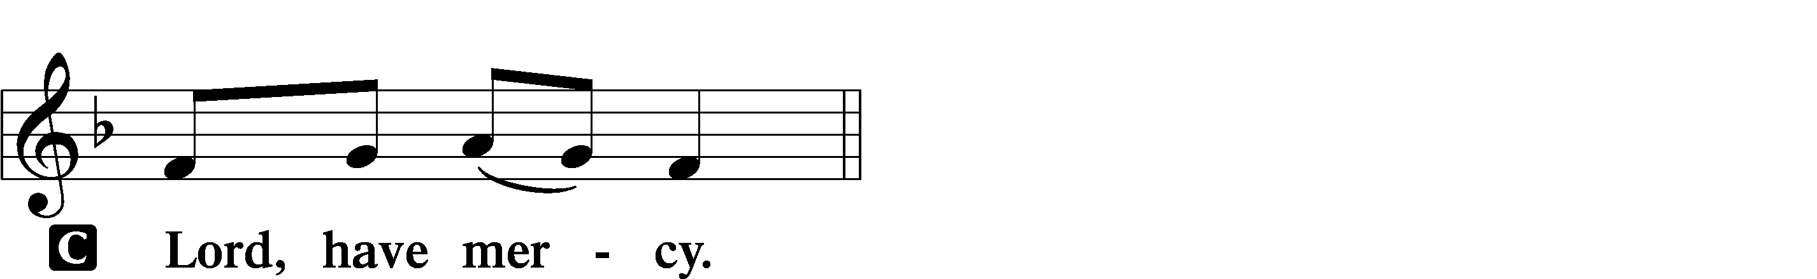

A For the peace from above and for our salvation let us pray to the Lord.
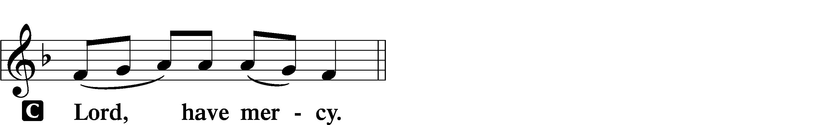

A For the peace of the whole world, for the well-being of the Church of God, and for the unity of all let us pray to the Lord.
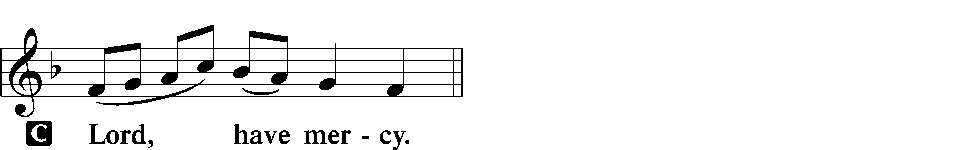

A For this holy house and for all who offer here their worship and praise let us pray to the Lord.
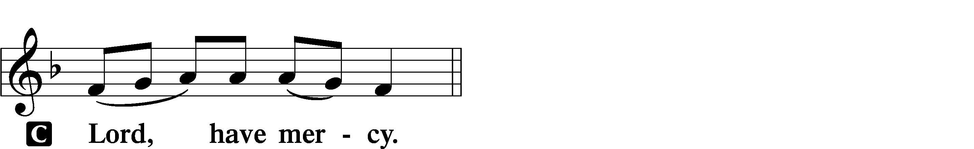

A Help, save, comfort, and defend us, gracious Lord.

Gloria in Excelsis LSB 154
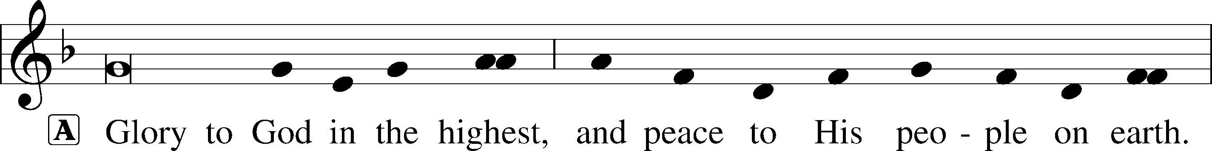
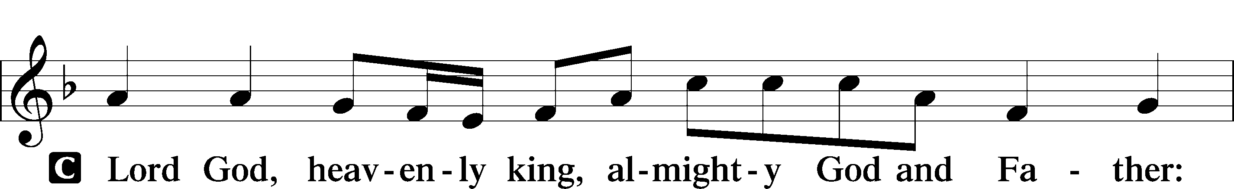
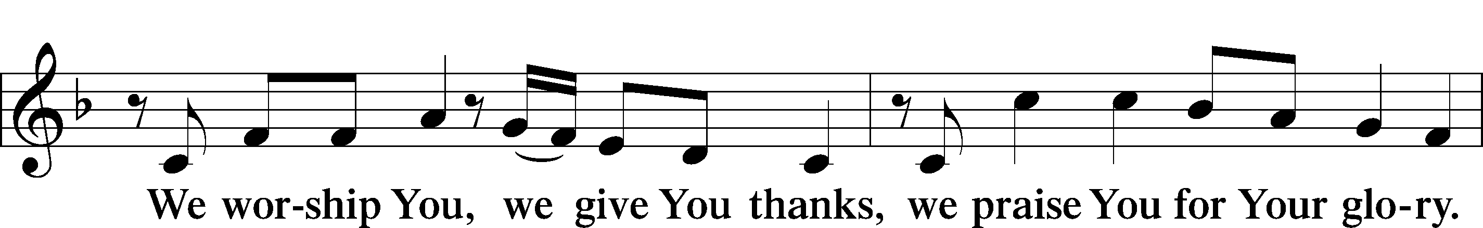
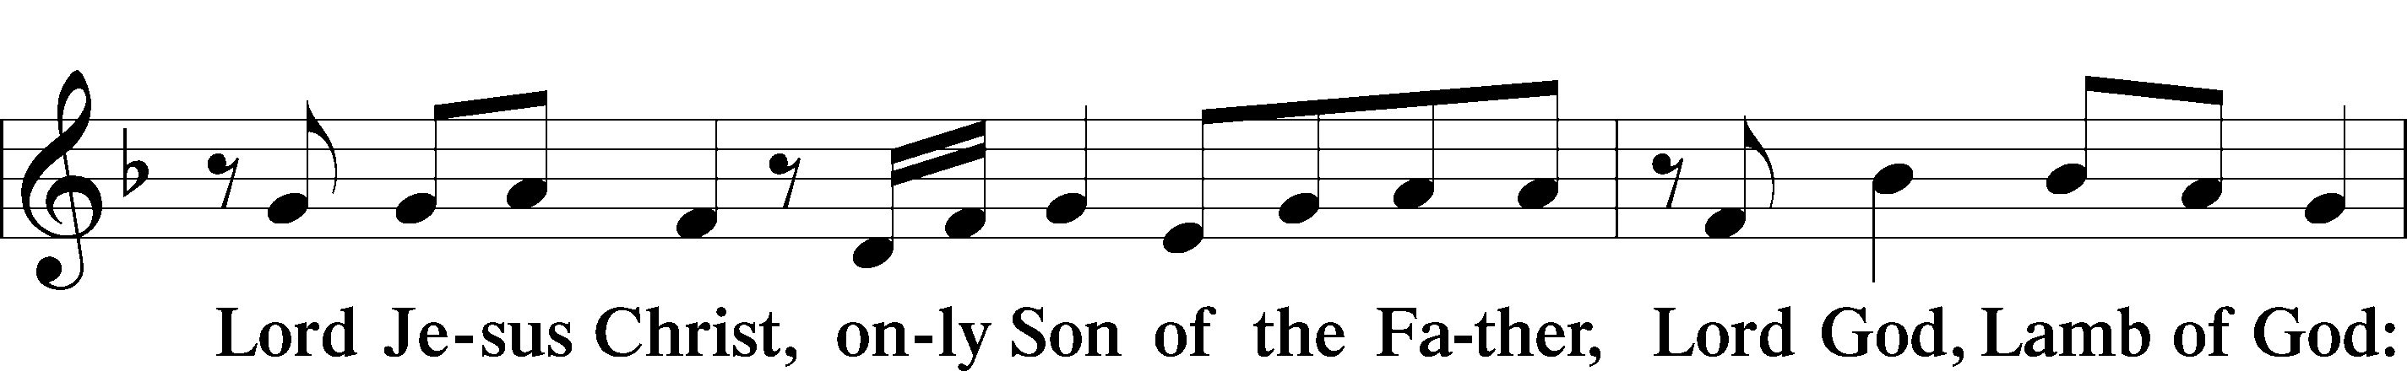
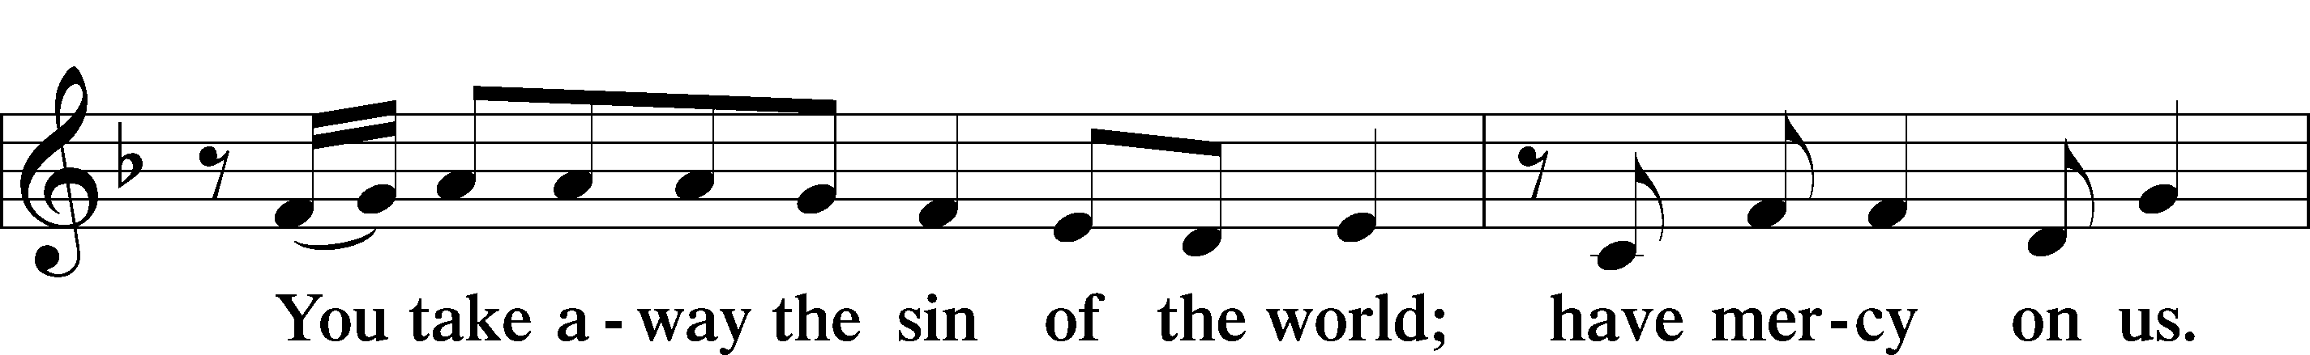
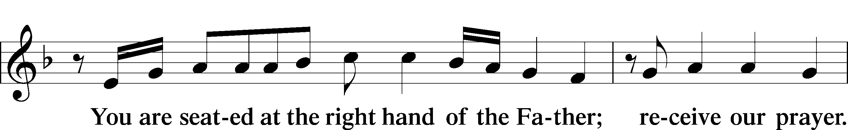
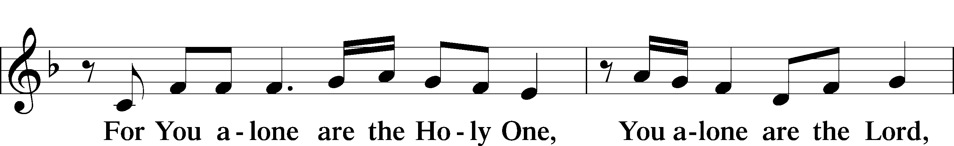
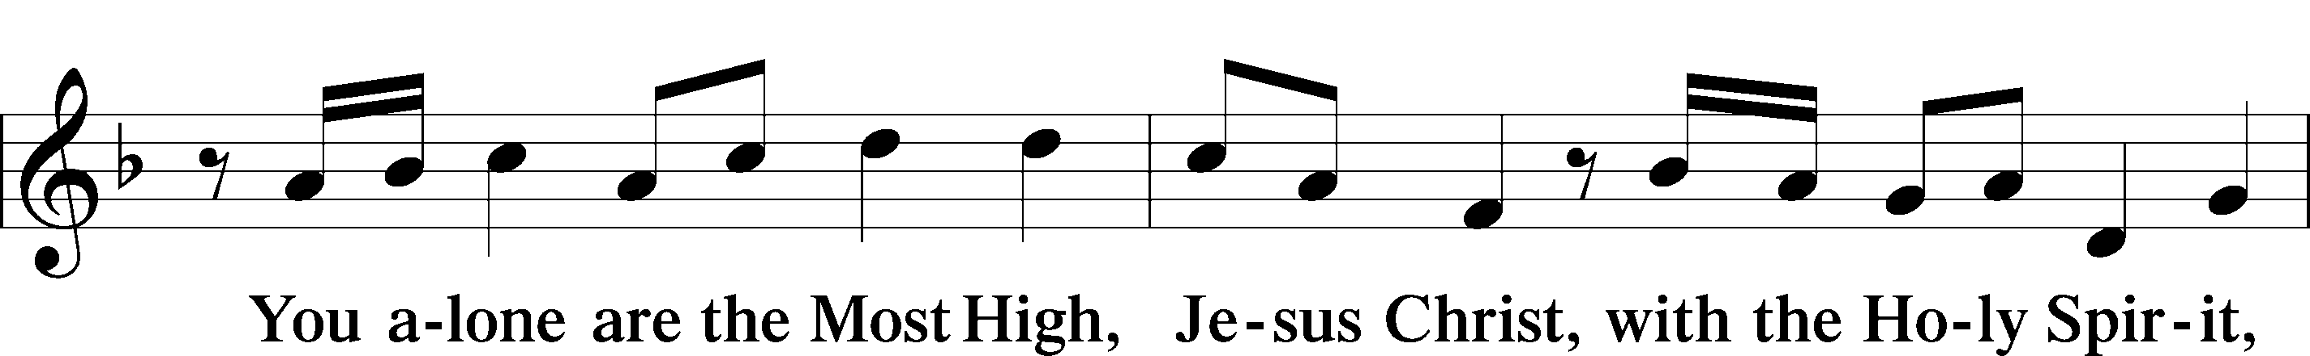
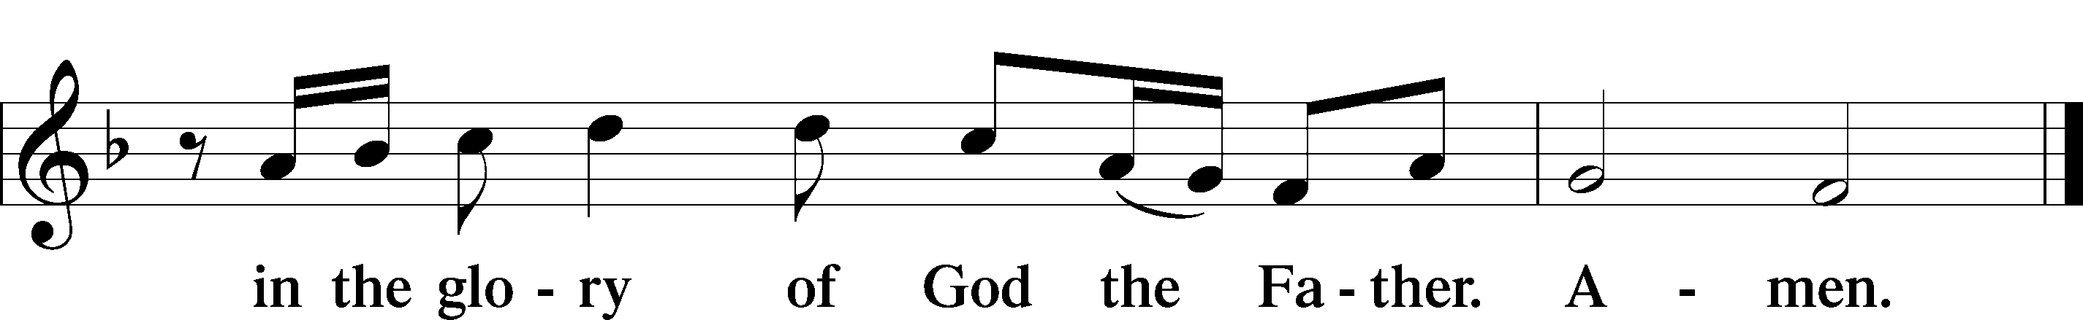

Salutation and Collect of the Day
P The Lord be with you.
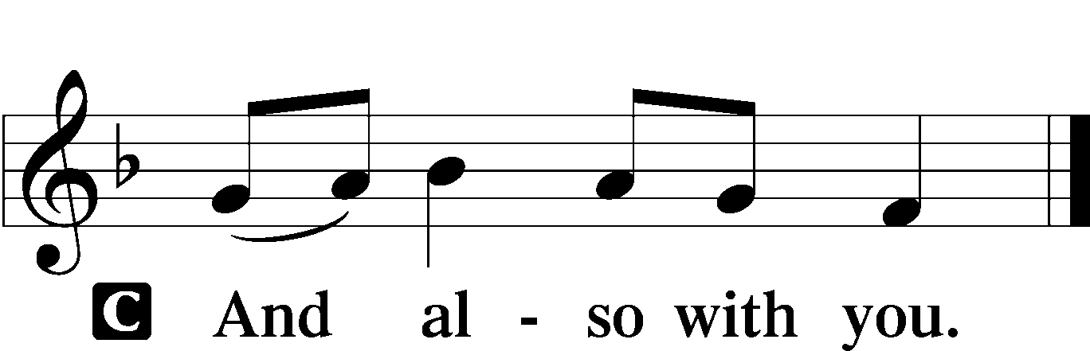

P Let us pray.
C O God, on this day You once taught the hearts of Your faithful people by sending them the light of Your Holy Spirit. Grant us in our day by the same Spirit to have a right understanding in all things and evermore to rejoice in His holy consolation; through Jesus Christ, Your Son, our Lord, who lives and reigns with You and the Holy Spirit, one God, now and forever. Amen.

Sit

Old Testament Reading Numbers 11:24–30
24Moses went out and told the people the words of the Lord.
And he gathered seventy men of the elders of the people and placed them around the tent. 25Then the Lord came down in the cloud and spoke to him, and took some of the Spirit that was on him and put it on the seventy elders. And as soon as the Spirit rested on them,
they prophesied. But they did not continue doing it.
26Now two men remained in the camp, one named Eldad, and the other named Medad, and the Spirit rested on them. They were among those registered, but they had not gone out to the tent, and so they prophesied in the camp. 27And a young man ran and told Moses, “Eldad and Medad are prophesying in the camp.” 28And Joshua the son of Nun, the assistant of Moses from his youth, said, “My lord Moses, stop them.”
29But Moses said to him, “Are you jealous for my sake? Would that all the Lord’s people were prophets, that the Lord would put his Spirit on them!” 30And Moses and the elders of Israel returned to the camp.

A This is the Word of the Lord.
C Thanks be to God.

Gradual Acts 2:17b; Romans 10:10
I will pour out my Spirit on all flesh,
and your sons and your daughters shall prophesy.
With the heart one believes and is justified,
and with the mouth one confesses and is saved.

Second Reading Acts 2:1–21
1When the day of Pentecost arrived, they were all together in one place. 2And suddenly there came from heaven a sound like a mighty rushing wind, and it filled the entire house where they were sitting. 3And divided tongues as of fire appeared to them and rested on each one of them. 4And they were all filled with the Holy Spirit and began to speak in other tongues as the Spirit gave them utterance.
5Now there were dwelling in Jerusalem Jews, devout men from every nation under heaven. 6And at this sound the multitude came together, and they were bewildered, because each one was hearing them speak in his own language. 7And they were amazed and astonished, saying, “Are not all these who are speaking Galileans? 8And how is it that we hear, each of us in his own native language? 9Parthians and Medes and Elamites and residents of Mesopotamia, Judea and Cappadocia, Pontus and Asia, 10Phrygia and Pamphylia, Egypt and the parts of Libya belonging to Cyrene, and visitors from Rome, 11both Jews and proselytes, Cretans and Arabians—we hear them telling in our own tongues the mighty works of God.”

12And all were amazed and perplexed, saying to one another,
“What does this mean?” 13But others mocking said, “They are filled with new wine.”
14But Peter, standing with the eleven, lifted up his voice and addressed them, “Men of Judea and all who dwell in Jerusalem,
let this be known to you, and give ear to my words. 15For these men are not drunk, as you suppose, since it is only the third hour of the day. 16But this is what was uttered through the prophet Joel:
17“‘And in the last days it shall be, God declares,
that I will pour out my Spirit on all flesh,
and your sons and your daughters shall prophesy,
and your young men shall see visions,
and your old men shall dream dreams;
18even on my male servants and female servants
in those days I will pour out my Spirit, and they shall prophesy.
19And I will show wonders in the heavens above
and signs on the earth below,
blood, and fire, and vapor of smoke;
20the sun shall be turned to darkness
and the moon to blood,
before the day of the Lord comes, the great and magnificent day.
21And it shall come to pass that everyone who calls upon the name of the Lord shall be saved.’”

A This is the Word of the Lord.
C Thanks be to God.

Stand

Alleluia and Verse LSB 156
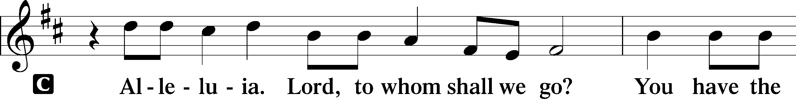
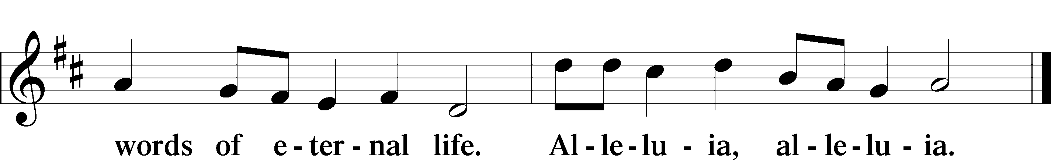

Holy Gospel John 7:37–39
P The Holy Gospel according to St. John, the seventh chapter.

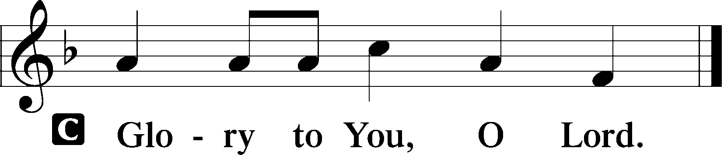

37On the last day of the feast, the great day, Jesus stood up and cried out, “If anyone thirsts, let him come to me and drink. 38Whoever believes in me, as the Scripture has said, ‘Out of his heart will flow rivers of living water.’” 39Now this he said about the Spirit, whom those who believed in him were to receive, for as yet the Spirit had not been given, because Jesus was not yet glorified.

P This is the Gospel of the Lord.

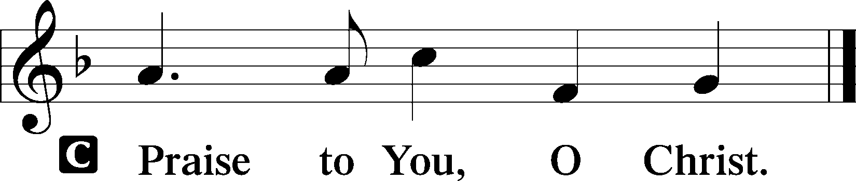

Nicene Creed
C I believe in one God,
the Father Almighty,
maker of heaven and earth
and of all things visible and invisible.

And in one Lord Jesus Christ,
the only-begotten Son of God,
begotten of His Father before all worlds,
God of God, Light of Light,
very God of very God,
begotten, not made,
being of one substance with the Father,
by whom all things were made;
who for us men and for our salvation came down from heaven
and was incarnate by the Holy Spirit of the virgin Mary
and was made man;
and was crucified also for us under Pontius Pilate.
He suffered and was buried.
And the third day He rose again according to the Scriptures
and ascended into heaven
and sits at the right hand of the Father.
And He will come again with glory to judge both the living and the dead,
whose kingdom will have no end.

And I believe in the Holy Spirit,
the Lord and giver of life,
who proceeds from the Father and the Son,
who with the Father and the Son together is worshiped and glorified,
who spoke by the prophets.
And I believe in one holy Christian and apostolic Church,
I acknowledge one Baptism for the remission of sins,
and I look for the resurrection of the dead
and the life T of the world to come. Amen.

Sit
Children's Message - "Are You Thirsty to Give?"

Hymn of the Day “Eternal Father, Strong to Save”
Sung to the Tune of LSB 717

Eternal Father, strong to save,
Whose arm hath bound the restless wave,
Who bidd'st the mighty ocean deep
Its own appointed limits keep,
O hear us when we cry to thee
For those in peril on the sea!

O Holy Spirit, who did brood
Upon the waters dark and rude,
And bid their angry tumult cease,
And give for wild confusion peace;
O hear us when we cry to Thee
For those in peril on the sea.

Eternal Father, grant, we pray,
To all Marines, both night and day,
The courage, honor, strength, and skill
Their land to serve, Thy law fulfill;
Be Thou the shield forevermore
From ev'ry peril to the Corps.

Lord, guard and guide all who fly
Through the great spaces of the sky
Be with them on their lonely flights
Through darkening day and endless nights
O hear us as we lift our prayers
For those in peril in the air.

Lord God, who speaks with voice so clear,
Speak that we know that thou art near;
Protect our troops upon the land,
And all who for their country stand,
Be with these guardians’ day and night,
And may their trust be in thy might.

Eternal Father, Lord of hosts,
Watch o'er the men who guard our coasts
Protect them from the raging seas
And give them light and life and peace.
Grant them from thy great throne above
The shield and shelter of thy love.

And for our chaplains, Lord, we pray,
Each serving you in their own way;
Grant them the grace to e'er be wise
And ne'er Your service compromise.
And may they, Lord, be always heard
Whene'er they preach Your Holy Word

Almighty God who gave us birth:
Ordered our days upon this earth.
Lord, when our life comes to its end.
And on Thy mercy we depend:
O give us grace that we may be,
Alive forevermore with Thee!

Sermon- “Waters of Life”

Stand
Prayer of the Church

Sit
Offering

Stand

Offertory LSB 159
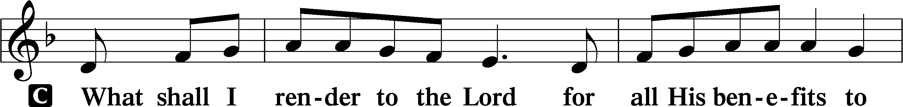
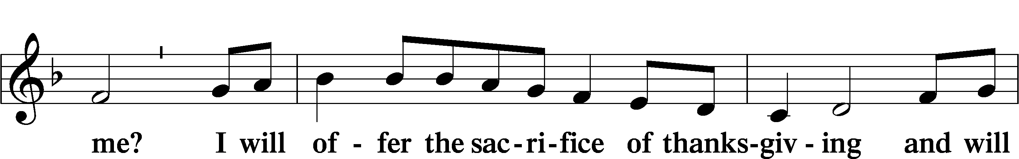
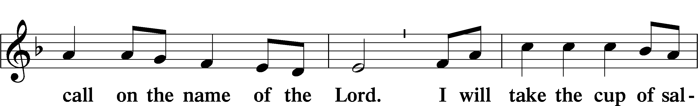
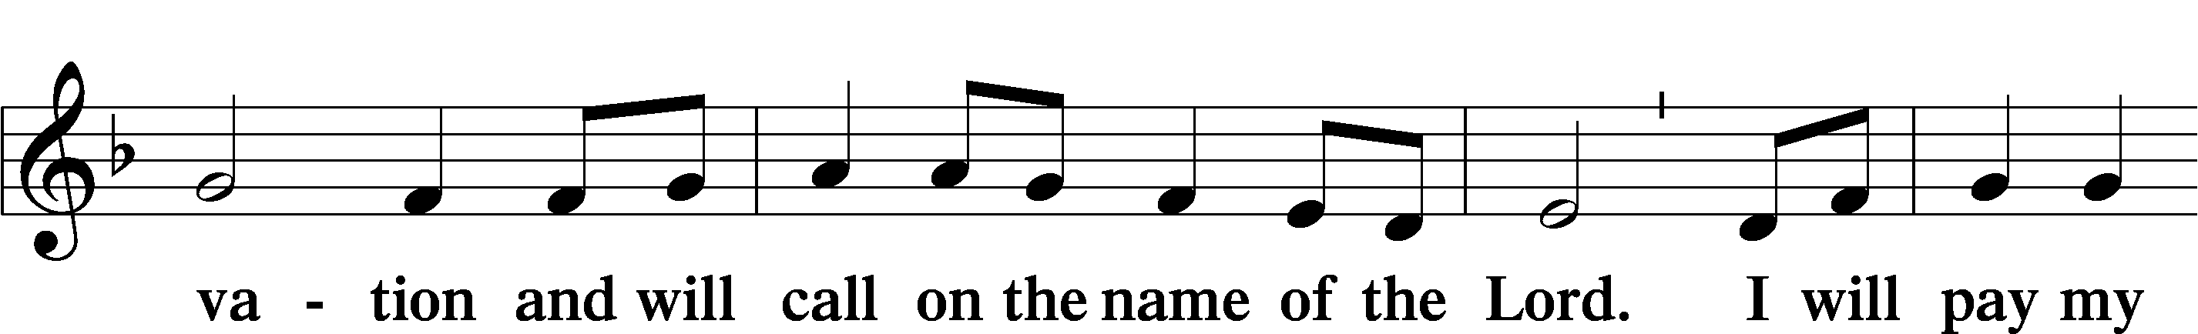
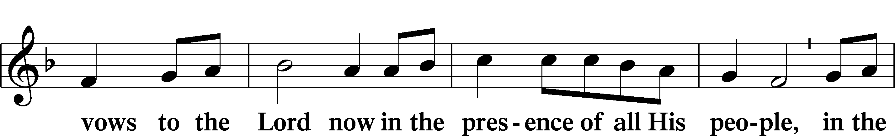
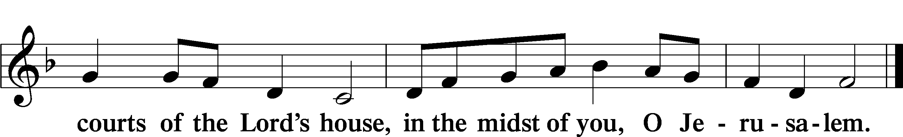

+SERVICE OF THE SACRAMENT+

Preface LSB 160
P The Lord be with you.

P Lift up your hearts.

P Let us give thanks to the Lord our God.
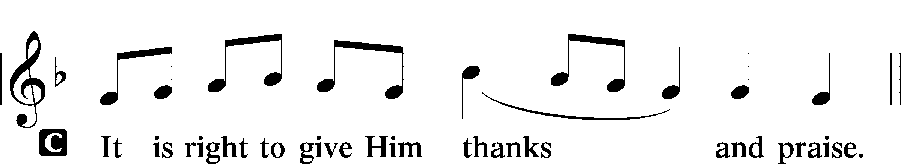

Proper Preface
P It is truly good, right, and salutary that we should at all times and in all places give thanks to You, holy Lord, almighty Father, everlasting God, through Jesus Christ, our Lord, who ascended above the heavens and, sitting at Your right hand, poured out on this day the promised Holy Spirit on His chosen disciples. For all this the whole earth rejoices with exceeding joy. Therefore with angels and archangels and with all the company of heaven we laud and magnify Your glorious name, evermore praising You and saying:

Sanctus LSB 161
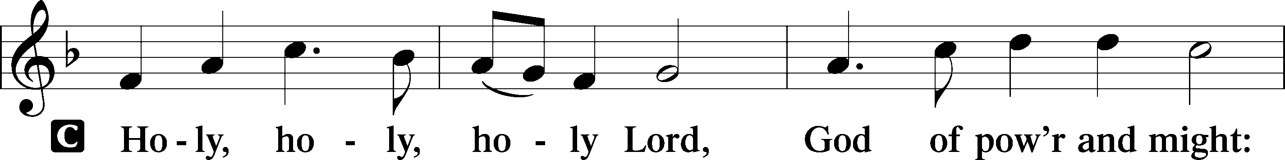
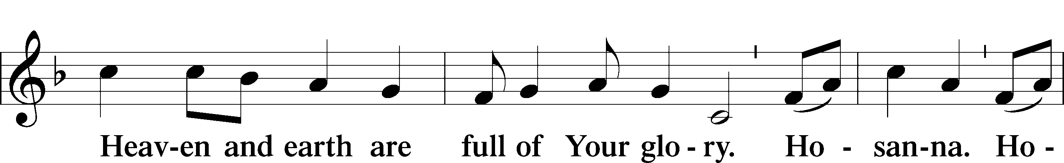
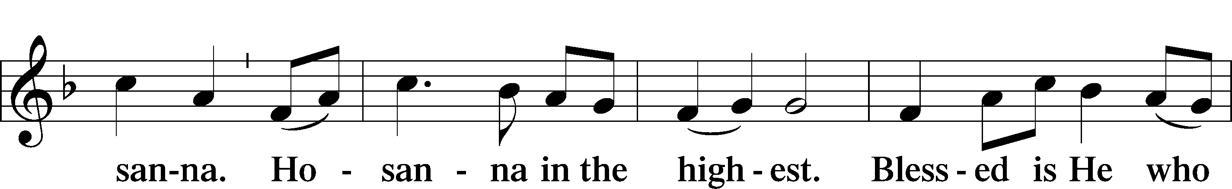
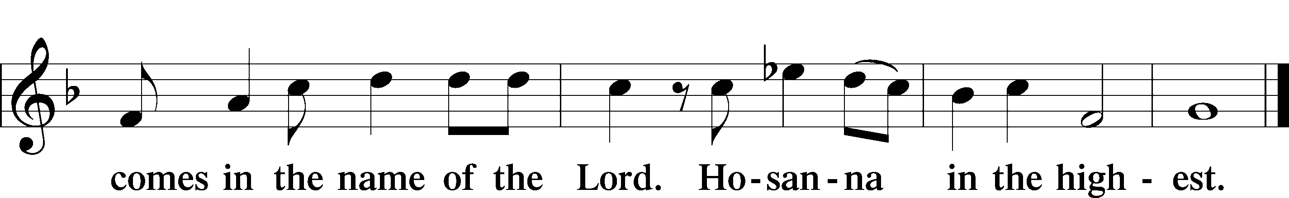

Prayer of Thanksgiving LSB 161
P Blessed are You, Lord of heaven and earth, for You have had mercy on those whom You created and sent Your only-begotten Son into our flesh to bear our sin and be our Savior. With repentant joy we receive the salvation accomplished for us by the all-availing sacrifice of His body and His blood on the cross.

Gathered in the name and the remembrance of Jesus, we beg You, O Lord, to forgive, renew, and strengthen us with Your Word and Spirit. Grant us faithfully to eat His body and drink His blood as He bids us do in His own testament. Gather us together, we pray, from the ends of the earth to celebrate with all the faithful the marriage feast of the Lamb in His kingdom, which has no end. Graciously receive our prayers; deliver and preserve us. To You alone, O Father, be all glory, honor, and worship, with the Son and the Holy Spirit, one God, now and forever.
C Amen.
Lord’s Prayer
C Our Father who art in heaven,
hallowed be Thy name,
Thy kingdom come,
Thy will be done on earth
as it is in heaven;
give us this day our daily bread;
and forgive us our trespasses
as we forgive those
who trespass against us;
and lead us not into temptation,
but deliver us from evil.
For Thine is the kingdom
and the power and the glory
forever and ever. Amen.

The Words of Our Lord
P Our Lord Jesus Christ, on the night when He was betrayed, took bread, and when He had given thanks, He broke it and gave it to the disciples and said: “Take, eat; this is My T body, which is given for you. This do in remembrance of Me.”

In the same way also He took the cup after supper, and when He had given thanks, He gave it to them, saying: “Drink of it, all of you; this cup is the new testament in My T blood, which is shed for you for the forgiveness of sins. This do, as often as you drink it, in remembrance of Me.”

Pax Domini LSB 163
P The peace of the Lord be with you always.
Agnus Dei LSB 163
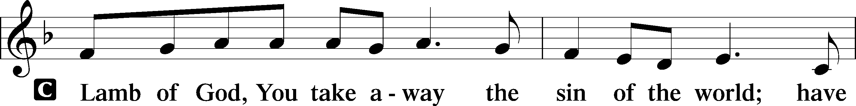
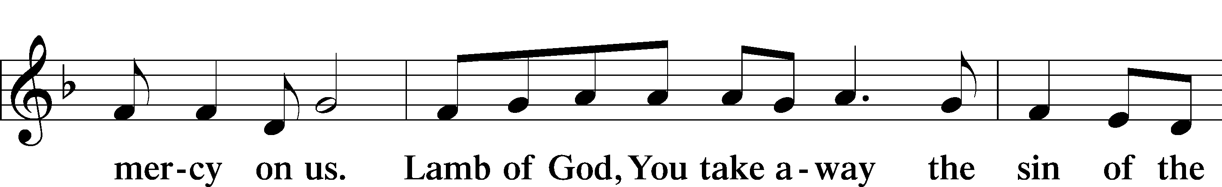
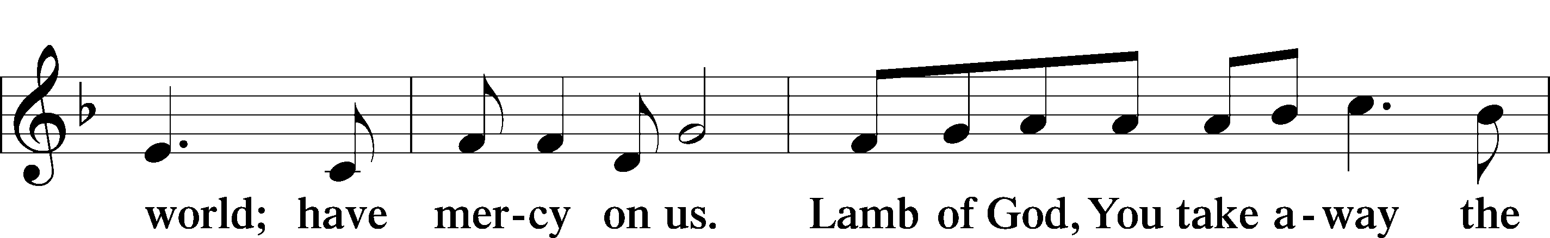
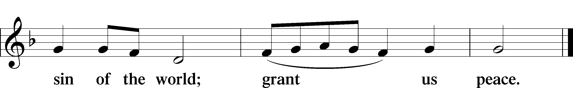

Sit

Distribution

Distribution Hymn “Today Your Mercy Calls Us” LSB 915
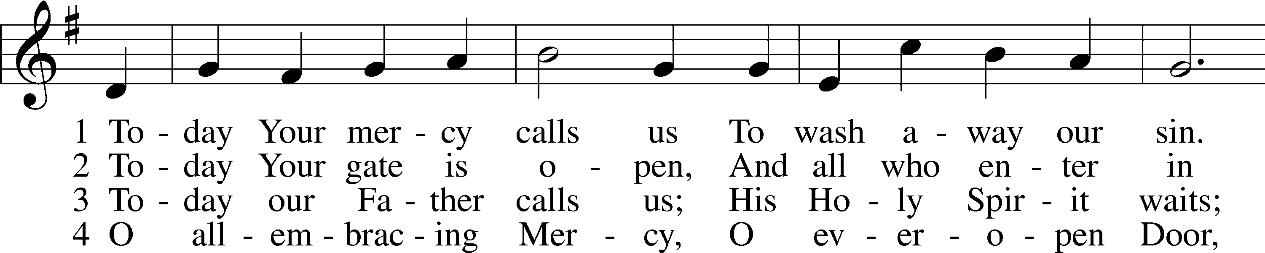
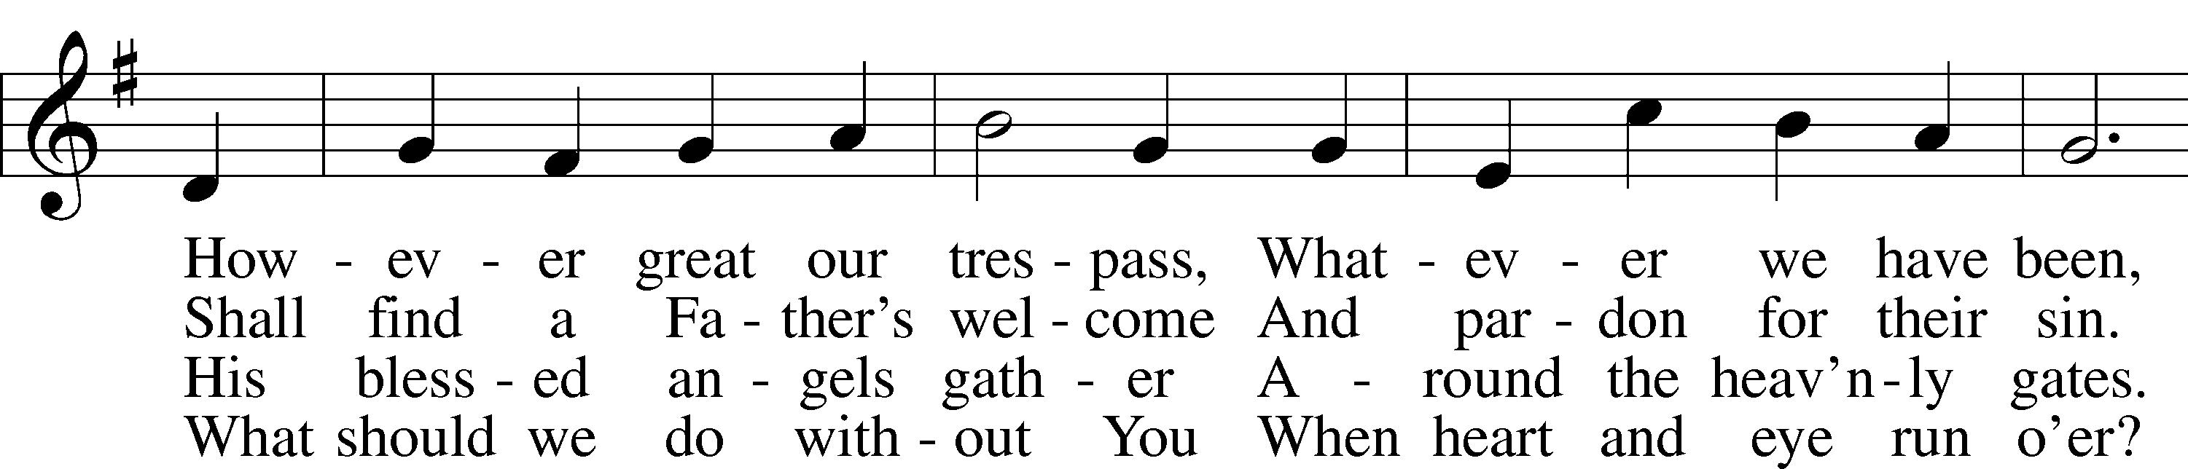
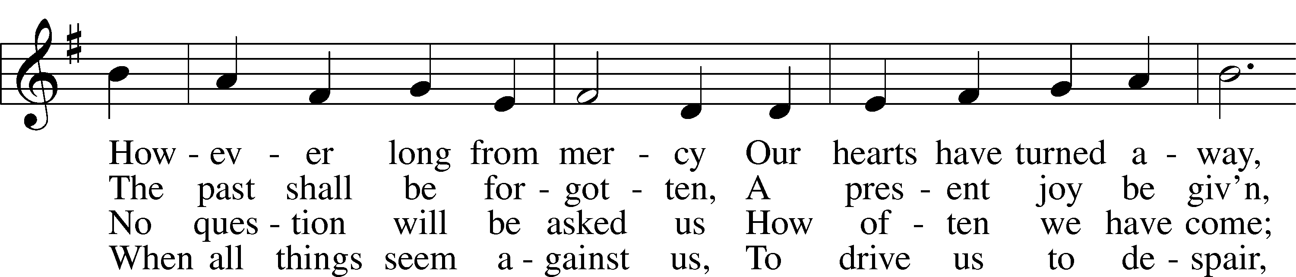
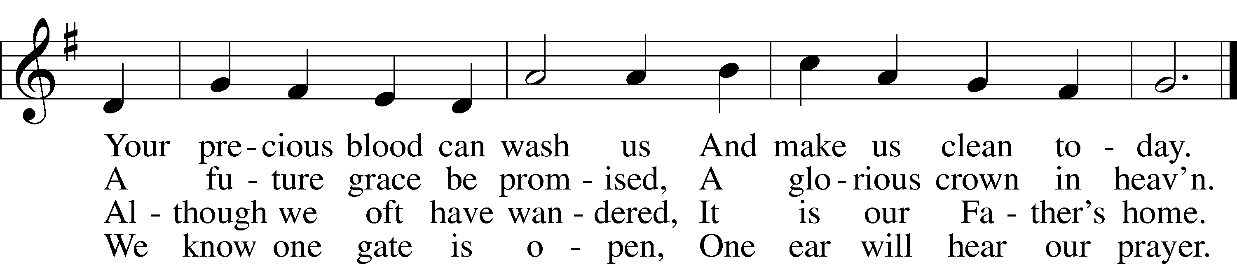
Text: Oswald Allen, 1816–78, alt.
Tune: Friedrich K. Anthes, 1812–after 1857
Text and tune: Public domain

Distribution Hymn “I Heard the Voice of Jesus Say” LSB 699
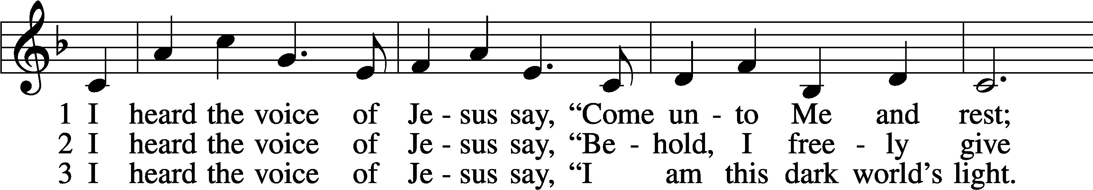
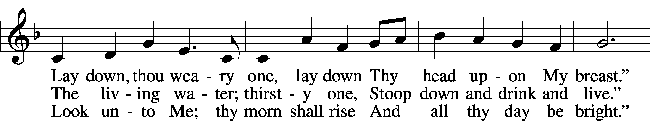
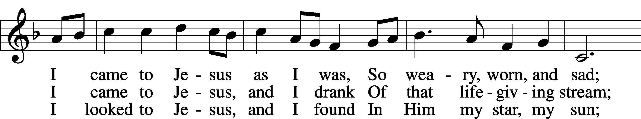
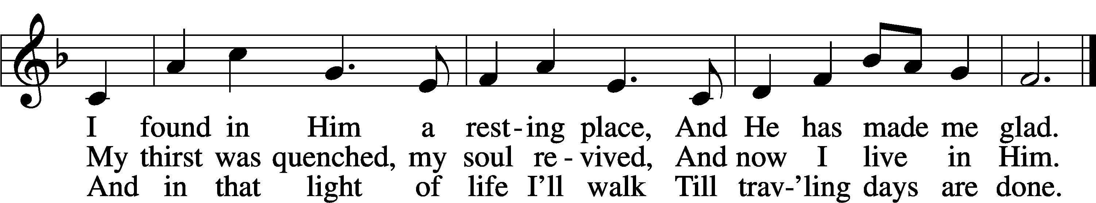
Text: Horatius Bonar, 1808–89, alt.
Tune: Amanda Husberg, 1940
Text: Public domain
Tune: © 1996 Amanda Husberg. Used by permission: LSB Hymn License no. 110016438

Stand
Nunc Dimittis LSB 165
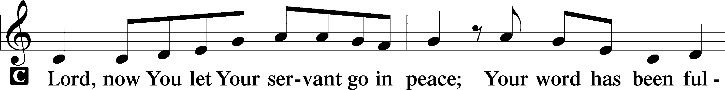
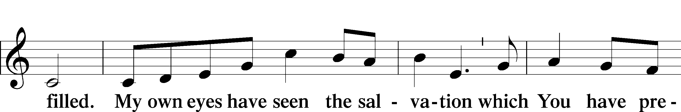
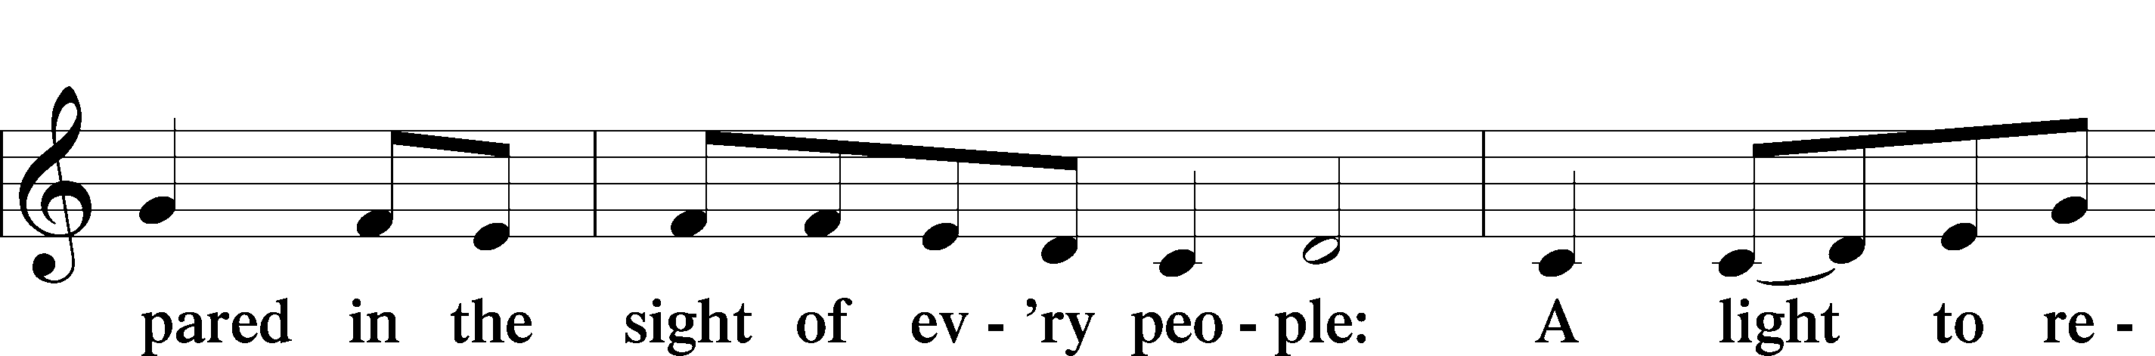
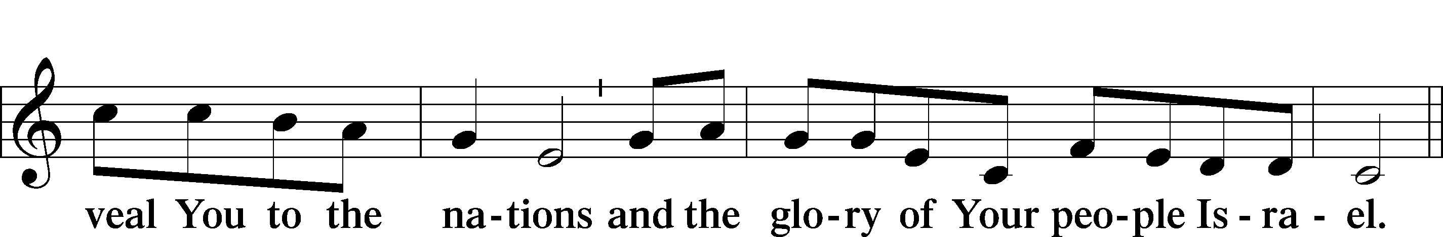
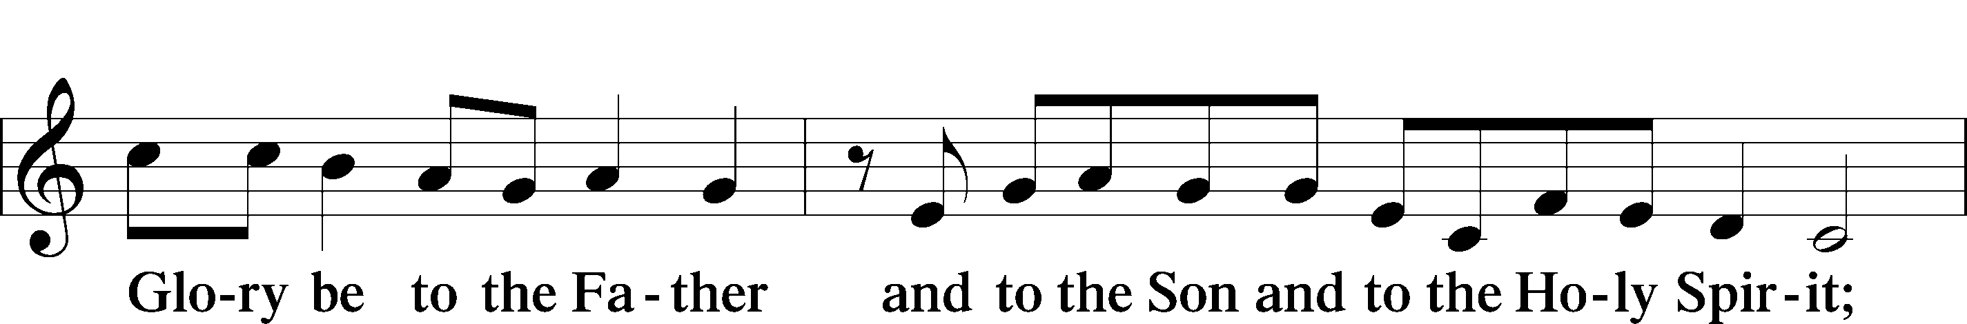
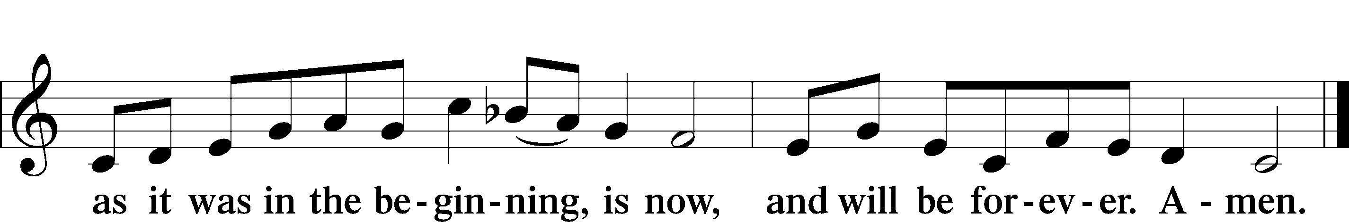

Post-Communion Collect
A Let us pray.
We give thanks to You, almighty God, that You have refreshed us through this salutary gift, and we implore You that of Your mercy You would strengthen us through the same in faith toward You and in fervent love toward one another; through Jesus Christ, Your Son, our Lord, who lives and reigns with You and the Holy Spirit, one God, now and forever.
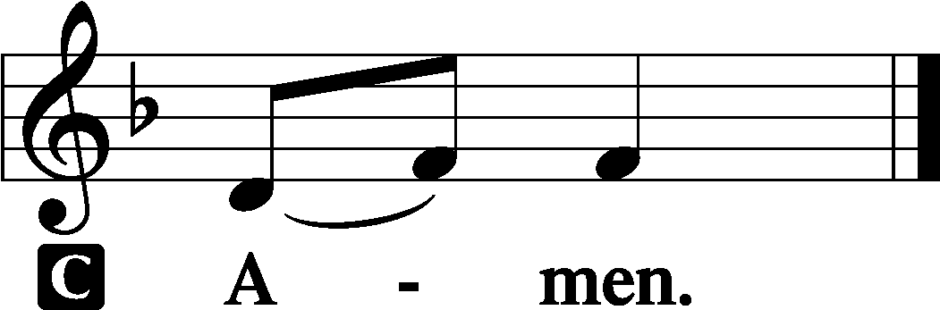

Benediction LSB 166
P The Lord bless you and keep you.
The Lord make His face shine on you and be gracious to you.
The Lord look upon you with favor and T give you peace.

Closing Hymn “God Bless Our Native Land” LSB 965
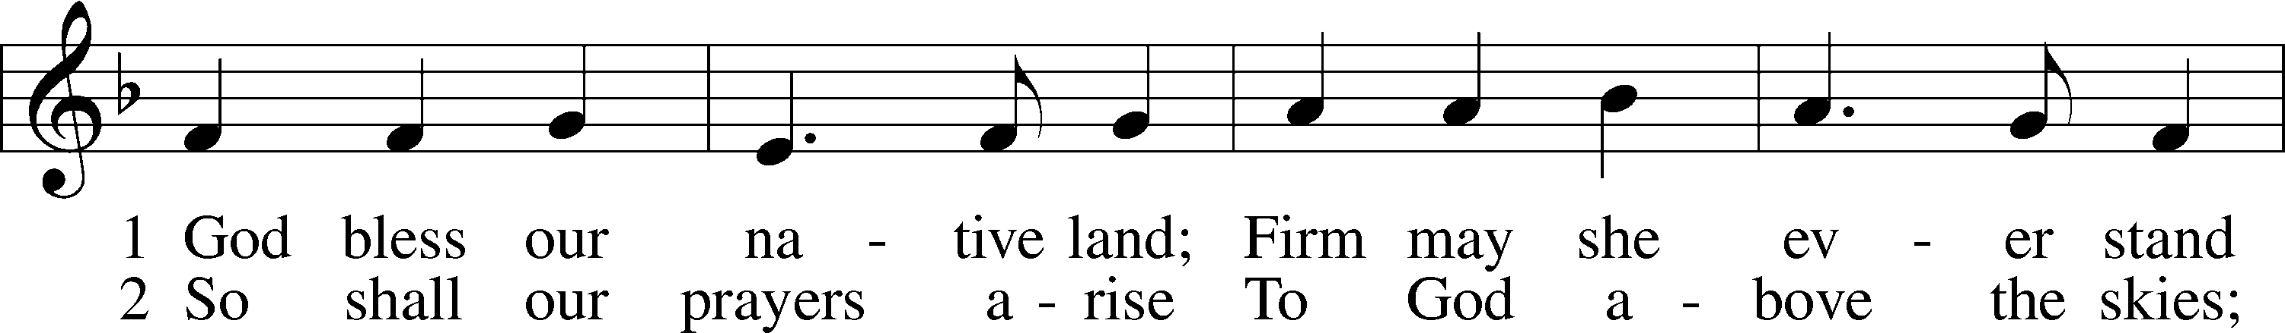
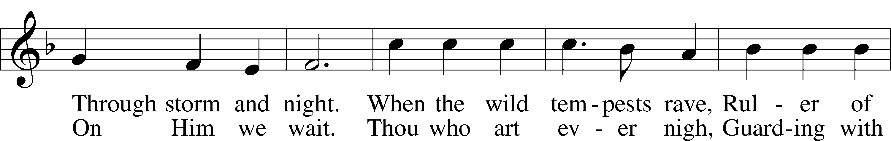
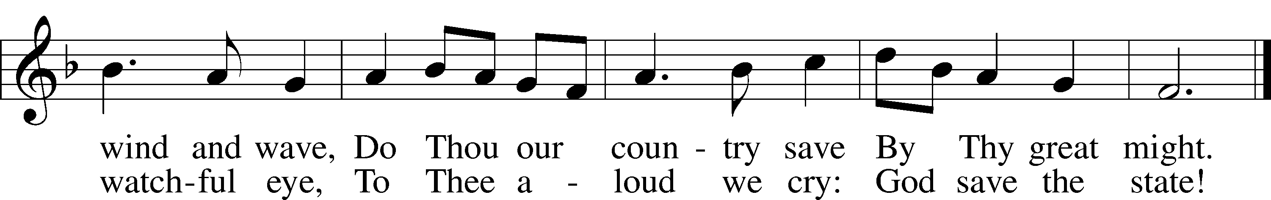
Text (st. 1): Charles T. Brooks, 1813–83, alt.; (st. 2): John S. Dwight, 1813–93, alt.
Tune: Thesaurus Musicus, c. 1740, London
Text and tune: Public domain

Acknowledgments
Unless otherwise indicated, Scripture quotations are from the ESV® Bible (The Holy Bible, English Standard Version®), copyright © 2001 by Crossway, a publishing ministry of Good News Publishers. Used by permission. All rights reserved.
Created by Lutheran Service Builder © 2023 Concordia Publishing House.

Serving Our Lord in His House Today:
Pastor: Rev. Steve Thomas
Organist: Rebecca Moseley
Elders: Jerry Ecker
Joe Engel & Dillin Lafferty (Wed.)

Gifts from God: Acts 2:1 – “When the day of Pentecost arrived, they were all together in one place.” Pentecost is the Old Testament harvest festival,
taking place around the time when the wheat and oats are ready to be brought in.
Of course, this was an image and foreshadowing of the great harvest of humankind that God means to carry out through the preaching of His Word. God gives the seed, and God brings about the harvest. From first to last, in things temporal and things eternal, we stand only by His grace.

Potluck Lunch: Sunday, June 4, 2023, will be the final Sunday School before summer. Please bring a dish to pass and join us for a Potluck luncheon next week following adult bible study and Sunday School.

Prayer for calling a faithful pastor:
O Gracious Father, You led Your holy apostles to ordain ministers for the proclamation of Your Word and the faithful administration of the Sacraments of Christ. Grant to this congregation the guidance of the Holy Spirit to choose a suitable pastor according to Your will for the blessing of Your Church in this place; through Jesus Christ our Lord.

Our Worship attendance last week: Sunday: 75
Wednesday: 4
Total: 79

Scripture Lessons for next week: Genesis 1:1-2:4a
Acts 2:14a, 22-36
Matthew 28:16-20

Secretary Office Hours: Tuesday-Friday: 8:15am-12:15pm
*Please note, the church office will be closed on Monday, May 29, 2023,
in observance of Memorial Day.

Our Week With Our Lord:
Today 9:00am Divine Service w/Holy Communion
(livestreamed via YouTube)
10:30am Adult Bible Study
Monday *Church Office Closed*
Tuesday 1:00pm Ladies Bible Study @church
Wednesday 7:00pm Divine Service
Thursday
Friday
Saturday
Sunday 9:00am Divine Service w/Holy Communion (livestreamed via YouTube) 10:30am Adult Bible Study & Sunday School
11:30am Potluck Luncheon

*Please view the following page for weekly prayers*

HIS FLOCK AT PRAYER
Propers for the Week of Pentecost

Psalm for the Week: Psalm 25:1-15

Daily Scripture Readings:
Sunday— John 14:23-31 Thursday—Acts 2:29-36
Monday— John 3:16-21 Friday—Acts 2:37-42
Tuesday—John 10:1-10 Saturday—1 John 4:9-12
Wednesday—Acts 2:22-28

Collect for the Week:
O God, on this day You once taught the hearts of Your faithful people by sending
them the light of Your Holy Spirit. Grant us in our day by the same Spirit to have a
right understanding in all things and evermore to rejoice in His holy consolation;
through Jesus Christ, Your Son, our Lord, who lives and reigns with You and the
Holy Spirit, one God, now and forever.

Hymn of the Week: “Eternal Father, Strong to Save” LSB 717

Congregational Petitions for this Week:
+ For those whose work is difficult or dangerous including the military away from home, especially: Isaac Preuss, Erica Preuss, Joshua Ecker, Tania Adler.
+ For those who are ill or recovering, especially: Brenda Kolb, Shawn Zabinski,
Velma Lutz, Juliann Baxter, District President John Wille, Joyce Cain,
Jerry Quam, Randy Roehl, Peyton Foster, Dawn Hawkins, Jan Stampfli,
Margaret Palmer, Nick Anderson, Mario Corrente, Lorie Walker, Rayna Knutson,
Michael Theurich.
+ For those who are home-bound, especially: John Fox, Darlene Griffin,
Lynda Goad, Roemelle McArdle, Sharon Herried, Muriel Finch.

