Good Shepherd Lutheran Church
Nineteenth Sunday after Trinity
October 10, 2021

Pre-Service Music & Welcome

Divine Service Setting Two – Lutheran Service Book (LSB) 167

+CONFESSION AND ABSOLUTION+

Stand

Opening Hymn “Lord Jesus Christ, with Us Abide” LSB 585
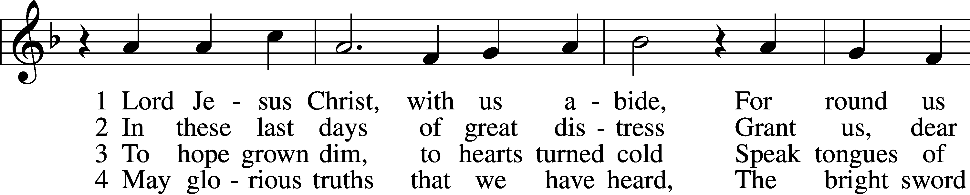
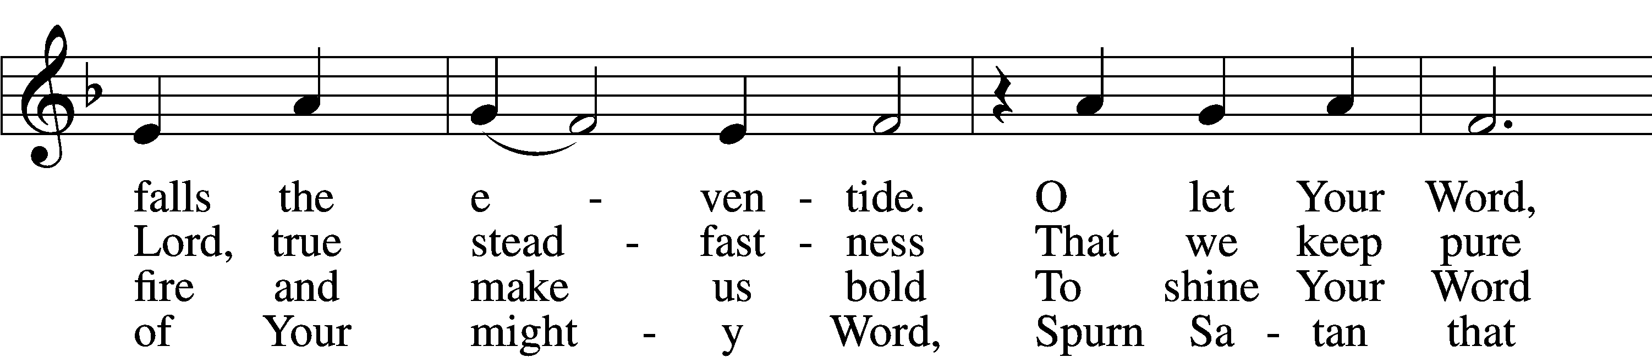
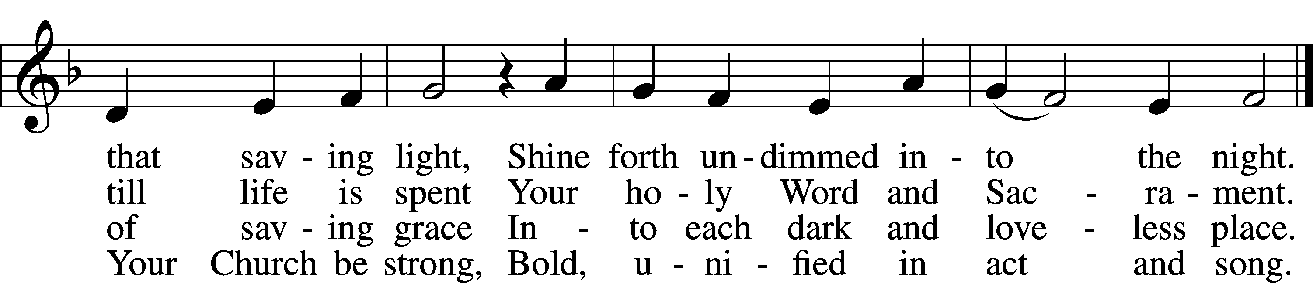

5 Restrain, O Lord, the human pride
That seeks to thrust Your truth aside
Or with some man-made thoughts or things
Would dim the words Your Spirit sings.

6 Stay with us, Lord, and keep us true;
Preserve our faith our whole life through—
Your Word alone our heart’s defense,
The Church’s glorious confidence.
Tune: Public domain
Text: © 1982 Concordia Publishing House. Used by permission: LSB Hymn License no. 110016438

The sign of the cross T may be made by all in remembrance of their Baptism.

Invocation
P In the name of the Father and of the T Son and of the Holy Spirit.
C Amen.

Exhortation LSB 167
P If we say we have no sin, we deceive ourselves, and the truth is not in us.
C But if we confess our sins, God, who is faithful and just, will forgive our sins and cleanse us from all unrighteousness.

Silence for reflection on God’s Word and for self-examination.

Confession of Sins LSB 167
P Let us then confess our sins to God our Father.
C Most merciful God, we confess that we are by nature sinful and unclean. We have sinned against You in thought, word, and deed, by what we have done and by what we have left undone. We have not loved You with our whole heart; we have not loved our neighbors as ourselves. We justly deserve Your present and eternal punishment. For the sake of Your Son, Jesus Christ, have mercy on us. Forgive us, renew us, and lead us, so that we may delight in Your will and walk in Your ways to the glory of Your holy name. Amen.

Absolution LSB 167
P Almighty God in His mercy has given His Son to die for you and for His sake forgives you all your sins. As a called and ordained servant of Christ, and by His authority, I therefore forgive you all your sins in the name of the Father and of the T Son and of the Holy Spirit.
C Amen.

+SERVICE OF THE WORD+

Introit Psalm 78:1–3, 4b; antiphon: Psalm 35:3b; 34:17a, 6b; 48:14a
Say to my soul, “I am your salvation!”*
When the righteous cry for help, the Lord hears.
[The Lord] saved him out of all his troubles;*
this is God, our God forever and ever.
Give ear, O my people, to my teaching;*
incline your ears to the words of my mouth!
I will open my mouth in a parable;*
I will utter dark sayings from of old,
things that we have heard and known,*
that our fathers have told us.
We will tell the coming generation the glorious deeds of the Lord, and his might,*
and the wonders that he has done.
Glory be to the Father and to the Son*
and to the Holy Spirit;
as it was in the beginning,*
is now, and will be forever. Amen.
Say to my soul, “I am your salvation!”*
When the righteous cry for help, the Lord hears.
[The Lord] saved him out of all his troubles;*
this is God, our God forever and ever.

Kyrie (spoken) LSB 168
A In peace let us pray to the Lord.
C Lord, have mercy.
A For the peace from above and for our salvation let us pray to the Lord.
C Lord, have mercy.
A For the peace of the whole world, for the well-being of the Church of God, and for the unity of all let us pray to the Lord.
C Lord, have mercy.
A For this holy house and for all who offer here their worship and praise let us pray to the Lord.
C Lord, have mercy.
A Help, save, comfort, and defend us, gracious Lord.
C Amen.

This Is the Feast LSB 171
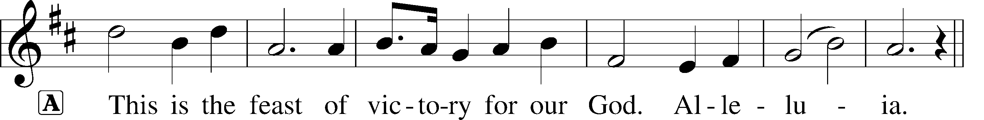
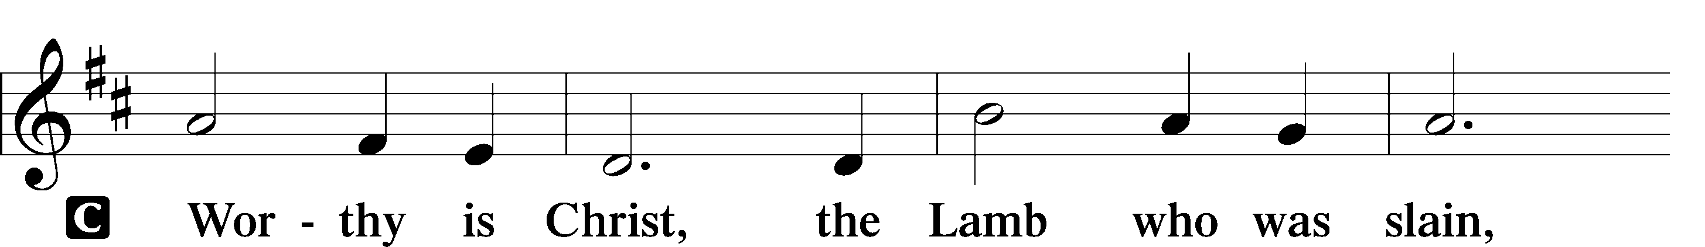
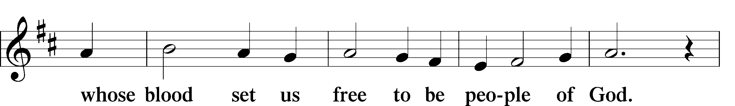
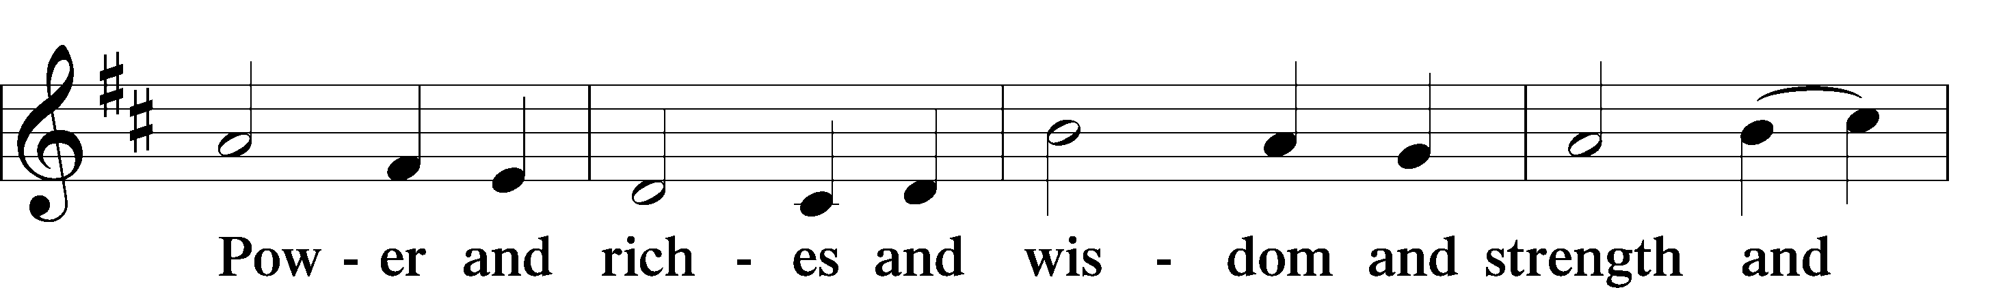
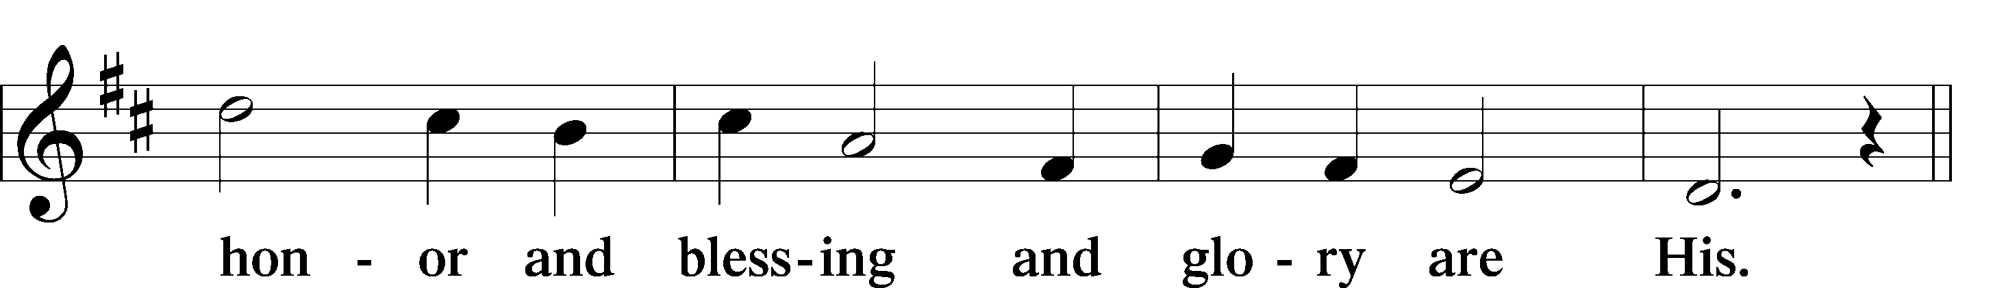
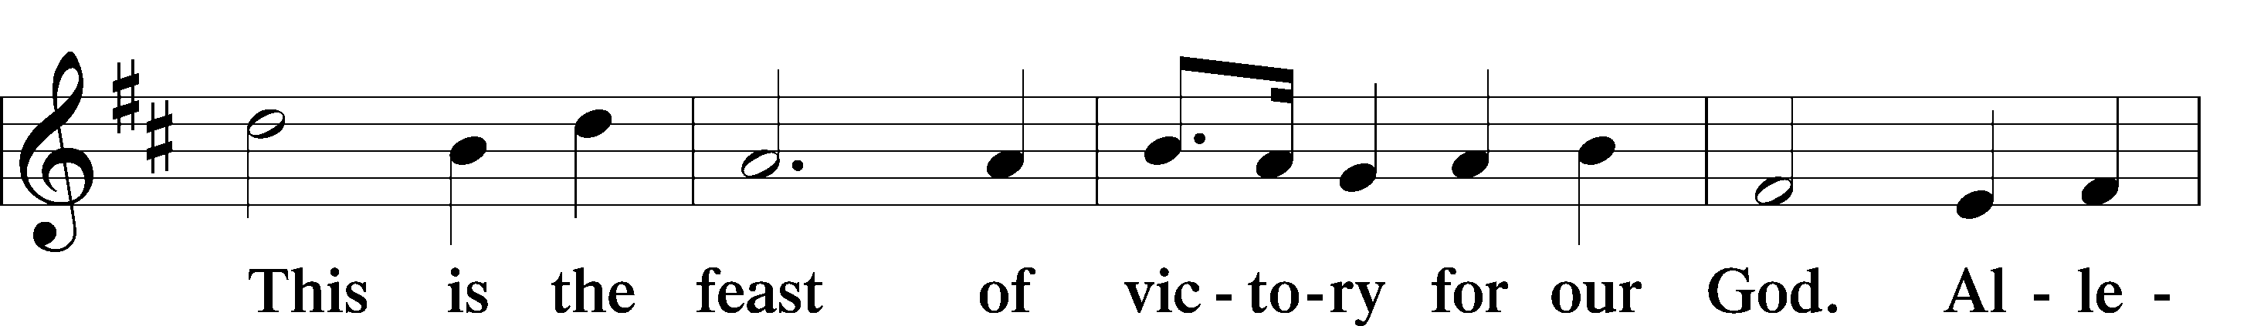
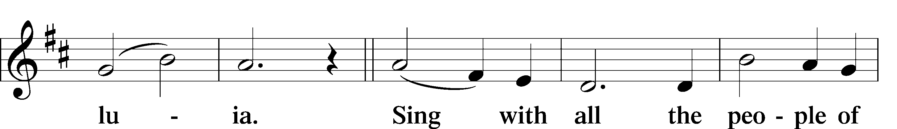
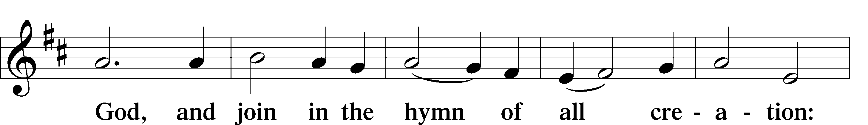
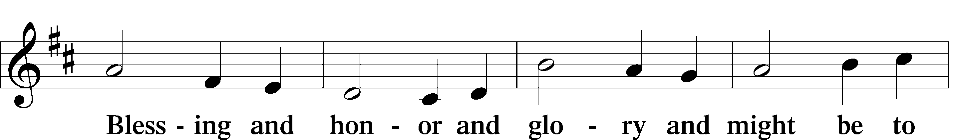
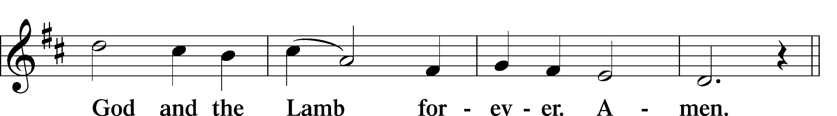
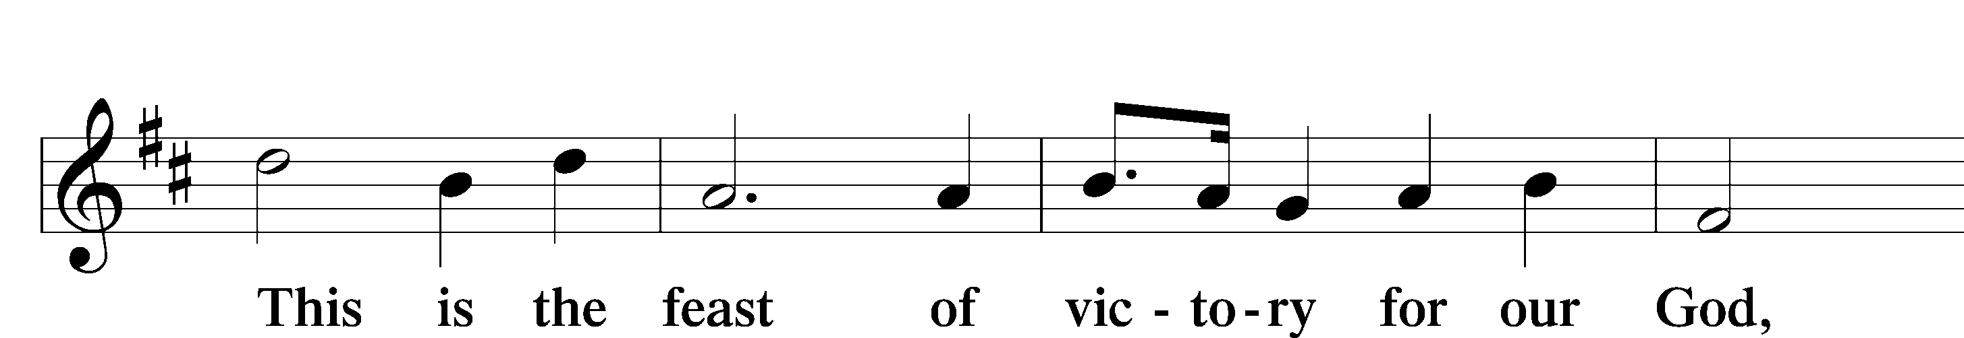
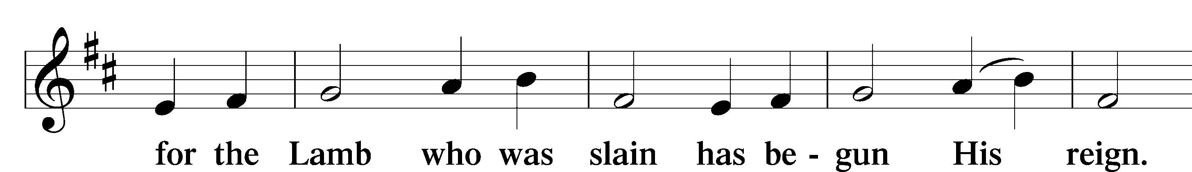
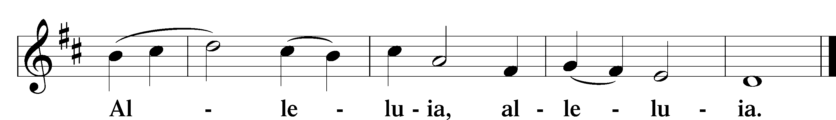

Salutation and Collect of the Day
P The Lord be with you.
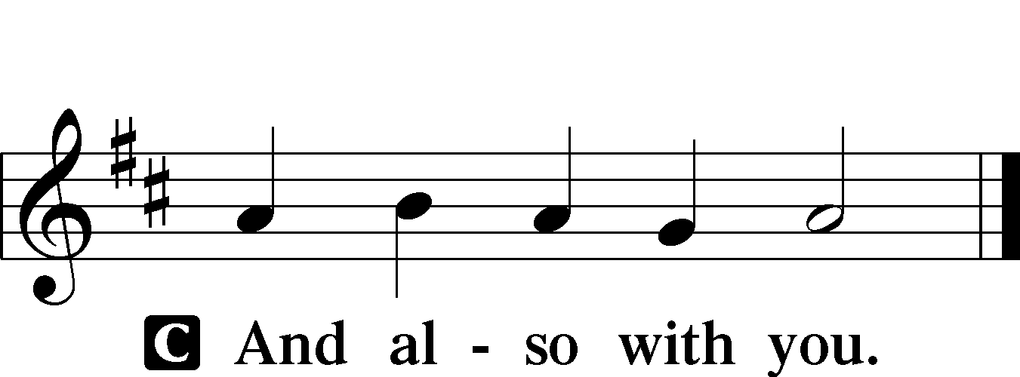

P Let us pray.
C Almighty and merciful God, of Your bountiful goodness keep from us all things that may hurt us that we, being ready in both body and soul, may cheerfully accomplish whatever You would have us do; through Jesus Christ, Your Son,
our Lord, who lives and reigns with You and the Holy Spirit, one God, now and forever. Amen.

Sit

Old Testament Reading Genesis 28:10–17
10Jacob left Beersheba and went toward Haran. 11And he came to a certain place and stayed there that night, because the sun had set. Taking one of the stones of the place, he put it under his head and lay down in that place to sleep. 12And he dreamed, and behold, there was a ladder set up on the earth, and the top of it reached to heaven. And behold, the angels of God were ascending and descending on it! 13And behold, the Lord stood above it and said, “I am the Lord, the God of Abraham your father and the God of Isaac. The land on which you lie I will give to you and to your offspring. 14Your offspring shall be like the dust of the earth, and you shall spread abroad to the west and to the east and to the north and to the south, and in you and your offspring shall all the families of the earth be blessed. 15Behold, I am with you and will keep you wherever you go, and will bring you back to this land. For I will not leave you until I have done what I have promised you.” 16Then Jacob awoke from his sleep and said, “Surely the Lord is in this place, and I did not know it.” 17And he was afraid and said, “How awesome is this place! This is none other than the house of God, and this is the gate of heaven.”

A This is the Word of the Lord.
C Thanks be to God.

Gradual Psalm 141:1–2
O Lord, I call upon you; hasten to me!*
Give ear to my voice when I call to you!
Let my prayer be counted as incense before you,*
and the lifting up of my hands as the evening sacrifice!

Epistle Ephesians 4:22–28
22Put off your old self, which belongs to your former manner of life and is corrupt through deceitful desires, 23and to be renewed in the spirit of your minds, 24and to put on the new self, created after the likeness of God in true righteousness and holiness.
25Therefore, having put away falsehood, let each one of you speak the truth with his neighbor, for we are members one of another.
26Be angry and do not sin; do not let the sun go down on your anger, 27and give no opportunity to the devil. 28Let the thief no longer steal, but rather let him labor, doing honest work with his own hands,
so that he may have something to share with anyone in need.

A This is the Word of the Lord.
C Thanks be to God.

Stand

Alleluia and Verse LSB 173
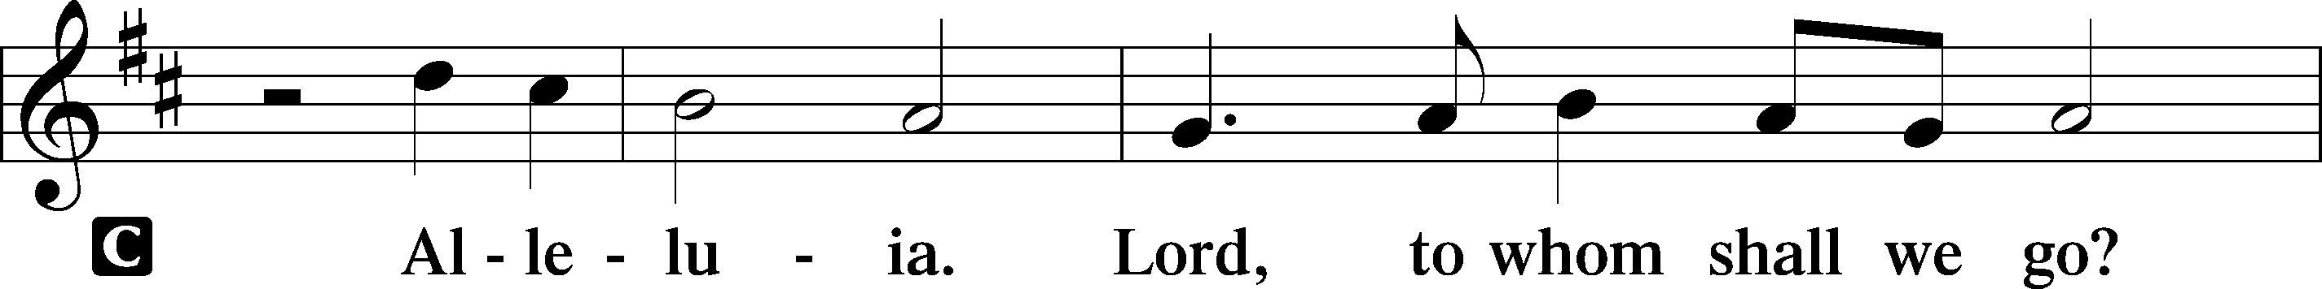
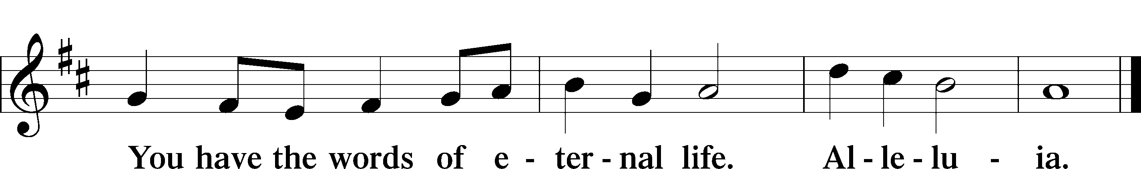

Holy Gospel Matthew 9:1–8
P The Holy Gospel according to St. Matthew, the ninth chapter.

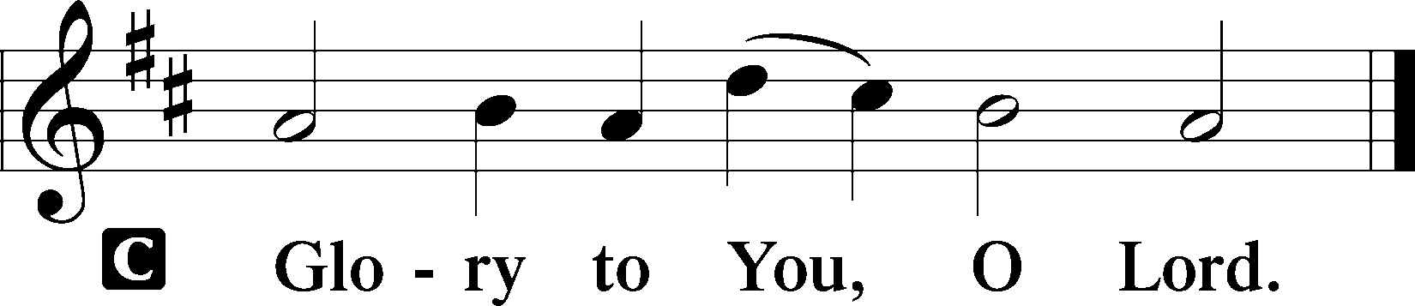

1Getting into a boat [Jesus] crossed over and came to his own city. 2And behold, some people brought to him a paralytic, lying on a bed. And when Jesus saw their faith, he said to the paralytic, “Take heart, my son; your sins are forgiven.” 3And behold, some of the scribes said to themselves, “This man is blaspheming.” 4But Jesus, knowing their thoughts, said, “Why do you think evil in your hearts?
5For which is easier, to say, ‘Your sins are forgiven,’ or to say,
‘Rise and walk’? 6But that you may know that the Son of Man has authority on earth to forgive sins”—he then said to the paralytic—“Rise, pick up your bed and go home.” 7And he rose and went home. 8When the crowds saw it, they were afraid, and they glorified God, who had given such authority to men.

P This is the Gospel of the Lord.

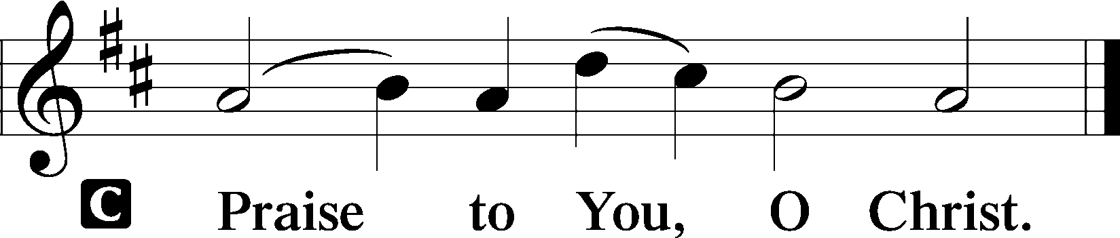

Nicene Creed
C I believe in one God,
the Father Almighty,
maker of heaven and earth
and of all things visible and invisible.

And in one Lord Jesus Christ,
the only-begotten Son of God,
begotten of His Father before all worlds,
God of God, Light of Light,
very God of very God,
begotten, not made,
being of one substance with the Father,
by whom all things were made;
who for us men and for our salvation came down from heaven
and was incarnate by the Holy Spirit of the virgin Mary
and was made man;
and was crucified also for us under Pontius Pilate.
He suffered and was buried.
And the third day He rose again according to the Scriptures
and ascended into heaven
and sits at the right hand of the Father.
And He will come again with glory to judge both the living and the dead,
whose kingdom will have no end.

And I believe in the Holy Spirit,
the Lord and giver of life,
who proceeds from the Father and the Son,
who with the Father and the Son together is worshiped and glorified,
who spoke by the prophets.
And I believe in one holy Christian and apostolic Church,
I acknowledge one Baptism for the remission of sins,
and I look for the resurrection of the dead
and the life T of the world to come. Amen.

Sit

Children’s Message: “Jesus can do anything.”

Hymn of the Day “Lord, Thee I Love with All My Heart” LSB 708
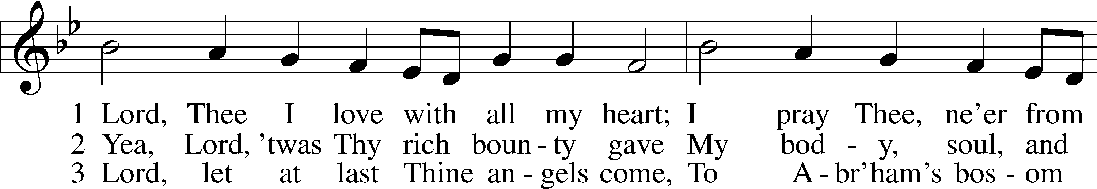
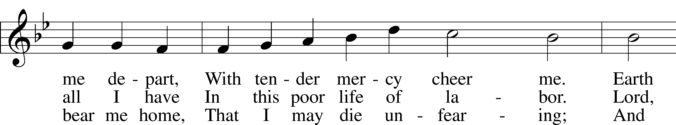
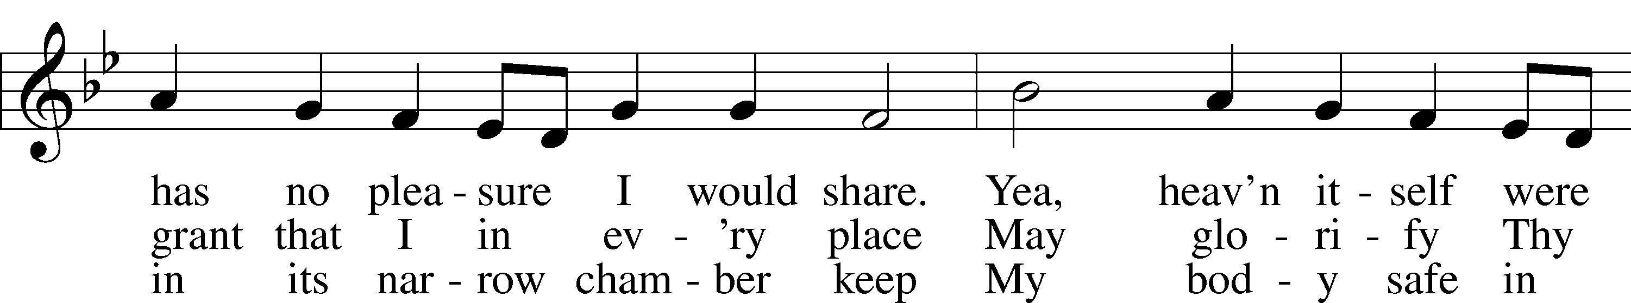
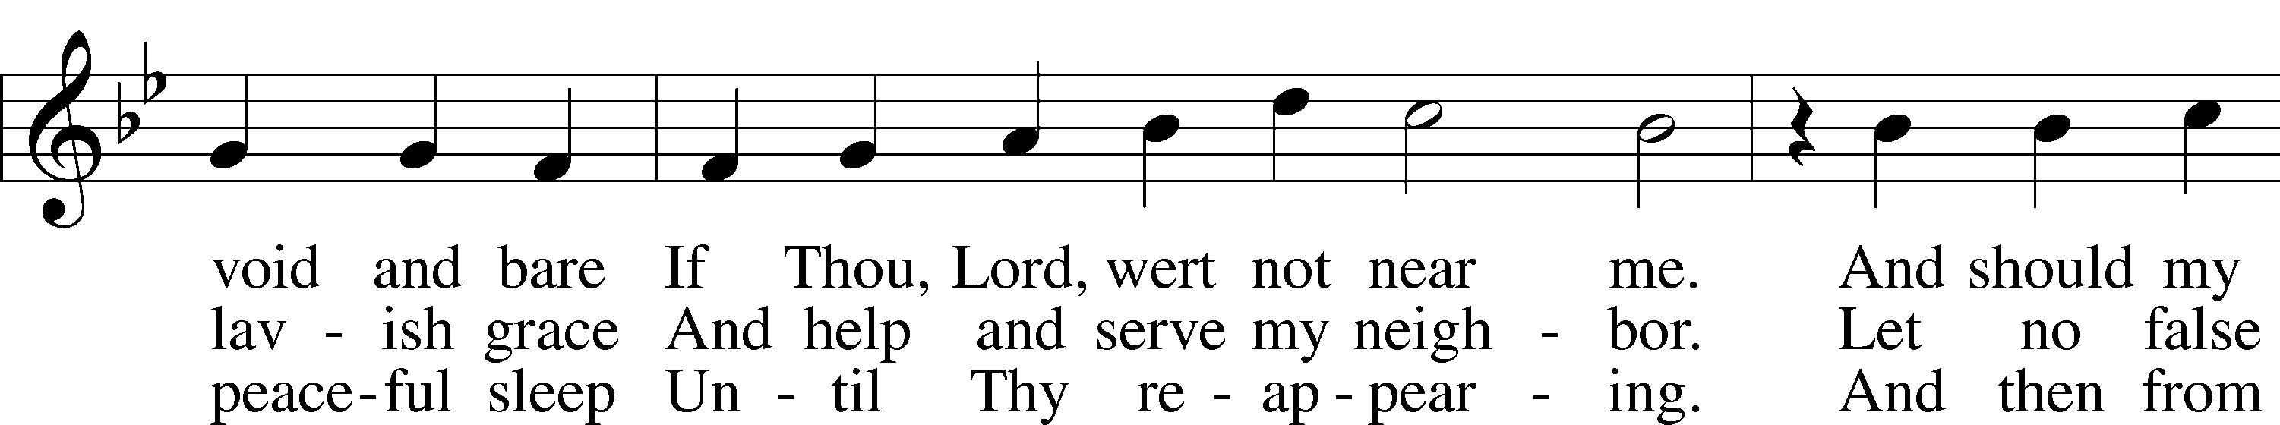
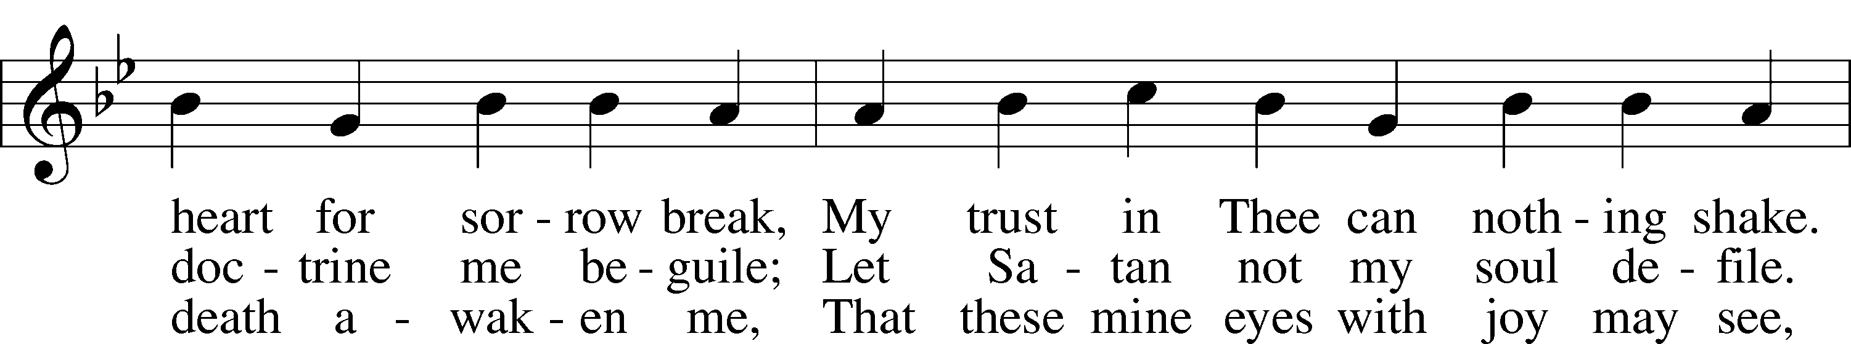
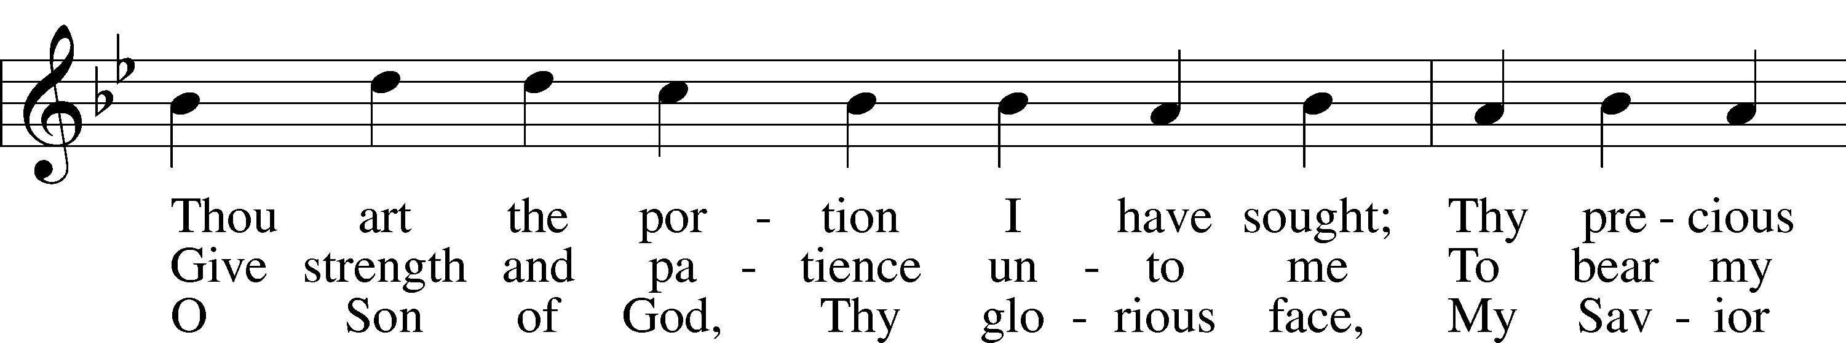
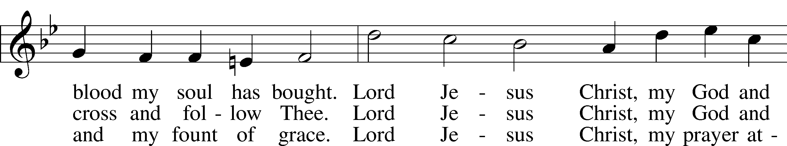
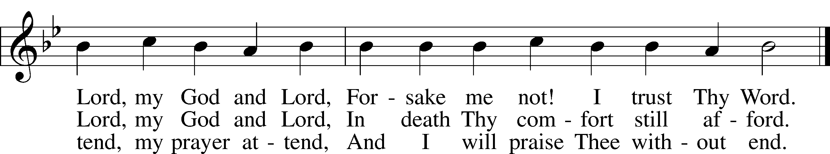
Text and tune: Public domain

Sermon: “Can Jesus, really forgive my sins?”

Offering

Stand

Offertory (spoken) LSB 176
C What shall I render to the Lord for all His benefits to me?
I will offer the sacrifice of thanksgiving and will call on the name of the Lord.
I will take the cup of salvation and will call on the name of the Lord.
I will pay my vows to the Lord now in the presence of all His people,
in the courts of the Lord’s house, in the midst of you, O Jerusalem.

Prayer of the Church

+SERVICE OF THE SACRAMENT+

Preface LSB 177
P The Lord be with you.
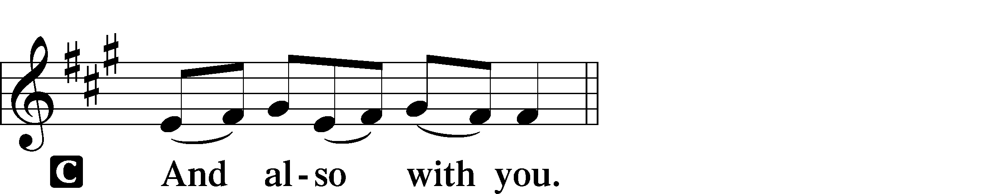

P Lift up your hearts.
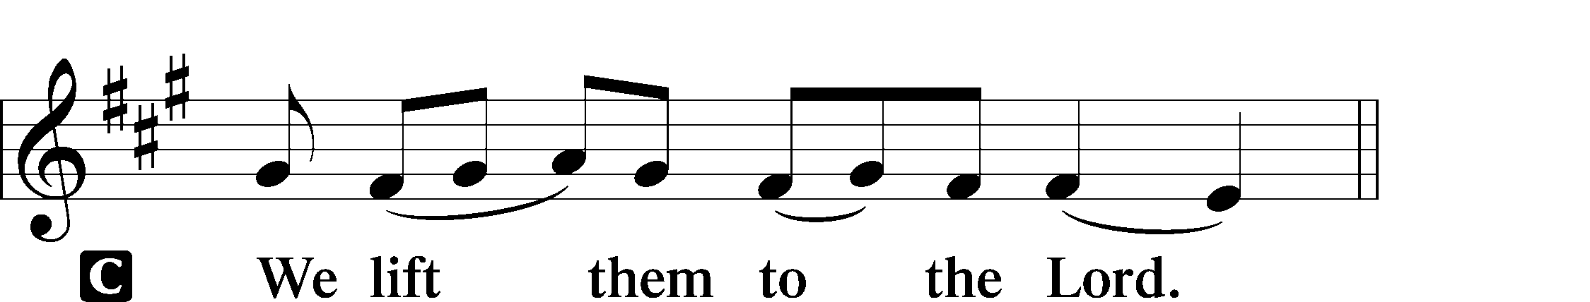

P Let us give thanks to the Lord our God.
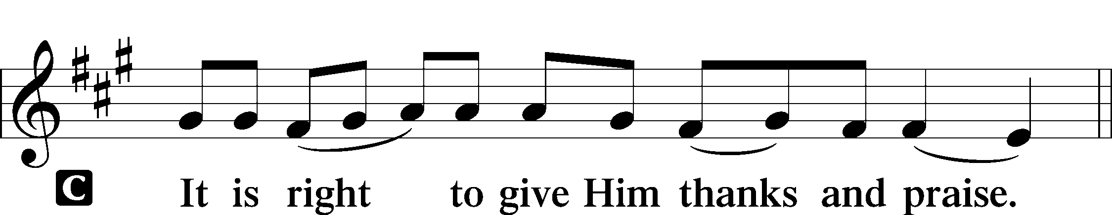

Proper Preface
P It is truly good, right, and salutary that we should at all times and in all places give thanks to You, holy Lord, almighty Father, everlasting God, through Jesus Christ, our Lord, who, out of love for His fallen creation, humbled Himself by taking on the form of a servant, becoming obedient unto death, even death upon a cross. Risen from the dead, He has freed us from eternal death and given us life everlasting. Therefore with angels and archangels and with all the company of heaven we laud and magnify Your glorious name, evermore praising You and saying:

Sanctus LSB 178
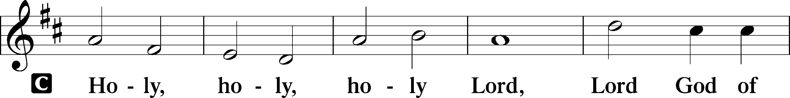
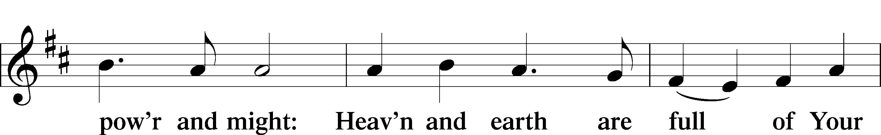
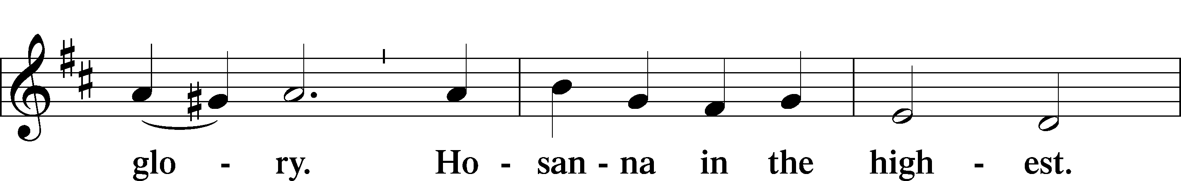
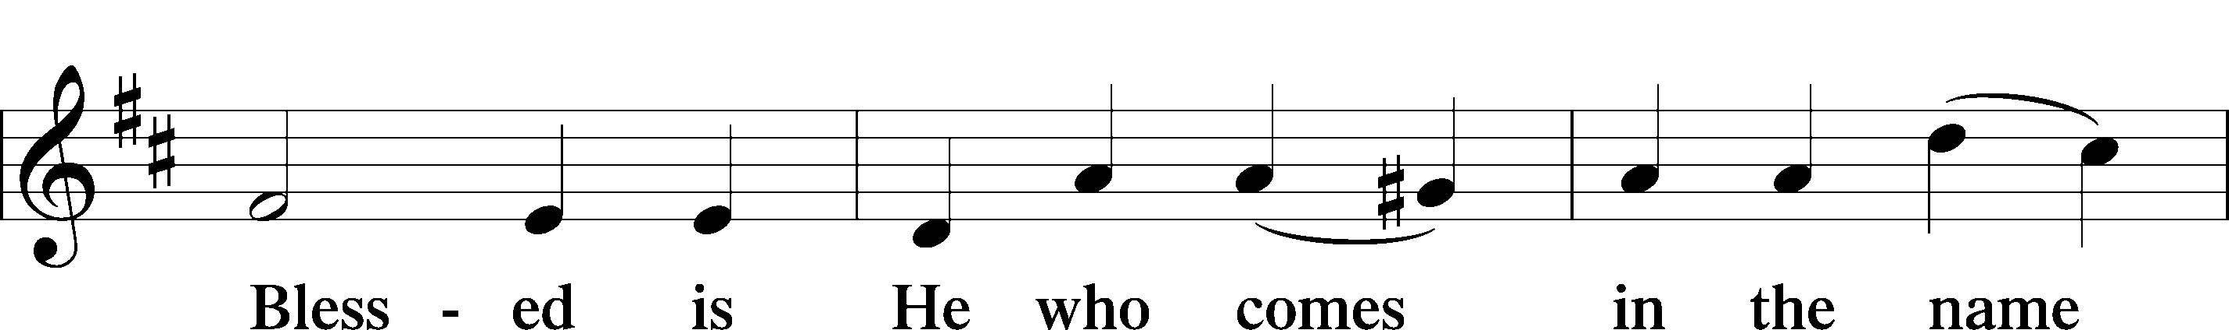
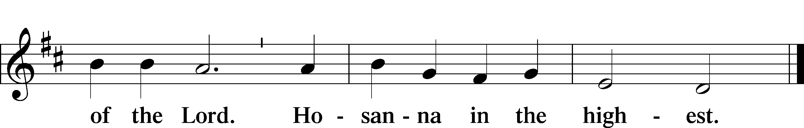
Lord’s Prayer
C Our Father who art in heaven,
hallowed be Thy name,
Thy kingdom come,
Thy will be done on earth
as it is in heaven;
give us this day our daily bread;
and forgive us our trespasses
as we forgive those
who trespass against us;
and lead us not into temptation,
but deliver us from evil.
For Thine is the kingdom
and the power and the glory
forever and ever. Amen.

The Words of Our Lord
P Our Lord Jesus Christ, on the night when He was betrayed, took bread, and when He had given thanks, He broke it and gave it to the disciples and said: “Take, eat; this is My T body, which is given for you. This do in remembrance of Me.”

In the same way also He took the cup after supper, and when He had given thanks, He gave it to them, saying: “Drink of it, all of you; this cup is the new testament in My T blood, which is shed for you for the forgiveness of sins. This do, as often as you drink it, in remembrance of Me.”

Pax Domini LSB 180
P The peace of the Lord be with you always.
C Amen.

Agnus Dei LSB 180
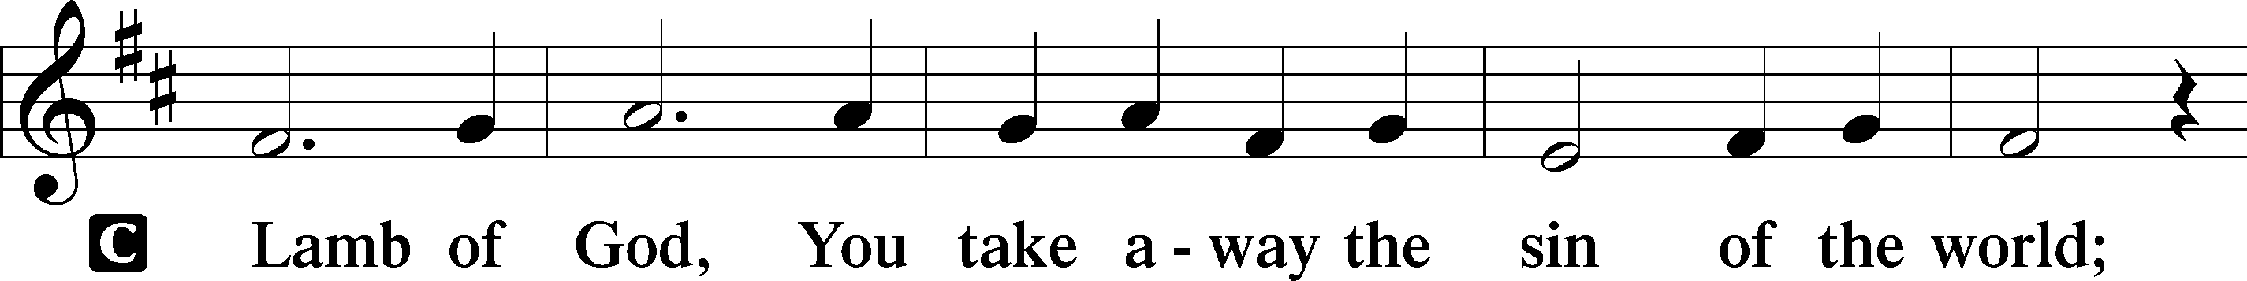
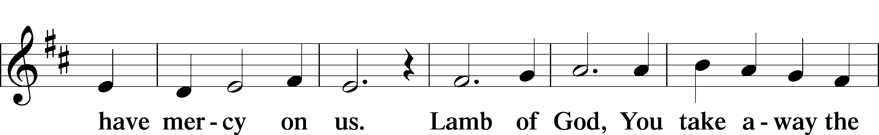
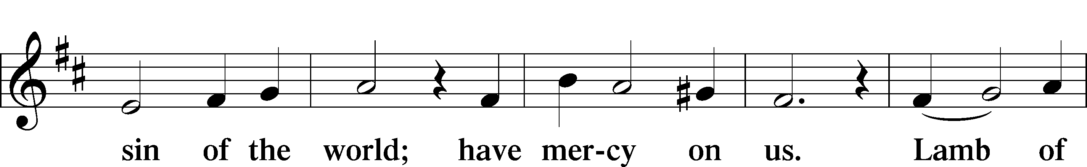
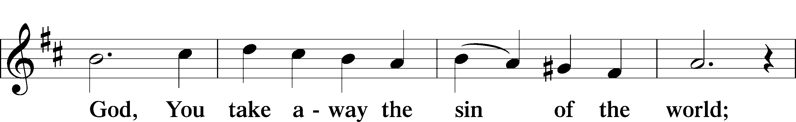
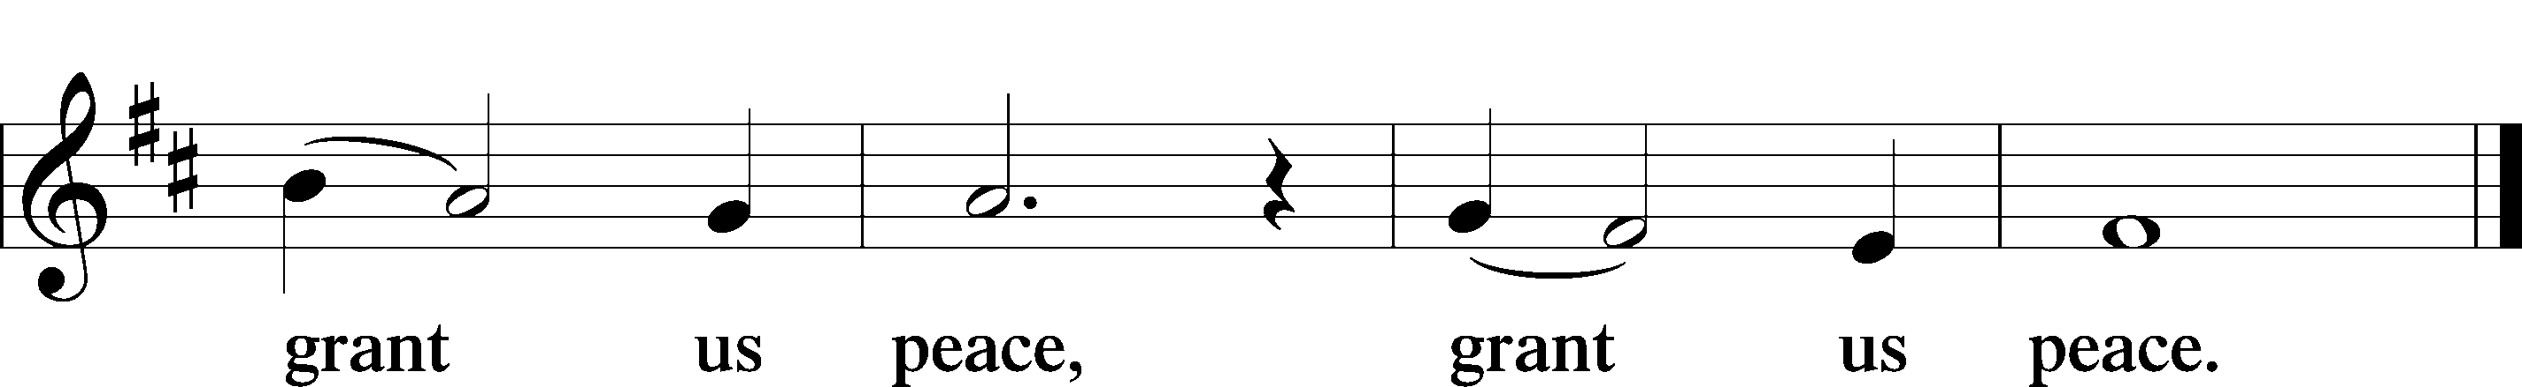

Sit

Distribution

Distribution Hymn “What Is This Bread” LSB 629
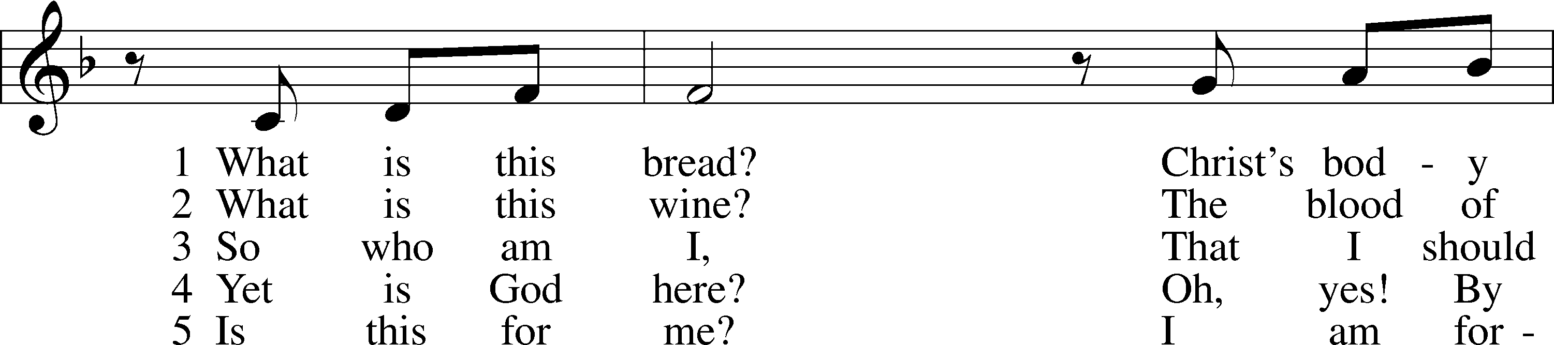
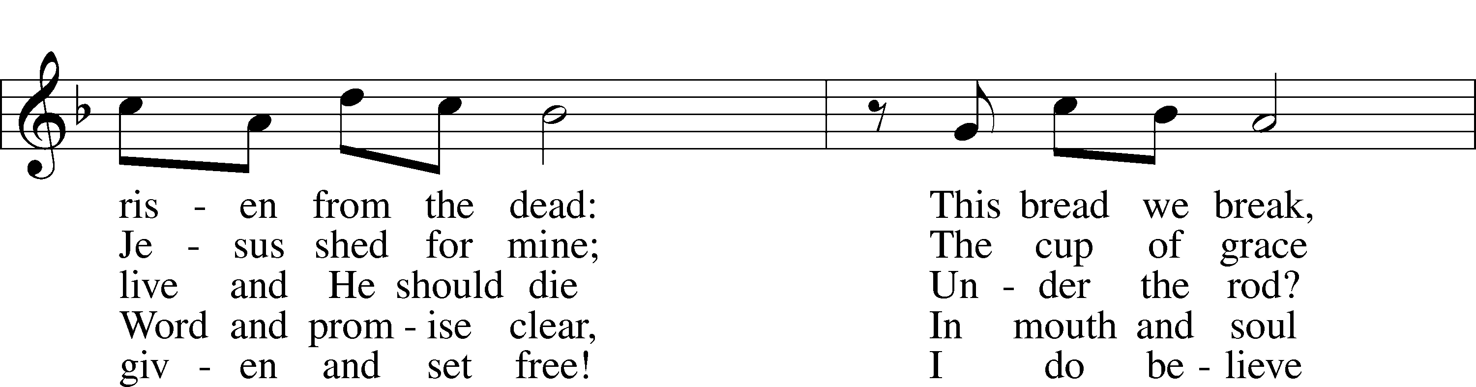
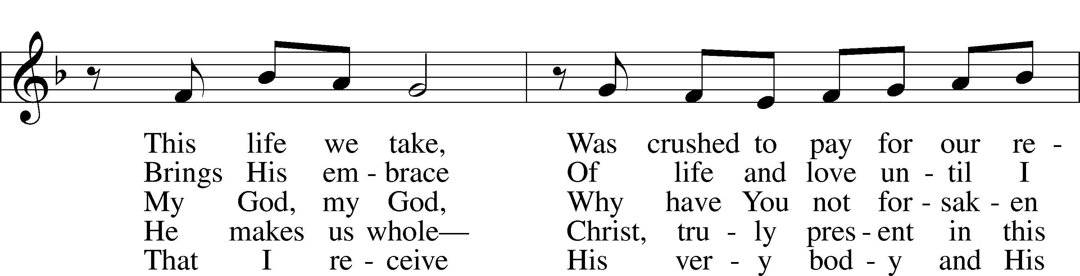
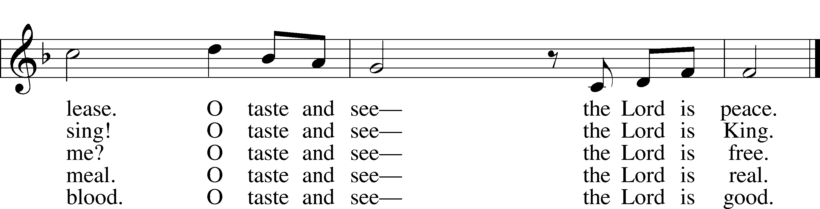
Tune and text: © 1991 Fred and Jean Baue. Used by permission: LSB Hymn License no. 110016438

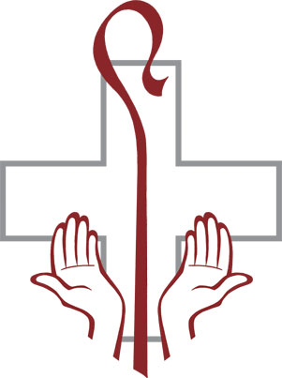
Distribution Hymn “Stand Up, Stand Up for Jesus” LSB 660
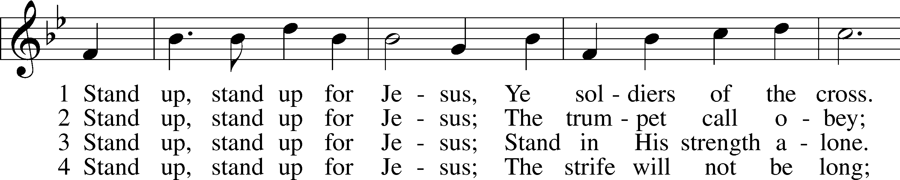
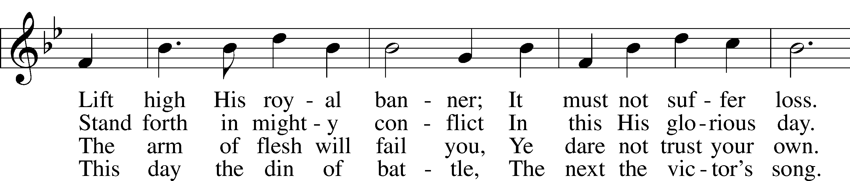
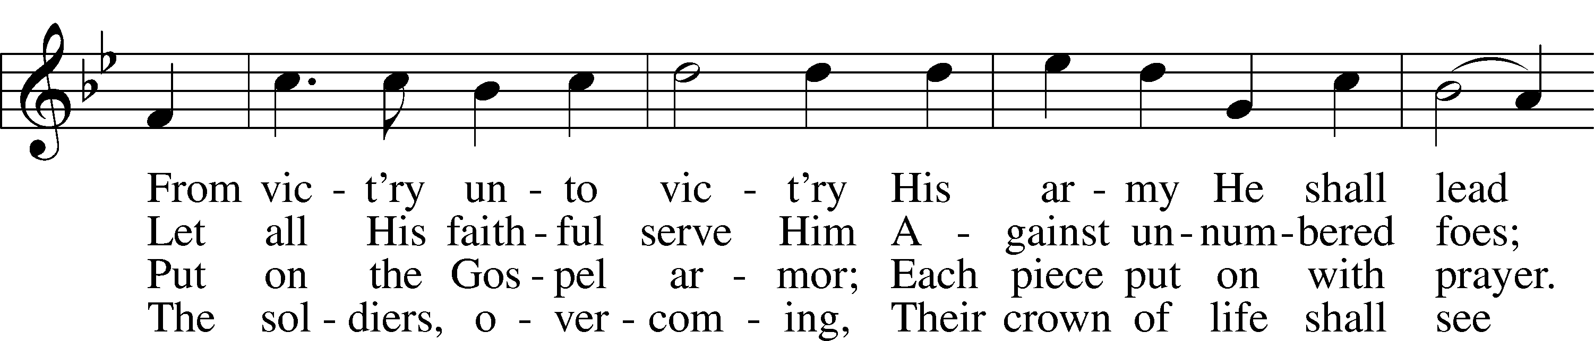
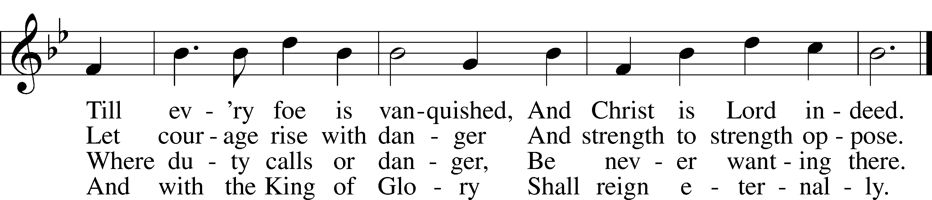
Tune and text: Public domain

Distribution Hymn “Chief of Sinners Though I Be” LSB 611
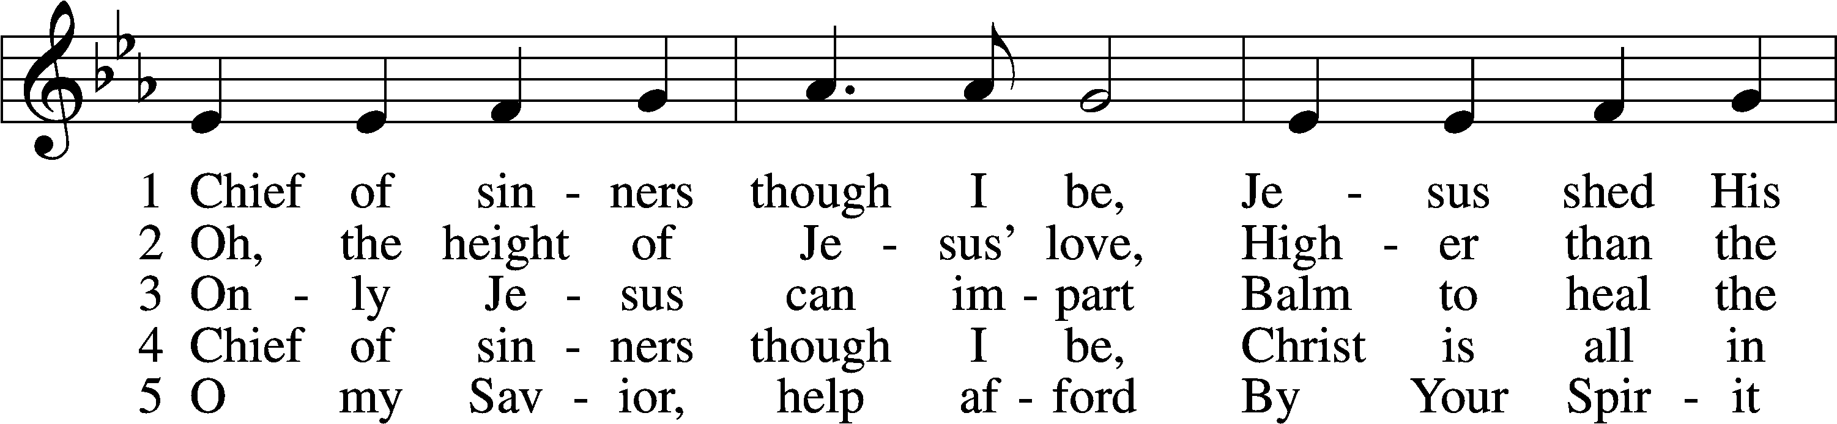
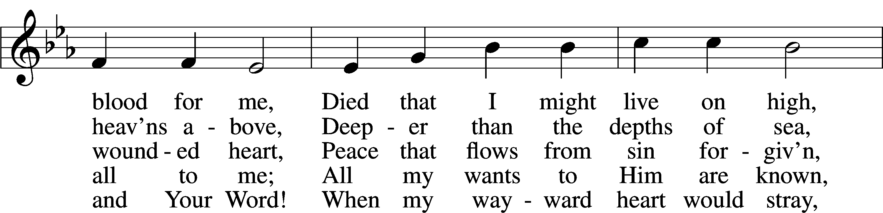
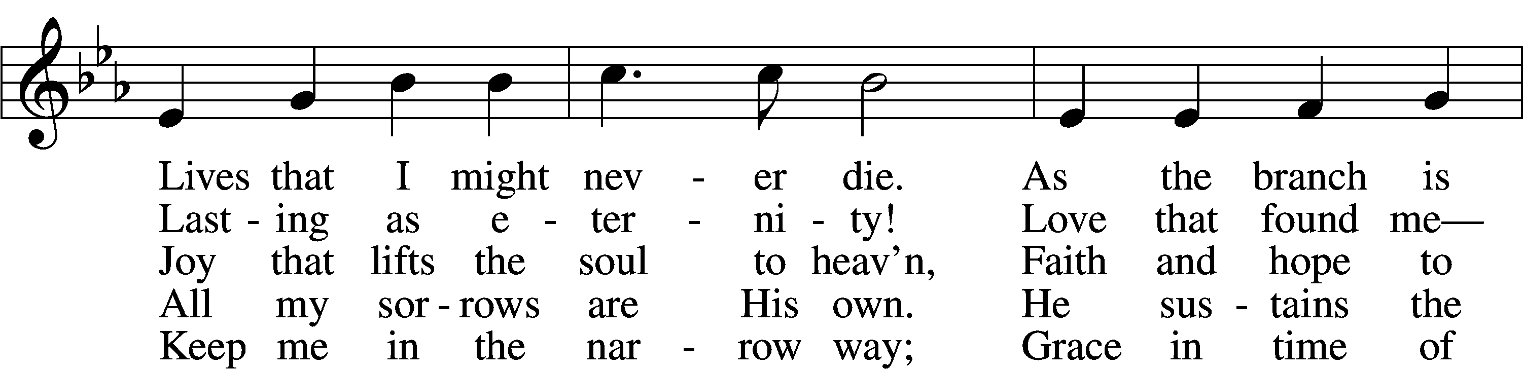
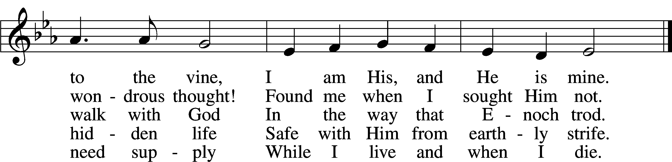
Tune and text: Public domain

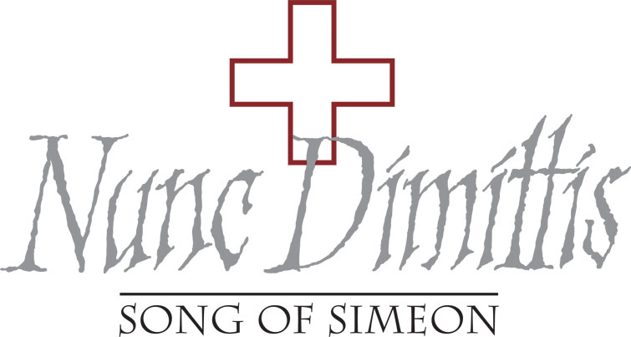

Stand

Nunc Dimittis LSB 182
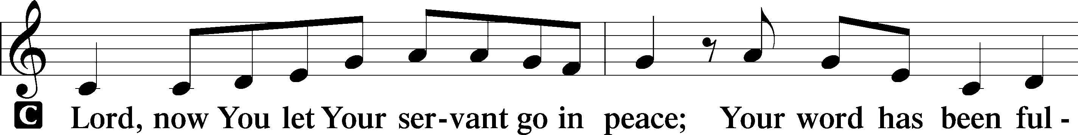
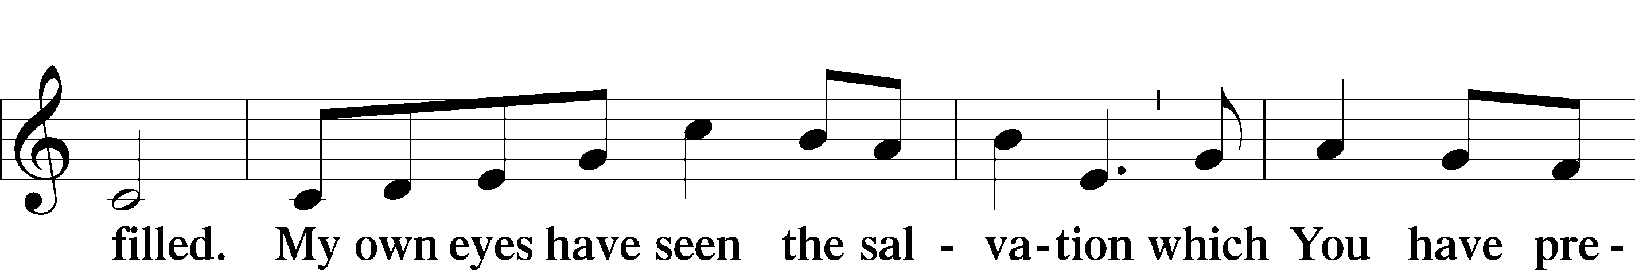
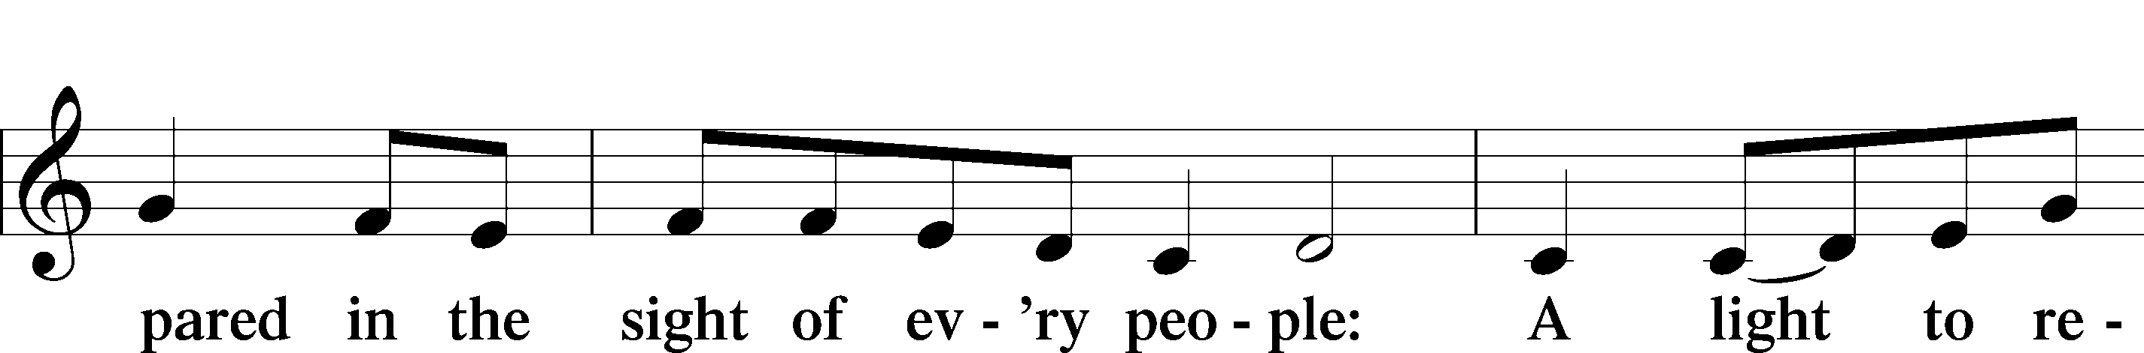
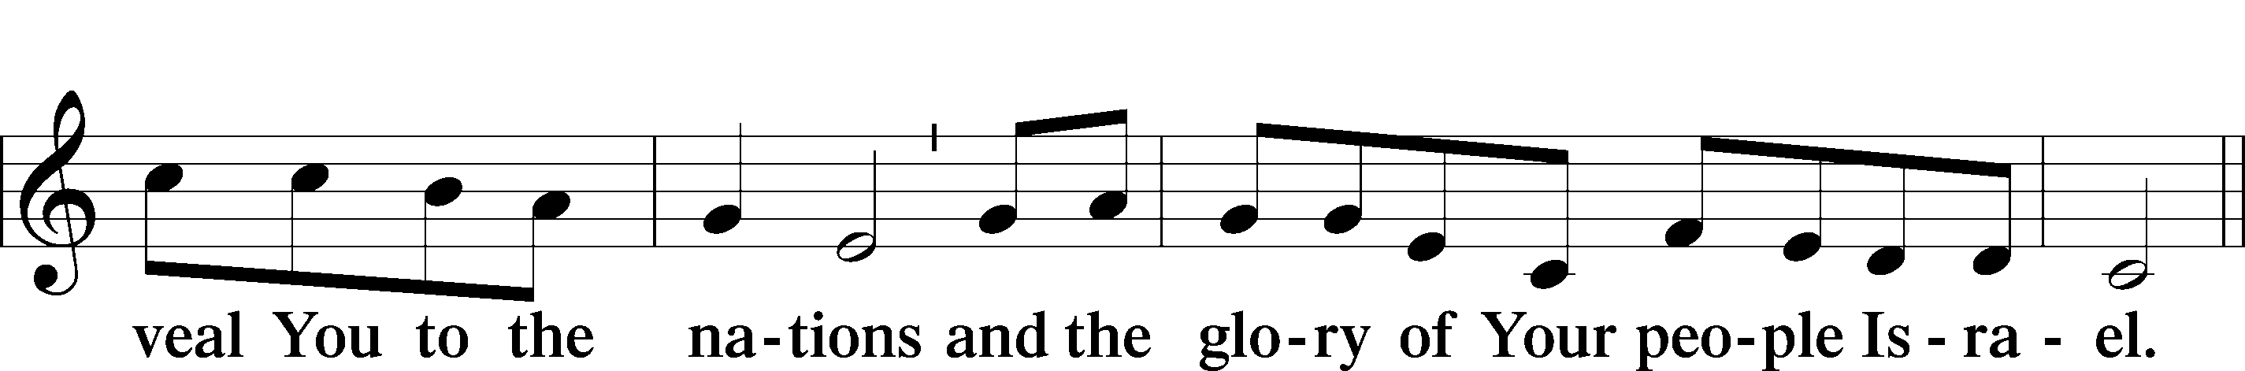
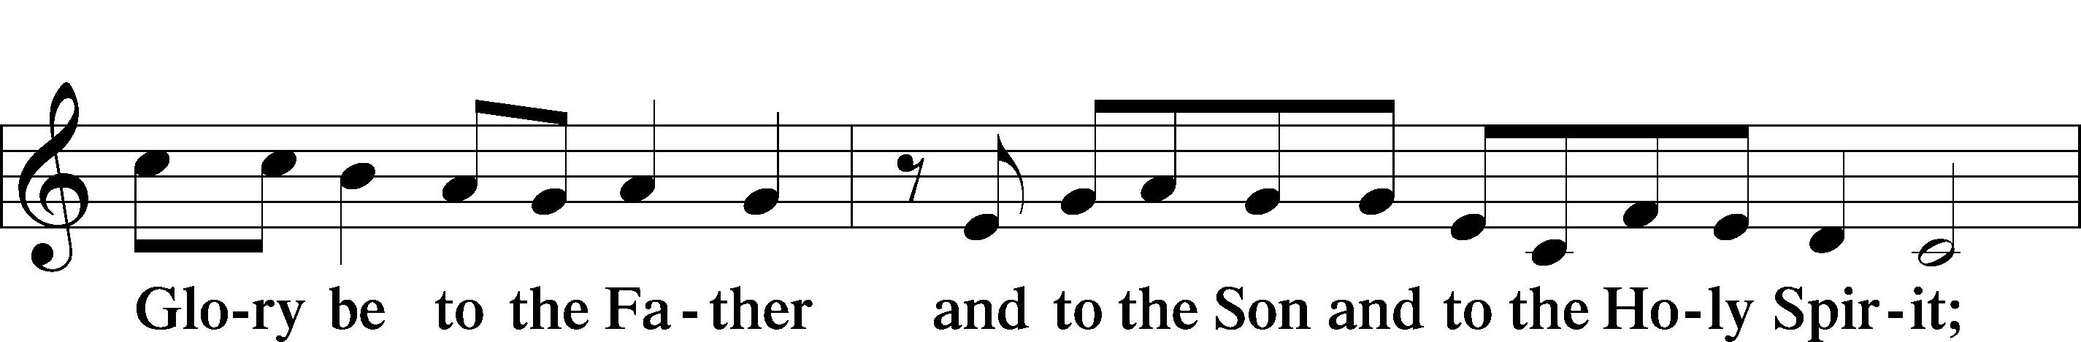
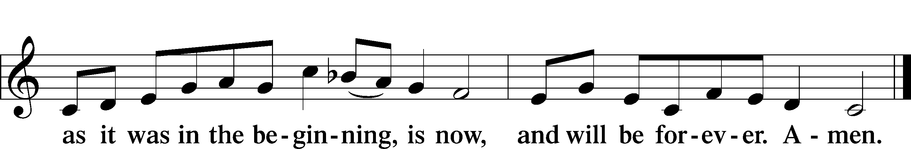

Post-Communion Collect
A Let us pray.
We give thanks to You, almighty God, that You have refreshed us through this salutary gift, and we implore You that of Your mercy You would strengthen us through the same in faith toward You and in fervent love toward one another; through Jesus Christ, Your Son, our Lord, who lives and reigns with You and the Holy Spirit, one God, now and forever.
C Amen.

Benediction LSB 183
P The Lord bless you and keep you.
The Lord make His face shine on you and be gracious to you.
The Lord look upon you with favor and T give you peace.

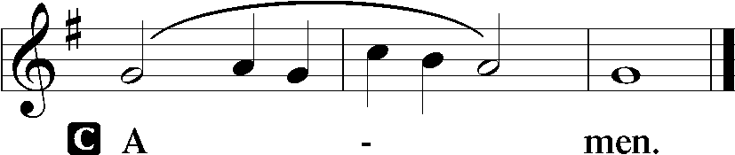

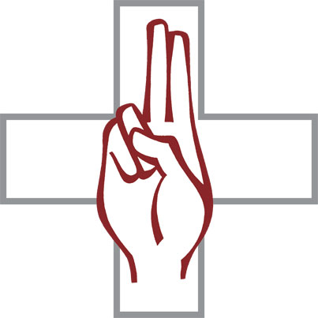
Closing Hymn “Let Us Ever Walk with Jesus” LSB 685
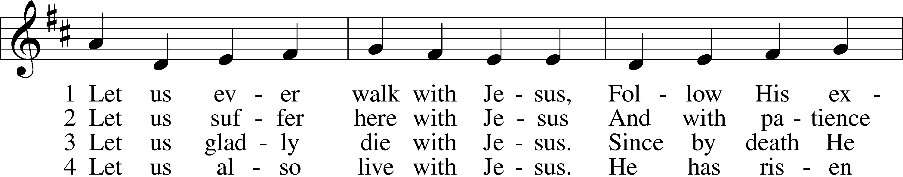
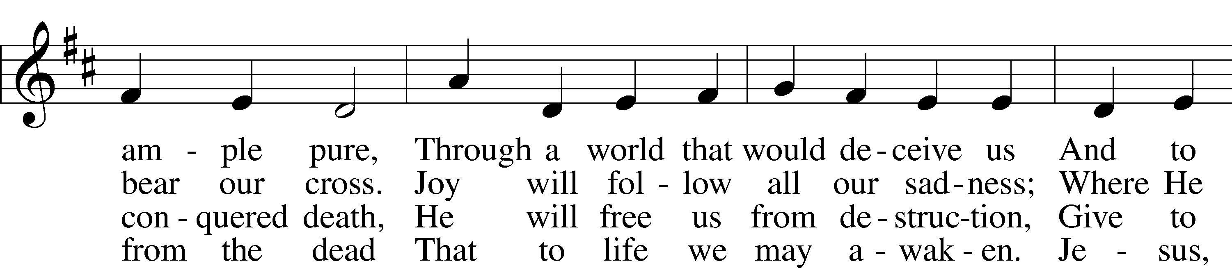
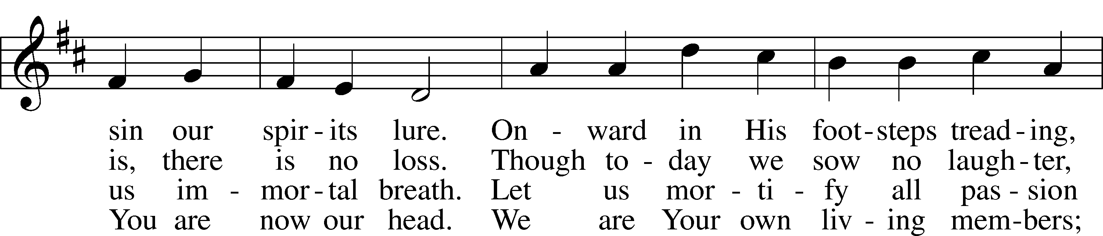
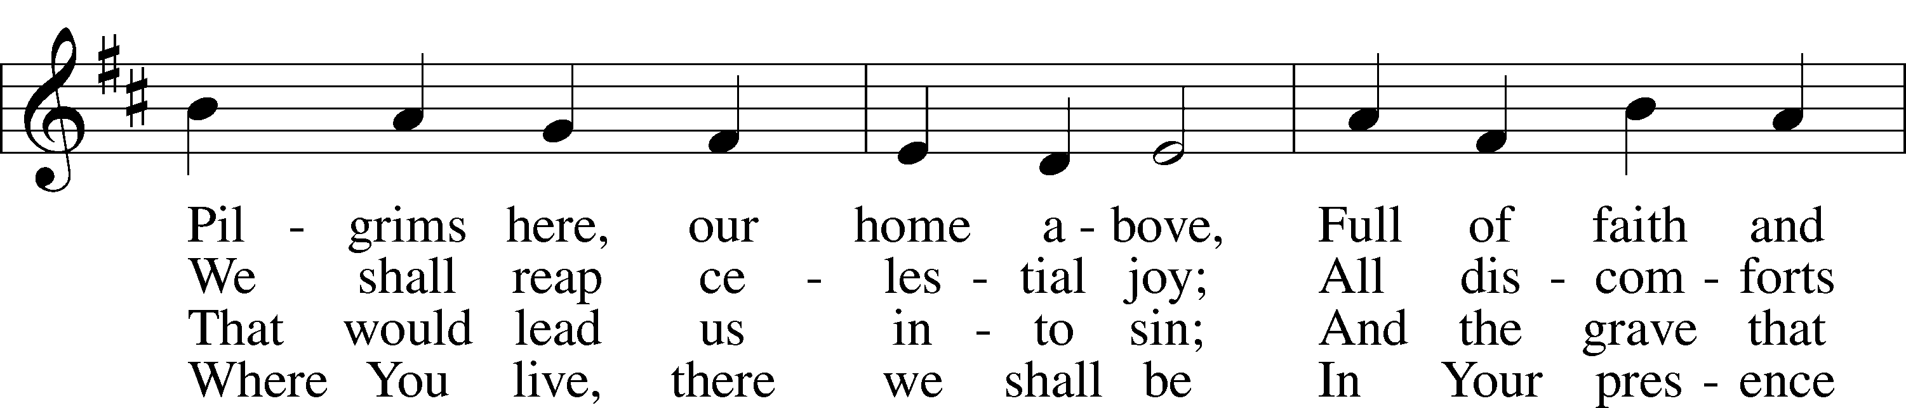
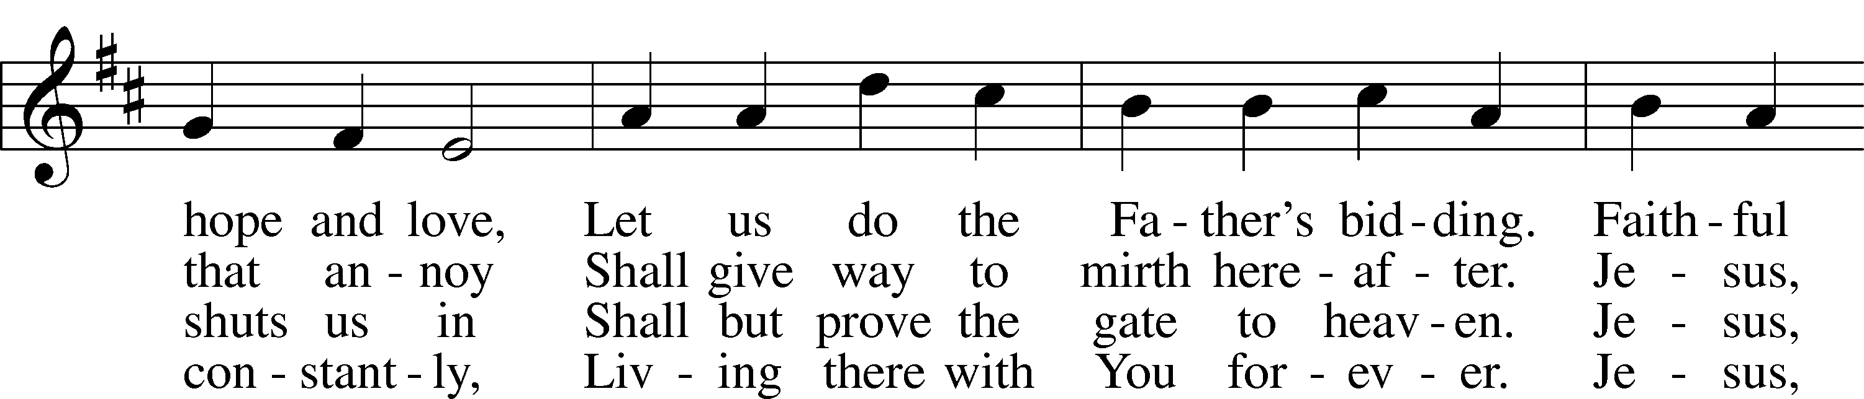
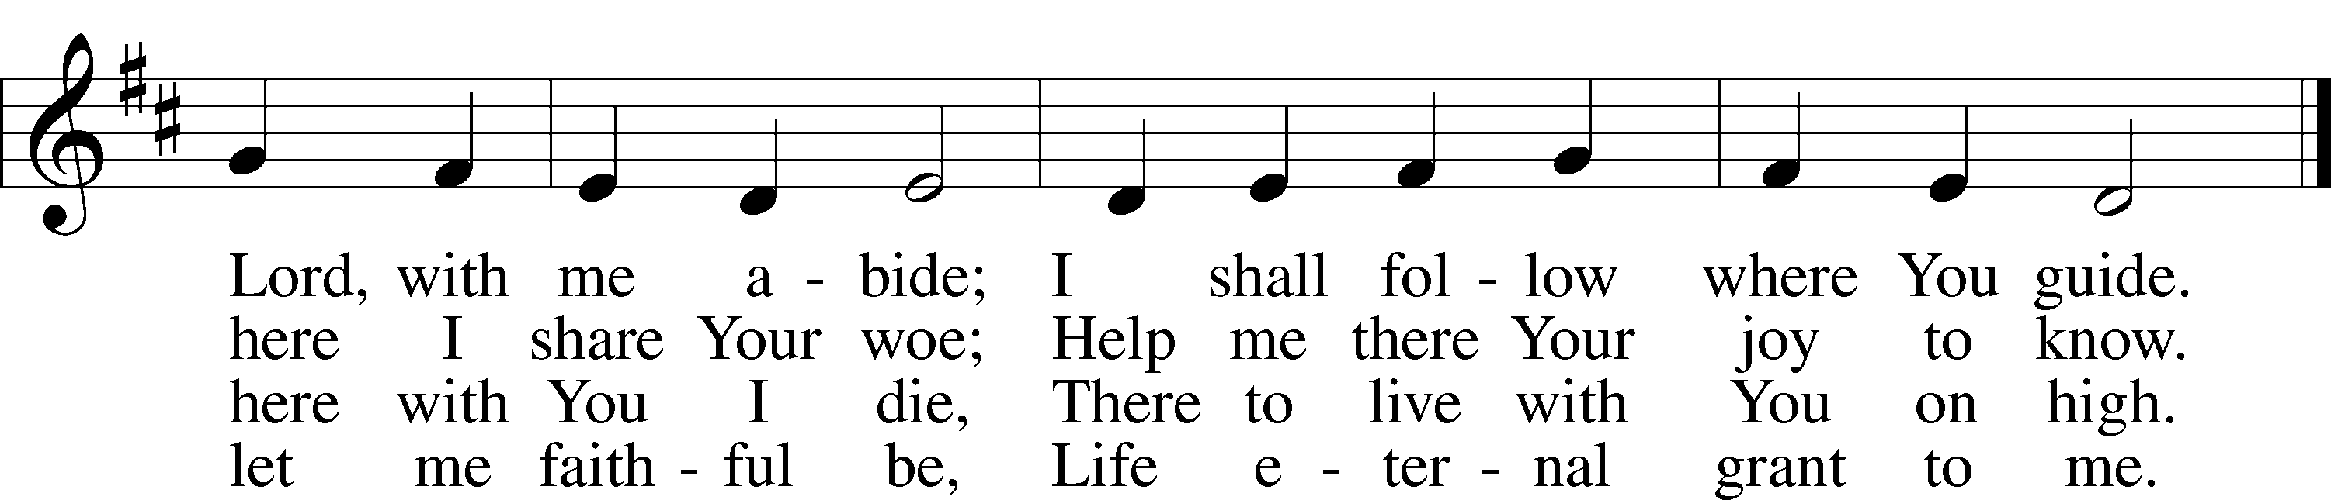
Text: © 1978 Lutheran Book of Worship. Used by permission: LSB Hymn License no. 110016438
Tune: Public domain

Acknowledgments
Unless otherwise indicated, Scripture quotations are from the ESV® Bible (The Holy Bible, English Standard Version®), copyright © 2001 by Crossway, a publishing ministry of Good News Publishers. Used by permission. All rights reserved.
Created by Lutheran Service Builder © 2021 Concordia Publishing House.

Serving Our Lord in His House Today:
Pastor: Rev. Steve Thomas
Organist: Rebecca Moseley
Elders: Bob Pulley & Josh Church
Joe Engel (Wednesday)

Gifts from God: Ephesians 4:24 – “Put on the new self, created after the likeness of God in true righteousness and holiness.” The battle between the old self in Adam and the new self in Christ is fought in the heart and mind of every Christian. Paul encourages us to put on the new man, which is created in the image of God. Our sanctification – our growth in godliness – is a growth into God’s image. We do this by keeping our eyes on Christ and imitating Him in everything with love, kindness, and self-giving generosity.

Pastor on Vacation: Please note, Pastor Wurdeman is currently on vacation through October 12, 2021. If you need pastoral care during this timeframe,
please contact the church office or your elder for assistance.

Family Promise Training: Training session will take place today, October 10th at 1 pm. All volunteers should attend, but anyone interested in the program is invited to attend.

Weekly Psalms Devotional Group: Our Thursday morning Bible study will resume Thursday, October 14, 2021. Please join us Thursday mornings at 10:00 a.m., as we read and pray through selected Psalms. We’ll learn about their meaning, application and ways to incorporate them into your prayer life.

LWML Announcements: The salad kick-off dinner will take place tomorrow, October 11, 2021. We will meet at 5:30pm for fellowship and dinner will be at 6:00pm. A short meeting will follow dinner. The Zone 14 Fall Rally will take place Saturday, October 23, 2021, at Immanuel Lutheran Church, Adams, WI. Registration begins at 8:30am with the program starting at 9:30am. If you have any questions regarding either event, please contact Kathy Berg.

Thank you: Allen Gutknecht would like to express his thanks to whomever gifted him his new cake pan with lid, cake mix and frosting!

Fall Clean-Up: There will be a fall clean-up day Saturday, October 23, 2021,
8am-12pm at the church. If you have questions regarding this contact
Dillin Lafferty.

Hayride and Bonfire: There will be a hayride and bonfire (weather permitting) at the Rapp Family farm on Saturday, October 16, 2021 at 3pm. Questions regarding this event, please contact Ethan Rapp.

Livestream: Our Sunday Service is livestreamed weekly on our YouTube channel “Good Shepherd Lutheran Church Tomah.”

PO Box: For mailed offerings, please use the following:
Good Shepherd Lutheran Church
P.O. Box 551
Tomah, WI 54660

Our Worship attendance last week: Sunday: 45
Wednesday: 0
Total: 45

Scripture Lessons for next week: Isaiah 55:1-9
Ephesians 5:15-21
Matthew 22:1-14

Secretary Office Hours: Monday-Friday: 8am-12pm

Pastor Office Hours: Pastor’s regular hours are Sunday-Thursday, 9am-5pm.
He is typically in the office in the mornings. In the afternoon, he is typically in the office, making pastoral visits, at meetings, or providing pastoral care in the
community. If you would like to visit with pastor, please call the church office at 608-374-2444 or his cell phone at 317-410-2271 to arrange a time.

Our Week With Our Lord:
Today 9:00am Divine Service w/Holy Communion
(livestreamed via YouTube)
10:30am Adult Bible Study & Sunday School
SCRIP Orders Due
Mite Box Sunday
1:00pm Family Promise Training @church
Monday 5:30pm LWML Kick-off Meeting-Fellowship 6:00pm LWML Kick-off Meeting-Dinner
followed by Meeting
6:15pm Outreach Committee Meeting
Tuesday 6:00pm Board of Education Meeting
Wednesday 5:00pm Divine Service w/Holy Communion
6:30pm Confirmation Class
Thursday 10:00am Psalm Devotion/Study
6:00pm Elders Meeting
7:00pm Trustees Meeting
Friday
Saturday 3:00pm Bonfire/Hayride at Rapp Farm (weather permitting)
Sunday 9:00am Divine Service w/Holy Communion
(livestreamed via YouTube)
10:30am Adult Bible Study & Sunday School

*Please view the following page for weekly prayers*

HIS FLOCK AT PRAYER
Propers for the Nineteenth Week after Trinity

Psalm for the Week: Psalm 84

Daily Scripture Readings:
Sunday—Matthew 9:1-8 Thursday—Psalm 25:1-11
Monday— Psalm 130 Friday—Romans 5:6-11
Tuesday—Lamentations 3:22-33 Saturday— Psalm 63:1-7
Wednesday—Micah 7:18-20

Collect for the Week:
Almighty and merciful God, of Your bountiful goodness keep from us all things
that may hurt us that we, being ready in both body and soul, may cheerfully
accomplish whatever You would have us do; through Jesus Christ, Your Son,
our Lord, who lives and reigns with You and the Holy Spirit, one God, now and forever.

Hymn of the Week: “Lord, Thee I Love with All My Heart” LSB 708

Congregational Petitions for this Week:
+ For those whose work is difficult or dangerous including the military away from
home, especially: Nick Siegl, Isaac Preuss, Joshua Ecker and Tania Adler.
+ For those who are ill or recovering, especially: Brenda Kolb, Paula Sopel,
Shawn Zabinski, Karen Griggel, Ladene Zabinski, Carrie Wilbanks,
Payton Pierce, Marie Drescher, Les Hackett, Joyce Pulley, Tom Coman,
Kelly Ingenthron, Jean Salzman, Pastor Jacob Sutton, Joan Rosenow,
Ro Scrivner, Roux York, Lois Dallman, Melvin Welch, David Keinath,
Scott Berg, Robert Chase, Lucy Sherwood, Bob Goad, Nick Anderson,
Rose Scweisthel, Kevin Franks, Troy Lenning.
+ For those who are home-bound, especially: John Fox, Darlene Griffin,
Al Mansfield, Virginia Tillman, Linda Goad, Roemelle McArdle,
Sharon Herried.
+ For those suffering from the pandemic, especially those in our congregation who have been infected, those who are suffering financially, and those who work in the medical field.

