Good Shepherd Lutheran Church
Twentieth Sunday after Trinity
October 17, 2021

Pre-Service Music & Welcome

Divine Service Setting Two – Lutheran Service Book (LSB) 167

+CONFESSION AND ABSOLUTION+

Stand

Opening Hymn “Hark, the Voice of Jesus Calling” LSB 827
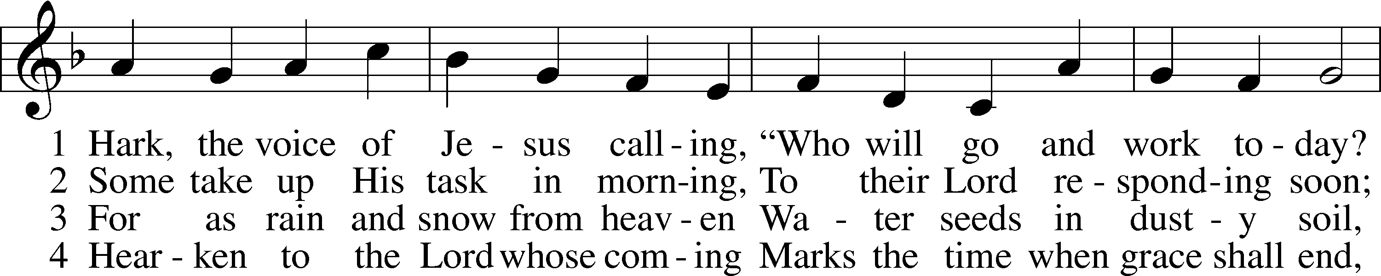
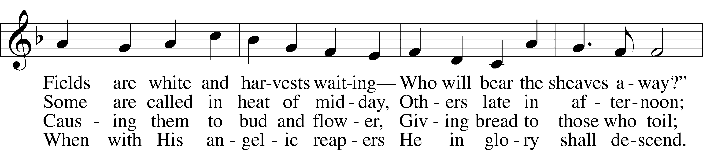
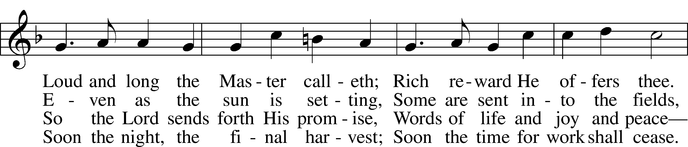
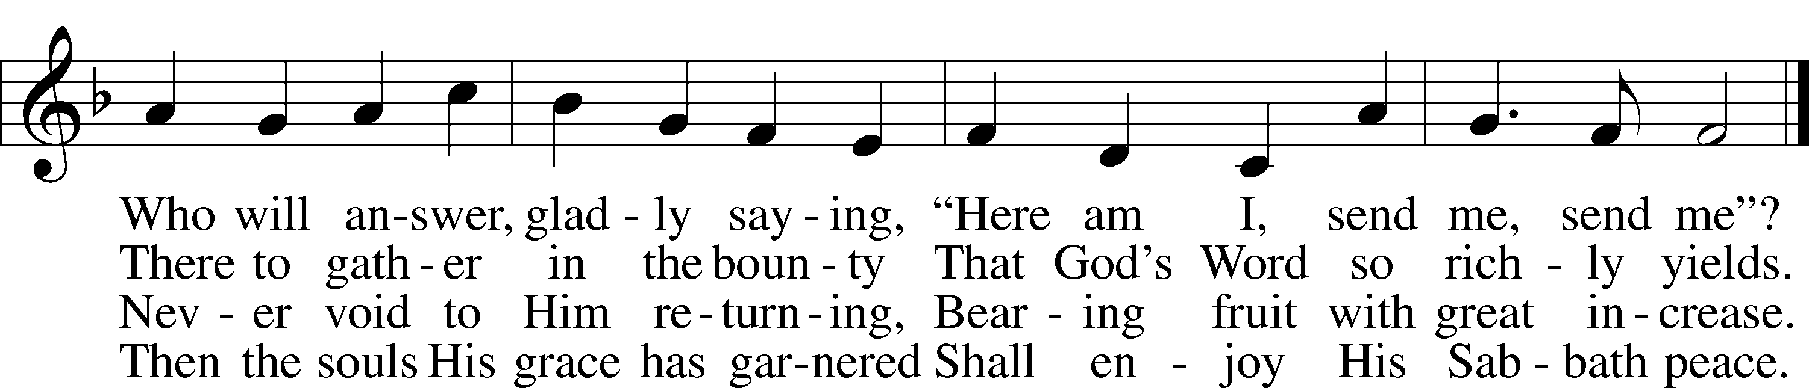
Text (st. 1) and tune: Public domain
Text (sts. 2–4): © 2001 Stephen P. Starke, admin. Concordia Publishing House. Used by permission: LSB Hymn License no. 110016438

The sign of the cross T may be made by all in remembrance of their Baptism.

Invocation
P In the name of the Father and of the T Son and of the Holy Spirit.
C Amen.

Exhortation LSB 167
P If we say we have no sin, we deceive ourselves, and the truth is not in us.
C But if we confess our sins, God, who is faithful and just, will forgive our sins and cleanse us from all unrighteousness.

Silence for reflection on God’s Word and for self-examination.

Confession of Sins LSB 167
P Let us then confess our sins to God our Father.
C Most merciful God, we confess that we are by nature sinful and unclean. We have sinned against You in thought, word, and deed, by what we have done and by what we have left undone. We have not loved You with our whole heart; we have not loved our neighbors as ourselves. We justly deserve Your present and eternal punishment. For the sake of Your Son, Jesus Christ, have mercy on us. Forgive us, renew us, and lead us, so that we may delight in Your will and walk in Your ways to the glory of Your holy name. Amen.

Absolution LSB 167
P Almighty God in His mercy has given His Son to die for you and for His sake forgives you all your sins. As a called and ordained servant of Christ, and by His authority, I therefore forgive you all your sins in the name of the Father and of the T Son and of the Holy Spirit.
C Amen.

+SERVICE OF THE WORD+

Introit Psalm 48:1, 9–11; antiphon: Liturgical Text
The Lord is righteous in all he has done to us,*
for we have not obeyed his commandments.
Glorify your name, O Lord;*
and deal with us according to your great mercy.
Great is the Lord and greatly to be praised*
in the city of our God, his holy mountain.
We have thought on your steadfast love, O God,*
in the midst of your temple.
As your name, O God, so your praise reaches to the ends of the earth.*
Your right hand is filled with righteousness.
Let Mount Zion be glad!*
Let the daughters of Judah rejoice because of your judgments!
Glory be to the Father and to the Son*
and to the Holy Spirit;
as it was in the beginning,*
is now, and will be forever. Amen.
The Lord is righteous in all he has done to us,*
for we have not obeyed his commandments.
Glorify your name, O Lord;*
and deal with us according to your great mercy.

Kyrie (spoken) LSB 168
A In peace let us pray to the Lord.
C Lord, have mercy.
A For the peace from above and for our salvation let us pray to the Lord.
C Lord, have mercy.
A For the peace of the whole world, for the well-being of the Church of God, and for the unity of all let us pray to the Lord.
C Lord, have mercy.
A For this holy house and for all who offer here their worship and praise let us pray to the Lord.
C Lord, have mercy.
A Help, save, comfort, and defend us, gracious Lord.
C Amen.

This Is the Feast LSB 171
Pastor sings (or speaks) the first line, the congregation joins in singing at “Worthy is Christ…”

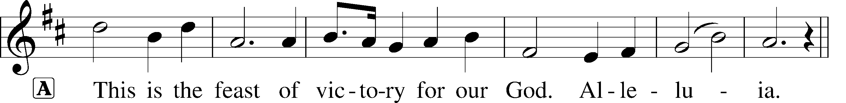
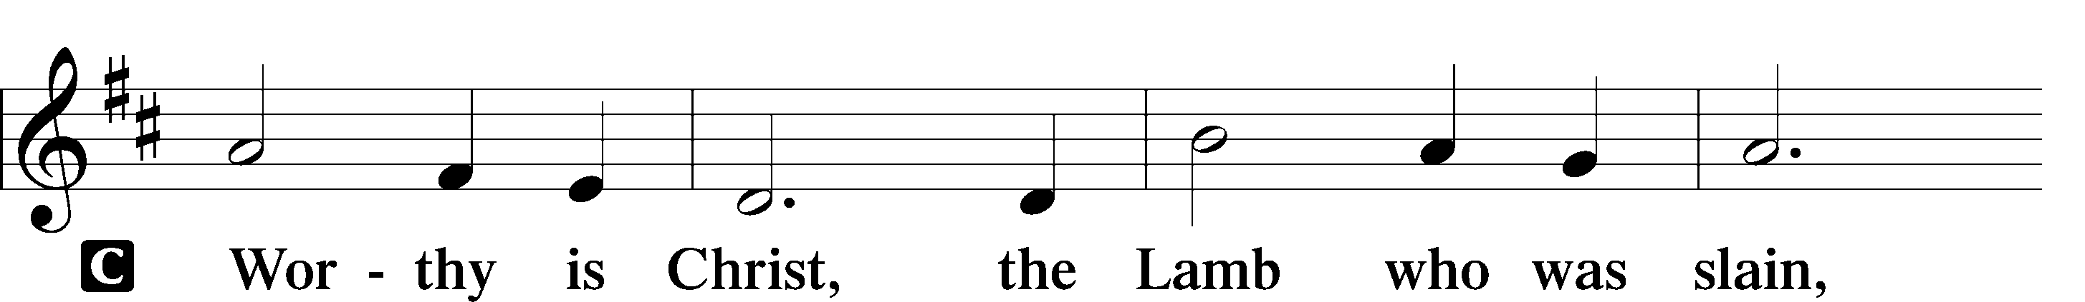
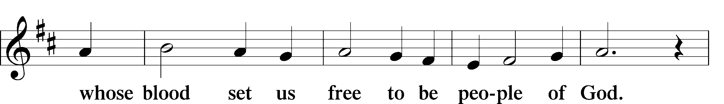
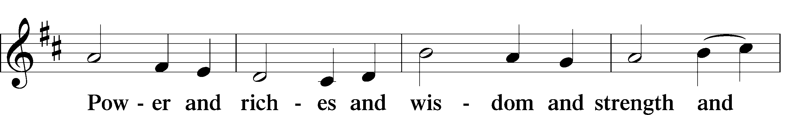
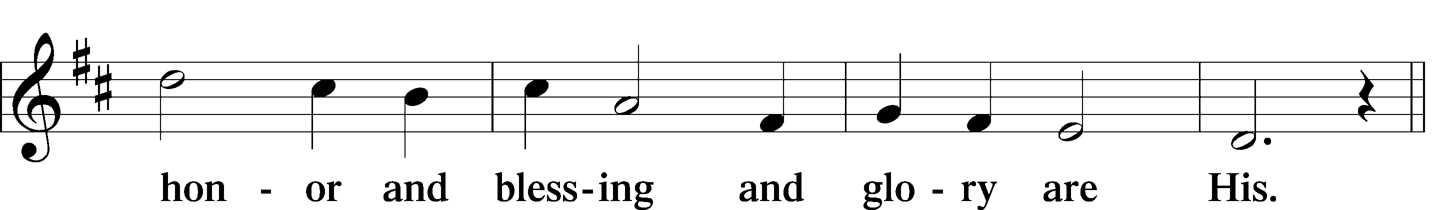
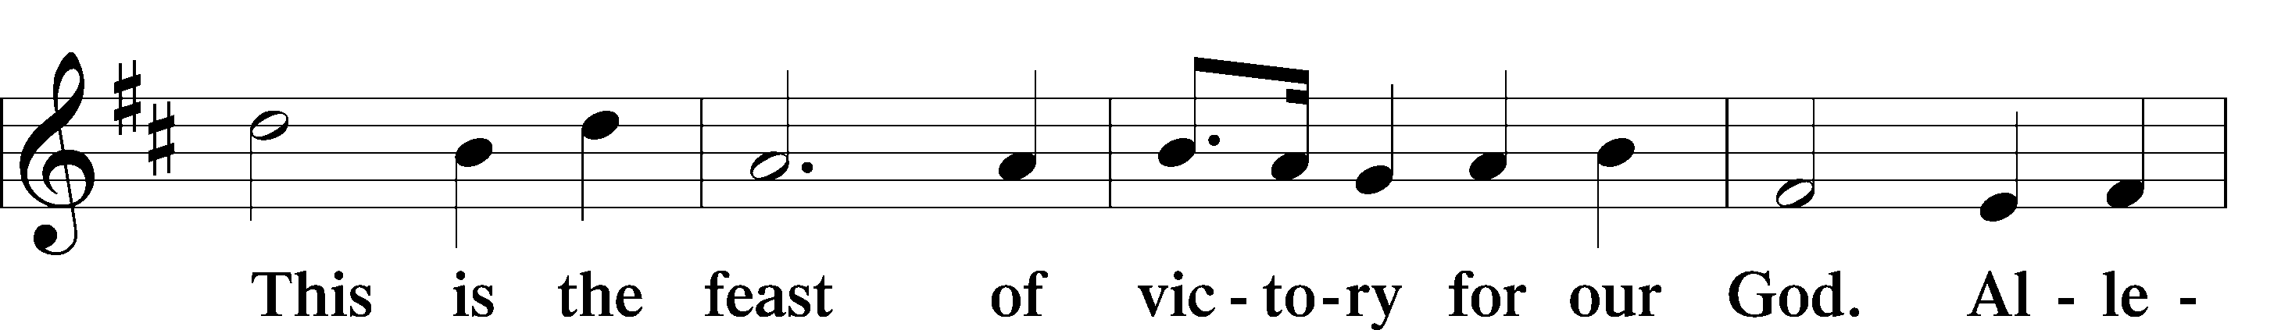
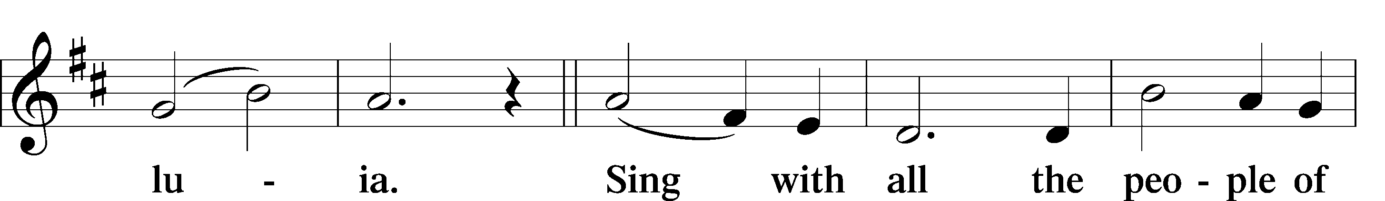
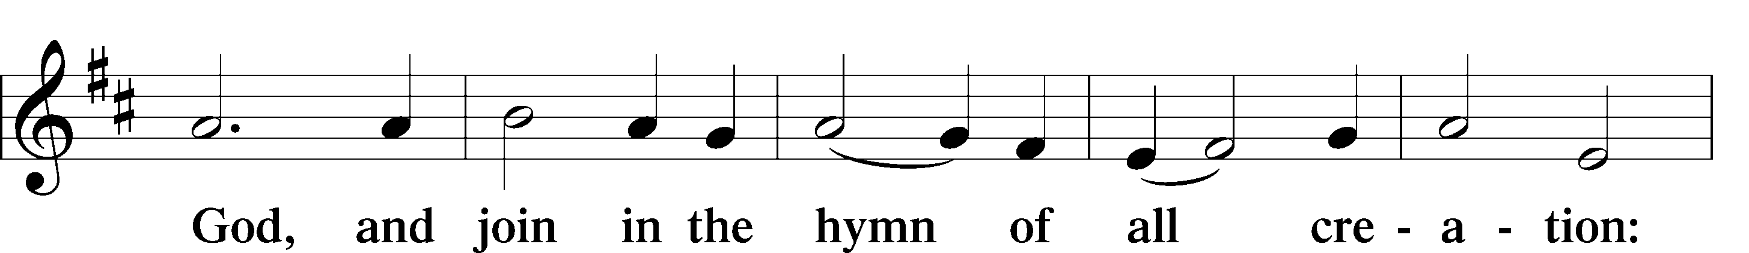
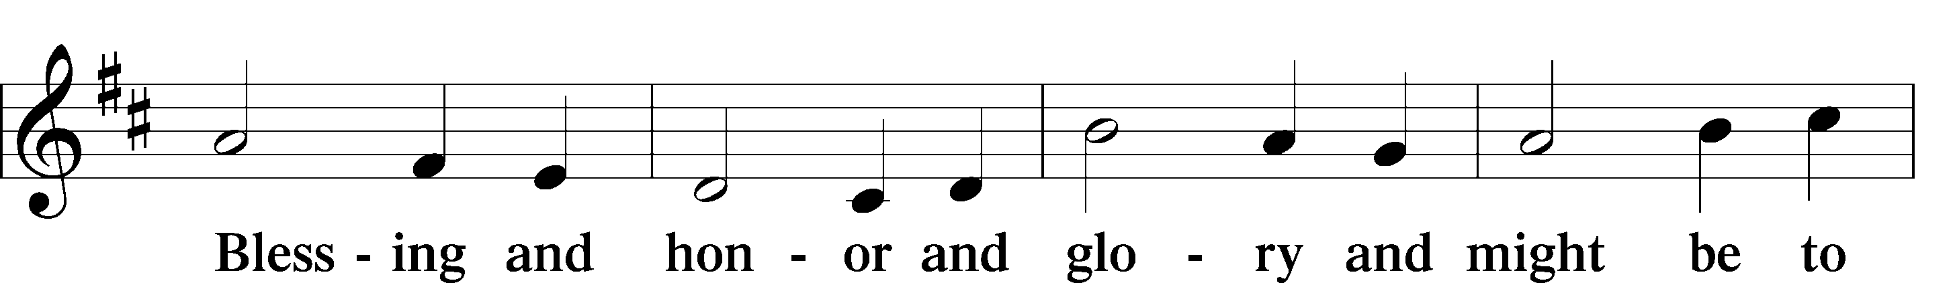
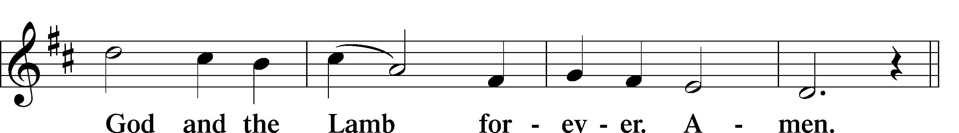
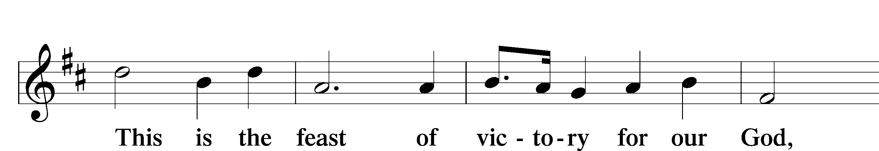
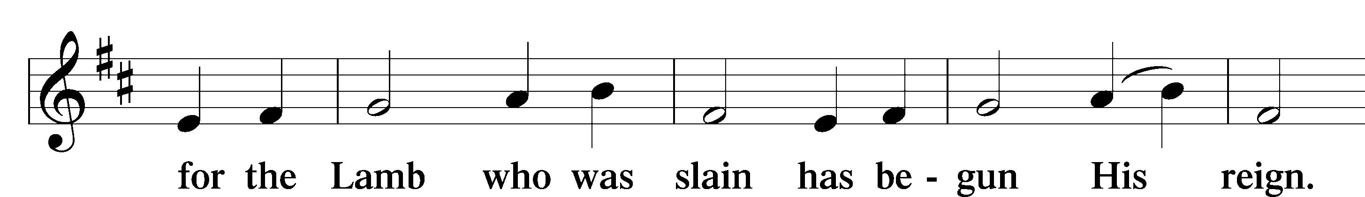
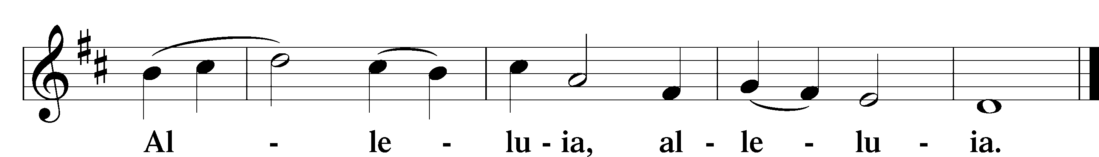

Salutation and Collect of the Day
P The Lord be with you.
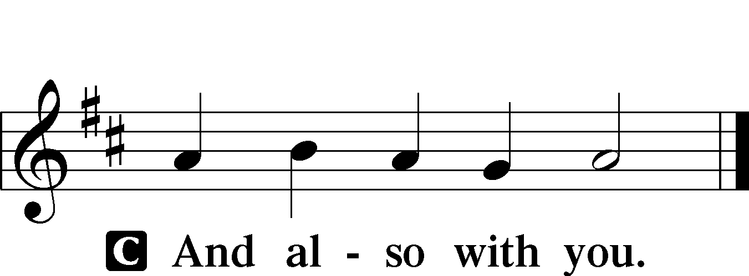

P Let us pray.
C O Lord, grant to Your faithful people pardon and peace that they may be cleansed from all their sins and serve You with a quiet mind; through Jesus Christ, Your Son, our Lord,
who lives and reigns with You and the Holy Spirit, one God, now and forever. Amen.

Sit

Old Testament Reading Isaiah 55:1–9
1“Come, everyone who thirsts,
come to the waters;
and he who has no money,
come, buy and eat!
Come, buy wine and milk
without money and without price.
2Why do you spend your money for that which is not bread,
and your labor for that which does not satisfy?
Listen diligently to me, and eat what is good,
and delight yourselves in rich food.
3Incline your ear, and come to me;
hear, that your soul may live;
and I will make with you an everlasting covenant,
my steadfast, sure love for David.
4Behold, I made him a witness to the peoples,
a leader and commander for the peoples.
5Behold, you shall call a nation that you do not know,
and a nation that did not know you shall run to you,
because of the Lord your God, and of the Holy One of Israel,
for he has glorified you.
6“Seek the Lord while he may be found;
call upon him while he is near;
7let the wicked forsake his way,
and the unrighteous man his thoughts;
let him return to the Lord, that he may have compassion on him,
and to our God, for he will abundantly pardon.
8For my thoughts are not your thoughts,
neither are your ways my ways, declares the Lord.
9For as the heavens are higher than the earth,
so are my ways higher than your ways
and my thoughts than your thoughts.”

A This is the Word of the Lord.
C Thanks be to God.

Gradual Psalm 145:15–16
The eyes of all look to you,*
and you give them their food in due season.
You open your hand;*
you satisfy the desire of every living thing.

Epistle Ephesians 5:15–21
15Look carefully then how you walk, not as unwise but as wise, 16making the best use of the time, because the days are evil. 17Therefore do not be foolish, but understand what the will of the Lord is. 18And do not get drunk with wine, for that is debauchery, but be filled with the Spirit, 19addressing one another in psalms and hymns and spiritual songs, singing and making melody to the Lord with all your heart, 20giving thanks always and for everything to God the Father in the name of our Lord Jesus Christ, 21submitting to one another out of reverence for Christ.

A This is the Word of the Lord.
C Thanks be to God.

Stand

Alleluia and Verse LSB 173
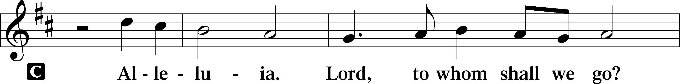
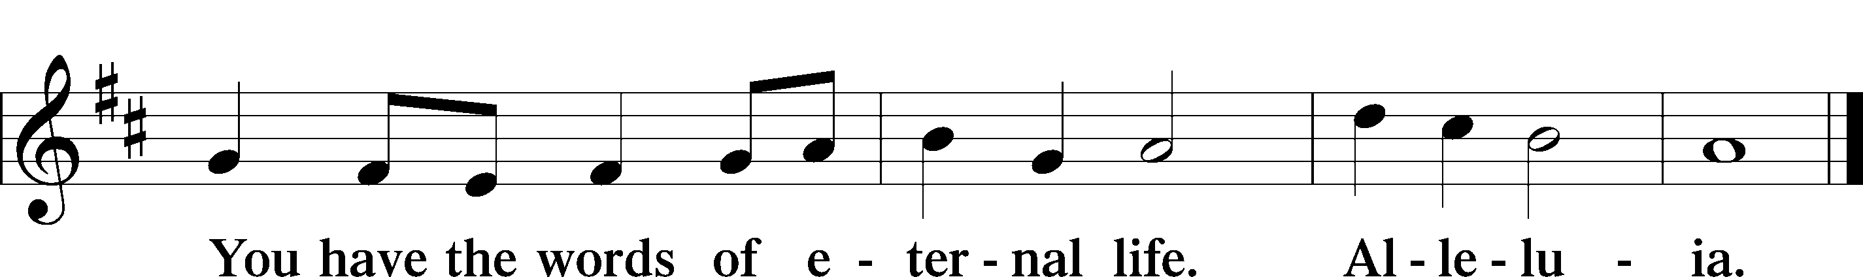

Holy Gospel Matthew 22:1–14
P The Holy Gospel according to St. Matthew, the twenty-second chapter.

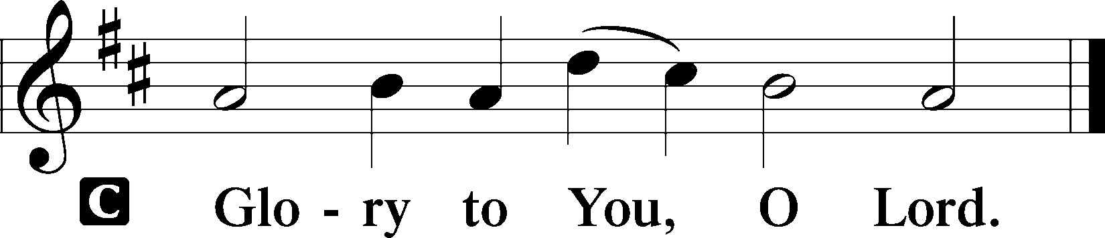

1Again Jesus spoke to them in parables, saying, 2“The kingdom of heaven may be compared to a king who gave a wedding feast for his son, 3and sent his servants to call those who were invited to the wedding feast, but they would not come. 4Again he sent other servants, saying, ‘Tell those who are invited, See, I have prepared my dinner, my oxen and my fat calves have been slaughtered, and everything is ready. Come to the wedding feast.’ 5But they paid no attention and went off, one to his farm, another to his business, 6while the rest seized his servants, treated them shamefully, and killed them. 7The king was angry, and he sent his troops and destroyed those murderers and burned their city. 8Then he said to his servants, ‘The wedding feast is ready, but those invited were not worthy. 9Go therefore to the main roads and invite to the wedding feast as many as you find.’ 10And those servants went out into the roads and gathered all whom they found, both bad and good. So the wedding hall was filled with guests.
11“But when the king came in to look at the guests, he saw there a man who had no wedding garment. 12And he said to him, ‘Friend, how did you get in here without a wedding garment?’ And he was speechless. 13Then the king said to the attendants, ‘Bind him hand and foot and cast him into the outer darkness. In that place there will be weeping and gnashing of teeth.’ 14For many are called, but few are chosen.”

P This is the Gospel of the Lord.

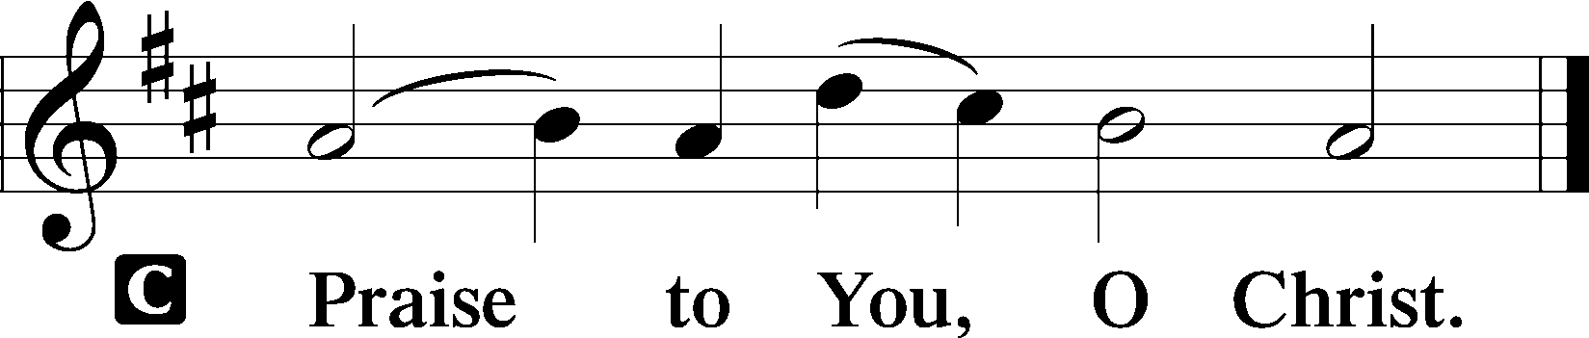

Nicene Creed
C I believe in one God,
the Father Almighty,
maker of heaven and earth
and of all things visible and invisible.

And in one Lord Jesus Christ,
the only-begotten Son of God,
begotten of His Father before all worlds,
God of God, Light of Light,
very God of very God,
begotten, not made,
being of one substance with the Father,
by whom all things were made;
who for us men and for our salvation came down from heaven
and was incarnate by the Holy Spirit of the virgin Mary
and was made man;
and was crucified also for us under Pontius Pilate.
He suffered and was buried.
And the third day He rose again according to the Scriptures
and ascended into heaven
and sits at the right hand of the Father.
And He will come again with glory to judge both the living and the dead,
whose kingdom will have no end.
And I believe in the Holy Spirit,
the Lord and giver of life,
who proceeds from the Father and the Son,
who with the Father and the Son together is worshiped and glorified,
who spoke by the prophets.
And I believe in one holy Christian and apostolic Church,
I acknowledge one Baptism for the remission of sins,
and I look for the resurrection of the dead
and the life T of the world to come. Amen.

Sit

Children’s Message

Hymn of the Day “Christ Is Our Cornerstone” LSB 912
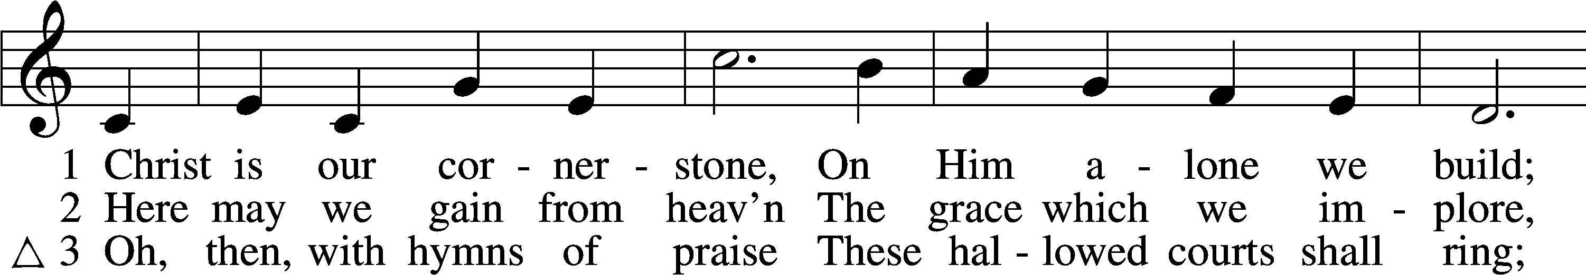
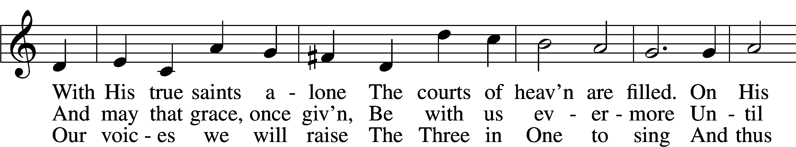
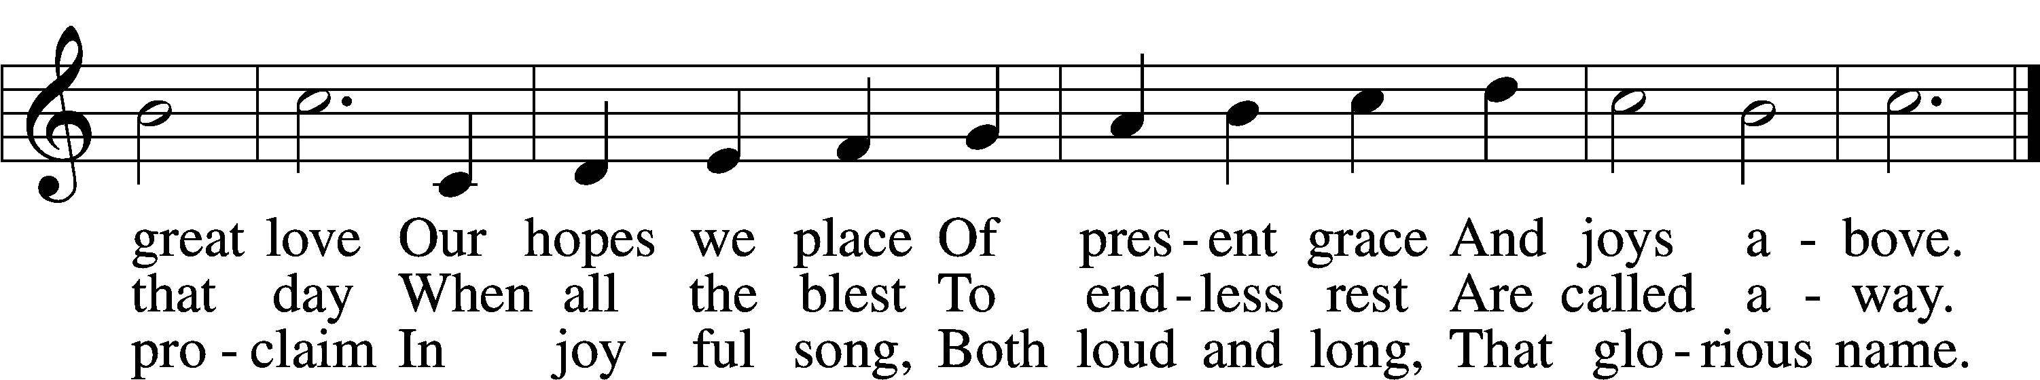
Text and tune: Public domain

Sermon

Offering

Stand

Offertory (spoken) LSB 176
C What shall I render to the Lord for all His benefits to me?
I will offer the sacrifice of thanksgiving and will call on the name of the Lord.
I will take the cup of salvation and will call on the name of the Lord.
I will pay my vows to the Lord now in the presence of all His people,
in the courts of the Lord’s house, in the midst of you, O Jerusalem.

Prayer of the Church

+SERVICE OF THE SACRAMENT+

Preface LSB 177
P The Lord be with you.
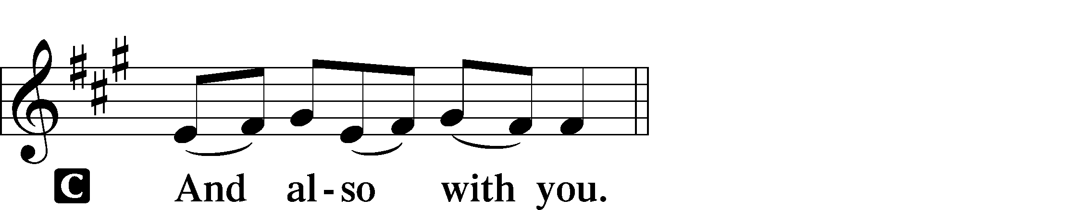

P Lift up your hearts.
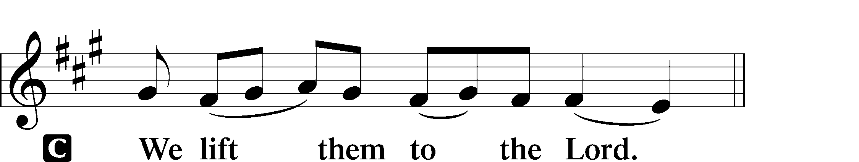

P Let us give thanks to the Lord our God.
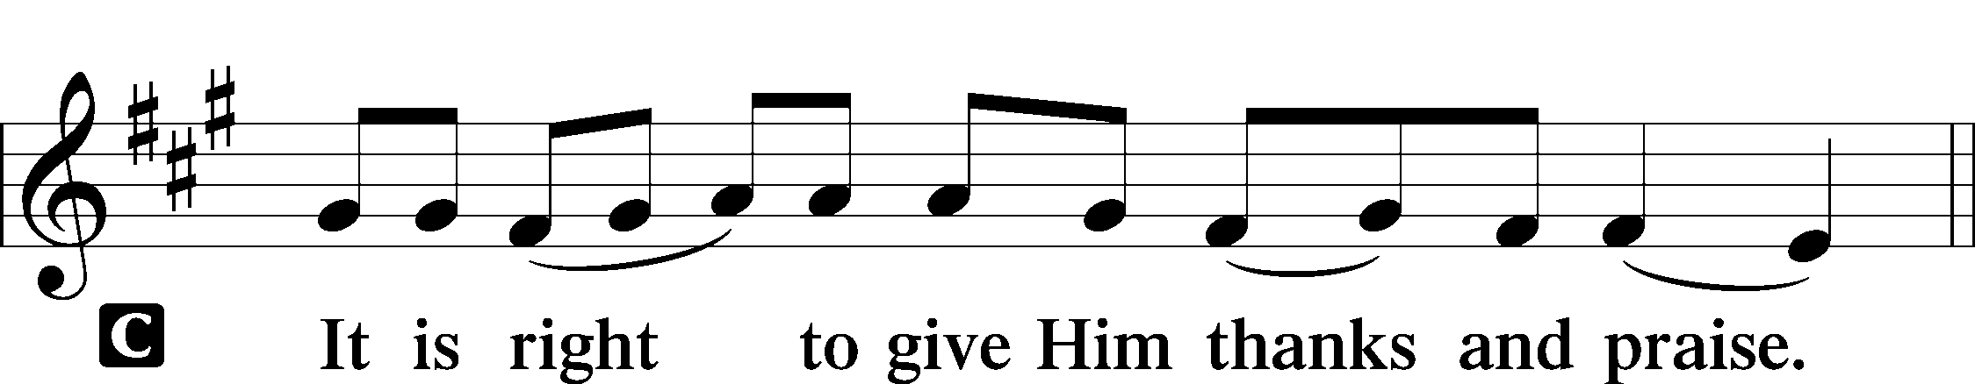

Proper Preface
P It is truly good, right, and salutary that we should at all times and in all places give thanks to You, holy Lord, almighty Father, everlasting God, through Jesus Christ, our Lord, who, having created all things, took on human flesh and was born of the virgin Mary. For our sake He died on the cross and rose from the dead to put an end to death, thus fulfilling Your will and gaining for You a holy people. Therefore with angels and archangels and with all the company of heaven we laud and magnify Your glorious name, evermore praising You and saying:

Sanctus LSB 178
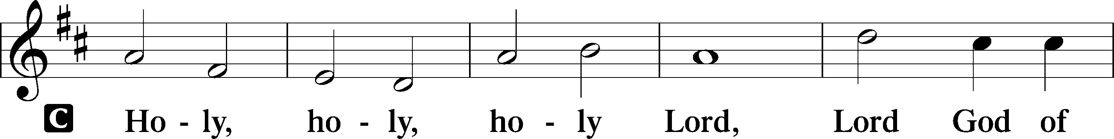
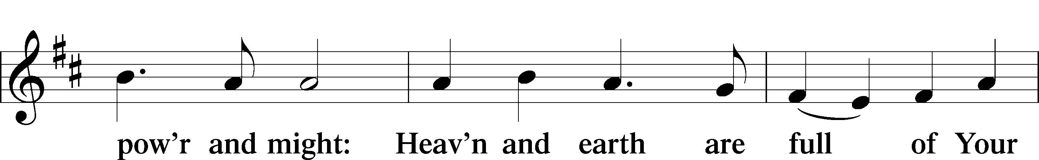
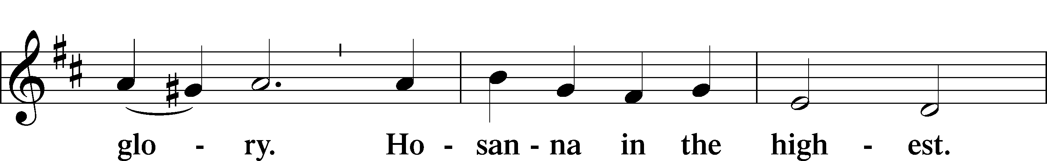
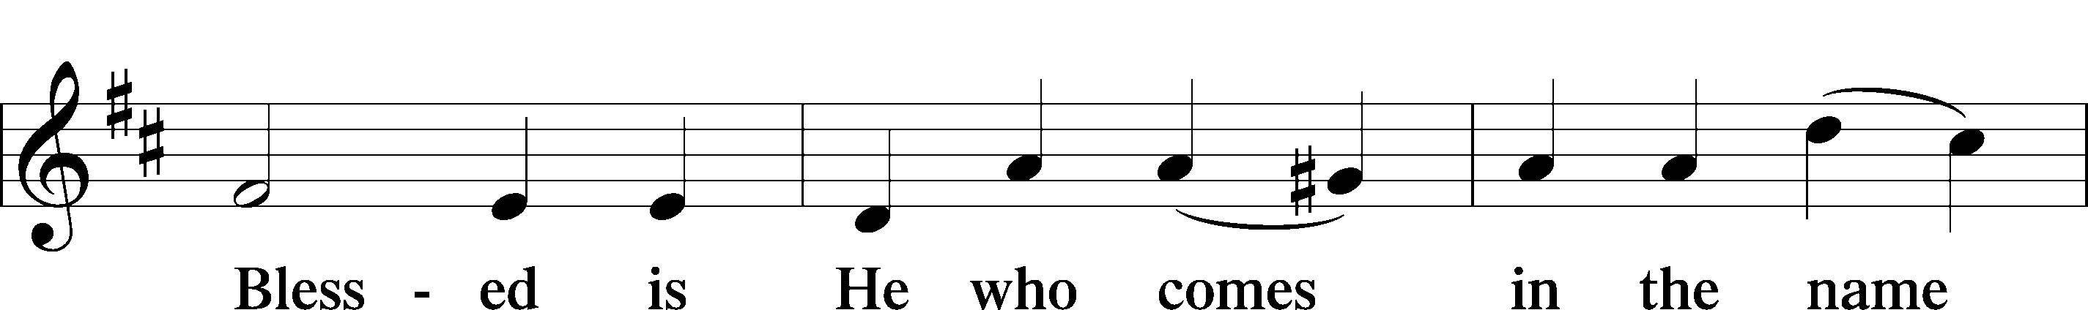
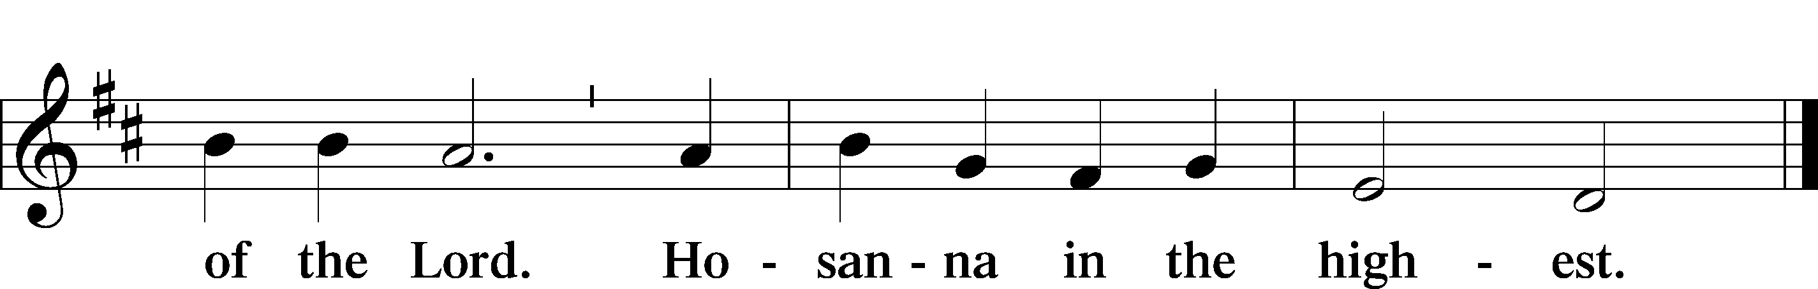

Lord’s Prayer
C Our Father who art in heaven,
hallowed be Thy name,
Thy kingdom come,
Thy will be done on earth
as it is in heaven;
give us this day our daily bread;
and forgive us our trespasses
as we forgive those
who trespass against us;
and lead us not into temptation,
but deliver us from evil.
For Thine is the kingdom
and the power and the glory
forever and ever. Amen.

The Words of Our Lord
P Our Lord Jesus Christ, on the night when He was betrayed, took bread, and when He had given thanks, He broke it and gave it to the disciples and said: “Take, eat; this is My T body, which is given for you. This do in remembrance of Me.”

In the same way also He took the cup after supper, and when He had given thanks, He gave it to them, saying: “Drink of it, all of you; this cup is the new testament in My T blood, which is shed for you for the forgiveness of sins. This do, as often as you drink it, in remembrance of Me.”

Pax Domini LSB 180
P The peace of the Lord be with you always.
C Amen.

Agnus Dei LSB 180
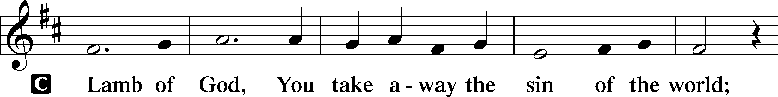
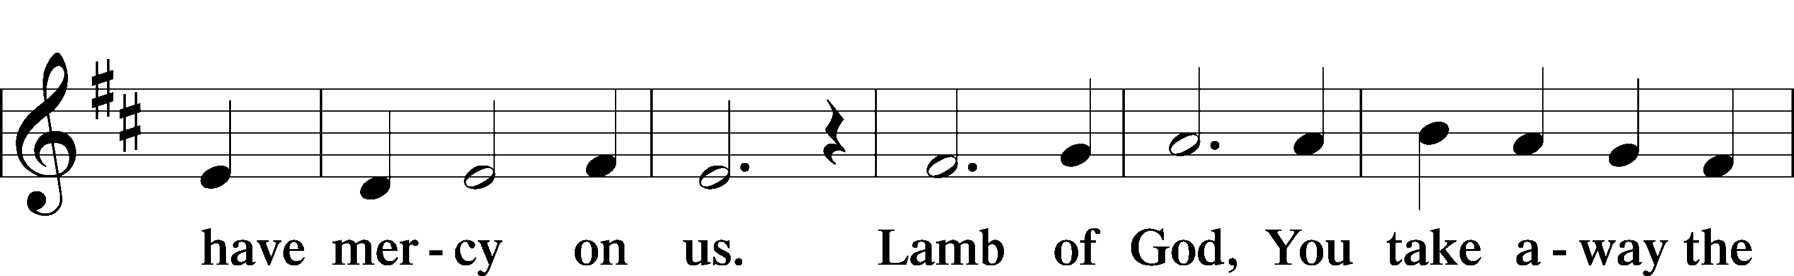
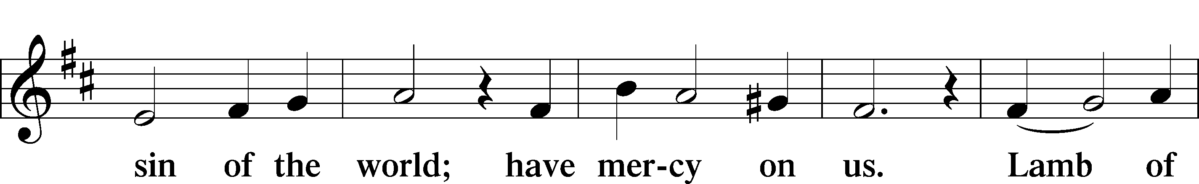
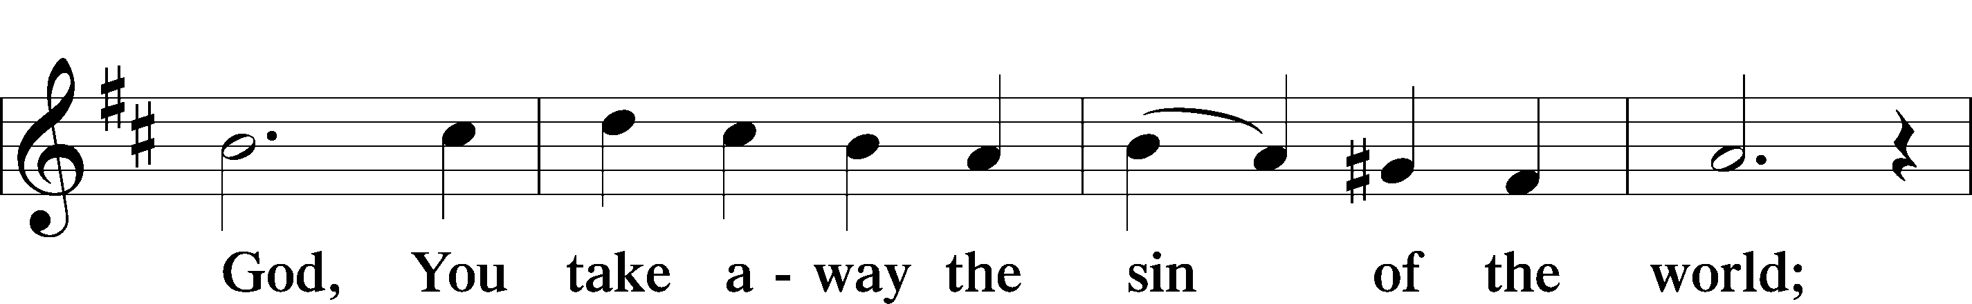
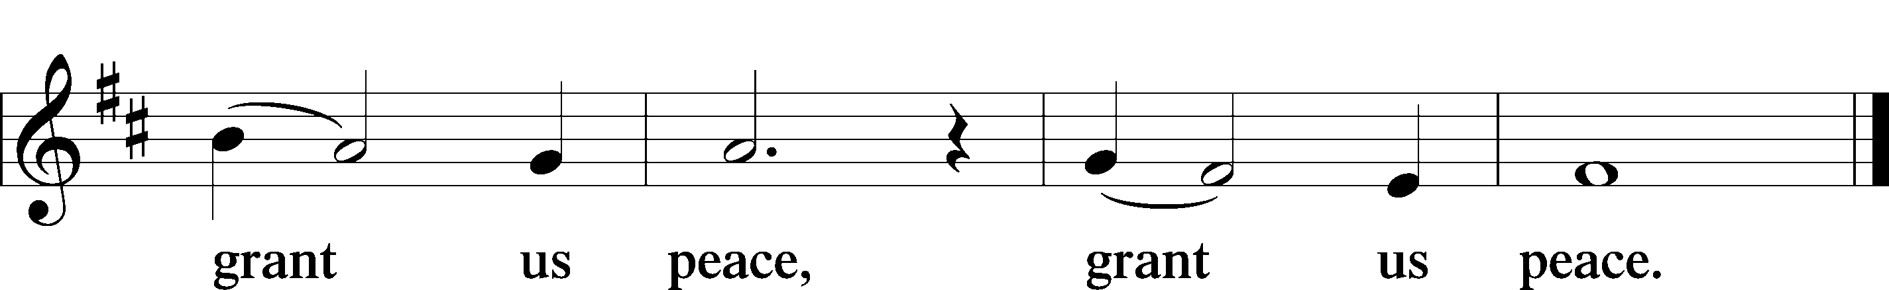

Sit

Distribution

Distribution Hymn “Seek Ye First” LSB 712
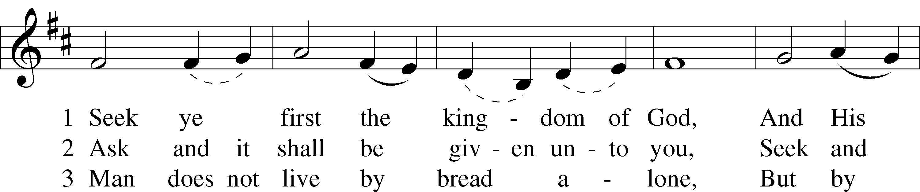
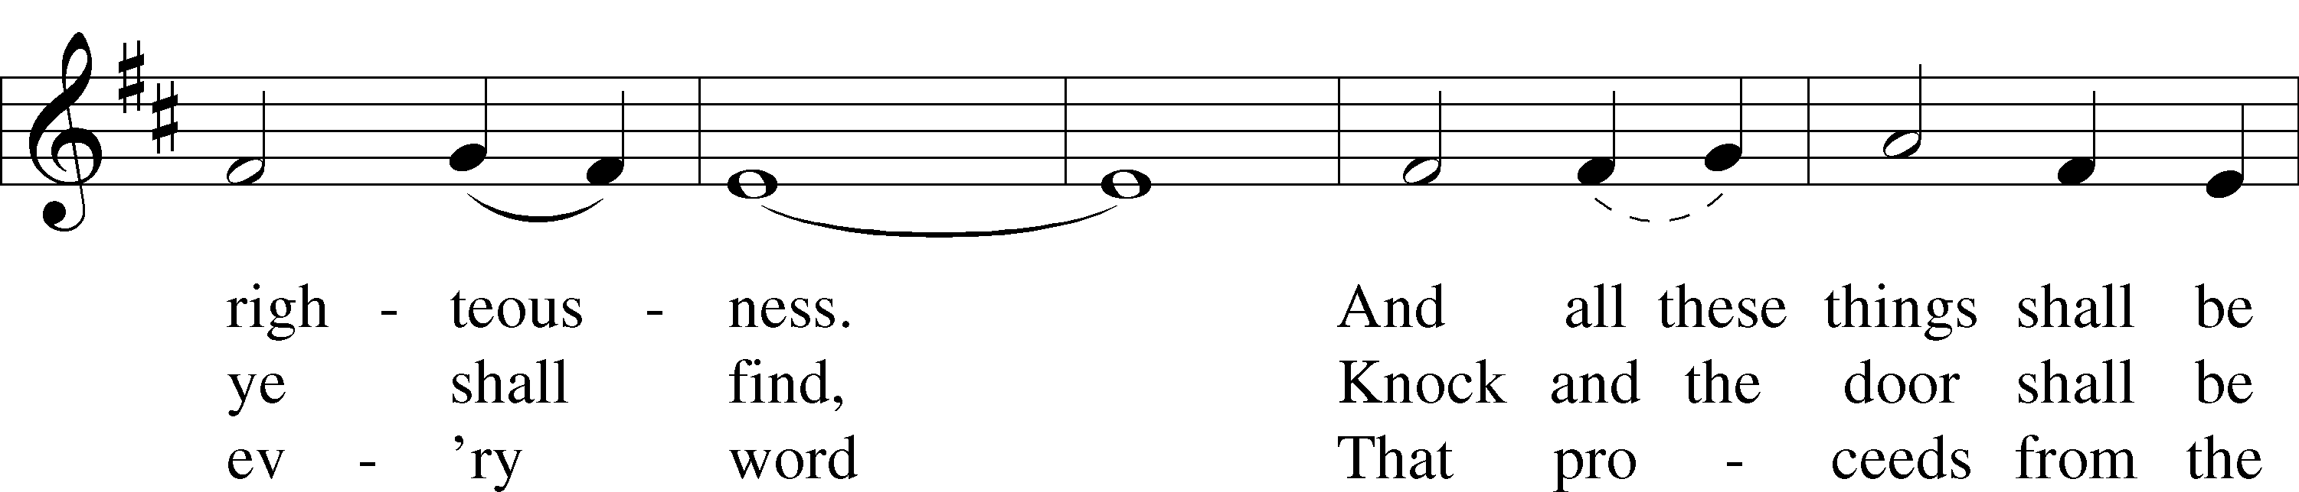
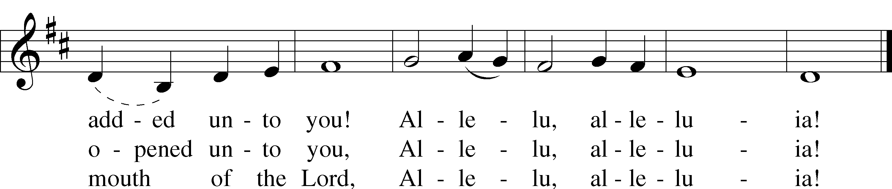
Text and tune: © 1972 Maranatha! Music, admin. EMI. Used by permission: CCLI no. 586279

Distribution Hymn “Jesus, Thy Blood and Righteousness” LSB 563
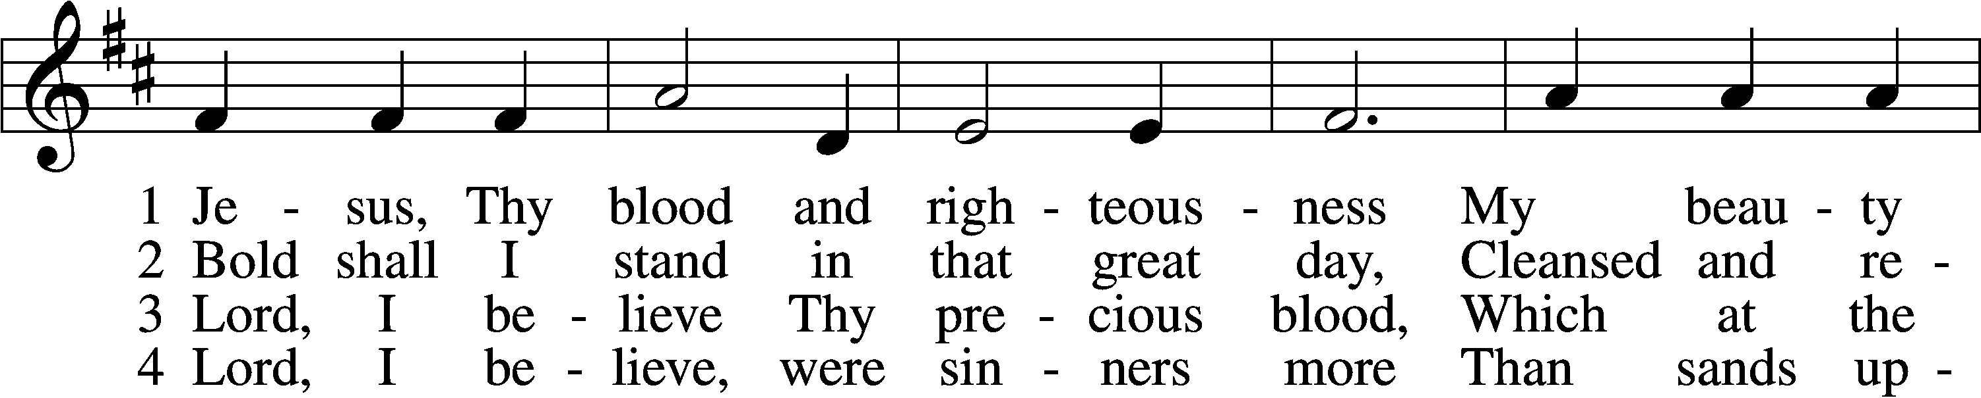
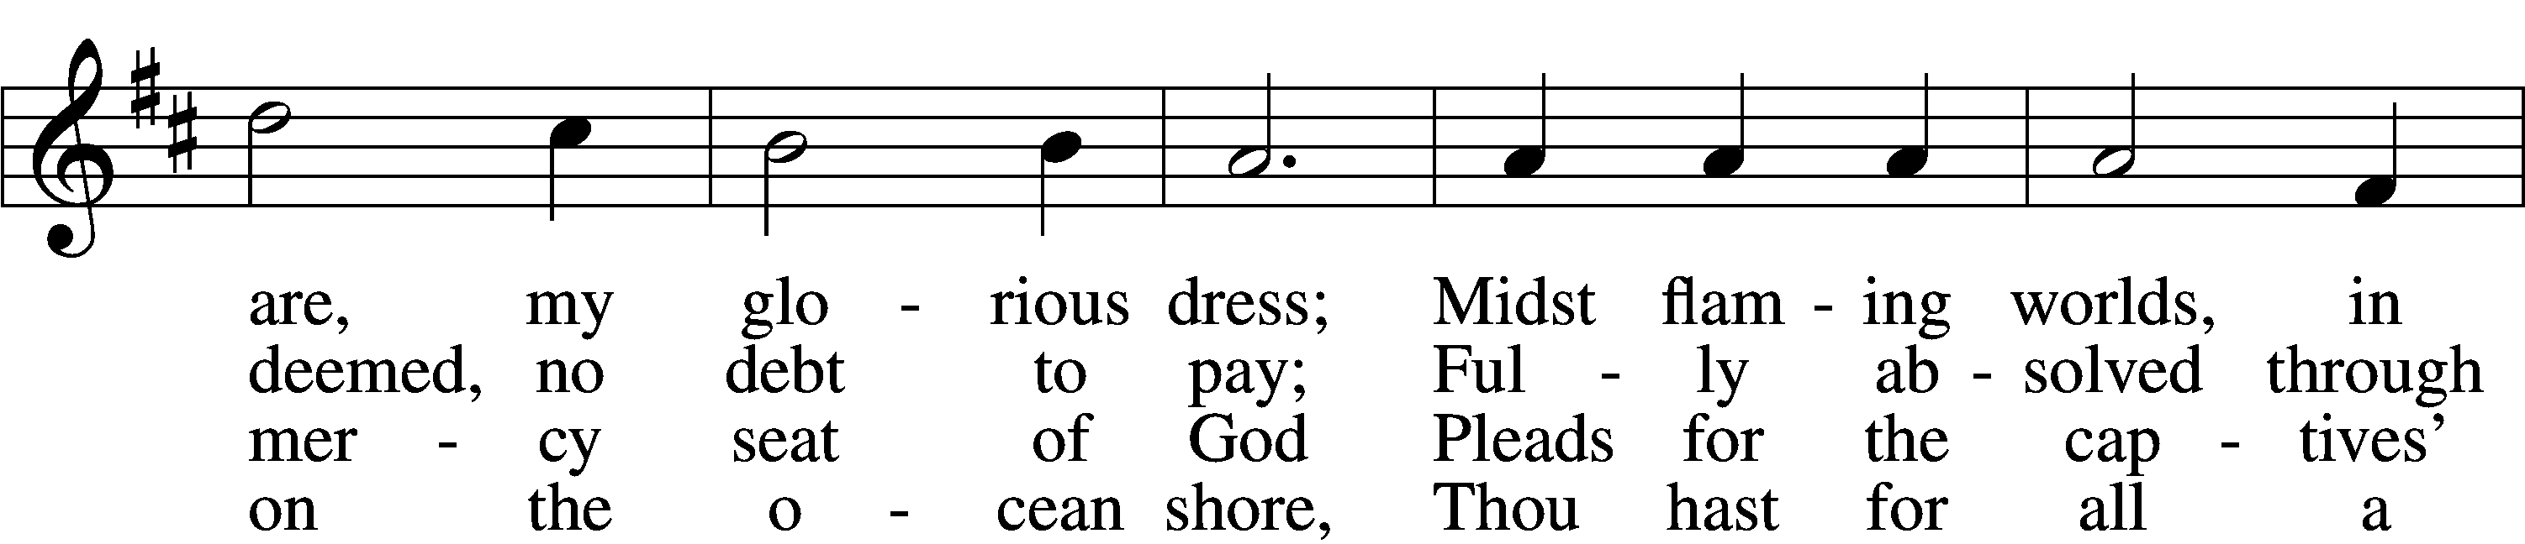
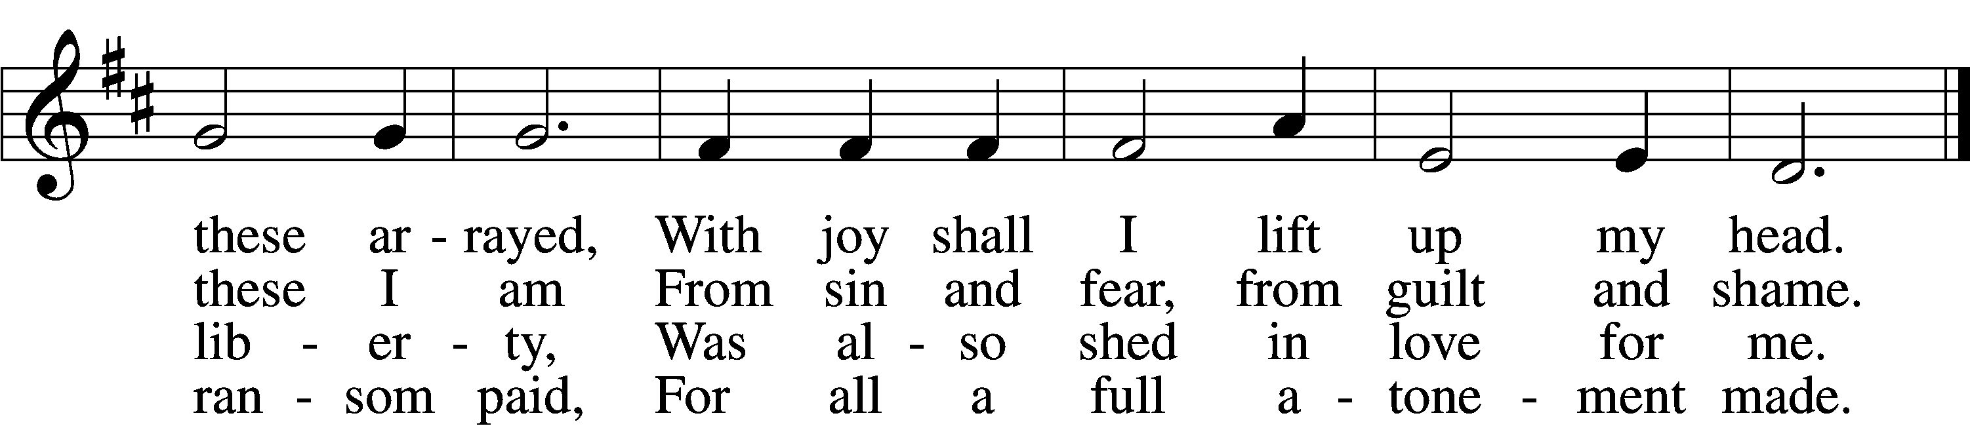

5 When from the dust of death I rise
To claim my mansion in the skies,
This then shall be my only plea:
Jesus hath lived and died for me.

6 Jesus, be endless praise to Thee,
Whose boundless mercy hath for me,
For me, and all Thy hands have made,
An everlasting ransom paid.
Text and tune: Public domain

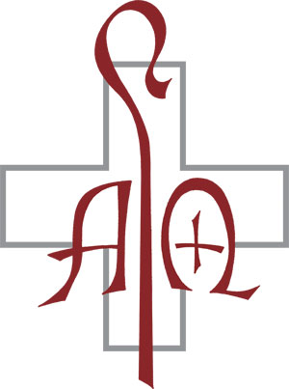
Distribution Hymn “How Great Thou Art” LSB 801
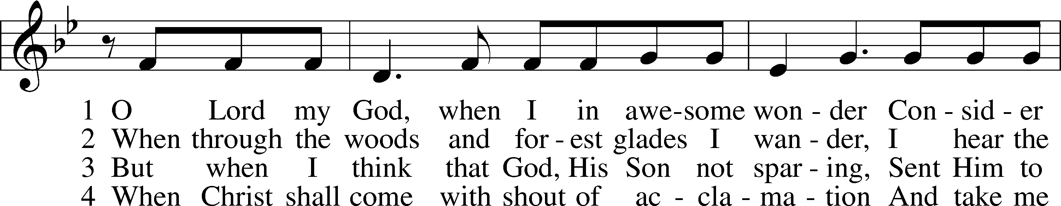
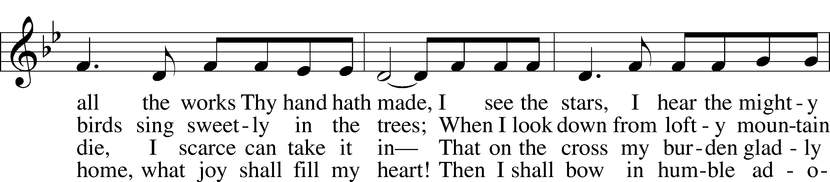
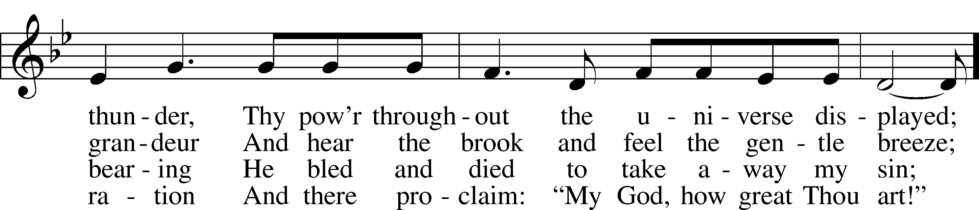
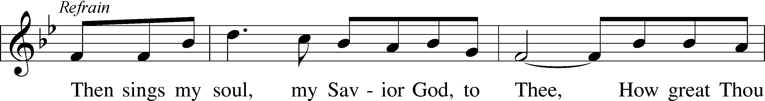
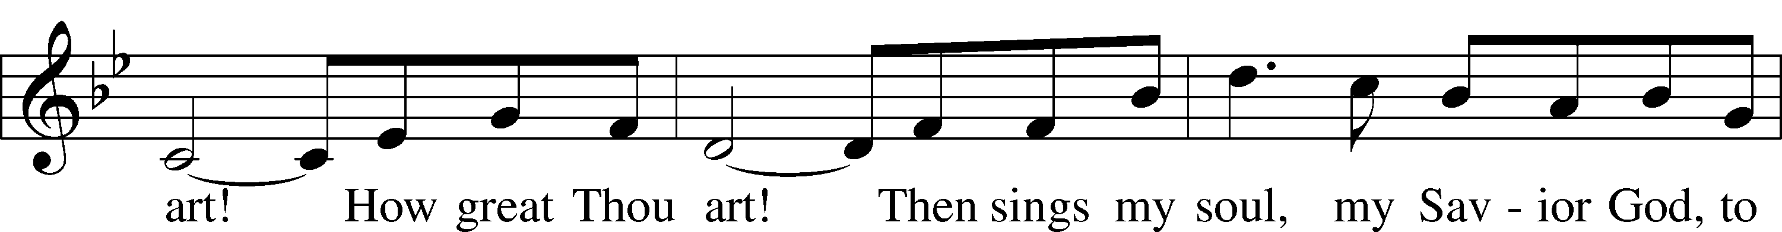
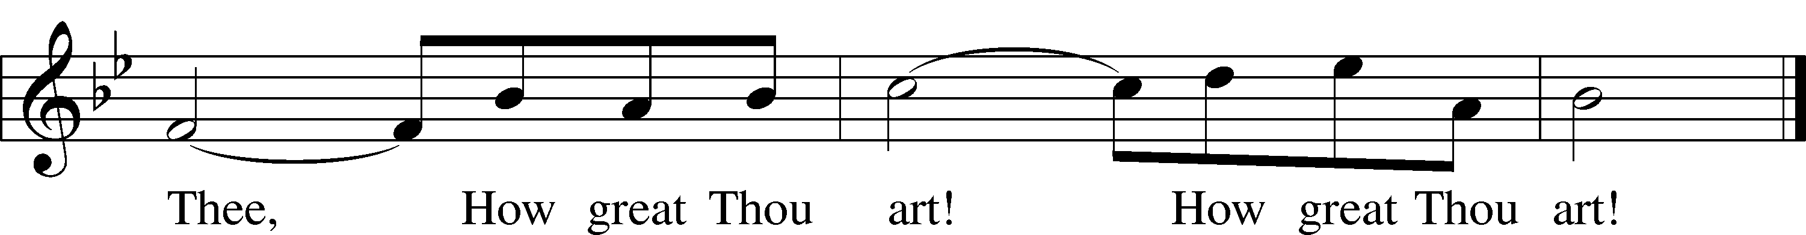
Tune and text: © 1949, 1953 The Stuart Hine Trust, admin. EMI CMG and Hope Publishing Co. Used by permission: LSB Hymn License no. 110016438

Stand

Nunc Dimittis LSB 182
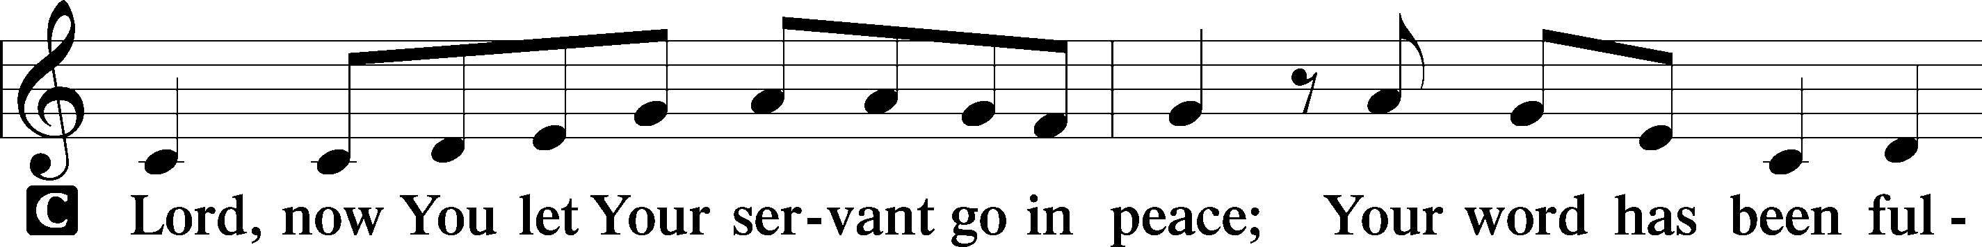
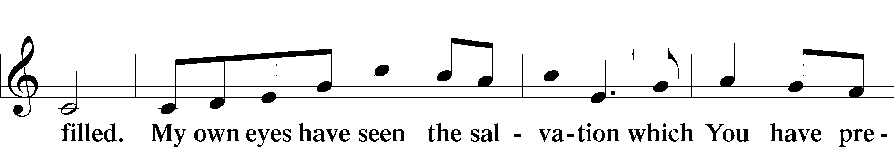
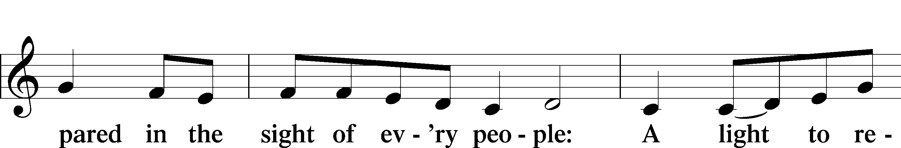
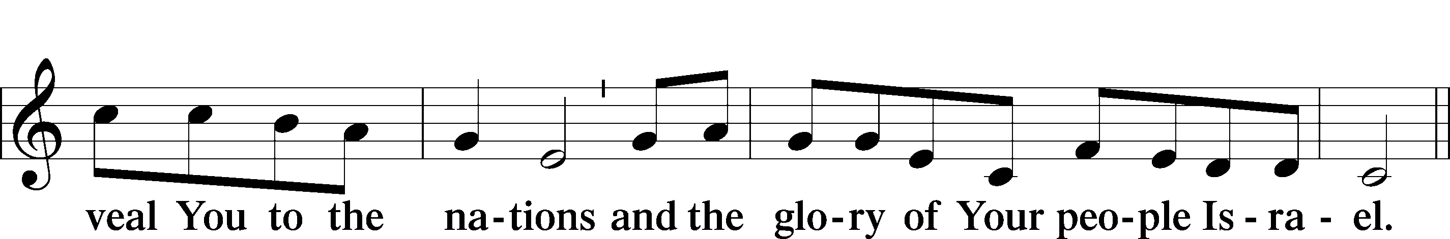
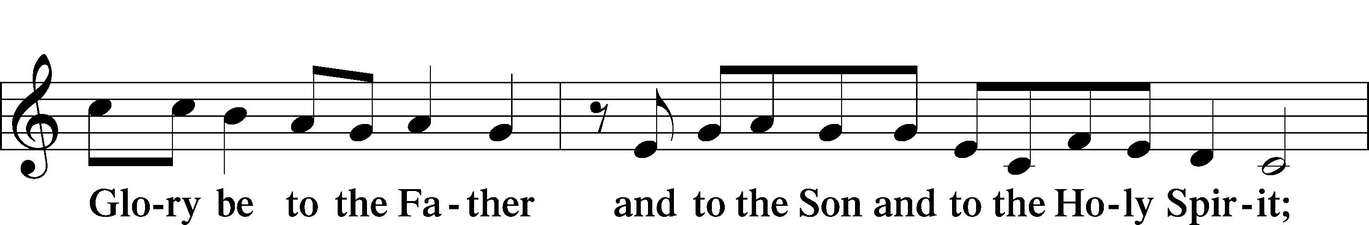
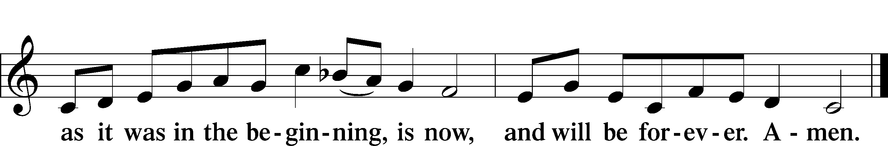

Post-Communion Collect
A Let us pray.
We give thanks to You, almighty God, that You have refreshed us through this salutary gift, and we implore You that of Your mercy You would strengthen us through the same in faith toward You and in fervent love toward one another; through Jesus Christ, Your Son, our Lord, who lives and reigns with You and the Holy Spirit, one God, now and forever.
C Amen.

Benediction LSB 183
P The Lord bless you and keep you.
The Lord make His face shine on you and be gracious to you.
The Lord look upon you with favor and T give you peace.

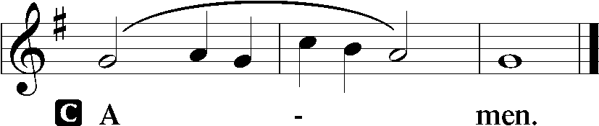

Closing Hymn “Holy God, We Praise Thy Name” LSB 940 sts. 1–5
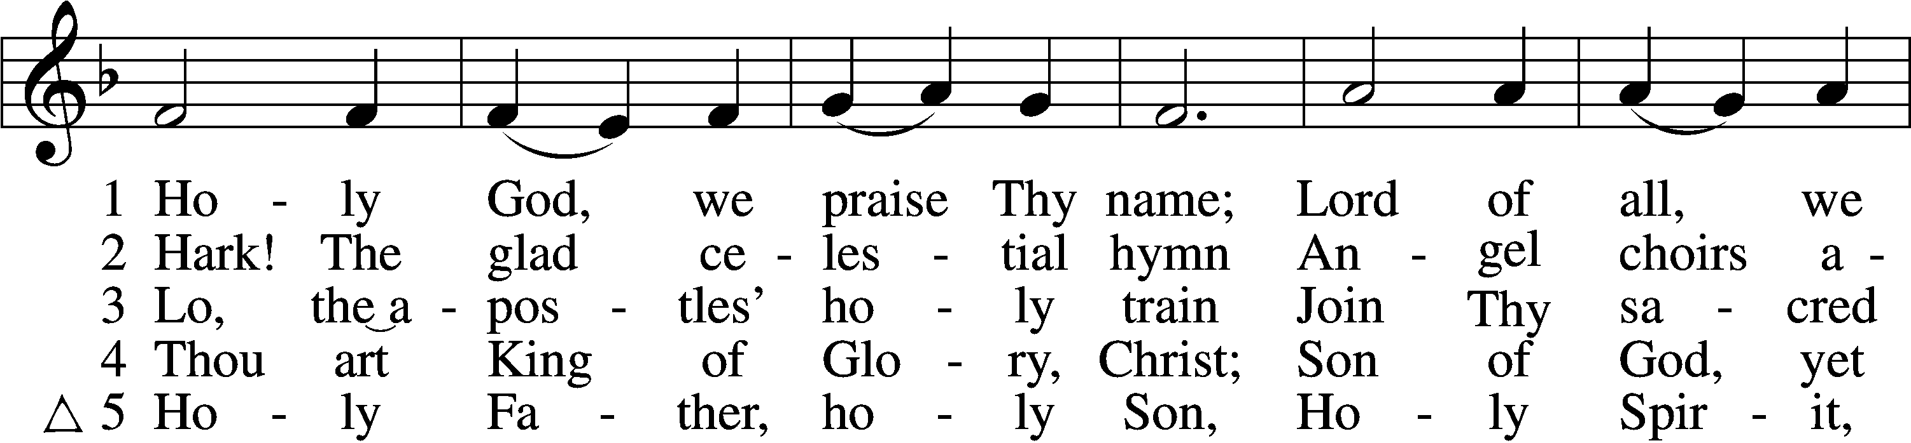
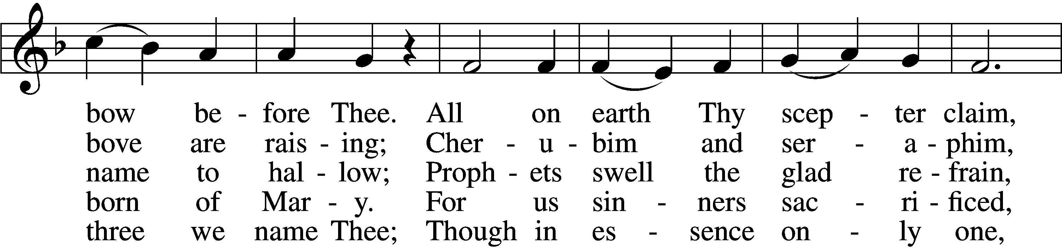
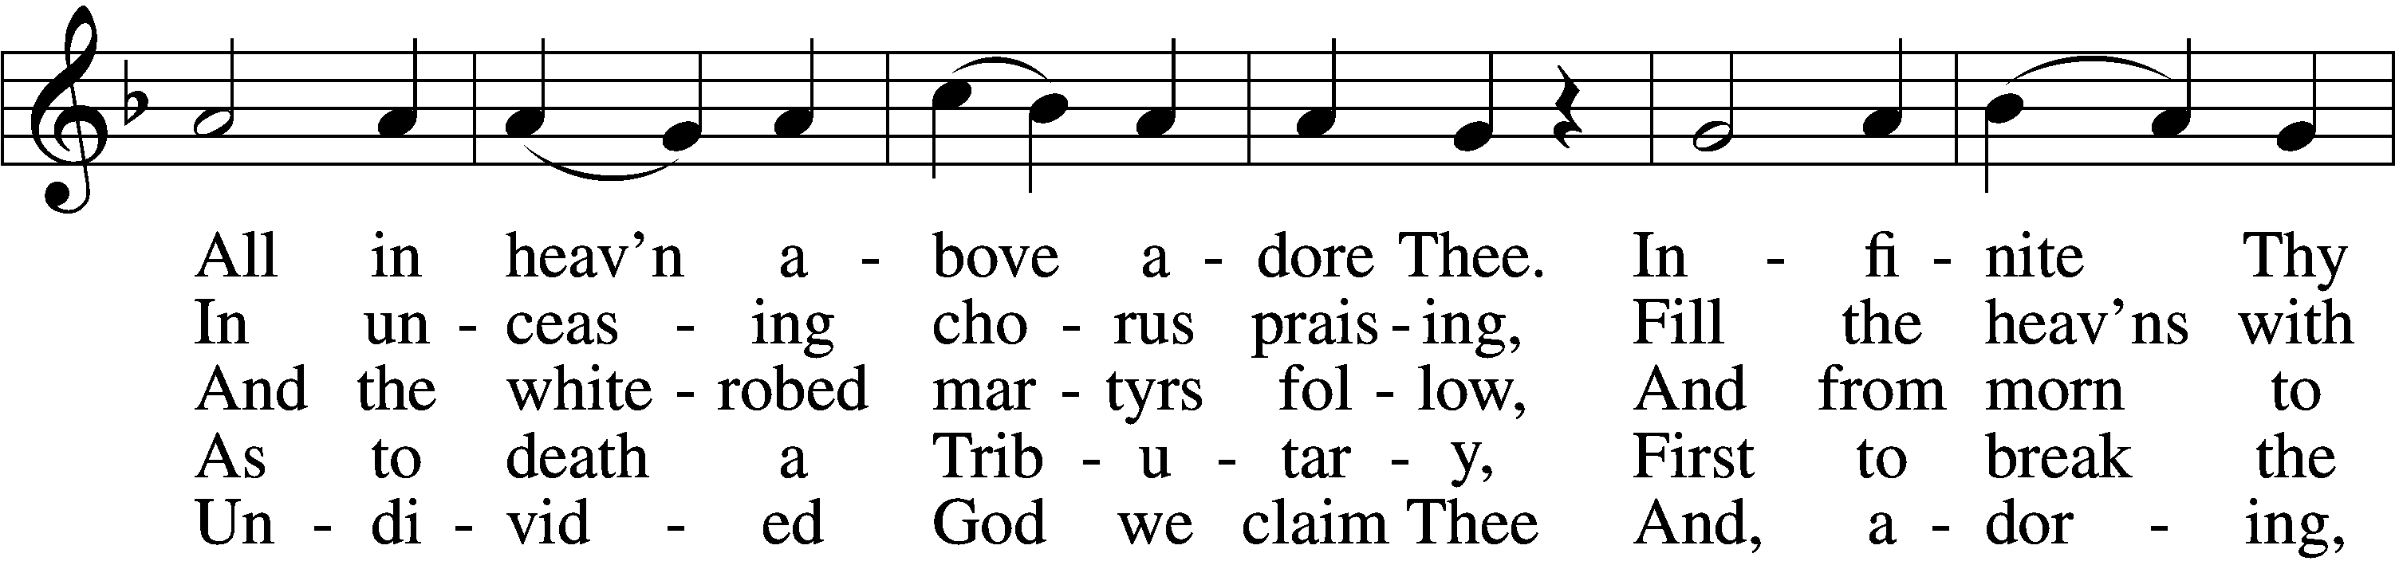
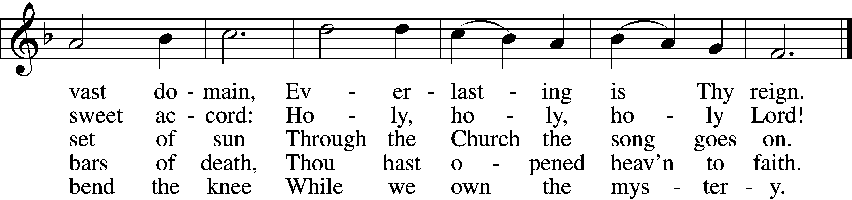
Text and tune: Public domain

Acknowledgments
Unless otherwise indicated, Scripture quotations are from the ESV® Bible (The Holy Bible, English Standard Version®), copyright © 2001 by Crossway, a publishing ministry of Good News Publishers. Used by permission. All rights reserved.
Created by Lutheran Service Builder © 2021 Concordia Publishing House.

Serving Our Lord in His House Today:
Pastor: Rev. Bert Thompson
Organist: Linda Ecker
Elders: Josh Church & Bob Pulley
Joe Engel (Wednesday)

Gifts from God: Isaiah 55:2 – “Why do you spend your money for that which is not bread, and your labor for that which does not satisfy?” What Isaiah says here is reminiscent of what Jesus says about putting our earthly wealth in places where “moth and rust destroy.” Where we put the money God has given us to manage says a lot about the way in which we actually view life. What do your spending priorities say about what you think is truly important in life?

Weekly Psalms Devotional Group: Please join us Thursday mornings at 10:00 a.m., as we read and pray through selected Psalms. We’ll learn about their meaning, application and ways to incorporate them into your prayer life.

LWML Announcements: The Zone 14 Fall Rally will take place Saturday, October 23, 2021, at Immanuel Lutheran Church, Adams, WI. Registration begins at 8:30am with the program starting at 9:30am. If you have any questions, please contact Kathy Berg.

Fall Clean-Up: There will be a fall clean-up day Saturday, October 23, 2021,
8am-12pm at the church. If you have questions regarding this contact
Dillin Lafferty.

Livestream: Our Sunday Service is livestreamed weekly on our YouTube channel “Good Shepherd Lutheran Church Tomah.”

PO Box: For mailed offerings, please use the following:
Good Shepherd Lutheran Church
P.O. Box 551
Tomah, WI 54660
Our Worship attendance last week: Sunday: 40
Wednesday: 10
Total: 50

Scripture Lessons for next week: Genesis 1:1-2:3
Ephesians 6:10-17
John 4:46-54

Secretary Office Hours: Monday-Friday: 8am-12pm

Pastor Office Hours: Pastor’s regular hours are Sunday-Thursday, 9am-5pm.
He is typically in the office in the mornings. In the afternoon, he is typically in the office, making pastoral visits, at meetings, or providing pastoral care in the
community. If you would like to visit with pastor, please call the church office at 608-374-2444 or his cell phone at 317-410-2271 to arrange a time.
Our Week With Our Lord:
Today 9:00am Divine Service w/Holy Communion
(livestreamed via YouTube)
10:30am Adult Bible Study & Sunday School
Monday
Tuesday 6:00pm Board of Directors Meeting
Wednesday 5:00pm Divine Service w/Holy Communion
6:30pm Confirmation Class
Thursday 10:00am Psalm Devotion/Study
12:00pm YAH Group Potluck Luncheon @church
Friday 12:00pm Newsletter Deadline
Saturday 8am-12pm Fall Clean-up Day @church
8:30am LWML Fall Rally@Immanuel Lutheran, Adams, WI
Sunday 9:00am Divine Service w/Holy Communion
(livestreamed via YouTube)
10:30am Adult Bible Study & Sunday School

*Please view the following page for weekly prayers*
HIS FLOCK AT PRAYER
Propers for the Twentieth Week after Trinity

Psalm for the Week: Psalm 27:1-9

Daily Scripture Readings:
Sunday—Matthew 22:1-14 Thursday—Revelations 3:14-22
Monday— Psalm 8 Friday—Hebrews 4:9-16
Tuesday—Ephesians 2:13-22 Saturday— Psalm 36:5-12
Wednesday—Isaiah 61:10-11

Collect for the Week:
O Lord, grant to Your faithful people pardon and peace that they may be
cleansed from all their sins and serve You with a quiet mind; through
Jesus Christ, Your Son, our Lord, who lives and reigns with You and the
Holy Spirit, one God, now and forever.

Hymn of the Week: “Christ Is Our Cornerstone” LSB 912

Congregational Petitions for this Week:
+ For those whose work is difficult or dangerous including the military away from
home, especially: Nick Siegl, Isaac Preuss, Joshua Ecker and Tania Adler.
+ For those who are ill or recovering, especially: Brenda Kolb, Paula Sopel,
Shawn Zabinski, Karen Griggel, Ladene Zabinski, Carrie Wilbanks,
Payton Pierce, Marie Drescher, Les Hackett, Joyce Pulley, Tom Coman,
Kelly Ingenthron, Jean Salzman, Pastor Jacob Sutton, Ro Scrivner, Roux York,
Lois Dallman, Melvin Welch, David Keinath, Scott Berg, Robert Chase,
Lucy Sherwood, Bob Goad, Nick Anderson, Rose Scweisthel, Kevin Franks,
Troy Lenning, Ken Anderson.
+ For those who are home-bound, especially: John Fox, Darlene Griffin,
Al Mansfield, Virginia Tillman, Linda Goad, Roemelle McArdle,
Sharon Herried.
+ For those who are mourning the loss of a loved one:
Family and friends, of Rick Wright who recently passed away.
+ For those suffering from the pandemic, especially those in our congregation who have been infected, those who are suffering financially, and those who work in the medical field.

