Good Shepherd Lutheran Church
Twenty-first Sunday after Trinity
October 24, 2021

Pre-Service Music & Welcome

Divine Service Setting Two – Lutheran Service Book (LSB) 167

+CONFESSION AND ABSOLUTION+

Stand

Opening Hymn “Thy Strong Word” LSB 578

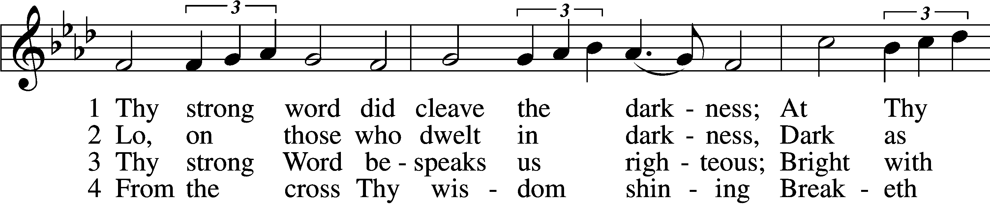
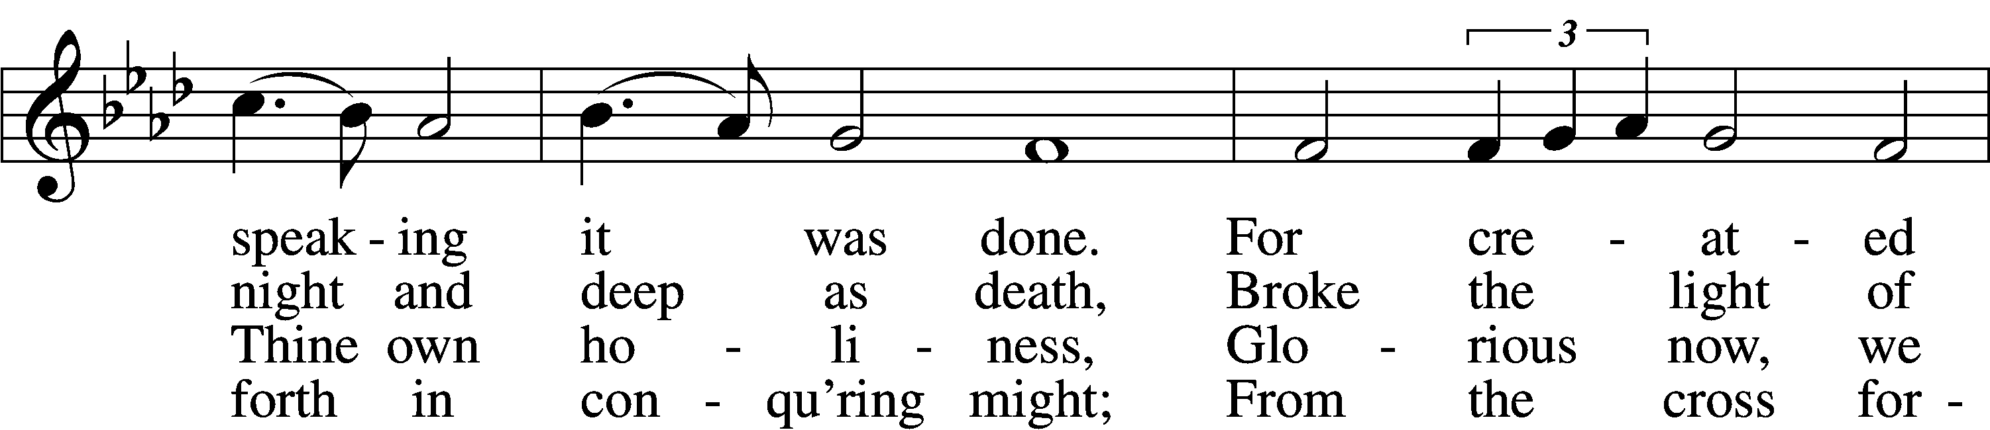
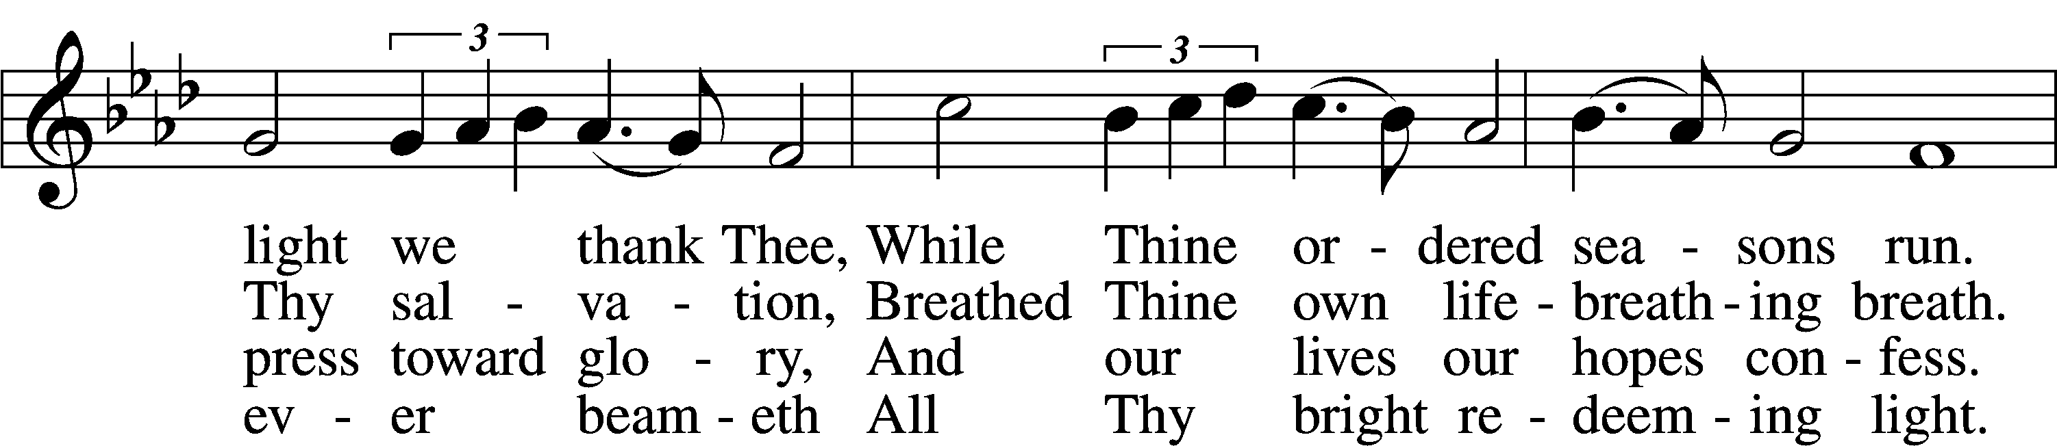
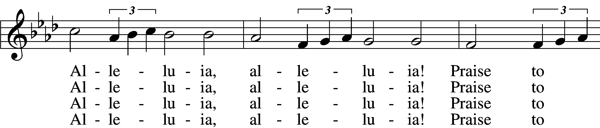
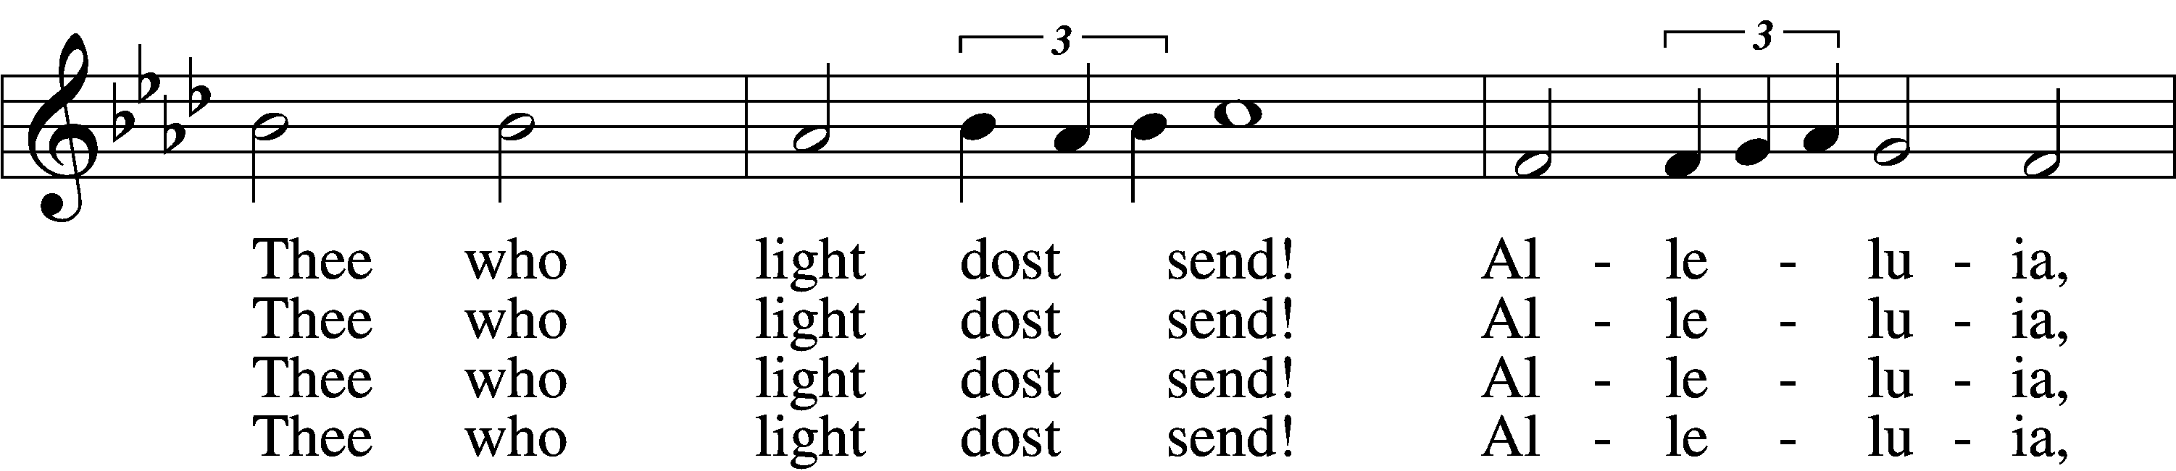
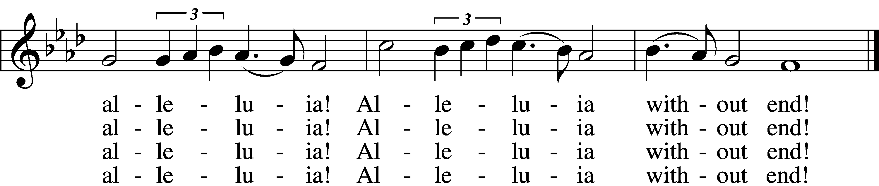

5 Give us lips to sing Thy glory,
Tongues Thy mercy to proclaim,
Throats that shout the hope that fills us,
Mouths to speak Thy holy name.
Alleluia, alleluia!
May the light which Thou dost send
Fill our songs with alleluias,
Alleluias without end!

D 6 God the Father, light-creator,
To Thee laud and honor be.
To Thee, Light of Light begotten,
Praise be sung eternally.
Holy Spirit, light-revealer,
Glory, glory be to Thee.
Mortals, angels, now and ever
Praise the holy Trinity!
Tune: Public domain
Text: © 1969 Concordia Publishing House. Used by permission: LSB Hymn License no. 110016438

The sign of the cross T may be made by all in remembrance of their Baptism.

Invocation
P In the name of the Father and of the T Son and of the Holy Spirit.
C Amen.

Exhortation LSB 167
P If we say we have no sin, we deceive ourselves, and the truth is not in us.
C But if we confess our sins, God, who is faithful and just, will forgive our sins and cleanse us from all unrighteousness.

Silence for reflection on God’s Word and for self-examination.

Confession of Sins LSB 167
P Let us then confess our sins to God our Father.
C Most merciful God, we confess that we are by nature sinful and unclean. We have sinned against You in thought, word, and deed, by what we have done and by what we have left undone. We have not loved You with our whole heart; we have not loved our neighbors as ourselves. We justly deserve Your present and eternal punishment. For the sake of Your Son, Jesus Christ, have mercy on us. Forgive us, renew us, and lead us, so that we may delight in Your will and walk in Your ways to the glory of Your holy name. Amen.

Absolution LSB 167
P Almighty God in His mercy has given His Son to die for you and for His sake forgives you all your sins. As a called and ordained servant of Christ, and by His authority, I therefore forgive you all your sins in the name of the Father and of the T Son and of the Holy Spirit.
C Amen.

+SERVICE OF THE WORD+

Introit Psalm 119:1, 38–40; antiphon: Liturgical Text
The whole world is in your power;*
O Lord, King Almighty, no one can gainsay you.
For you have made heaven and earth;*
you are Lord of all!
Blessèd are those whose way is blameless,*
who walk in the law of the Lord!
Confirm to your servant your promise,*
that you may be feared.
Turn away the reproach that I dread,*
for your just decrees are good.
Behold, I long for your precepts;*
in your righteousness give me life!
Glory be to the Father and to the Son*
and to the Holy Spirit;
as it was in the beginning,*
is now, and will be forever. Amen.
The whole world is in your power;*
O Lord, King Almighty, no one can gainsay you.
For you have made heaven and earth;*
you are Lord of all!

Kyrie LSB 168
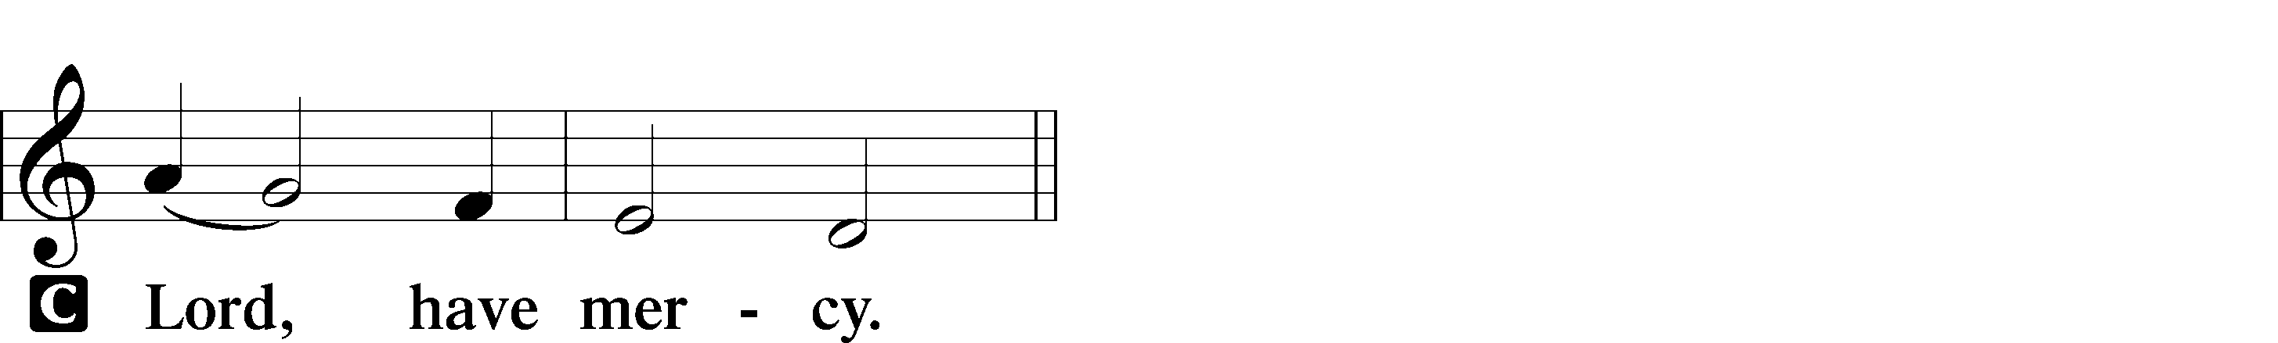

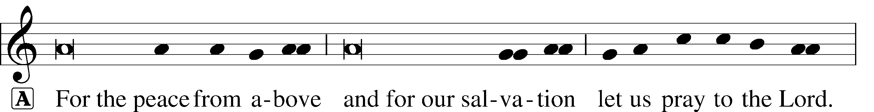
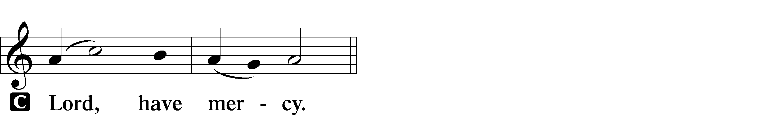

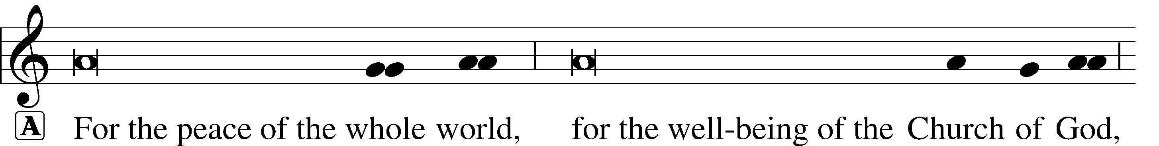
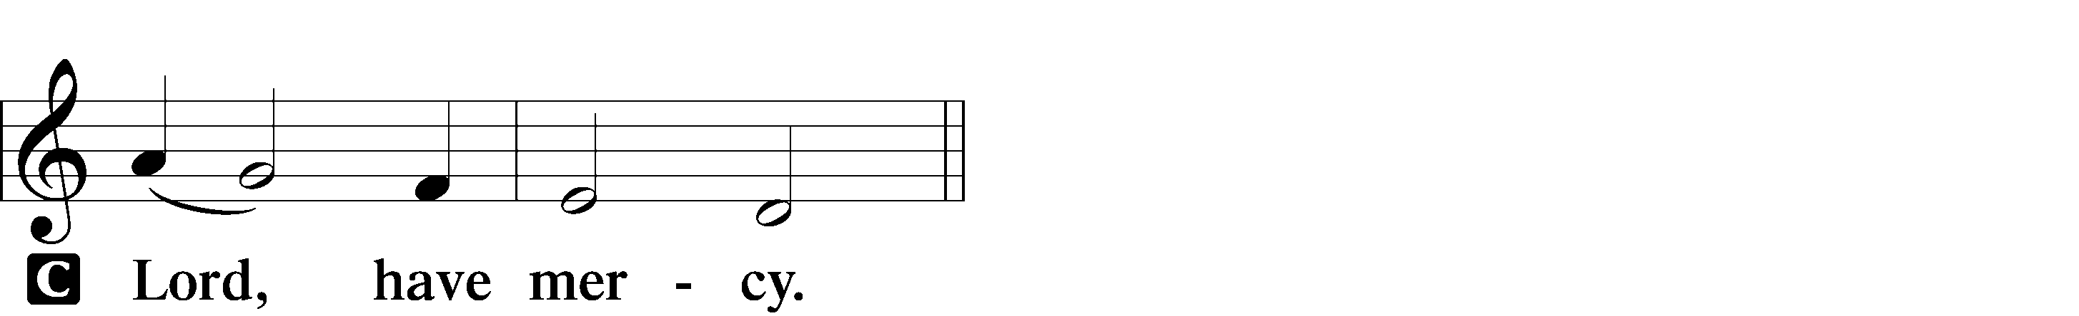

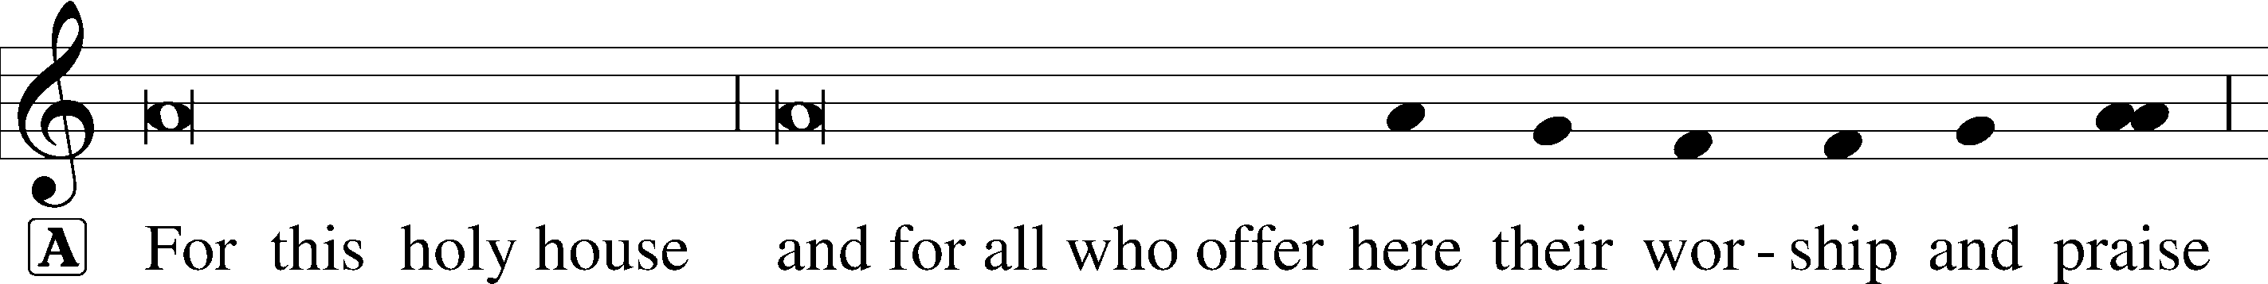
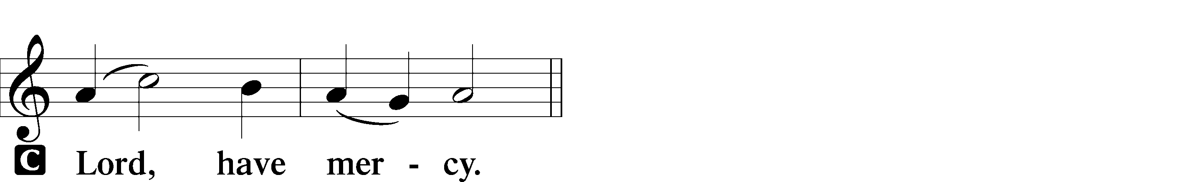

This Is the Feast LSB 171
Pastor sings the first line, the congregation joins in singing at “Worthy is Christ…”

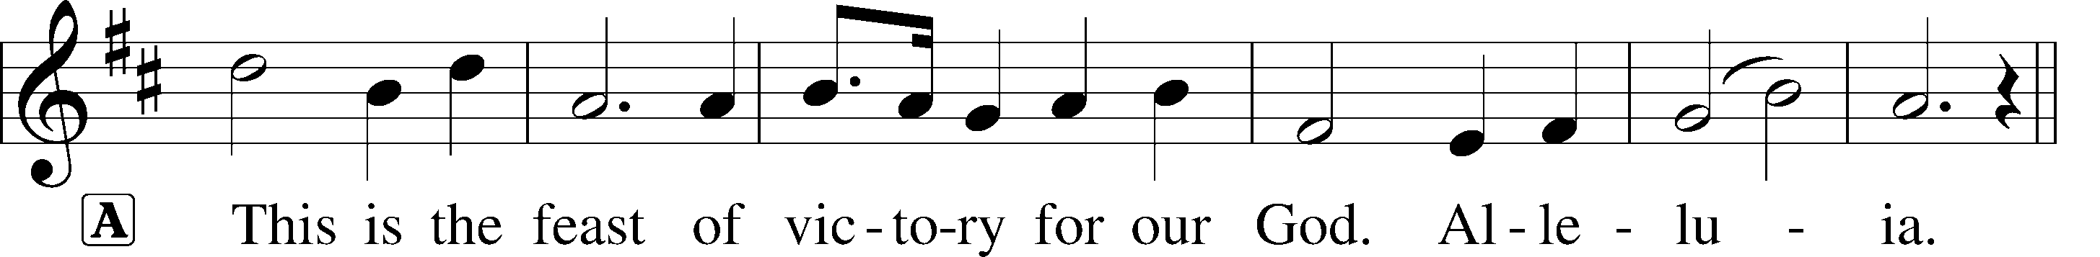
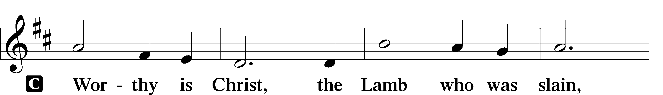
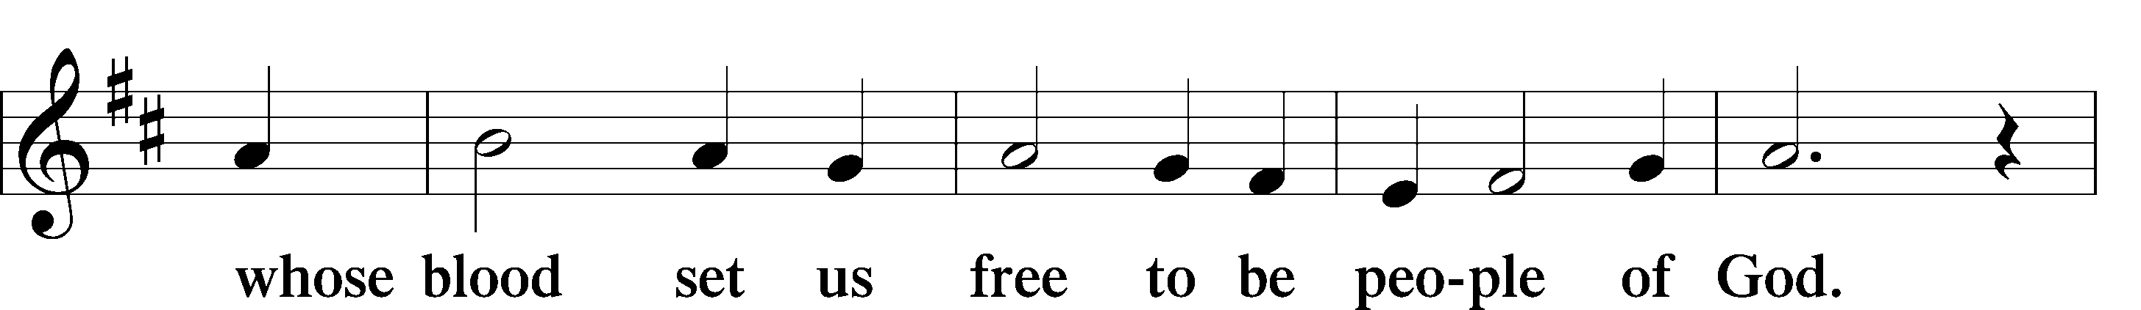
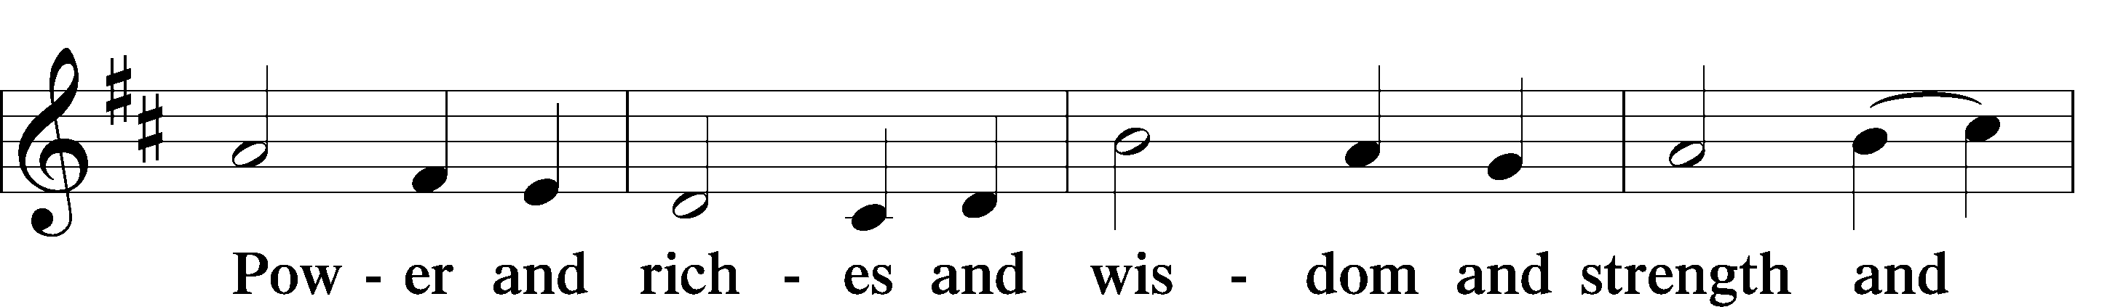
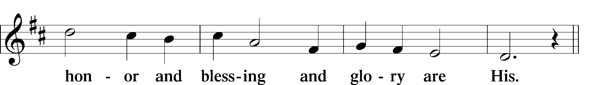
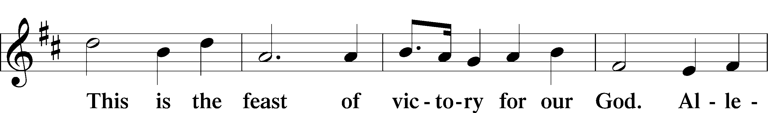
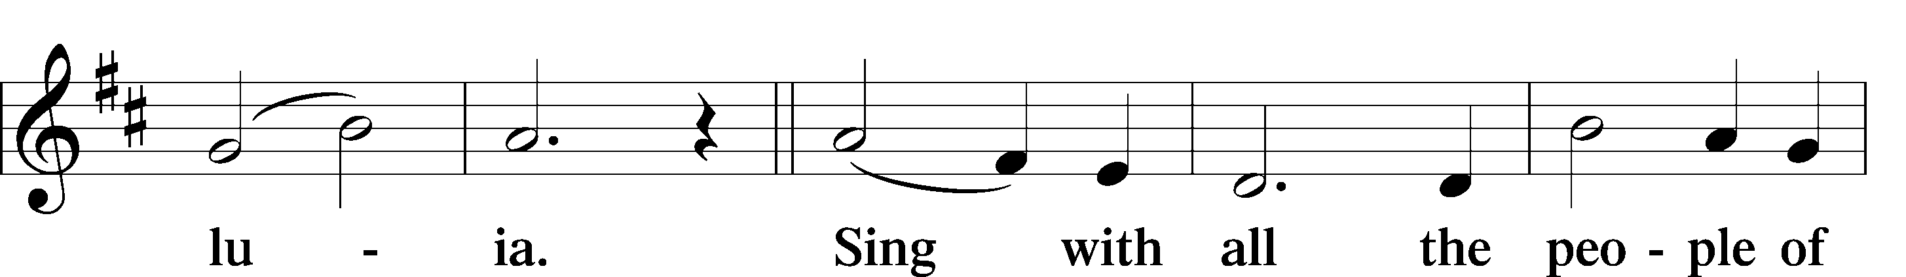
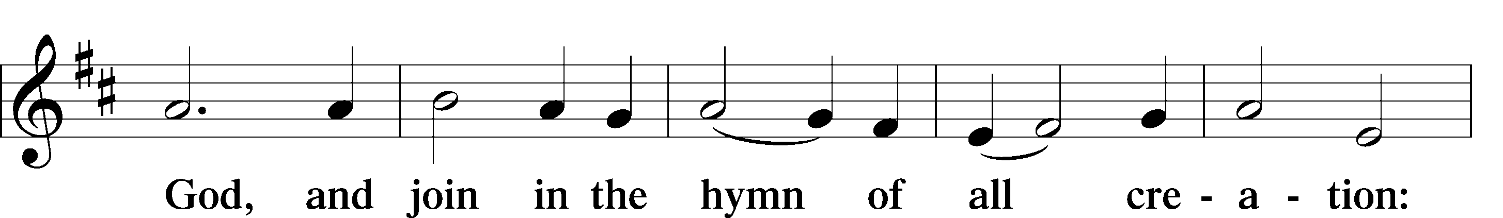
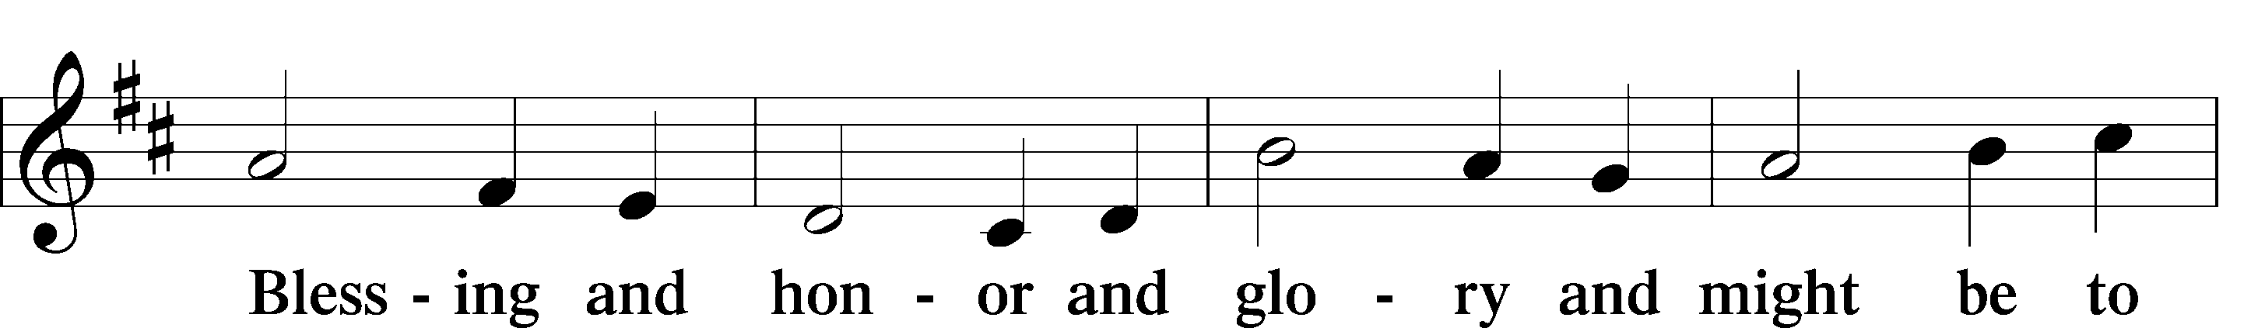
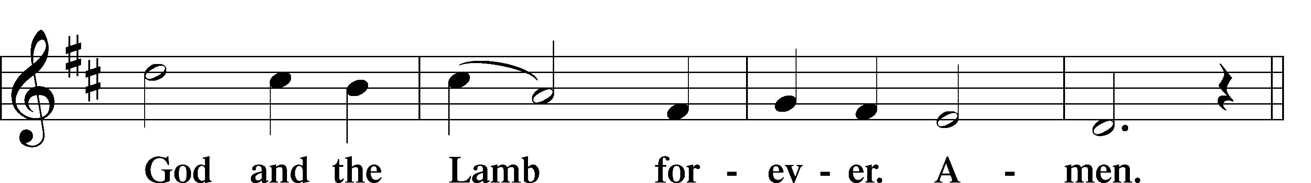
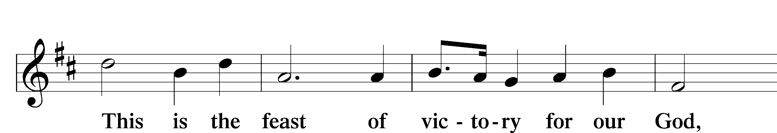
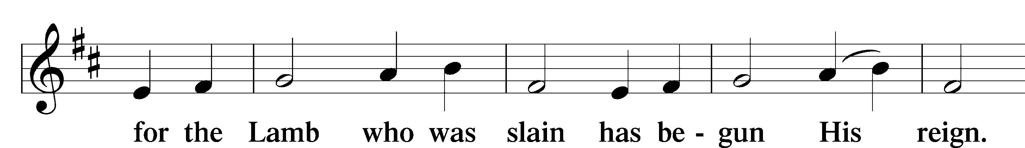
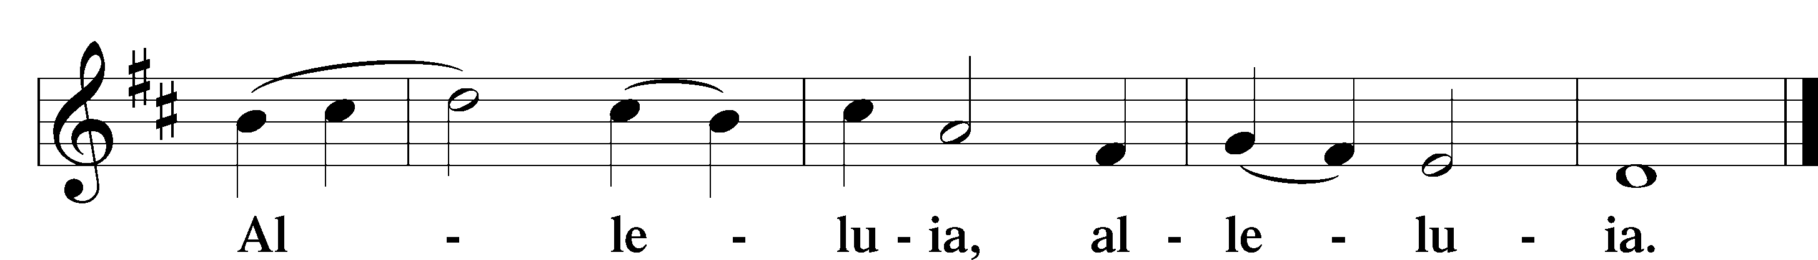

Salutation and Collect of the Day
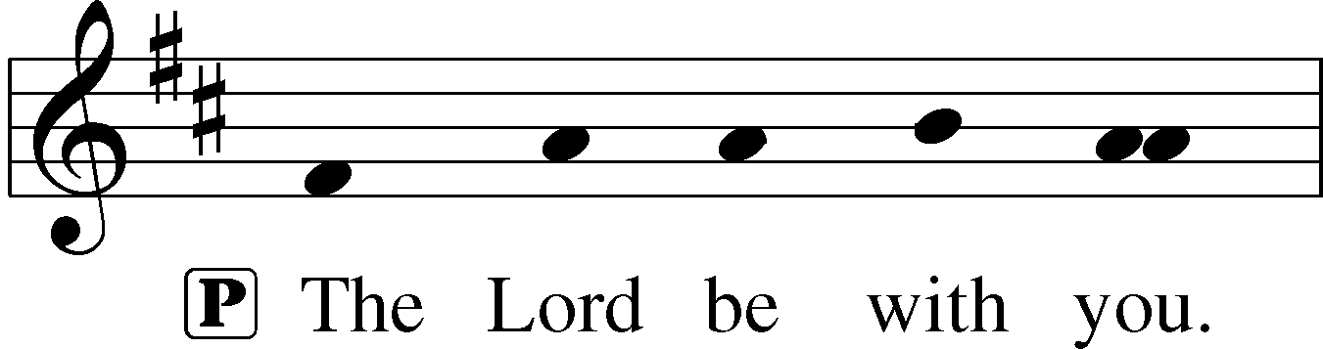
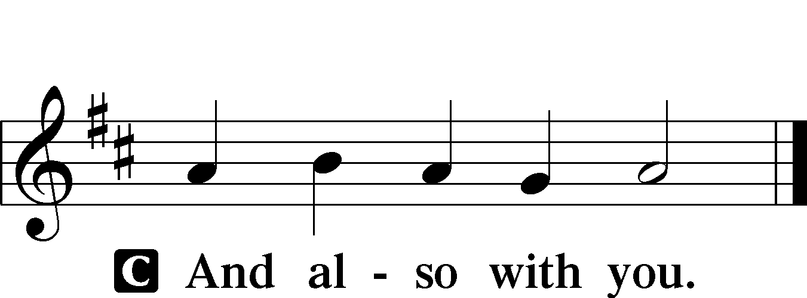

P Let us pray.
C O Lord, keep Your household, the Church, in continual godliness that through Your protection she may be free from all adversities and devoutly given to serve You in good works; through Jesus Christ, Your Son, our Lord, who lives and reigns with You and the Holy Spirit, one God, now and forever. Amen.

Sit

Old Testament Reading Genesis 1:1—2:3
1In the beginning, God created the heavens and the earth.
2The earth was without form and void, and darkness was over the face of the deep. And the Spirit of God was hovering over the face of the waters.
3And God said, “Let there be light,” and there was light. 4And God saw that the light was good. And God separated the light from the darkness. 5God called the light Day, and the darkness he called Night. And there was evening and there was morning, the first day.
6And God said, “Let there be an expanse in the midst of the waters, and let it separate the waters from the waters.” 7And God made the expanse and separated the waters that were under the expanse from the waters that were above the expanse. And it was so.
8And God called the expanse Heaven. And there was evening and there was morning, the second day.
9And God said, “Let the waters under the heavens be gathered together into one place, and let the dry land appear.” And it was so. 10God called the dry land Earth, and the waters that were gathered together he called Seas. And God saw that it was good.
11And God said, “Let the earth sprout vegetation, plants yielding seed, and fruit trees bearing fruit in which is their seed,
each according to its kind, on the earth.” And it was so. 12The earth brought forth vegetation, plants yielding seed according to their own kinds, and trees bearing fruit in which is their seed, each according to its kind. And God saw that it was good. 13And there was evening and there was morning, the third day.
14And God said, “Let there be lights in the expanse of the heavens to separate the day from the night. And let them be for signs and for seasons, and for days and years, 15and let them be lights in the expanse of the heavens to give light upon the earth.” And it was so. 16And God made the two great lights—the greater light to rule the day and the lesser light to rule the night—and the stars. 17And God set them in the expanse of the heavens to give light on the earth,
18to rule over the day and over the night, and to separate the light from the darkness. And God saw that it was good. 19And there was evening and there was morning, the fourth day.
20And God said, “Let the waters swarm with swarms of living creatures, and let birds fly above the earth across the expanse of the heavens.” 21So God created the great sea creatures and every living creature that moves, with which the waters swarm, according to their kinds, and every winged bird according to its kind. And God saw that it was good. 22And God blessed them, saying, “Be fruitful and multiply and fill the waters in the seas, and let birds multiply on the earth.” 23And there was evening and there was morning, the fifth day.
24And God said, “Let the earth bring forth living creatures according to their kinds—livestock and creeping things and beasts of the earth according to their kinds.” And it was so.
25And God made the beasts of the earth according to their kinds and the livestock according to their kinds, and everything that creeps on the ground according to its kind. And God saw that it was good.
26Then God said, “Let us make man in our image, after our likeness. And let them have dominion over the fish of the sea and over the birds of the heavens and over the livestock and over all the earth and over every creeping thing that creeps on the earth.”
27So God created man in his own image,
in the image of God he created him;
male and female he created them.
28And God blessed them. And God said to them, “Be fruitful and multiply and fill the earth and subdue it and have dominion over the fish of the sea and over the birds of the heavens and over every living thing that moves on the earth.” 29And God said, “Behold, I have given you every plant yielding seed that is on the face of all the earth, and every tree with seed in its fruit. You shall have them for food. 30And to every beast of the earth and to every bird of the heavens and to everything that creeps on the earth, everything that has the breath of life, I have given every green plant for food.” And it was so.
31And God saw everything that he had made, and behold, it was very good. And there was evening and there was morning, the sixth day.
1Thus the heavens and the earth were finished, and all the host of them. 2And on the seventh day God finished his work that he had done, and he rested on the seventh day from all his work that he had done. 3So God blessed the seventh day and made it holy, because on it God rested from all his work that he had done in creation.

A This is the Word of the Lord.
C Thanks be to God.

Gradual Psalm 90:1–2
Lord, you have been our dwelling place*
in all generations.
Before the mountains were brought forth, or ever you had formed the earth and the world,*
from everlasting to everlasting you are God.

Epistle Ephesians 6:10–17
10Finally, be strong in the Lord and in the strength of his might. 11Put on the whole armor of God, that you may be able to stand against the schemes of the devil. 12For we do not wrestle against flesh and blood, but against the rulers, against the authorities, against the cosmic powers over this present darkness, against the spiritual forces of evil in the heavenly places. 13Therefore take up the whole armor of God, that you may be able to withstand in the evil day, and having done all, to stand firm. 14Stand therefore, having fastened on the belt of truth, and having put on the breastplate of righteousness,
15and, as shoes for your feet, having put on the readiness given by the gospel of peace. 16In all circumstances take up the shield of faith, with which you can extinguish all the flaming darts of the evil one; 17and take the helmet of salvation, and the sword of the Spirit,
which is the word of God.

A This is the Word of the Lord.
C Thanks be to God.

Stand

Alleluia and Verse LSB 173
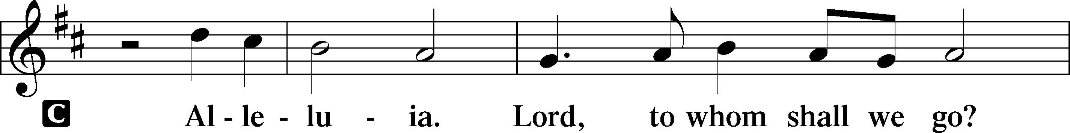
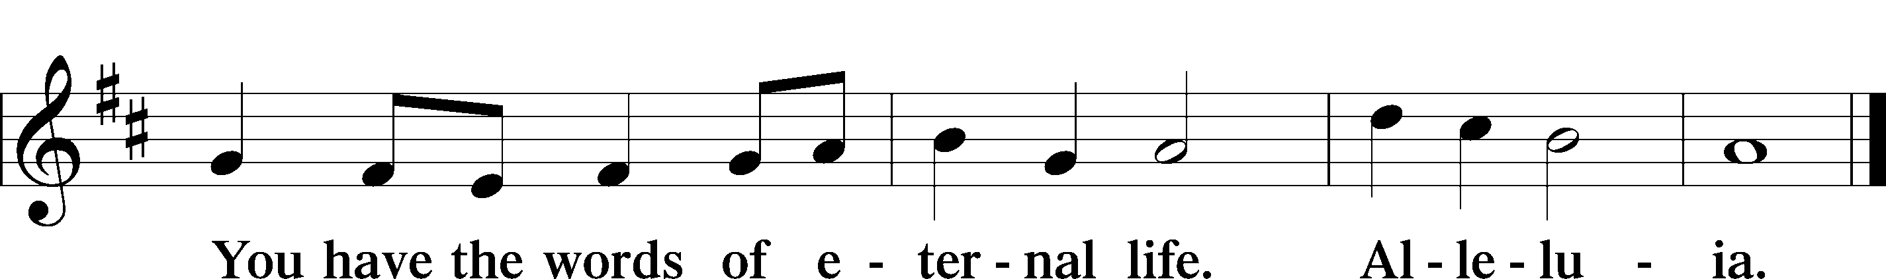

Holy Gospel John 4:46–54
P The Holy Gospel according to St. John, the fourth chapter.

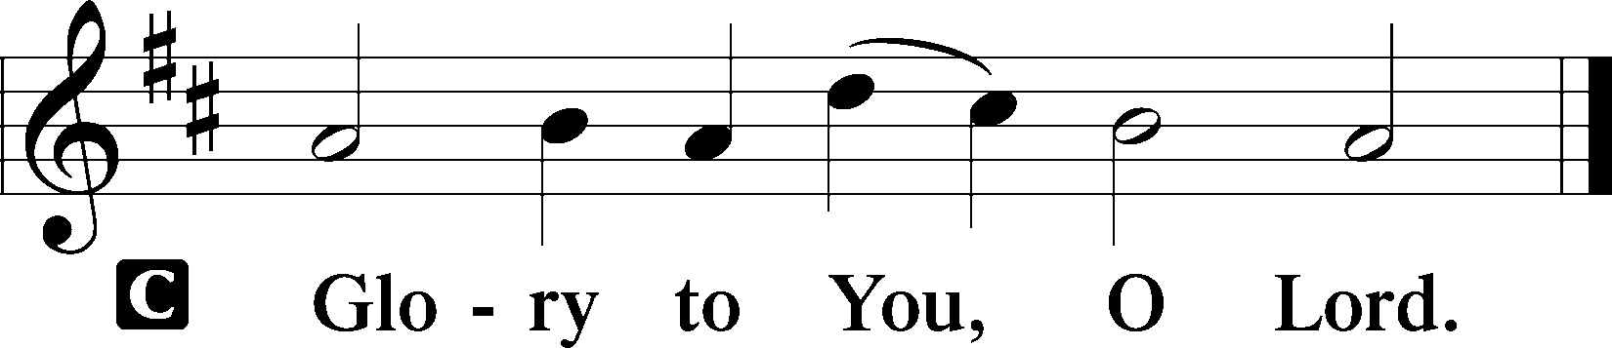

46[Jesus] came again to Cana in Galilee, where he had made the water wine. And at Capernaum there was an official whose son was ill. 47When this man heard that Jesus had come from Judea to Galilee, he went to him and asked him to come down and heal his son, for he was at the point of death. 48So Jesus said to him, “Unless you see signs and wonders you will not believe.” 49The official said to him, “Sir, come down before my child dies.” 50Jesus said to him,
“Go; your son will live.” The man believed the word that Jesus spoke to him and went on his way. 51As he was going down, his servants met him and told him that his son was recovering. 52So he asked them the hour when he began to get better, and they said to him, “Yesterday at the seventh hour the fever left him.” 53The father knew that was the hour when Jesus had said to him, “Your son will live.” And he himself believed, and all his household. 54This was now the second sign that Jesus did when he had come from Judea to Galilee.

P This is the Gospel of the Lord.

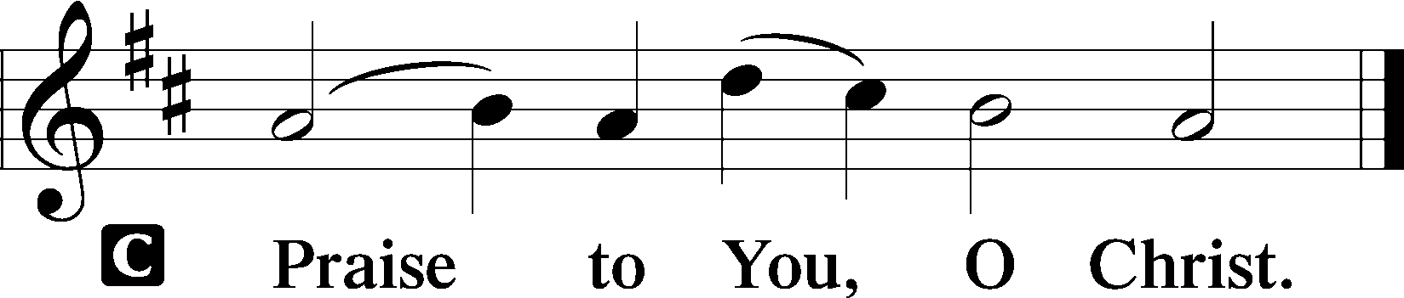

Nicene Creed
C I believe in one God,
the Father Almighty,
maker of heaven and earth
and of all things visible and invisible.
And in one Lord Jesus Christ,
the only-begotten Son of God,
begotten of His Father before all worlds,
God of God, Light of Light,
very God of very God,
begotten, not made,
being of one substance with the Father,
by whom all things were made;
who for us men and for our salvation came down from heaven
and was incarnate by the Holy Spirit of the virgin Mary
and was made man;
and was crucified also for us under Pontius Pilate.
He suffered and was buried.
And the third day He rose again according to the Scriptures
and ascended into heaven
and sits at the right hand of the Father.
And He will come again with glory to judge both the living and the dead,
whose kingdom will have no end.

And I believe in the Holy Spirit,
the Lord and giver of life,
who proceeds from the Father and the Son,
who with the Father and the Son together is worshiped and glorified,
who spoke by the prophets.
And I believe in one holy Christian and apostolic Church,
I acknowledge one Baptism for the remission of sins,
and I look for the resurrection of the dead
and the life T of the world to come. Amen.

Sit

Children’s Message

Hymn of the Day “O Little Flock, Fear Not the Foe” LSB 666
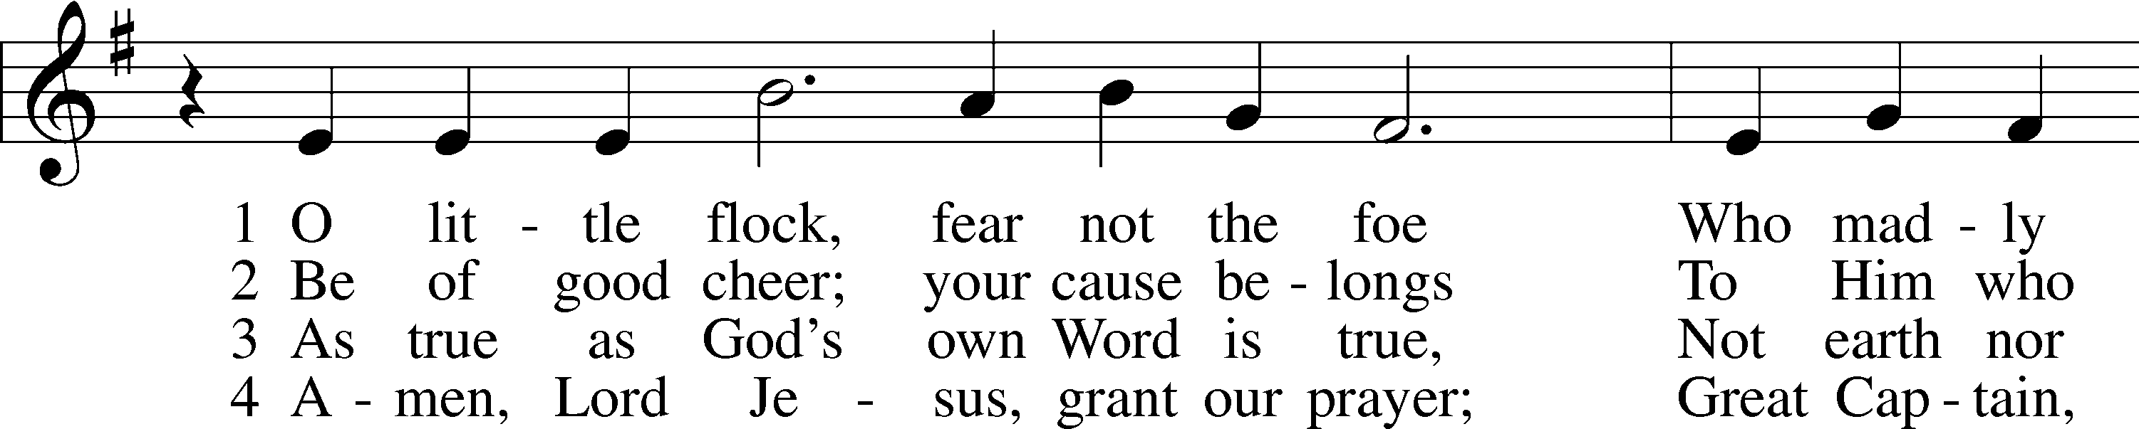
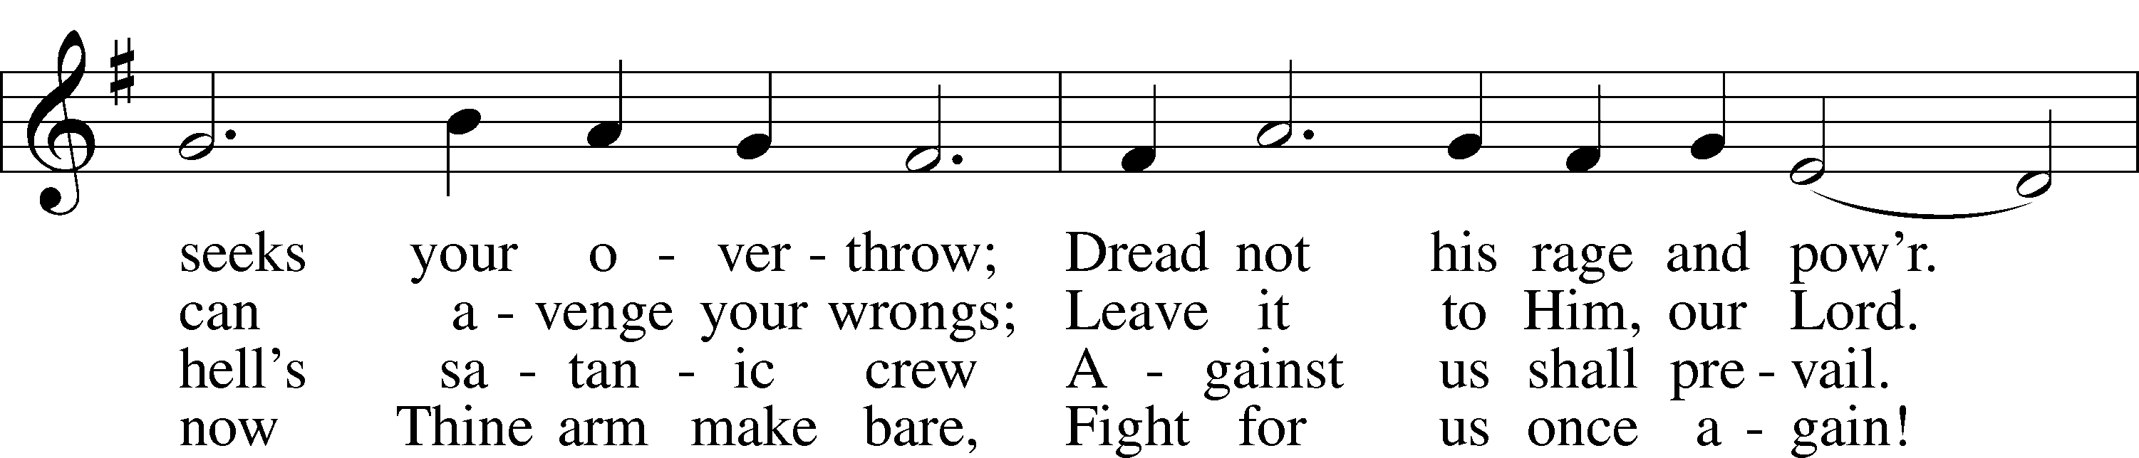
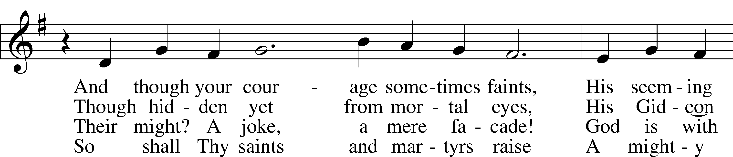
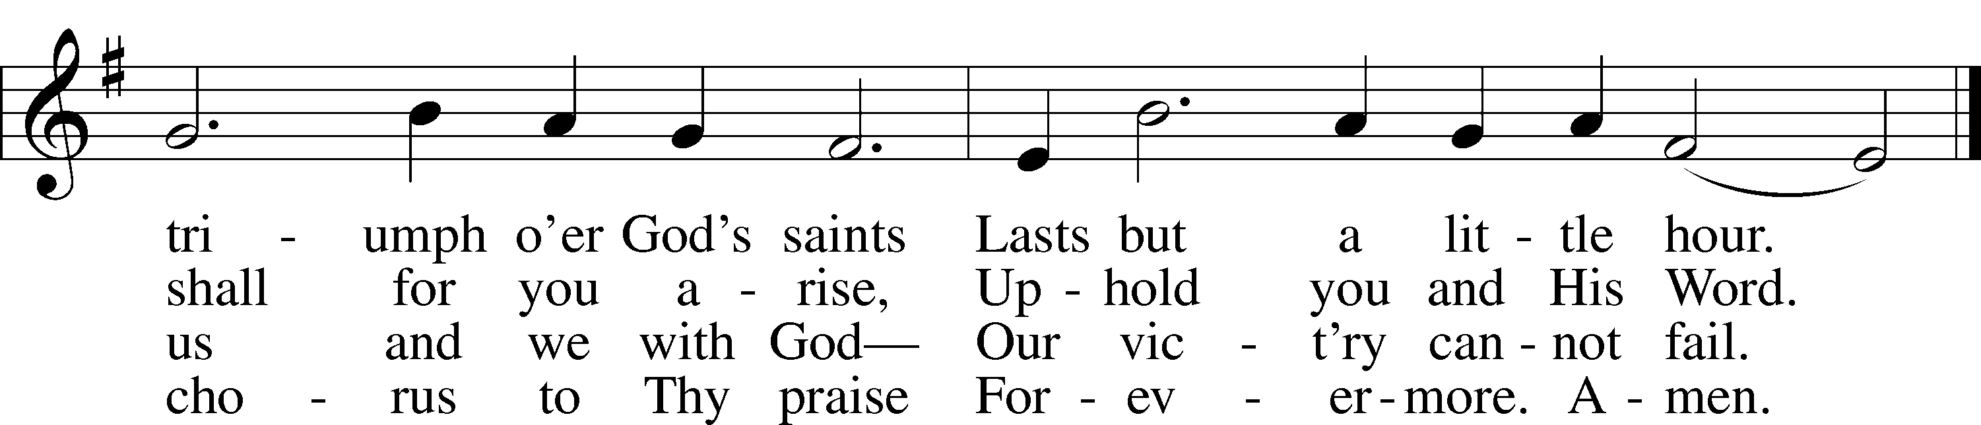
Tune and text: Public domain
Sermon

Offering

Stand

Offertory LSB 176
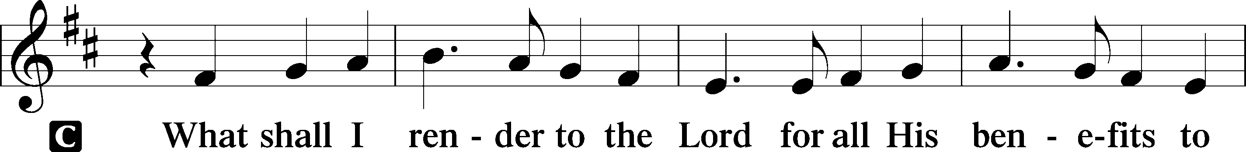
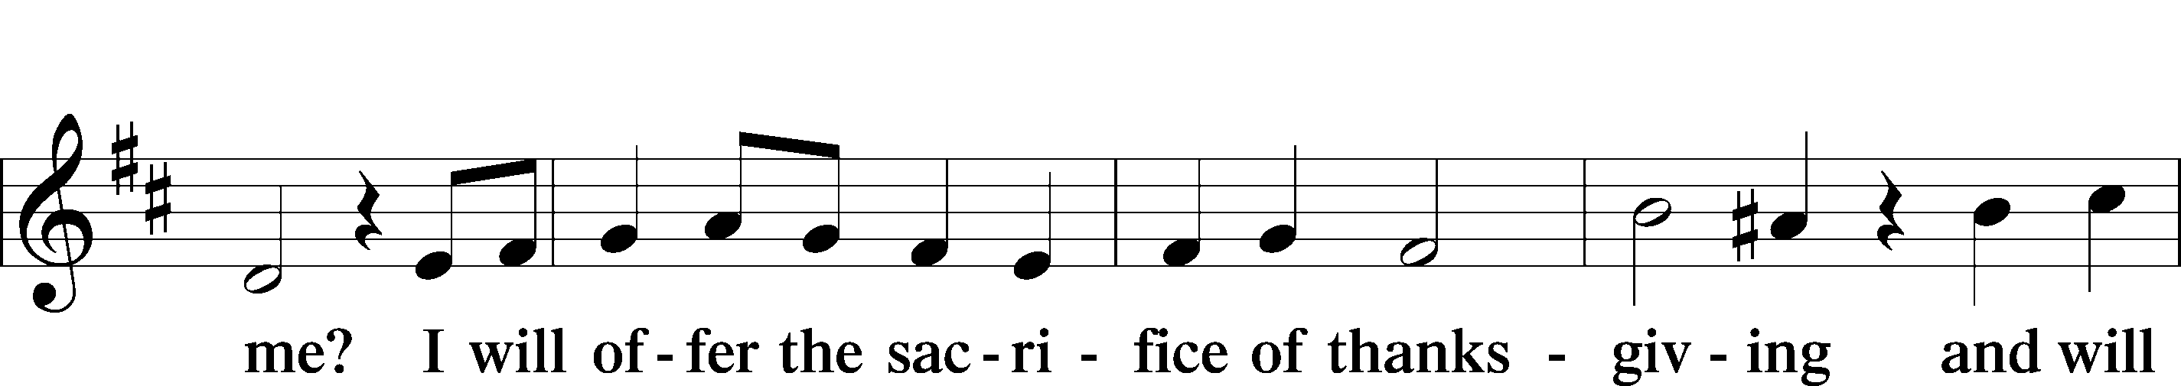
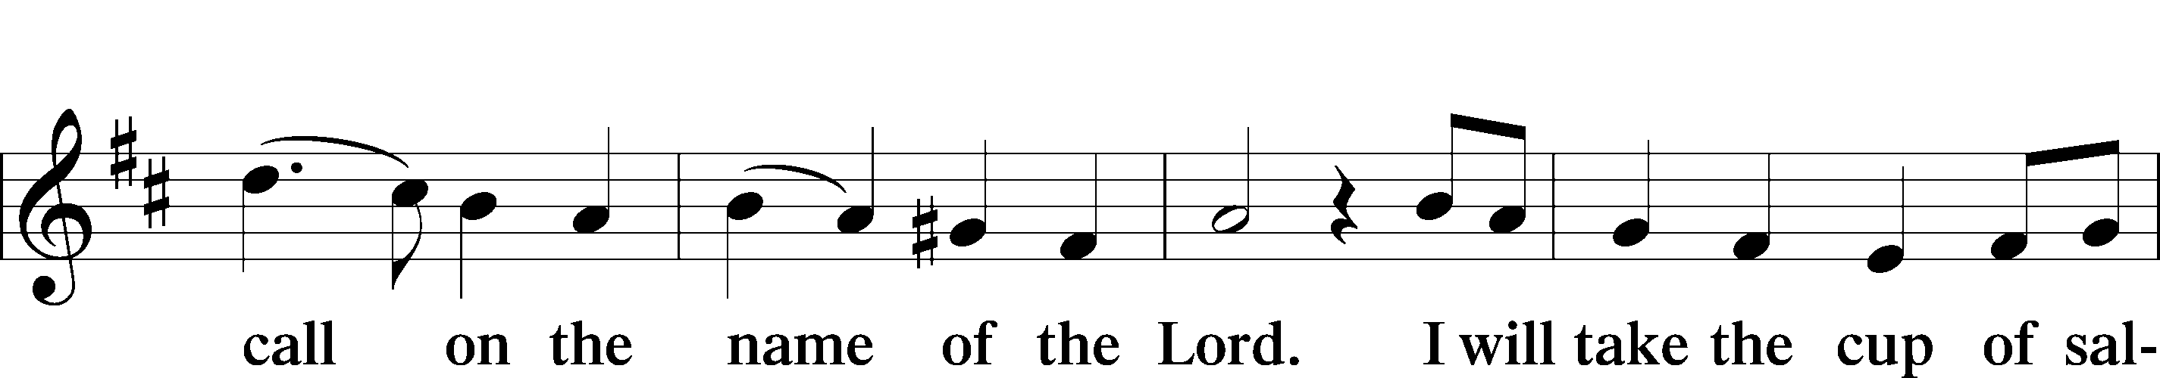
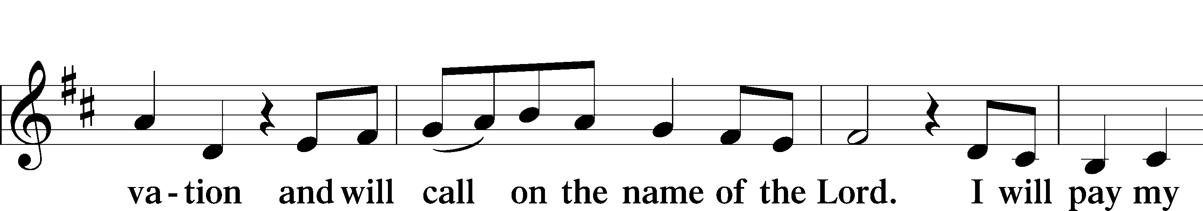
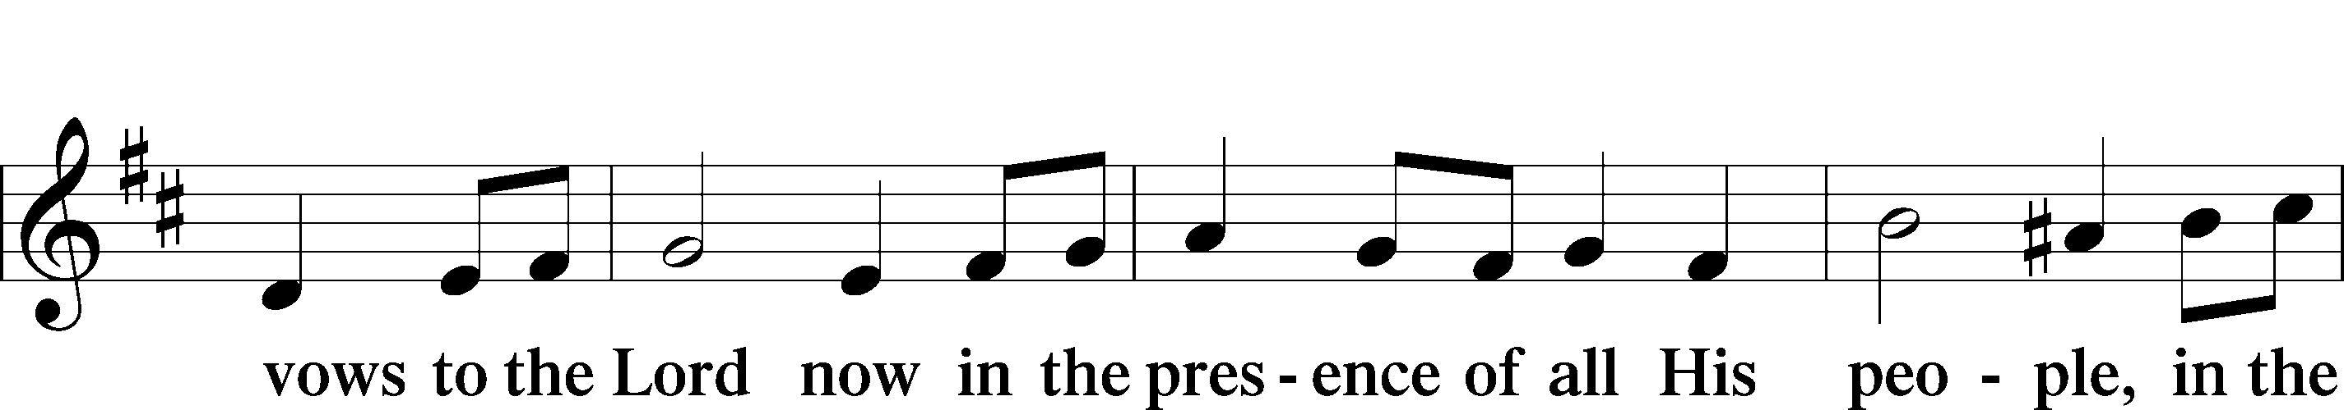
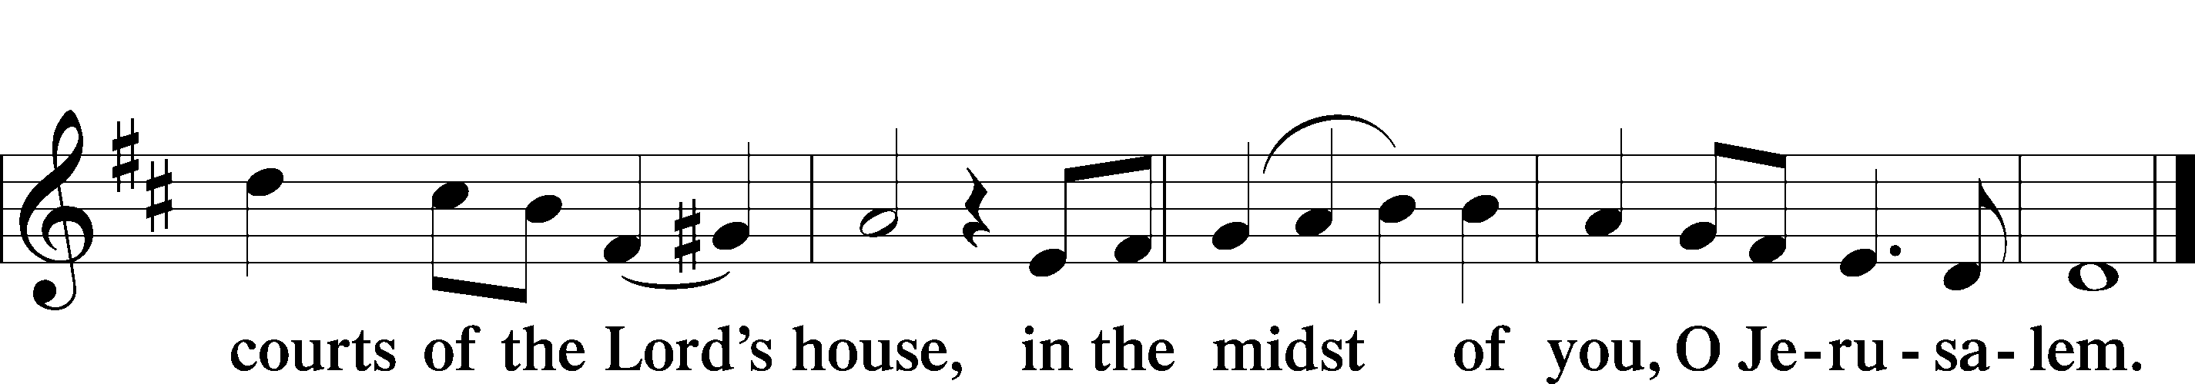

Prayer of the Church

+SERVICE OF THE SACRAMENT+

Preface LSB 177

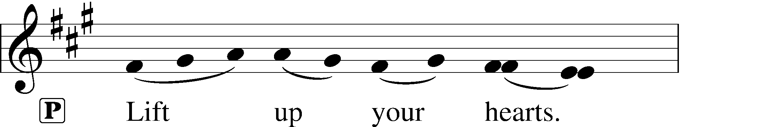

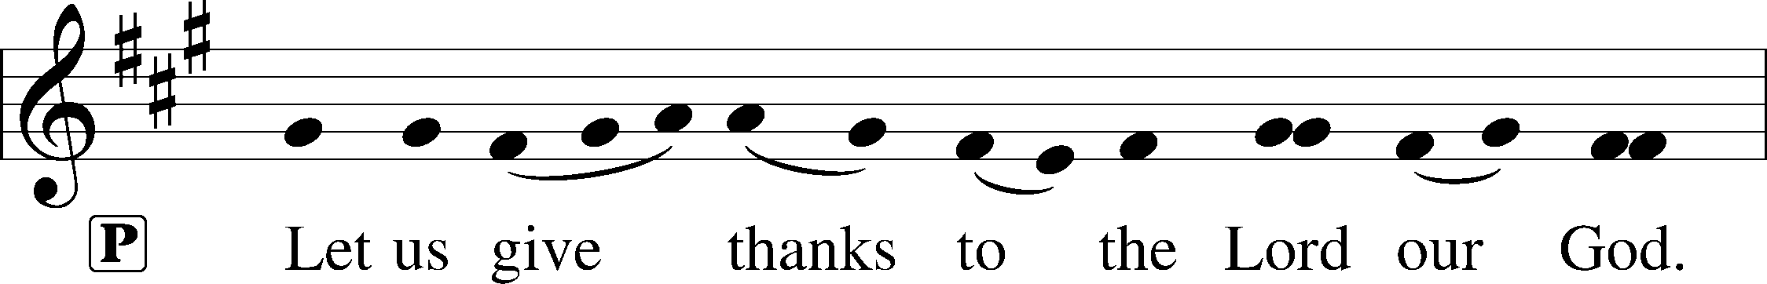
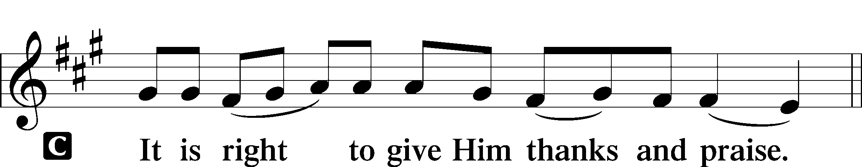

Proper Preface
P It is truly good, right, and salutary that we should at all times and in all places give thanks to You, holy Lord, almighty Father, everlasting God, through Jesus Christ, our Lord, who on this day overcame death and the grave and by His glorious resurrection opened to us the way of everlasting life. Therefore with angels and archangels and with all the company of heaven we laud and magnify Your glorious name, evermore praising You and saying:
Sanctus LSB 178
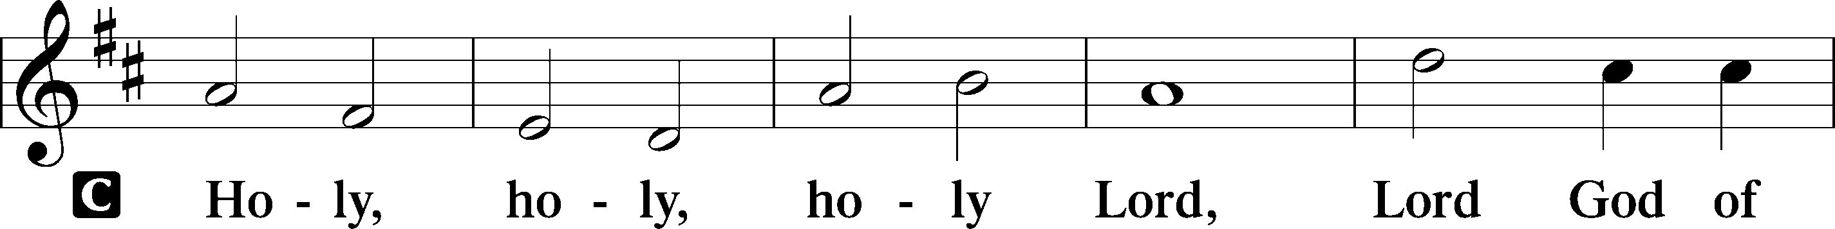
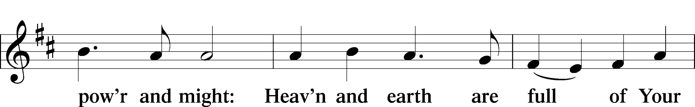
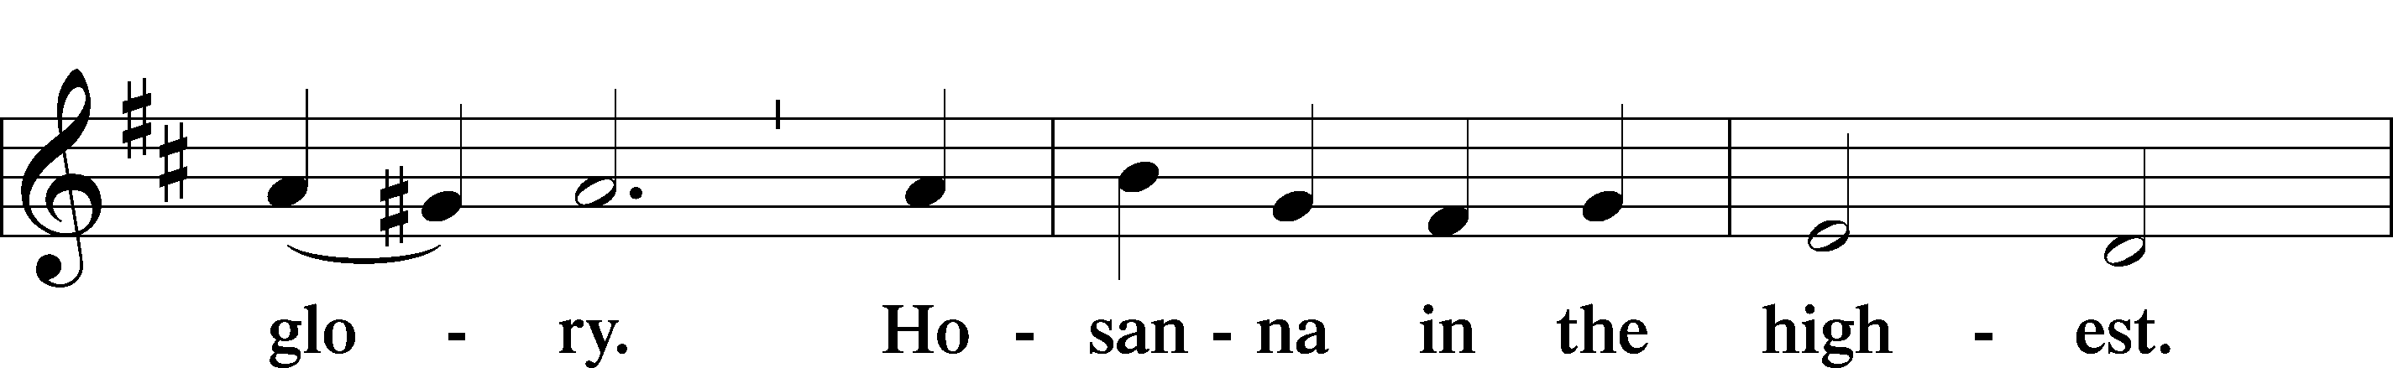
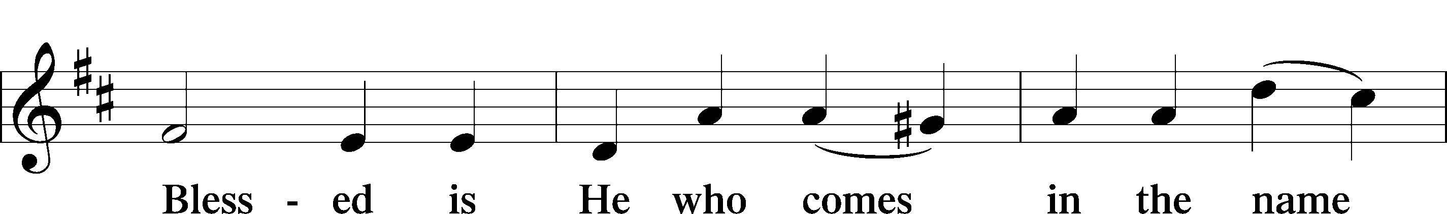
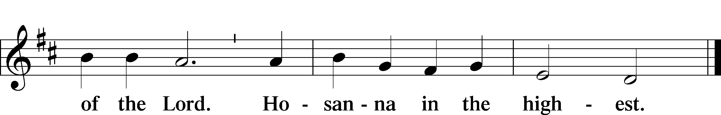

Lord’s Prayer
C Our Father who art in heaven,
hallowed be Thy name,
Thy kingdom come,
Thy will be done on earth
as it is in heaven;
give us this day our daily bread;
and forgive us our trespasses
as we forgive those
who trespass against us;
and lead us not into temptation,
but deliver us from evil.
For Thine is the kingdom
and the power and the glory
forever and ever. Amen.

The Words of Our Lord
P Our Lord Jesus Christ, on the night when He was betrayed, took bread, and when He had given thanks, He broke it and gave it to the disciples and said: “Take, eat; this is My T body, which is given for you. This do in remembrance of Me.”

In the same way also He took the cup after supper, and when He had given thanks, He gave it to them, saying: “Drink of it, all of you; this cup is the new testament in My T blood, which is shed for you for the forgiveness of sins. This do, as often as you drink it, in remembrance of Me.”

Pax Domini LSB 180
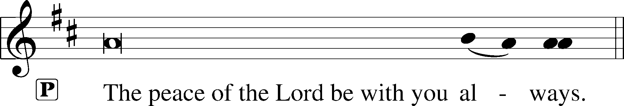

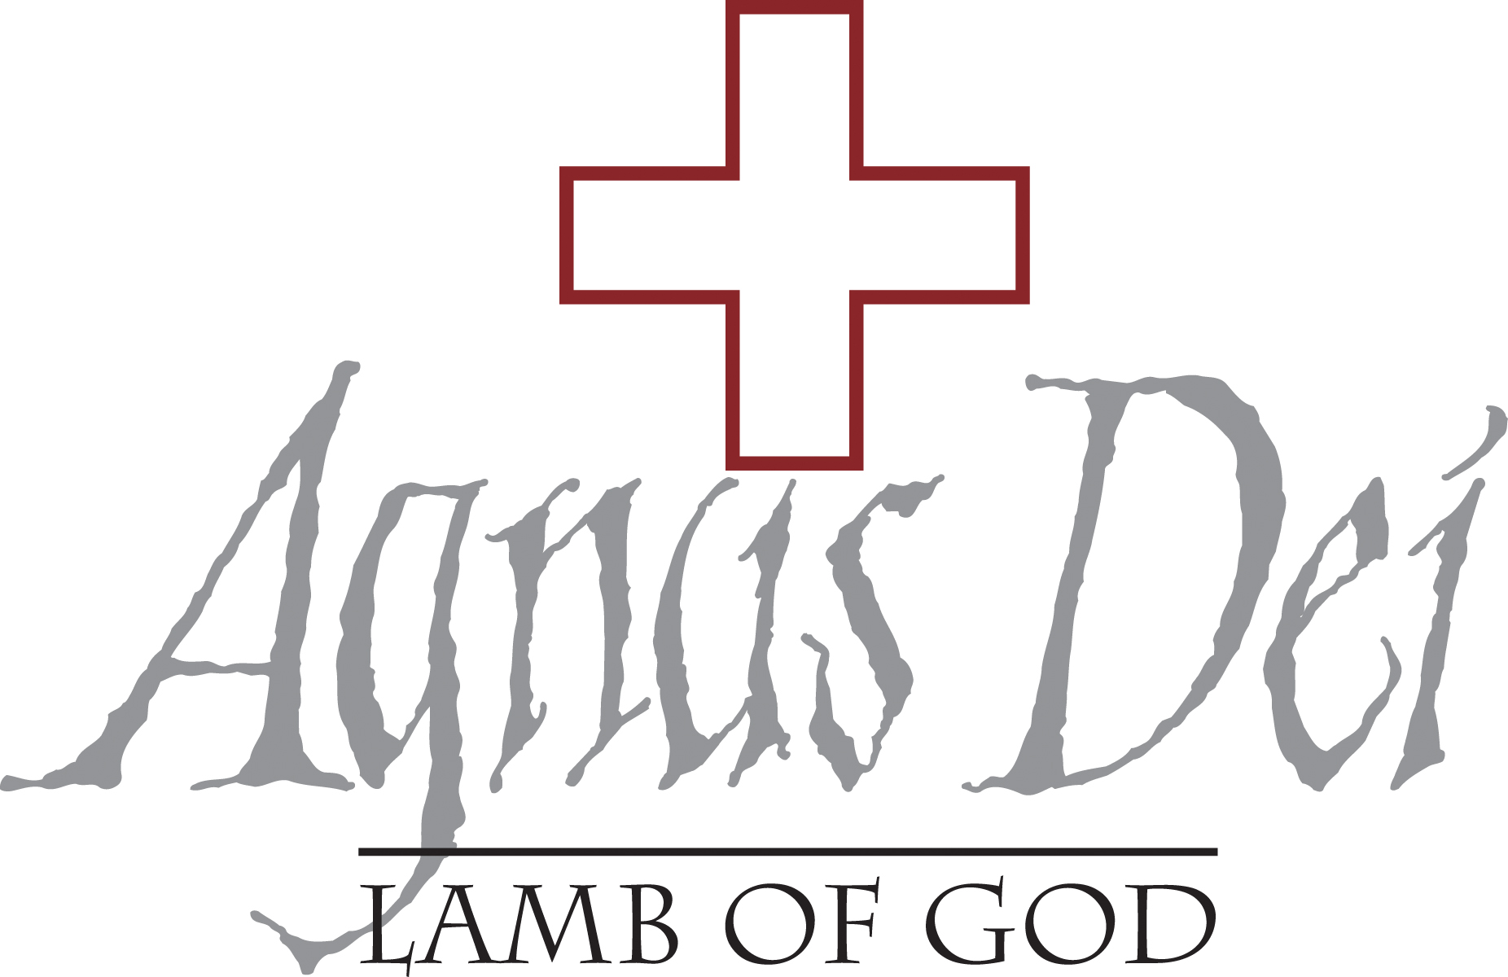
Agnus Dei LSB 180
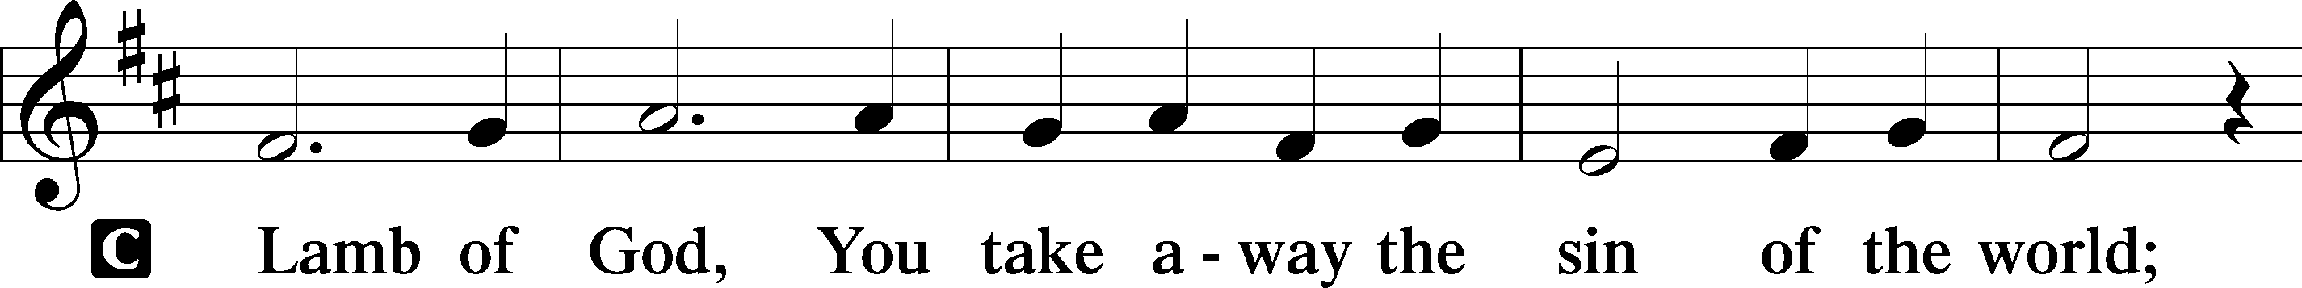
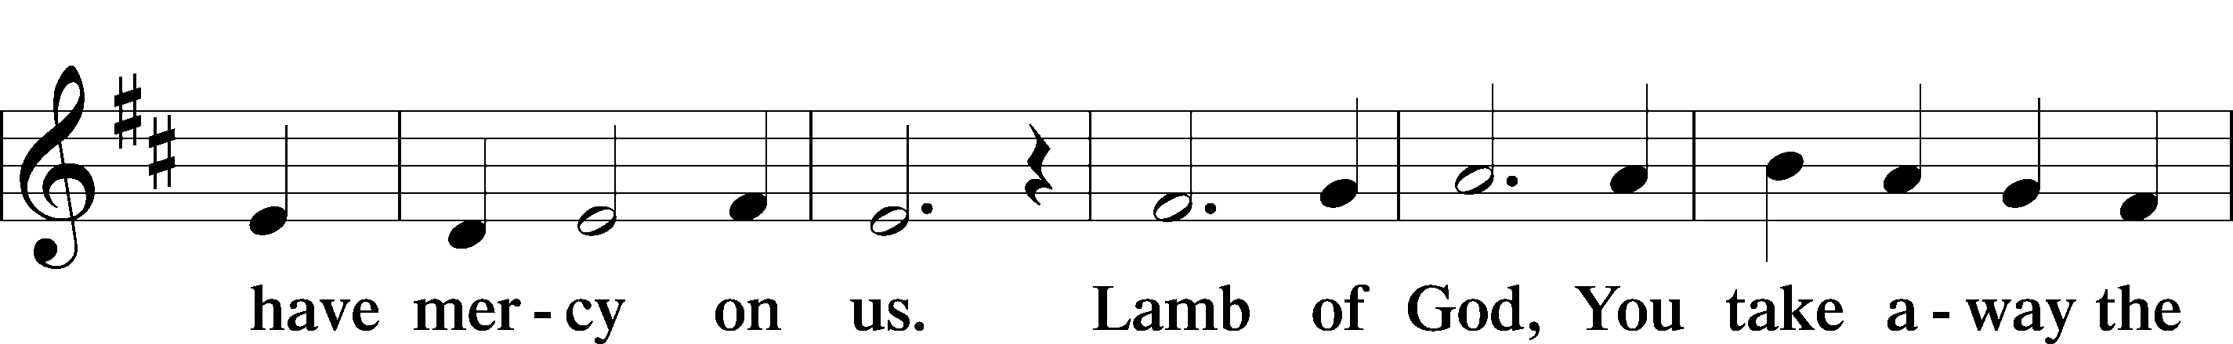
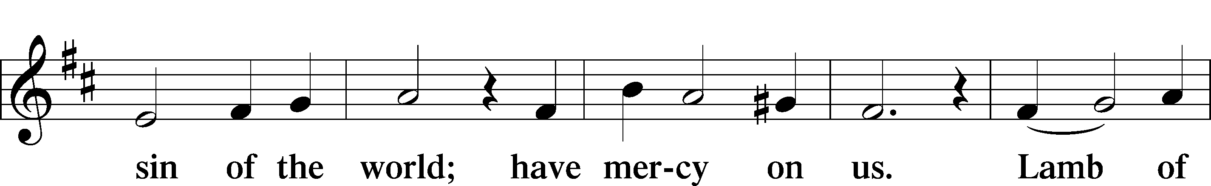
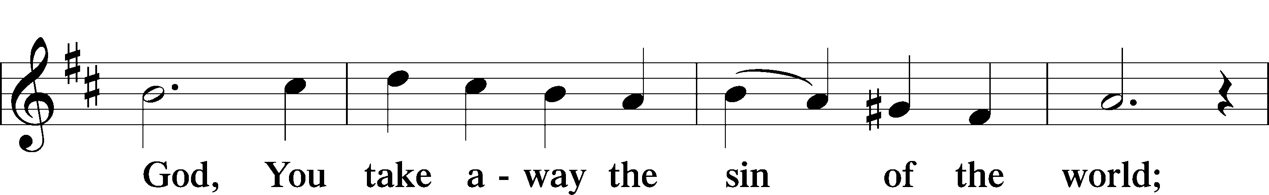
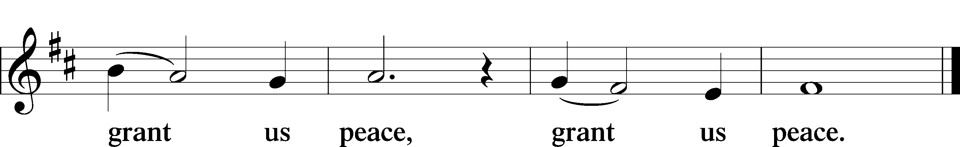

Sit

Distribution

Distribution Hymn “Lord Jesus Christ, Life-Giving Bread” LSB 625

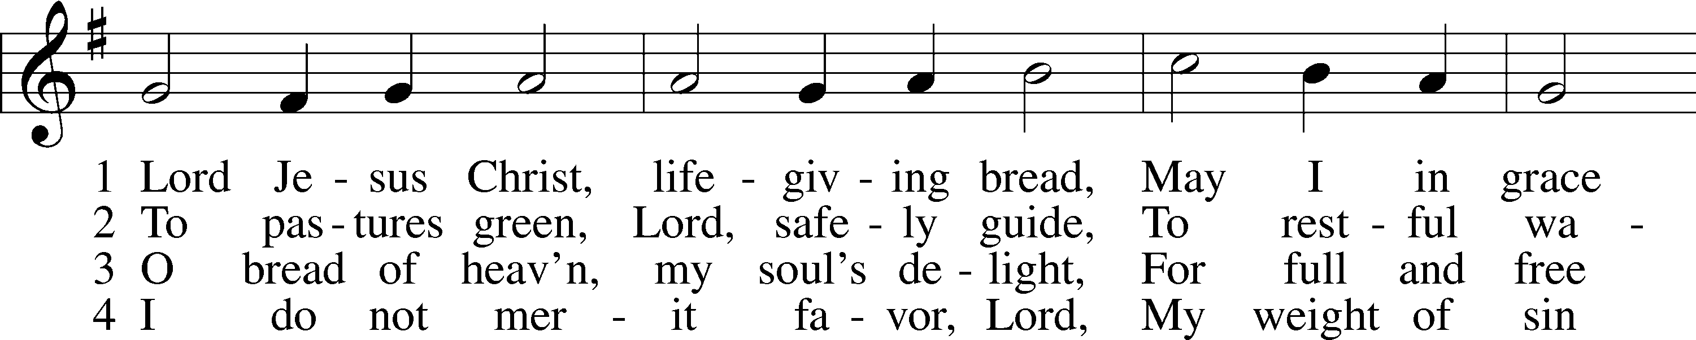
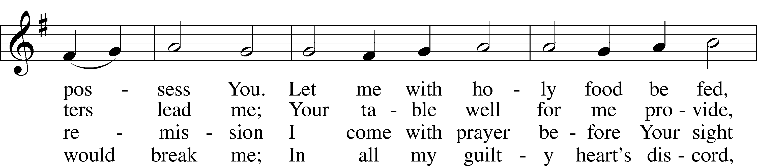
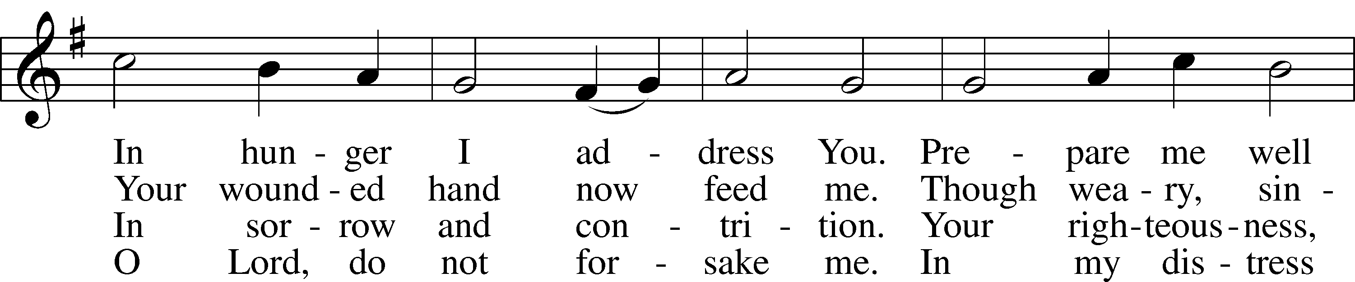
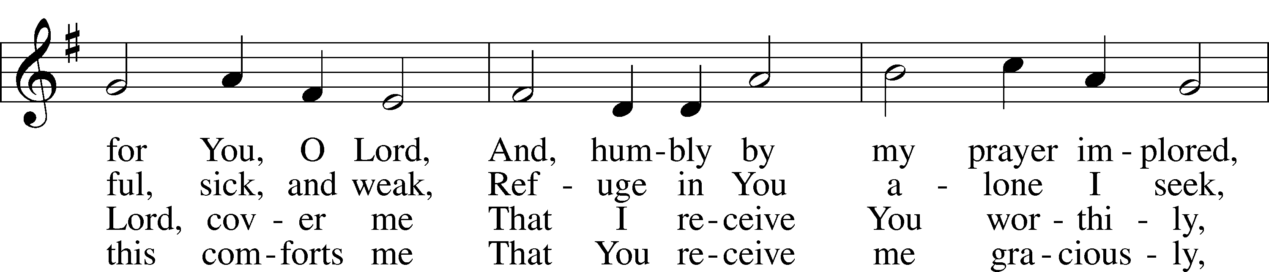
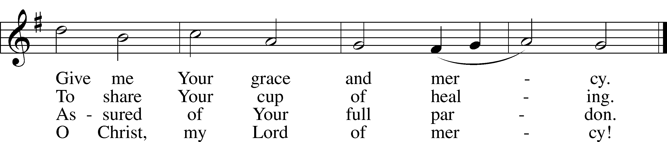
Text and tune: Public domain

Distribution Hymn “The Infant Priest Was Holy Born” LSB 624
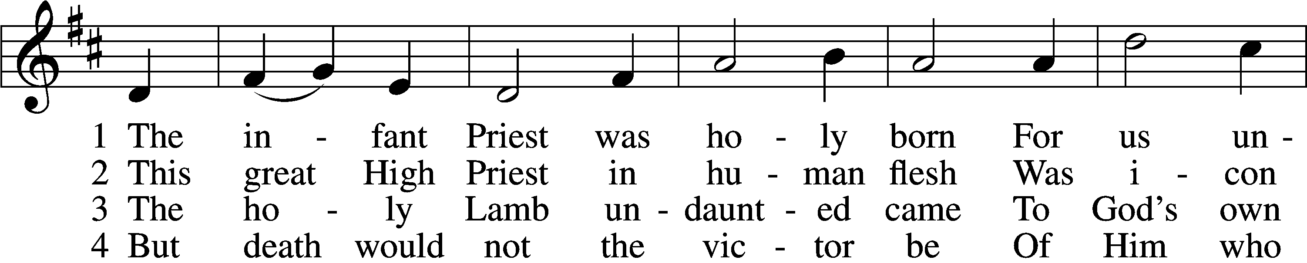
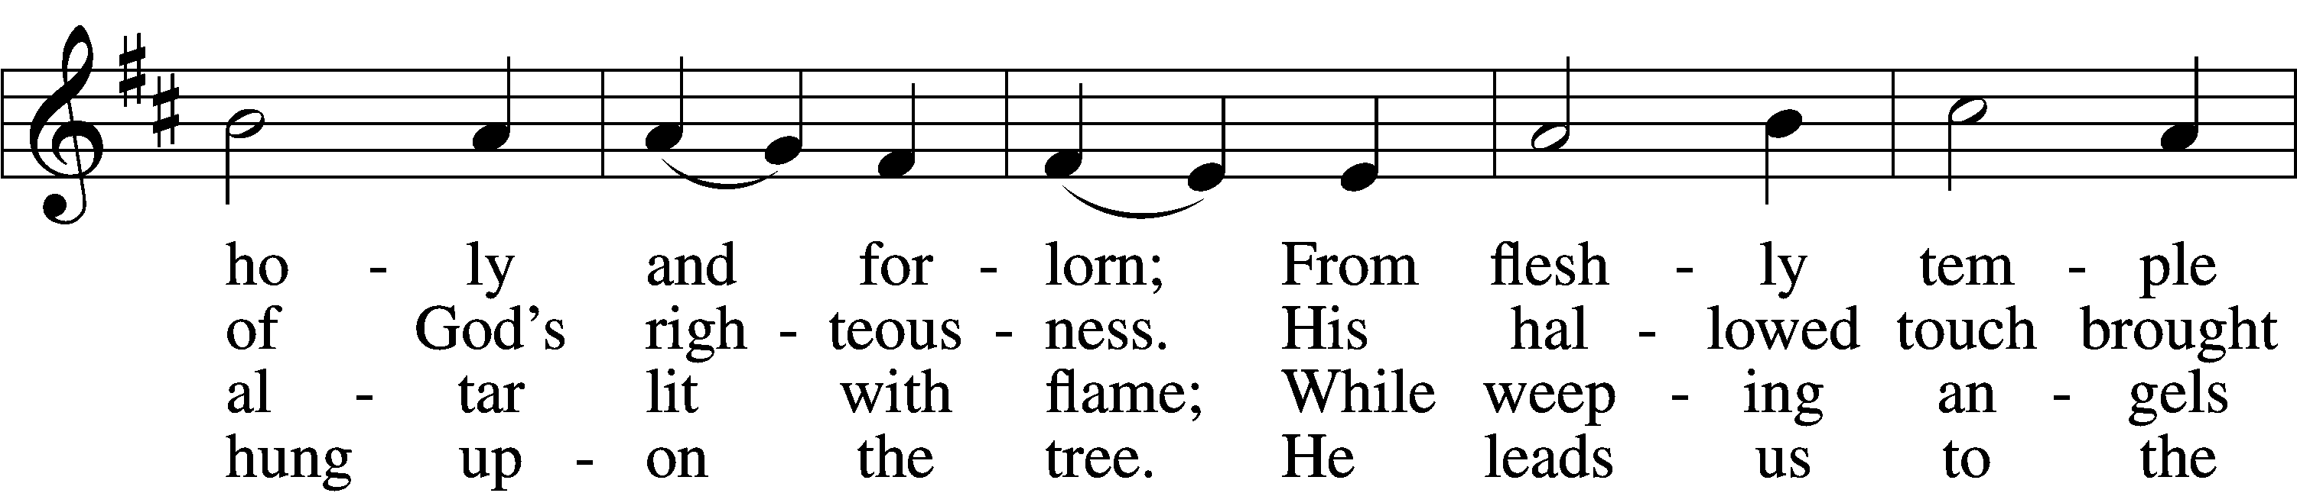
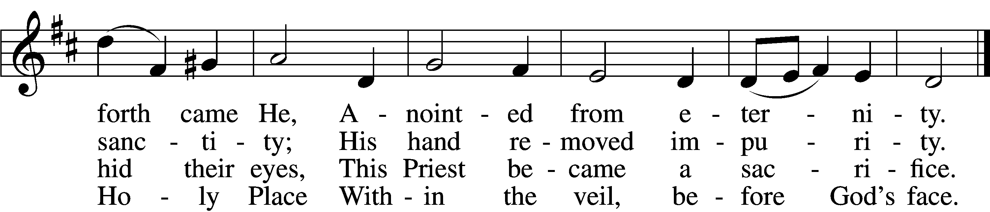

5 The veil is torn, our Priest we see,
As at the rail on bended knee
Our hungry mouths from Him receive
The bread of immortality.

6 The body of God’s Lamb we eat,
A priestly food and priestly meat;
On sin-parched lips the chalice pours
His quenching blood that life restores.

7 With cherubim and seraphim
Our voices join the endless hymn,
And “Holy, holy, holy” sing
To Christ, God’s Lamb, our Priest and King.
Text: © 1997, 2003 Chad L. Bird. Used by permission: LSB Hymn License no. 110016438
Tune: Public domain

Distribution Hymn “Lift High the Cross” LSB 837sts. ref–6
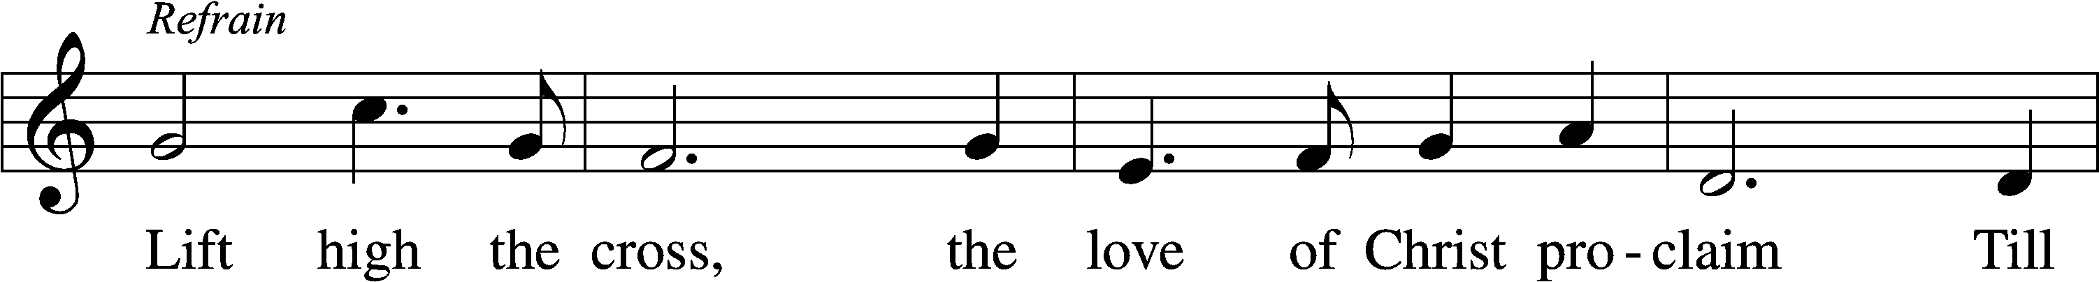
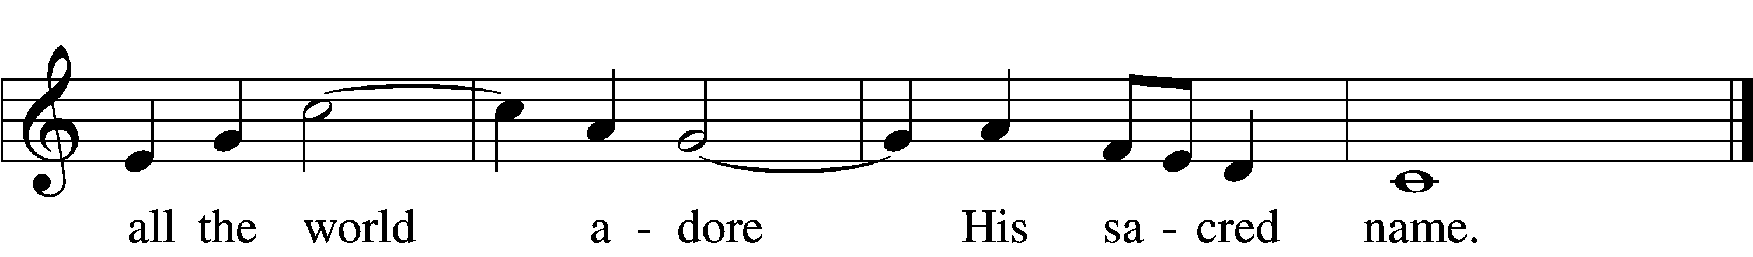
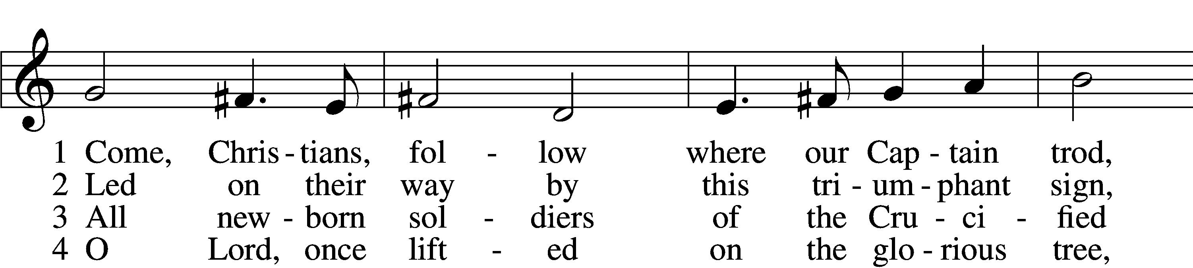
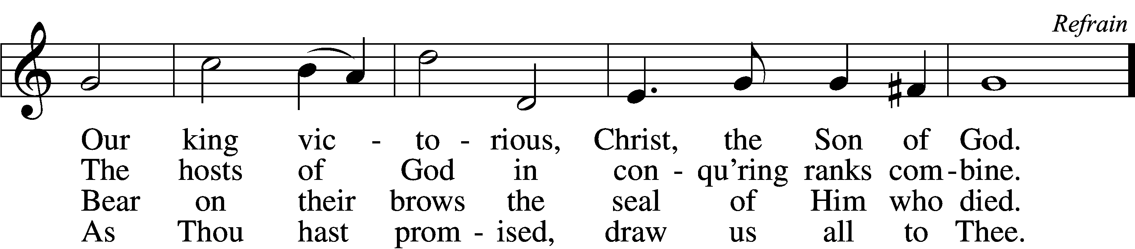

5 Let ev’ry race and ev’ry language tell
Of Him who saves our lives from death and hell. Refrain

6 So shall our song of triumph ever be:
Praise to the Crucified for victory! Refrain
Tune and text: © 1974 Hope Publishing Co. Used by permission: LSB Hymn License no. 110016438

Stand

Nunc Dimittis LSB 182
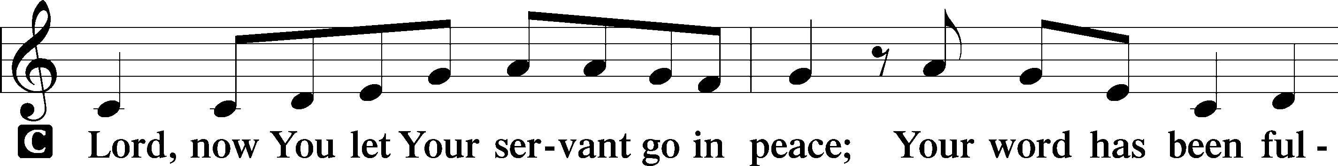
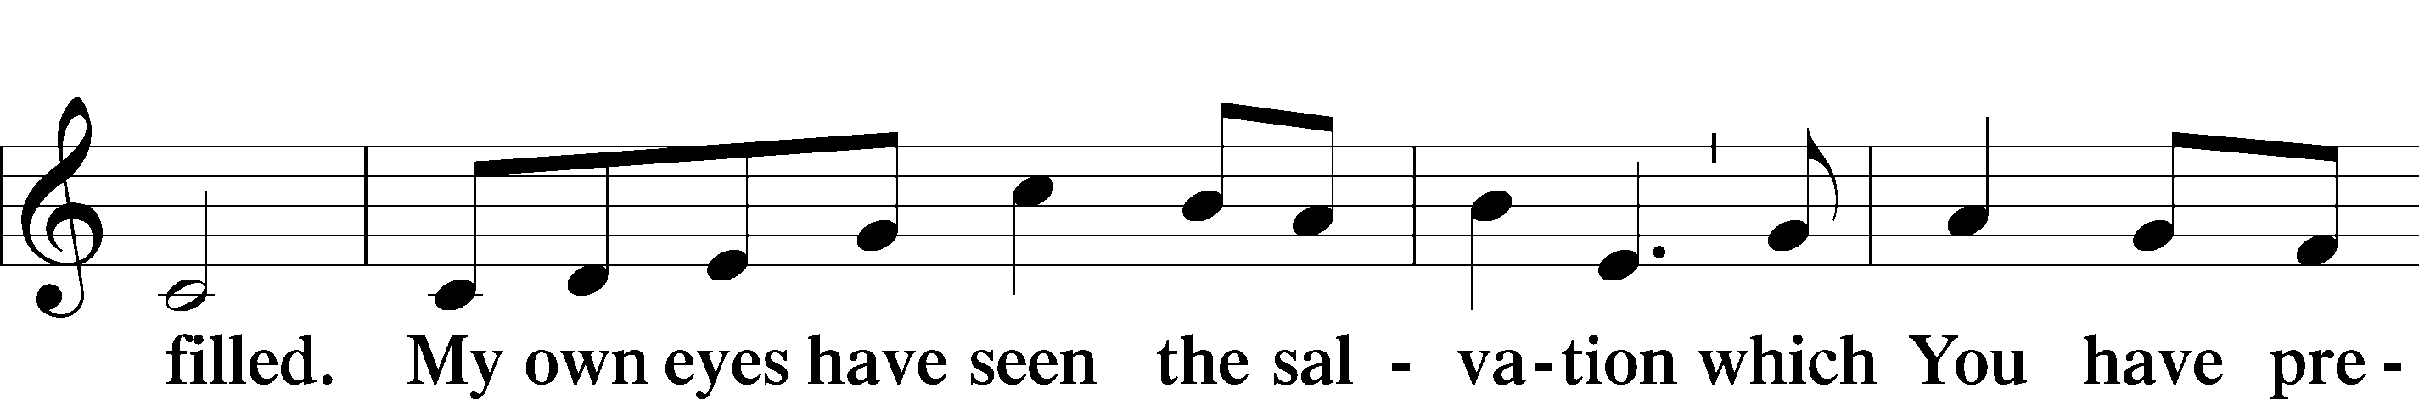
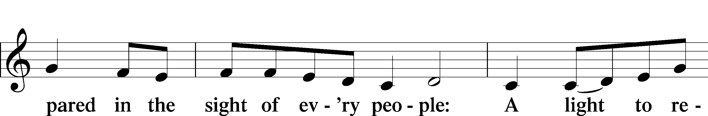
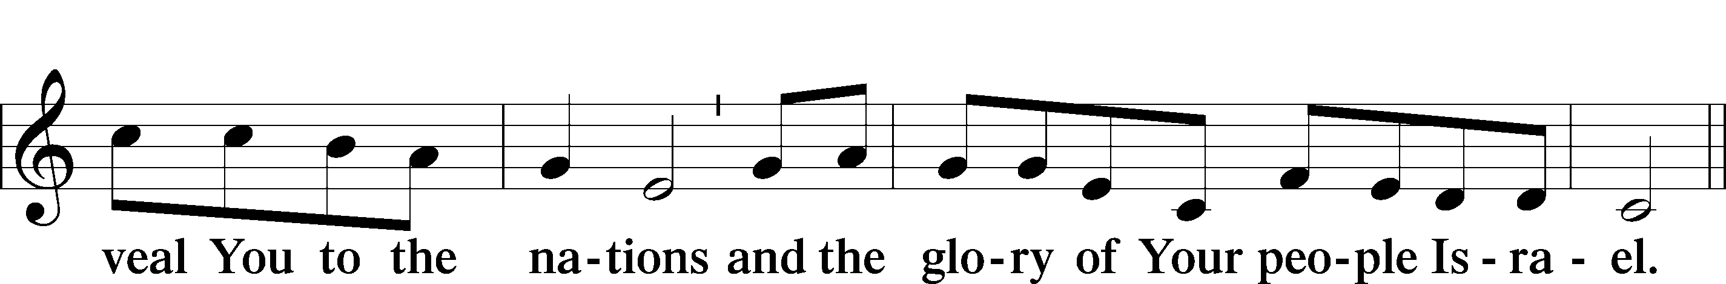
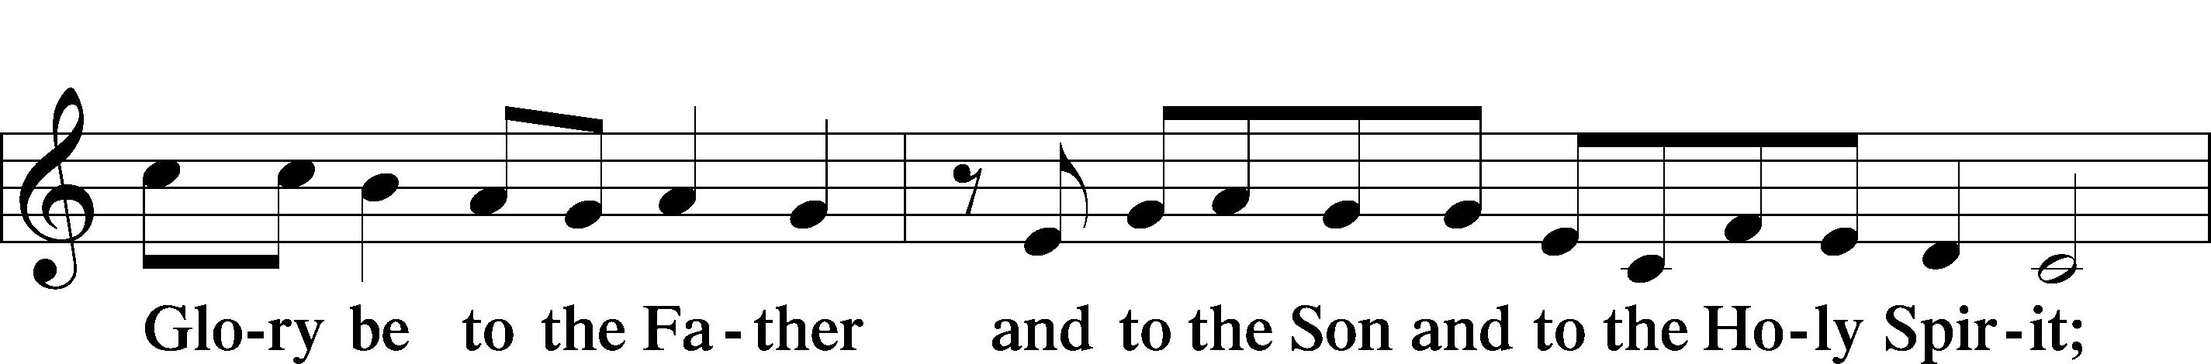
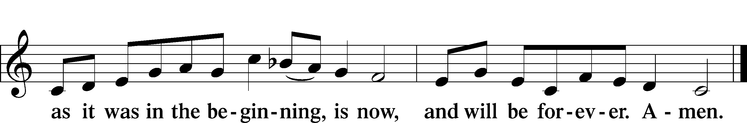

Post-Communion Collect
A Let us pray.
We give thanks to You, almighty God, that You have refreshed us through this salutary gift, and we implore You that of Your mercy You would strengthen us through the same in faith toward You and in fervent love toward one another; through Jesus Christ, Your Son, our Lord, who lives and reigns with You and the Holy Spirit, one God, now and forever.
C Amen.

Benediction LSB 183
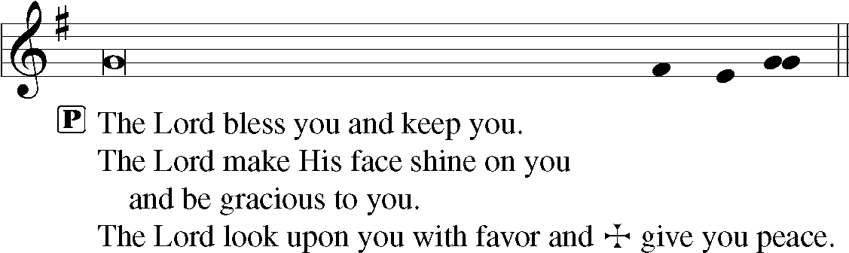

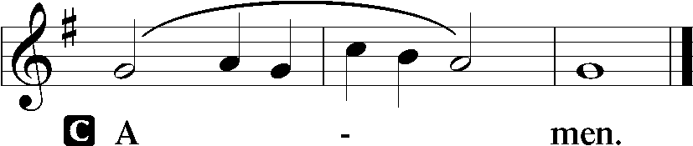

Closing Hymn “Now Thank We All Our God” LSB 895
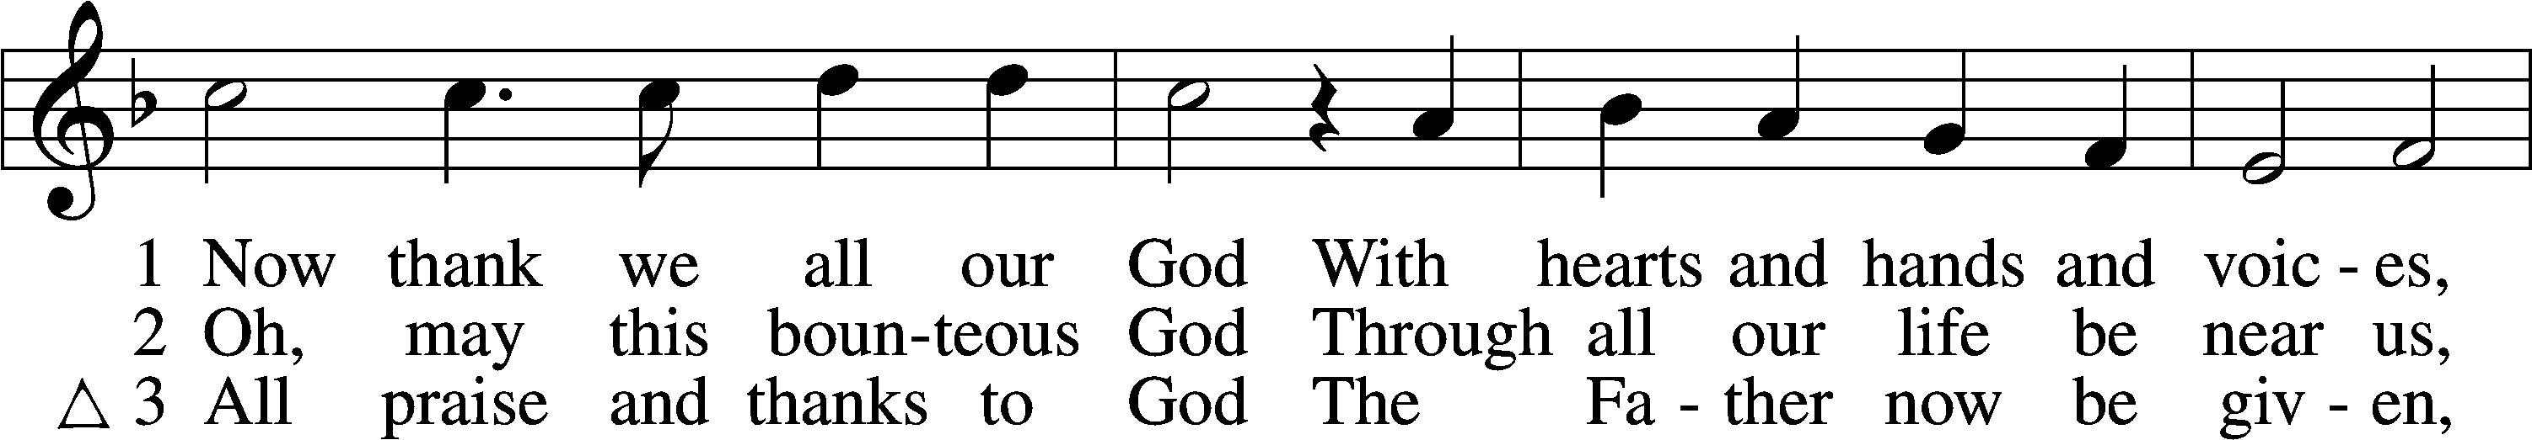
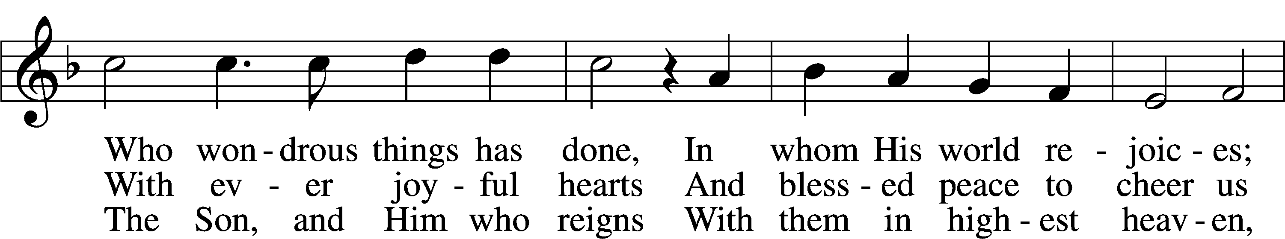
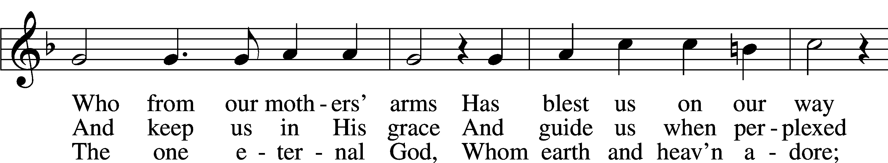
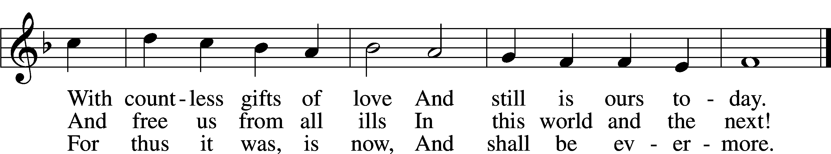
Text and tune: Public domain

Acknowledgments
Unless otherwise indicated, Scripture quotations are from the ESV® Bible (The Holy Bible, English Standard Version®), copyright © 2001 by Crossway, a publishing ministry of Good News Publishers. Used by permission. All rights reserved.
Created by Lutheran Service Builder © 2021 Concordia Publishing House.

Serving Our Lord in His House Today:
Pastor: Rev. David Wurdeman
Organist: Rebecca Moseley
Elders: Jake Mallmann & Jerry Ecker
Joe Engel (Wednesday)

Gifts from God: Genesis 1:1 – “In the beginning, God created the heavens and the earth.” Many studies report that atheism is on the rise in our culture. The appeal of atheism is in the denial of a Creator. If the world just happens to exist – and if we are just accidents that arose out of a long process of random, directionless evolution – then we get to make our own rules, and nobody has any right to tell us otherwise. Since there is indeed a Creator, though, then obviously He knows best, and we try our best to follow His commands. Christians know this Creator very well, and we have seen not only His power and commands but also His grace and mercy in His Son, our Lord Jesus Christ.

Altar Flowers: Are placed today by Joe and Sylvia Engel in thankfulness to God for all of his blessings on them as well as all his blessings on our church family.

Wednesday Evening Bible Study: All are invited to join the new Bible Study, which begins this Wednesday, October 27th at 6:00 p.m. The class, led by Jerry Ecker and Jake Mallmann, will be studying the Gospel of John, using the book "JOHN -- The Word Became Flesh." Books will be provided.

Weekly Psalms Devotional Group: Please join us Thursday mornings at 10:00 a.m., as we read and pray through selected Psalms. We’ll learn about their meaning, application and ways to incorporate them into your prayer life.

Good Shepherd Women’s Card Sale: Need cards? The women’s group is having a sale on their existing cards. Buy 2 boxes of cards at regular price buy a 3rd box at half price.

Livestream: Our Sunday Service is livestreamed weekly on our YouTube channel “Good Shepherd Lutheran Church Tomah.”

The church needs assistance on November 5 and 6.
We need help at church on Friday, November 5th starting at 12:00pm to set up for the Craft Fair which takes place Saturday, November 6 at Cranberry Lodge, Best Western and the Masonic Lodge, all in Tomah. We are also in need of baked goods for this craft fair. Please drop off your baked goods to church by Friday, November 5. Deb will be in the office 8-12 and Lorna will be at the church in the afternoon. Saturday, November 6th we need volunteers to work at each location from 7am until the afternoon. There will be shifts to work, and a sign- up sheet is placed on the easel in the narthex. If you have any questions regarding this Craft Fair, please contact Lorna Rosenow at 608-372-6584 (home) or 608-343-5584 (cell). We are also in need of the following items for the craft fair: Baked Goods, Paper Boxes and/or totes, Coolers, Money/Cash Boxes, Plastic (Walmart) Bags
*Please label all items with your name that you wish to be returned to you.

PO Box: For mailed offerings, please use the following:
Good Shepherd Lutheran Church
P.O. Box 551
Tomah, WI 54660

Our Worship attendance last week: Sunday: 53
Wednesday: 11
Total: 64

Scripture Lessons for next week: Revelation 14:6-7
Romans 3:19-28
Matthew 11:12-19

Secretary Office Hours: Monday-Friday: 8am-12pm

Pastor Office Hours: Pastor’s regular hours are Sunday-Thursday, 9am-5pm.
He is typically in the office in the mornings. In the afternoon, he is typically in the office, making pastoral visits, at meetings, or providing pastoral care in the
community. If you would like to visit with pastor, please call the church office at 608-374-2444 or his cell phone at 317-410-2271 to arrange a time.
Our Week With Our Lord:
Today 9:00am Divine Service w/Holy Communion
(livestreamed via YouTube)
10:30am Adult Bible Study & Sunday School
Monday 10:00am Staff Meeting
Tuesday 2:00pm Ladies Bible Study @church
Wednesday 5:00pm Divine Service w/Holy Communion
6:00pm Bible Study- JOHN: The word became
flesh
6:30pm Confirmation Class
Thursday 10:00am Psalm Devotion/Study
Friday
Saturday
Sunday 9:00am Divine Service w/Holy Communion
(livestreamed via YouTube)
10:30am Adult Bible Study & Sunday School

*Please view the following page for weekly prayers*

HIS FLOCK AT PRAYER
Propers for the Twenty-first Week after Trinity

Psalm for the Week: Psalm 8

Daily Scripture Readings:
Sunday—John 4:46-53 Thursday—Mark 9:17-27
Monday— Romans 4:18-25 Friday—Hebrews 10:19-25
Tuesday—Matthew 16:1-4 Saturday— Psalm 57
Wednesday—Hebrews 11:1-6

Collect for the Week:
O Lord, keep Your household, the Church, in continual godliness that through Your
protection she may be free from all adversities and devoutly given to serve You in
good works; through Jesus Christ, Your Son, our Lord, who lives and reigns with
You and the Holy Spirit, one God, now and forever.

Hymn of the Week: “O Little Flock, Fear Not the Foe” LSB 666

Congregational Petitions for this Week:
+ For those whose work is difficult or dangerous including the military away from
home, especially: Nick Siegl, Isaac Preuss, Joshua Ecker and Tania Adler.
+ For those who are ill or recovering, especially: Brenda Kolb, Paula Sopel,
Shawn Zabinski, Karen Griggel, Ladene Zabinski, Carrie Wilbanks,
Payton Pierce, Marie Drescher, Les Hackett, Joyce Pulley, Tom Coman,
Kelly Ingenthron, Jean Salzman, Pastor Jacob Sutton, Ro Scrivner, Roux York,
Lois Dallman, Melvin Welch, David Keinath, Scott Berg, Robert Chase,
Lucy Sherwood, Bob Goad, Nick Anderson, Kevin Franks, Troy Lenning,
Ken Anderson, Gloria Vano.
+ For those who are home-bound, especially: John Fox, Darlene Griffin,
Al Mansfield, Virginia Tillman, Linda Goad, Roemelle McArdle,
Sharon Herried.
+ For those who are mourning the loss of a loved one:
Family and friends, of Rick Wright who recently passed away.
Emily, Alayna & Miriam Homann, family and friends of Rev. Brian P.E.
Homann, who recently passed away.
+ For those suffering from the pandemic, especially those in our congregation who have been infected, those who are suffering financially, and those who work in the medical field.

