Good Shepherd Lutheran Church
Eighteenth Sunday after Trinity
October 3, 2021

Pre-Service Music & Welcome

Divine Service Setting Two – Lutheran Service Book (LSB) 167

+CONFESSION AND ABSOLUTION+

Stand

Opening Hymn “O Holy Spirit, Enter In” LSB 913
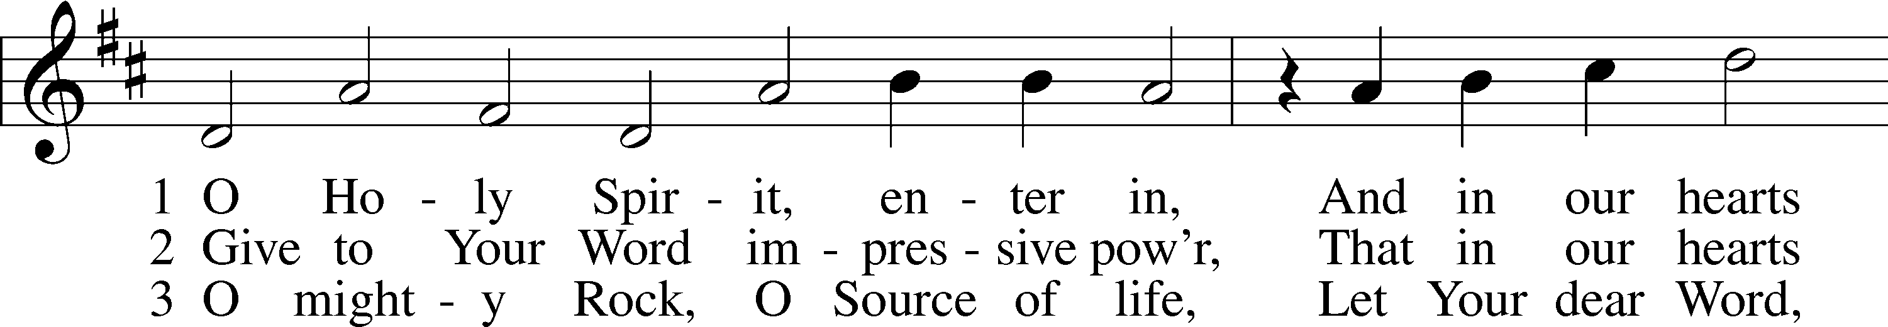
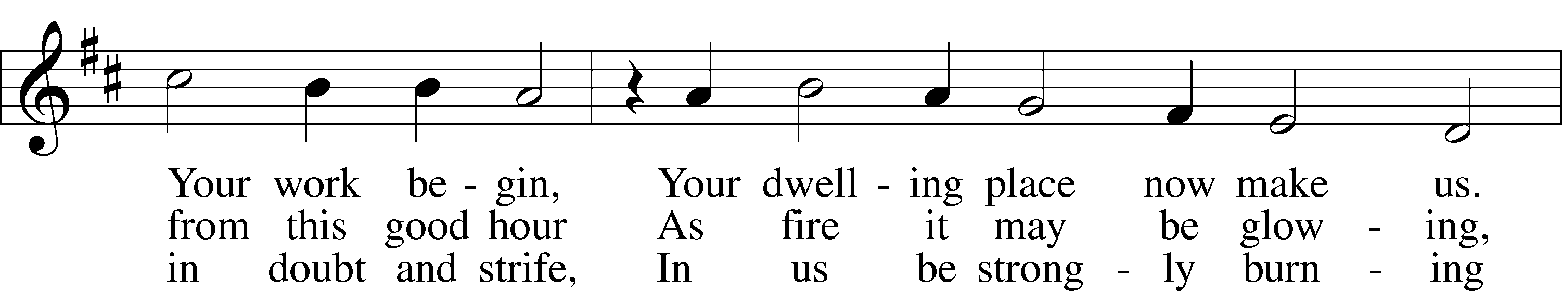
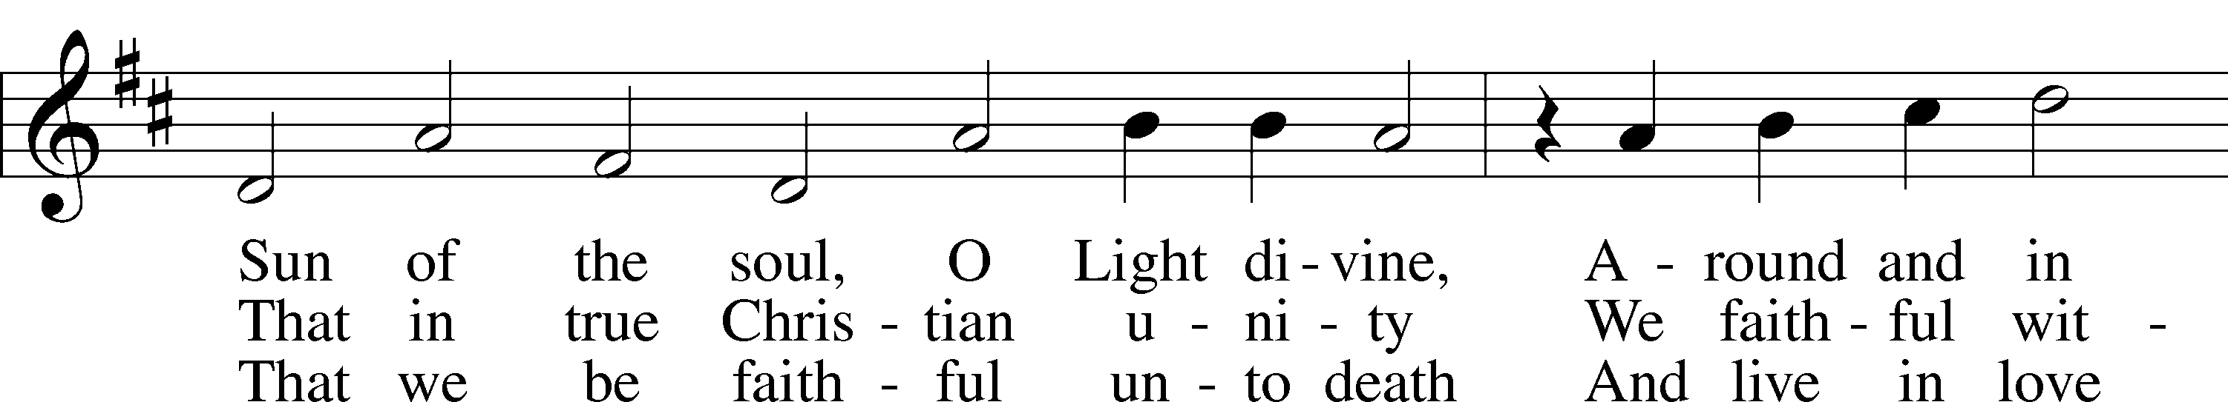
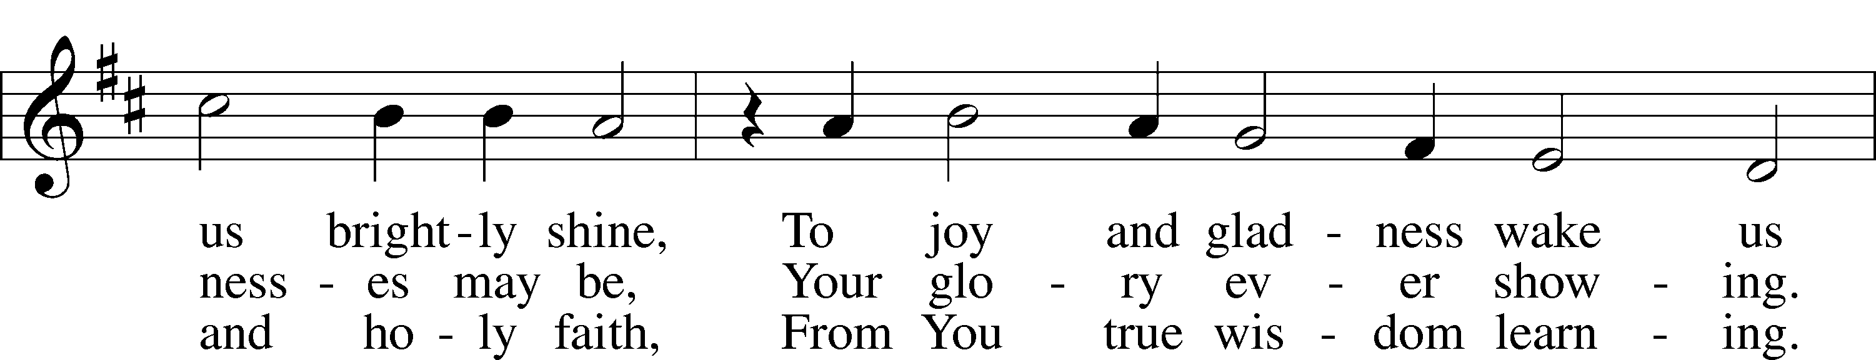
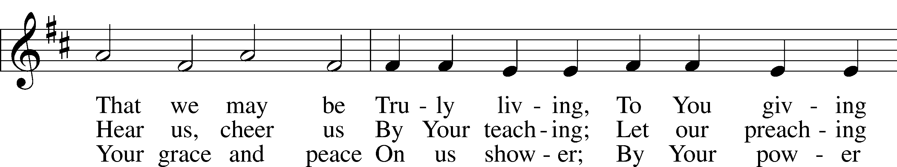
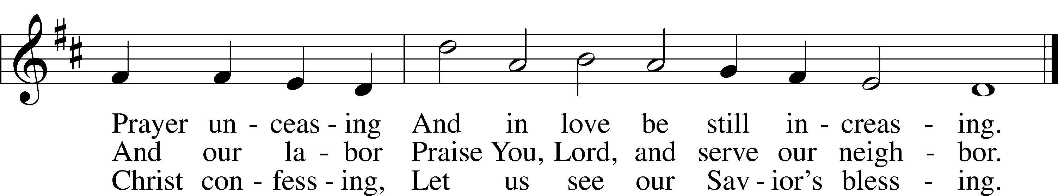
Tune and text: Public domain

The sign of the cross T may be made by all in remembrance of their Baptism.

Invocation
P In the name of the Father and of the T Son and of the Holy Spirit.
C Amen.

Exhortation LSB 167
P If we say we have no sin, we deceive ourselves, and the truth is not in us.
C But if we confess our sins, God, who is faithful and just, will forgive our sins and cleanse us from all unrighteousness.

Silence for reflection on God’s Word and for self-examination.

Confession of Sins LSB 167
P Let us then confess our sins to God our Father.
C Most merciful God, we confess that we are by nature sinful and unclean. We have sinned against You in thought, word, and deed, by what we have done and by what we have left undone. We have not loved You with our whole heart; we have not loved our neighbors as ourselves. We justly deserve Your present and eternal punishment. For the sake of Your Son, Jesus Christ, have mercy on us. Forgive us, renew us, and lead us, so that we may delight in Your will and walk in Your ways to the glory of Your holy name. Amen.

Absolution LSB 167
P Almighty God in His mercy has given His Son to die for you and for His sake forgives you all your sins. As a called and ordained servant of Christ, and by His authority, I therefore forgive you all your sins in the name of the Father and of the T Son and of the Holy Spirit.
C Amen.

+SERVICE OF THE WORD+

Introit Psalm 122:1, 6, 8–9; antiphon: Liturgical Text
Give peace, O Lord, to those who wait for you,*
and let your prophets be proven faithful.
Hear the prayer of your servants,*
according to the blessing of Aaron upon your people.
I was glad when they said to me,*
“Let us go to the house of the Lord!”
Pray for the peace of Jerusalem!*
May they be secure who love you!
For my brothers and companions’ sake*
I will say, “Peace be within you!”
For the sake of the house of the Lord our God,*
I will seek your good.
Glory be to the Father and to the Son*
and to the Holy Spirit;
as it was in the beginning,*
is now, and will be forever. Amen.
Give peace, O Lord, to those who wait for you,*
and let your prophets be proven faithful.
Hear the prayer of your servants,*
according to the blessing of Aaron upon your people.

Kyrie (spoken) LSB 168
A In peace let us pray to the Lord.
C Lord, have mercy.
A For the peace from above and for our salvation let us pray to the Lord.
C Lord, have mercy.
A For the peace of the whole world, for the well-being of the Church of God, and for the unity of all let us pray to the Lord.
C Lord, have mercy.
A For this holy house and for all who offer here their worship and praise let us pray to the Lord.
C Lord, have mercy.
A Help, save, comfort, and defend us, gracious Lord.
C Amen.

This Is the Feast LSB 171
Pastor sings the first line, the congregation joins in singing at “Worthy is Christ…”

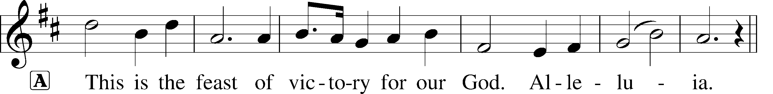
_---------------------------------------------------------------------------------------------
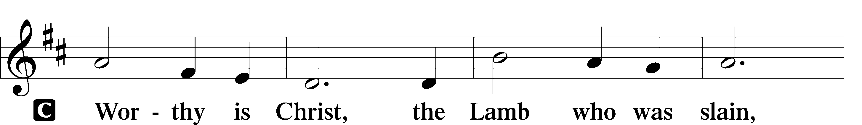
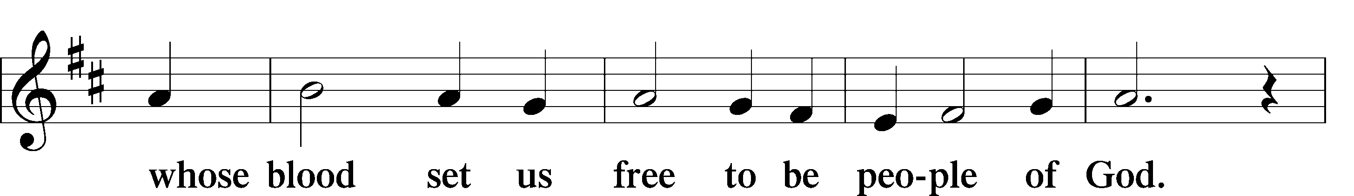
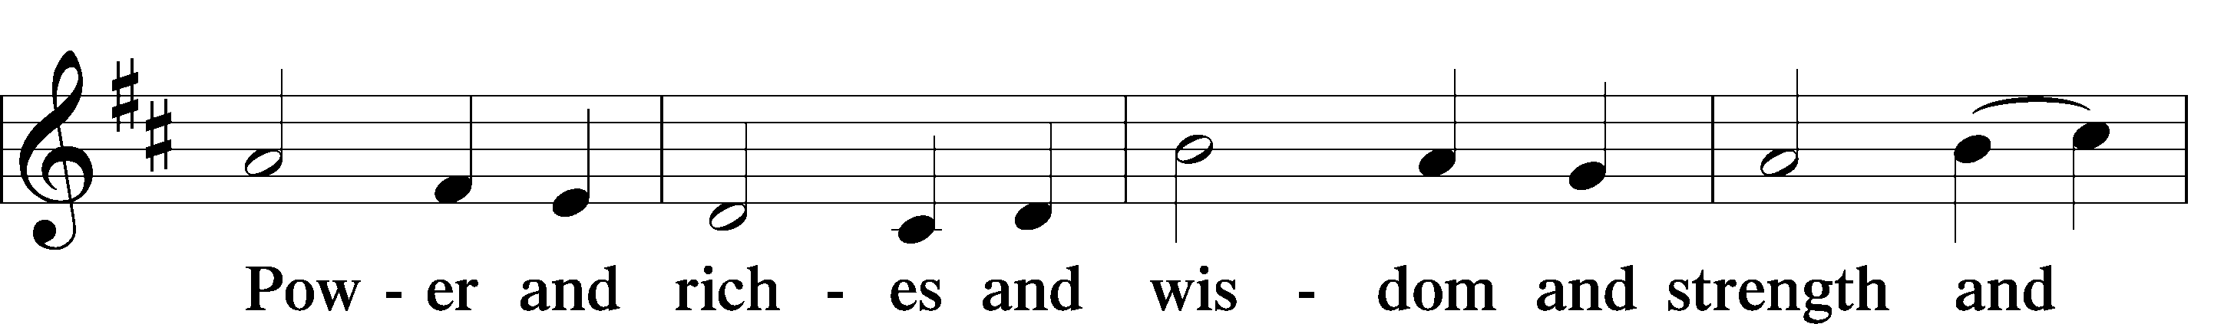
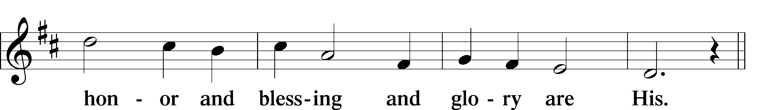
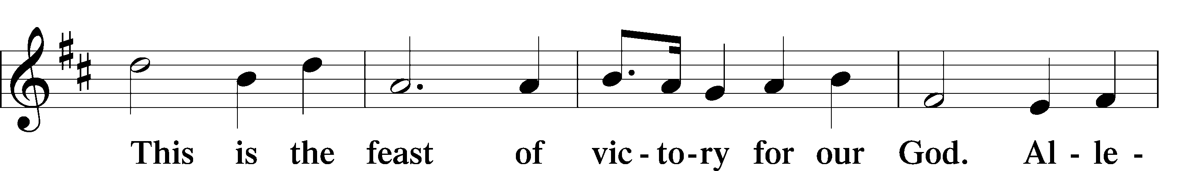
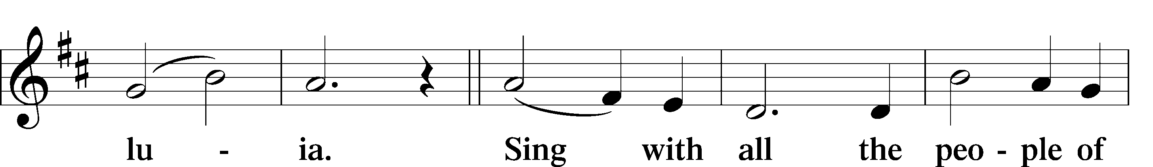
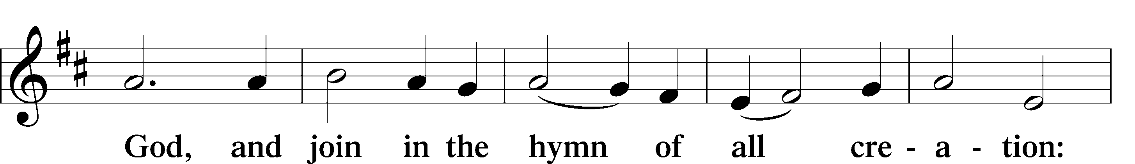
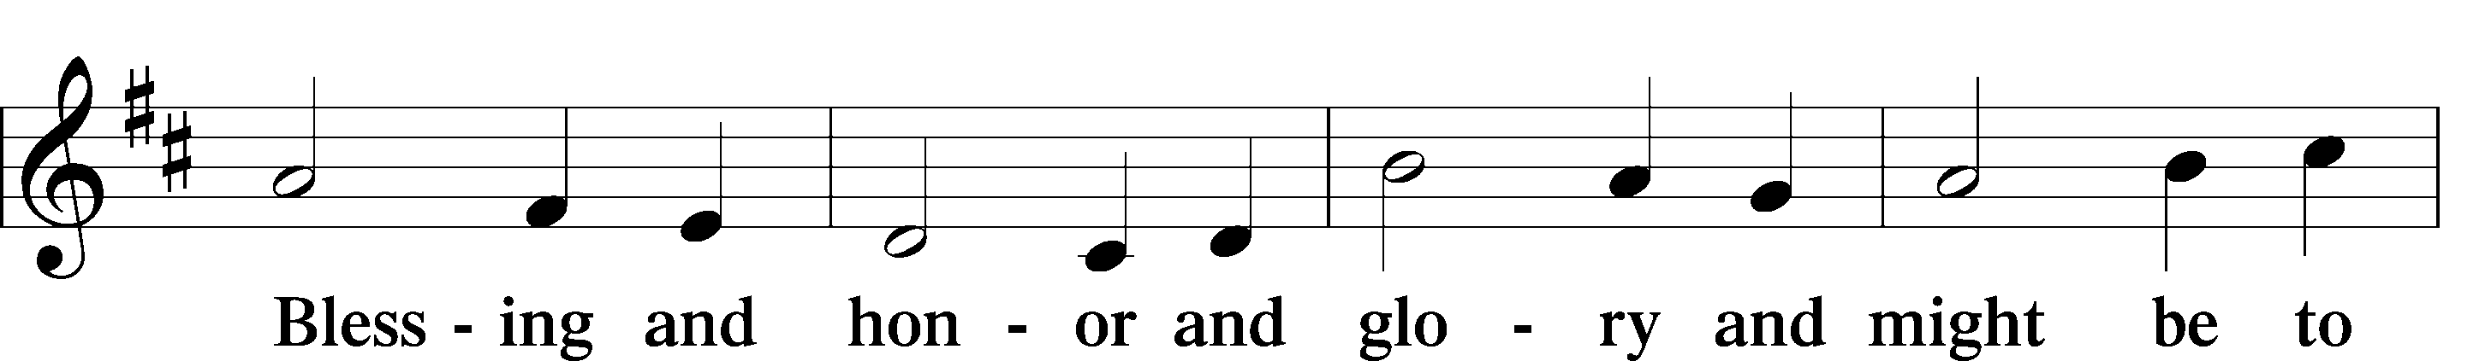
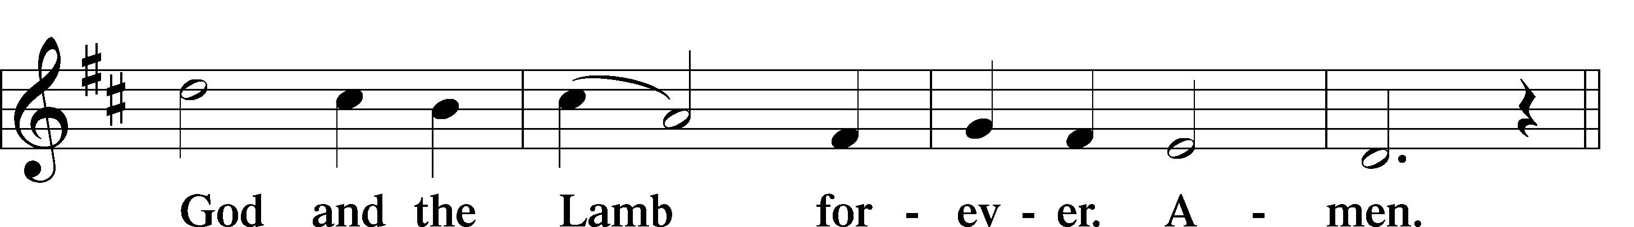
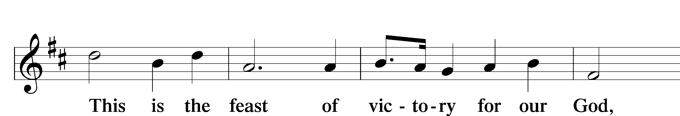
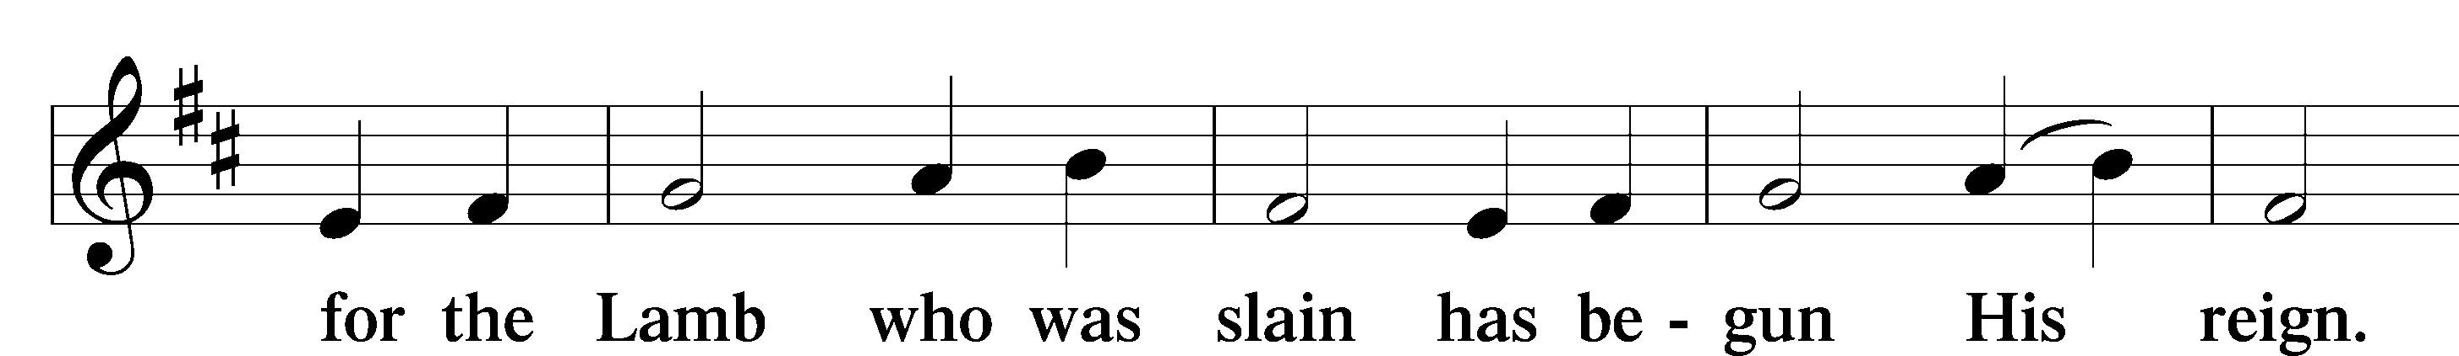
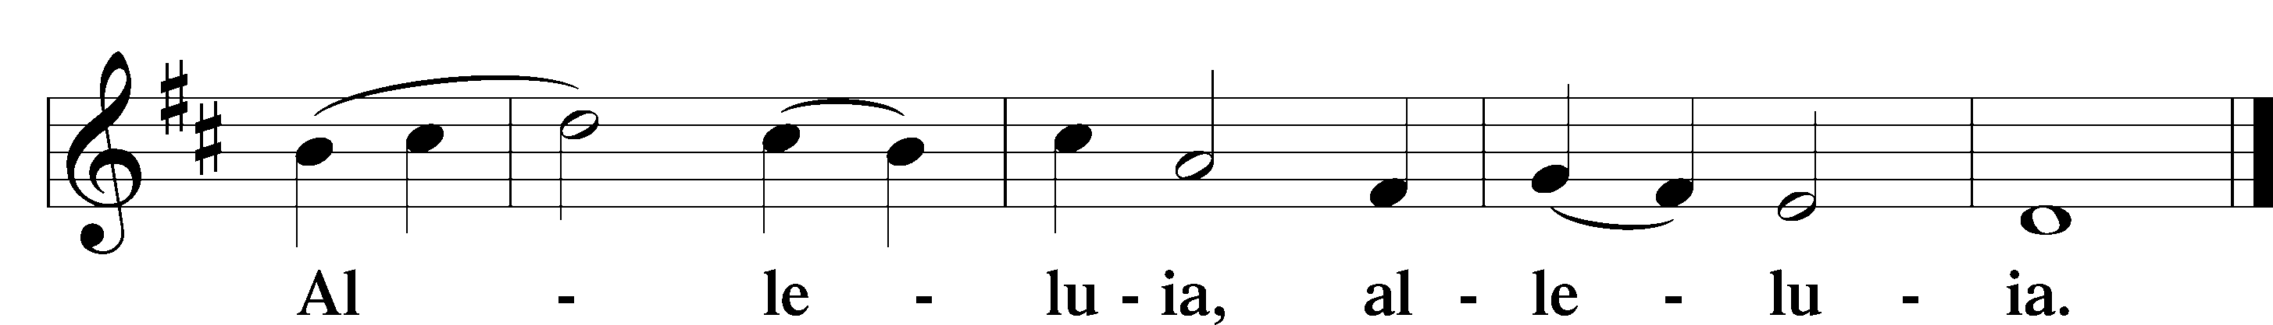

Salutation and Collect of the Day
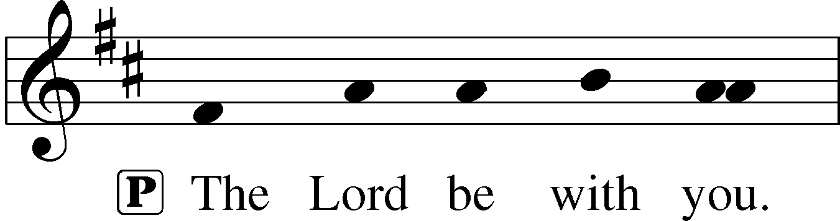
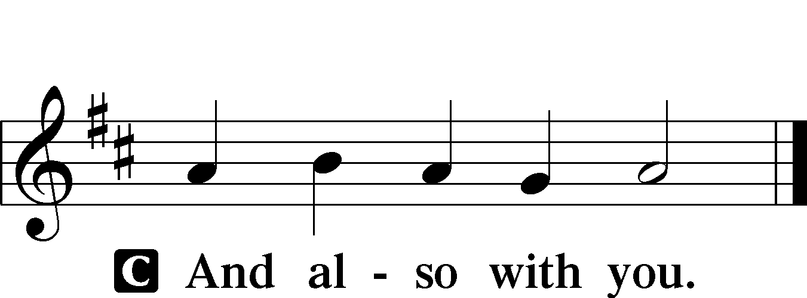

P Let us pray.
C O God, because without You we are not able to please You, mercifully grant that Your Holy Spirit may in all things direct and rule our hearts; through Jesus Christ, Your Son, our Lord, who lives and reigns with You and the Holy Spirit, one God, now and forever. Amen.

Sit

Old Testament Reading Deuteronomy 10:12–21
12“And now, Israel, what does the Lord your God require of you, but to fear the Lord your God, to walk in all his ways, to love him, to serve the Lord your God with all your heart and with all your soul, 13and to keep the commandments and statutes of the Lord, which I am commanding you today for your good? 14Behold, to the Lord your God belong heaven and the heaven of heavens, the earth with all that is in it. 15Yet the Lord set his heart in love on your fathers and chose their offspring after them, you above all peoples,
as you are this day. 16Circumcise therefore the foreskin of your heart, and be no longer stubborn. 17For the Lord your God is God of gods and Lord of lords, the great, the mighty, and the awesome God,
who is not partial and takes no bribe. 18He executes justice for the fatherless and the widow, and loves the sojourner, giving him food and clothing. 19Love the sojourner, therefore, for you were sojourners in the land of Egypt. 20You shall fear the Lord your God. You shall serve him and hold fast to him, and by his name you shall swear.
21He is your praise. He is your God, who has done for you these great and terrifying things that your eyes have seen.”

A This is the Word of the Lord.
C Thanks be to God.

Gradual Psalm 122:1, 7
I was glad when they said to me,*
“Let us go to the house of the Lord!”
Peace be within your walls*
and security within your towers!

Epistle 1 Corinthians 1:1–9
1Paul, called by the will of God to be an apostle of Christ Jesus, and our brother Sosthenes,
2To the church of God that is in Corinth, to those sanctified in Christ Jesus, called to be saints together with all those who in every place call upon the name of our Lord Jesus Christ, both their Lord and ours:
3Grace to you and peace from God our Father and the Lord Jesus Christ.
4I give thanks to my God always for you because of the grace of God that was given you in Christ Jesus, 5that in every way you were enriched in him in all speech and all knowledge—6even as the testimony about Christ was confirmed among you—7so that you are not lacking in any spiritual gift, as you wait for the revealing of our Lord Jesus Christ, 8who will sustain you to the end, guiltless in the day of our Lord Jesus Christ. 9God is faithful, by whom you were called into the fellowship of his Son, Jesus Christ our Lord.

A This is the Word of the Lord.
C Thanks be to God.

Stand

Alleluia and Verse LSB 173
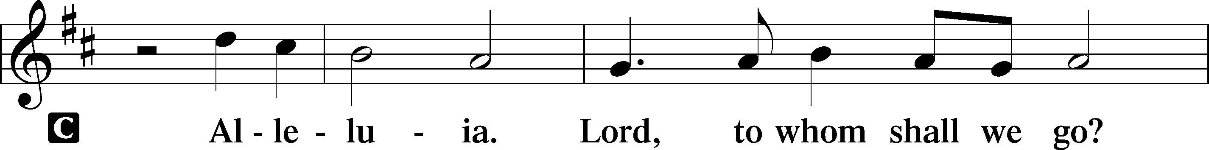
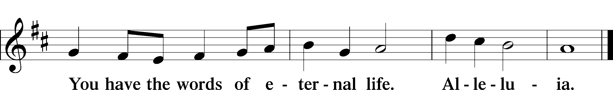

Holy Gospel Matthew 22:34–46
P The Holy Gospel according to St. Matthew, the twenty-second chapter.

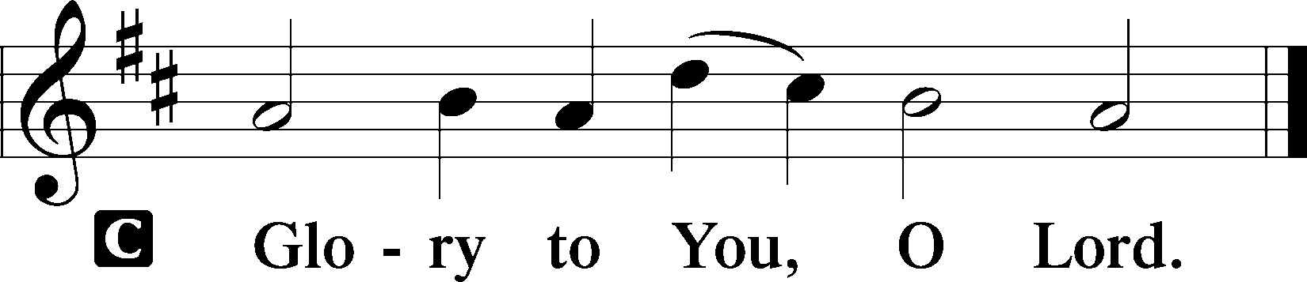

34When the Pharisees heard that [Jesus] had silenced the Sadducees, they gathered together. 35And one of them, a lawyer, asked him a question to test him. 36“Teacher, which is the great commandment in the Law?” 37And he said to him, “You shall love the Lord your God with all your heart and with all your soul and with all your mind. 38This is the great and first commandment. 39And a second is like it: You shall love your neighbor as yourself. 40On these two commandments depend all the Law and the Prophets.”
41Now while the Pharisees were gathered together, Jesus asked them a question, 42saying, “What do you think about the Christ? Whose son is he?” They said to him, “The son of David.” 43He said to them, “How is it then that David, in the Spirit, calls him Lord, saying,
44“‘The Lord said to my Lord,
Sit at my right hand,
until I put your enemies under your feet’?
45If then David calls him Lord, how is he his son?” 46And no one was able to answer him a word, nor from that day did anyone dare to ask him any more questions.

P This is the Gospel of the Lord.

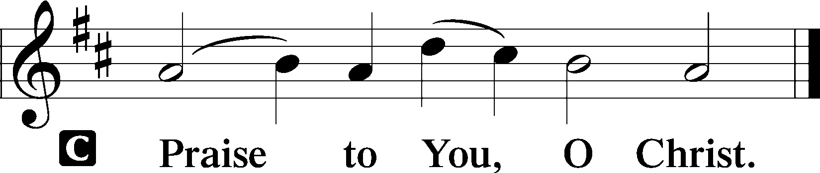

Nicene Creed
C I believe in one God,
the Father Almighty,
maker of heaven and earth
and of all things visible and invisible.

And in one Lord Jesus Christ,
the only-begotten Son of God,
begotten of His Father before all worlds,
God of God, Light of Light,
very God of very God,
begotten, not made,
being of one substance with the Father,
by whom all things were made;
who for us men and for our salvation came down from heaven
and was incarnate by the Holy Spirit of the virgin Mary
and was made man;
and was crucified also for us under Pontius Pilate.
He suffered and was buried.
And the third day He rose again according to the Scriptures
and ascended into heaven
and sits at the right hand of the Father.
And He will come again with glory to judge both the living and the dead,
whose kingdom will have no end.

And I believe in the Holy Spirit,
the Lord and giver of life,
who proceeds from the Father and the Son,
who with the Father and the Son together is worshiped and glorified,
who spoke by the prophets.
And I believe in one holy Christian and apostolic Church,
I acknowledge one Baptism for the remission of sins,
and I look for the resurrection of the dead
and the life T of the world to come. Amen.

Sit

Children’s Message

Hymn of the Day “The Only Son from Heaven” LSB 402
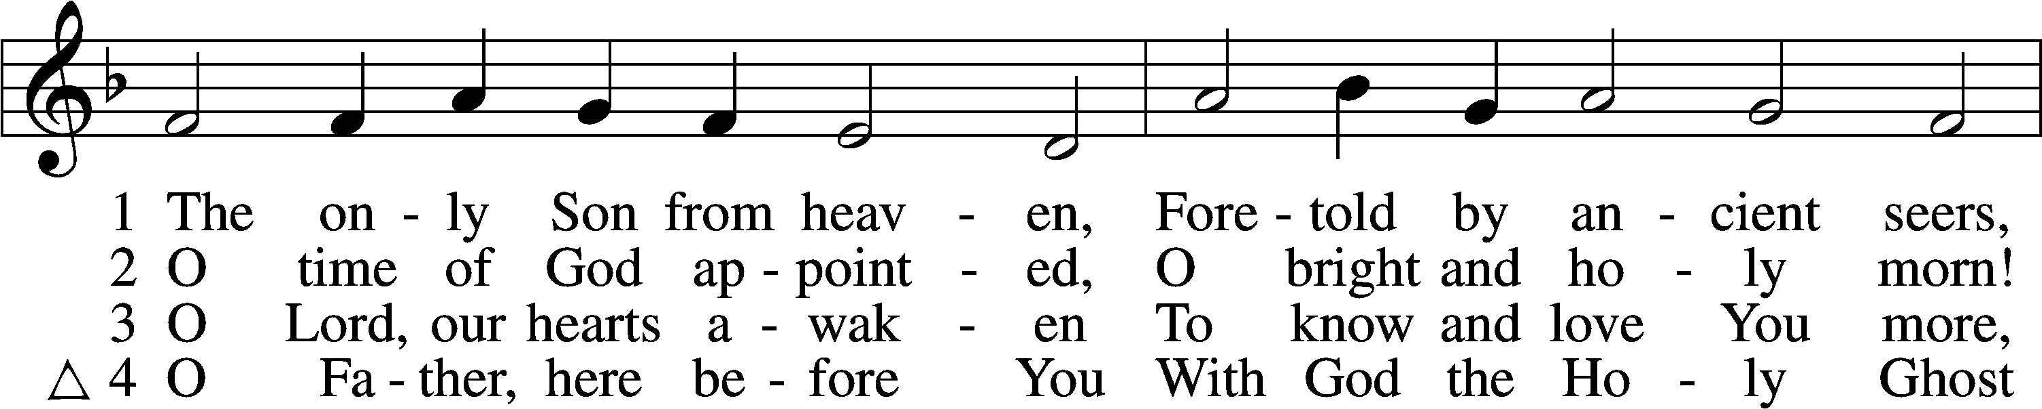
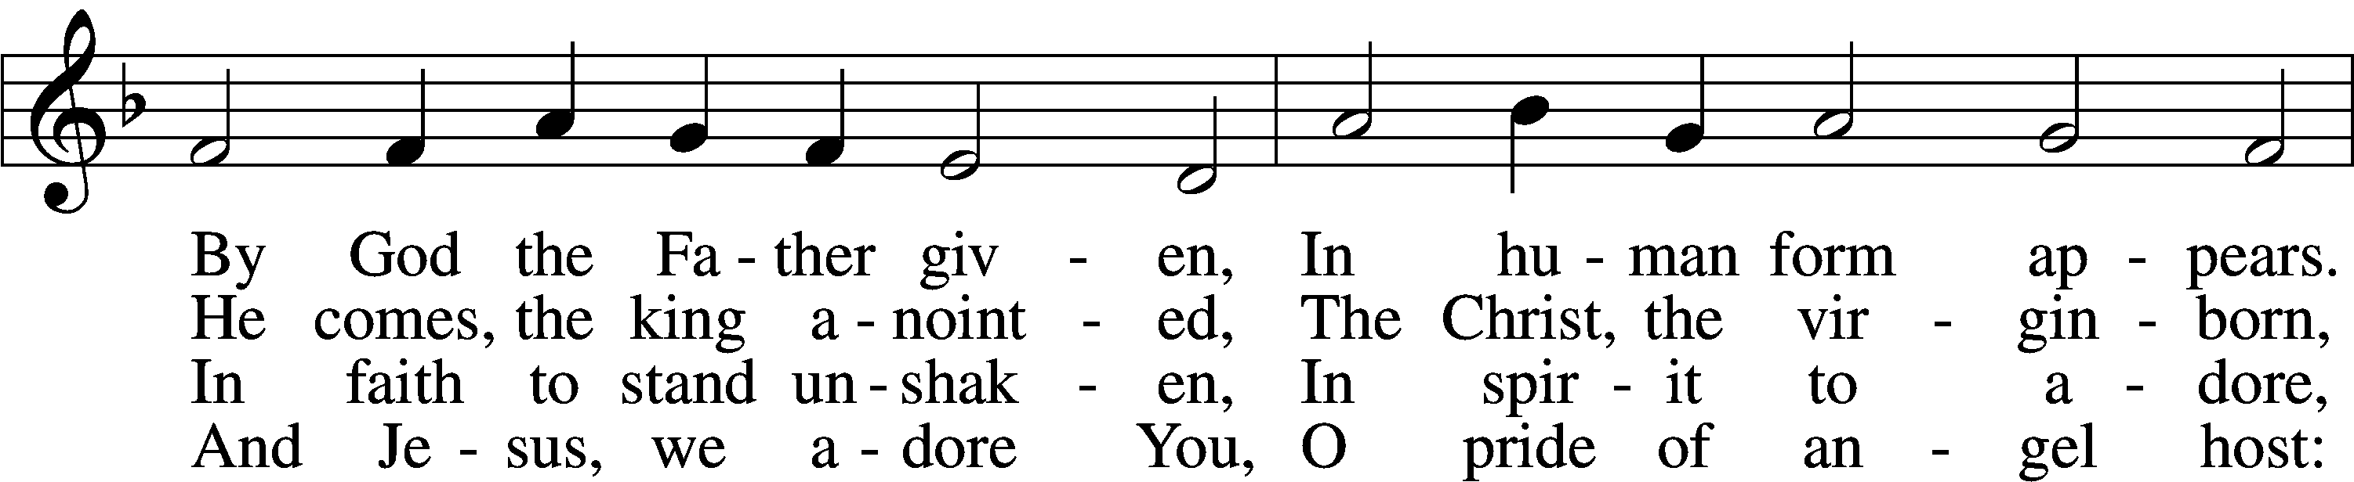
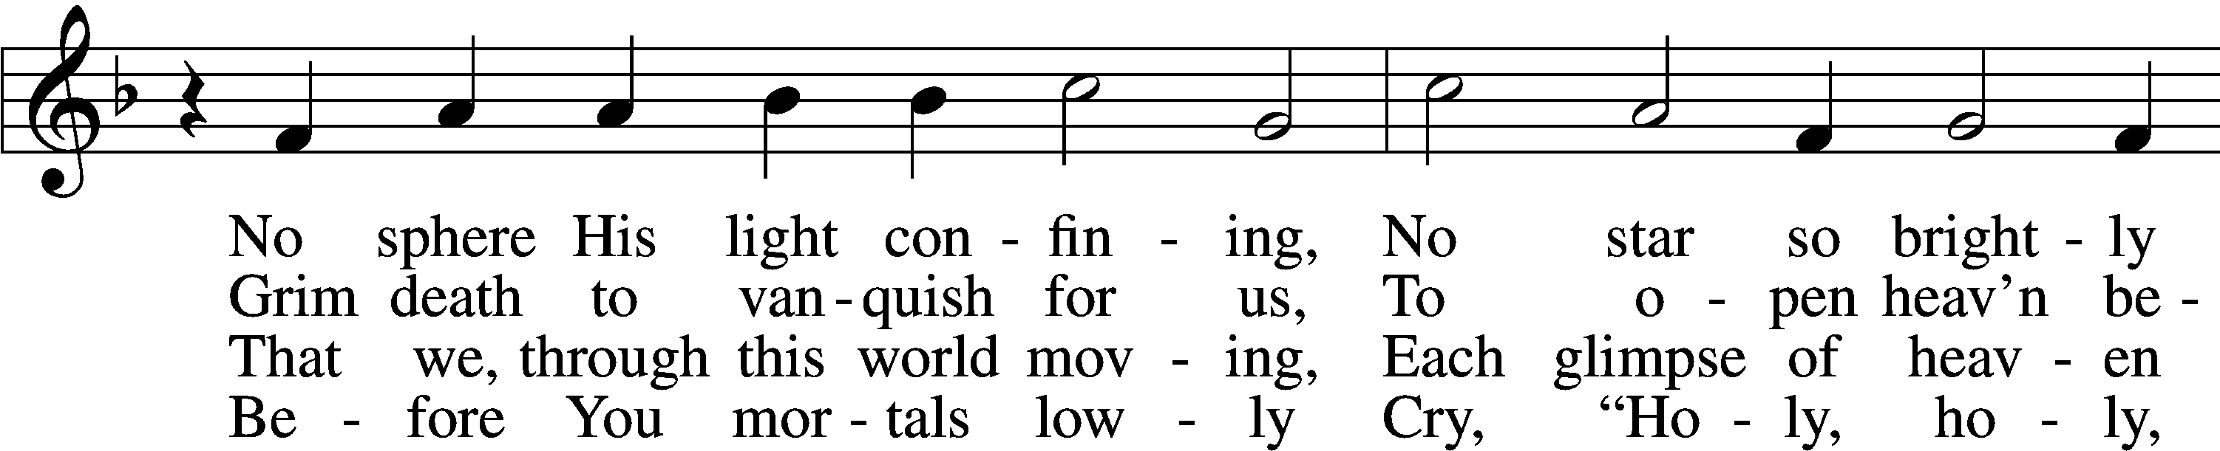
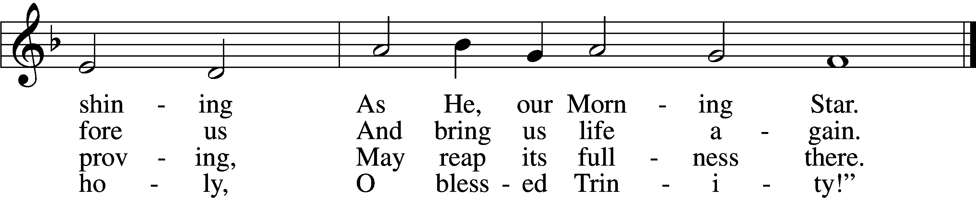
Tune and text: Public domain

Sermon

Offering

Stand

Offertory (spoken) LSB 176
C What shall I render to the Lord for all His benefits to me?
I will offer the sacrifice of thanksgiving and will call on the name of the Lord.
I will take the cup of salvation and will call on the name of the Lord.
I will pay my vows to the Lord now in the presence of all His people,
in the courts of the Lord’s house, in the midst of you, O Jerusalem.

Prayer of the Church

+SERVICE OF THE SACRAMENT+

Preface LSB 177
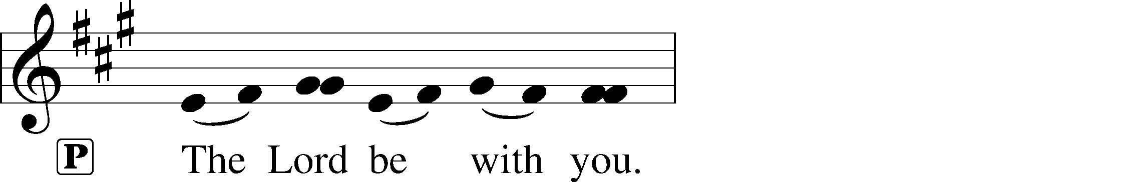
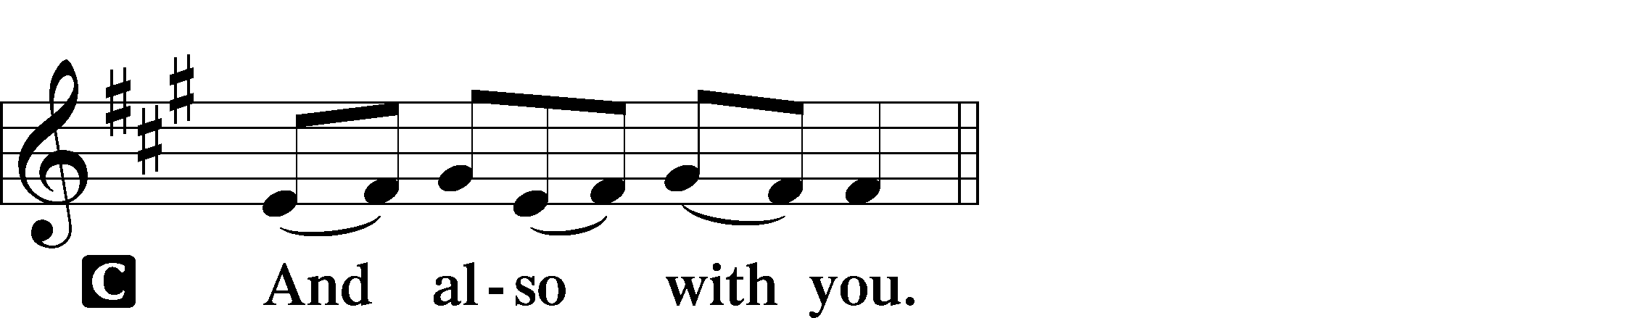

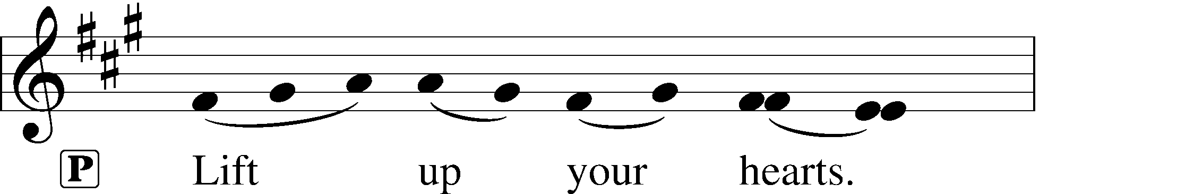
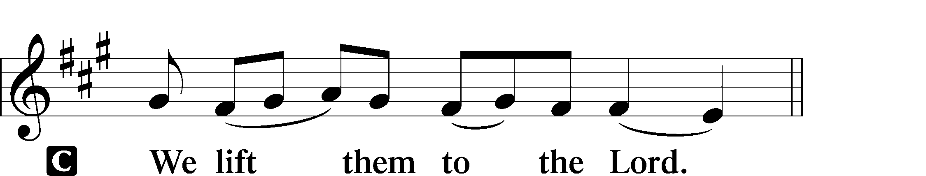

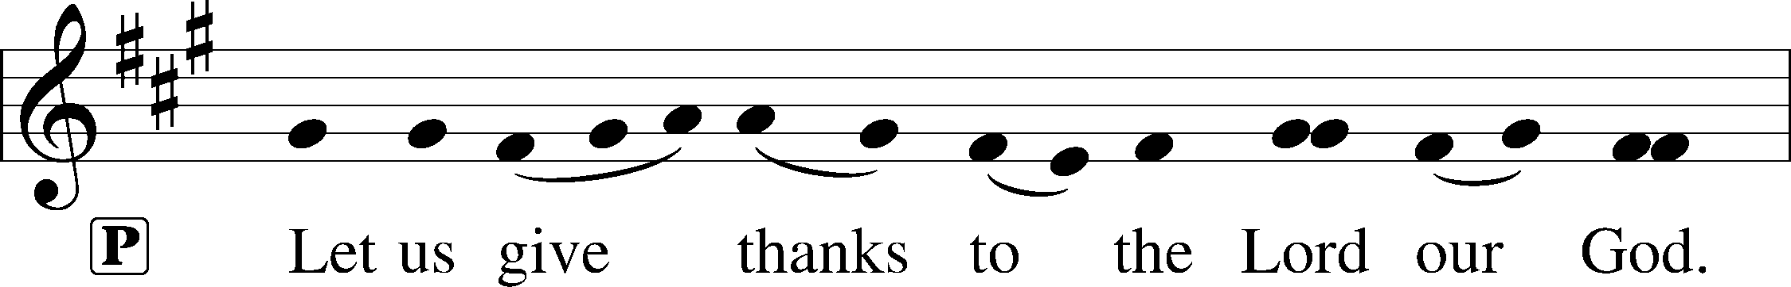
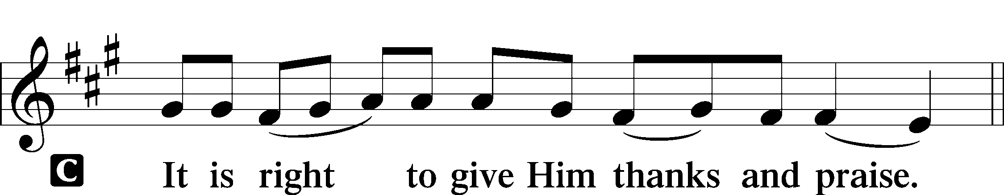

Proper Preface
P It is truly good, right, and salutary that we should at all times and in all places give thanks to You, holy Lord, almighty Father, everlasting God, through Jesus Christ, our Lord. Therefore with angels and archangels and with all the company of heaven we laud and magnify Your glorious name, evermore praising You and saying:

Sanctus LSB 178
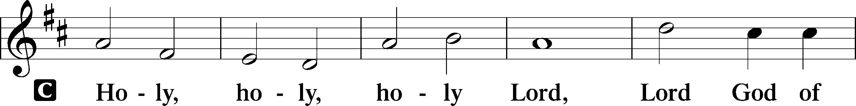
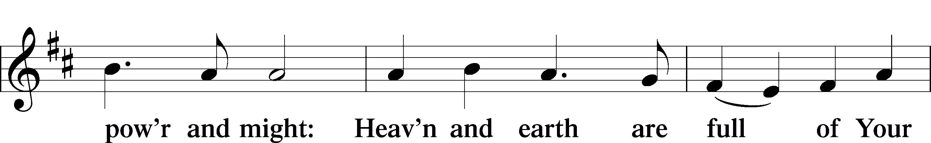
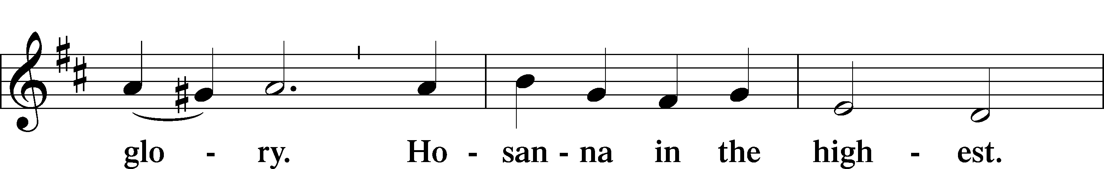
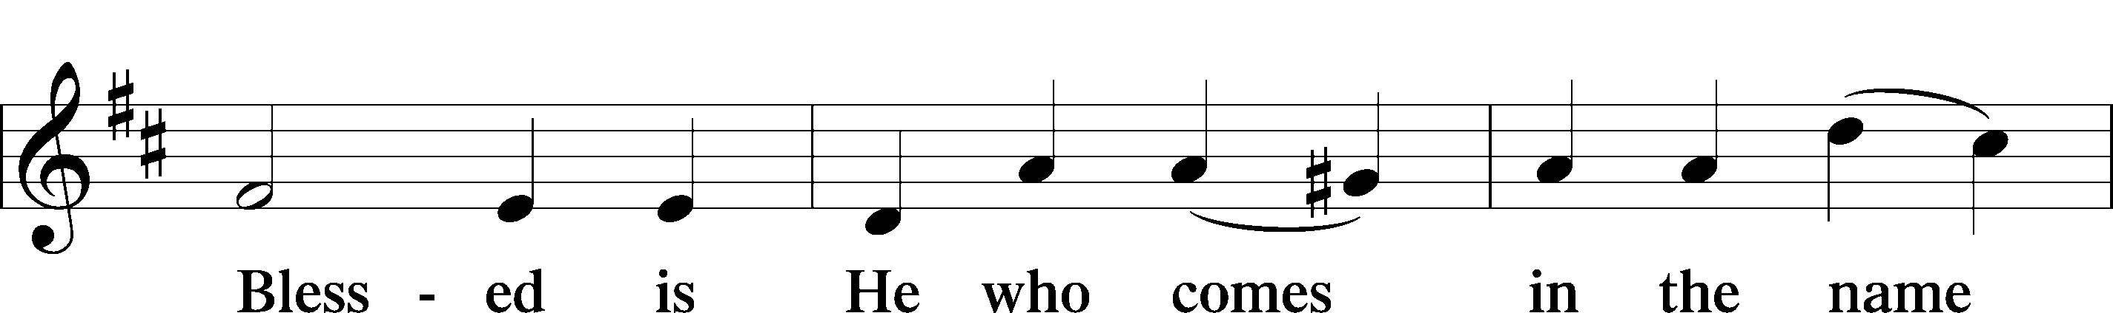
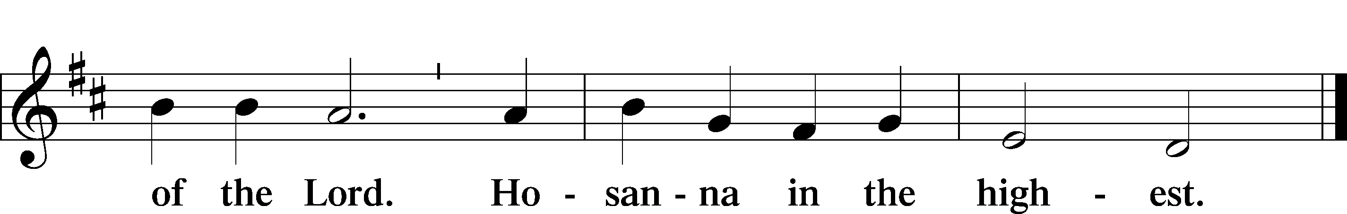

Lord’s Prayer
C Our Father who art in heaven,
hallowed be Thy name,
Thy kingdom come,
Thy will be done on earth
as it is in heaven;
give us this day our daily bread;
and forgive us our trespasses
as we forgive those
who trespass against us;
and lead us not into temptation,
but deliver us from evil.
For Thine is the kingdom
and the power and the glory
forever and ever. Amen.

The Words of Our Lord
P Our Lord Jesus Christ, on the night when He was betrayed, took bread, and when He had given thanks, He broke it and gave it to the disciples and said: “Take, eat; this is My T body, which is given for you. This do in remembrance of Me.”

In the same way also He took the cup after supper, and when He had given thanks, He gave it to them, saying: “Drink of it, all of you; this cup is the new testament in My T blood, which is shed for you for the forgiveness of sins. This do, as often as you drink it, in remembrance of Me.”

Pax Domini LSB 180
P The peace of the Lord be with you always.
C Amen.

Agnus Dei LSB 180
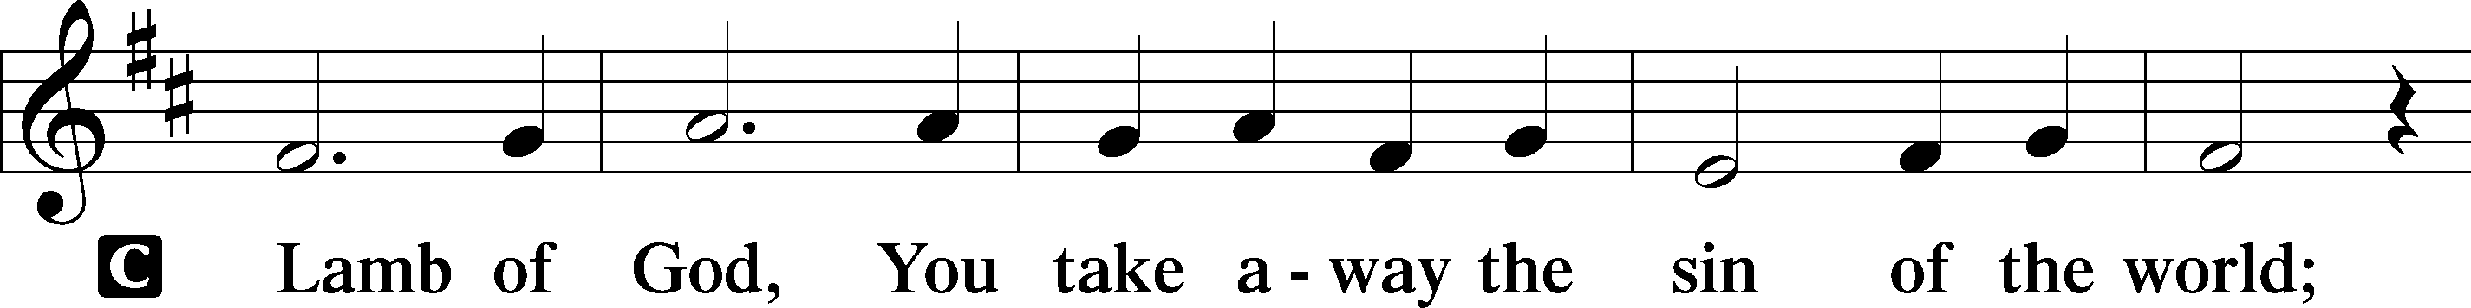
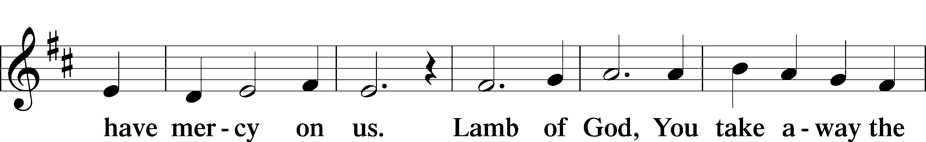
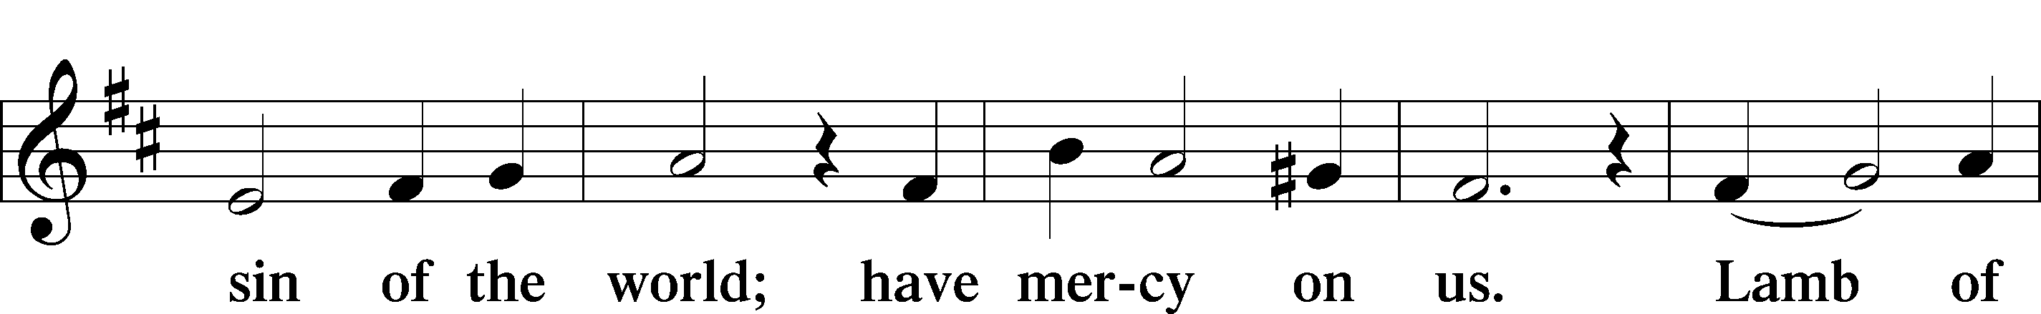
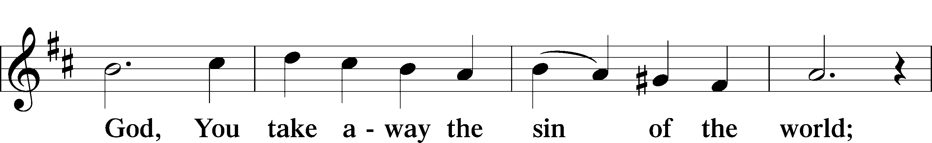
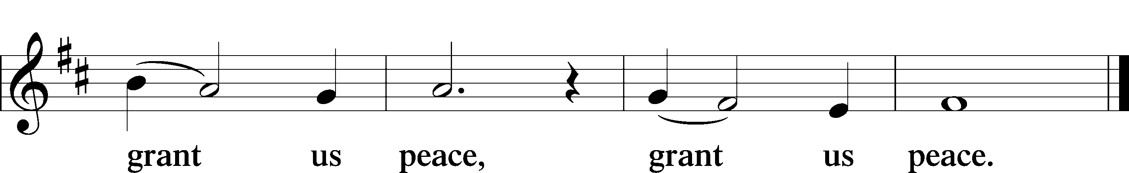

Sit
Distribution
Distribution Hymn “Beautiful Savior” LSB 537
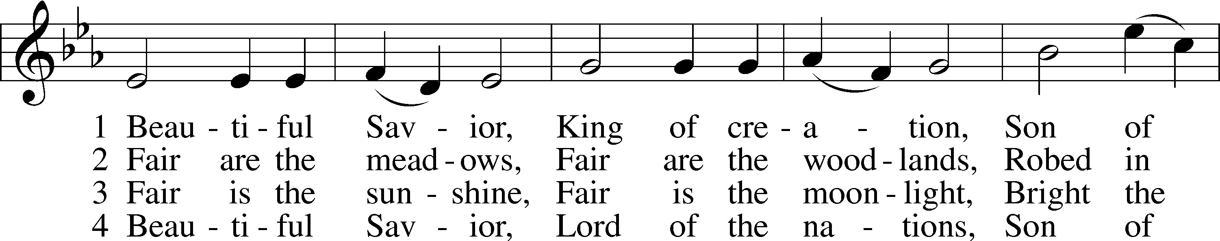
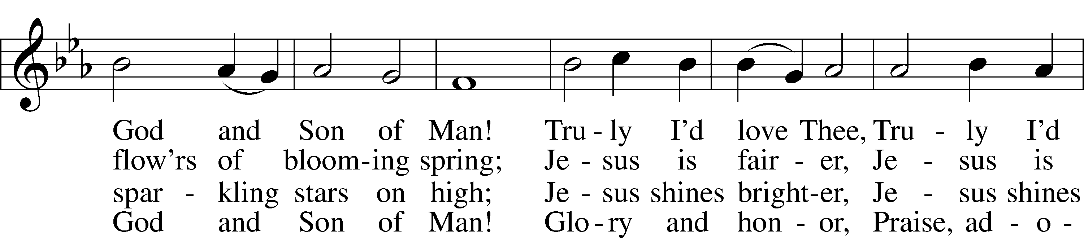
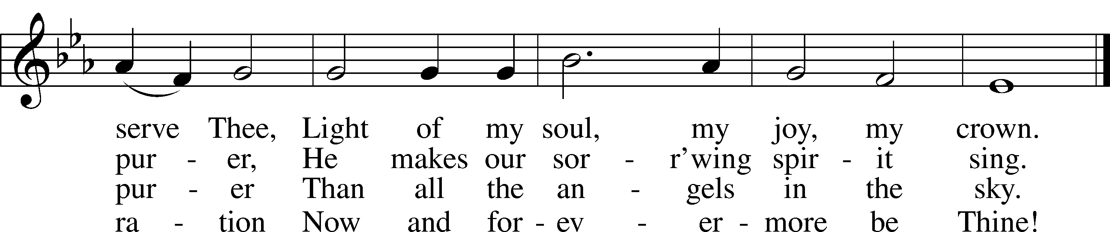
Tune and text: Public domain

Distribution Hymn “Alleluia! Let Praises Ring” LSB 822
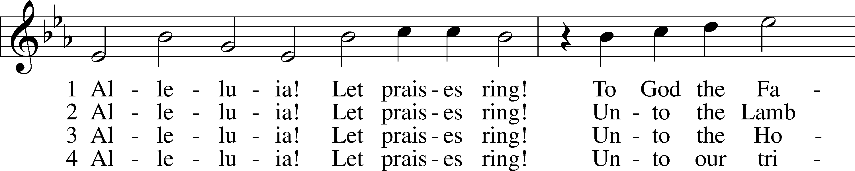
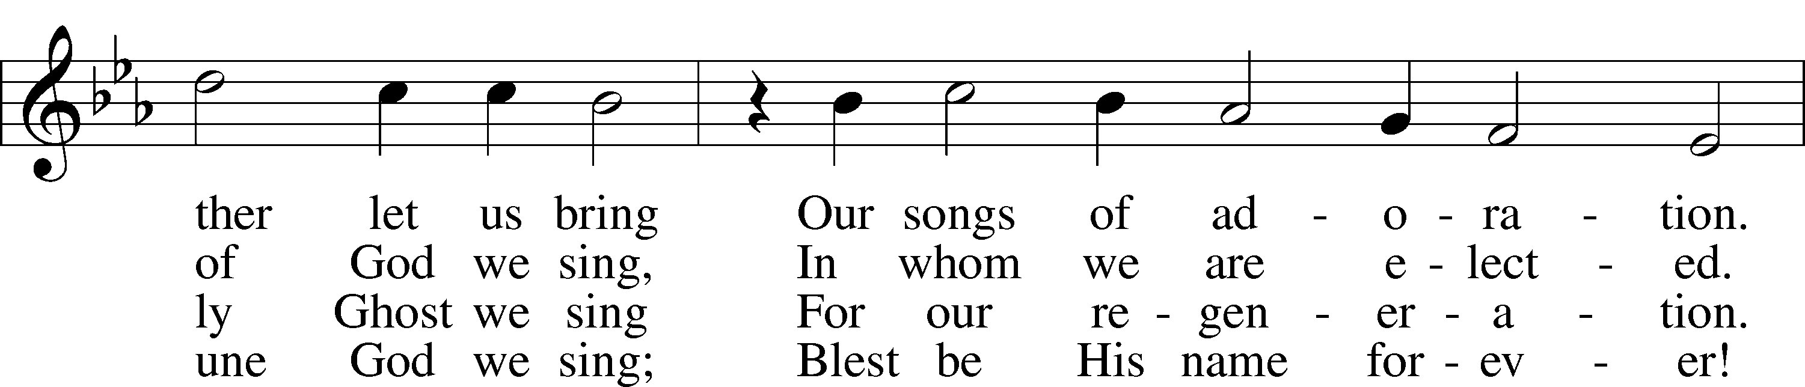
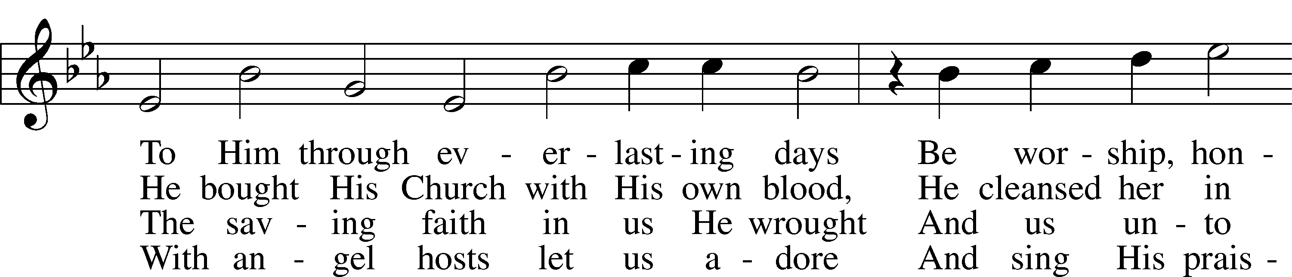
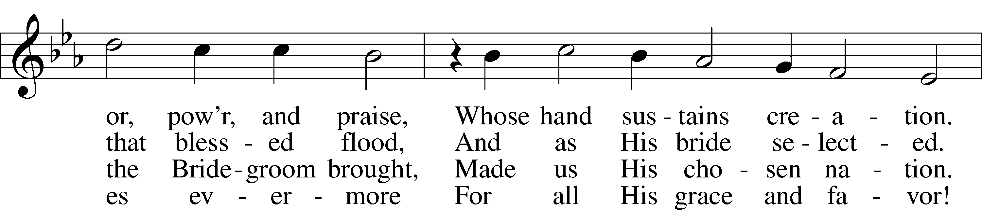
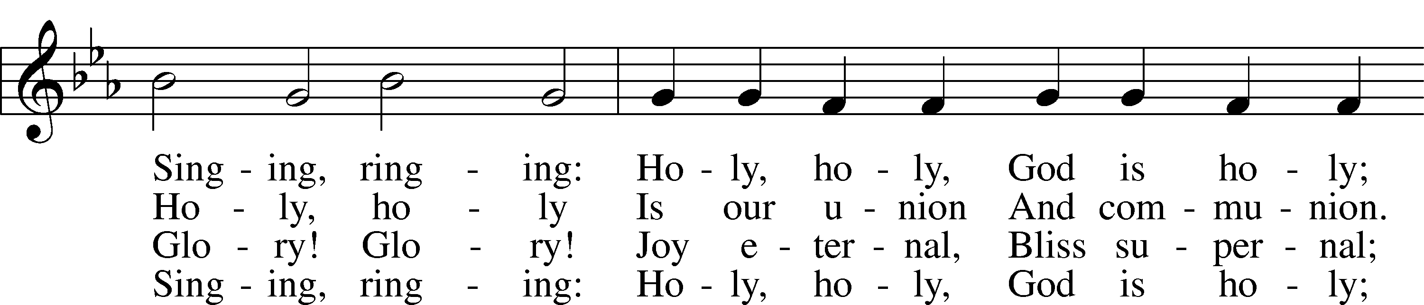
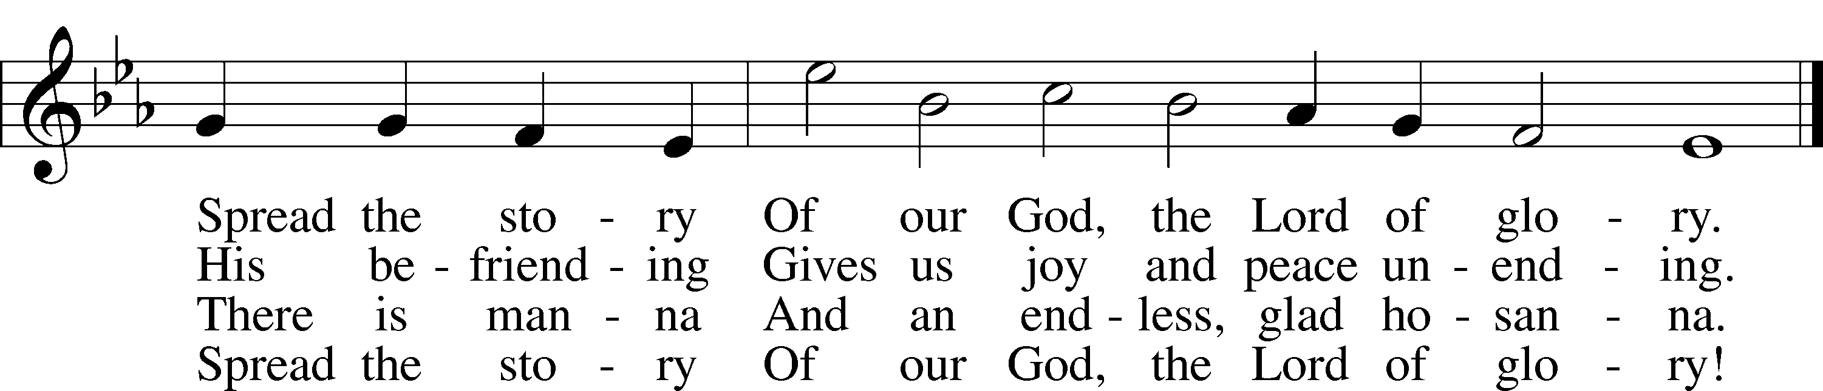
Tune and text: Public domain

Distribution Hymn “Father Most Holy” LSB 504
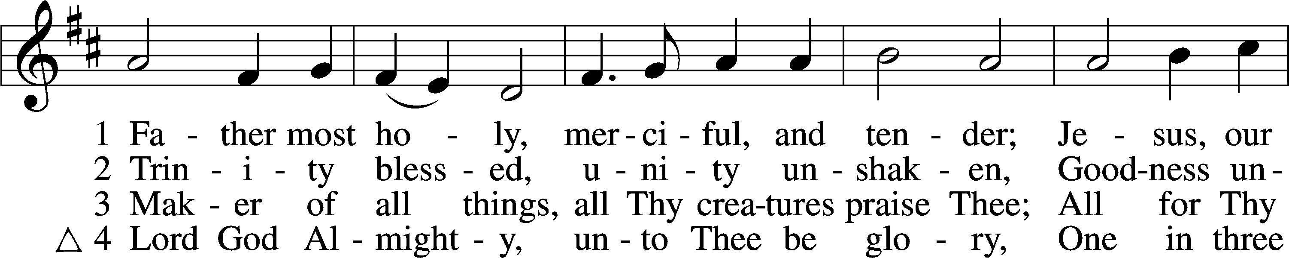
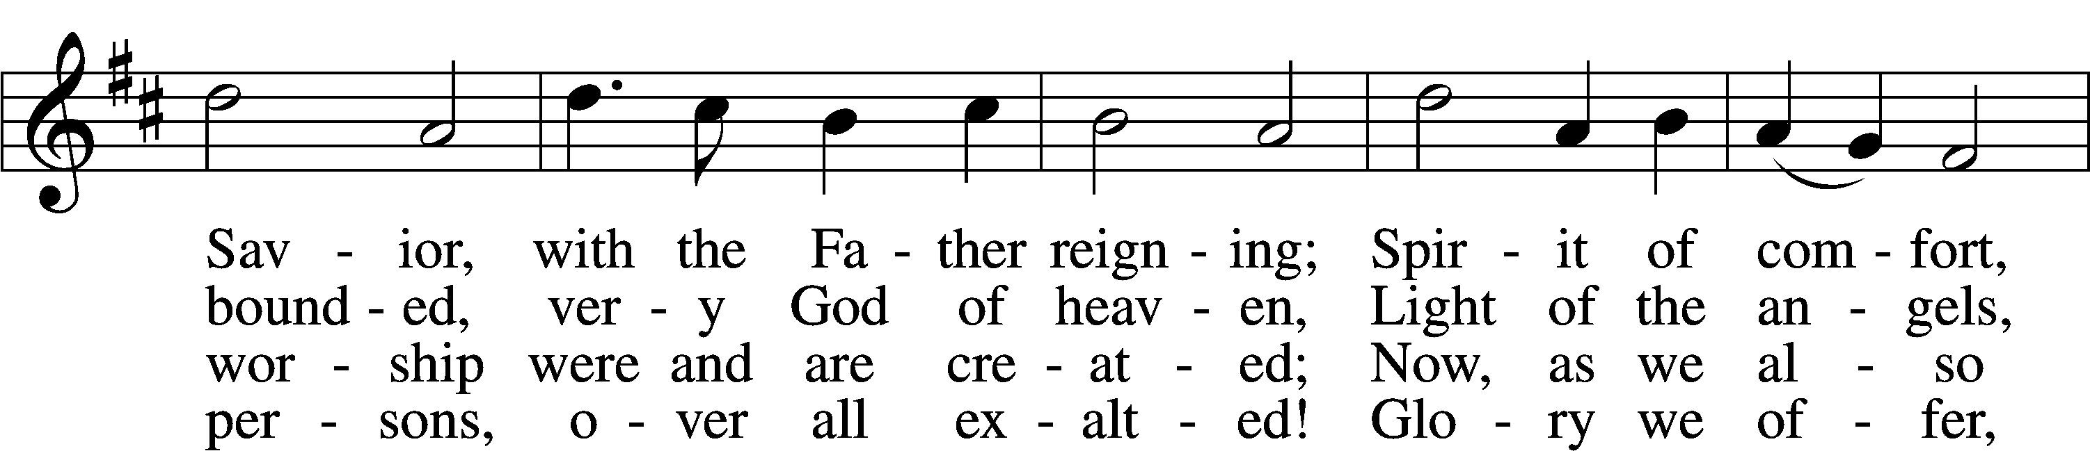
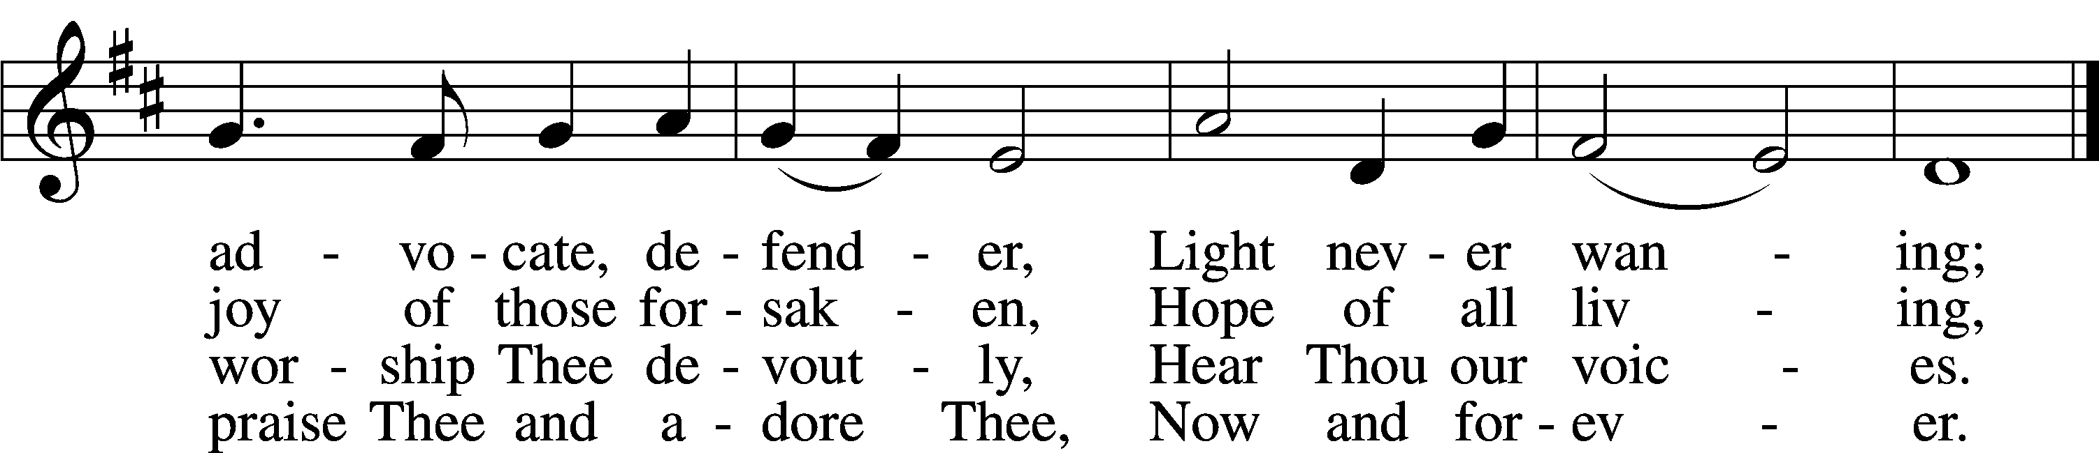
Tune and text: Public domain

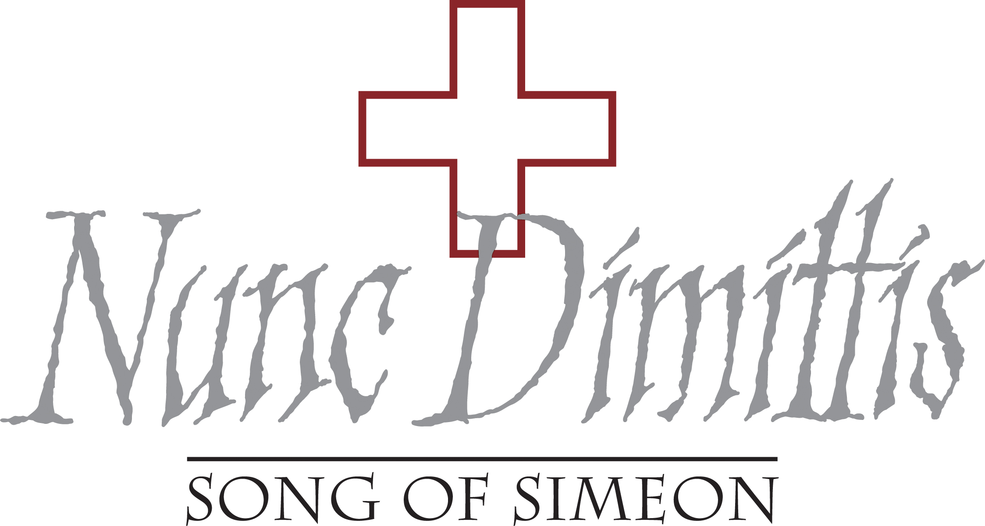

Stand

Nunc Dimittis LSB 182
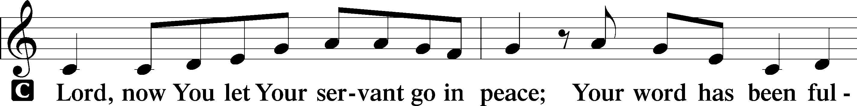
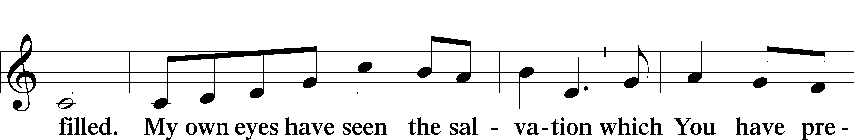
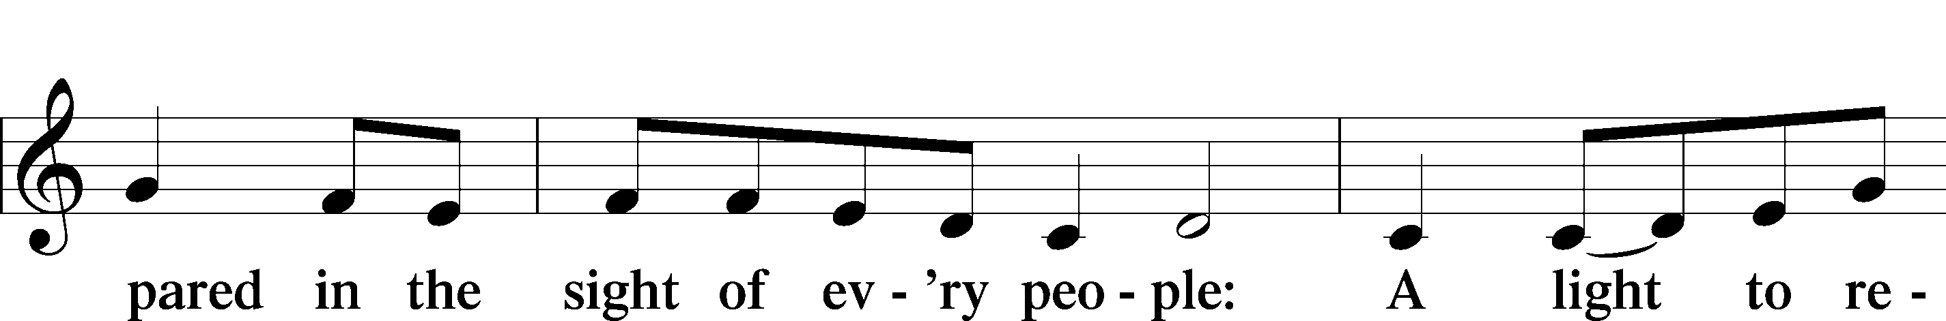
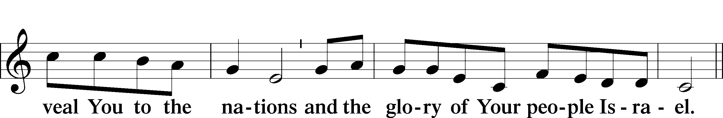
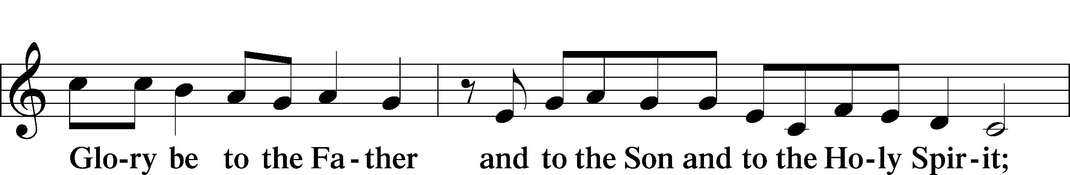
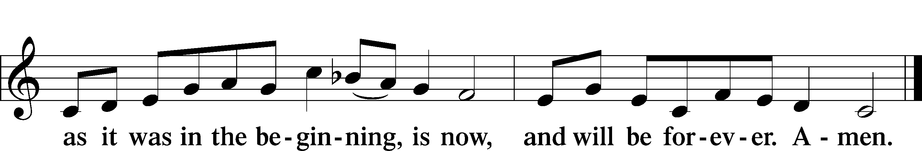

Post-Communion Collect
A Let us pray.
We give thanks to You, almighty God, that You have refreshed us through this salutary gift, and we implore You that of Your mercy You would strengthen us through the same in faith toward You and in fervent love toward one another; through Jesus Christ, Your Son, our Lord, who lives and reigns with You and the Holy Spirit, one God, now and forever.
C Amen.

Benediction LSB 183
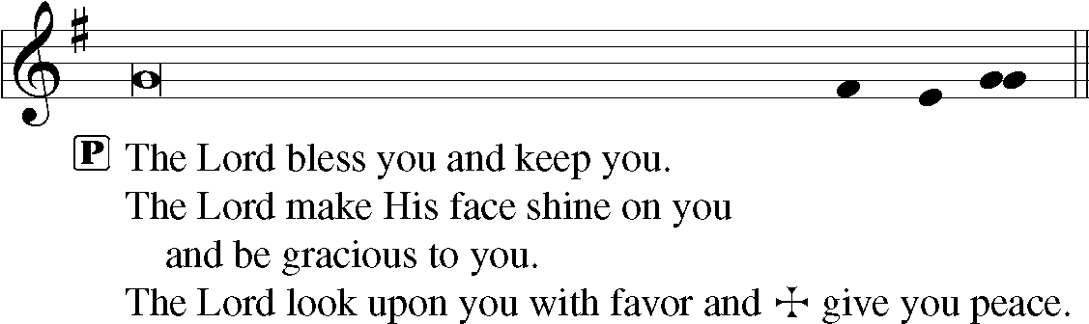

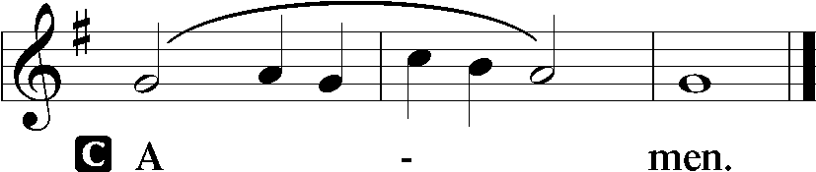

Closing Hymn “The Lord, My God, Be Praised” LSB 794
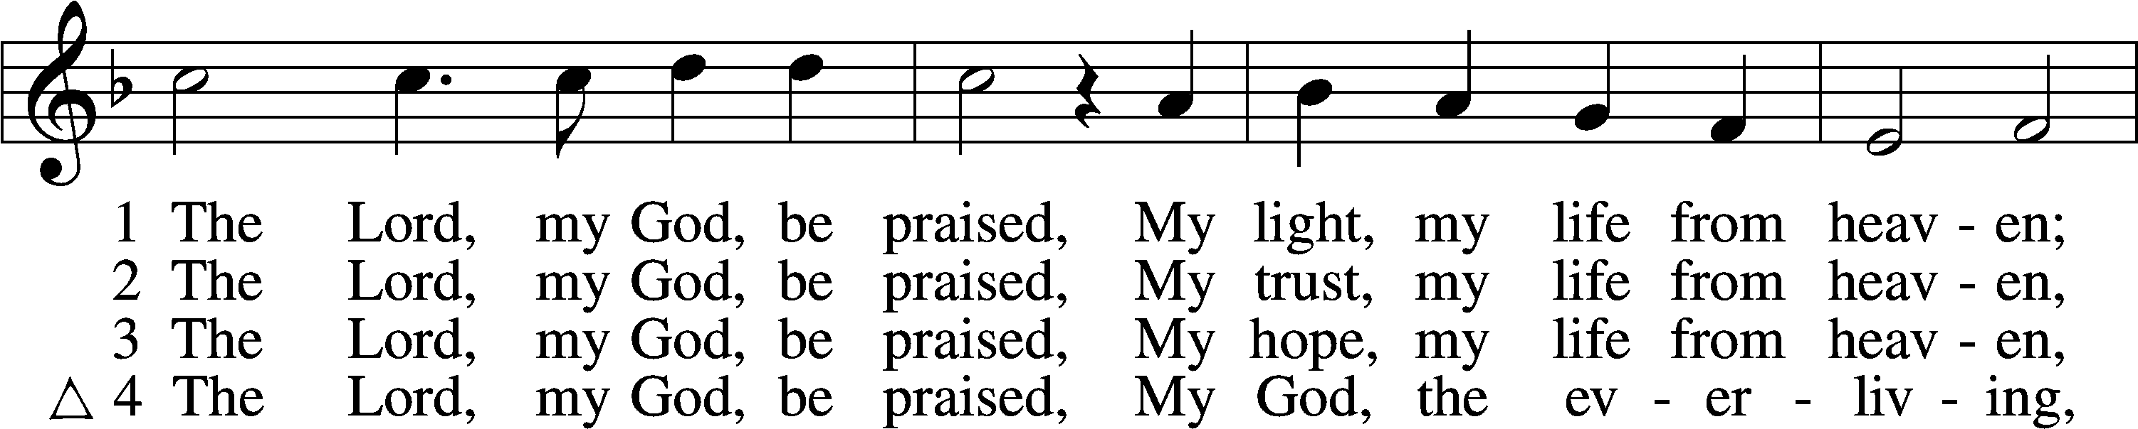
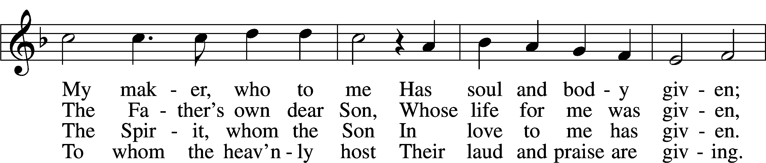
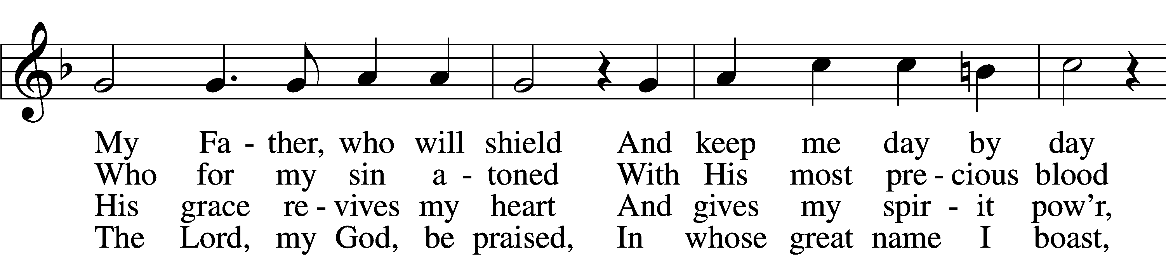
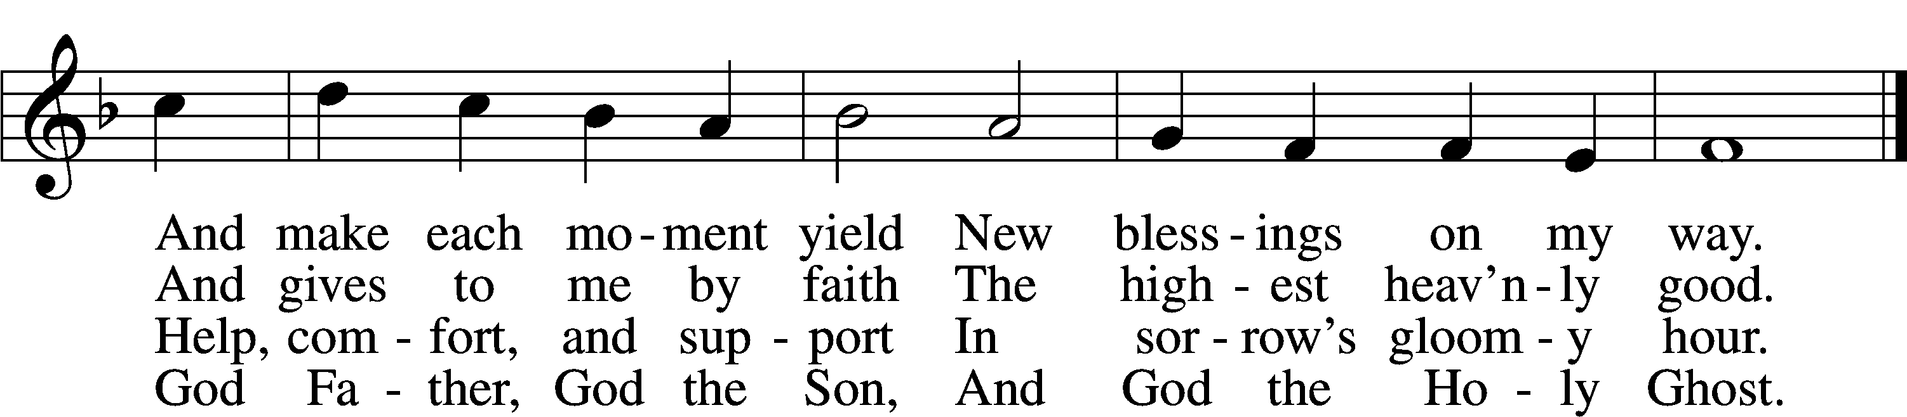
Text and tune: Public domain

Acknowledgments
Unless otherwise indicated, Scripture quotations are from the ESV® Bible (The Holy Bible, English Standard Version®), copyright © 2001 by Crossway, a publishing ministry of Good News Publishers. Used by permission. All rights reserved.
Created by Lutheran Service Builder © 2021 Concordia Publishing House.

Serving Our Lord in His House Today:
Pastor: Rev. David Wurdeman
Organist: Linda Ecker
Elders: Jake Mallmann & Josh Church
Joe Engel (Wednesday)
Greeter: Tracy Theurich-York

Gifts from God: 1 Corinthians 1:4 – “I give thanks to my God always for you because of the grace of God that was given you in Christ Jesus.” The grace of God and our thanksgiving go together. When God gives to us, thankfulness wells up inside of us. How could it not? And as Paul shows us here, it’s not only the grace given to us that causes us to give thanks but even the grace given to others. We certainly have much to be thankful for when we look at the gifts of grace all around us.

Quarterly Voter’s Meeting/Rally Day (rescheduled): Please join us today for the Quarterly Voter’s Meeting which will take place at 11:30 a.m. (following Bible Study and Sunday School). We will also use this time as our rescheduled Rally Day. We will have a potluck lunch following the Voter’s Meeting. Please bring a dish to pass and join us for fellowship.

Family Promise Training: Training session will be provided on Sunday, October 10th at 1 pm. All volunteers should attend, but anyone interested in the program is invited to attend.

Pastor on Vacation: Please note, Pastor Wurdeman will be on vacation October 6, 2021-October 12, 2021. If you need pastoral care during this timeframe, please contact the church office or your elder for assistance.

Weekly Psalms Devotional Group: Our Thursday morning Bible study will be cancelled for this week; Thursday, October 7, 2021. We will resume Thursday, October 14, 2021. Please join us Thursday mornings at 10:00 a.m., as we read and pray through selected Psalms. We’ll learn about their meaning, application and ways to incorporate them into your prayer life.
Livestream: Our Sunday Service is livestreamed weekly on our YouTube channel “Good Shepherd Lutheran Church Tomah.”

PO Box: For mailed offerings, please use the following:
Good Shepherd Lutheran Church
P.O. Box 551
Tomah, WI 54660

Our Worship attendance last week: Sunday: 43
Wednesday: 7
Total: 50

Scripture Lessons for next week: Genesis 28:10-17
Ephesians 4:22-28
Matthew 9:1-8

Secretary Office Hours: Monday-Friday: 8am-12pm

Pastor Office Hours: Pastor’s regular hours are Sunday-Thursday, 9am-5pm.
He is typically in the office in the mornings. In the afternoon, he is typically in the office, making pastoral visits, at meetings, or providing pastoral care in the
community. If you would like to visit with pastor, please call the church office at 608-374-2444 or his cell phone at 317-410-2271 to arrange a time.

Our Week With Our Lord:
Today 9:00am Divine Service w/Holy Communion
(livestreamed via YouTube)
10:30am Adult Bible Study & Sunday School
11:30am Quarterly Voter’s Meeting, Potluck
luncheon to following the meeting
Monday 10:00am Staff Meeting
Tuesday
Wednesday 5:00pm Service of Prayer and Preaching
6:30pm Confirmation Class
7:00pm Women’s Bible Study – “Chosen”
Thursday
Friday 12:00pm Ladies Birthday Luncheon @Mauston
Park Oasis, Mauston
Saturday
Sunday 9:00am Divine Service w/Holy Communion
(livestreamed via YouTube)
10:30am Adult Bible Study & Sunday School
SCRIP Orders Due
Mite Box Sunday

*Please view the following page for weekly prayers*

HIS FLOCK AT PRAYER
Propers for the Eighteenth Week after Trinity

Psalm for the Week: Psalm 34:8-22

Daily Scripture Readings:
Sunday—Matthew 22:34-46 Thursday—1 John 2:4-11
Monday— Ephesians 1:3-7 Friday—Galatians 2:19-21
Tuesday—Ephesians 1:8-14 Saturday— Psalm 102:1-14
Wednesday—Romans 8:1-4

Collect for the Week:
O God, because without You we are not able to please You, mercifully grant that Your Holy Spirit may in all things direct and rule our hearts; through Jesus Christ, Your Son, our Lord, who lives and reigns with You and the Holy Spirit, one God, now and forever.

Hymn of the Week: “The Only Son from Heaven” LSB 402

Congregational Petitions for this Week:
+ For those whose work is difficult or dangerous including the military, especially:
Nick Siegl, Isaac Preuss, Joshua Ecker and Tania Adler.
+ For those who are ill or recovering, especially: Brenda Kolb, Paula Sopel,
Shawn Zabinski, Karen Griggel, Ladene Zabinski, Carrie Wilbanks,
Payton Pierce, Marie Drescher, Les Hackett, Joyce Pulley, Tom Coman,
Kelly Ingenthron, Jean Salzman, Pastor Jacob Sutton, Amanda Mallmann,
Joan Rosenow, Ro Scrivner, Roux York, Lois Dallman, Melvin Welch,
David Keinath, Scott Berg, Corrine Wurdeman, Robert Chase, Rick Wright,
Lucy Sherwood, Bob Goad, Nick Anderson, Rose Scweisthel.
+ For those who are home-bound, especially: John Fox, Darlene Griffin,
Al Mansfield, Virginia Tillman, Linda Goad, Roemelle McArdle,
Sharon Herried.
+ For those suffering from the pandemic, especially those in our congregation who have been infected, those who are suffering financially, and those who work in the medical field.

